TITLE | Visual Sound : Acoustic Imaging of Sight
AUTHOR
Family Name: | TEOW
Given Name: | Sok Hong
DATE | November 5 2004 | SUPERVISOR |  |  | Iain Murray
DEGREE | Electronics and Communications Engineering | OPTION
ABSTRACT:
Visual Sound is a system which aims to help those who suffer from low vision and possibly even those who are blind to 'see' again. Common devices are utilised to keep the costs of the system down so as to increase accessibility. These include a laptop, a digital camera or a web-cam and a set of stereo headphones. The camera will capture images which are fed to the laptop. The laptop will contain the Visual Sound software which will encode the image to a sound language. This is then outputted to the user via the stereo headphones.

To begin the project, work will be done with stills as opposed to live video streaming. The Visual Sound code will be written with Matlab due to its large functionality. This project will cover the implementation and testing of the viability of Visual Sound.

INDEXING TERMS:
Matlab, vision, seeing, sound, frequency, image processing, sound processing, stereo

 |  |  | GOOD | AVERAGE |  | POOR
TECHNICAL WORK
REPORT PRESENTATION
EXAMINER: |  |  | CO-EXAMINER:



Visual Sound
Acoustic Imaging of Sight

Sok Hong Teow

A dissertation submitted for the degree of
Bachelor of Engineering of Electronics and Communications

Prof Syed Islam
Head of School

School of Electrical and Computing Engineering
Curtin University of Technology
BENTLEY WA 6102

04 November 2004

RE: Engineering Project 406

Dear Prof Syed Islam

As part of the requirements for the Bachelor of Engineering Degree (Electronics and Communications), I hereby submit this thesis titled ‘Visual Sound – Acoustic Imaging of Sight’.

Yours sincerely

Sok Hong Teow
2/23 Wavel Avenue
RIVERTON WA 6148

Synopsis

Visual Sound is a system which aims to help those who suffer from low vision and possibly even those who are blind to 'see' again. Common devices are utilised to keep the costs of the system down so as to increase accessibility. These include a laptop, a digital camera or a web-cam and a set of stereo headphones. The camera will capture images which are fed to the laptop. The laptop will contain the Visual Sound software which will encode the image to a sound language. This is then outputted to the user via the stereo headphones.

To begin the project, work will be done with stills as opposed to live video streaming. The Visual Sound code will be written with Matlab due to its large functionality. This project will cover the implementation and testing of the viability of Visual Sound.

Acknowledgements

I would like to thank my project supervisor Iain Murray for his support and guidance throughout this project. This project was initiated by Iain and his work with those who are visually impaired. This is a very interesting field and it is nice to know that it is not all circuitry and maths equations after graduation.

Index

1.0 Introduction 1
1.1 Problem Introduction 1
1.2 Problem Analysis 3
1.3 Thesis Summary 4
2.0 Background 5
2.1 Seeing with Sound 5
2.2 Optophone 6
2.3 vOICe 8
2.4 Solution 10
3.0 System Requirements 12
3.1 Requirements Summary 12
3.2 Hardware Requirements 12
3.3 Software Requirements 14
4.0 The Sound Language 17
4.1 What is a Sound Language? 17
4.2 Edge Detection 17
4.3 Direct Translation 20
5.0 Reading the Image 22
5.1 Image Formats 22
5.2 Reading the image : Matlab imread Function 22
6.0 Image Processing 24
6.1 Translation Problems 24
6.2 Grey-Scaling 25
6.2.1 Colour Classifications 25
6.2.2 Matlab I = rgb2gray(RGB) Function 26
6.2.3 Matlab gray2ind Function 26
6.3 Matlab resize Function 29
7.0 Sound Processing 32
7.1 Sound Range 32
7.1.1 Range of Pitch 32
7.1.2 Range of Amplitudes 35
7.2 Creating Sound Bank 37
7.2.1 Sound Bank Design 37
7.2.2 Creating Sound File 37
7.4 Creating Stereo Sound 38
8.0 Program Testing 40
8.1 Test Environment 40
8.2 Test 1 - Known Shapes 41
8.3 Test 2 – Random Simple Shapes 41
8.4 Test 3 – Complex Pictures 42
9.0 Discussion 44
9.1 Current Issues 44
9.1.1 Learning Curve 44
9.1.2 Loss of Detail 45
9.1.3 Matlab 46
9.2 Future Extensions 47
9.2.1 Depth Perception 47
9.2.2 Object Tracking 49
9.2.3 Stereo Sound 50
10.0 Conclusion 51
11.0 Reference 52
Appendix A – Matlab Code 54

List of Figures

Figure 1 : Classification of World Blindness 1
Figure 2 : Ultrasound 6
Figure 3: Fournier Albert’s Optophone 6
Figure 4: vOICe Optophone 9
Figure 5 : System Setup 12
Figure 6 : Lena 19
Figure 7 : Comparison of Edge Detection Techniques 19
Figure 8 : Principles of the Optophone 21
Figure 9 : Matlab RGB Image 23
Figure 10 : Colour Schemes 25
Figure 11 : Lena 27
Figure 12 : Quantisation Levels 28
Figure 13 : Re-Sizing 30
Figure 14 : Lena 64x64, quantisation 16 31
Figure 15 : Frequencies of Music 33
Figure 16 : Test 1 Results 41
Figure 17 : Test 2 Results 42
Figure 18 : Test 3 Results 43
Figure 19 : Comparison of the Lenas 46

Table 1 : Matlab Software Requirements 16
Table 2 : Canning Algorithm 19

Equation 1 : 12 Octave Range 34
Equation 2 : 24 Octave Range 34
Equation 3 : Algorithm for Pitch Range 35
Equation 4 : Algorithm for Sound Amplitudes 35
Equation 5 : Amplitude Quantisation 37
Equation 6 : Sound Bank 38

1.0 Introduction

1.1 Problem Introduction
It is estimated that there are 180 million people in the world currently who are affected by problems with their vision. Within this number, approximately 40 – 45 million are blind, by definition not able to walk unaided. With an estimated 7 million people going blind each year, the number of people visually impaired is expectedly to double by the year 2020. [6]

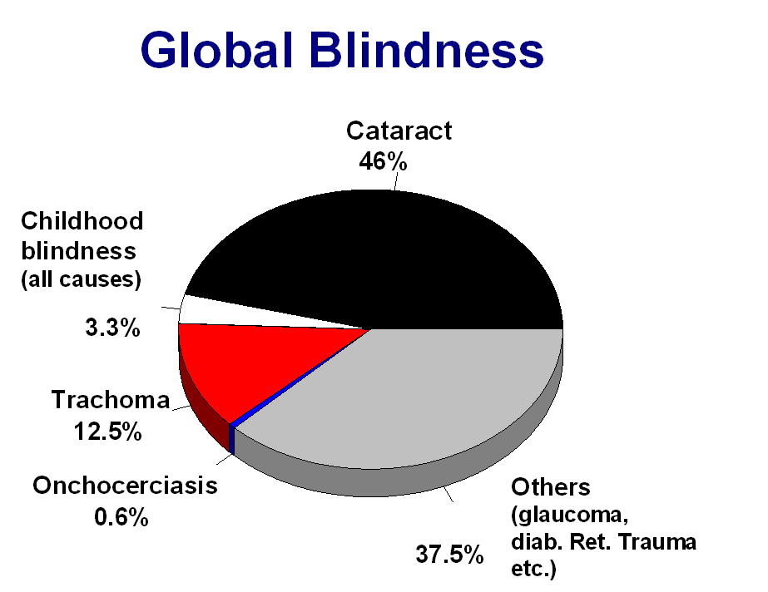
Figure 1 : Classification of World Blindness [2]

Looking at this locally, we see that within Australia, it is estimated that there are 380 thousand people who have low vision or are classed as legally blind. A person who cannot see at 6m nor has a field vision of 10ْ or less is considered legally blind. 95% of people classed as legally blind have some vision. To be classed as blind, there is a total loss of vision. Low vision cannot be corrected by visual aids such as glasses and contacts. [1]

With the general population living longer due to advances in medical technology, more people are being affected by Age-Related Macular Degeneration (AMD). This is a leading cause of blindness on the developed countries with an estimated 25 – 30 million people affected worldwide. This number is expected to triple in the coming 25 years. AMD causes the degeneration of central vision, leaving only peripheral view. This is caused by damage to the damage to the retina and hence cannot be corrected. While it rarely causes blindness, it can deteriorate into severe cases causing large disruption to normal life.

From the statistics provided above out of the 180 million who are visually impaired, only 40-45 million are blind. There exist 135 – 140 million people who still retain vision. Upon the mention of blindness, the first images conjured are Braille, the White Cane and the Guide Dog. These three aids, amongst many others have contributed an immeasurable amount towards the freedom and independence of the blind.

Most of the conceptions of blindness deal with total blindness. There is no real understanding in the general public with regards to those who suffer a loss of vision, as opposed to blindness. In most of these instances, it is very hard to learn to live a different life-style.

While all of the aids listed above help improve the life-style of those who are visually impaired, they do not offer anything with regards to vision. With the cane, obstacles are identified and the guide dog helps with navigation. However these aids do not offer anything with regards to visual sensory perceptions. This is especially true to those who have low vision as opposed to blindness. To gain further independence and freedom, the best aid would be something which would enable the continuation of the life-style they are used to.

Rehabilitative engineering is a relatively small field in today’s society as it does not have the monetary rewards most other fields offer. As engineers, we may not be able to restore their vision, but can help alleviate the problems encountered in everyday life. While much work has been done towards helping those who are visually impaired with counselling and the education of the public from discrimination, this does not compare to the experience of seeing. The aim of Visual Sound is to enable the user to have a sense of vision again. Taking advantage of the sense of sound, this can be used to enable vision in a different way. By interpreting the immediate surroundings into a predefined language based on sound, it would enabled people who are visually impaired a more detailed account of their surroundings.

1.2 Problem Analysis
The aim here is to develop a system that will eventually be capable to interpreting real visual images into an understandable sound language. This is a large undertaking. As a beginning, the first step here is to develop a prototype capable of processing simple still images and translate them correspondingly into sound.

The aim of this project, Visual Sound is to enable those are visually impaired the capability of ‘seeing’. While they may be experiencing problems with their vision, through the use of the remaining senses, sound, Visual Sound works to build visual images which the user can then interpret. The aim is to translate visuals via a sound language such that the user is able to build a mental picture in their minds, thus enabling them to effectively ‘see’.

1.3 Thesis Summary
Chapter 2 looks at the current applications in this field and the necessity for the undertaking of this project. Chapter 3 looks at the equipment required and the setup for the system. Chapter 4 will describe the sound language used to develop the system. Chapters 5 and 6 describe the design aspects of the system, describing the points taken into consideration in choosing the final dimensions of the image and sound processing. The final two Chapters 7 and 8 will discuss the workings and testing of the system, final conclusions and possible extensions to the system.

Background

2.1 Seeing with Sound
Upon the mention of seeing with sound, the first things to come to mind would of course be bats and dolphins. Both bats and dolphins produce a bio-sonar signal which is then broadcasted into its environment. Upon hitting an obstacle it will be reflected back to the animal’s receiver. By analysing the difference between the transmitted and received signal and knowing the speed of sound, the animal is thus able to locate objects in their immediate surroundings. Research shows that they are capable of building a full complete picture of the immediate surroundings to help with navigation.

The most common use of sound waves in practical applications would be in the field of medical sonography, ultrasounds. The most common use of ultrasounds is with the scanning of babies during pregnancies. Ultrasonic probes generate high frequency signals which are absorbed and reflected from matter of different densities, for example tissue, bone and body fluids. The reflected signals then form a picture of the analysed area, in this instance the baby. It is usually two dimensional and being black and white, it does not convey a lot of information. It is generally used to detect the gender of the baby and for any abnormalities such as Down syndrome.

Other common imaging practices are x-rays. X-rays do have a higher penetrative ability, but works on a different premise to ultra-sounds. The images created by an x-ray are not based on reflected waves. X-rays are passed through matter, bone and tissue, as the matter has different densities, the wave received at the end will consist of different components. These are then collected on an imaging plate and analysed. The use of ultra-sound is preferable on unborn babies as x-rays have been proven to be quite destructive and may cause serious damages to the baby. While there currently do not seem to be any dangerous side effects to the use of ultra-sounds, this aspect of medical imaging is still being researched.

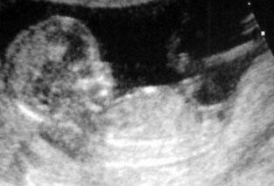
Figure 2 : Ultrasound [13]

2.2 Optophone
These same principles will be used to help those with low vision to see through the translation of vision through sound. The science of converting sight to sound is by no means a new feat. While the applications of sonography have been around for the last few decades, the optophone was developed by Dr E. E. Fournier in 1913 as a reading aid for the blind. The principles behind this can be described by the image below:

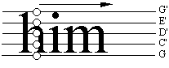
Figure 3: Fournier Albert’s Optophone [10]

A pattern of lights are setup to scan a page of text going from left to right. Each of the lights has a particular pitch assigned to it. In scanning from left to right, the lights will see a contract between black and white, the text and the page. Upon recognising text, the corresponding pitch will be emitted. Each character in the alphabet will have its own signature sound cord. By learning these sound cords, the user is then able to read through an interpretation of the sound cords produced.

Due to the time frame, the work of Dr Fournier was interrupted by World War I. continuing work on it after it did manage to reach production lines and would have been a successful device. However interest in the device dropped due to several reasons. The first problem to appear was the difficulty in learning the system. Looking books and texts would have a different font. While the characters themselves would not defer too much, these slight difference would be enough to cause the characters to sound slightly different between texts. In addition to this, in the early 1950’s a large percentage of the population were still illiterate and of the working class. Many did not have the time or the resources available to learn a system which will not help towards putting bread on the table.

Round about production time, there was the invention of reading books, negating the need of the blind to have to read books themselves. As such, the Optophone was never mass-produced, sinking back in obscurity. After the ending of the Optophone project by Dr Fournier, an independent project team carried out a 30 year investigation into the principles of the optophone and concluded that at its current capacity, it is not a feasible device to incorporate into everyday use. As that time, processes were a lot slower and this in turn inhibited the reading speed of the user. In additional to this, the thought of using this system on scripts other then English, for example Chinese characters is quite daunting.

2.3 vOICe
Though the optophone was deemed without a future, the intuitive nature of its portrayal of sound is the base principle for the vOICe system by Dr Meijer. While there have been several device between the development of the Optophone to current times, the most prominent device would be the vOICe system. This is by far the most developed product with regards to the conversion of sight to sound. The vOICe, (Oh, I can see) developed by Dr Peter Meijer, Philips Research, Eindhoven, the Netherlands. With the first prototype completed in 1998, the new edition has gone through several improvements to be the success it is today. The vOICe is software based and requires a laptop, camera and stereo headphones to operate.

While the same problems with the difficulties involved in learning the system remains, due to more powerful processors, the vOICe software is capable of processing in real-time. As it uses only common everyday components only, the system is accessible to everyone as there are no special devices required for operation. The vOICe software is also currently available as a free-ware for users to download from the internet.

The vOICe program breaks down an image into a 64 x 64 pixel frame. A scan is conducted from the left to the right, column by column. Each pixel of the column will produce a sound wave whose frequency is indicative of its position, for example a pixel at the bottom of the column will have a low frequency and a pixel high in the column will have a high frequency. The amplitude of the sound wave is decided by the brightness of the pixel on a 16 tone grey scale.

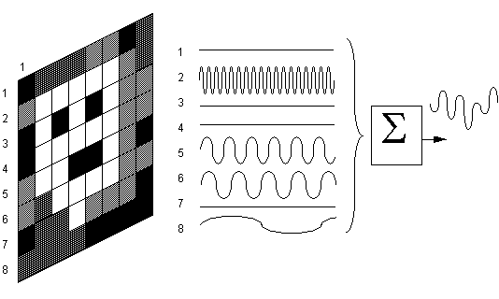
Figure 4: vOICe Optophone [10]

The limitations of this are that there is no depth perception. As it processes each of the video frames separately, there is no relativity between successive frames. Due to this, there are no means of tracking objects either. For example, a moving will appear as separate objects in each frame as opposed to being recognised as the same object displaced. The vOICe has gone through several testing stages. As the output is a clashing of notes, training is required before any kind of interpretation is possible. Within the test group by Peter Meijer, one beta tester Patsy Fletcher has reported that it provides low vision aid and with extensive training, she is able to make out some depth perceptions too. [12]

2.4 Solution
The aim of this project is to be able to produce a similar system to vOICe, which will interpret a user’s surroundings to again enable them to see through sound. Information gathered via sight will always contain more data then that of sound. Sound has only two characteristics, pitch and intensity. With vision, there is exists numerous characteristics. Besides the range of colours which exists in sight, there is also intensity and range. In translating from sight to sound, there will always be a loss of data. To successfully transcribe across, the characteristics of a visual image will have to be downscaled.

The following are the principles behind Visual Sound. The obvious choice would be to display the images through an intensity scale. By quantising the greyscale, the colour spectrum is effectively reduced to the level designated in the greyscale. Similar to vOICe, the processed image will then be broken into pixels with the position of the pixel denoting pitch and intensity denoting power.

The first thing to consider is the technical complexity of the project. Video projects at least 30 frames per second, effectively resulting in 30 images per second. Aside the fact that this will be extremely hard to work with, the user of Visual Sound cannot process at the rate of 30 frames per second, nor will the system be capable of producing distinguishable sounds at the rate of 30 frames per second. As such, work will begin with stills, and Visual Sound programmed through Matlab.

The final product of Visual Sound will be similar to that of vOICe. As such, it is not a revolutionary break-through but the undertaking is necessary as the aim here is to have software which will perform as vOICe does, but is not copyrighted, the source code is thus available for manipulation. While vOICe is available as free-ware, it is propriety to Dr Meijer and not accessible for analysis and changes. The aim here is to eventually have code which is on par to vOICe, and maybe even surpass it, but be able for changes and improvements. We wish to have code which we can change is necessary and to be able to take it in the direction desired for future ventures.

3.0 System Requirements

3.1 Requirements Summary
To keep the costs of the system down to increase availability, only common devices are used in the construction of Visual Sound. The user will require a digital camera to perform image capturing duties, a laptop onto which Visual Sound will be loaded for processing and a set of stereo headphones for the output of the program. The laptop will also need to have a Matlab installed for the processing of the image.

3.2 Hardware Requirements
The devices required for the system are a digital camera, a laptop and a set of stereo headphones. The diagram bellows shows the basic connection between each of the devices.


camera
laptop
headphones
Figure 5 : System Setup

A digital camera obtains an image of the surroundings. As the video images need to be streamed directly to the computer for processing, it is best to use a web-cam which has such capabilities inherent in its design. Note any digital camera will suffice if it comes with the necessary drivers to stream video on a continuous basis to the computer. The connection between the camera and the laptop will be the usual connection used by the camera.

The laptop is obtains the video stream from the camera and processes it through the Visual Sound program. A laptop is chosen over a desktop for mobility, as the aim of Visual Sound to help those who are visually challenged to navigate and experience the sensation of vision through sound. As with the digital camera, while there are not much specifications placed upon the laptop, it must be capable of running Matlab, the program with which Visual Sound is coded with. The specifications for each operating system required to run Matlab are listed below in software requirements..

The Visual Sound program will convert the digital images captured by the digital camera into a sound file which will be outputted to the receiver via a set of stereo headphones. Again there are no particular specifications for the headphones which are used. The usual connection method is used to connect the headphones to the laptop.

The aim is to keep the system requirements to the most basic devices. This is why the three main hardware pieces are listed as just any generic device. Brand and specifics have not been listed to enable the user to use devices already owned. It is hard to picture a household without the three basic devices, a web-cam, a laptop and a set of stereo headphones available. The aim of specifying only generic devices is to keep the costs of the system low, making it more accessible to the general population.

3.3 Software Requirements
As previously mentioned, the software program required to run Visual Sound is Matlab. Matlab was developed by The MathWorks in 1984. Since then it has grown to be one of the leading programs in design and computer modelling. Visual Sound is also programmed with Matlab. The main reason for this is the high functionality of Matlab.

Matlab has several in-built toolboxes containing functions for image and sound processing. As Matlab is also available on most operating platforms, this also resolves compatibility issues with compliers and programming language. As this is also the beginning of the project, working with defining functions simplifies the system as the design of the system can then be focused on as opposed to the programming of the system. The system requirement for each operating system is listed below.

General Requirements
General
- CD-ROM drive (for installation)
- Netscape Navigator 4.0 and above or Microsoft Internet Explorer 4.0 and above or Mozilla 1.x
- Adobe Acrobat Reader 3.0 or above (required to view and print the MATLAB online documentation in PDF format)
- Some license types require a license server running FLEXlm 9.2, which is provided by the MathWorks installer
- TCP/IP is required on all platforms when using a license server

What Is MATLAB 7.0 (R14) Built With?
Architecture | Compiler version
HP-UX | HP aC++ B3910B A.03.37 (B11.11.06)
Linux 32 | gcc/g++ version 3.2.3
Macintosh | Apple Computer, Inc. version gcc-3.3
Solaris | Sun One Studio 8 C++ 5.5 Patch 113817-06 2004/01/29
Windows | Microsoft Visual C/C++ 7.1 Professional Edition

Running Matlab on Windows
Windows Specific
Operating System | Processors | Disk Space | RAM
XP (Service Pack  1 or 2) | Pentium III, IV, Xeon, Pentium M, AMD Athlon, Athlon XP, Athlon MP | 340 MB (MATLAB ONLY with Help)* | 256 MB  512 MB (recommended)
2000 (Service Pack  3 or 4) |  | 340 MB (MATLAB ONLY with Help)* | 256 MB  512 MB (recommended)
NT 4.0 (Service Pack  5 or 6a) |  | 340 MB (MATLAB ONLY with Help)* | 256 MB  512 MB (recommended)
* Disk space requirement varies depending on size of partition. The MATLAB installer will inform you of the hard disk space requirement for your particular partition. Installation size will be determined by the installer and can vary for NTFS and FAT formats.
Graphics
- 16-, 24- or 32-bit OpenGL capable graphics adapter

Other Recommended Products
- MS Windows supported graphics accelerator card
- MS Windows supported printer
- MS Windows supported sound card
- Office 2000, Office XP, or Office 2003 is required to run MATLAB Notebook, MATLAB Excel Builder, Excel Link, Database Toolbox and MATLAB Web Server

Running on a Macintosh
Macintosh Specific
Operating System | Processors | Disk Space | RAM
Mac OS X 10.3.2  Mac OS X 10.3.4  (Panther) | PowerMac G4  PowerMac G5 | 220 MB  (MATLAB ONLY with Help) | 256 MB  512 MB (recommended)  64 MB swap space

Graphics
- 16-bit graphics or higher adaptor and display (24-bit recommended)
- X11 (X server) for Mac OS X*
- Apple supports X11 in Mac OS X 10.3 and higher versions only.
Other Recommended Products
- Postscript printer

Running on a Unix/Linux
UNIX/Linux Specific - 32-bit Operating Environment
Operating System | Processors | Disk Space | RAM
Sun Solaris 2.8 | SPARC  ULTRA | 335 MB  (MATLAB ONLY with Help) | 256 MB  512 MB (recommended)  64 MB swap space
Sun Solaris 2.9 | SPARC  ULTRA | 335 MB  (MATLAB ONLY with Help) | 256 MB  512 MB (recommended)  64 MB swap space
HP-UX 11.0 | PA-RISC 2.0 | 335 MB  (MATLAB ONLY with Help) | 256 MB  512 MB (recommended)  64 MB swap space
HP-UX 11.i | PA-RISC 2.0 | 335 MB  (MATLAB ONLY with Help) | 256 MB  512 MB (recommended)  64 MB swap space
Linux - built using Kernel 2.4.x and glibc (glibc6) 2.2.5 | Pentium III, IV  AMD Opteron**,  AMD Athlon,  Athlon XP,  Athlon MP¹, | 335 MB  (MATLAB ONLY with Help) | 256 MB  512 MB (recommended)  64 MB swap space
Linux Kernel 2.4.x and glibc (glibc6) 2.3.2 |  | 335 MB  (MATLAB ONLY with Help) | 256 MB  512 MB (recommended)  64 MB swap space
Linux Kernel 2.6.x and glibc (glibc6) 2.3.2 |  | 335 MB  (MATLAB ONLY with Help) | 256 MB  512 MB (recommended)  64 MB swap space

** Runs MATLAB in 32-bit emulation mode.
UNIX/Linux Specific - 64-bit Operating Environment
Operating System | Processors | Disk Space | RAM
Linux – built using Kernel 2.4.x and glibc (glibc6) 2.3.2 | AMD64 –  AMD Opteron,  AMD Athlon 64  Intel EM64T | 270 MB (MATLAB ONLY with Help) | 256 MB  512 MB (recommended)  64 MB swap space

Graphics
- 16-bit graphics or higher adaptor and display (24-bit recommended)
- 24-bit graphics display for Sun Solaris
Other Recommended Products
- Postscript printer
- Graphics accelerator card

Table 1 : Matlab Software Requirements [7]

The specifications above apply to Matlab 7.0.1, the latest release. The version used to program Visual Sound was on Matlab 6.0. As most programs these days are designed to be backwards compatible, there would be no problems in running Visual Sound on later Matlab versions.

4.0 The Sound Language

4.1 What is a Sound Language?
To begin, how will the system discern whether there are objects in the image to be translated to the user? The system needs to be able to decide as to whether or not there are objects in the image. Once the system has decided as to whether there is an object or not, how is the information to be conveyed to the user? Once the object has been discovered, it will be mapped to a characteristic sound function to project to the user.

Before any programming can be done, the first thing to design is the sound language. How can an image be depicted as sound such that the user can understand? Intuitively, we can position objects due to sound. A good example of this would be the Doppler Effect. The user can perceive the sound source moving. Taking advantage of this, the sound signature of the object can be emitted from left to right, allowing the user to then place the object accordingly. Another point would be pitch. It is also intuitive to assign higher pitched tones to objects positioned higher relative to other objects.

4.2 Edge Detection
The initial concept conceived is through the use of edge detection. As different objects will have their own distinctive shapes, if the user then learns the sound signature of each object, they are then able to recognise the stand-alone objects. To do this, each of the objects in the image is discovered and a sound signature is assigned depending on its shape.

The first step is to decide if there is an object within the image which needs to be related. The most common method is via edge detection. This method does not directly discern objects within an image. It traces the edges within an image, hence edge detection. An edge is defined as the boundary where a sharp change in density occurs. An edge is a property of an individual pixel and its relation to its neighbouring pixels.

To find differences between neighbouring pixels, it makes sense to use the gradient function. There are many first order derivatives edge detection methods developed. These include Roberts, Marr, Prewitt and Sobel. Second order derivative edge detector algorithms are also known as Laplacian models. The most used would be the Canny method. This will also be the method used here.

The Canny algorithm states
- Repeat steps (2) till (6) for ascending values of the standard deviation .
- Convolve an image g with a Gaussian of scale .
- Estimate local edge normal directions n using equation (4.61) for each pixel in the image.
- Find the location of the edges using equation (4.63) (non-maximal suppression).
- Compute the magnitude of the edge using equation (4.64).
- Threshold edges in the image with hysteresis to eliminate spurious responses.
- Aggregate the final information about edges at multiple scale using the `feature synthesis' approach.
Printed with Permission from [11]
Table 2 : Canning Algorithm

A comparison of the Canny algorithm to other methods of edge detection are displayed below. Below is the most famous picture in image processing Lena.

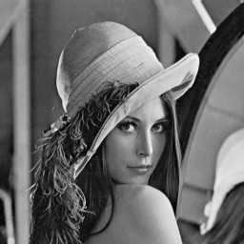
Figure 6 : Lena

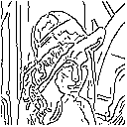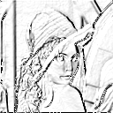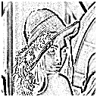
Canning Sorbel Laplacian
Figure 7 : Comparison of Edge Detection Techniques

4.3 Direct Translation
The main disadvantage of edge detection is that only the outline of each shape is recognised. While this does simplify the image being translated, there is generally a loss of detail and more importantly a loss of colour. Due to this, a direct translation from the image to sound is performed.

In the direct translation, the image is not pre-processed in any way. The images obtained are directly scanned and processed by the system. No attempts will be made to verify the contents of the image. The image will firstly be re-sized. This step is necessary as it is important to standardise incoming images for efficiency in calculations. As the system will then know the size of the image, it is able to correctly locate and reference points of interest in the image.

Each of the pixels in the image will have two properties attached. Each pixel will have a pitch which will depend on the position of the pixel and loudness depending on the intensity of the pixel. Each of the pixels in the column has a pitch allocated due to its position. Pixels low in the column will have a low pitch and correspondingly a pixel high in the column will have a high pitch allocated. As the image is scanned from left to right, columns of pixels are passed over and a chord will be sounded depending on the position and intensity of the pixels. In addition to this, the sound emit will emit from left to right, allowing the user to experience the position of the object due to the location of the sound itself. This corresponds to Figure 4, depicting the principles of vOICe.

This can be seen in the simple examples below.

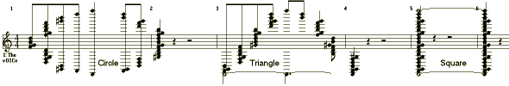
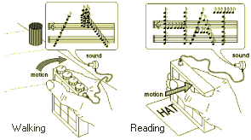

Figure 8 : Principles of the Optophone [10]

Reading the Image

5.1 Image Formats
Matlab does contain an extensive Image Processing toolbox, including the capability of video streaming. As work is does only from stills, it is not necessary to utilise these for the time being.

With the advent of advancing technology, there exists several picture formats. Matlab itself recognises nine different image formats. The most image formats associated with high definition colour as such produced by a digital camera are the jpeg images. A jpeg, Joint Photographic Experts Group, was originally formed for use with photographs as it has the capability of capturing the large amounts of colour. Due to this, jpeg images are generally quite large. The main advantage of jpeg’s is that they can be compressed to a percentage which offers the best balance between quality and size.

As the image obtained will be from a digital camera, it is logical to use jpegs in the modelling of the system.

5.2 Reading the image : Matlab imread Function
The function of reading an image into the Matlab program is performed by the imread function. Being a jpeg, the image read into Matlab will be formatted as a RGB format. Most of the images expected by Matlab will have an 8-bit depth. Jpegs’ are able to contain a larger colour scheme are it is capable of a 25-bit depth. When reading a colour image into Matlab, it will format it correspondingly to RGB format. The image will retain its size, but will have three indices associated to the varying intensities of RGB in each pixel. [8]
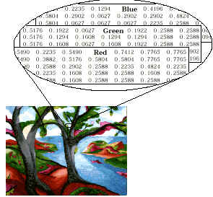
Figure 9 : Matlab RGB Image

6.0 Image Processing

6.1 Translation Problems
Low quality video streaming does produce up to 25 frames per second. High quality video streaming can get up to 50 frames per second. If a direct translation is to be done, this is equivalent to 50 images being produced and transmitted as sound per second. It is highly unlikely that the human ear is capable of distinguishing between 30 sound patterns per second. The most likely solution to this is to monitor the video streaming and sample say every 50 frames, or to select only 1 frame every 2 seconds. In this instance, this project will deal with stills only. The first thing to note about this is that there will be a loss of information in translating from sight to sound.

Sound waves have three main characteristics, pitch, loudness and quality. Focusing on a single note, a secondary characteristic of length of sound can be added. To translate a visual image, the first thing to consider is the fact that there are so many characteristics of vision. Sight depends on the eye. When looking at an image, there exist many characteristics. Besides the colour of the image, there is depth perception, the positioning of the objects within the image as well as the direction in which the object is travelling.

Looking into the current developments of image processing, While a lot of work has been done in this aspect, it is mostly all to do with image enhancement as opposed the downscaling of an image. To downscale an image, it will have to be passed through relevant filters and down-sampled. Before this can be done, first need to decide what the desired size is.

6.2 Grey-Scaling

6.2.1 Colour Classifications
When looking at an image, one of the first things noted are the colours in the image. If a child is asked to name their favourite colours, they may say blue, green, pink, base primary colours, while asking a more sophisticated adult the same question will result in answers like fuchsia, periwinkle or magenta. There are hundreds of colours which has been named and hundreds more which are undistinguishable by the human eye. Below are some of the colour maps generated by artists through time.

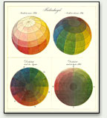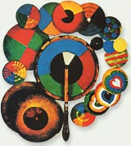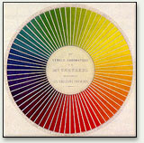
Philipp Otto Runge 1810 James Clark Maxwell 1850 Michel-Eugene Chevreul

Figure 10 : Colour Schemes [3]

With technology’s use of colour in TV, camera and photos, there exists several technical definitions of colour. There is the additive RGB scheme used with light projection in TV’s and computer screens, the subtractive CMKY scheme used with paints and oils, there is also then the scientific HSL and CIE schemes used in scientific research and psychological analysis. The point being there are too many colours to be translated to sound.

6.2.2 Matlab I = rgb2gray(RGB) Function
The logical solution will be to translate the image initially to an intensity scale. This will drastically reduce the amount of information the image will contain. To transform the RGB image read by Matlab into an intensity scale. The function used to complete this operation is rgb2gray.

RGB images can be of class unit8, unit16 or double. The corresponding output from the rgb2gray function will have the same class. While the format of the image does not affect the algorithm, the class of the image is of importance with regards to storage. It is not evident at the moment as work is being completed on stills, so the focus the on one image.

With the current system, an array of the pitches possible is stored. As the image is being scanned from left to right, each of the pixels in the column will be assigned a corresponding pitch due to position and loudness due to intensity. This will eventually be advanced such that the streaming of video is possible. As previously mentioned, in the streaming of video, there will be numerous frames per second. While this will be down-sampled such that only 1 frame is captured per 2 seconds, this is still a lot of frames and a lot of memory.

Matlab gray2ind Function
In working with the intensity scale, the first thing to decide is the level of intensity. Below is the image of Lena, the most famous picture in image processing. Lena is 256 x 256, 128 bit image.

Figure 11 : Lena

The image above is currently encoded at 128 bits. Keeping in mind with the sound language definition, the level of intensity is equivalent to the levels of loudness. By having an image at 128 bits, the user of Visual Sound will have to be able to distinguish between 128 different amplitude levels of sound. Aside the fact that this is a very hard task to perfect, we again come back to the problem of storage. It is not efficient for the system to store 128 different pitches.

To be able to configure the quantisation levels of the image, it first has to be changed from the greyscale to the index scale. This is achieved through the gray2ind command. In the processing of changing from greyscale to index, it is also possible to specify the intensity level at the same time. The image is thus quantised to different intensity levels. The results are shown below.

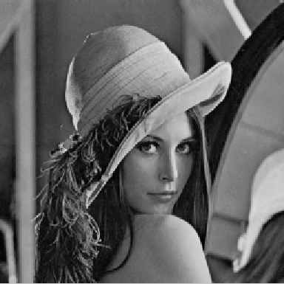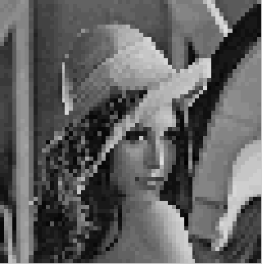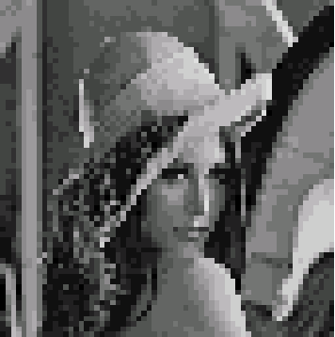
2⁶ = 64 2⁵ = 32 2⁴ = 16
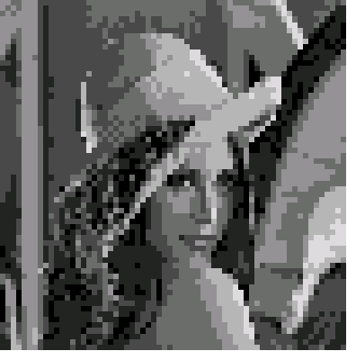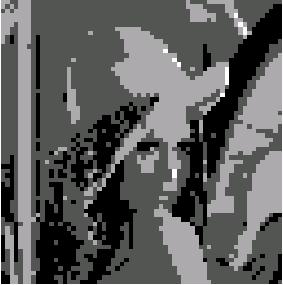
2³ = 8 2² = 4 2¹ = 2
Figure 12 : Quantisation Levels

The lower the quantisation level, the lesser shades of grey are available. From the sound language, each shade of grey corresponds to an amplitude level. The lower the quantisation level, the easier the system is to understand. However, it is evident that the lower the quantisation level, the larger the loss of detail. As always when comparing quality to efficiency, it is always a trade-off situation. From the images above, a decision needs to be made on the level of details desired to the ease of use to the user.

In the case of vOICe developed by Dr Peter Meijer, he has decided to use 16 quantisation levels. This equates to 16 different amplitude levels which the user will have to learn to differentiate between. Comparing the images with 8 bits and 16 bits, the major differences are with shading and shadows of the image. To enable the user a richer experience with Visual Sound, a quantisation level of 16 is chosen.

6.3 Matlab resize Function
The images will also have to be standardised. With the sound language, there needs to be a standard size, a set pixel width and height. Remembering that Visual Sound will scan from left to right, at each column of pixels, the pixels within allocated a particular pitch. The system will need to know the range of frequency pitches, as well as the time taken to traverse one scan of the image.

The resize function is used to standardise the images. Again as with the issue of quantisation, there is always a trade-off between efficiency and quality. In this instance, the size of the image, pixel-wise, is equivalent to the range of the frequency pitches the user has to differentiate between. The larger the size of the image, the more details contained within, but the larger the range of sounds the user has to recognise as the position of each pixel is assigned a particular pitch.

This is illustrated below.
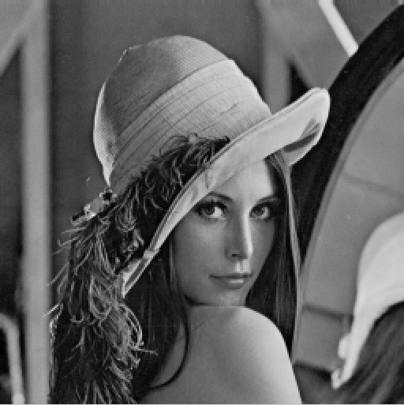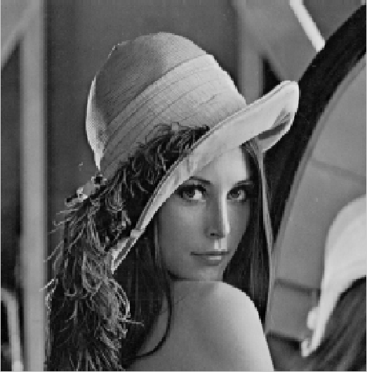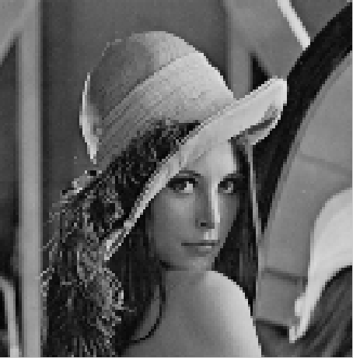
512 x 512 256 x 256 128 x 128
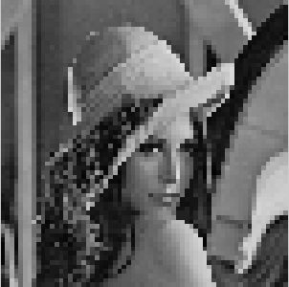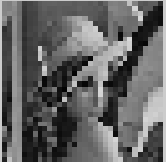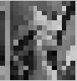
64 x 64 32 x 32 16 x 16
Figure 13 : Re-Sizing

The number of pixels per column corresponds to the different pitch levels required, or the range of the pitch. If the image of 16 x 16 is selected, this would mean that there are 16 pitches which the user will have to learn to differentiate the position of the object in the image. Intuitively, the smaller the size of the image, the smaller the range of pitches and the easier it is for the user to learn the system. It is notable that the smaller the size, the larger the loss in detail.

The first image starts to lose a large amount of detail is the 32 x 32. It is thus decided to go with a 64 x 64 image. Note there while having a height of 64 equates to 64 different pitches, it is not necessary to keep of the width of the image to 64. The width of the image corresponds to the scan time, or the time taken to process the image. As each column of pixels will produce a chord, the width of the image then decides the number of chords produced by the image. This will be discussed further in Chapter 7, Sound Processing.

As most images, pictures are still square as opposed to panoramic, the size of the image has been set as 64 x 64. This corresponds to vOICe by Dr Peter Meijer. A scan of Lena at 64 x 64, with 16 levels of quantisation is below.

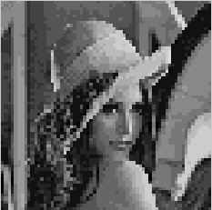
Figure 14 : Lena 64x64, quantisation 16

It is notable that the dimensions of the image above with regards to both resizing and quantisation deal only with powers of 2. This was done deliberately for ease of calculation with binary arithmetic.

7.0 Sound Processing

7.1 Sound Range

7.1.1 Range of Pitch
As with vOICe, the height of various pixels will correspond to pitch, the lower the pixel in relation to the height of the page, the lower the corresponding pitch. The human ear can distinguish the frequencies from 20 Hz to 20 kHz. These are the two extremes. Upon deciding on a range, the musical range was looked at. Rather then selecting the mid-point as a reference, the accepted mid note was selected. This is usually middle C. As such, middle C will be the mid note and there will be 32 pitches on either side of this frequency.

When looking into the frequency to assign to middle C, it was discovered that there are two different standards at the moment, the International Standard and the American Standard. With both in equal temperament, this refers to the constant ratio between neighbouring notes, the International Standard A₄ is at 435 Hz and hence middle C, C₅ is 517.3 Hz and the American Standard lists A₄ at 440Hz and hence C₅ at 523.25 Hz. The use of the American standard was adopted as it contained numbers that were easier to handle.
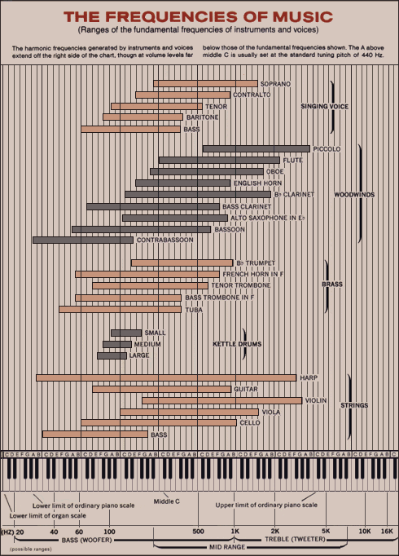
Figure 15 : Frequencies of Music [5]

Taking the ratio of notes from music, each octave has 12 intervals with the frequencies of notes in successive octaves doubled. For example, A₃ is 220 Hz, hence A₄ is 440 Hz and A₅ is 880 Hz and so on and so forth. In keeping with this, to have 32 pitch intervals on either side of A₄ will result in a very large sound range. Doing the maths here, as there are 12 notes in an octave:
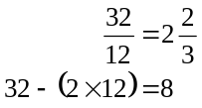
A₄ is 440Hz
32 notes below A₃ is 220 Hz
A₂ is 110 Hz
8 remaining notes 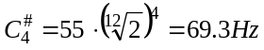
32 notes above A₅ is 880 Hz
A₆ is 1760 Hz
8 remaining notes 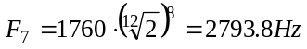
Equation 1 : 12 Octave Range

This is a very large range. Instead, the number of intervals in an octave is doubled. While this decrease the range, it is also more difficult to discern between pixels. As this is an aid to those with low vision as opposed to providing sight to those who are blind, these little losses of details are not significant. Doing the maths here

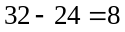
A₄ is 440 Hz
32 notes below A₃ is 220 Hz
8 remaining notes 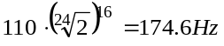
32notes above A₅ is 880 Hz
8 remaining notes 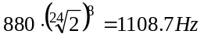
Equation 2 : 24 Octave Range

Note that in this instance, there are no references to notes. While a musical note does exist at these frequencies, they are no longer important as they were only being used as a reference point for the sound range. The initial basis for using musical notes was to enable a more harmonious chord should a lot of notes need to be struck at the same time. While the accepted musical internals are not being kept, the ratio of the musical notes are still been kept. Below is the algorithm used to generate the sound range used in Visual Sound.

Algorithm
- The first pitch is base =
- For i = 1 to 64
  - pitch i = 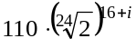
Equation 3 : Algorithm for Pitch Range

Unlike the initial test for the range with 12 notes in an octave, there are no musical instruments that are capable of producing 24 notes in an octave. The sound range was tested within Matlab and the difference between neighbouring tones while slight is noticeable. Therefore, to reduce the sound range such that the two end notes are not at such extremes, it was decided that the range of 64 will be expressed through a 24 interval octave.

7.1.2 Range of Amplitudes
From the previous analysis of Lena, it was decided that the quantisation level to be used is 16. As it is currently an intensity scale, the possible values range from 0.0 to 1.0. Performing some maths,

Algorithm
- The levels of quantisation level = 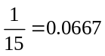
- For i = 0 to 15
  - quantisation = i * level
Equation 4 : Algorithm for Sound Amplitudes

Again to verify the above conclusions, testing was performed in Matlab. It was discovered while Matlab has an extensive image processing Toolbox, it is quite limited with regards to sound processing. Unless the signal is passed filters to achieve the ends required, the only way of changing the amplitude of the sound signal is to directly increase the amplitude of the signal. To do so with 16 levels is a large task. To ensure that the levels are distinct, a respectable interval has to be allowed between each amplitude level.

Going up by quarters from silence, 0, the largest amplitude of the sound signals is 3.75. Testing the sound range via Matlab, it was found that an amplitude of near 4 is extremely disagreeable. Comparing the quantisation levels of the original Lena, a level of 8 was chosen instead. Again keeping with quarters, the maximum amplitude is now only 2.

Algorithm
- The levels of quantisation level = 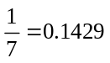
- For i = 0 to 7
  - quantisation = i * level

let amplitude = A(i, j)
- For rows j = 1 to 64
  - For cols k = 1 to 64
classify switch image(i,j)
case 0 A(i, j) = 0;
case 36 A(i, j) = 0.25;
case 73 A(i, j) = 0.5;
case 109 A(i, j) = 0.75;
case 146 A(i, j) = 1.0;
case 182 A(i, j) = 1.25;
case 219 A(i, j) = 1.50;
case 255 A(i , j) = 1.75;

For each amplitude
Tally the length – as this will be how long each note will be held
Equation 5 : Amplitude Quantisation

7.2 Creating Sound Bank

7.2.1 Sound Bank Design
Having now decided that there would be 64 different sounds and having decided the range and pitches, the next step is to create the actual sound bank of pitches. Two separate sound banks would have to be created. One would hold all the different pitches corresponding to the position of each pixel. The other sound bank would hold the various intensity levels require by the system.

7.2.2 Creating Sound File
Having already generated the sound file, all that remains is to apply an algorithm to the resized and quantised image to obtain a sound signature. As it has been quantised to 8 levels of intensity, this will also be the level of power of each pixel, the darker the pixel, the louder the sound.

Before creating the sound, it is also important to note that the default sampling frequency for Matlab is 8kHz. If desirous, the sampling frequency can be changed, however the need to do so does not arise in this circumstance. As such, the default sampling rate of 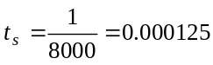 has been kept.

The next thing to decide upon is length of the sound file. Again this is a balance of quality and efficiency. It is desirable to have a sound file with a large length of time as this then allows the user more time to analyse the chord generated by Visual Sound after a column of pixels. However, Visual Sound will eventually be extended to real-time video streaming. As such, it cannot afford to spend 5 seconds on individual frames as tis would mean the sample rate of the video frames will be very low. The possibility of the user losing information between frame captures increases. As Visual Sound is meant to be an aid for those with low vision, this would be a very bad scenario. Balancing efficiency and quality, a frame time of 2 seconds was selected.

Algorithm
- Sampling rate ts = 1/8000;
- factor = 2^(1/24);
- freq = zeros(1,64);
- creating the required pitch
- for i = 1:64
    - freq(i) = 110 * (factor ^ (15+i));
- For rows j = 1 to 64
  - For cols k = 1 to 64
    - Notes = amplitude* sin(2*pi*freq*[0:ts:length])
Equation 6 : Sound Bank

7.4 Creating Stereo Sound
Once each individual sound signal was created, it was a matter of combining the signals such that they will form a chord of sound. The chords themselves would be played in succession to imitate the passing of time. This will enable the user to track the position of the vision lengthwise.

Another way of depicting position to the user would have been through the use of stereo sound. The completed sound file would fade from right to left, enabling the user to ‘see’ the image from right to left for positioning. However, with limited sound processing capabilities, this feature was not utilised in this version of Visual Sound. All sound file generated from Visual Sound 1.0 are mono.

The possibility of using the Doppler Effect to simulate this was investigated. The Doppler Effect portrays the movement of a sound source, which would be ideal in this instance. However, this is done via a shift of frequencies as the
Doppler shift = 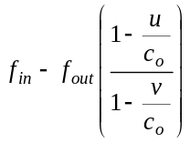
Equation 7 : Doppler shift

A simple example would be to generate a signal of 50Hz on the right and a signal of 51Hz on the left. By playing the right the then left sound signals the sound source appears to move from the right to the left. To apply this to Visual sound, this would mean that each of the frequencies of the pixels of the came pitch would have to increase slightly as the system scans from right to left.

The final size of the image decided on was 64 x 64, there thus also exist the possibility that the slight increments in frequency when moving from right to left could increase to such a degree that it would be confused for the pitch of the frequency above it. For a 64 x 64 sized image, this will also be very computational exhaustive. Due to this, it was decided to stay mono on with the current version of Visual Sound.

8.0 Program Testing

8.1 Test Environment
The Visual Sound program was test over a period of 6 weeks with 10 different subjects. Sessions were held twice a day, three times a week. The 10 subject were chosen such that there was a range of age, sex and nationality. While none of the subjects were blind or visually impaired, half did perform the testing blind-folded.

The basics of the sound language was explained, advising that the pitch of the note represented the position of the object, the loudness of the note represented the intensity and length of the note the relative size of the object.

The testing was broken into three stages. In the first test, the subjects were given sound files of known objects, and the goal was to identify them. In the second test, the subjects were given sound files of random simple objects and this time, they were to draw the various shapes. In the last test, scans of pictures were used and the subjects again asked to draw them.

In each of the tests, the sound files were played once, then played a second time after a 10 second lapse. Each sequence would only be played twice. Sessions are held three times a week, twice a day. The twice daily sessions have an 8 hour break between. This was arranged to see if the subjects’ capability of learning increased if the training was intensive by have sessions twice a day.

As this version of Visual Sound was not fully complete with stereo sound as intended, the subjects were played the sound files once with Visual Sound in mono and once again with vOICe in stereo.

8.2 Test 1 - Known Shapes
In this test, the subjects were firstly given the sound files of 6 simple shapes. The sound files were then played randomly and the subjects asked to identify the various shapes. The various shapes and sound files are listed below
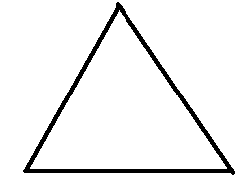

 | Subjects Blindfolded |  |  |  |  | Subjects Not Blindfolded
Sessions | 1 | 2 | 3 | 4 | 5 | 6 | 7 | 8 | 9 | 10
1 | 1/6 | 1/6 | 0/6 | 2/6 | 1/6 | 0/6 | 0/6 | 1/6 | 2/6 | 2/6
2 | 1/6 | 2/6 | 0/6 | 2/6 | 3/6 | 2/6 | 2/6 | 2/6 | 1/6 | 2/6
3 | 3/6 | 2/6 | 2/6 | 4/6 | 3/6 | 3/6 | 3/6 | 3/6 | 2/6 | 1/6
4 | 4/6 | 4/6 | 1/6 | 4/6 | 4/6 | 2/6 | 4/6 | 4/6 | 4/6 | 1/6
5 | 4/6 | 5/6 | 4/6 | 3/6 | 3/6 | 4/6 | 4/6 | 3/6 | 4/6 | 3/6
6 | 5/6 | 4/6 | 5/6 | 4/6 | 5/6 | 3/6 | 5/6 | 4/6 | 5/6 | 3/6
Figure 16 : Test 1 Results

After a few sessions, the results indicate that the simple shapes are easily learnt and are recognisable.

8.3 Test 2 – Random Simple Shapes
In the second test, the same 10 subjects were kept, however subjects did not know the shapes of the sound files in advance. Keeping with simple shapes, random sound files were given to the subjects and they were asked to draw or identity the shapes. The shapes given were simple shapes as above and some of the characters from the alphabet and numbers.

Session 1 A 1 X
Session 2 X X 3
Session 3 X S O K X
Session 4 A 0 M
Session 5 + 6 A W $
Session 6 1 2 # 4 5
 | Subjects Blindfolded |  |  |  |  | Subjects Not Blindfolded
Sessions | 1 | 2 | 3 | 4 | 5 | 6 | 7 | 8 | 9 | 10
1 | 1/5 | 1/5 | 0/5 | 2/5 | 2/5 | 3/5 | 2/5 | 0/5 | 2/5 | 0/5
2 | 2/5 | 3/5 | 2/5 | 3/5 | 2/5 | 3/5 | 3/5 | 2/5 | 2/5 | 2/5
3 | 2/5 | 3/5 | 1/5 | 3/5 | 3/5 | 3/5 | 4/5 | 1/5 | 3/5 | 1/5
4 | 3/5 | 5/5 | 2/5 | 4/5 | 4/5 | 4/5 | 5/5 | 2/5 | 4/5 | 3/5
5 | 5/5 | 4/5 | 2/5 | 3/5 | 4/5 | 4/5 | 3/5 | 3/5 | 4/5 | 3/5
6 | 4/5 | 5/5 | 3/5 | 5/5 | 4/5 | 4/5 | 4/5 | 3/5 | 3/5 | 2/5
Figure 17 : Test 2 Results

It is notable that while this test is more difficult, the subjects did score quite highly as they adapt to the system.

Test 3 – Complex Pictures
The last test was the most difficult as scans of pictures were used instead of simple shapes. As it is hard to draw a picture, the ratings given here are based on a standardised scale. The main features of the pictures were marked and if the subjects had noticed the more important edges, points were given according to that. As the pictures are more complex, only 2 pictures are shown. These are given through 3 sessions each, giving the subjects more time to get used to the picture. The first image used is of course Lena and the second a simple picture of a tree.
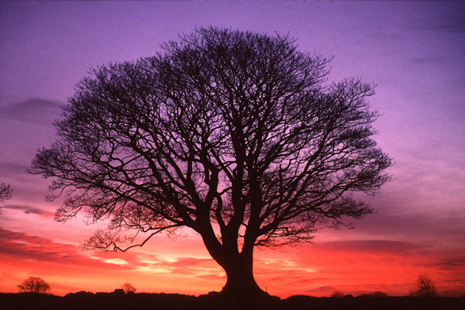 [4]
 | Subjects Blindfolded |  |  |  |  | Subjects Not Blindfolded
Sessions | 1 | 2 | 3 | 4 | 5 | 6 | 7 | 8 | 9 | 10
1 | 5% | 8% | 3% | 3% | 4% | 4% | 2% | 6% | 10% | 13%
2 | 10% | 20% | 20% | 10% | 20% | 13% | 10% | 10% | 25% | 10%
3 | 15% | 20% | 15% | 20% | 30% | 23% | 15% | 13% | 30% | 20%
4 | 20% | 20% | 15% | 13% | 30% | 25% | 15% | 10% | 30% | 30%
5 | 25% | 30% | 20% | 15% | 30% | 25% | 25% | 15% | 30% | 30%
6 | 40% | 30% | 34% | 20% | 32% | 30% | 30% | 20% | 30% | 35%
Figure 18 : Test 3 Results

It is notable that while the simple image of the tree was better interpreted by the subjects, the details of their drawings did not improve much. While the basics of the Visual Sound language is intuitive and easy to pick up, to be proficient at it will take a while.

9.0 Discussion

9.1 Current Issues

9.1.1 Learning Curve
The first point to note is that a lot of training is required before the user is capable of using the system to its full potential. While the sound language used here may be quite intuitive, the ability to use Visual Sound depends on the ability of the user to distinguish the various notes in each chord and assign it to the corresponding position. The perfect example would be music. While a large percentage of the population listens to music, they are not able to distinguish the various notes in a chord nor does this educate them in music.

In the recent bi-annual meeting of the Federation of European Neuroscience Societies, FENS forums, research regarding the vOICe program was disclosed. An experiment was conducted with 4 sighted people with their vision blocked. The basic idea was explained, with stereo panning and pitch as indicators of position and pixel brightness as loudness. Group A, consisting of 2 people, were given sound files of basic geometric shapes. Group B, consisting of the remaining 2 people were given sound files of photographic stills. Neither group were given any training and were asked to draw the ‘shapes’.

Group A were able to discern the shapes are a few sessions, but did not seem to improve after. Group B did have a slower learning curve, but their ability to discern the objects did improve as the number of sessions increased. The findings indicating that the system does work as the users are able to continually learn and improve use. These results are similar to the results obtained in Chapter 8.

As this is aimed at people with low vision as opposed to those who are blind, the learning curve will not be as steep as it will help to distinguish obstacles as opposed to navigation. However, it is believed that with enough training, even those who are blind should be able to use Visual Sound to ‘see’.

9.1.2 Loss of Detail
One of the main drawbacks of this system is the loss of detail with the system. There are too many characteristics in vision to translate to sound. The images go through two image processing procedures. The first greyscales the image, this already introduces a loss of details as colours will merge. The second process of resizing also results in a large loss of detail as to downsize, pixels are merged and averaged.

While this is meant as an aid to those with limited sight as opposed to no sight, if there was a fine wire stretched between two points, the user will not be able to see this and this would result in a very unfortunate accident. However, the general population with ‘normal’ vision do still walk into spider webs. The fact remains that there will not be a system which will be able to translate all visual sights into sound such that it will be easy for the user to hear.

A little side point is that this will most likely be used by the older population whose vision is failing. However, most of the older population will most likely have hearing defects as well. Will Visual Sound then really help towards improving their quality of life?

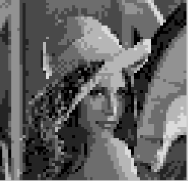
original 256 x 256 64 x 64, quantisation 16 64 x 64, quantisation 8
Figure 19 : Comparison of the Lenas

9.1.3 Matlab
The most prominent part of the problem here is that Matlab is not capable of producing quality stereo sound. While selected in the beginning for its extensive image processing capabilities, the fact that it was lacking with regards to sound processing was missed. While Matlab does have the capability of stereo sound, it is not very well supported. To give the illusion of stereo sound, the mono sound file created will have to be passed through several filtering options to enable it to fade from right to left. This would complicate matters as well as adding again to the computational time.

Another method of creating a sound system for the visually impaired is via Head Related Transfer Functions (HRTF). A lot of work has been done with regards to HRTF which aims at measuring the way the human ears perceive sound sources from different locations. This would be ideal for the case of Visual Sound, however the sound sources do require hardware much more sophisticated then that of a set of normal stereo headphones. Current practices are not mobile as it involves the setup of several speakers in a surround sound environment. Research is being carried out involving the design of a helmet-like device which will act as a surround sound system, having speakers situated around the rim of the helmet. Aside the fact that it is not very sightly, this will also increase the cost of the system when the aim of the project is to provide a low cost visual aid.

While unable to simulate stereo sound with Matlab, this is but only one of the technical issues with using Matlab. Admittedly the code has yet to be fully optimised, however it has not be able to hide the fact that Matlab will not be capable of processing the required tasks in real time. Even now when working with stills, there is a noticeable delay with the processing of the more complex pictures.

9.2 Future Extensions

9.2.1 Depth Perception
A thing to note with Visual Sound is that there does not appear to be a way of conveying depth perception to the user. As previously discussed, there are only two main characteristics of sounds to be used. The pitch depicts position and the loudness depicts pixel brightness, or the colour intensity of the object. This does not leave a characteristic for depth perception.

The problem of this is that the user with Visual Sound will not be able to differentiate between a 20m object at a distance of 100m and an object of 1m directly in front. In working with still, as it is only 2 dimensional, this problem was not evident until the testing stages. As such, the analysis of depth perception will have to be extended to video streaming.

Firstly, as Visual Sound obtains images via a digital camera, and then samples the frames to obtain stills for processing, it is effectively working from stills. As such, there is no way of obtaining information which will allow the system to calculate distance. For this to be possible, an extra device will too sense distance will have to be implemented. The most common devices for detecting distance would be infra-red and sonar. These devices will emit a known signal and by comparing the returned signal with the generated signal and knowing the speed at which it travelled, the distance to the object which it reflected from can be calculated.

The inclusion of this device will mean that the user will no longer be able to utilise the system from everyday devices. The sensor will have to be programmed specifically for this purpose and will have to be mounted somewhere on the system to enable it to monitor surroundings. In addition to this, another sound signal will have to be engineered to convey the details the proximity of objects to the user. This will also increase the total cost of the system, making it less accessible to the general public.

Research has been conducted into the transmitting of distance as sound. Using infra-red, the distance between objects were measured then transmitted to the user with a scale based on the length of the object. The furtherer away it was, the longer the sound. Similar to Visual Sound, the position of the object was conveyed by the pitch of the sound, and in this case the length of a note depicts the distance from the user as opposed to the ‘size’ of an object.

9.2.2 Object Tracking
Another point to come up is the inability to track objects. Again this was not encountered when working with stills as there is only one image as reference. When Visual Sound is extended to video streaming, the system should be able to keep track of objects so as to allow the user to identify motion. This is will allow the user to know the direction of the objects’ travel in the image as well as their position. It is easy to imagine the usefulness of this by picturing traffic. While a car may be on the road at a point in time, the user will recognise this at the first fame snapshot. In the next frame approximately 2 seconds later, again there is a car in the frame snapshot. Assuming we have a system which enables the user to translate depth perception, the car in this shot is noticeable closer. Is this that same car but closer, or another car altogether. If it is the same car, if it is to continue along its direction or travel, will it eventually end up in a head-on collision with the user?

With the current algorithm of Visual Sound, there is no way of object tracking, even with the extension to video streaming as images are grey scaled and re-sized with no discrimination given to the contents of the image. As such, it is not possible to discriminate between objects in the image. The only way which the system would be able to distinguish between objects would be to go back t the original concept of edge detection.

With edge detection, the outline of each object is obtained. By keeping a database of the images encountered, it should be able to match objects from frame to frame, enabling the user to track. However, as previously discussed the use of edge detection results in only the outline of the object and does not convey colour or intensity to the user. To keep the tracking capability and to convey colour, it will be necessary to combine the two principles of detection. Tis again results in the same predicament, there are not enough characteristics of sound to convey the amount of information desired. A new sound language will have to be devise.

9.2.3 Stereo Sound
In the event that Visual Sound will be ported and additional devices added, a simple way of implementing stereo sound is via a converter. The generated sound file will be passed over a converter and this will induce a natural fade from right to left, mimicking stereo sound. Stock converter chips are not too expensive and will not add too much to the cost of the system.

10.0 Conclusion

The aim of this project was to develop a system which will enhance the quality of life of those who are visually impaired. Through the use of other available senses, Visual Sound aims to help interpret visual surroundings through a sound language to enable the user to ‘see’ again. In a recent FENS convention, it was shown that while the sound language and system may initially be difficult to understand, it is a system where the user can continually grow and understand, enhancing the use of Visual Sound.

The current version of Visual Sound will successfully read and process a simple image into the required sound format. However, the code has yet to be optimised and thus may be cumbersome for large files. Due to the limited capabilities of the sound processing toolbox from Matlab, a successful algorithm for the output of stereo sound has yet to be derived. However, in taking Visual Sounds forward, it is necessary to port the system onto a different programming platform.

In addition to this, should Visual Sound eventually be required to calculate depth perception and have to ability to track objects, it will be necessary to revise the current sound language. At the moment, all the characteristics of sound have all been adapted for use, there are currently no features left for to be utilised in conveying extra information.

11.0 Reference

[1] Australian Bureau of Statistics, 2003, Blindness (Complete/Partial) [Online],
Available:http://www.abs.gov.au/ausstats/abs@.nsf/0/5796EA76D51A2403CA256D3A002C7153?Open&Highlight=0.Blind [2004 March 10]

[2] Blindness: Vision 2020 – The Global Initiative for the Prevention of Avoidable Blindness 2002, [Online], Available: http://www.who.int/mediacentre/factsheets/fs213/en/ [2004 May 24]

[3] Causes of Colour; [Online], Available: http://webexhibits.org/causesofcolor/1B.html [2004 July 27]

[4] © Freefoto.com, 2004, Tree, Sunrise, Northumberland, [Online], Available: http://www.freefoto.com/preview.jsp?id=15-19-1 [2004 May31]

[5] Copyright © 1980 by Hachette Filipacchi Magazines, Inc.
Reprinted from Stereo Review, April 1980, with permission.
The Frequencies and Sounds of Music, [Online], Available:
http://www.psbspeakers.com/FrequenciesOfMusic.html [2004 March 5]

[6] Kocur, Ivo & Resnikoff, Serge 2002 World Sight Day: 10 October [Online]
Available: http://www.who.int/mediacentre/releases /pr79/en/ [2004 March 24]

[7] MATLAB ® 7.0.1: Platforms and Requirements, [Online], Available:
http://www.mathworks.com/products/matlab/requirements.html [2004 October 10]

[8] MATLAB Image Processing Toolbox, 1998, [Online], Available:
http://www.ece.ucsb.edu/Faculty/Manjunath/courses/ece178/matlabip.htm
[2004 April 2004]

[9] Meijer P B L, 2004 Related Seeing with Sound Projects, [Online], Available:
http://www.visualprosthesis.com/projects.htm [2004 April 15]

[10] Picton P. & Capp M., The Optophone: some questions and answers, [Online], Available: http://oldweb.northampton.ac.uk/aps/eng/research/optophone/optophone2.html
[2004 May 31]

[11] Sonka M., Digital Image Processing: Chapter 4 Part III: Image Pre-Processing; Local Pre-Processing, [Online], Available:
http://www.icaen.uiowa.edu/~dip/LECTURE/PreProcessing3.html#canny [2004 April 13]

[12] Tech Live, April 1 2002, newscast program TechTV US

[13] Ultrasounds, [Online], Available: http://www.birth.com.au/class.asp?class=6610&page=1#listen [2004 May 29]

Appendix A – Matlab Code
A1 - Reading in the Image
%
% This function is the beginning of the system and reads in
% the image placed in the work folder. Note that in the
% extension to video, the images will not be obtained from
% the work folder.
%
% The image is also resized to the desired 64 x 64 and
% quantised to 8 levels. To save memory, it is then converted
% to uint8.
%

image = imread('lenna.gif');
iresize = imresize(image, [64, 64], 'nearest');
[i8_index, map] = gray2ind(iresize, 8);
i8double = ind2gray(i8_index, map);
i8uint = im2uint8(i8double);

A2 - finding the amplitude of each pixel
%
% This function finds the intensity of each of the pixel.
% This is important as intensity dictates the amplitude
% of the signal. As mentioned in the design aspects, 8
% levels were chosen.
%

i = zeros(1,64);
j = zeros(1,64);
A = zeros(64, 64)
for i = 1:64
for j = 1:64
switch i8uint(i,j)
case 0 A(i,j) = 0;
case 36 A(i,j) = 0.25;
case 73 A(i,j) = 0.5;
case 109 A(i,j) = 0.75;
case 146 A(i,j) = 1.0;
case 182 A(i,j) = 1.25;
case 219 A(i,j) = 1.50;
case 255 A(i,j) = 1.75;
end
end
end

A3 - the mapping of instances of how long to hold each note
%
% This function discover how long a particular amplitude
% is being held for at a particular pitch. This is
% required as notes of the same pitch at the same
% amplitude should be held for the set amount of time as
% opposed to being re-sounded at the next pixel
%

% This section will tally the amplitudes that were
% classified from A2.

i = zeros(1,64);
j = zeros(1,64);
hold = zeros(64,64);
for i=1:64
for j=1:64
if j = 1
hold(i,j) = 1;
elseif i8uint(i,j-1) == i8uint(i,j)
hold(i,j) = hold(i, j-1)+1;
else hold(i,j)=1;
end
end
end

% In this section, once the amplitudes have been tallied,
% the total for each amplitude at the particular pitch is
% recorded. From this, the system si able to determine
% how long each note would be.

length = zeros(64,64)
for i=1:64
for j=1:63
if hold(i,j) >= hold(i, j+1)
length(i,j) = hold(i,j);
else length(i,j) = 0
end
end

length(i,64) = hold(i,64);
end

A4 - creating the sound bank
%
% The actual sound signal are produced here. By default
% Matlab samples at a frequency of 8kHz. This default
% frequency was kept.

% This section creates the 64 frequencies used in the
% system.

ts = 1/8000;
factor = 2^(1/24);
freq = zeros(1,64);

for i = 1:64
freq(i) = 110 * (factor ^ (15+i));
end

% In this section, each of the pixels are examined and
% the corresponding sound signal is created. The sound file should be no longer then 2 seconds.

sample = 2/ts;

for i=1:64
for j=1:64
if length(i, j) ~= 0
note = A(i,j)*sin(2*pi*freq(i)*[0:ts:
(sample*length(i, j))]);

