A Portable Device for the Translation of Braille to Literary Text

Iain Murray, Andrew Pasquale

Abstract-- A novel device has been developed and tested to provide a portable means of automatic Braille to text translation. The device uses a CCD based camera system in conjunction with a Digital Signal Processor that performs optical character recognition and outputs the equivalent literary text to a LCD or text-to-speech converter.

I. INTRODUCTION
Approximately 300 000 Australian’s suffer from some form of severe vision impairment [1]. The preferred means of written communications for many of these persons is through tactile Braille mediums. While these persons can read and write using the Braille system, the majority of sighted persons in society can not, and thus there exists a written communications barrier between seeing and vision impaired persons (VIP’s).
This problem is particularly apparent in the education system, where nowadays blind students are taught in mainstream schools. Many of these students perform all assessment, note making and homework writing using the Braille medium. However most teachers of these students are Braille illiterate, so presently all the students work must first be sent to a special unit of the Ministry for Education, where the Braille is translated to literary text and then sent back to the teacher before it can marked. This creates unnecessary hindrance and cost for the student, teacher and government. Problems also exist in the workplace where any information written by a VIP in Braille that is to be interpreted by other Braille illiterate persons, needs to be first translated by the VIP themselves.
To overcome this communications barrier, the developed device provides a means by which Braille illiterate persons can read what a VIP has written in Braille. The device is essentially a hand held scanner that is rolled along the desired Braille line, and in real time the equivalent literary text is computed for visual display, on a Liquid Crystal Display (LCD) for example.
The device also has application for vision impaired persons who suffer Diabetic Peripheral Polyneuropathy (DPP). Diabetes is a major cause of blindness in Australia [1], and persons who suffer DPP lose touch sensitivity in their fingertips, causing considerable distress as they are unable to read even Braille mediums. (Similar conditions exist for geriatrics and persons suffering head injuries [2]). These persons could use this device to roughly feel the location of dots on the Braille line to operate the scanner, with the literary text equivalent spoken out in real time through the use of a text to speech converter with speaker output. All specifications and requirements for the device were taken from the Association for the Blind Western Australia.

II. PROTOTYPE SYSTEM

To allow the method of braille to text translation to be a user friendly operation the prototype system uses a hand held unit that incorporates a camera system for the image capture of the braille medium. The device can then be scanned along the desired braille line with the equivalent literary text displayed in real time, mimicking the abstract reading method of sighted readers with standard text.
The prototype system block diagram can be seen below in Figure 1.
Basically, in operation the camera system on the hand held unit captures one dimensional photo frames of the Braille page as the device is scanned along the Braille line. These frames are then sent to a digital signal processor (DSP) which optically recognises the Braille characters present and determines the equivalent literary text equivalent for real time display on the host PC. (The display of output on the host PC is purely for prototyping purposes, a developed device will utilise a LCD display or text to speech converter to enable the device to be truly portable)
The codewheel assembly, also located on the handheld unit, provides the DSP with information on the scanner’s direction and distance of movement for the correlation of photo frames from the camera system with the actual physical braille page. Doing so allows the DSP to construct an accurate two dimensional map of the braille page for optical character recognition from a one dimensional camera system.
A timing board is included to manage the operation of the camera system and also to condition the various control signals from the handheld device for the DSP.
The prototype of the system is displayed in figure 2 and 3. Note however that in the developed device all of the system components will be located all within a handheld unit for ease of use and portability.

A. Image Capture System

The image capture of the braille medium is achieved by a camera system consisting of an illumination source, focusing lens and linear CCD photodiode array. When in operation, the illumination source, constructed of a row of 4 LED’s, shines at a right angle to the braille page causing shadows to form behind the raised dots of the braille cell as seen in figure 4. The selfoc lens used consists of a 2*12 array of micro–lens, designed to focus the braille dot shadows image onto to the linear CCD photodiode array. The lens as seen in figure 4, moves above the braille cell in when the scanner is in motion, and as such causes no wear and tear on the braille medium..
The CCD utilised in this application is the Taos TSL202R 128 x 1 Linear Sensor Array. The device contains 128 photodiode pixels orientated in a row as indicated in figure 4 by the grey line on the linear CCD array. The CCD outputs each photo frame of the braille page serially, pixel by pixel, to the ADC (analogue to digital converter) of the DSP. The voltage output of each pixel is proportional to the amount of light incident on that pixel since the last camera frame.
The entire image capture system (illumination, lens and CCD combination) produced the output frame of 3 braille dots in figure 5. Clearly from this output, the position of braille dots within an image slice can be determined.

B. DSP Platform

The Digital Signal Processor used in this project for the optical recognition of Braille and the translation to literary text was the Texas Instruments TMS320VC5402. The DSP is highly suitable for this application due to its high computational speed (i.e. 100 MHz, required in this application for the demands of real time image processing), low power usage (i.e. 0.33mA/MHz [3], considering the portable requirements of the device and the need to run on batteries) and low cost ($5.66 US per DSP at 1000 unit volumes, to allow the developed device to be financially accessible).
The DSP is programmed to allow the Braille to text translation operation as simple as possible for the user. For example, when a user is operating the device, it would be unreasonable to assume they would hold the scanners camera over the braille line perfectly constant and stable when in motion. The device needs to be tolerant to any changing location of dots within the camera frames so that the user can concentrate on understanding the text they are scanning, not on the actual scanning process itself. The DSP can allow for the varying location of braille dots within the camera image by using fuzzy logic principles to ‘estimate’ whether a particular braille dot is present, and is restricted solely by the height of the braille cell and the camera’s finite field of view. The DSP is also capable of compensating for situations when the 1D camera is at an angle to the Braille cell in operation, and the Braille shadows of a Braille cell side occur in different camera frames. This is achieved via the use of a memory function

C. Braille to Text Translation

Once the binary coded braille cell has been determined, the task of converting to literary text is dependent on the type of braille code being scanned and is a relatively trivial and well understood task. Decompression algorithms for translating the context sensitive braille medium to literary text have already been developed. For example, the algorithm developed by Paul Blenkhorn [4] and Iain Murray [2] consists basically of a state machine for control with switchable look up tables for the different braille codes (math, Greek, English etc) to allow universal operation.
For prototype testing purposes a simplified decompression algorithm for translating Grade 2 English Braille into literary text was used. The algorithm substitutes braille characters for literary text equivalent characters on a one to one basis. Hence the prototype’s operation for the case when scanning the alphabet could be examined for testing purposes. Refer to the screen capture of figure 6.

III. Results
In scanning the grade 2 English alphabet, the prototype system averaged an accuracy of 80.7 %. The accuracy is however totally dependent on the user’s ability to keep the camera’s limited field of view over the braille line and roughly straight. This is due to the fact that the prototype handheld device is quite large and clumsy in the hand, and rests on a one wheel tracking system when in motion, making it quite easy to twist, turn and roll off the braille line (→ dots out of the camera’s field of view). In a developed device however, the handheld ergonomics should be improved and ideally ought to run on a four wheel tracking system. This would prevent any twisting and turning of the scanner on the page and would force the scanner to move consistently in parallel with the braille line, keeping the braille dots within the vertical view range of the camera.
In fact, the system delivered nearly 100% accuracy when ideal (straight and on the braille line) scanner operating conditions were forced. Such operation is portrayed in figure 7 when scanning a line of ‘X’ characters.
IV. Discussion and Conclusion

The most significant aspect of the project was the development of a proven architecture for a portable, real time braille to literary text translation device. The unique optical method of operation also has many inherent advantages in application.
Thus a practical written communications gateway between seeing and vision impaired persons now exists. The device conveniently will also allow blind person’s suffering Diabetic Peripheral Polyneuropathy to continue to communicate through their preferred written medium.
The cost of all parts for a LCD output device is approximately $64 US, and $75 US for speech output device. These costs can be used to estimate the production costs of a manufactured device, which should be quite reasonable.

REFERENCES
[1] Association for the Blind of Western Australia 2001, Understanding Blindness [Online], Available: http://www.abwa.asn.au/about_the_association.html [Mar 2003]

[2] Murray Iain (1998), A Portable Device for the Optical Recognition of Braille, Curtin University of Technology, Perth Western Australia
[3] Texas Instruments 2002, DSP Platforms : C5000™ DSPs, [Online], Available: http://dspvillage.ti.com/docs/catalog/generation/overview.jhtml?templateId=5147&path=templatedata/cm/dspovw/data/c5000_ovw?, [Oct 2002]
[4] Blenkhorn Paul (1997), A System for Converting Print into Braille, IEEE Transactions
on Rehabilitation Engineering, Vol 5 No 2, pp 121-130
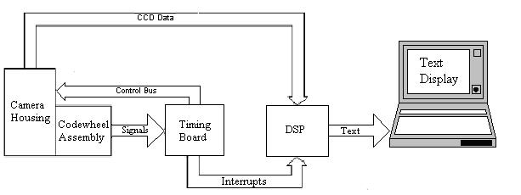
Figure 1: System Block Diagram and Flow

Figure 2: Prototype System Implementation (View 1)

Figure 3: Prototype System Implementation (View 2)

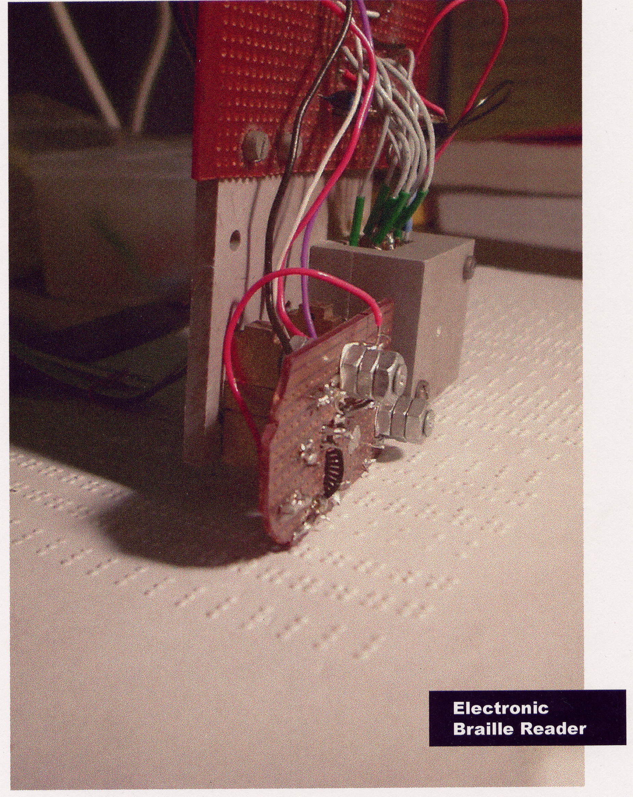
Figure 4: Camera system in operation and dot shadow’s effect

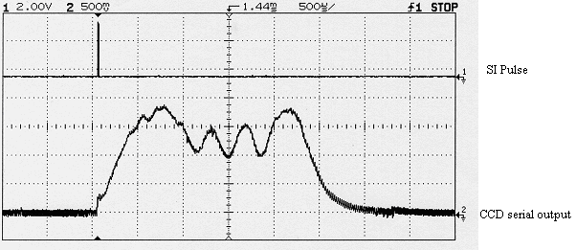
Figure 5: CCD output displaying 3 braille dots

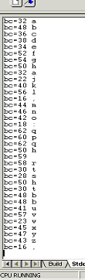
Figure 6: Prototype operation in scanning the English Alphabet

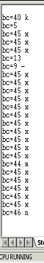
Figure 7: Prototype operation when scanning a line of ‘X’ characters

