Colour Sensor for the Blind

By

Chee-Yiau Vincent HAU

A Thesis Submitted for the Degree of:

Bachelor of Engineering
(Electronic and Communications Engineering)


TITLE:

DATE
DEGREE
ABSTRACT
GOOD
AVERAGE
POOR
EXAMINER
CO-EXAMINER
TECHNICAL WORK

REPORT PRESENTATION
Colour Sensor For The Blind
AUTHOR:

FAMILY NAME:

GIVEN NAME:
SUPERVISOR
HAU
Chee-Yiau Vincent
Iain Murray
5 November 2004
Bachelor of Engineering (Elect. & Comms. Eng.)

A prototype of a colour sensor device which has the capabilities to recognize and speak out at least 64 different colours has been designed. The design uses a Red-Green-Blue LED to illuminate a surface. The level of reflected light from each of these primary colours is measured with a photodiode. The output current of the photodiode is amplified to a suitable range using a current-voltage operational amplifier. The operation of the system is controlled by a Mitsubishi M16C/62 microcontroller and the determined colour is spoken through a ISD2548 chipcorder speech chip. This colour sensor device is suitable to vision-impaired people as it allows them to perform basic colour recognition tasks.

INDEXING TERMS
Colour sensor, vision impaired, M16C/62, ISD2548 chipcorder

SYNOPSIS
A prototype of a colour sensor device which has the capabilities to recognize and speak out at least 64 different colours has been designed. The design uses a Red-Green-Blue LED to illuminate a surface. The level of reflected light from each of these primary colours is measured with a photodiode. The output current of the photodiode is amplified to a suitable range using a current-voltage operational amplifier. The operation of the system is controlled by a Mitsubishi M16C/62 microcontroller and the determined colour is spoken through a ISD2548 chipcorder speech chip. This colour sensor device is suitable to vision-impaired people as it allows them to perform basic colour recognition tasks.

7 Tremont Gardens
Canning Vale, Western Australia 6155
AUSTRALIA

10th November 2004

Professor Syed Islam
Head of Department
Department of Electrical and Computer Engineering
Curtin University of Technology
Kent Street
Bentley, Western Australia 6102
AUSTRALIA

Dear Sir,

I hereby offer this thesis titled “Colour Sensor for the Blind” as a partial satisfaction of the requirements of the degree, Bachelor of Engineering in Electronic and Communications Engineering. I declare that this thesis is entirely my own work except where due reference are made.

Yours Sincerely,

Chee-Yiau Vincent HAU
ACKNOWLEDGEMENTS

Firstly, to my supervisor Iain Murray, thanks for your guidance and patience throughout the year. This project would not have progressed without your aid.

Secondly, to Chris, for his knowledge on the Mitsubishi M16C/62 microcontroller and supplying the compatible software required.

Thanks to the Department of Electrical and Computer Engineering and its technical staff for providing the necessary resources for this project.

NOMENCLATURE

V_{F} Forward Voltage
I_{F} Forward Current
V_{S} Supply Voltage
R Resistance
Vp Photodiode Voltage
Ip Photodiode Current
RGB Red-Green-Blue
LED Light Emitting Diode
FET Field Effect Transistor
V_{O} or Vout Output Voltage
Vin Input Voltage
A/D Analogue to Digital
I/O Input/Ouput
Vref Reference Voltage
M16C/62 Mitsubishi M16C/62 Microcontroller
TABLE OF CONTENTS

1. INTRODUCTION 1
1.1. RATIONALE 1
1.2. PROJECT OBJECTIVES 2
1.3. THESIS OUTLINE 3
2. Aspects of colour 5
2.1. COLOUR 5
2.2. COLOUR ADDITION 6
2.3. COLOUR SUBTRACTION 7
2.4. COLOUR RATIO 8
2.5. COLOUR SENSING 9
2.6. PREVIOUS CIRCUIT DESIGN 10
2.6.1. INTRODUCTION 10
2.6.2. LED SWITCHING CIRCUIT 10
2.6.3. OPERATIONAL AMPLIFIER CIRCUIT 12
3. HOUSING DESIGN 13
3.1. INTRODUCTION 13
3.2. CURRENT DESIGN 13
3.3. ALTERNATIVE DESIGN ONE 13
3.4. ALTERNATIVE DESIGN TWO 14
3.5. DESIGN COMPARISON 14
3.6. HOUSING MODIFICATION 15
4. LIGHT SENSOR 16
4.1. INTRODUCTION 16
4.2. THE PHOTODIODE 16
4.3. THE BPW21 PHOTODIODE 19
5. Light source 22
5.1. Light source selection 22
5.2. THE RGB LED 22
6. RGB LED Operation 26
6.1. introduction 26
6.2. Transistor characteristics 27
6.3. RGB LED SWITching results 28
6.4. RGB led switching conclusion 28
6.5. Rgb led switch control 29
7. Signal conditioning 30
7.1. introduction 30
7.2. Previous work design 31
7.3. Previous Design Flaws 32
7.4. Signal Conditioning re-design 33
8. Microcontroller 35
8.1. Introduction 35
8.2. The M16c/62 microcontroller 35
8.3. power 36
8.4. Analogue to digital converter (A-D) 36
8.4.1. A-d overview 36
8.4.2. A-D converter modes 37
8.4.3. One-shot mode 38
8.5. I/O ports 40
9. Speech chip 42
9.1. introduction 42
9.2. Isd2548 chipcorder 42
9.3. Microcontroller Interface 44
9.3.1. Introduction 44
9.3.2. Direct Address method 45
10. Software 48
10.1. introduction 48
10.2. Development environment 48
10.3. Software Behaviour 49
10.4. Development process and issues 49
10.5. I/O port addressing 51
10.6. Colour Derivation 51
10.7. Key functions overview 52
11. conclusion 54
12. Bibliography 55
13. Appendix A – Project plan 56
14. Appendix B – Modified Sect30.inc Header File 57
15. Appendix C – Sensor Program Source Code 62

LIST OF FIGURES

Figure 2.1: Primary Colours Combination 6
Figure 2.2: Colour Subtraction 7
Figure 3.1: Resized Housing 15
Figure 4.1: Response of Photodiode 17
Figure 4.2: Relative Spectral Sensitivity 18
Figure 4.3: Photodiode Output Voltage vs. Intensity 21
Figure 5.1: Specifications of RGB LED 23
Figure 5.2: Dimensions of RGB LED 23
Figure 5.3: Pin Allocation 23
Figure 5.4: Pin Configuration 24
Figure 6.1: LED Switch Circuit 26
Figure 7.1: Previous Op-Amp 31
Figure 7.2: TLC251 Pin Configuration 31
Figure 7.3: Power Supply Regulators 32
Figure 7.4: 4-Stage Op-Amp 33
Figure 8.1: M16C/62 Starter Kit 36
Figure 8.2: Pins Related to A/D Convertor 37
Figure 8.3: Flow Diagram of A-D Converter 39
Figure 8.4: A-D Control Register 0 40
Figure 8.5: A-D Control Register 1 40
Figure 8.6: M16C/62 I/O Ports 41
Figure 8.7: Direction Registers of I/O Ports 41
Figure 9.1: Pin Configuration of ISD2548 43
Figure 9.2: Operational Modes of ISD2548 44
Figure 9.3: Message Addressing Scheme 45
Figure 9.4: Direct Addressing Circuit 47
Figure 10.1: Software Behavious Flowchart 49
Figure 10.2: Flow Chart of Sensor Program 50
Figure 10.3: Colour Decision Tree 52

LIST OF TABLES

Table 2.1: Wavelengths of Distinct Colours 5
Table 2.2: RGB Ratios 8
Table 4.1: Characteristics of BPW 21 20
Table 5.1: RGB LED Resistor Table 25
Table 6.1: Derived R_{B} Values from Collector Resistance and Voltage 28
Table 6.2: Finalized Base Resistances 29
Table 8.1: Specifications of One-shot mode 38
Table 9.1: Recorded Messages 46
Table 10.1 Software Tools 48
Table 10.2: Pin Application 51
Table 10.3: LED Control Comands 53

INTRODUCTION

RATIONALE
The world is full of colour. Colour is what gives objects their physique and beauty. Such beauty is utilised by peacocks when they display their colourful tails to attract their mates. Colour has many applications as it can be used to express moods and emotions or even a method of communication. Yellow coloured signs in factories are used to warn us of danger and on a spiritual level, the colour blue can symbolize peace. For sight-able people, basic colour related tasks such as colour coordination of clothing are taken for granted. For the vision impaired, these tasks can be difficult and frustrating. Colour sensing device would be of much aid for their independence.

By having a colour sensor device, the problem may be solved but cost and reliability is an issue. In today’s market, these devices are quite expensive and range around AUD$500. This is unaffordable to many and so the possession of such a device is considered a luxury. In the case of reliability, the device must accurately identify each colour on different types of surfaces. With inconsistent readings and inaccurate identification, the device would be useless.

This thesis examines different designs of colour sensing devices to achieve a low cost and reliable prototype.

PROJECT OBJECTIVES
This project is to design a prototype of a colour sensor device, which can recognize at least 64 different colours and speak the recognized colour. The device should be suitable for use by vision-impaired people to allow them to perform basic colour recognition tasks. The development process followed is as shown below:

- The previous design was examined for any flaws and possible modifications that would result in a more reliable and low cost prototype was noted down.

- The previous source code was examined for any flaws and possible modifications that could be made were noted down.

- An understanding and knowledge of the Mitsubishi M16C/62 microcontroller was achieved through online tutorials, manuals and sample programs.

- An understanding and knowledge of the ISD2548 chipcorder speech chip was acquired through manuals.

- Alternative designs were explored and compared with to see which one was closest to achieving the desired goal.

- A small, cost effective and easy to use prototype which can accurately recognize 64 colours was designed.

THESIS OUTLINE

Chapter 2: Background – The necessary aspects of colour are explored in this chapter to gain adequate knowledge to proceed.

Chapter 3: Housing design – This chapter analyses different types of design and compares to find the most suitable design to achieve the desired goal

Chapter 4: Light sensor – This chapter discusses the different types of light sensor and gives reasoning for the chosen.

Chapter 5: Light source – Different type of light sources are analysed in this chapter and reasoning are given for the chosen.

Chapter 6: RGB LED Control – This chapter discuss how the RGB LED are sequentially turned on and off. The configuration to achieve this is discussed.

Chapter 7: Signal Condition - Discusses the design to deal with the small output current produced from the photodiode.

Chapter 8: Mitsubishi M16c/62 Microcontroller – Discusses the operations of the microcontroller and its characteristics.

Chapter 9: Speech Chip – This chapter discusses the characteristics of the speech chip and the possible modes it can operate in.

Chapter 10: Software – Discusses what programming language is used and how the software is incorporated with the microcontroller.

Chapter 11: Conclusion – Future considerations and achievements are discussed in this chapter.

Aspects of colour

COLOUR
Colour is the sensation resulting from the stimulation of the retina of the eye by light waves of particular wavelengths. These wavelengths are of the visible spectrum. Multiple wavelengths are perceived and combined to distinguish a colour. The distinct colours of the spectrum can be tabulated as below:
COLOUR | WAVELENGTH (nanometers)
Violet | 400-430
Indigo | 430-450
Blue | 450-500
Green | 500-570
Yellow | 570-590
Orange | 590-610
Red | 610-700

Table 2.1: Wavelengths of Distinct Colours

COLOUR ADDITION
Colour addition is as the name states. Colours are added or combined together to form other colours. White light is an example of this. The combination of the seven distinct colours, red, orange, yellow, green, blue, indigo and violet, forms the colour white. Combining three different wavelengths such as red, green and blue (RGB) can also form white light on the condition that the three different wavelengths must be widely spread on the visible spectrum. The three colours are called primary colours or an additive set. Below shows how these primary colours can be combined to form other colours.

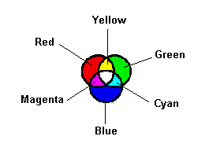

White

Figure 2.1: Primary Colours Combination

Some applications of colour addition are in colour televisions, colour monitors and on-stage lighting at theatres. The technique of mixing and combining colours are to give desired effect or appearance.

COLOUR SUBTRACTION
As colour can be added, it can also be subtracted to form other colours. Colour subtraction is a result of pigments on surfaces. These pigments are chemicals which have the ability to absorb one or more frequencies. Below shows the result of a surface which absorbs blue light when illuminated by white light:

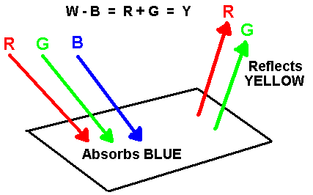

Figure 2.2: Colour Subtraction

Applications of where colour subtraction is used are in paints. From the other above figure it is logical that yellow paints absorb blue light. Other examples are magenta and cyan paints absorbing green and red lights respectively. When combining yellow, magenta and cyan, the colour black is produced. This is known as a subtractive set.

COLOUR RATIO
A particular colour can be represented as one or more frequencies. This can be shown from the methods of colour addition or colour subtraction. As there are many shades of a colour, there are also a number of colour combinations possible. A light red colour would represent a different frequency and intensity to that of the colour red. When considering a particular colour, it can be treated as a ratio of the primary colours, red green and blue. Some generalized RGB ratios can be tabulated as below:

 | RGB RATIOS
Colour | R | G | B
Black | 0 | 0 | 0
Grey | 0.5 | 0.5 | 0.5
White | 1 | 1 | 1
Red | 1 | 0 | 0
Yellow | 1 | 1 | 0
Green | 0 | 1 | 0
Cyan | 0 | 1 | 1
Blue | 0 | 0 | 1
Magenta | 1 | 0 | 1

Table 2.2: RGB Ratios

COLOUR SENSING
A particular colour can be represented as combination of other colours. The seven distinct colours of the visible spectrum, red, orange, yellow, green, blue, indigo and violet can represent the colour white. As it made of all the colours of the visible spectrum, it is a good reference. Due to this fact, there are two methods of detecting colour of a surface. First method is to illuminate the surface with white light and measure the reflected light intensity passing through a variety of coloured filters. These coloured filters may prove to be a negative aspect as the sensor will receive a weaker intensity than with no filters. A higher intensity of white light will have to be used resulting in a less power efficient device.

The colour white can also be represented by the three primary colours or additive set. The second method of colour sensing utilises three light sources, the primary colours, and one sensor. Each colour takes turn in illuminating the surface and the reflected light intensity is measured. Using light emitting diodes (LED) as the light sources is advantageous as the actual wavelengths of the light sources are known.

With light intensity measurements take from either method, these measurements are compared with a pre-determined table to conclude the resulting colour of the surface. This pre-determined table is produced from a number of testing.

PREVIOUS CIRCUIT DESIGN

INTRODUCTION
This section details the outcomes of the previous design attempt of the colour sensor for the blind. A RGB LED and a photodiode were used in the 2003’s colour sensor design to determine the colour of the tested surface. A chipcorder speech chip was chosen to speak out the determined colour.

LED SWITCHING CIRCUIT
A RGB LED illuminated the tested surface in sequence of red, green and blue light.
The switching circuit is as shown below:

Figure 2.3: LED Switching Circuit

From the above it can be seen that NPN transistors were used to perform the switching. Two 5 V power supplies were required for this circuit to give a ‘LIVE’ and ‘ACTIVE’ signal. This was due to blue and green LED segments sharing a common cathode. As red and green LEDs did not share a common cathode, one power supply sourced power to the red and green LEDs while the other sourced the blue LED. LED control logic is as shown below:

L_{R/G} | L_{B} | A_{R} | A_{G} | A_{B}
1 | 0 | 1 | 0 | 0 | Red LED
1 | 0 | 0 | 1 | 0 | Green LED
0 | 1 | 0 | 0 | 1 | Blue LED

Table 2.3: LED Control Logic

The following is a table of the derived resistor values. The brightness of the LEDs was determined by the R_{C} resistor values.

RGB LED | R_{B}Ω | R_{C}Ω
Red | 20k | 306
Green | 18k | 297
Blue | 220k | 1114

Table 2.4 LED Circuit Resistor Values

The reflected light intensities of each colour are measured with a photodiode. This photodiode is encased with the RGB LED in a small clay mould.
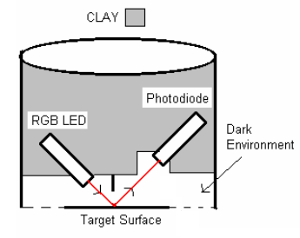
Figure 2.4 Clay Mould Housing

OPERATIONAL AMPLIFIER CIRCUIT
A 2-stage operational amplifier (Op-Amp) was used to amplify the photodiode current to a suitable level. The circuit is as below:

Figure 2.5: Photodiode Amplifier Circuit

HOUSING DESIGN

INTRODUCTION
The housing contains the components of the light source and the sensor. There are several methods of sensing colour and hence several designs for the housing. Housing design will be chosen so it achieves the desired goal as close as possible, this being small, low cost and simple.

CURRENT DESIGN
This housing design incorporated a RGB LED with a photodiode. Red, green and blue lights are turned on sequentially with the photodiode measuring the brightness of each. The cost incurred for this housing design is as below:
- Photodiode $25.40
- RGB LED $13.30
- Total $38.70

ALTERNATIVE DESIGN ONE
This design is similar to the current design of the housing. The RGB LED is replaced with a separate red, green and blue LED. Each LED is turned on sequentially with the photodiode taking the necessary measurements. Cost incurred is as below:
- Photodiode $25.40
- Red LED $00.80
- Green LED $00.27
- Blue LED $04.37
- Total $30.85

ALTERNATIVE DESIGN TWO
This design utilized a white LED as its light source. A white LED resulted in the design having three filtered photodiodes where filtered photodiodes could not purchased. To filter photodiodes, the use cellophane paper was required. The following shows the cost for this design:
- White LED $09.95
- 3 x Photodiode $76.20
- Cellophane Paper $02.00
- Total $88.15

DESIGN COMPARISON
The desired design is to fulfil the requirements of being small, low cost and simple. For the alternative design two, the three photodiodes that it requires has dramatically increased the cost when compared with the other two designs. The number of components it possesses also requires a larger housing. With a larger housing, portability is compromised. To achieve a low cost and small device, this design has been discarded. Comparing the cost of the two remaining designs, the alternative design one is slightly lower though this design requires the use of three LEDs which again results in a larger housing. With size and simplicity as a factor, a higher price was chosen over more electronic components in housing. The current design was implemented.

HOUSING MODIFICATION
The housing encasing the RGB LED and the sensor was made from a small clay mould. With its current size, the device illuminated a test surface covering a diameter of 6 cm. One of the objectives of this project was to make a small and accurate colour sensor device. With a 6 cm diameter of test surface, the readings from the photodiode were inaccurate when the test object covered a significantly smaller area. Unnecessary colour intensities were being measured by the photodiode which influenced the end result. A smaller housing with a diameter of 3cm was made to refine this.

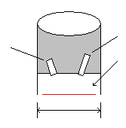
Dark Environment
3cm
Photodiode
RGB LED
Figure 3.3: Resized Housing

LIGHT SENSOR

INTRODUCTION
The light sensor has the purpose of measuring the intensity/brightness of the reflected light from the test surface after it has been illuminated. There are a number of different light sensors available for this application such as the photodarlington, photodiode and phototransistor. The current conducted in these sensors vary accordingly to the level of intensity of light exposed onto them. The sensors differ by their biasness towards certain wavelengths of the visible spectrum and are chosen for certain applications depending on the conditions.

THE PHOTODIODE
The photodiode light sensor was chosen for this design of the colour sensor primarily due to its linear characteristic between illumination intensity and photo-voltage. This linearity property is a critical factor for detecting light intensities. The photodiode operates by inducing a current when exposed to light. The amount of current induced is proportional to the light intensity and a small leakage current is produced when the component is reverse biased. Without the linearity property of the photodiode, a change in light intensity results in an unpredictable change in induced current making any measurement analysis nearly impossible.

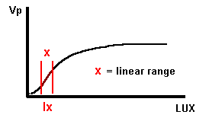
Figure 4.4: Response of Photodiode

Other advantages the photodiode possess over the other two light sensors include, fast response times, low leakage currents, high efficiency and low noise levels. These properties are all desirable especially fast response times. Fast response times leads to faster processing time which is important requirement in digital applications.

Light sensors have different sensitivities towards different wavelengths of the visible spectrum. For colour sensing, a sensor with similar spectral responses with the human eye would be an accurate sensor. The following shows the spectral responses of the chosen photodiode (BPW 21) and the human eye.

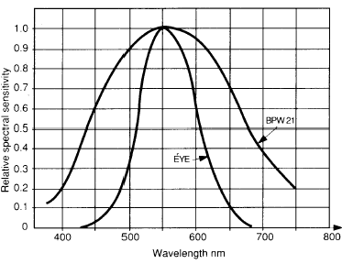

Figure 4.5: Relative Spectral Sensitivity

The plot shows the close similarities between the two spectral sensitivities of the photodiode and the human eye. The photodiode is therefore suitable for the desired application. At a wavelength of 550nm, the spectral sensitivities are exactly the same. From table 2.1, this wavelength lies in the green colour range. This gives a possibility of not scaling the reading of green light intensity when doing the data analysis.

One small negative aspect of the photodiode is the low current output it produces when low level of light intensity is incident on the component. This can be corrected with a low-noise operational amplifier, amplifying the small current to a suitable useful level.

THE BPW21 PHOTODIODE
The chosen light sensor for the design is the BPW 21, manufactured by Centronic and supplied by RS Components. The light sensor is a hermetically sealed photodiode which has a flat window with a built-in colour correction filter for light in the visible spectrum. This built-in colour correction filter gives a close approximation to the spectral response of the human eye. The photodiode is designed for high precision linear applications and can operated in a photovoltaic cell set up. Some applications where the photodiode may be used include colour sensors, light monitoring and control, exposure control and other optical instrumentation control. The dimensions (in mm) of the BPW 21 photodiode is as below:

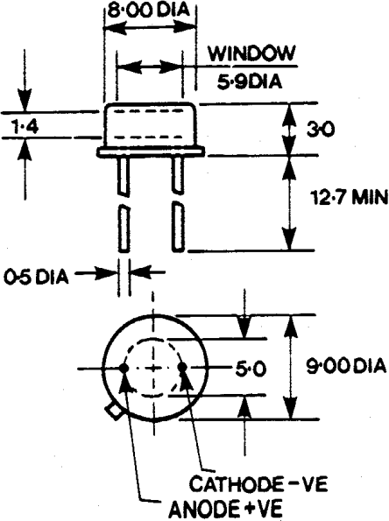
Figure 4.3 Photodiode Dimensions

The technical specifications of the BPW 21 photodiode is as follows:

CHARACTERISTIC | VALUE
Peak Spectral Response | 560 nm
Wavelength (min.) | 460 nm
Wavelength (max.) | 750 nm
Power Dissipation (max.) | 250 mW
Sensitivity (short circuit) | 7 nA/lux
Open Circuit Volts  (E = 1 k lux) | 280 mV
Dark Current (V_{R} = 5V) | 2 nA
Rise Time  (I = 100 µA, R_{L} = 1 kΩ ) | 3.5 μs
Junction Capacitance  (V_{R} = 5V) | 170 pF
S.S.M | 1

Table 4.3: Characteristics of BPW 21

The previous year students derived the linear region of operation of the BPW 21 photodiode through a number of tests. The tests involved increasing the intensity of the white light produced at certain increments and measuring the output voltage of the photodiode in parallel with a 5.6 MΩ resistor. The linear region existed where a change in intensity lead to a significant change in the output. The following graph was produced:

Figure 4.6: Photodiode Output Voltage vs. Intensity

The graph shows that the linear range is between the intensity levels of 10 – 50 Ix and a photodiode output voltage of 50 – 150 mV. A 5.6 MΩ resistor used with the photodiode would require 112 mV for a current output of 20 nA. This is a significant small value and would possibly be require to be amplified for it to be useful.

Light source

Light source selection
From chapter 3, the three light source considered were the white LED, the RGB LED and three individual coloured LEDs. All designs incorporated LEDs as the light source in the housing. This was primarily due to LEDs having low power consumption, long life expectancy and for its small size when compared to normal filament or incandescent lamps. Incandescent lamps were also found to give off a yellow tinge light which influenced the end results. With the above properties of a LED, a small, portable, power efficient and durable colour sensor is produced.

THE RGB LED
The RGB LED was chosen as the light source for this project. The RGB LED used was the LF59EMBGMBC, manufactured by Kingbright and supplied by RS Components. This LED features two blue, one green and one red chip on a T-1 ¾ (5mm) plastic package with water clear lens. With this configuration, any colour of the visible spectrum can be produced at high intensities. The characteristics of this RGB LED can be tabulated as on the next page:

CHARACTERISTIC | Red | Green | Blue | Units
Lens Type: Water Clear
I_{F} (max.) | 30 | 25 | 30 | mA
V_{F} (typical) | 2 | 2.2 | 4.5 | V
Intensity (min.) | 90 | 50 | 12.5 | mcd
Intensity (max.) | 200 | 150 | 40 | mcd
View Angle | 15 | 15 | 15 | °
Peak Wavelength | 625 | 565 | 430 | nm
I_{F} (typical) | 20 | 20 | 20 | mA
V_{F} (max.) | 5 | 5 | 5 | V
Temp. (min.) | -40 | -40 | -40 | °C
Temp. (max.) | 85 | 85 | 85 | °C
S.S.M | 1 | 1 | 1

Figure 5.7: Specifications of RGB LED

The dimension of the RGB LED are given as:

DIMENSIONS | VALUE
Length | 8.6 mm
Diameter | 5 mm
Lead Pitch | 2.54 mm
Leads | 0.5 mm²

Figure 5.8: Dimensions of RGB LED

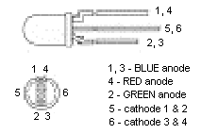
Figure 5.9: Pin Allocation

From the above, it is evident that the RGB LED possesses six pins. Four of these pins are the anodes of the colours it can produce. Note that there is two chips for the colour blue hence two anode pins. Pin 5 is the cathode pin for colours blue1 and green. Pin 6 is the cathode pin for the colours blue2 and red.

As there are two chips for the colour blue, only one of these needs to be utilised. With only one blue LED being operated, the device is more efficient and simple. The following configuration is applied for the prototype:

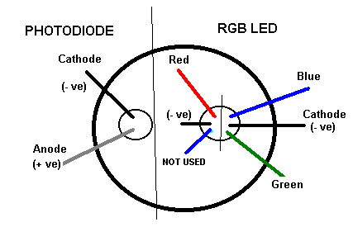
Figure 5.10: Pin Configuration

The brightness of the LEDs is controlled via a variable resistor in a series arrangement. Ohms law is used to calculate the minimum resistance for each LED. The following equation was used:

$R_{\text{min}}=\frac{V_{S}−V_{F}}{I_{F}}$

The resistance calculated from this equation are only minimum values to avoid any damage. The variable resistors are adjusted to give the sensor an equal response to each colour. The housing is placed over white paper and values for each resistance are recorded. Below are values of the minimum resistance for each LED and the actual resistance. The actual values are the same as the previous year’s as they were found to be suitable for the configuration. A common 5 V power supply was used.

LED | Calculated R_{MIN} Ω | Actual R Ω
Red | 100 | 306
Green | 112 | 297
Blue | 16.67 | 1114

Table 5.4: RGB LED Resistor Table

RGB LED Operation

introduction
The purpose of RGB LED is to illuminate the test surface of each colour as the photodiode takes a reading. The red, green and blue lights are therefore turned on and off sequentially. This is achieved by switching via the use of three NPN transistors. One NPN transistor is allocated for each LED operation and in a common-emitter configuration, with no bias voltage and connected to the base through a resistor. Resistor R_{B} is connected in series with the base and then to a microcontroller output line. The resistor R_{C} is also connected to one of the microcontroller output lines. This is as two 5 V power supplies are required due to two colour LEDs sharing cathodes.

Figure 6.11: LED Switch Circuit

A transistor can act as either an amplifier or a switch. For it to operate as a switch it must be operated in saturation mode. The 5 V input signal supplied from the microcontroller is to be used to saturate the transistor. To achieve this, the resistance values of R_{B} and R_{C} are specifically chosen to allow enough base current to flow through and saturate the transistor.

Transistor characteristics
The transistor used for this design is the 2N2222A. It possesses the following features:

- High speed switching applications, at collector current up to 500 mA
- Low leakage currents
- Low saturation voltage
- Useful current gain over a wide range of collector current

Operating the transistor in saturation results in V_{BE} = 0.8 volts and V_{CE} = 0.2 volts.
Some important assumptions needed to be included into the switching design are as follows:
- V_{CE} = 0V (saturation)
- Vcc = 5V
- I_{C}(sat) = (Vcc – Vd)/Rc
- (Vd is voltage drop, also known as V_{F})
- I_{B} = (Vin – V_{BE})/R_{B}
- I_{B}(min) = Ic(sat)/β

RGB LED SWITching results
With the aid of the assumptions, the following values are calculated. The base resistance is calculated using the values for the voltage drop across each LED and relative resistances, found previously.

 | Ic (sat) mA | I_{B} (min) mA | R_{B} Ω | R_{B} (equiv.) kΩ
RED | 19.1 | 0.191 | 21980 | 22
GREEN | 21.4 | 0.214 | 19460 | 20
BLUE | 1.83 | 0.0183 | 228951 | 230

Table 6.5: Derived R_{B} Values from Collector Resistance and Voltage

The base resistance can also be calculated using the values for the collector current.

 | Ic (sat) mA | I_{B} (min) mA | R_{B} Ω | R_{B} (equiv.) kΩ
RED | 17.95 | 0.1795 | 23398 | 23
GREEN | 19.8 | 0.198 | 21212 | 21
BLUE | 1.8 | 0.018 | 233333 | 230

RGB led switching conclusion
Comparing the two tables, the values for the base resistance are similar. The base resistance chosen must be lower than what is calculated to ensure that sufficient base current is entering the transistor. A lower base resistance is desirable making the device more power efficient. The following are the final values concluded for sufficient current to operate each LED.

 | R_{B} (equiv.) kΩ
RED | 20
GREEN | 18
BLUE | 220

Table 6.6: Finalized Base Resistances

Rgb led switch control
From the design of the RGB LED, the blue LED shares a cathode with the green LED. With one power supply, both LEDs would be turned on simultaneously. A second power supply is introduced to correct this. With the red LED not sharing a cathode with either blue or green, it could share a power supply with either one of them. A 5 V power supply was then designated to source the red and green LEDs and another to source the blue LED. The control circuit and logic can be found in chapter 2.

Signal conditioning

introduction
With the BPW 21 photodiode set up to operate in its linear region, from previous years testing it was found that the induced current would range between 0 – 20 nA. This current is then processed by the microcontroller to derive the resultant colour. With a maximum photodiode output current of 20 nA, this current must be amplified to suitable level before being processed. From the specifications of the microcontroller, a suitable voltage range is between 0 – 5 V. This is achieved using a low noise operational amplifier. There are different types of amplifiers available but the operational amplifier was chosen due to the following features:

- High gain
- High input impedance
- Low power requirements
- Simple and easily modified configuration

With a significant low output current, high input impedance is most desirable as it results in a high gain in the correct configuration.

Previous work design
The previous op-amp circuit is as shown below. The signal conditioning design utilises two Texas Instruments TLC251 op-amps in a cascading formation. The purpose of the capacitors used in the design was to discard any unwanted AC frequencies interfering with the DC measurements.

Figure 7.12: Previous Op-Amp

The Texas Instruments TLC251 op-amp utilizes LinCMOS technology and has characteristic of low noise, high gain and high impedance inputs. It has the following pin configuration:
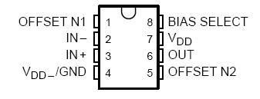
Figure 7.13: TLC251 Pin Configuration
The signal conditioning design also included a power supply regulator. The power supply regulator was built with the use of LM7805CT IC’s. Its purpose was to provide a stable power supply to the colour sensor. A +5 V and –5 V rail was sourced with the following circuits:

Figure 7.14: Power Supply Regulators

Previous Design Flaws
There were some issues with the op-amp design for signal conditioning. The op-amp was found to operate at its maximum capacity, leaving no room for alterations if required. The gain of each of the stages was also found to be significantly high. A slight change in the input would hence result in a dramatic change in the output and give inaccurate measurements.

For the power supply regulator, in theory was to source out a steady ±5 V rail. With the use of voltmeters, this was found to be not the case. Output voltage varied under the 4 V range. With insufficient voltage being sourced to the colour sensor prototype, it would not operate as desired. Voice of the speech chip was slowed and LEDs did not have the sufficient power to be turned on.

Signal Conditioning re-design
Given the problems stated, a 4-stage operational amplifier was designed. Four Texas Instruments TLC 251 op-amps were utilised in a cascading layout. The op-amps are designed in a non-inverting configuration, resulting in high input impedance. The closed loop gain of this non-inverting op-amp is dependent on the values of external resistors. Capacitors were used again in a negative feedback loop to neglect any AC frequencies present. The following circuit was designed:

Figure 7.15: 4-Stage Op-Amp

For the power supply regulator, the circuit for it was discarded. With the re-designed op-amp, the laboratory DC power supply was sufficient and could be checked with a voltmeter.

Microcontroller

Introduction
The microcontroller is the most important component of the colour sensor. It is what controls the operations of this colour sensor. The following is a list of operation it was required to perform:

- Supply power to the light source
- LED switching control
- Analogue to digital conversion of values from signal conditioning
- Process digital values and derive resultant colour
- Speech chip control

Control applications and colour derivation are achieved by programming the chip of the microcontroller. This is discussed in later chapters.

The M16c/62 microcontroller
The Mitsubishi M16C/62 microcontroller was chosen for this prototype. The M16C/62 microcontroller are built using the high-performance CMOS technology and with 1 M bytes of address space, they are capable of executing instructions at high speed. The microcontroller is ideal in applications of audio, cameras, office equipment, communications equipment and portable equipment. For the development of the prototype, the M16C/62 Starter Kit was used. The kit provides a board which contains a surface mounted M16C/62, 96-pin I/O connector, two 7-segment displays, 3 external interrupt switches, reset switch, serial port, power supply connecter and a external crystal connecter. The layout is as follows:
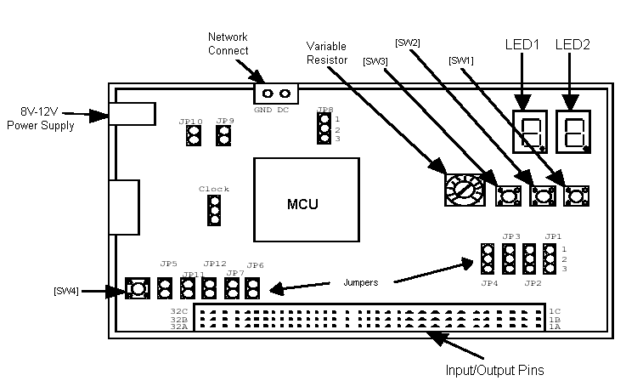

Figure 8.16: M16C/62 Starter Kit

power
One role of the microcontroller was to provide power to external components. By supplying the M16C/62 with 5 V from the laboratory DC power supply, individual components could also be sourced via the output pins. The “Active” and “Live” control lines made to source the RGB LED is an example of this.

Analogue to digital converter (A-D)

A-d overview
The photodiode takes measurements of colour intensities from the reflected light and is amplified to a suitable range for analogue to digital conversion. The M16C/62 microcontroller uses the following pins for A/D conversion:

AN0 pin through AN7 pin | Input pins of the A-D converter
AVcc pin | Power source pin of the analog section
VREF pin | Input pin of reference voltage
AVss pin | GND pin of the analog section
ANEX0 pin, ANEX1 pin | Expanded input pins of the A-D converter
___________
ADTRG pin | Trigger input pin of the A-D converter

Figure 8.17: Pins Related to A/D Convertor

A-D converter modes
There are five modes of operation for the analogue to digital converter. These are listed below:

- One-shot mode - The pin selected by the analog input pin select bit is used for one A-D conversion.
- Repetition mode - The pin selected by the analog input pin select bit is used for repeated A-D conversion.
- One-shot sweep mode - The pins selected by the A-D sweep pin select bit are used for the one-by-one A-D conversion.
- Repeated sweep mode 0 - The pins selected by the A-D sweep pin select bit are used for repeat sweep A-D conversion.
- Repeated sweep mode 1 - All pins perform repeat sweep A-D conversion, with emphasis on the pin or pins selected by the A-D sweep pin select bit.

One-shot mode

The A-D conversion mode used in this project was the one-shot mode. The output of the operational amplifier was inputted to a selected pin and the A-D conversion was performed when required. That is the selected pin would only be active when taking the desired readings. This was the reason for the choice of the one-shot mode. If the selected pin was active continuously, unnecessary readings would be taken and therefore increasing the processing time or even produce inaccurate results. The one-shot mode has the following specifications:

Item | Specification
Function | The pin selected by the analog input pin select bit is used for one A-D conversion
Start condition | Writing “1 ” to A--D conversion start flag
Stop condition | •End of A-D conversion (A-D conversion start flag changes to “0 ”,except  when external trigger is selected)  •Writing “0 ” to A--D conversion start flag
Interrupt request generation timing | End of A-D conversion
Input pin | One of AN0 to AN7,as selected
Reading of result of A-D converter | Read A-D register corresponding to selected pin

Table 8.7: Specifications of One-shot mode

From these specifications, the operation of the one-shot mode can be illustrated with the following flow diagram:

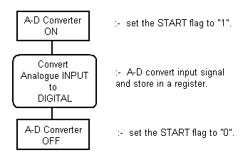

Figure 8.18: Flow Diagram of A-D Converter

From this flow diagram, the A-D converter commences when the START flag is set to “1” and is ended when the flag is “0”. A sample and hold function is utilized when A-D conversion starts. The function samples and digitizes the input voltage and then stores it in a register. The sample and hold function is set up by setting bit 0 of the register to bit 1 and setting the operation clock to 1 MHz or higher. The following are diagrams of the A-D control register 0 and 1:

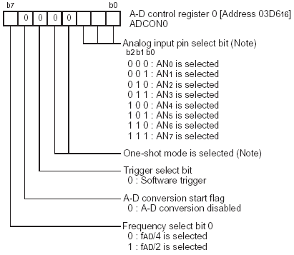

Figure 8.19: A-D Control Register 0
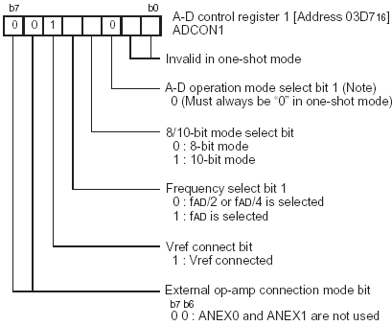

Figure 8.20: A-D Control Register 1

As one-shot mode is utilized in the project, the forth and fifth bits of register 0 and the third bit of register 1 must be zero. The seventh bit of register 0 determines if A-D conversion is being commenced or ended. The sixth bit for register 0 corresponds to a software trigger and is set to 0. This allows the code programmed into the M16C/62 to activate the A-D conversion. The seventh and eighth bit of register is for external op-amp connection mode bit and is set to zero as ANEX0 and ANEX1 are not used.

I/O ports
The Mitsubishi M16C/62 has 9 I/O ports where most of them can act as either an input or output port. This is achieved by configuring the port’s direction register to give the desire result.

The below shows the I/O ports and their direction registers:

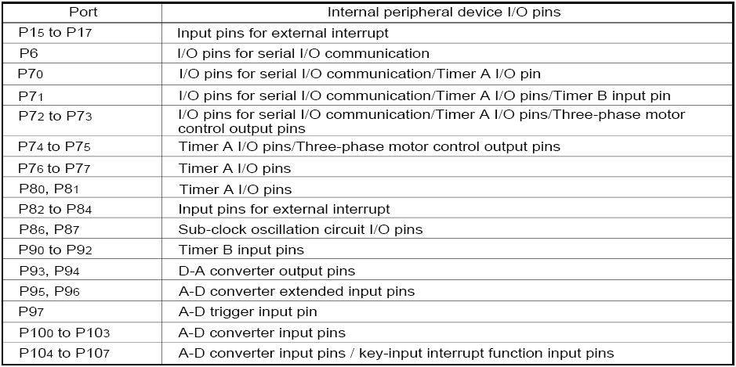
Figure 8.21: M16C/62 I/O Ports

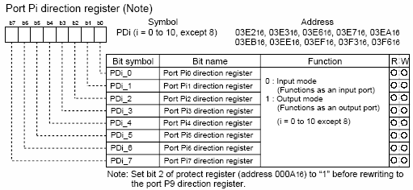

Figure 8.22: Direction Registers of I/O Ports

Speech chip

introduction
With the M16C/62 microcontroller converting the output voltages of the op-amp from analogue to digital values, it is then compared to a pre-determined table to derive the resultant colour. This resultant colour is outputted via a synthesized voice with the use of a speech chip. Voices are pre-recorded onto the chip and are called up after readings have been processed

Isd2548 chipcorder
The chosen speech chip for this project is the ISD 2548 chipcorder by WINBOND. This CMOS device includes an on-chip oscillator, microphone preamplifier, automatic gain control, anti-aliasing filter, smoothing filter, speaker amplifier and high density multi-level storage array. The WINBOND ISD2500 chipcorder series also has the following features:

- Easy-to-use single-chip, voice record/playback solution
- High-quality, natural voice/audio reproduction
- Manual switch or microcontroller compatible
- Playback can be edge- or level-activated
- Automatic Power-Down – standby current 1μA
- Zero-power message storage
- Fully addressable to handle multiple messages
- 100-year message retention
- 100,000 record cycles
The pin configuration of the ISD2548 speech chip is as follows:

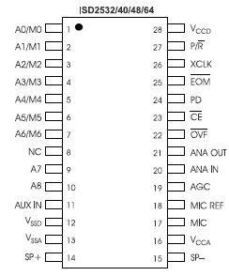
Figure 9.23: Pin Configuration of ISD2548

The ISD2500 series is designed with several built-in operational modes to provide maximum functionality. From the above pin configuration, A7 and A8 are the most significant bits (MSBs). These bits determine whether the chip is operating in addressing mode or operational mode. With either or both of the MSBs being low, the inputs are interpreted as address bits and determines where record/playback cycle. If both MSBs are high, the other bits are referred to as mode bits. The six operational modes available are as follows:

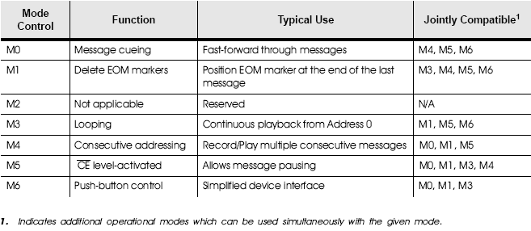

Figure 9.24: Operational Modes of ISD2548

Microcontroller Interface

Introduction
The microcontroller digitized output voltages from the op-amp, compared the three values with a predetermined table and controls the speech chip to playback a pre-recorded word of the resultant colour. To achieve this there are two methods of interfacing the M16C/62 with the ISD 2548. These include the message cueing method and the direct address method. With the message cueing method, messages could be skipped without knowing its physical address. From previous years work this method was found to be unreliable as messages were passed when they should not have. The direct address method was then implemented.

Direct Address method
For the direct address method to be set up, the MSBs A7 and A8 are required to be low. This sets the pins of A0 to A8 to be interpreted as address pins. Addresses then can be allocated to messages via jumper wires. The pins are set high or low according to that address.
With the ISD2548 having an addressable space of 320 rows, with each row corresponding to a record time of 150 ms, the time duration is significantly small and any accurate message allocation is close to impossible. For known start addresses, one method is to divide each start address eight rolls apart, giving a recording time of 1.2 seconds for each message. Satisfying the condition of recording each segment before the next start address will result in a known start location of each message.

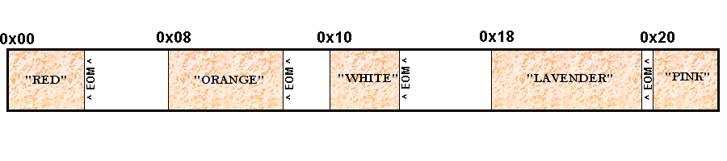
Figure 9.25: Message Addressing Scheme

To playback a recorded message, the start address of a message must be known. By setting the address pins to the address and making pin low, the audio will play from the start address to the next EOM flag. The following are words that have been pre-recorded into the ISD 2548 chipcorder:

No. | Word | Address | A₇ | A₆ | A₅ | A₄ | A₃ | A₂ | A₁ | A₀
0 | Light | 0x00 | 0 | 0 | 0 | 0 | 0 | 0 | 0 | 0
1 | Dark | 0x08 | 0 | 0 | 0 | 0 | 1 | 0 | 0 | 0
2 | Very | 0x10 | 0 | 0 | 0 | 1 | 0 | 0 | 0 | 0
3 | Medium | 0x18 | 0 | 0 | 0 | 1 | 1 | 0 | 0 | 0
4 | White | 0x20 | 0 | 0 | 1 | 0 | 0 | 0 | 0 | 0
5 | Black | 0x28 | 0 | 0 | 1 | 0 | 1 | 0 | 0 | 0
6 | Blue | 0x30 | 0 | 0 | 1 | 1 | 0 | 0 | 0 | 0
7 | Green | 0x38 | 0 | 0 | 1 | 1 | 1 | 0 | 0 | 0
8 | Yellow | 0x40 | 0 | 1 | 0 | 0 | 0 | 0 | 0 | 0
9 | Orange | 0x48 | 0 | 1 | 0 | 0 | 1 | 0 | 0 | 0
10 | Red | 0x50 | 0 | 1 | 0 | 1 | 0 | 0 | 0 | 0
11 | Purple | 0x58 | 0 | 1 | 0 | 1 | 1 | 0 | 0 | 0
12 | Pink | 0x60 | 0 | 1 | 1 | 0 | 0 | 0 | 0 | 0
13 | Brown | 0x68 | 0 | 1 | 1 | 0 | 1 | 0 | 0 | 0
14 | Grey | 0x70 | 0 | 1 | 1 | 1 | 0 | 0 | 0 | 0
15 | Pastel | 0x78 | 0 | 1 | 1 | 1 | 1 | 0 | 0 | 0
16 | Hot | 0x80 | 1 | 0 | 0 | 0 | 0 | 0 | 0 | 0
17 | Lavender | 0x88 | 1 | 0 | 0 | 0 | 1 | 0 | 0 | 0
18 | Maroon | 0x90 | 1 | 0 | 0 | 1 | 0 | 0 | 0 | 0
19 | Aqua | 0x98 | 1 | 0 | 0 | 1 | 1 | 0 | 0 | 0

Table 9.8: Recorded Messages

The schematic of the ISD 2548 chipcorder used is as follows. To avoid any dmange to the microctroller, 100 kΩ resistors were connected to each pin of the ISD 2548 where a connection to the M16C/62 was made. This limited I/O lines to an output current of 50mA. Port connections to the M16C/62 are indicated with number 2.x.

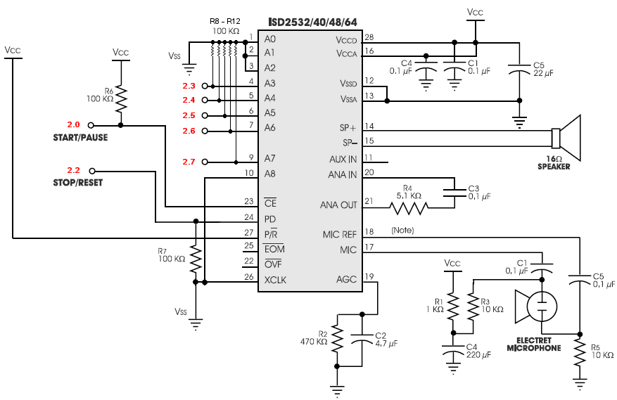
Figure 9.26: Direct Addressing Circuit

Software

introduction
A software code was written to program the chip of the M16C/62 microcontroller for the control of the LED switching, processing of the A-D converted values and control of the speech chip. The M16C/62 supports both C language and the conventional assembly language without any compromise on memory.

Development environment
A number of Microsoft Windows based software was utilised with the M16C/62 microcontroller to aid software development. The following is a table of the tool’s name, function and version which was utilised:

Name | Function | Version
NC30WA | C Compiler | V5.00 Release 1
Tool Manager | Integrated Development Environment | V3.20
KD30 | Debugger | V3.00 Release 1
Flash Start | Flash Programmer | V2.00.0
Monitor | Monitor Program | V2.00

Table 10.9 Software Tools

The version of the above tools is slightly different to what was used last years. These versions were installed as described in the M16C/62 Starter Kit 2 User Manual and found to give best results.

Software Behaviour
The software behaviour can be illustrated in the following flow chart. The code written for the sensor program initialises interrupt priorities and started timer A1 as the main. The INT0 interrupt commenced the colour sensor process.

Initialise Interrupts & Program Variables
Endless While Loop
Turn RED LED ON
Take AD Sample
Turn GREEN LED ON
Take AD Sample
Turn RED LED ON
Take AD Sample
External Interrupt INT0
Use Nested IF Statement to Determine Colour
Call sayWord() Function to Speak Colour
Main
Set PD bit to power down speech chip
Pulse CE pin Low for one clock cycle
Delay to allow speech chip to finish current message
Send address of word to be spoken to speech chip
Clear PD bit to power up speech chip
sayWord()

Figure 10.27: Software Behavious Flowchart

Development process and issues
Using the versions of tools as last year, it was found that the KD30 debugger did not function properly. This resulted in the prototype to not operate at all. Without a debugger, the task of refining a code is made more tedious. The newest versions of the tools were also tested and gave also an undesirable outcome. This could be due to the incompatibility of the software. This problem wasted much time as older versions of the tools was not readily available. The working of set of tools mentioned before had to be found from fellow colleagues. With proper working tools, the M16C/62 could be familiar with the sample provided sample programs. One tasks of the sample program was the enabling of interrupts. This was vital for the operation of the code to be successful. The modified sect30.int file done by previous students for the colour sensor can be found in Appendix B.

The development of the program for the colour sensor was based on last year’s code. Last year code was based on the sample program 5. This program was modified to switch each LED on sequentially and take a voltage reading of each. This was achieved by making the A-D to be software triggered. An external interrupt INT0 would call up functions in the code to trigger the A-D three times. The code was further modified to compare the three A-D values with a predetermined table and then output the resultant colour via the speech chip.

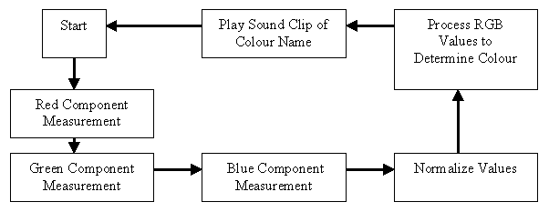

Figure 10.28: Flow Chart of Sensor Program

This sensor program was only capable of recognising a maximum of 27 colours. This year code is modified to have the capabilities of detecting 64 colours.

I/O port addressing
13 I/O pins were used for the design of the colour sensor. All pins were used as outputs except for the A-D pin. The sfr62.h header file allowed the use of custom made names for various ports. The following pins application can be tabulated:

Pin Use | Pin Description | Pin No. | Pin Location
Speech Chip | P2.0 | 72 | 11C
Speech Chip PD | P2.2 | 70 | 11A
Speech Chip A3 | P2.3 | 69 | 12C
Speech Chip A4 | P2.4 | 68 | 12B
Speech Chip A5 | P2.5 | 67 | 12A
Speech Chip A6 | P2.6 | 66 | 13C
Speech Chip A7 | P2.7 | 65 | 13B
LED Red LIVE | P3.0 | 63 | 13A
LED Blue/Green LIVE | P3.1 | 61 | 14C
LED Red ON | P3.2 | 60 | 14B
LED Green ON | P3.3 | 59 | 14A
LED Blue ON | P3.4 | 58 | 15C
A/D Input | A/D | 97 | 2A

Table 10.10: Pin Application

Seven pins have been allocated to control the speech chip and five for the LED switching control. These seven pins plus one other, makes up port 2. From previous chapter it was noted that the first five pins determined the address of the message, therefore it is the five pins of port 2 which determines the address of a message for the speech chip.

Colour Derivation
An expert system was used to derive the resultant colour from the amplified values of the photodiode. Like last year, an IF statement tree was implemented. With colour range split in three resulting in a maximum of 27 colours, it was furthered split in four to give a maximum of 64 possible colours. The process of derivation is as follows:

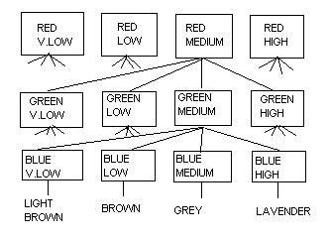
Figure 10.29: Colour Decision Tree

Key functions overview
The following is a list of the key functions and there description:

Initport(void) – sets the direction of the I/O port. Is declared at start of code.
pd2 = 0 x FF makes all port 2 pins as outputs.

RedOn() – Performs bitwise OR on port 3. If red LED’s live pin is connected
to pin 0 on port 3 and the red LED’s ON pin is connected to pin 3, port 3, both P3.0 and P3.3 must be high for red to be switched on. For red LED, a bitwise OR is performed with the value 0x05

Values used for the LEDs are tabulated below:

Function | Value (hex) | Value (binary)
Red ON | 0x05 | 0000 0101
Green ON | 0x0A | 0000 1010
Blue ON | 0x12 | 0001 0010
All OFF | 0xE0 | 1110 0000

Table 10.11: LED Control Comands

Sayword() – Controls Speech chip. Upper five bits of port 2 determines word
spoken.

Int0() – External interrupt. Commences the colour sensor process.

The final code of the colour sensor can be found in Appendix C.

conclusion
A colour sensor for the blind which is small, easy to use, cost efficient and can accurately recognise at least 64 colours has been designed. There have been some positive developments though there are also some issues to be concerned with.

For the hardware aspects of the prototype, a small and power efficient housing has been successfully constructed to illuminate and take reading from a test surface. An op-amp has been redesigned to give better flexibility and performance in its signal-conditioning task. In terms of software control, the LED switching and speech chip are successfully controlled through the use of the Mitsubishi M16C/62 microcontroller.

The outstanding issue which exists in this project is the accuracy of the prototype. Surfaces tested so far have been on pieces of card or normal paper. With different types of test surfaces such as glossy paper and clothing, the reflected light intensities are surely to be altered. One future proposal is to make the system be able to recognise the type of the test surface and to compensate for it if necessary.

Bibliography
EasyRGB - Color calculator and chromatic space converter
Retrieved 4 April 2004 from:
http://www.easyrgb.com/calculator.php

Horowitz, P., Hill, W., (1995), The Art of Electronics, 2nd Edition. Chap. 4. pp 175 -261. Cambridge University Press, Melbourne, Australia

ISD Chipcorder ISD2500 Series Datasheet
Retrieved 13 April 2003 from:
http://www.winbond.com

Mitsubishi Electric Australia M16C Web Site - Home Page
Retrieved 12 March 2004 from:
http://www.m16canz.com/

Mitsubishi M16C MCU Help Page
Retrieved 12 March 2004 from:
http://murray.newcastle.edu.au/users/staff/pturner/Mitsubishi.html

Named Colours with RGB and Hex Values
Retrieved 21 March 2004 from:
http://www.cloford.com/resources/colours/namedcol.htm

Data Sheet Search System
Retrieved 5 May 2004 from:
http://www.datasheetarchive.com/

Seah, G. & Seal, A., (2002), Colour Sensor for the Blind,
Curtin University of Technology, Perth, Australia.

Sedra, A., Smith, K., (1998), Microelectronic Circuits 4th Edition,
Oxford University Press, Melbourne.

Appendix A – Project plan
This project is to design a prototype of a colour sensor device, which can recognize at least 64 different colours and speak the recognized colour. The device should be suitable for use by vision-impaired people to allow them to perform basic colour recognition tasks.

The prototype uses a Red-Green-Blue LED to illuminate a surface. The level of reflected light from each colour is measured with a photodiode. The operation of the system is controlled by a Mitsubishi M16C/62 microcontroller. The determined colour is spoken through a ISD2548 chipcorder speech chip.

Given the time restriction of 12 weeks for the first semester unit, the following Gantt chart is produced.
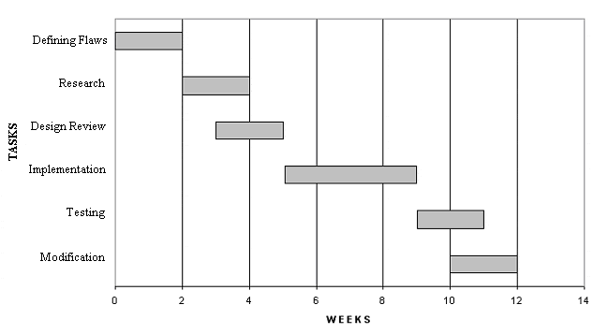
By 2nd April, a final design should be produced and ready for implementation. Implementation phase is given the time duration of 4 weeks where by the hardware should be completed by 30th April. The Alpha version of the source code should also be completed by 14th May finishing off the implementation phase. Given 3 weeks for testing and modification, the final prototype of the colour sensor should be completed by 4th June.

With the second semester unit also restricted to 12 weeks, the following time allocation results.

1. Writing the thesis and editing it 5 weeks
2. Draft review by Supervisor 1 week
3. Correction of the draft 1 week
4. Final production of the draft, including drawings 1 week
5. Oral preparations 4 weeks

Hence the desired date for the conclusion of this project is 5th November.

Appendix B – Modified Sect30.inc Header File
;*******************************************************************************
;
; C Compiler for M16C/60,20
; Copyright 2001 MITSUBISHI ELECTRIC CORPORATION
; AND MITSUBISHI ELECTRIC SEMICONDUCTOR APPLICATION ENGINEERING CORPORATION
; All Rights Reserved.
;
; Written by T.Aoyama, modified for use in Colour Sensor by Craig Treeby
; & Mark Chiam
;
; sect30.inc : section definition
; This program is applicable when using the basic I/O library
;
; $Id: sect30.inc,v 1.11 2001/11/12 04:06:53 muranaka Exp $
;
;******************************************************************************
;---------------------------------------------------------------
;
; Arrangement of section
;
;---------------------------------------------------------------
; Near RAM data area
;---------------------------------------------------------------
; SBDATA area
.section data_SE,DATA
.org 400H
data_SE_top:

.section bss_SE,DATA,ALIGN
bss_SE_top:

.section data_SO,DATA
data_SO_top:

.section bss_SO,DATA
bss_SO_top:

; near RAM area
.section data_NE,DATA,ALIGN
data_NE_top:

.section bss_NE,DATA,ALIGN
bss_NE_top:

.section data_NO,DATA
data_NO_top:

.section bss_NO,DATA
bss_NO_top:

;---------------------------------------------------------------
; Stack area
;---------------------------------------------------------------
.section stack,DATA
.blkb STACKSIZE
stack_top:

.blkb ISTACKSIZE
istack_top:

;---------------------------------------------------------------
; heap section
;---------------------------------------------------------------
.section heap,DATA
heap_top:
.blkb HEAPSIZE

;---------------------------------------------------------------
; Near ROM data area
;---------------------------------------------------------------
.section rom_NE,ROMDATA,ALIGN
rom_NE_top:

.section rom_NO,ROMDATA
rom_NO_top:

;---------------------------------------------------------------
; Far RAM data area
;---------------------------------------------------------------
.section data_FE,DATA
.org 10000H
data_FE_top:

.section bss_FE,DATA,ALIGN
bss_FE_top:

.section data_FO,DATA
data_FO_top:

.section bss_FO,DATA
bss_FO_top:

;---------------------------------------------------------------
; Far ROM data area
;---------------------------------------------------------------
.section rom_FE,ROMDATA
.org 0F0000H
rom_FE_top:

.section rom_FO,ROMDATA
rom_FO_top:

;---------------------------------------------------------------
; Initial data of 'data' section
;---------------------------------------------------------------
.section data_SEI,ROMDATA
data_SEI_top:

.section data_SOI,ROMDATA
data_SOI_top:

.section data_NEI,ROMDATA
data_NEI_top:

.section data_NOI,ROMDATA
data_NOI_top:

.section data_FEI,ROMDATA
data_FEI_top:

.section data_FOI,ROMDATA
data_FOI_top:

;---------------------------------------------------------------
; Switch Table Section
;---------------------------------------------------------------
.section switch_table,ROMDATA
switch_table_top:

;---------------------------------------------------------------
; code area
;---------------------------------------------------------------

.section program

.section interrupt
;.org ;must be set internal ROM area
.section program_S

;---------------------------------------------------------------
; variable vector section
;---------------------------------------------------------------
.section vector ; variable vector table
.org VECTOR_ADR

.if M62TYPE==1
.lword dummy_int ; BRK (vector 0)
.lword dummy_int ; (vector 1)
.lword dummy_int ; (vector 2)
.lword dummy_int ; (vector 3)
.lword dummy_int ; int3(for user)(vector 4)
.lword dummy_int ; timerB5(for user)(vector 5)
.lword dummy_int ; timerB4(for user)(vector 6)
.lword dummy_int ; timerB3(for user)(vector 7)
.lword dummy_int ; si/o4 /int5(for user)(vector 8)
.lword dummy_int ; si/o3 /int4(for user)(vector 9)
.lword dummy_int ; Bus collision detection(for user)(v10)
.lword dummy_int ; DMA0(for user)(vector 11)
.lword dummy_int ; DMA1(for user)(vector 12)
.lword dummy_int ; Key input interrupt(for user)(vect 13)

.glb _ADCint
.lword _ADCint ; A-D(for user)(vector 14)
; .lword dummy_int ; A-D(for user)(vector 14)

.lword dummy_int ; uart2 transmit(for user)(vector 15)
.lword dummy_int ; uart2 receive(for user)(vector 16)
.lword dummy_int ; uart0 transmit(for user)(vector 17)
.lword dummy_int ; uart0 receive(for user)(vector 18)

.lword 0FF900H ; uart1 transmit - Monitor V2
; .lword dummy_int ; uart1 transmit(for user)(vector 19)
.lword 0FF900H ; uart1 receive - Monitor V2
; .lword dummy_int ; uart1 receive(for user)(vector 20)

; .glb _TimerA0int
; .lword _TimerA0int ; timer A0(for user)(vector 21)
.lword dummy_int ; timer A0(for user)(vector 21)

.glb _TimerA1int
.lword _TimerA1int ; timer A1(for user)(vector 22)
; .lword dummy_int ; timer A1(for user)(vector 22)

.lword dummy_int ; timer A2(for user)(vector 23)
.lword dummy_int ; timer A3(for user)(vector 24)
.lword dummy_int ; timer A4(for user)(vector 25)
.lword dummy_int ; timer B0(for user)(vector 26)
.lword dummy_int ; timer B1(for user)(vector 27)
.lword dummy_int ; timer B2(for user)(vector 28)

.glb _INT0int
.lword _INT0int ; int0 (for user)(vector 29)
; .lword dummy_int ; int0 (for user)(vector 29)

.lword dummy_int ; int1 (for user)(vector 30)
.lword dummy_int ; int2 (for user)(vector 31)
.else
.lword dummy_int ; vector 0 (BRK)
.lword dummy_int ; vector 1
.lword dummy_int ; vector 2
.lword dummy_int ; vector 3
.lword dummy_int ; vector 4
.lword dummy_int ; vector 5
.lword dummy_int ; vector 6
.lword dummy_int ; vector 7
.lword dummy_int ; vector 8
.lword dummy_int ; vector 9
.lword dummy_int ; vector 10
.lword dummy_int ; DMA0 (for user) (vector 11)
.lword dummy_int ; DMA1 2 (for user) (vector 12)
.lword dummy_int ; input key (for user) (vector 13)

.glb _ADCint
.lword _ADCint ; A-D(for user)(vector 14)
; .lword dummy_int ; A-D(for user)(vector 14)

.lword dummy_int ; vector 15
.lword dummy_int ; vector 16
.lword dummy_int ; uart0 trance (for user) (vector 17)
.lword dummy_int ; uart0 receive (for user) (vector 18)

.lword 0FF900H ; uart1 transmit - Monitor V2
; .lword dummy_int ; uart1 transmit(for user)(vector 19)
.lword 0FF900H ; uart1 receive - Monitor V2
; .lword dummy_int ; uart1 receive(for user)(vector 20)

; .glb _TimerA0int
; .lword _TimerA0int ; timer A0(for user)(vector 21)
.lword dummy_int ; timer A0(for user)(vector 21)

.glb _TimerA1int
.lword _TimerA1int ; timer A1(for user)(vector 22)
; .lword dummy_int ; timer A1(for user)(vector 22)

.lword dummy_int ; TIMER A2 (for user) (vector 23)
.lword dummy_int ; TIMER A3 (for user) (vector 24)
.lword dummy_int ; TIMER A4 (for user) (vector 25)
.lword dummy_int ; TIMER B0 (for user) (vector 26)
.lword dummy_int ; TIMER B1 (for user) (vector 27)
.lword dummy_int ; TIMER B2 (for user) (vector 28)

.glb _INT0int
.lword _INT0int ; int0 (for user)(vector 29)
; .lword dummy_int ; int0 (for user)(vector 29)

.lword dummy_int ; INT1 (for user) (vector 30)
.lword dummy_int ; INT2 (for user) (vector 31)
.endif
.lword dummy_int ; vector 32 (for user or MR30)
.lword dummy_int ; vector 33 (for user or MR30)
.lword dummy_int ; vector 34 (for user or MR30)
.lword dummy_int ; vector 35 (for user or MR30)
.lword dummy_int ; vector 36 (for user or MR30)
.lword dummy_int ; vector 37 (for user or MR30)
.lword dummy_int ; vector 38 (for user or MR30)
.lword dummy_int ; vector 39 (for user or MR30)
.lword dummy_int ; vector 40 (for user or MR30)
.lword dummy_int ; vector 41 (for user or MR30)
.lword dummy_int ; vector 42 (for user or MR30)
.lword dummy_int ; vector 43 (for user or MR30)
.lword dummy_int ; vector 44 (for user or MR30)
.lword dummy_int ; vector 45 (for user or MR30)
.lword dummy_int ; vector 46 (for user or MR30)
.lword dummy_int ; vector 47 (for user or MR30)
.lword dummy_int ; vector 48
.lword dummy_int ; vector 49
.lword dummy_int ; vector 50
.lword dummy_int ; vector 51
.lword dummy_int ; vector 52
.lword dummy_int ; vector 53
.lword dummy_int ; vector 54
.lword dummy_int ; vector 55
.lword dummy_int ; vector 56
.lword dummy_int ; vector 57
.lword dummy_int ; vector 58
.lword dummy_int ; vector 59
.lword dummy_int ; vector 60
.lword dummy_int ; vector 61
.lword dummy_int ; vector 62
.lword dummy_int ; vector 63

;===============================================================
; fixed vector section
;---------------------------------------------------------------
.section fvector ; fixed vector table
;===============================================================
; special page defination
;---------------------------------------------------------------
; macro is defined in ncrt0.a30
; Format: SPECIAL number
;
;---------------------------------------------------------------
; SPECIAL 255
; SPECIAL 254
; SPECIAL 253
; SPECIAL 252
; SPECIAL 251
; SPECIAL 250
; SPECIAL 249
; SPECIAL 248
; SPECIAL 247
; SPECIAL 246
; SPECIAL 245
; SPECIAL 244
; SPECIAL 243
;
; Note! Due to space considerations, this section has been shortened. However
; the actual sect30.inc file continues from SPECIAL 243 through to SPECIAL 23
;
; SPECIAL 24
; SPECIAL 23
; SPECIAL 22
; SPECIAL 21
; SPECIAL 20
; SPECIAL 19
; SPECIAL 18
;
;===============================================================
; fixed vector section
;---------------------------------------------------------------
.org 0fffdch
UDI:
.lword dummy_int
OVER_FLOW:
.lword dummy_int
BRKI:
.lword dummy_int
ADDRESS_MATCH:
.lword dummy_int
SINGLE_STEP:
.lword dummy_int
WDT:
.lword dummy_int
DBC:
.lword dummy_int
NMI:
.lword dummy_int
RESET:
.lword start
;
;*******************************************************************************
;
; C Compiler for M16C/60,20
; Copyright 2001 MITSUBISHI ELECTRIC CORPORATION
; AND MITSUBISHI ELECTRIC SEMICONDUCTOR SYSTEMS CORPORATION
; All Rights Reserved.
;
;*******************************************************************************

Appendix C – Sensor Program Source Code
/********************************************************/
/* COLOUR SENSOR FOR MSA0654-MEAUST BOARD */
/* FILENAME: sensor.c */
/* WRITTEN BY: Craig Treeby & Mark Chiam 2003, */
/* Modified by Vincent Hau 2004 */
/* DESCRIPTION: */
/* -- Use INT0# line to start conversion. */
/* -- Uses Timer A1 to multiplex refresh of LED1 */
/* and LED2. */
/* */
/********************************************************/

#include "sfr62.h"
#include "leddata.h"
void main(void);
void initport(void);
void initADC(void);
void setADCint(void);
void ADCint(void);
void initTimerA1(void);
void startTimerA1(void);
void setTimerA1int(void);
void TimerA1int(void);
void redon(void);
void greenon(void);
void blueon(void);
void alloff(void);
void sayword(int);
void delaytime(int);
void INT0int(void);
void setINT0int(void);

#pragma INTERRUPT ADCint
#pragma INTERRUPT TimerA1int
#pragma INTERRUPT INT0int

#define LIGHT (0x00)
#define DARK (0x08)
#define VERY (0x10)
#define MEDIUM (0x18)
#define WHITE (0x20)
#define BLACK (0x28)
#define BLUE (0x30)
#define GREEN (0x38)
#define YELLOW (0x40)
#define ORANGE (0x48)
#define RED (0x50)
#define PURPLE (0x58)
#define PINK (0x60)
#define BROWN (0x68)
#define GREY (0x70)
#define PASTEL (0x78)
#define HOT (0x80)
#define LAVENDER (0x88)
#define MAROON (0x90)
#define AQUA (0x98)

unsigned char pot_rdg = 0;
unsigned char red,green,blue, ad_reading;
unsigned int colour = 0;
unsigned int i,j,k,l,delaylength, low, mid, high;
unsigned int wordnumber = 0;

void main(void)
{
initport();
initADC();
initTimerA1();
setADCint();
setTimerA1int();
setINT0int();
startTimerA1();
while(1); // endless loop
}

void initport(void)
{
pd0 = 0xFF; // output mode
pd1 = 0xFF; // output mode
pd3 = 0xFF; // output mode
pd2 = 0xFF; // Port 2_0 to 2_2 output mode, 2_3 input
pu00 = 0; // no pull up for P0_0 to P0_3
pu01 = 0; // no pull up for P0_4 to P0_7
pu02 = 0; // no pull up for P1_0 to P1_3
p1 = 0xFD; // enable LED2 and disable LED1
p0 = 0xFF; // turn off all segments
p2 = 0x05; // initialise voice chip
}

void initADC(void)
{
adcon2 = 0x01; // ---- ---X
// +- 0: without sample and hold
// 1: with sample and hold

adcon0 = 0x00; // X0X0 0000- AN0 SELECTED
// |||| +---- must be fixed to 0 in one shot mode
// |||+------ must be fixed to 0 in one shot mode
// ||+------- trigger select bit
// || 0: software trigger
// || 1: external trigger (ADtrg, P10.0)
// |+-------- 0: A-D conversion disabled
// | 1: A-D conversion enabled
// +--------- frequency select bit 0:
// 0: fad/4 is selected
// 1: fad/2 is selected
// please look at bit 4 of ADCON1
// (ADCON1.4) also)

adcon1 = 0x30; // XX1X X0--
// |||| |+--- must be fixed to 0 in one shot mode
// |||| +---- 0: 8-bit mode
// |||| 1: 10-bit mode
// |||+------ frequency select bit 1
// ||| 0: fad/2 or fad/4 is selected
// ||| please look at bit 7 of ADCON0
// ||| 1: fad is selected
// ||+------- 1: Vref connected (must be fixed to
// || 1 if A-D conversion is used)
// |+-------- ext. op amp connection mode bits
// +--------- ext. op amp connection mode bits
// 00: ANEX0 and ANEX1 are not used
// 01: ANEX0 input is A-D converted
// 10: ANEX1 input is A-D converted
// 11: external op amp connection mode
}

void setADCint(void)
{
adic = 0x03; // ---- XXXX
// ||||
// |||+-- Interupt priority level select bit
// ||+--- Interupt priority level select bit
// |+---- Interupt priority level select bit
// | 000: Level 0 (interrupt disabled)
// | 001: Level 1
// | 010: Level 2
// | 011: Level 3
// | 100: Level 4
// | 101: Level 5
// | 110: Level 6
// | 111: Level 7
// +----- Interupt request bit
// 0: Interrupt not requested
// 1: Interrupt requested
}

void ADCint(void) // A/D interrupt function
{
asm("fset I");
ad_reading = ad0l;
}

void setINT0int(void)
{
int0ic = 0x01; // --0X XXXX
// || ||||
// || |||+-- Interupt priority level select bit
// || ||+--- Interupt priority level select bit
// || |+---- Interupt priority level select bit
// || | 000: Level 0 (interrupt disabled)
// || | 001: Level 1
// || | 010: Level 2
// || | 011: Level 3
// || | 100: Level 4
// || | 101: Level 5
// || | 110: Level 6
// || | 111: Level 7
// || +----- Interupt request bit
// || 0: Interrupt not requested
// || 1: Interrupt requested
// |+------- Polarity select bit
// | 0: Selects falling edge
// | 1: Selects rising edge
// +-------- Reserved bit - always set to "0"
}

void INT0int(void)
{
asm("fset I"); // enable interrupts
redon(); // turn on red LED
delaytime(2); // delay to allow photodiode reading to stabilise
adst = 1; // start AD conversion
while (adst == 1); // wait till AD conversion is completed
red = (ad_reading); // store reading
pot_rdg = red; // set 7 segment display value to show red voltage
delaytime(10);
alloff(); // turn off all LEDs

greenon(); // turn on green LED
delaytime(2); // delay to allow photodiode reading to stabilise
asm("fset I"); // enable interrupts
adst = 1; // start AD conversion
while (adst == 1); // wait till AD conversion is completed
green = (ad_reading); // store reading
pot_rdg = green; // set 7 segment display value to show green voltage
delaytime(10);
alloff(); // turn off all LEDs

blueon(); //turn on blue LED
delaytime(2); // delay to allow photodiode reading to stabilise
asm("fset I"); // enable interrupts
adst = 1; // start AD conversion
while (adst == 1); // wait till AD conversion is completed
blue = (ad_reading * 0.9); // store reading (scaled due to high readings
pot_rdg = blue; // set 7 segment display value to show blue voltage
delaytime(10);
alloff(); // turn off all LEDs

vlow = 60; // very low range 0 - 60
low = 120; // low range 61 - 120
mid = 180; // medium range 121 - 180
high = 255; // high range 181 - 255

if (red <= low) // red minimum range
{
if (green <= low) // green minimum range
{
if (blue <= low)
{
colour = 1; // black
sayword(BLACK);
}
if (blue > low && blue <= mid)
{
colour = 2; // dark blue
sayword(DARK);
sayword(BLUE);
}
if (blue > mid && blue <= high)
{
colour = 3; // blue
sayword(BLUE);
}
}
if (green > low && green <= mid) // green mid range
{
if (blue <= low)
{
colour = 4; // dark green
sayword(DARK);
sayword(GREEN);
}
if (blue > low && blue <= mid)
{
colour = 5; // jade
sayword(GREEN);
}
if (blue > mid && blue <= high)
{
colour = 6; // sky blue
sayword(LIGHT);
sayword(BLUE);
}
}
if (green > mid && green <= high) // green high range
{
if (blue <= low)
{
colour = 7; // light green
sayword(LIGHT);
sayword(GREEN);
}
if (blue > low && blue <= mid)
{
colour = 8; // apple green
sayword(MEDIUM);
sayword(GREEN);
}
if (blue > mid && blue <= high)
{
colour = 9; // light blue
sayword(LIGHT);
sayword(BLUE);
}
}
}
/////////////////////////////////////////////
if (red > low && red <= mid) // red mid range
{
if (green <= low) // green minimum range
{
if (blue <= low)
{
colour = 10; // maroon
sayword(MAROON);
}
if (blue > low && blue <= mid)
{
colour = 11; // dark purple
sayword(DARK);
sayword(PURPLE);
}
if (blue > mid && blue <= high)
{
colour = 12; // lavender
sayword(LAVENDER);
}
}
if (green > low && green <= mid) // green mid range
{
if (blue <= low)
{
colour = 13; // brown
sayword(BROWN);
}
if (blue > low && blue <= mid)
{
colour = 14; // mid grey
sayword(MEDIUM);
sayword(GREY);
}
if (blue > mid && blue <= high)
{
colour = 15; // lavender
sayword(LAVENDER);
}
}
if (green > mid && green <= high) // green high range
{
if (blue <= low)
{
colour = 16; // lime green
sayword(LIGHT);
sayword(GREEN);
}
if (blue > low && blue <= mid)
{
colour = 17; // pastel green
sayword(PASTEL);
delaytime(5);
sayword(GREEN);
}
if (blue > mid && blue <= high)
{
colour = 18; // pastel blue
sayword(PASTEL);
delaytime(5);
sayword(BLUE);
}
}
}
/////////////////////////////////////////////
if (red > mid && red <= high) // red high range
{
if (green <= low) // green minimum range
{
if (blue <= low)
{
colour = 19; // red
sayword(RED);
}
if (blue > low && blue <= mid)
{
colour = 20; // hot pink
sayword(HOT);
sayword(PINK);
}
if (blue > mid && blue <= high)
{
colour = 21; // fushia pink
sayword(HOT);
sayword(LAVENDER);
}
}
if (green > low && green <= mid) // green mid range
{
if (blue <= low)
{
colour = 22; // orange
sayword(ORANGE);
}
if (blue > low && blue <= mid)
{
colour = 23; // light pink
sayword(LIGHT);
sayword(PINK);
}
if (blue > mid && blue <= high)
{
colour = 24; // light purple
sayword(LIGHT);
sayword(PURPLE);
}
}
if (green > mid && green <= high) // green high range
{
if (blue <= low)
{
colour = 25; // canary yellow
sayword(YELLOW);
}
if (blue > low && blue <= mid)
{
colour = 26; // pastel yellow
sayword(PASTEL);
delaytime(5);
sayword(YELLOW);
}
if (blue > mid && blue <= high)
{
colour = 27; // white
sayword(WHITE);
}
}
}
}

void initTimerA1(void)
{
ta1mr = 0x80; // XX0X XX00
// |||| |||+- must always be 0 in timer mode
// |||| ||+-- must always be 0 in timer mode
// |||| |+--- 0: pulse is not output at pin TA1out
// |||| | 1: pulse is output at pin TA1out
// |||| | TA0out is automatically output
// |||| +---- 0: gate function: timer counts only
// |||| when TA0in is held "L"
// |||| 1: gate function: timer counts only
// |||| when TA0in is held "H"
// |||+------ 0: gate function not available
// ||| 1: gate function available
// ||+------- must always be 0 in timer mode
// |+-------- count source select bits:
// +--------- count source select bits:
// 00: f1
// 01: f8
// 10: f32
// 11: fc32

ta1 = 0x1388; // Set up Timer A1 Reload Register for 10 msec interval
// for a LED refresh rate of 100Hz
}

void startTimerA1(void)
{
tabsr |= 0x02; // 1: start timer A1 (count flag)
}

void setTimerA1int(void)
{
ta1ic = 0x02; // ---- XXXX
// ||||
// |||+-- Interupt priority level select bit
// ||+--- Interupt priority level select bit
// |+---- Interupt priority level select bit
// | 000: Level 0 (interrupt disabled)
// | 001: Level 1
// | 010: Level 2
// | 011: Level 3
// | 100: Level 4
// | 101: Level 5
// | 110: Level 6
// | 111: Level 7
// +----- Interupt request bit
// 0: Interrupt not requested
// 1: Interrupt requested
}

void TimerA1int(void) // interrupt function
{
static unsigned char led_select = 0;
unsigned char offset, pot_rdg_scaled;

asm("fset I"); // enable interrupts
/* if (led_select == 0)
{
led_select = 1;
p1 = 0xFD;
offset = colour % 10;
p0 = leddigit[offset];
}
else
{
led_select = 0;
p1 = 0xFE;
offset = colour /10;
p0 = leddigit[offset];
}*/

if (led_select == 0)
{
led_select = 1;
p1 = 0xFD; // enable LED2 and disable LED1
pot_rdg_scaled = (pot_rdg * 5 * 10)/255; // 5.0V full scale
offset = pot_rdg_scaled % 10;
p0 = leddigit[offset]; // display remainder
}
else
{
led_select = 0;
p1 = 0xFE; // disable LED2 and enable LED1
pot_rdg_scaled = (pot_rdg * 5 * 10)/255; // 5.0V full scale
offset = pot_rdg_scaled / 10;
p0 = leddigit[offset]; // display quotient
p0 &= 0x7F; // turn on DP segment
}
}

void redon(void)
{
p3 |= 0x05; // Turn on Pin 3_0 and Pin 3_2
}

void greenon(void)
{
p3 |= 0x0A; // Turn on Pin 3_3 and Pin 3_1
}

void blueon(void)
{
p3 |= 0x12; // Turn on Pin 3_4 and Pin 3_1
}

void alloff(void)
{
p3 &= 0xE0;
}

void delaytime(delaylength)
{
for (i=0;i<255;i++)
{
for (j=0;j<255;j++)
{
for (k=0;k<delaylength;k++)
{
}
}
}
}

void sayword(wordnumber)
{
// XXXX XXXX
// |||| ||||
// |||| |||+-- CE pin
// |||| ||+--- NC
// |||| |+---- PD pin
// |||| +----- A3
// |||+------- A4
// ||+-------- A5
// |+--------- A6
// +---------- A7

p2 = 0x01; // PD cleared (0), CE = 1

p2 = (wordnumber | 0x01);
p2 = wordnumber;
p2 = (wordnumber | 0x01);

delaytime(18); // delay before power down, only needed to reduce power consumption

p2 = 0x05; // PD high, low power mode, stop playing
}

