Department Of Electrical and Computer Engineering

Braille Translation Program

by

Daniel Lee

A thesis submitted for the degree of
Bachelor of Engineering (Computer Systems Engineering)

November 2006

Department Of Electrical And Computer Engineering
TITLE:Braille Translation Program
AUTHOR
FAMILY NAME:Lee
GIVEN NAMES:Daniel Shen Yeow
DATE2nd November 2006
SUPERVISORMr Iain Murray
DEGREEBachelor of Engineering
OPTIONComputer Systems
ABSTRACT
GOOD
AVERAGE
POOR
TECHNICAL WORK

REPORT PRESENTATION
EXAMINER
CO-EXAMINER
INDEXING TERMS

This thesis details the development of software to perform the translation of multiple grades of Braille to and from different languages of print and the implementation of this software on the Mac OS X. The software developed is a translation engine and interface that allows the user to create large documents with allow multiple languages and grades.

Computerized Braille Translation, Assistive technology

Synopsis

This thesis details the development of software to perform the translation of print to Braille and Braille to print with the support of translation tables to allow translation to Braille from many languages with the translation following different grades rules. The implementation of this software is using Objective C on a computer running Mac OS X. The tables may not he fully implemented but the software has been developed to a stage where they may be developed and added later.

Daniel Lee
11 Killara Drive,
Willetton, WA, 6155
2nd November 2006

Professor Syed Islam
Head of Department
Department of Electrical and Computer Engineering
Curtin University of Technology
Bentley WA 6102

Dear Professor Islam,

I am pleased to present this thesis entitled “Braille Translation Program” as part of the requirements for the degree of Bachelor of Engineering, majoring in Computer Systems Engineering. This is entirely my own work outside of the acknowledgements given.

Yours faithfully,

Daniel Lee

Acknowledgements

I would like to thank my supervisor Mr. Iain Murray for his guidance and support throughout this project.

I would also like to thank Shannon Thrower for his previous work on the algorithm for print to Braille and Braille to print translation.

Contents

Synopsis i
Acknowledgements iii
List of Figures vii
List of Tables viii
1 Introduction 1
1.1 The nature of the problem 1
1.2 Aim of the project 2
1.3 Thesis structure 3
2 Evolution of Braille 4
2.1 History of Braille 4
2.2 Braille Representation 5
2.2.1 The Braille Code 5
2.2.2 Different grades of Braille 6
2.2.3 ASCII Braille 7
2.2.4 Complexities of Braille 7
2.3 Current methods of Computerised Braille-Print translation 10
3 Detailed Requirements 11
3.1 Requirements Analysis 11
3.2 Use Case Diagrams 12
3.3 Proposed Solution 13
4 Development and Implementation 16
4.1 Design 16
4.1.1 Graphical User Interface 16
4.1.2 Translation Tags 16
4.1.3 Tag Loading 18
4.1.4 Text Translation 20
4.1.5 Translation Algorithm 22
4.1.6 Speech 23
4.1.7 Use Cases 24
4.2 Implementation 25
4.2.1 Coding Standard 25
4.2.2 Implementation model 25
4.2.3 UML Class Diagrams 26
4.2.4 Creation of the GUI 28
4.2.5 Braille Tables 29
5 Verification and Results 30
5.1 Structural testing 30
5.2 Table Verification 35
6 Recommendations and Conclusions 36
6.1 Concluding Remarks 36
6.2 Considerations for Future Development 37
7 References 39
Appendix A – Project Plan 43
Appendix B – Use Cases 46
Appendix B.1 – loadBrailleTags 46
Appendix B.2 – insertBrailleTag 47
Appendix B.3 – editText 48
Appendix B.4 – load 49
Appendix B.5 – print 50
Appendix B.6 – save 51
Appendix C – Computer Braille 52
Appendix D – Source code 55
Appendix D.1 – BrailleConverter.h 55
Appendix D.2 – BrailleConverter.m 57
Appendix D.3 – BrailleTranslator.h 69
Appendix D.4 – BrailleTranslator.m 71
Appendix D.5 – Speech.h 94
Appendix D.6 – Speech.m 95
Appendix E – Structure of CD 97

List of Figures

Figure 2.1. Braille Cell Numbering 5
Figure 2.2 Braille Cell representing ‘h’ 5
Figure 2.3 Braille Cell representing ‘3’ in ASCII 7
Figure 3.1 Use case diagram for Braille Translation Program 12
Figure 3.2 Proposed translation interface 14
Figure 4.1 Tag loading activity sequence 19
Figure 4.2 Text translation activity sequence 21
Figure 4.3 Translation activity sequence 23
Figure 4.4 Final Class Diagram 27
Figure 4.5 Final Program Interface 29
Figure 5.1 Sample output from the program 30
Figure 5.2 Error window showing an incomplete tag error 32
Figure 5.3 Error window showing that extra files are present for a tag 32
Figure 5.4 Error window showing that two files are needed after a tag 33
Figure 5.5 Error window showing that duplicate tags are present 33
Figure 5.6 Error window showing the files which are missing 34
Figure 5.7 Error window showing that a tag or file has a new line character 34

List of Tables
Table 2-1 Relationship between Print, Grade 2 Braille and Computer Braille 9
Table 4-1 Example contents of an ideal tag file initialisation table. 17
Table 4-2 Example contents of a non-ideal tag file initialisation table. 18
Table 5-1 Content of tag_table.ini for an incomplete tag error 32
Table 5-2 Content of tag_table.ini for extra files for a tag 32
Table 5-3 Content of tag_table.ini for missing file names 33
Table 5-4 Content of tag_table.ini for an duplicate tags 33
Table 5-5 Content of tag_table.ini for an files which are missing 34
Table 5-6 Content of tag_table.ini for a new line in a tag 34

Introduction

The nature of the problem
Braille is a method of representing characters through a pattern of raised dots so that they can be read through touch. While it was originally developed as a means for soldiers to read communications at night without the need for lighting which could expose their position (Wikipedia, 2006), Braille has now been adopted as the standard form of written communication for visually impaired people.

Written communication between two people is an easy task provided they can both read and write the same language. However if this communication is between a sighted and a blind person problems can arise if the sighted person does not understand Braille. A translator is needed to convert a print message to Braille so that a blind person can read it or alternatively to convert a Braille message to print so that a sighted person can read it. This translation between Braille and print is not a simple task as grade 2 Braille is essentially as shorthand representation of English (International Braille Research Center, 1997), consequently there are many rules governing when abbreviations or contractions may be used.

With the invention of computers, several approaches to computerised Braille translation have been developed and thus this makes computerized Braille is a recently new phenomenon with the Braille language. Many applications have been created for translation from print to Braille. However, there is a shortage of programs designed for the use of allowing multiple translation grades within one text field and also a shortage of programs which allows translation from Braille to print. Another feature which is missing in all known available software currently is the ability to have two or more different languages to be typed into the same document and have the resultant Braille output as the translation of their respective translation rules.

Aim of the project
The Braille system consists of six cells per character. This limits the alphabet of the system to 64 characters, much less than the English alphabet with all the punctuation and special characters included. There are several grades of Braille, which includes contractions, but sometimes these contractions may be confusing when the text includes single characters. For example, the character string ‘ble’ translates to the character # when translated through grade 2 Braille. However, some texts uses just the character ‘#’ within a sentence and the user may be confused by their translation of this character and whether or not it means the actual character ‘#’ or the string of ‘ble’.

The algorithm for translation which was developed by Shannon Thrower (2005) was initially designed to translate English to Braille and to also translate back into print, although it could, through the use of the translation rules and states in a table, translate any language into Braille and also allow translate using any of the grades of translation.

Thus the project was to create a software program which would have the ability to have two or more different languages to be typed into the same document and have the resultant Braille output as the translation of their respective translation rules, which would allow the blind to create text documents through the user of Braille, or for people to create complex Braille documents by allowing multiple language and grade translations.

Thesis structure
The thesis begins with an introduction to Braille translation in chapter 2 which gives a brief history overview of Braille before assessing current trends in Braille-Print translation programs and discusses the approaches that have been taken to create these programs. A detailed explanation of the requirements and the proposed solution is in chapter 3. Chapter 4 details the construction of the program, the interface, the background code and how it was writing in Objective-C and implemented on the Mac. The verification of the program is discussed in chapter 5 with recommendations on future improvements to the program and conclusions in chapter 6.

Evolution of Braille

History of Braille
Braille is a system developed by Louis Braille in the ninetieth century to allow the blind to read and write. Charles Barbier originally developed this coded system, named ‘Night writing’ or sonography, in response to the need for a code that enabled soldiers to communicate silently and without light during the night. However, this code was designed to have two columns of six dots embossed on cardboard and this complexity made the system too hard for the soldiers to learn it since it gave a possible of 4096 unique characters for each cell. Barbier in 1821 later went to the Royal Institution for Blind Youth in Paris, France, where he met Louis Braille where he shared the Night writing system. Louis Braille was inspired by this system and in turn then went to create a modified code to make more easy to use and then took several more years to make a system which was suitable to include all the letters of the French language. Eventually the Braille system has become widespread with the support of a group who was to become the Royal National Institute for the Blind. Today the majority of the languages have been mapped into Braille allowing may blind people in the majority of countries to read Braille in their own language. Louis Braille had also extended the Braille system in 1837 to include other areas of communication; music and mathematics; so that the blind were able to understand these sophisticated systems. (Wikipedia, 2006)

Braille Representation

The Braille Code
The Braille system comprises of a cell per character and these themselves consist of six embossed or raised dots arranged as shown below. The way the dots are raised gives meaning and in grade one Braille, each cell has the meaning of only one letter, number or simple punctuation mark.

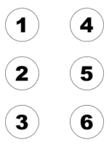 | 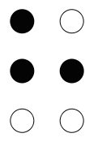
Figure 2.1. Braille Cell Numbering | Figure 2.2 Braille Cell representing ‘h’

The numbering system for the dots in the Braille cell is shown in Figure 2.1 and shows that the Braille cell contains six dots which are formed by two rows of three. For example, Figure 2.2 has the dots 1, 2 and 5 raised which give the letter ‘h’. These six cells allow 2⁶ = 64 characters to be represented, being split up into 26 letters,

There is also an 8-dot cell (2 dots wide by 4 dots high) for Braille which gives a total of 256 combinations and is encoded using the Unicode standard. The advantage of this system is outweighed by that fact that it is more difficult for people to remember 256 characters, as opposed to 64. Therefore the usage of this system is not widespread.

Different grades of Braille
This system of representing one character at a time is called grade one Braille. Grade one Braille letters are assumed lower cause unless there is a capitalisation symbol in front of a letter. However, there are limitations to this grade. Braille is bulky since it represents one character with each cell and would expand a normal book size several fold. Also, since there are only six cells, it can only represent a few characters (26 upper case letters +26 lower case letter +10 numerals + punctuation marks and symbols greatly exceeds 64).

Thus grade two was introduced which allowed contractions such as ‘b’ for but and ‘tm’ for tomorrow to be used, greatly shortening texts and is the norm for printed texts. However, there are special cases, such as the noun do representing a musical note must be spelled out in full.

There is also a grade 3 Braille system, which includes many more contractions and would be considered to be almost a shorthand method for Braille. But this is mainly used for individuals for their personal convenience and thus is not used for publication.

ASCII Braille
ASCII Braille (formally The North American Braille ASCII Code) is a subset of ASCII character set and consists of 64 of the printable ASCII characters to represent the combination in six-dot Braille. ASCII Braille is also known as Grade 0 Braille.

This system would take characters from the ASCII tables of values 32 to 95 inclusive and map these to the Braille system. Thus this system has a separate set of Braille cells dedicated for the upper case letters, the lower case letter and for the numbers.
The full of the ASCII characters is shown in Appendix C (King 2001).

Complexities of Braille

With the Braille system, one character can have many meanings, depending on where it is placed within a word and to which grade it was translated into.

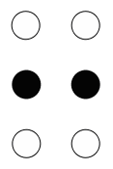
Figure 2.3 Braille Cell representing ‘3’ in ASCII

For example, the character with dots 2 and 5 raised has three meanings. For grade 2, it could mean ‘cc’ if it is in the middle, ‘con’ if it is at the front of a word or could mean the number 3 in the ASCII Braille. Another example would be the character with the dots 2, 3 and 5 raised is the letter ‘f’. This character could mean ‘ff’ when used in the middle of a word, at the beginning of a word, it would mean ‘to’ and at the end of a word, the same character represents an exclamation point.

The contraction rules take into account the linguistic structure of the word; thus, contractions are not to be used when their use would alter the usual Braille form of a base word to which a prefix or suffix has been added. And some portions of the transcription rules are not fully codified and rely on the judgement of the transcriber. Thus, when the contraction rules permit the same word in more than one way, preference is given to "the contraction that more nearly approximates correct pronunciation." (Wikipedia, 2006). Another example of this complexity is shown where ‘wh’ can be replaced by one character, except when the word is actually two words combined. So the ‘wh’ in awhile can be replaced by a character, but the ‘wh’ in rawhide can not be replaced by one character. Trying to find out whether or not a word is actually two words combined together would require a large dictionary and thus would also an increase the CPU usage with very little benefit in the actual translation since this occurrence would occur infrequently at best. Thus, for computerized Braille translation, either both rules would either be left out of the translation tables or allow the contraction into one character. Also, contractions could not be used across syllable boundaries, would fall into the above category.

In Table 2-1 (Shannon, 2005) shows the relationship between Print, Braille and Computer Braille representations of the word ‘knowledgeable’. This shows how parts of the word are contracted to different characters. For example the part of the word ‘know’ is translated to the cell 1-3 which is represented in ASCII by the character ‘k’, ‘ed’ is contracted to the cell 1-2-4-6 which in ASCII is represented by the ASCII character “$” with the letters ‘ble’ being contracted into the ASCII character ‘#’ which is the Braille cell of 3-4-5-6.

Print |  | knowledgeable
Grade 2 Translation | Braille Characters | 
Grade 2 Translation | ASCII Characters | KL$GEA#
Table 2-1 Relationship between Print, Grade 2 Braille and Computer Braille

There is also the extra problem with grade 2 Braille is that in translating into this grade gives problems with loss of translation. For example, translating | and / into Braille gives the same character, thus losing the capability to translate back into English.

There are also problems as different cultures or people using different languages would use different Braille translation rules which can cause confusion. So having a system where Braille can be translated into one language and then into a Braille system of a different nature so that the same text can be translated from one Braille system into another would be useful.

Current methods of Computerised Braille-Print translation
There is a lot of translation software available for English to Braille, but some lack certain features, such as the ability to change the translation grade or are very expensive, with a licence costing anywhere between three hundred to thirteen hundred dollars, with the market leader, Duxbury Braille Translator, costs just fewer than six hundred dollars. There are also free translation software packages but these do not allow the user to format the Braille text or have multiple grade translations within the text itself and that the software would not allow the user to have multiple languages for translation within a document. This is the most significant lacking feature of all the software packages on the market. Another problem is that most of the software available would only allow for translation in one direction, mainly from print to Braille.

Several online translation services are offered which allow the user to type in a small text string, and then choose the grade of translation. It also allowed a different language to be chosen for the translation, but this too has the problem of not allowing multiple grade translations and also for not allowing different languages to translate within one text field.

Detailed Requirements

Requirements Analysis
The main requirement is that the user to use a program where typed text would be translated from English Braille or from English into Braille.

The translator will have simple word processing (copy, cut, paste and spell check) and would use third party programs to translate using grades 0, 1 and 2. The program will allow the user to insert new Braille tags while typing to allow for some characters to be translated under different rules. The program also needed to allow the user to change the direction of translation.

An extra requirement was in which the user did not have to worry about explicitly telling the program through a button click, the user will just have to click inside the field to change the direction of translation forwards or backwards. In addition, the user will also be able to extend the range of the tags, which will be available for them to use and to supply the translation tables to accompany the forward and backward translations.

In addition, the program is required to output speech at certain events. One of these evens is when the user will know when the translation has been switched from Braille to print or vice versa. Another event is when a new tag has been inserted into the text field.

Use Case Diagrams
Use case diagrams are a technique for capturing functional requirements of a system from an end user’s point of view and it to provide a clear and unambiguous description of how the end-user and the system are to interact with each other and to provide a basis for validation testing.

The use cases for the software package to be created were generalized for the things which the user of the software should be able to do, without making any assumptions about how this design is to be implemented, thus is a high level of design.

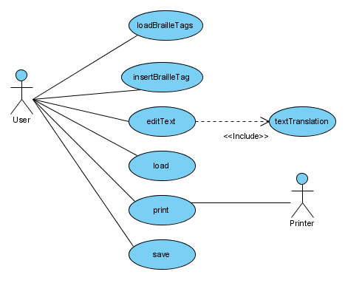
Figure 3.4 Use case diagram for Braille Translation Program

The use case diagram above is to show the types of scenarios the user can participate within the program. The user would be able to insert a Braille tag, change translation direction, edit the text, load or save to and from a file and to print to a Braille embosser or to a normal printer. Each of these would need to be fully developed and are explained further in chapter 4.

Proposed Solution
The proposed solution to the problem is to create an interface to allow the user to type text into one text field and let the program translate the text. Tags are to be inserted into the input text field and these serve as flags for the program to switch translation tables for the rest of the text until it finds another tag. During this translation, the tags would be removed so that the tags would not appear in the translated text field. This reason is so that the user would not have to remember what the tags had meant or to have a table ready for reference since it would be possible that the translated Braille text would be printed and then taken elsewhere for users to read without knowledge of the tags. This would put the burden on the writer to ensure that the reader would know what he or she is reading.

The proposed software should also be able to take any length of text per tag and then translate each part before adding to the result of the return string. This would give the user a near unlimited sized document to translate.

Several open source translation packages were considered in deciding which one would be most suitable in getting print translated into Braille and vice versa. The available translation software that was available to be chosen from were NFBTrans, LibBraille and Shannon Thrower’s translation algorithm. Shannon Thrower’s translation algorithm was chosen to be used because it was built on a previous project work and was thoroughly tested as was demonstrated in his thesis. (Thrower, 2005)

In proposing a solution, a screenshot was required to demonstrate how the solution could potentially look like once the implementation was complete. This screenshot is presented below in Figure 3.2.
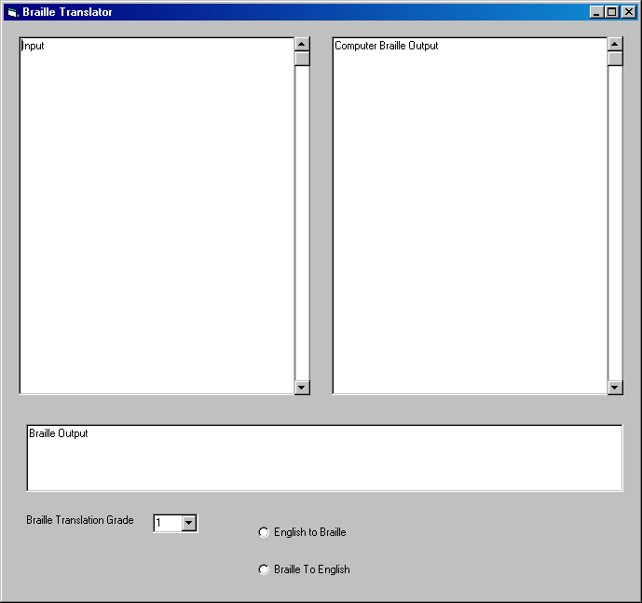
Figure 3.5 Proposed translation interface

The above diagram was created in January 2006 using Microsoft Visual Basic as a mock up of what the actual software would possibly look like when it was done. The software program was to be coded on the Mac using Objective-C with the Cocoa Foundation Library and Xcode.

Xcode was used because it gives a graphical interface builder with ready made components (such as the text fields with spell checking and drop down menus), which greatly reduces the time required to build the interface and also allows a skeleton of the program to be automatically created. Xcode also is an integrated development environment for the Mac OS X.

Objective-C was used because it is an extension of C, which allows objects oriented programming to be used. It also is supported by Xcode and also provides an Objective-C API (Application Programming Interface), called the Cocoa Frameworks, which helps in giving already defined functions and classes for a developer to use in building complexity into the system.

The Mac OS-X also provides a speech synthesizer and speech recogniser system and Cocoa gives interfaces for these provided systems which would be extremely useful.

An extra requirement was added from when the screenshot for Figure 3.5 Proposed translation interface was done, requiring that the software had to also translate other languages into Braille instead of just English to Braille gave rise to the system only having one tag menu where the user could select a new tag to insert into the text field at the location of the cursor, which would correspond to a language and a grade. This change has been documented in appendix A.

Development and Implementation

Design

Graphical User Interface
The interface for the program was designed to be a GUI. The user will be able to see the input into the text field, the output in another text field and then the ASCII values which is a direct copy from the Braille text field without the Braille font.

There was also to be a drop down menu for the user to select a new tag for inserting at the current placement of the cursor. The interface would also have to allow the user to switch translation direction, which means that the top two of the text fields have to be able to be selected.

Translation Tags
The program was initially designed to have different set languages and set grades, with set file names defined for these tables. These would have been inserted into the text by selecting a new Braille grade from a drop down list and also taking the knowledge from the current selection of the language and the selection of the direction to see where the tag is to be inserted.

With the change to allow the program to have user extensibility, the user will need to have a file for storing information on the tags, and the name of the two translation tables, one for print to Braille and the other file for Braille to print translation. There would be error checking placed within the code to ensure that for each tag there is a forward and backward translation table.

Limits have also been placed within the program so that each tag consists of a total of three characters, be surrounded by <>; which brings the total length of the tag to five. To allow the ‘<’ and ‘>’ to be used, the program will not allow the ‘<’ or ‘>’ characters to be used as part of the tag itself. The tag length limit was set to five, as it will reduce tag confirmation times. In addition, having three characters allows the user to have over two hundred and thirty thousand combinations. This is assuming that the tag set allowed alphanumeric characters only. If all the printable characters were allows to be used except for the ‘<’ or the ‘>’ characters then the total combinations would have a scope of four hundred and twenty thousand combinations. Either of these two sets would give a copious amount of tag names for all the languages and the grades that are available.

The file names will consist of a name for the table and these will be placed within quotation marks. Then there will be the forward translation as the first file and the backward translation as the second file. An example of this is shown in Table 4-1.

<g1> "English to Braille lvl 1.txt" "Braille to English lvl 1.txt"
<g2> "English to Braille lvl 2.txt" "Braille to English lvl 2.txt"

Table 4-2 Example contents of an ideal tag file initialisation table.

Even with the three tags all on one line, this need not be the case; the tags could be spread out on different lines or separated by more than one character. This feature was created to give a margin of error for the tag table. An example of this is shown in Table 4-2.

<g1> "English to Braille lvl 1.txt"
"Braille to English lvl 1.txt"
<g2>
"English to Braille lvl 2.txt" "Braille to English lvl 2.txt"

Table 4-3 Example contents of a non-ideal tag file initialisation table.

However, the text between the tag or file delimiters must not have a new line character in it because the tags would be harder to read, and also the operating systems would not allow new line characters in the file names.

Tag Loading
As the new design was designed to be user extensible, so that users could add or delete translation tags. This can be done by editing a file, which would be read by the program, and this would be designated as ‘tag_table.ini’. This file would store the tag and the names of the translation tables inside.

The program when started would use a tag-loading algorithm to check each segment. The configuration of the data in the file is in the format of having a tag, then the names of the print to Braille and from Braille to print respectively.

A high-level flowchart of the events in reading the tag table is shown in figure 4.1.

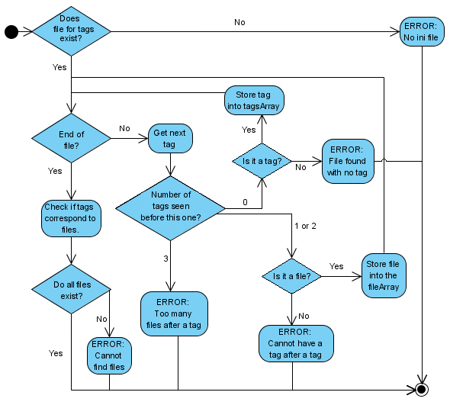
Figure 4.6 Tag loading activity sequence

In obtaining the next tag, it would have to detect if a new line character appears at all in the tag. This must be done during the verification of a tag of whether or not it is a tag or a file. If a new line character appears within a tag or file name, this would render it useless and thus would not actually allow the program to work properly. Or let the user see the tags easily. Because of this, if a new line character was found while looking at the next tag; the program would abort its operations and give an error message for the user before closing itself. There is also the problem of having a stray ‘<’, ‘>’ or “ which could create errors, so this would have to be taken care of as well.

Once the algorithm has gone through the entire file and storing all the tags and file, it will then search from local directory for the files which are needed. It will keep checking through all the files and if it can not find more than one of the files, it will open up a window showing all the files which are unavailable for the translation and this would prompt the user to either add the missing translation tables or to remove the tags. Screenshots of these errors windows are shown in chapter 5.1.

Text Translation
The code was designed to be event driven. This translates into the program that when the user edits the text in the field, an event is initiated which is then handled by a function that will then go through the entire text, separating sections of text in between the tags. Each text segment would be passed to an object with information about the tag that preceded it and about the direction of translation. This object that does the translation will then load up the table which corresponds to the tag and the direction of translation before passing the text through the translation code. A flowchart of the process is shown in figure 4.2.

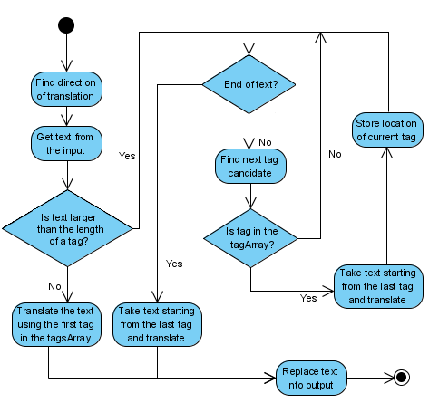
Figure 4.7 Text translation activity sequence

For simplicity, each time the text changes, the entire input text will be translated as text is entered into the text field. Thus, there is no need for a table to store the locations for the tags or any complex algorithm to keep track of these tags, which may go missing if the user decided to delete them manually in the text field.

Firstly, the algorithm would check the length of the text to be translated. If the algorithm finds that this length is smaller than the tag length limit, then it will translate the entire text using the first tag, which was loaded into the tag storage array.

However, if the length were greater than this tag length limit, then it would move to start finding the first tag. When finding a tag, the algorithm would search character by character in rapid succession to find a tag starter, designated as ‘<’. Once this found, then a search would occur to find the end of a tag within the limit set by the programmer. If the end of the tag is not found, designated as ‘>’ then the search loop would leave a flag unset causing the translation to not execute.

Translation Algorithm
This algorithm is activated when the text translation algorithm sends out information to translate text into either Braille or print. The translation tables would be changed first and then it would start splitting up the text into sizes which are small enough to fit into the translation array while keeping the end word intact, which is to be sent off to be translated from print to Braille or vice versa.

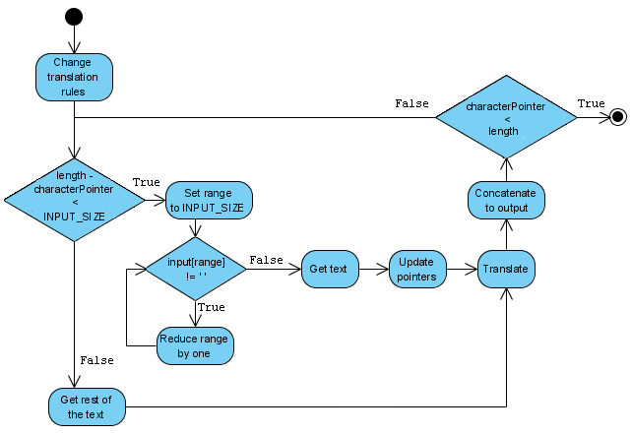
Figure 4.8 Translation activity sequence

Shannon Thrower (2005) established the algorithms for translation from print to Braille or vice versa for his thesis, “Grade 2 Braille-Print Translation on the OMAP Microprocessor” and the algorithm and code that supports the loading of the tables have been taken from his source code, which was provided with his thesis. No modification of the algorithm was required for translation with other tables.

Speech
The Cocoa API has particular classes which uses technologies available on the Mac OS X system which can both speak text which is passed to it and to also the recognize speech. For this project, the speak function from the NSSpeechSynthesizer class was used. The initialization process requires that a voice would be set to the voice that the user would have set on their computer.

Use Cases
The use case scenarios are an extension of the use case diagram, which was shown in chapter 3.2. These use cases will also help in creating the structural test cases which are discussed in chapter 5 as use cases describes how the systems responds to the users actions.

Cockburn’s template was used to create the use cases scenarios. This template was used because it allows an extension that allows the combination of many similar use cases into one. This is because the original use case scenario template lacked the capability for extensions, which are additional or alternative steps that are taken under pre-specified conditions (Cockburn, 2001). This meant that for the original template, each variation, no matter how small from the main scenario required its own scenario.

The use case scenarios are listed in appendix B except for the tag loading use case, which has already been covered in chapter 4.1.3.

Implementation

Coding Standard
Coding standards are a way of keeping the format of the code in a project in a simple and conforming way. This is so that the code produced can be read and understood later in the future and can be easily maintained when the need arises.

For the project, the Java Coding Standard was chosen as the standard to be used, which has been specified by the Department of Computing at Curtin University.

Implementation model
The implementation stage was following loosely on the Component-based development model, where a component is identified as been required, then creating the components if there is none available in the code libraries, then inserting the components into the system before verification. The full system of the component model also includes risk analysis before engineering the design and implementation and that would also includes customer evaluation and customer communication (Pressman, 2000). There was also version control with backups done at the end of each day where work was completed.

Each of the components, the GUI, the front end to the translation algorithm, the tag loading and the text translation were modular, meaning that they could be replaced with no changes to the rest of the software. This was done to increase maintainability and to allow the functions to be used with other software programs.

The interface was created first and then the background code was created. The background code had stubs placed for the translations so that the code could be verified to be detecting the tags correctly.

There was some difficulty in getting the NSMutableArray to initialize and with some research, the answer was found on a developers web forum, (CocoaDev: NSMutableArray, 2006) where the variable has to allocated first, then initialized before it could be used.

UML Class Diagrams
UML class diagrams are for modeling the systems classes, the attributes and their relationships between the classes. These classes are what are to be seen in the code structures of the program would be.

Figure 4.4 shows the UML class diagrams for the implementation of the software package.

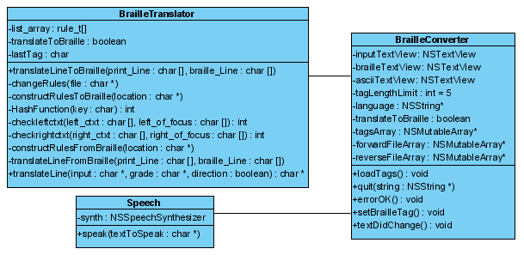
Figure 4.9 Final Class Diagram

The above class diagram has the program split into three main parts, the BrailleConverter, the BrailleTranslator, and the Speech classes.

The BrailleConverter class was designed to be the GUI section of the program, as well as the tag loading area as well as the majority of the text translation algorithm, except for Shannon Thrower’s print to Braille and Braille to print algorithm which is in the BrailleTranslator class.

In the textDidChange function, there were pointers which would be set after the system discovers if the translation direction if from print to Braille or vice versa. These pointers would include two pointers for the text field for print and the text field for Braille. The input and output pointer values would depend on which one has been currently selected as the input text field and which one is the output text field. This decision for this was to reduce the duplication of code segments and to also to reduce the complexity of the code so that it made maintenance easier, with only one main section of code to maintain, than having two separate, but nearly identical code segments.

The BrailleTranslator class is where this translation will occur. This area consists of the heart of the program, with the table loading and translation functions. There is function which is the public function which all other classes which want to use the translation algorithms uses. This public function which all other classes interact with is the translateLine function which requires the parameters of the line to translate, the grade and the direction of translation. This function will call the other functions to change the table and translate the text.

The Speech class was split apart from the other two classes so that in the future, it could be replaced by a NULL class if speech was to be disabled or be changed to suit another platform.

Creation of the GUI
The interface shown in Figure 4.5 was created using the Interface Builder which was provided with Xcode. This was a simple process of laying out the text fields and the drop down menu on a window and then creating the classes which would be used to interact with the GUI. There were also several things which needed to be selected, such as the ASCII text field which was made so that it could not be edited, but was able to be selected, which limited editing to both the print and the Braille text fields. Also, the drop down menu was designed so that it was replaced when the translation tags from the tag table were loaded into memory.

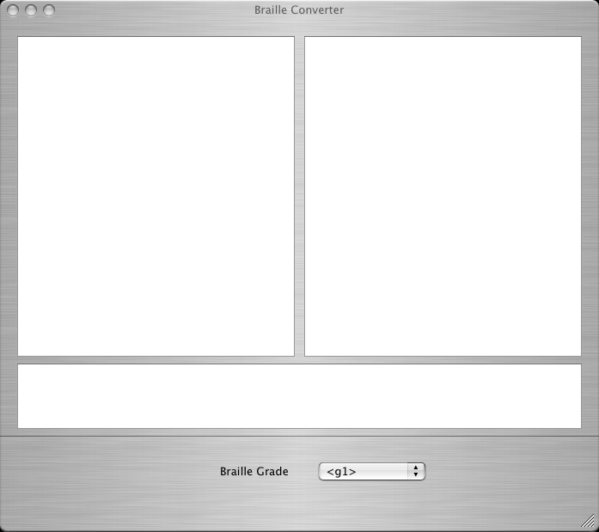
Figure 4.10 Final Program Interface

Braille Tables
Four extra tables were created for the software package. These tables were English to Braille grade 1, Braille to English grade 1, English to Braille grade 0 and Braille to English grade 0.

The tables were created by using the method of having each print character and having it transformed into a form which is in ASCI Braille. The English to Braille grade 2 and Braille to English grade 2 tables were already provided with Shannon Thrower’s project.

Verification and Results

Structural testing
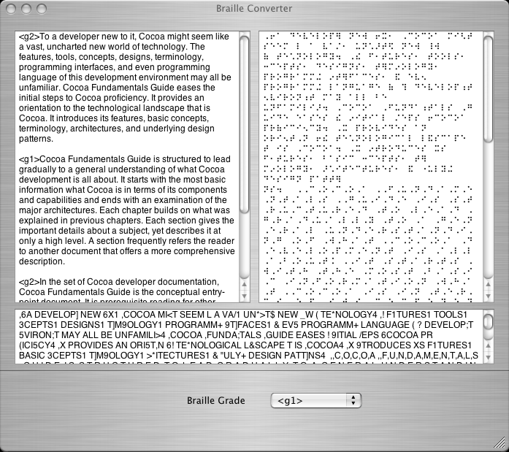
Figure 5.11 Sample output from the program

Test cases where designed to be used from the structural testing procedure (Sommerville, 2004) which is an approach to test case design where the tests are derived from knowledge of the software’s structure and implementation.

In using the use case scenarios, test cases were created for the verification of the system. The following were a checklist of items which needed to be verified.
- Inserts a tag into a text field at the cursor when a new one is chosen.
- Checks for the tags to be loaded in properly.
- Check for swap in translation direction.
- Translation actually is reflected correctly in the Braille, print and ASCII text fields. That is, if text is typed into the print text field, then the translation will appear in both the Braille and ASCII fields.
- The translation algorithm doesn’t eat characters with the limitation of the arrays (tested by reducing the input array size to 64 and then inputting more than 64 characters before looking at the output to see if any characters (including spaces) are missing.
The simple process of opening the program up and testing each point verified the above list. Figure 5.1 has proved points 2, 3, 4 and 5 from the above list. The text in the print text field was pasted from a section from the Cocoa API web site. Point 1 was verified by inserting an actual tag and the result of this can be seen in Figure 5.1.

While checking the tags in the ‘tag_table.ini’ table for correct format and then storing it into the arrays could also result in incorrect files loading causing the program to abort. Otherwise, the program will be ready to accept data in either of the print or Braille text fields. The following six screenshots shows the different errors that the tag loading section can produce when an error occurs, with the following table showing the tag table file.
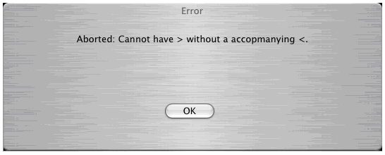
Figure 5.12 Error window showing an incomplete tag error

<g1> > "English to Braille lvl 1.txt" "Braille to English lvl 1.txt"
<g2> "English to Braille lvl 2.txt" "Braille to English lvl 2.txt"
Table 5-4 Content of tag_table.ini for an incomplete tag error

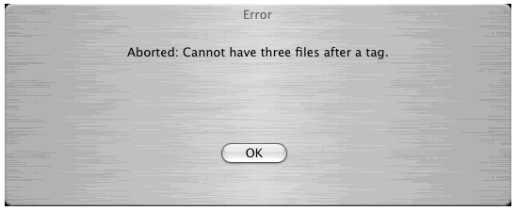
Figure 5.13 Error window showing that extra files are present for a tag

<g1> "English to Braille lvl 1.txt" "Braille to English lvl 1.txt" "File lvl 1.txt"
<g2> "English to Braille lvl 2.txt" "Braille to English lvl 2.txt"
Table 5-5 Content of tag_table.ini for extra files for a tag

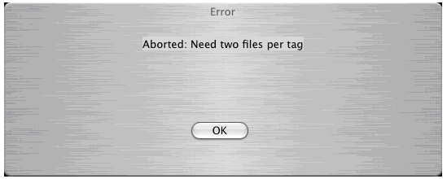
Figure 5.14 Error window showing that two files are needed after a tag

<g1> "English to Braille lvl 1.txt" "Braille to English lvl 1.txt”
<g2> "English to Braille lvl 2.txt"
Table 5-6 Content of tag_table.ini for missing file names

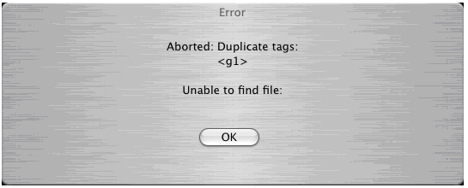
Figure 5.15 Error window showing that duplicate tags are present

<g1> "English to Braille lvl 1.txt" "Braille to English lvl 1.txt”
<g1> "English to Braille lvl 2.txt" "Braille to English lvl 2.txt"
Table 5-7 Content of tag_table.ini for an duplicate tags

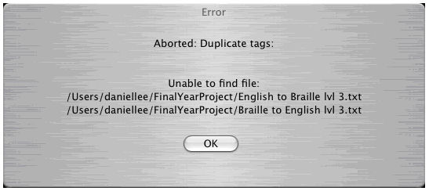
Figure 5.16 Error window showing the files which are missing

<g1> "English to Braille lvl 1.txt" "Braille to English lvl 1.txt”
<g2> "English to Braille lvl 2.txt" "Braille to English lvl 2.txt"
<g3> "English to Braille lvl 3.txt" "Braille to English lvl 3.txt”
Table 5-8 Content of tag_table.ini for an files which are missing
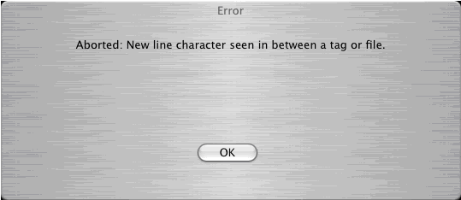
Figure 5.17 Error window showing that a tag or file has a new line character

<g2> "En
glish to Braille lvl 2.txt" "Braille to English lvl 2.txt"
Table 5-9 Content of tag_table.ini for a new line in a tag

Table Verification
As the program is designed to translate using tables, then the accuracy of the translation is effectively the accuracy of the rules in the tables that have been written.

The grade 2 print to Braille and Braille to print tables has been shown in Shannon Thrower’s thesis to give an accuracy of about 97%. This accuracy is not 100% because of the intricacies of the translation rules, rules with exceptions such as the one shown in chapter 2 and that there is a loss of information in translation to grade 2 Braille.

With grade 1, 100% accuracy is observed with translation of text from Braille to Print. This was confirmed by comparing each character and also the capitalized word and number combinations to a chart which shows the grade 1 Braille. This can be done because grade 1 Braille has simple rules with print characters just being mapped into Braille. There are no contraction rules at all and this makes verification of the table to be done by character comparisons.

The grade 0 table gave trouble with as it gave bad memory access errors and this has given been some trouble in the full implementation. Re-constructing this table would be something that can be worked on in the future so that print can be translated into Computer Braille.

Recommendations and Conclusions

Concluding Remarks
A program fulfilling the requirements was created. A more fully functioning program would be recommended to be created as a fully functioning program would help both the blind and those without sight problems may be able to create documents for each other. The program would also help in encouraging more people to use Braille as it allows a larger scope of texts to be translated and would help in spreading the use of Braille due to the ease of use of such a program with multiple grade and language translations in a document.

Through software engineering principles and practices, design of the system and implementation of the system kept the design simple and which made it easy to verify that the code was implemented properly through the walk through of the use cases.

A number of problems were encountered in creating the tables, which caused delays in testing them and thus has prevented some of the other minor functions to be implemented. In addition, more problems were encountered in the verification of the grade 0 table, however, this can be resolved in the future.

However, a successful translation program was created which the Human Interface group from Apple had agreed to the system interface (Murray, 2005), which gives the software package some approval from a research group.

Considerations for Future Development
There are several possibilities for future development with this software package as the software is not fully developed with only the core fully completed.

There is the need to save files and then to load text from files. This possibility would make the text files dependant on the translation tables, except for the Braille file, which would be independent from this translation table and can be taken from the Braille file, have a Braille font applied to it and then sent out to a printer or embosser.

A function for printing out to an embosser would also be useful, however, this is a minor function with operating systems using drivers for printers and a driver could be created for the embosser.

There is also the refinement of continuous translation, where tag tracking could be implemented, to make sure that when an editing event occurs, the program would be able to detect which text segment the editing is occurring. Then it would retrieve the tag for that segment before translating just that segment before replacing the text segment that corresponds on the other text field. Last, it would update the pointers to the tags and the text segment limits.

The Human Interface group from Apple also mentioned about the separation of language and grade for the tags (Murray, 2005). This would be so that the user could have many grade tags within a language tag set allowing the user to change the grade tags with ease.

The grade 0 translation table as was mentioned in chapter 6.1 gave problems in the verification stage. However, this feature would be best to be implemented to give as wide a choice of Braille grades in translations.

A future program could include speech recognition to give the ability for the blind to speak commands into the program for use in giving commands to the computer and for adding in text into the system, allowing keyless use of the program that would be a good feature to have. This would allow the blind to dispense with using the keyboard and be able to create documents more rapidly.

References

- American Foundation for the Blind. Braille - American Foundation for the Blind, Accessed March, 2006 from http://www.afb.org/braille.asp

- American Foundation for the Blind. What is Braille? - American Foundation for the Blind, Accessed February 2006, from http://www.afb.org/Section.asp?SectionID=6&TopicID=199

- Apple Computers. Developer Connection - Cocoa Guides, Accessed March to July 2006 from http://developer.apple.com/documentation/Cocoa/index.html

- Apple Computers. Developer Connection - Cocoa Reference, Accessed January to August 2006 from http://developer.apple.com/reference/Cocoa/index.html

- Borck, M., Ivins, J., VonKonsky, B. 2002 Java Coding Standard, Curtin University of Technology - Department Of Computing, Accessed March 2006 from http://www.computing.edu.au/java.shtml

- Cockburn, A. 2001, Writing Effective Use Cases, Addison-Wesley.

- CocoaDev. CocoaDev: NSMutableArray, Accessed May 2006 from http://www.cocoadev.com/index.pl?NSMutableArray

- Duxbury Systems Inc. Duxbury Products - Duxbury Braille Translator, May 16, 2006, Accessed June 2006 from http://www.duxburysystems.com/dbt.asp

- International Braille Research Center, International Braille Research Center (IBRC), Accessed June 2006 from http://www.braille.org/

- King, A. 2001, Text and Braille Computer Translation, University of Manchester Isnstitute of Science and Technology.

- Lewis, D. VisionTechnology:Braille, Statewide Vision Resource Centre, September 2005, Accessed June 2006 from http://www.visiontech.svrc.vic.edu.au/brailleaccess.htm

- Murray I. 2006, Personal communication

- National Federation of the Blind. NFB – NFBTRANS, Accessed March, 2006 from http://www.nfb.org/nfb/nfbtrans.asp?SnID=31041476

- O’Reilly. Learning Cocoa with Objective-C, 2nd Edition, Davidson and Apple Computer Inc, 2002.

- Page-Jones, M. 2000, Fundamentals of Object oriented Design in UML, Addison-Wesley.

- Pressman, R. S. Software Engineering – A Practitioner’s Approach, 5th Edition, McGraw Hill, 2000

- Sablé, S. libbraile – Library for Braille Display, Accessed March, 2006 from http://libbraille.org/

- Sommerville, I. Software Engineering, 7th Edition, cap. 23, p. 557, Addison Wesley

- Sullivan, J. 2006, Duxbury Systems - Early History of Braille Translators and embossers,, Accessed March 2006 from http://www.duxburysystems.com/bthist.asp

- Thrower, S. 2005, Grade 2 Braille-Print Translation on the OMAP Microprocessor, Undergraduate thesis, Curtin University of Technology

- Wikipedia, Braille - Wikipedia, the free encyclopedia, Accessed February 2006 from http://en.wikipedia.org/wiki/Braille

- Wikipedia, Braille ASCII - Wikipedia, the free encyclopedia, Accessed April, 2006 from http://en.wikipedia.org/wiki/Braille_ASCII

- Wikipedia, Louis Braille - Wikipedia, the free encyclopedia, Accessed March, 2006 from http://en.wikipedia.org/wiki/Louis_Braille
- Wikipedia, Night writing - Wikipedia, the free encyclopedia, Accessed March 2006 from http://en.wikipedia.org/wiki/Night_writing

- Wikipedia, Use Case - Wikipedia, the free encyclopedia, Accessed September 2006 from http://en.wikipedia.org/wiki/Use_case

Appendix A – Project Plan

The following two figures show the planned and actual project schedules. The main reason for deviations from the planed timeline resulted from difficulties arising from learning and using Objective C.

Several events happened over the period of the project execution.
It was found that learning Cocoa and Objective-C took a lot longer to learn initially and even then it was not a complete learning process with frequent accesses to the Coca Foundation Library. The entire programming over the semester was comprised of small iterative steps; requirements, design, programming, testing. The project no longer followed the waterfall model as was stated in the original project plan. Also, there was a requirements change at 15th March which added a language extension, meaning that the input can be from another language. There was another requirements change on 17th May to introduce user extensibility of tags and the user not needing to be explicit about which direction the translation was being done. This means removing several features from the program and to edit the background code to allow the tag to be searched within the table, which stores the tags.

Planned Timeline
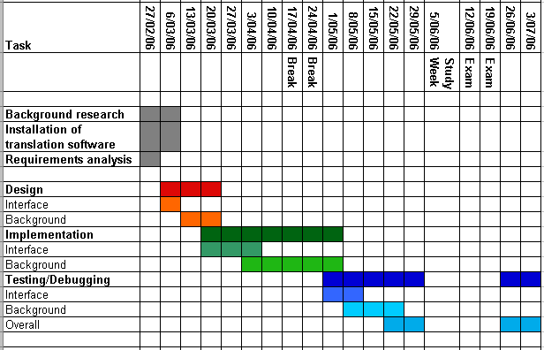
Actual Timeline (And proposed from June onwards)
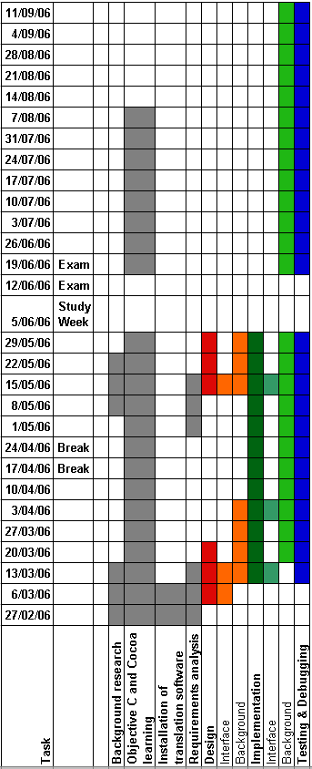

Appendix B – Use Cases

Appendix B.1 – loadBrailleTags
Use Case name: loadBrailleTags
Characteristic Information
– Goal in Context: To insert a Braille tag into the input
Pre-Conditions: Nil
Primary Actor: Nil
Main Success Scenario Steps:
- Use case begins when the program is initialized.
- The system will open a file, which will contain all the tags and the files.
- The system then looks for the first tag in the system
- The system will then add the names of the files for the tags and inserts them into two arrays, one for storing the forward translation and another one for backwards translation.
- The system will repeat steps 3 and 4 until there are no more tags to be found. The use case ends when the end of the file has been reached.
Extensions:
3. a. The system finds a file name instead of a tag. The use case ends when an error message is displayed.
b. The system cannot find the end of the tag. The use case ends when an error message is displayed.
4. a. The system finds a tag after one file. The use case ends when an error message is displayed.
b. The system finds a tag after the initial tag. The use case ends when an error message is displayed.
c. The system cannot find the end of a file tag. The use case ends when an error message is displayed.

Appendix B.2 – insertBrailleTag
Use Case name: insertBrailleTag
Characteristic Information
– Goal in Context: To insert a Braille tag into the input
Pre-Conditions: Nil
Primary Actor: User
Main Success Scenario Steps:
- Use case begins when the use clicks on the combo box and selects a grade tag.
- The system locates where the text cursor is at and which input text field it is currently in.
- The system then updates the text field so that a tag corresponding to the selection is inserted at the location of the cursor in the input box.
- The use case ends when the system tells the user that the grade has been changed.
Extensions:

Appendix B.3 – editText
Use Case name: editText
Characteristic Information
– Goal in Context: To update the output field when the input changes
Pre-Conditions: Nil
Primary Actor: User
Main Success Scenario Steps:
- The use case begins when the user starts to type into an input text field or pastes text into it.
- The system will then find which box the user is typing or pasting text into.
- The system will initialize the location of the last tag to the front of the field.
- The system will then search through the text and find a candidate for a tag.
- The system will then search a tag array for a match.
- The system will then take the text from the location of the last tag to the current tag and translate the text using the last value.
- The system will then concatenate the return string to a temporary storage string.
- The system when the system stores the location of the tag and the value.
- The system will then repeat steps 4 to 8 until it reaches the end of the text in the input text field.
- The use case ends when the system puts the temporary storage string into the output text field and also copies the text from the Braille text field and puts it into the ASCII text field
Extensions:
5. a. The system find no match and the use case will go to step 4.

Appendix B.4 – load
Use Case name: load
Characteristic Information
– Goal in Context: To load info from a file
Pre-Conditions: Nil
Primary Actor:
Main Success Scenario Steps:
- The use case begins when the user clicks on or uses a key combo to load a file.
- The system will then display an open panel to ask which file to be opened.
- The user will then select a file
- The system will test the file to see if it can be opened.
- The system finds that the file can be opened and the use case ends when the data has been loaded and the display updated.
Extensions:
4. a. The system finds that the file is cannot be opened and the use case ends when the systems displays a rejection window to tell the user that the file is not of the type that is required.

Appendix B.5 – print
Use Case name: print
Characteristic Information
– Goal in Context: print the Braille text
Pre-Conditions: Nil
Primary Actor: User
Main Success Scenario Steps:
- The use case begins when the user selects the print function from the menu.
- The system will ask the user for the settings before it prints.
- The system will then print the document according to the settings
Extensions:

Appendix B.6 – save
Use Case name: save
Characteristic Information
– Goal in Context: To save the workbench
Pre-Conditions: Nil
Primary Actor: User
Main Success Scenario Steps:
- The use case starts when the user selects save from the menu
- The system responds by asking the user for the name of the document if it has not got a name
- The user then chooses a name
- The system accumulates the text and the use case ends when the data is saved to a file
Extensions:

Appendix C – Computer Braille
ASCII  Value | ASCII Character | Braille  Character | Binary Representation
ASCII  Value | ASCII Character | Braille  Character | D6 | D5 | D4 | D3 | D2 | D1
32 | (space) |  | 0 | 0 | 0 | 0 | 0 | 0
33 | ! | ! | 1 | 0 | 1 | 1 | 1 | 0
34 | “ | " | 0 | 1 | 0 | 0 | 0 | 0
35 | # | # | 1 | 1 | 1 | 1 | 0 | 0
36 | $ | $ | 1 | 0 | 1 | 0 | 1 | 1
37 | % | % | 1 | 0 | 1 | 0 | 0 | 1
38 | & | & | 1 | 0 | 1 | 1 | 1 | 1
39 | ‘ | ' | 0 | 0 | 0 | 1 | 0 | 0
40 | ( | ( | 1 | 1 | 0 | 1 | 1 | 1
41 | ) | ) | 1 | 1 | 1 | 1 | 1 | 0
42 | * | * | 1 | 0 | 0 | 0 | 0 | 1
43 | + | + | 1 | 0 | 1 | 1 | 0 | 0
44 | , | , | 1 | 0 | 0 | 0 | 0 | 0
45 | - | - | 1 | 0 | 0 | 1 | 0 | 0
46 | . | . | 1 | 0 | 1 | 0 | 0 | 0
47 | / | / | 0 | 0 | 1 | 1 | 0 | 0
48 | 0 | 0 | 1 | 1 | 0 | 1 | 0 | 0
49 | 1 | 1 | 0 | 0 | 0 | 0 | 1 | 0
50 | 2 | 2 | 0 | 0 | 0 | 1 | 1 | 0
51 | 3 | 3 | 0 | 1 | 0 | 0 | 1 | 0
52 | 4 | 4 | 1 | 1 | 0 | 0 | 1 | 0
53 | 5 | 5 | 1 | 0 | 0 | 0 | 1 | 0
54 | 6 | 6 | 0 | 1 | 0 | 1 | 1 | 0
55 | 7 | 7 | 1 | 1 | 0 | 1 | 1 | 0
56 | 8 | 8 | 1 | 0 | 0 | 1 | 1 | 0
57 | 9 | 9 | 0 | 1 | 0 | 1 | 0 | 0
58 | : | : | 1 | 1 | 0 | 0 | 0 | 1
59 | ; | ; | 1 | 1 | 0 | 0 | 0 | 0
60 | < | < | 1 | 0 | 0 | 0 | 1 | 1
61 | = | = | 1 | 1 | 1 | 1 | 1 | 1
62 | > | > | 0 | 1 | 1 | 1 | 0 | 0
63 | ? | ? | 1 | 1 | 1 | 0 | 0 | 1
64 | @ | @ | 0 | 0 | 1 | 0 | 0 | 0
65 | A | A | 0 | 0 | 0 | 0 | 0 | 1
66 | B | B | 1 | 0 | 0 | 0 | 1 | 1
67 | C | C | 0 | 0 | 1 | 0 | 0 | 1
68 | D | D | 0 | 1 | 1 | 0 | 0 | 1
69 | E | E | 0 | 1 | 0 | 0 | 0 | 1
70 | F | F | 0 | 0 | 1 | 0 | 1 | 1
71 | G | G | 0 | 1 | 1 | 0 | 1 | 1
72 | H | H | 0 | 1 | 0 | 0 | 1 | 1
73 | I | I | 0 | 0 | 1 | 0 | 1 | 0
74 | J | J | 0 | 1 | 1 | 0 | 1 | 0
75 | K | K | 0 | 0 | 0 | 1 | 0 | 1
76 | L | L | 0 | 0 | 0 | 1 | 1 | 1
77 | M | M | 0 | 0 | 1 | 1 | 0 | 1
78 | N | N | 0 | 1 | 1 | 1 | 0 | 1
79 | O | O | 0 | 1 | 0 | 1 | 0 | 1
80 | P | P | 0 | 0 | 1 | 1 | 1 | 1
81 | Q | Q | 0 | 1 | 1 | 1 | 1 | 1
82 | R | R | 0 | 1 | 0 | 1 | 1 | 1
83 | S | S | 0 | 0 | 1 | 1 | 1 | 0
84 | T | T | 0 | 1 | 1 | 1 | 1 | 0
85 | U | U | 1 | 0 | 0 | 1 | 0 | 1
86 | V | V | 1 | 0 | 0 | 1 | 1 | 1
87 | X | X | 1 | 1 | 1 | 0 | 1 | 0
88 | X | X | 1 | 0 | 1 | 1 | 0 | 1
89 | Y | Y | 1 | 1 | 1 | 1 | 0 | 1
90 | Z | Z | 1 | 1 | 0 | 1 | 0 | 1
91 | [ | [ | 1 | 0 | 1 | 0 | 1 | 0
92 | \ | \ | 1 | 1 | 0 | 0 | 1 | 1
93 | ] | ] | 1 | 1 | 1 | 0 | 1 | 1
94 | ^ | ^ | 0 | 1 | 1 | 0 | 0 | 0
95 | _ | _ | 1 | 1 | 1 | 0 | 0 | 0

Appendix D – Source code

Appendix D.1 – BrailleConverter.h

// FILE: BrailleConverter.h
// AUTHOR: Daniel Lee
// PURPOSE:
// REFERENCE: None.
// COMMENTS:
// REQUIRES: BrailleTranslator.h, Speech.h, TranslationConfig.h
// Last Mod: 16-08-2006

#import <Cocoa/Cocoa.h>
#import <Foundation/NSString.h>
#import <AppKit/NSNibLoading.h>
#import "BrailleTranslator.h"
#import "Speech.h"

@interface BrailleConverter : NSObject
{
IBOutlet id brailleMenu;

IBOutlet NSTextView *inputTextView;
IBOutlet NSTextView *brailleTextView;
IBOutlet NSTextView *asciiTextView;

IBOutlet Speech *speechObject;
IBOutlet BrailleTranslator *translatorObject;

IBOutlet NSTextField *errorMessage;
IBOutlet NSWindow *errorWindow;
IBOutlet NSWindow *mainWindow;
}

NSString * const tagTable = @"/Users/daniellee/FinalYearProject/tag_table.ini";
int const TAG_LENGTH_LIMIT = 5;
NSString * const TAG_LENGTH_LIMITName = @"5";
BOOL oldDirection; // To stop the speech from occuring at each keystroke

NSString *language;
BOOL translateToBraille;
NSMutableArray *tagsArray;
NSMutableArray *forwardFileArray;
NSMutableArray *reverseFileArray;

- (void) loadTags;
- (void) quit: (NSString *) string;
- (IBAction) setBrailleTag: (id) sender;
- (IBAction) errorOK: (id) sender;

- (void) textDidChange: (NSNotification *) aNotification;
- (NSString *) textTranslation: (NSString *) stringToCheckTags;
//- (void) textViewDidChangeSelection: (NSNotification *) aNotification;

@end

Appendix D.2 – BrailleConverter.m

// FILE: BrailleConverter.m
// AUTHOR: Daniel Lee
// PURPOSE:
// REFERENCE: None.
// COMMENTS: Required that the Braille Font is installed, or the program will not function
// REQUIRES: BrailleConverter.h
// Last Mod: 16-08-2006

#import "BrailleConverter.h"

@implementation BrailleConverter

// NAME: awakefromNib
// PURPOSE: To initilise the view for use
// IMPORTS: nil
// EXPORTS: nil
// AUTHOR: Daniel Lee
// REMARKS: Should be called after the object is started
// LAST MODIFIED: 31-07-2006

- (void) awakeFromNib
{

// *******************
// Initialise the data
// *******************

oldDirection = TRUE;
translateToBraille = TRUE;

// Build up the language list and to set it to the interface so that
// language switching is possible
// Also, should be set to the current language of the system

// Set the boxes to set the delegate to this object
[inputTextView setDelegate: self];
[brailleTextView setDelegate: self];
// asciiTextView does not needs a delegate since only braille is being sent there
// There is no input that is allowed to be placed in that box

// Set the font of the asciiTextView and brailleTextView to Braille
NSFont* braille = [NSFont fontWithName: @"Braille" size: 0.0];
[brailleTextView setFont: braille];

// create the tags
[self loadTags];
//
// Build the tags into the systembrailleMenu
//
[brailleMenu removeAllItems];
[brailleMenu addItemsWithTitles: tagsArray];

return;
}

// NAME: loadTags
// PURPOSE: To read the ini file and create the tags
// IMPORTS: nil
// EXPORTS: nil
// AUTHOR: Daniel Lee
// REMARKS: None
// LAST MODIFIED: 27-07-2006

- (void) loadTags
{
NSFileManager *fileManager = [NSFileManager defaultManager];
NSData *dataFromFile;
tagsArray = [[NSMutableArray alloc] init];
forwardFileArray = [[NSMutableArray alloc] init];
reverseFileArray = [[NSMutableArray alloc] init];
BOOL tags = FALSE;
BOOL file = FALSE;
int numberOfFiles = 2;

if( [fileManager fileExistsAtPath: tagTable] )
{
dataFromFile = [fileManager contentsAtPath: tagTable];
NSString *stringData = [NSString stringWithCString: (const char*) [dataFromFile bytes] encoding: NSASCIIStringEncoding];

NSRange range;
int tagLocation = 0;
int fileLocation = 0;

int i;

// Parsing the tags
for( i = 0; i < [stringData length]; i++ )
{
if( [stringData characterAtIndex: i] == '<' )
{
// Check to see if there is any tags open already
// or if there is shortage of files following a tag
if( tags )
{
[self quit: @"Cannot have < in a tag."];
}
else if( file )
{
[self quit: @"Cannot have < in a file."];
}
else if( numberOfFiles < 2 )
{
[self quit: @"Need two files per tag"];
}
else
{
tags = TRUE;
tagLocation = i;
numberOfFiles = 0;
}
}
else if( [stringData characterAtIndex: i] == '>' )
{
// No need to check lastItem_Tag.
// If there is no '<' found first, it is still an abort
if( file )
{
[self quit: @"Cannot have > in a file."];
}
else if( !tags )
{
[self quit: @"Cannot have > without a accopmanying <."];
}
else
{
tags = FALSE;
range.location = tagLocation;
range.length = i - tagLocation + 1;

// There is a limit of how large the tag is
if( range.length > TAG_LENGTH_LIMIT )
{
NSString *error = @"Length of the tag is too long. Limit is ";
error = [error stringByAppendingString: TAG_LENGTH_LIMITName];
[self quit: error];
}

NSString* tagData = [stringData substringWithRange: range];
// NSLog( tagData );
[tagsArray addObject: tagData];
}
}
else if( [stringData characterAtIndex: i] == '\"' )
{
// Should check is the tag is still set
// No quotation marks in the tags at all

// If there is a tag, then abort using a window

if( tags )
{
[self quit: @"\" found between a tag."];
}
else if( numberOfFiles == 2 ) // Three files after a tag?
{
[self quit: @"Cannot have three files after a tag."];
}
else if( numberOfFiles == 1 )
{
if( file ) // If the file tag is set then assume end of file
{
file = FALSE;
numberOfFiles = 2;
range.location = fileLocation + 1;
range.length = i - fileLocation - 1;
NSString* fileName = [stringData substringWithRange: range];
// NSLog( fileName );
[reverseFileArray addObject: fileName];
}
else
{
file = TRUE;
fileLocation = i;
}
}
else // first file after tag?
{
// If lastItem_Tag and file are false
// Then the last item was a file and this is
// a new file. Violates the pair

if( file ) // If the file tag is set
{
file = FALSE;
numberOfFiles = 1;
range.location = fileLocation + 1;
range.length = i - fileLocation - 1;
NSString* fileName = [stringData substringWithRange: range];

[forwardFileArray addObject: fileName];
}
else
{
file = TRUE;
fileLocation = i;
}
}
}
else if( ( [stringData characterAtIndex: i] == '\r' )
|| ( [stringData characterAtIndex: i] == '\n' ) )
{
// If there is a dangling tag or file name.
if( file || tags )
{
[self quit: @"New line character seen in between a tag or file."];
}
}
}
}
else
{
// Need to make a window for a missing file
NSString *iniError = @"No ini file found at";
iniError = [iniError stringByAppendingString: tagTable];
[self quit: iniError];
}

//
// Check end conditions
//
if( tags )
{
[self quit: @"Lone tag"];
}
else if( numberOfFiles < 2 ) // No lone tag, but not enough files?
{
[self quit: @"Need two files per tag"];
}

// Check to see if the files exist
int i;
BOOL filePass = TRUE;
NSString *failFileString = @"Unable to find file:\n";

// Checking through the forward file array for file existance
for( i = 0; i < [forwardFileArray count]; i++ )
{
NSString *fileName = (NSString *) [forwardFileArray objectAtIndex: i];
fileName = [tempName stringByAppendingString: fileName];

// If a file is not present, mark it on an error string and keep going
if( ![fileManager fileExistsAtPath: fileName] )
{
filePass = FALSE;
fileName = [fileName stringByAppendingString: @"\n"];
failFileString = [failFileString stringByAppendingString: fileName];
}
}

// Checking through the forward file array for file existance
for( i = 0; i < [reverseFileArray count]; i++ )
{
NSString *fileName = (NSString *) [reverseFileArray objectAtIndex: i];
fileName = [tempName stringByAppendingString: fileName];

// If a file is not present, mark it on an error string and keep going
if( ![fileManager fileExistsAtPath: fileName] )
{
filePass = FALSE;
fileName = [fileName stringByAppendingString: @"\n"];
failFileString = [failFileString stringByAppendingString: fileName];
}
}

// To give spacing between error sections
failFileString = [failFileString stringByAppendingString: @"\n"];

// Checking for tag duplicates
BOOL duplicates = FALSE;
NSString *duplicateTagString = @"Duplicate tags:\n";
i = 0; // Reusing variable

while( i < [tagsArray count] )
{
NSString * stringI = (NSString *) [tagsArray objectAtIndex: i];
NSString * stringJ;
int j;
for( j = i + 1; j < [tagsArray count]; j++ )
{
stringJ = (NSString *) [tagsArray objectAtIndex: j];
if( [stringI isEqualToString: stringJ] )
{
duplicates = TRUE;
duplicateTagString = [duplicateTagString stringByAppendingString: stringJ];
}
}
i++;
}

duplicateTagString = [duplicateTagString stringByAppendingString: @"\n\n"];
if( !filePass || duplicates )
{
duplicateTagString = [duplicateTagString stringByAppendingString: failFileString];
[self quit: duplicateTagString];
}

// Print tagsArray
int j;
for( j = 0; j < [tagsArray count]; j++ )
{
NSLog( @"Tag table: %@", [tagsArray objectAtIndex: j]);
}

}

// NAME: quit
// PURPOSE: If there is a problem, esp with loading tags, exit the program
// IMPORTS: nil
// EXPORTS: nil
// AUTHOR: Daniel Lee
// REMARKS: The window mainWindow may need to be changed so that the performClose
// is not required and can stay in the system while he error message is
// shown.
// LAST MODIFIED: 31-05-2006

- (void) quit: (NSString *) string
{
NSString *error = @"Aborted: ";
error = [error stringByAppendingString: string];
// NSLog( error );

[errorMessage setTitleWithMnemonic: error];
[mainWindow performClose: self];
[errorWindow makeKeyAndOrderFront: self];
}

// NAME: setBrailleTag
// PURPOSE: To get the value and insert a tag.
// IMPORTS: nil
// EXPORTS: nil
// AUTHOR: Daniel Lee
// REMARKS: None
// LAST MODIFIED: 01-06-2006

- (IBAction) setBrailleTag: (id) sender
{
NSString* data = [brailleMenu titleOfSelectedItem];
NSString* speakingText;
NSTextView *input, *output;
int locationOfCursor = 0;

// Set the input and output variables to the respective ones which are to be used
// This is done because the code is very similar on a lot of places and that the
// program should be a s compact as possible.

if( translateToBraille )
{
input = inputTextView;
output = brailleTextView;
}
else
{
input = brailleTextView;
output = inputTextView;
}

locationOfCursor = [input selectedRange].location;
[input insertText: data];
speakingText = @"Tag inserted.";
speakingText = [speakingText stringByAppendingString: data];

// Output which grade had been changed
if( ![speakingText isEqualToString: @""] )
{
[speechObject speak:speakingText];
}
}

// NAME: errorOK
// PURPOSE: User presses OK on the error window. Shut down program
// IMPORTS: id
// EXPORTS: nil
// AUTHOR: Daniel Lee
// REMARKS:
// LAST MODIFIED: 31-05-2006

- (IBAction) errorOK: (id) sender;
{
exit(0);
}

// NAME: textDidChange
// PURPOSE: Called when the interface detects a change to the text at input
// IMPORTS: NSNotification
// EXPORTS: nil
// AUTHOR: Daniel Lee
// REMARKS: This function does set the direction of translation so if this event
// driven function is not used, it is best that the direction be set.
// LAST MODIFIED: 13-08-2006

- (void) textDidChange: (NSNotification *) aNotification
{

NSTextView *input, *output;
NSString* translatedOutput;

// Set the input and output variables to the respective ones which are to be used
// This is done because the code is very similar on a lot of places and that the
// program should be as compact as possible.

// if the notification is coming from the inputTextView then it is the box to take
// text from and modify
if( [aNotification object] == inputTextView )
{
input = inputTextView;
output = brailleTextView;
translateToBraille = TRUE;

if( oldDirection != TRUE )
{
oldDirection = TRUE;
[speechObject speak: @"Translation changed from print to braille."];
}
}
else
{
input = brailleTextView;
output = inputTextView;
translateToBraille = FALSE;

if( oldDirection != FALSE )
{
oldDirection = FALSE;
[speechObject speak: @"Translation changed from bralle to print."];
}
}

NSTextStorage* textInputString = [input textStorage];
NSMutableAttributedString* copiedString = ( NSMutableAttributedString* ) [textInputString mutableCopy];
NSString* stringToCheckTags = [copiedString string];
//NSLog( @"Data to convert: %@", stringToCheckTags );

translatedOutput = [self textTranslation: stringToCheckTags]; // Translation starts here

// Output to braille and ascii
[output setString: translatedOutput];
// NSLog( @"Output string: %@", translatedOutput);

textInputString = [brailleTextView textStorage];
copiedString = ( NSMutableAttributedString* ) [textInputString mutableCopy];
[asciiTextView setString: [copiedString string] ];

}

// NAME: textTranslation
// PURPOSE: A delegate function to do the translation when the text is edited
// IMPORTS: NSString
// EXPORTS: NSString
// AUTHOR: Daniel Lee
// REMARKS: If there is no tag at the start of the text, then the first tag is assumed to be used.
// This function is also heavily dependant on a particular table, so if the tags are not
// in the tag_table.ini file, then it will be assumed that it is to be translated.
// LAST MODIFIED: 16-08-2006

- (NSString *) textTranslation: (NSString *) stringToCheckTags
{

// Stripping tags,
// Firstly, check the entire code and then convert sections
unsigned int i = 0;
unsigned int last_Tag_Location = 0;
unsigned int current_Tag_Location = 0;
NSString* outputString = @"";
NSString* lastBrailleTag;
NSRange range;
BOOL matchEndOfTag = FALSE;
BOOL matchTable = FALSE;

if( translateToBraille )
{
lastBrailleTag = [forwardFileArray objectAtIndex: 0]; // Take rule from first spot
}
else
{
lastBrailleTag = [reverseFileArray objectAtIndex: 0]; // Take rule from first spot
}

if( [stringToCheckTags length] > TAG_LENGTH_LIMIT ) // string needs to be bigger than the tag to bother
{
NSLog( @"Length : %i", [stringToCheckTags length]);

while( i <= ( [stringToCheckTags length] - TAG_LENGTH_LIMIT) ) // i is not to close to the end
{
if( [stringToCheckTags characterAtIndex: i] == '<' )
{
range.location = i; // Reusing the variable range for the tag searching

int j = 1;

// While loop to get the location of the end of the tag.
// If it's too long then it is not tag
matchEndOfTag = FALSE;
while( !matchEndOfTag && ( j < TAG_LENGTH_LIMIT ) )
{
if( [stringToCheckTags characterAtIndex: (i + j)] == '>' )
{
matchEndOfTag = TRUE;
}
else
{
j++;
}
}

range.length = j + 1; // To set the pointer to the end of the tag
NSString *temp = [stringToCheckTags substringWithRange: range];

// match against the tagsArray
matchTable = FALSE;
int tagSearch = 0; // Reused variable

// If matchEndOfTag is successful, then start search in the tag table
if( matchEndOfTag )
{
while( ( tagSearch < [tagsArray count] ) && !matchTable )
{
if( [temp isEqualToString: (NSString *) [tagsArray objectAtIndex: tagSearch]] )
{
matchTable = TRUE;
// NSLog( @"Tag found in tagsArray: %@", temp);
}
else
{
tagSearch++;
}
}
}

if( matchTable ) // matched to an item in table
{
current_Tag_Location = i + j + 1; // End of the tag
range.location = last_Tag_Location;
range.length = current_Tag_Location - last_Tag_Location - j - 1; // To remove the tag

// Get substring from the text
NSString* translationString = [stringToCheckTags substringWithRange: range];
// NSLog( @"Text to translate %@", translationString );
// Fix up to include sending the file over
outputString = [outputString stringByAppendingString: [translatorObject translateLine: translationString grade: lastBrailleTag direction: translateToBraille]];

last_Tag_Location = i + j + 1; // To show the end of the tag
if( translateToBraille )
{
lastBrailleTag = [forwardFileArray objectAtIndex: tagSearch];
}
else
{
lastBrailleTag = [reverseFileArray objectAtIndex: tagSearch];
}
// NSLog( @"Tag: %@\n", lastBrailleTag );
}
}
i++;
} // End of while loop

//NSLog( @"End of tag checks" );

// Catch the last section of text which hasn't been translated yet
if( last_Tag_Location < [stringToCheckTags length] ) // If there isn't a tag at the end
{
range.location = last_Tag_Location;
range.length = [stringToCheckTags length] - last_Tag_Location;
NSString* lastBit = [stringToCheckTags substringWithRange: range];
// NSLog( @"Last bit: %@ \n", lastBit );
outputString = [outputString stringByAppendingString: [translatorObject translateLine: lastBit grade: lastBrailleTag direction: translateToBraille]];
}
}
else // [stringToCheckTags length] <= TAG_LENGTH_LIMIT
{
// Translate anything shorter than the TAG_LENGTH_LIMIT using
// the first braille tag
range.location = 0;
range.length = [stringToCheckTags length];
NSString* lastBit = [stringToCheckTags substringWithRange: range];
outputString = [outputString stringByAppendingString: [translatorObject translateLine: lastBit grade: lastBrailleTag direction: translateToBraille]];
}

return outputString;
}

@end

Appendix D.3 – BrailleTranslator.h

// FILE: BrailleTranslator.h
// AUTHOR: Daniel Lee
// PURPOSE:
// REFERENCE: None.
// COMMENTS:
// REQUIRES: Nil
// Last Mod: 11-10-2006

#import <Cocoa/Cocoa.h>
#import <stdio.h>
#import <stdlib.h>
#import <string.h>
#import <ctype.h>

/*********************** Constant Macros *********************************************/
#define RULESIZE 50 // maximum length of a rule
#define FOCUSSIZE 20 // maximum length of a rule's focus
#define CONTEXTSIZE 10 // maximum length of a rule's right context
#define OUTSIZE 25 // maximum length of a rule's output
#define NO_RIGHT_CONTEXT "]=" // used to determine when there is no right context
#define OUTPUT_SIZE 512 // max length of a translated word
#define INPUT_SIZE 256 // max length of a braille input word to be translated
#define RULE_ARRAY_SIZE 27

// Test for rules
#define RULES_PATH "/Users/daniellee/FinalYearProject/English to Braille lvl 2.txt"
#define RULES_PATH_B "/Users/daniellee/FinalYearProject/Braille to English lvl 2.txt"
// tempName used to add on the absolute path before the final build
// Need to remove @ final build
NSString *tempName = @"/Users/daniellee/FinalYearProject/";

@interface BrailleTranslator : NSObject
{
}

typedef struct myRule
{
int input_class;
char left_context[CONTEXTSIZE]; // structure holds all the information
char focus[FOCUSSIZE]; // about a particular rule. This struct
char right_context[CONTEXTSIZE]; // is used in a linked list hence the
char output[OUTSIZE]; // last component is a link to the next
int next_state; // rule in the list.
struct myRule *next;
} rule_t;

rule_t *list_array[27]; // stores the head of each linked list where there is one list
// for each letter and another for all other characters
BOOL translateToBraille;

- (void) changeRules: (NSString *) grade;
- (NSString *) translateLine: (NSString *) input grade: (NSString *) grade direction: (BOOL) newTranslateToBraille;

// Common function for both directions
int HashFunction( char key );

// Methods for forward translation
void translateLineToBraille( char print_line[], char braille_line[] );
void constructRulesToBraille( char* location );
int CheckLeftCtxt( char left_ctxt[], char left_of_focus[] );
int CheckRightCtxt( char right_ctxt[], char right_of_focus[] );

// Methods for backward translation
void constructRulesFromBraille( char* location );
void translateLineFromBraille( char print_line[], char braille_line[] );

@end

Appendix D.4 – BrailleTranslator.m

// FILE: BrailleTranslator.m
// AUTHOR: Daniel Lee (unless stated)
// PURPOSE: To translate text to braille or vice versa.
// REFERENCE: None.
// COMMENTS:
// REQUIRES: BrailleTranslator.m
// Last Mod: 11-10-2006

#import "BrailleTranslator.h"

@implementation BrailleTranslator

// NAME: init
// PURPOSE: To initialise the data
// IMPORTS: nil
// EXPORTS: nil
// AUTHOR: Daniel Lee
// REMARKS: Used to ensure tt the values are initialised properly.
// LAST MODIFIED: 17-05-2006

- (id) init
{
int listIndex;
// Initialise the items and wait a function call from another object
// to reset these values.

for( listIndex = 0; listIndex < RULE_ARRAY_SIZE; listIndex++ )
{
list_array[listIndex] = NULL;
}

translateToBraille = YES;

return self;
}

// NAME: changeRules
// PURPOSE: To switch the rules of translation
// IMPORTS: int grade
// EXPORTS: nil
// AUTHOR: Daniel Lee
// REMARKS:
// LAST MODIFIED: 03-08-2006

- (void) changeRules: (NSString *) grade
{
int listIndex;
// Switch the tables to reflect the change

// Initialise the rule array
for( listIndex = 0; listIndex < RULE_ARRAY_SIZE; listIndex++ )
{
list_array[listIndex] = NULL;
}

// Find the file for the language and the grade, then construct the rules
NSString * filePath = [tempName stringByAppendingString: grade];
char * path = (char *) [filePath cStringUsingEncoding: NSASCIIStringEncoding];
if( translateToBraille )
{
constructRulesToBraille( path );
}
else
{
constructRulesFromBraille( path );
}
}

// NAME: translateLine
// PURPOSE: To serve as an interface for the two C functions
// IMPORTS: NSString input, int grade
// EXPORTS: NSString
// AUTHOR: Daniel Lee
// REMARKS: 1) Function calls changeRules
// 2) Need to split the
// LAST MODIFIED: 11-10-2006

- (NSString *) translateLine: (NSString *) input grade: (NSString *) grade direction: (BOOL) newTranslateToBraille
{
// returnCharArray needs to be initalised to a set length
// inputCharArray is set to the input and cast into a c string
NSString * returnString = @"";
char returnCharArray[OUTPUT_SIZE] = "\0";
char inputCharArray[OUTPUT_SIZE] = "\0";
char * inputString = (char *) &inputCharArray;
char * output_String = (char *) &returnCharArray;
int charactersLocation = 0;
NSRange range;
range.location = 0;

translateToBraille = newTranslateToBraille;

[self changeRules: grade]; // Change the rules here.

do
{
if( ( [input length] - charactersLocation ) < INPUT_SIZE )
{
// Get remainder
range.location = charactersLocation;
range.length = [input length] - charactersLocation;
inputString = (char*) [[input substringWithRange: range] cStringUsingEncoding: NSASCIIStringEncoding];
charactersLocation = [input length];
// NSLog( @"Final bit to translate. CharacterLocation: %i\n", charactersLocation);
}
else
{
// Get INPUT_SIZE - 1 characters
range.location = charactersLocation;
range.length = INPUT_SIZE - 1;

while( [input characterAtIndex: (range.location + range.length)] != ' ')
{
range.length = range.length - 1;
// NSLog( @"%i", range.length);
}

range.length = range.length + 1; // To add back the space character

inputString = (char*) [[input substringWithRange: range] cStringUsingEncoding: NSASCIIStringEncoding];
charactersLocation = charactersLocation + range.length; // To push the cursor one space ahead
// NSLog( @"CharacterLocation: %i\n", charactersLocation);
}

// Convert string into NSTextStorage and then convert into an array of words
if( translateToBraille )
{
translateLineToBraille( inputString, returnCharArray );
}
else
{
translateLineFromBraille( inputString, returnCharArray );
}
// initWithCString requires a cast to const char* and to include encoding pattern, which is ASCII
NSString* tempString = [NSString stringWithCString: (const char*) output_String encoding: NSASCIIStringEncoding];
returnString = [returnString stringByAppendingString: tempString];

} while( charactersLocation < [input length] );

// NSLog( @"BrailleTranslator: returnString - %@", returnString);

return returnString;
}

// NAME: hashFunction
// PURPOSE: To return the hash value to which a rule will be applied.
// IMPORTS: char key
// EXPORTS: int index
// AUTHOR: Shannon Thrower
// REMARKS: This function determines the index of the hash table list_array[] to which a rule should
// be applied. It compares the first letter of the rule's focus to the letter A and typecasts
// the result to an integer thus defining the index.
// LAST MODIFIED: 29-03-2006

int HashFunction(char key)
{
int index = (int)key - (int)'A';

if(index<0 || index>25)
{
index = 26;
}
return index;
}

/**************************************

Methods for forward translation

***************************************/

// NAME: translateLineToBraille
// PURPOSE: To translate from text to braille
// IMPORTS: char print_Line[]
// EXPORTS: char braille_Line[]
// AUTHOR: Shannon Thrower
// REMARKS: This version v8 date 01-11-05
// LAST MODIFIED: 06-04-2006

void translateLineToBraille( char print_line[], char braille_line[] )
{
int current_state = 1, array_index, match_flag=0, focus_length;
int focus_match, state_match,
lctxt_match, rctxt_match; // used as flags to represent a match occuring
char right_of_focus[INPUT_SIZE], // stores the braille input to the right of the current focus
left_of_focus[INPUT_SIZE]="\0"; // stores the braille input to the left of the current focus
char current_character = braille_line[0];
char focus[FOCUSSIZE], temp_focus[FOCUSSIZE], print_line_copy[INPUT_SIZE];

rule_t *current_rule;
int decision_table [5][6]={{1,1,0,0,0,0}, //row represents the current state
{1,0,0,0,0,0}, //column represents the current input class
{1,0,1,0,0,0}, //rule fires if there is a 1 corresponding to
{1,0,0,1,0,0}, //current state and input class
{0,0,0,0,1,0}};
int new_word=1; //flag used to indicate the beginning of a new word

//initialise variables
strcpy(print_line_copy, print_line);
strcpy(right_of_focus, "\0");
strcpy(braille_line, "\0");

//remove misc chars. tabs new lines etc
int i;
for (i=0; i<strlen(print_line);i++){ //for all char in the input string
if ((int)print_line[i]<32){ //delete the chars that are misc ie less than 32
print_line[i]=' ';//note this line actually converts misc chars to space chars
}
}

while(print_line[0] !='\0' && print_line[0] !='\n'){
match_flag=0;

//check if capital signs are needed.
if(new_word && !isspace(print_line[0])){
if(isalpha(print_line[0])){
new_word = 0;
}
if(isupper(print_line[0])){
braille_line = strcat(braille_line, ",");
if(isupper(print_line[1])){
braille_line = strcat(braille_line, ",");
}
}
}

//convert the char to upper case for comparison.
current_character = toupper((int)print_line[0]);
array_index = (int)current_character-(int)'A';
if(array_index<0 || array_index>25){
array_index = 26;
}

//search linked list corresponding to array_index for a match
current_rule = list_array[array_index];

while(!match_flag && current_rule != NULL){
strcpy(focus, current_rule->focus); //ie focus = current_rule->focus
focus_length = strlen(focus);

//check the focus for a match irrelevant of case. Note that windows and linux use different
//comands to do this.
//returns 0 if the rule's focus matches the braille word (up to the lengh of the focus)
//focus_match = strnicmp(focus, print_line, focus_length); //windows function
focus_match = strncasecmp(focus, print_line, focus_length); //linux function

if (focus_match == 0){
// the focus has been matched. Now check the state
// use the rule's state and current input class to check the decision table

state_match = decision_table[current_state-1][current_rule->input_class-1];

if (state_match){
// the state has been matched. now check the left context
//strncpy(left_of_focus,print_line, position_of_focus);
lctxt_match = CheckLeftCtxt(current_rule->left_context, left_of_focus);
if (lctxt_match){
// the left context has been matched. now check the right context
strcpy(right_of_focus, &print_line[strlen(current_rule->focus)]);
// ie. right_of_focus = braille_line from the end of the current focus
rctxt_match = CheckRightCtxt(current_rule->right_context, right_of_focus);
if (rctxt_match){
match_flag=1;
}
}
}
}
if(!match_flag){
//if a match has not been found move to the next rule in the linked list
current_rule = current_rule->next;
}
}
//a rule has been matched OR the end of the linked list has been reached

if (match_flag){
// a match has been found the rule should fire.
// update the output, the new state and remove the focus from the input braille word

//update new word flag
if(!isalpha((int)current_rule->focus[0])){
new_word=1;
}

//update the state
if (current_rule->next_state != 99){
current_state = current_rule->next_state;
}

//concatenate the output of the rule to the translated word
//braille_line = strcat(braille_line, current_rule->output);
strcpy(braille_line, strcat(braille_line, current_rule->output));

//remove the focus from the input print line and attach it to the left of the focus
strcpy(print_line, &print_line[focus_length]);
strcat(left_of_focus, current_rule->focus);
}else{
/**/ //commented text may be used for debugging new rules
//printf("!!!!!!!!!!!!!!!!!!!!!!!!!!!!!!!!!!!!!!!!!!!!!!!!!!!!!!!!!!!!\n");
//printf("!!!The translation has exited without a match being found!!!\n");
//printf("!!!!!!!!!!!!!!!!!!!!!!!!!!!!!!!!!!!!!!!!!!!!!!!!!!!!!!!!!!!!\n");
//printf("the print input was:%s.\n", print_line);
//printf("The right of focus was:%s.\n", right_of_focus);

// Print "ERROR" to the output file
strcpy(braille_line, strcat(braille_line, "\n\n\nERROR\n\n\n"));
// remove character from the input
int i;
for (i=0; i<=strlen(print_line); i++){
print_line[i]=print_line[i+1];
}
}
}
}

// NAME: constructRulesToBraille
// PURPOSE: To contruct the rules for text to braille
// IMPORTS: char* location
// EXPORTS: Nil
// AUTHOR: Shannon Thrower
// REMARKS:
// LAST MODIFIED: 29-03-2006

void constructRulesToBraille( char* location )
{
/*variable declarations*/
char rule[RULESIZE], tempRule[RULESIZE];
int array_index;
rule_t *current_rule, *last_rule=NULL, *next_rule;
char *pch;
/*open the rules input file as defined by RULES_PATH so that a linked list of rules can be constructed*/
FILE *rulesfile;
rulesfile = fopen(location,"r");
if (rulesfile == NULL)
{
printf("**************************************\n* Cannot open the rules file *\n* The rules file should be stored at *\n* %s\n**************************************\n",RULES_PATH);
}
else
{
/*for each rule go through the input file and split the rule into its various components to be stored
in the rule_t data structure*/
while(fgets(rule, 1000, rulesfile)!=NULL){
current_rule = malloc(sizeof(rule_t));
current_rule->next = NULL;
/*set the input class of the rule*/
current_rule->input_class = (int)rule[0]-48;//must subtract 48 for the integer typecast
/*set the focus parameter of the rule*/
strcpy(tempRule, rule);
if(strstr(tempRule, "[]]")){
strcpy(current_rule->focus, "]");
} else {
pch = strtok (tempRule,"[");
pch = strtok (NULL, "]");
strcpy(current_rule->focus, pch);
}

/*set the output field of the rule*/
/* the tokenising of the output is complex due to some rule using multiple equal signs
hence tokensing at an equal sign creates ambiguity as to which of the multiple equal signs
to tokenise from. the majority of rules that contain multiple equal signs are those with an
equal sign in the focus and those translation "for" to the equal sign and hence have an equal
sign in the output. */
strcpy(tempRule, rule);
// check if there are multiple equal signs in the rule
int counta=0;
int temp=0;
for ( temp=0; temp<strlen(tempRule); temp++){
if (tempRule[temp]=='='){
++counta;
}
}
if(counta==1){
/* there is only one equal sign in the rule. this should be the majority of rules. the only
complication occurs in some rules that may have no output. these rules are used only to
change the state of program. eg the number sign. */
if (!strstr(tempRule, "=\t")){
// an output exists
pch = strtok (tempRule,"=");
pch = strtok (NULL, "\t");
strcpy(current_rule->output, pch);
} else {
// an output does not exist
strcpy(current_rule->output, "\0"); // note "\0" is the null character
}
} else {
/*the rule contains multiple equal signs.
remove anything before the first equal sign AFTER the end of the focus ie after ']' */
int index=0;
//move index to the end of the focus
while (tempRule[index] !=']'){
++index;
}
//move index to the fist equal sign
while (tempRule[index] !='='){
++index;
}
//remove anything before this index
strcpy(tempRule, &tempRule[index+1]);
pch = strtok (tempRule, "\t");
strcpy(current_rule->output, pch);
}

/*set the next state field of the rule*/
if (rule[strlen(rule)-2] == '-'){ //if the rule has a next state of - then set the next state field
current_rule->next_state = 99; //to 99. then when updating state do not change if the next state is 99
}else{
current_rule->next_state = (int)rule[strlen(rule)-2]-48;//must subtract 48 for the integer typecast
}

/*if there is no right context the strtok command has some problems hence
*some we need to check if "]=" occurs in the rule. ie if there is no right context.*/
strcpy(tempRule, rule);
if (!strstr(tempRule, NO_RIGHT_CONTEXT)){
// a right context exists
pch = strtok (rule,"]");
pch = strtok (NULL, "=");
strcpy(current_rule->right_context, pch);
}else{
// a right context does not exist
strcpy(current_rule->right_context, "\0"); // note "\0" is the null character
}

/*set the left context field of the rule*/
strcpy(tempRule, rule);
if (!strstr(tempRule, "\t[")){
pch = strtok (rule,"\t");
pch = strtok (NULL, "[");
strcpy(current_rule->left_context, pch);
}else{
// a left context does not exist
strcpy(current_rule->left_context, "\0");
}

/*determine the list index to according to the first char of the focus*/
array_index = HashFunction(current_rule->focus[0]);
if (list_array[array_index] == NULL){
//Nothing entered in array yet for this focus
//Add current record into array
list_array[array_index] = current_rule;
}else{ //Array entry contains records, go to the end to add this one
next_rule = list_array[array_index];
while (next_rule->next != NULL){
next_rule = next_rule->next;
}
//When we get here nextRecord contains the last entry
//Now just point it to the new entry
next_rule->next = current_rule;
}
}
}
fclose(rulesfile);
}

// NAME: checkLeftCtxt
// PURPOSE:
// IMPORTS: char left_CTxt[], char left_Of_Focus[]
// EXPORTS: int ctxt_match
// AUTHOR: Shannon Thrower
// REMARKS:
// LAST MODIFIED: 29-03-2006

int CheckLeftCtxt( char left_ctxt[], char left_of_focus[] )
{
int ctxt_match = 0,
char_ctxt_match; // used as a flag when matching a single character of a rules right context;
int n; // used to process each char of a rule's right context
int lof_len; // length of the left of focus string
char left_focus_cpy[INPUT_SIZE]; //function manipulates a COPY of the left of focus string since manipulation
//of the left of focus string would alter the string being passed in as the argument.
strcpy(left_focus_cpy, left_of_focus);

//get the length of the left of focus string
if (strlen(left_focus_cpy) == 0){
lof_len = 0;
} else {
lof_len = strlen(left_focus_cpy)-1;
}

if(left_ctxt[strlen(left_ctxt)-1] == '\0'){
//this rule does not have a right context. hence it is a match
ctxt_match=1;
}else{ /* a right context exists for the rule, check the braille input
* left of the focus to see if a match occurs.*/

/* match each right context character of the rule. if any one of the chars
in the right context does not match then rule can not fire */
char_ctxt_match = 1;
for (n=strlen(left_ctxt); n>0; n--){
/* wild cards "!"= a letter
"#"= a number
"~"= a space or punctuation
" "= a space char only
"|"= zero or mote capital signs
"`"= one or more roman numerals
";"= zero or more letters
"+"= one or more digits */
int i; //used for looping in some of the case statements
switch (left_ctxt[n-1]){
case '!': // a letter
if(!isalpha((int)left_focus_cpy[lof_len])){
char_ctxt_match = 0;
} else {//remove the letter char from input to the right of the focus
//strcpy(right_of_focus, &right_of_focus[1]);
left_focus_cpy[lof_len]='\0';
}
break;
case '#': // a number
if( (left_focus_cpy[lof_len]<48) || (left_focus_cpy[lof_len]>57) ){
// note these are the asci values of 0 and 9. ie if right_of_focus
// is not a number then set the match to false.
char_ctxt_match = 0;
} else {//remove the white space char from input to the right of the focus
left_focus_cpy[lof_len]='\0';
}
break;
case '~': // a space or punct char
/* if the frist character to the right of the focus is not a white space character
or a punctuation char then set the chat_ctxt_match to false */
if(isspace((int)left_focus_cpy[lof_len]) || ispunct((int)left_focus_cpy[lof_len]) || (left_focus_cpy[lof_len] == '\0')){
//remove the space/punct char from the input to the right of the focus
left_focus_cpy[lof_len]='\0';
} else {
char_ctxt_match = 0;
}
break;
case ' ': // a space only
/* if the frist character to the right of the focus is not a white space character
then set the chat_ctxt_match to false */
if(isspace((int)left_focus_cpy[lof_len]) || (left_focus_cpy[lof_len]=='\0')){
//remove the white space char from input to the right of the focus
left_focus_cpy[lof_len]='\0';
} else {
char_ctxt_match = 0;
}
break;
case '|': //zero or more capital signs
if(left_focus_cpy[lof_len] == ',' ){
left_focus_cpy[lof_len]='\0';
} else {
char_ctxt_match = 0;
}
break;
case '`': //one or more roman letters (I, V, M, C)
if (left_focus_cpy[lof_len]!='I' && left_focus_cpy[lof_len]!='V' && left_focus_cpy[lof_len]!='M' && left_focus_cpy[lof_len]!='C'){
char_ctxt_match = 0;
} else {//remove the roman letter for the input to the right of the focus
int i=lof_len;
while (left_focus_cpy[i]=='I' || left_focus_cpy[i]=='V' || left_focus_cpy[i]=='M' || left_focus_cpy[i]=='C'){
left_focus_cpy[i]='\0';
--i;
}
}
break;
case ';': //zero or more letters
/* do not change the value of char_ctxt_match since there will always be
zero or more. the vale of char_ctxt_match must be preserved.*/
//if there are punctuation characters remove them from the right of focus
i=lof_len;
while (isalpha((int)left_focus_cpy[i])){//is ture if char is an alpha/letter char.
left_focus_cpy[i]='\0';
--i;
}
//strcpy(right_of_focus, &right_of_focus[i]);
break;
case '+': //one or more digits
/* note there must be at least one digit. */
if(!isdigit((int)left_focus_cpy[lof_len])){
char_ctxt_match = 0;
} else {//remove the space/punct char from the input to the right of the focus
int i=lof_len;
while (isalpha((int)left_focus_cpy[i])){//is ture if char is a punctuation char.
left_focus_cpy[i]='\0';
--i;
}
}
break;
default:
//left context character is not a wild card. it must be tested as it is. ie the ctxt
//char must be the next char in the left of focus string.
if ( toupper((int)left_focus_cpy[lof_len]) == left_ctxt[n-1] ){
//left context matches rule for a particular char. then remove it.
left_focus_cpy[lof_len]='\0';
} else {
char_ctxt_match = 0;
}
}
}// end FOR statement...for each char of rule's right context

if (char_ctxt_match == 1){
ctxt_match = 1;
}else{
ctxt_match = 0;

}
}
return ctxt_match;
}

// NAME: checkRightCtxt
// PURPOSE:
// IMPORTS: char right_CTxt[], char right_Of_Focus[]
// EXPORTS: int ctxt_match
// AUTHOR: Shannon Thrower
// REMARKS:
// LAST MODIFIED: 29-03-2006

int CheckRightCtxt( char right_ctxt[], char right_of_focus[] )
{
int ctxt_match = 0,
char_ctxt_match; // used as a flag when matching a single character of a rules right context;
int n; // used to process each char of a rule's right context

if(right_ctxt[0] == '\0'){
//this rule does not have a right context. hence it is a match
ctxt_match=1;
}else{ /* a right context exists for the rule, check the braille input
* right of the focus to see if a match occurs.*/

/* match each right context character of the rule. if any one of the chars
in the right context does not match then rule can not fire */
char_ctxt_match = 1;
for (n=0; n<strlen(right_ctxt); n++){
/* wild cards "!"= a letter
"#"= a number
"~"= a space or punctuation
" "= a space char only
"`"= one or more roman numerals
";"= zero or more letters
"+"= one or more digits */

int i; //used for looping in some of the case statements
switch (right_ctxt[n]){
case '!': // a letter
if(!isalpha((int)right_of_focus[0])){
char_ctxt_match = 0;
} else {//remove the letter char from input to the right of the focus
strcpy(right_of_focus, &right_of_focus[1]);
}
break;
case '#': // a number
if( (right_of_focus[0]<48) || (right_of_focus[0]>57) ){
// note these are the asci values of 0 and 9. ie if right_of_focus
// is not a number then set the match to false.
char_ctxt_match = 0;
} else {//remove the white space char from input to the right of the focus
strcpy(right_of_focus, &right_of_focus[1]);
}
break;
case '~': // a space or punct char
/* if the frist character to the right of the focus is not a white space character
or a punctuation char then set the chat_ctxt_match to false */
if(isspace((int)right_of_focus[0]) || ispunct((int)right_of_focus[0]) || (right_of_focus[0] == '\0')){
//remove the space/punct char from the input to the right of the focus
strcpy(right_of_focus, &right_of_focus[1]);
} else {
char_ctxt_match = 0;
}
break;
case ' ': // a space only
/* if the frist character to the right of the focus is not a white space character
then set the chat_ctxt_match to false */
if(isspace((int)right_of_focus[0]) || (right_of_focus[0]=='\0')){
//remove the white space char from input to the right of the focus
strcpy(right_of_focus, &right_of_focus[1]);
} else {
char_ctxt_match = 0;
}
break;
case '`': //one or more roman letters (I, V, M, C)
if (right_of_focus[0]!='I' && right_of_focus[0]!='V' && right_of_focus[0]!='M' && right_of_focus[0]!='C'){
char_ctxt_match = 0;
} else {//remove the roman letter for the input to the right of the focus
i=0;
while (right_of_focus[i]=='I' || right_of_focus[i]=='V' || right_of_focus[i]=='M' || right_of_focus[i]=='C'){
++i;
}
strcpy(right_of_focus, &right_of_focus[i]);
}
break;
case ';': //zero or more letters
/* do not change the value of char_ctxt_match since there will always be
zero or more. the vale of char_ctxt_match must be preserved.*/
//if there are punctuation characters remove them from the right of focus
i=0;
while (isalpha((int)right_of_focus[i])){//is ture if char is a punctuation char.
++i;
}
strcpy(right_of_focus, &right_of_focus[i]);
break;
case '+': //one or more digits
/* note there must be at least one digit. */
if(!isdigit((int)right_of_focus[0])){
char_ctxt_match = 0;
} else {//remove the space/punct char from the input to the right of the focus
int i=0;
while (isalpha((int)right_of_focus[i])){//is ture if char is a punctuation char.
++i;
}
strcpy(right_of_focus, &right_of_focus[i]);
}
break;
default:
if ( toupper((int)right_of_focus[0]) == right_ctxt[n] ){
//right context matches rule for a particular char. then remove it.
strcpy(right_of_focus, &right_of_focus[1]);
} else {
char_ctxt_match = 0;
}
}
}// end for statement...for each char of rule's right context

if (char_ctxt_match == 1){
ctxt_match = 1;
}else{
ctxt_match = 0;

}
}
return ctxt_match;
}

/**************************************

Methods for backward translation

***************************************/

// NAME: constructRulesFromBraille
// PURPOSE: To contruct the rules for braille to text
// IMPORTS: char* location
// EXPORTS: Nil
// AUTHOR: Shannon Thrower
// REMARKS:
// LAST MODIFIED: 29-03-2006

void constructRulesFromBraille( char* location )
{
/*variable declarations*/
char rule[RULESIZE], tempRule[RULESIZE];
int array_index;
rule_t *current_rule, *next_rule;
char *pch;
/*open the rules input file as defined by RULES_PATH so that a linked list of rules can be constructed*/
FILE *rulesfile;
rulesfile = fopen(location,"r");
if (rulesfile == NULL)
{
printf("**************************************\n* Cannot open the rules file *\n* The rules file should be stored at *\n* %s\n**************************************\n",RULES_PATH);
}
else
{
/*for each rule go through the input file and split the rule into its various components to be stored
in the rule_t data structure*/
while(fgets(rule, 100, rulesfile)!=NULL){
//reserve memeory for the new rule
current_rule = malloc(sizeof(rule_t));
//initialise the next rule pointer
current_rule->next = NULL;
/*set the input class of the rule*/
current_rule->input_class = (int)rule[0]-48;//must subtract 48 for the integer typecast

/*set the focus parameter of the rule*/
strcpy(tempRule, rule);
if(strstr(tempRule, "[]]")){
strcpy(current_rule->focus, "]");
} else {
pch = strtok (tempRule,"[");
pch = strtok (NULL, "]");
strcpy(current_rule->focus, pch);
}

/*set the output field of the rule*/
strcpy(tempRule, rule);
if (!strstr(tempRule, "=\t")){
/* an output exists (some may not have an output they
are used to change the state of the program*/

/*this section is all very dodgy. basically it finds if there are
multiple occurences of the equal sign in a rule and if there is
it replaces the first occurence with an F. then tokenising can
be applied as normal.*/
int count=0, index=0;
int temp=0;
for (temp=0; temp<strlen(tempRule); temp++){
if (tempRule[temp]=='='){
++count;
if (count==1){
index=temp;
}
}
}
if(count==2){
tempRule[index]='F';
}
//now we can tokenise as normal
pch = strtok (tempRule,"=");
pch = strtok (NULL, "\t");

strcpy(current_rule->output, pch);
}else{
// an output does not exist. some rules such as the letter sign do not have an output.
// These are used to change the state of the program.
strcpy(current_rule->output, "\0"); // note "\0" is the null character
}

/*set the next state field of the rule*/
current_rule->next_state = (int)rule[strlen(rule)-2]-48;//must subtract 48 for the integer typecast
/*note: the value subtracted from strlen() may be platform dependent.
when using a file edited in windows the newline char is not included in this strlen count
but the newline char is included in a linux strlen count.
for windows this value should be 2 but for linux this file should be 3.*/

/*if there is no right context the strtok command has some problems hence
* we need to check if "]=" occurs in the rule. ie if there is no right context.*/
strcpy(tempRule, rule);
if (!strstr(tempRule, NO_RIGHT_CONTEXT)){
// a right context exists
pch = strtok (tempRule,"]");
pch = strtok (NULL, "=");
strcpy(current_rule->right_context, pch);
}else{
// a right context does not exist
strcpy(current_rule->right_context, "\0"); // note "\0" is the null character
}

/*determine the list index to according to the first char of the focus*/
array_index = HashFunction(current_rule->focus[0]);
if (list_array[array_index] == NULL){
//Nothing entered in array yet for this focus
//Add current record into array
list_array[array_index] = current_rule;
}else{ //Array entry contains records, go to the end to add this one
next_rule = list_array[array_index];
while (next_rule->next != NULL){
next_rule = next_rule->next;
}
//When we get here nextRecord contains the last entry
//Now just point it to the new entry
next_rule->next = current_rule;
}
}
printf("\n");
}
fclose(rulesfile);
}

// NAME: translateLineFromBraille
// PURPOSE: To translate from braille to text
// IMPORTS: char braille_Line[]
// EXPORTS: char print_Line[]
// AUTHOR: Shannon Thrower
// REMARKS:
// LAST MODIFIED: 29-03-2006

void translateLineFromBraille( char braille_line[], char print_line[] )
{
//char print_line[OUTPUT_SIZE];
int current_state = 1, array_index, match_flag=0, focus_length;
int focus_match, state_match; // used as flags to represent a match occuring
int char_ctxt_match; // used as a flag when matching a single character of a rules right context
int shift_char=0, shift_word=0; //used as flags to capitalise a char or a word
int n; //used to process each char of a rule's right context
char right_of_focus[INPUT_SIZE]; //stores the braille input to the right of the current focus
char current_character = braille_line[0]; //the first char of the braille input
char focus[FOCUSSIZE], braille_line_copy[INPUT_SIZE];
char new_out[OUTSIZE]; //temporarily holds a rules output while capitalizing may be done
rule_t *current_rule;

int decision_table [6][7]={{1,1,1,0,0,0,0},
{1,0,1,0,0,0,0}, //row represents the current state
{1,0,0,1,0,0,0}, //column represents the current input class
{1,0,0,0,0,0,1}, //rule fires if there is a 1 corresponding to
{1,0,0,0,1,0,0}, //current state and input class
{0,0,0,0,0,1,0}};

//initialise variables
strcpy(braille_line_copy, braille_line);
strcpy(right_of_focus, "\0");
strcpy(print_line, "\0");

while(braille_line[0] !='\0' && braille_line[0] !='\n'){
match_flag=0;

/*ASCII char 12 is the form feed or new page char.
for now just remove it and ignore it*/
if((int)braille_line[0]==12){
strcpy(braille_line, &braille_line[1]);
}
//determine which linked list needs to be searched
current_character = braille_line[0];
array_index = (int)current_character-(int)'A';
if(array_index<0 || array_index>25){
array_index = 26;
}
//search linked list corresponding to array_index for a match
current_rule = list_array[array_index];

while(!match_flag && current_rule != NULL){
strcpy(focus, current_rule->focus); //ie focus = current_rule->focus
focus_length = strlen(focus);

/*strnicmp returns 0 if the rule's focus matches the
braille word (up to the lengh of the focus)*/
focus_match = strncasecmp(focus, braille_line, focus_length); /*linux command*/
//focus_match = strnicmp(focus, braille_line, focus_length); /*windows command*/

if (focus_match == 0){
// the focus has been matched. Now check the state
// use the rule's state and current input class to check the decision table
state_match = decision_table[current_state-1][current_rule->input_class-1];
if (state_match){
// the state has been matched. now check the right context
if(current_rule->right_context[0] == '\0'){
match_flag=1;
}else{ /* a right context exists for the rule, check the braille input
* right of the focus to see if a match occurs.*/
strcpy(right_of_focus, "\0"); //initialise right_of_focus to NULL
// ie. right_of_focus = braille_line from the end of the current focus
strcpy(right_of_focus, &braille_line[strlen(current_rule->focus)]);
/* match each right context character of the rule. if any one of the chars
in the right context does not match then rule can not fire */
char_ctxt_match = 1;

for (n=0; n<strlen(current_rule->right_context); n++){
/* wild cards "!"= one or more of the set "&!(A)."
" "= anywhite space char (space \t \n...)
"~"= one or more roman letters (I, V, M, C)
":"= zero or more punctuation chars
"-"= a space char */
int i=0; // used for counting and removing characters
switch (current_rule->right_context[n]){
case '!': // one or more of the set "&!(A)."
if (right_of_focus[0]=='&' || right_of_focus[0]=='!' || right_of_focus[0]=='(' || right_of_focus[0]=='A' || right_of_focus[0]==')'){
while (right_of_focus[i]=='&' || right_of_focus[i]=='!' || right_of_focus[i]=='(' || right_of_focus[i]=='A' || right_of_focus[i]==')'){
++i;
}
strcpy(right_of_focus, &right_of_focus[i]);
} else {
char_ctxt_match = 0;
}
break;
case ' ': // anywhite space char (space \t \n...)
/* if the frist character to the right of the focus is not a white space character
then set the chat_ctxt_match to false */
if(isspace((int)right_of_focus[0]) || right_of_focus[0]=='\0'){
// if there is white space or nothing to the right of the focus
strcpy(right_of_focus, &right_of_focus[1]);
// then remove the white space char from input to the right of the focus
}else{
char_ctxt_match = 0;
}
break;
case '~': //one or more roman letters (I, V, M, C)
if (right_of_focus[0]!='I' && right_of_focus[0]!='V' && right_of_focus[0]!='M' && right_of_focus[0]!='C'){
char_ctxt_match = 0;
}else{//remove the roman letter for the input to the right of the focus
while (right_of_focus[i]=='I' || right_of_focus[i]=='V' || right_of_focus[i]=='M' || right_of_focus[i]=='C'){
++i;
}
strcpy(right_of_focus, &right_of_focus[i]);
}
break;
case ':': //zero or more punctuation chars
/* do not change the value of char_ctxt_match since there will always be
zero or more. the vale of char_ctxt_match must be preserved.*/

//if there are punctuation characters remove them from the right of focus
while ( ((ispunct((int)right_of_focus[i])|| isdigit((int)right_of_focus[i])))
&& (right_of_focus[i] != '5')
&& (right_of_focus[i] != ']')
&& (right_of_focus[i] != '[')){
++i;
}
strcpy(right_of_focus, &right_of_focus[i]);
break;
case '_': //a space char
//set char_ctxt_match to false if the char immediately right of the focus is not a space
if(right_of_focus[0] != ' '){
char_ctxt_match = 0;
}else{//remove the space char from input to the right of the focus
strcpy(right_of_focus, &right_of_focus[1]);
}
break;
default: // right context may be a particular letter
if ( current_rule->right_context[n]>='A' && current_rule->right_context[n]<='Z'){
// char is an alpha and hence requires a literal match
if ( right_of_focus[0] == current_rule->right_context[n]){
//right context matches rule for a particular alpha char
strcpy(right_of_focus, &right_of_focus[1]);
} else {
char_ctxt_match = 0;
}
} else {
char_ctxt_match = 0;
}
}
}// end for statement...for each char of rule's right context

if (char_ctxt_match == 1){
// the right context has been matched so set the match flag
match_flag = 1;
}
}
}
}
if(!match_flag){
//if a match has not been found move to the next rule in the linked list
current_rule = current_rule->next;
}
}
//a rule has been matched OR the end of the linked list has been reached

if (match_flag){
// a match has been found the rule should fire.
// update the output, the new state and remove the focus from the input braille word

//update the state
current_state = current_rule->next_state;

//copy the rules output to another string so that it can be capitalised etc
strcpy(new_out, current_rule->output);

// if the output is not an alpha letter then we are at the end of a
// word and must set the shift_word flag to false.
if(!isalpha(current_rule->output[0])){
shift_word=0;
}

//capitalise the first letter or the whole word depending on the flags
if(shift_char && isalpha(current_rule->output[0])){
new_out[0]=new_out[0]-32; //subtract 32 from a letter to capitalise it
shift_char=0; //set flag to false
} else if (shift_word){
//capitalise all letters in the output
int j=0;
for (j=0; j<strlen(new_out); j++){ //for all letters in the new output
if(isalpha(new_out[j])){
new_out[j]=new_out[j]-32; //subtract 32 from a letter to capitalise it
}
}
}

//set capitalisation flags or append new output to translated line
if(!strcmp(current_rule->output, "<SHIFT_CHAR>")){
shift_char=1;
}else if(!strcmp(current_rule->output, "<SHIFT_WORD>")){
shift_word=1;
}else{
//concatenate the new output to the translated line
strcpy(print_line, strcat(print_line, new_out));
}

//remove the focus from the input braille word
int i=0;
for (i=0; i<=strlen(braille_line); i++){
braille_line[i]=braille_line[focus_length+i];
}
}else{
/**/ //commented text may be used for debugging new rules
//printf("!!!!!!!!!!!!!!!!!!!!!!!!!!!!!!!!!!!!!!!!!!!!!!!!!!!!!!!!!!!!\n");
//printf("!!!The translation has exited without a match being found!!!\n");
//printf("!!!!!!!!!!!!!!!!!!!!!!!!!!!!!!!!!!!!!!!!!!!!!!!!!!!!!!!!!!!!\n");
//printf("the input was:%s.\n", braille_line);
//printf("the state was:%d.\n", current_state);
//strcpy(print_line, strcat(print_line, "\n\n\n\n\n!!!!!!!!!!!!!!!\n!!!!!!!!!!!!!!!\n\n\n\n\n"));

/*append ERROR to the output. this may be changed to append the character which
is causing the error to the output. ie strcat(print_line, braille_line[0])*/
strcpy(print_line, strcat(print_line, "\n\n\nERROR\n\n\n"));
//remove the first character from the input
int i=0;
for (i=0; i<=strlen(braille_line); i++){
braille_line[i]=braille_line[i+1];
}
}
}

//append a new line char to the end of the line.
strcpy(print_line, strcat(print_line, "\n"));
}

@end

Appendix D.5 – Speech.h

// FILE: Speech.h
// AUTHOR: Daniel Lee
// PURPOSE:
// REFERENCE: None.
// COMMENTS:
// REQUIRES: Nil
// Last Mod: 23-03-2006

#import <Cocoa/Cocoa.h>

@interface Speech : NSObject
{
NSSpeechSynthesizer *synth;
}

- (id) init;
- (void) speak: (NSString*) textToSpeak;

@end

Appendix D.6 – Speech.m
// FILE: Speech.m
// AUTHOR: Daniel Lee
// PURPOSE:
// REFERENCE: None.
// COMMENTS:
// REQUIRES: Speech.h
// Last Mod: 05-04-2006

#import "Speech.h"

@implementation Speech

// NAME: init
// PURPOSE: To initialize this object and the Synthesizer. It will also speak to the user with an intro.
// IMPORTS: nil
// EXPORTS: nil
// AUTHOR: Daniel Lee
// REMARKS: The default voice is used as to let the user be more comfortable with the program.
// LAST MODIFIED: 05-04-2006

- (id) init
{
self = [super init];
if ( self )
{
synth = [[NSSpeechSynthesizer alloc] init]; // Allow the default voice to be used.
// Set the delegate as self to make this object the one which does anything
[synth setDelegate: self];
[synth startSpeakingString: @"Welcome to the Braille Converter."];

// To put to the logs to see if the speech is working
if( [synth isSpeaking] )
{
NSLog( @"Speech active");
}
else
{
NSLog( @"Speech seems to be disabled");
}
}

return self;
}

// NAME: speak
// PURPOSE: To speak the given text
// IMPORTS: NSString textToSpeak
// EXPORTS: nil
// AUTHOR: Daniel Lee
// REMARKS:
// LAST MODIFIED: 05-04-2006

- (void) speak: (NSString*) textToSpeak
{
// If a new text to speak is parsed in, stop it (with the synthisizer discarding
// the old text) and speak the newer one.

if( [synth isSpeaking] )
{
[synth stopSpeaking];
}

[synth startSpeakingString: textToSpeak];

// Log what has been spoken
// NSLog( @"Spoke: %@", textToSpeak);
}

- (void) delloc
{
[synth release];
}

@end

Appendix E – Structure of CD

Directory | Contents
Root | Contains the readme file
/code | Contains the version control, sorted by month and then by day
/final product | Contains the code course of the final edition of the software program, with readme file for the program
/screenshots/development | Contains the screenshots for development
/screenshots/verification | Contains the screenshots for verification

The software which was used to create the software program is Xcode 2.0 with Mac OS X version 10.4. The format of the disc is in CD-R format and the operating systems that the disc is compatible with are Windows XP, Linux and Mac OS X.

