Display Subsystem Development for the Low Vision Image Enhancer

By
Joshua T. Lowe

A thesis submitted for the degree of
Bachelor of Engineering in Computer Systems Engineering

Abstract

A portable device has been developed to capture, enhance and display a video stream for the vision impaired, with a range of enhancements included to assist the most common visual effects. The display subsystem of the device uses custom designed logic to provide an interface between the main processor and the screen, and is capable of displaying up to 4096 different colours or 64 shades of grey.
4 Wilson Street
Bassendean WA 6054

5 November 2004

Professor Syed Islam
Head of Department
Department of Electrical and Computer Engineering
Curtin University of Technology
GPO Box U1987
Perth WA 6845

Dear Professor Islam,

I hereby offer this thesis in partial satisfaction of the requirements of the degree of
Bachelor of Engineering in Computer Systems Engineering. I declare that this
thesis is entirely my own work except where credited otherwise.

Yours sincerely,

Joshua Lowe

Acknowledgements

This project would not have been possible were it not for the assistance and guidance provided by my supervisor, Iain Murray.

Sincere thanks also to James Beaumont-Field and Elankumaran Arulliah, my project partners, who were a pleasure to work with and whose ideas and capacity for teamwork enriched the project outcomes.

Nomenclature

EMIF | External Memory Interface
EDMA | Enhanced Direct Memory Access
GPIO | General Purpose Input/Output
HPI | Host Port Interface
LoVIE | Low Vision Image Enhancer
McBSP | Multi-Channel Buffered Serial Port
Contents
1.0 Introduction 1
1.1. Why is it needed? 1
1.2. Broad overview of solution 2
1.3. Organisation of thesis 3
2.0 Low Vision Impacts and Countermeasures 6
2.1. Introduction 6
2.2. Prevalence and impact of visual disabilities 7
2.3. Visual aids in typical classrooms 8
2.4. Assistive technology available 9
2.5. Commercially available electronic enhancement products 11
2.6. Discussion 14
3.0 Broad Requirements for a Portable Enhancer 15
3.1. Usability requirement outline 15
3.2. Enhancements required 15
3.3. Portability requirements 16
3.4. Cost requirement 16
3.5. Frame rate of enhanced video stream 17
3.6. Display size 17
3.7. Display brightness 18
3.8. User interface 18
3.9. Image acquisition requirements 19
3.10. Discussion 21
4.0 Discussion of Key DSP Features 22
4.1. Overview of C6711 22
4.2. EMIF 22
4.3. EDMA 25
4.4. McBSP 25
4.5. External Interrupts 25
4.6. Discussion 26
5.0 Display Subsystem Specific Requirements 27
5.1. Introduction 27
5.2. Use existing hardware 27
5.3. Functional panel requirements 28
5.4. Comply with needs of other aspects of system 30
5.5. Discussion 32
6.0 The High Level Design of the LoVIE 33
6.1. Design overview of complete system 33
6.2. Image acquisition subsystem 34
6.2.1. Introduction 34
6.2.2. Broad camera structure 34
6.2.3. Camera interface design 36
6.3. Design overview of other system elements 37
6.3.1. Image enhancements 37
6.3.2. User interface 38
6.4. Discussion 38
7.0 Design of the Display Subsystem 39
7.1. Introduction to display subsystem 39
7.2. Selecting the screen technology 39
7.3. Display interface requirements 41
7.4. Key Factors Influencing Design 44
7.4.1. Overview 44
7.4.2. Screen driving requirements 44
7.5. Controller designs explored 45
7.5.1. External controller chipset 45
7.5.2. DSP generates all signals 46
7.5.3. M16C as external LCD controller 47
7.5.4. FPGA as external LCD controller 48
7.6. Design optimisations examined 49
7.6.1. Compressing data stream to screen 49
7.6.2. Reduction of colour resolution 50
7.6.3. Separate handling of greyscale and colour modes 52
7.7. Required data format for display subsystem 53
7.8. Ultimate control logic design selected (EMIF and FPGA) 53
7.8.1. Controller design overview 53
7.8.2. EMIF interface logic 55
7.8.3. Buffering RAM 56
7.8.4. LCD timing signal generation 58
7.8.5. LCD protection 59
7.8.6. Colour mode selection 60
7.8.7. DSP-accessible control register 61
7.9. C6711 operation 61
7.9.1. Transfer requirements 61
7.9.2. EMIF configuration 62
7.10. Discussion 64
8.0 Implementation 65
8.1. Software tools used 65
8.1.1. Max+plusII IDE 65
8.1.2. Code Composer Studio (CCS) IDE 66
8.2. Hardware overview 67
8.3. Screen selected 68
8.4. Controller 69
8.4.1. Overview 69
8.4.2. FPGA hardware used 70
8.4.3. Resource usage 70
8.4.4. Screen usage 71
8.4.5. Interface with DSP 72
8.5. Image acquisition 73
8.5.1. Camera module 73
8.5.2. Data interfacing betweeen the camera and the DSP 74
8.5.3. Controlling the camera 79
8.5.4. Further developments to camera interface 80
8.6. Discussion 80
9.0 Testing and Results 81
9.1. Overview of testing methods 81
9.2. Logic Simulation Results 82
9.3. Results of FPGA module testing 83
9.3.1. EMIF interface logic 83
9.3.2. LCD timing signal generation 83
9.3.3. Clock Dividing Logic 84
9.4. Results of system-wide testing 84
9.5. Discussion 84
10.0 Conclusions 86
10.1. Summary of overall system 86
10.2. Further developments to product 87
10.3. Improvements to design of subsystem 89
10.4. Future enhancements to increase utility 90
11.0 References 92
A. Appendix A – Project Plan 98
B. Appendix B – Project Cost Estimation 100
C. AppeNDIX C: SOFTWARE TOOL VERsions 101
D. Appendix D - Effective Bandwidth Usage Calculations 102
D.1. Derivation 102
D.2. Case 1: Direct Connection of DSP to LCD 103
D.3. Case 2: FPGA Used as an LCD controller 105
E. Appendix E – Table of Wiring Connections between DSP and FPGA 107
F. Appendix F – Description of Logic Modules 109
F.1. ClockDivider 109
F.2. AsyncEMIFInterface 110
F.3. IO_Register_Logic 113
F.4. Output_Signal_Gating 115
F.5. BW_Colour_Selector 117
F.6. DPRAM_Buffer 119
F.7. LCDCounterH 121
G. Appendix G – Max+plus II Sources for LCD Controller Elements 123
H. Appendix H - Max+plusII Simulation Timing Diagrams 128

List of Figures

Figure 2.1: The Flipper 12
Figure 2.2: The Aladdin Classic 13
Figure 2.3: The Liberty Solo 14
Figure 4.1: Asynchronous EMIF read timing 23
Figure 4.2: Asynchronous EMIF write timing 24
Figure 6.1: Simplified Block Diagram of the LoVIE 33
Figure 6.2: Timing for OV7120 CMOS sensor 35
Figure 7.1: Physical pixel arrangement for TFT-LCD panel 41
Figure 7.2: TFT LCD vertical and horizontal timing 42
Figure 7.3: Required pixel data structure 53
Figure 7.4: Block Diagram of LCD Controller Design 54
Figure 7.5: Simplified block diagram of EMIF interface logic 55
Figure 7.6: Structure of Buffer RAM 56
Figure 7.7: LCD timing signal flowchart and timing diagrams 58
Figure 7.8: Overlap of DMA Transfer and Pixel Display 63
Figure 8.1: Max+plus II screenshot 65
Figure 8.2: Code Composer Studio Screenshot 66
Figure 8.3: The final display hardware assembly 68
Figure 8.4: Screen usage example 72
Figure 8.5: M3188A CMOS camera module 74
Figure 8.6: Pin Control Register Structure 75
Figure 8.7: Camera Connection to both McBSP Channels 76
Figure 8.8: Synchronisation and control signals for camera 77
Figure 8.9: Greyscale image captured from camera 79
Figure 9.1: Simulated FPGA input delay 82
Figure A.1: Project plan page one 98
Figure A.2: Project plan page two 99
Figure D.1: Bandwidth usage of a Periodic Transfer 102
Figure F.1: ClockDivider module symbol 109
Figure F.2: AsyncEMIFInterface module symbol 110
Figure F.3: EMIF – WR_Data Restructuring 112
Figure F.4: IO_Register_Logic module symbol 113
Figure F.5: Output_Signal_Gating module symbol 115
Figure F.6: BW_Colour_Selector module symbol 117
Figure F.7: Data Restructuring Detail 118
Figure F.8: DPRAM_Buffer module symbol 119
Figure F.9: LCDCounterH module symbol 121
Figure G.1: Overall Controller logic schematic 123
Figure G.2: AsyncEMIFInterface logic schematic 124
Figure G.3: DPRAM_Buffer logic schematic 124
Figure G.4: IO_Register_Logic logic schematic 125
Figure G.5: Output_Signal_Gating logic schematic 125
Figure G.6: ClockDivider logic schematic 126
Figure G.7: BW_Colour_Selector logic schematic 126
Figure G.8: Verilog listing for LCDCounterH module 127
Figure H.1: Overall controller simulation at pixel level 128
Figure H.2: Overall controller simulation at line level 129
Figure H.3: ClockDivider Logic Timing Simulation 130
Figure H.4: AsyncEMIFInterface Timing Simulation 131
Figure H.5: IO_Register_Logic Timing Simulation 132
Figure H.6: Output_Signal_Gating Timing Simulation 133
Figure H.7: BW_Colour_Selector Timing Simulation 134
Figure H.8: DPRAM_Buffer Timing Simulation 135
Figure H.9: LCDCounterH timing simulation at pixel level 136
Figure H.10: LCDCounterH timing simulation at line level 137
Figure H.11: LCDCounterH timing simulation at frame level 138

List of Tables

Table 7.1: Comparison of Display Technologies (NEC, 2004), (IBM, 2004) 40
Table 7.2: LCD-TFT Timing Parameters 42
Table 7.3: Effect of colour depth on storage and transfer requirements 51

Introduction

Why is it needed?
For students with visual impairment learning in the traditional classroom environment can be difficult, as typical teaching methods require each student frequently switch between material at the front of the class and in a personal textbook. This is problematic because many visual disabilities make reading print at a normal reading distance difficult, and unaided viewing of a board at the front of a room impossible. Optical and electronic options exist to assist the vision impaired overcome these difficulties, but all suffer shortcomings relating to size, price or capability in a learning environment where more than eight hours in a single day may be spent concentrating in multiple classrooms or lecture theatres. Furthermore, some eye conditions have in multiple effects which in combination result in an additional reduction in the effectiveness of existing solutions.

Assistive technology is available, in both electronic and non-electronic forms. The capabilities are limited in both cases, especially in the ability to enhance the image to achieve maximum visibility for a particular user. Purely optical devices are incapable of any form of image enhancement beyond magnification, but are relatively cheap. Electronic magnifiers, which are significantly more expensive, were known in the past as closed circuit television (CCTV), and require much less manipulation to use than optical magnifiers. They typically allow a variable zoom, and may apply a thresholding function to the image to resolve it into two colours, easing interpretation and reducing eye fatigue. Beyond these functions, electronic magnifiers are limited in the enhancements they apply to counteract the common effects of visual impairment.

This thesis is primarily concerned with the development of the display subsystem of an electronic magnifier with adaptive enhancement capabilities, and includes details relating to additional work undertaken cooperatively with the other members of the project group for the image acquisition subsystem of the same device.

Broad overview of solution
A portable electronic magnifier was proposed, primarily inspired by limitations of existing aids when used within a teaching environment. Using an in-built camera and display, the device includes the functionality available in existing solutions and would be capable of magnifying for both book and board distance. The key difference for the device is the advanced image processing performed, which enhances subject material to best match it to the user’s visual impairment. The device is titled the Low Vision Image Enhancer (LoVIE).

The LoVIE captures a video stream from the camera and enhances the individual images to improve the legibility of text and diagrams for users. Separate enhancements are available to assist blurred vision, localised vision degradation and altered colour/contrast perception, and can operate in combination to maximise the improvement for an individual user. The parameters for each enhancement are all adjustable, to allow the user to tune the each aspect of the device to their needs.

The LoVIE was broadly divided into four subsystems: image acquisition, image processing, display and user interface. Work on the image processing aspect was undertaken cooperatively by James Beaumont-Field and Elankumaran Arulliah. The display subsystem was the responsibility of the author, and the image acquisition and user interface aspects were developed by all group members working together.

In addition to its education-based uses, the LoVIE would have utility in other environments, including those where CCTVs are currently used. At home, the effort required for everyday activities could be reduced – for example, if the LoVIE is used to enlarge text in a cookbook, the user can read a recipe while cooking without needing to interrupt the cooking process to use a hand magnifier. If equipped with a built-in battery, a production LoVIE would allow the user to read the spines of library books on the shelf. For environments where the use of visible light to illuminate the text may disturb others, such as on a commercial aircraft at night or in a dark lecture theatre, the infrared sensitivity of the camera could be exploited by providing an infrared spotlight to allow reading of texts in low- or no-light conditions.

Organisation of thesis
Chapter 2 describes the prevalence and impact of visual disabilities in the community, and the measures commercially available to assist people with low vision. The advantages and drawbacks of different categories of aids are detailed, with a brief outline of the capabilities of some specific devices.

Chapter 3 explores the high level requirements of the LoVIE, describing qualitatively the key features and attributes of a complete image enhancer.

Chapter 4 describes in brief important features of the DSP used within the LoVIE. The capabilities and operation of both the EMIF and EMDA controller are described.

Chapter 5 examines in detail the constraints on the display subsystem, and defines technical requirements which the design should meet. The requirements incurred by use of a TFT LCD display are outlined, and relevant requirements from chapter three are expanded and described quantitatively.

Chapter 6 describes the high level design of the LoVIE and the interaction of the different subsystems within the device. A brief description is given of the design of each of the subsystems.

Chapter 7 describes the detailed design of the display subsystem of the device, considering a range of rough designs and then developing the specific design selected. The impacts of the developed design on other aspects of the LoVIE are considered.

Chapter 8 describes the implementation of the solution. The hardware and software implementation for the image acquisition and display subsystems are both described.

Chapter 9 includes the testing methods proposed for the display subsystem and comment on the results of those tests which were carried out.

Chapter 10 concludes this report with the a discussion of the delivered product, and suggestions of further developments for both the display subsystem and the LoVIE.

Finally, the appendices contain the original project plan submitted, calculations for the bandwidth required of the DSP, tables detailing hardware connections made, descriptions of the logic modules developed, and the timing diagrams used in testing the modules.

Low Vision Impacts and Countermeasures

Introduction
The specific effect of visual impairment varies from one individual to another, and so the most image treatment will vary depending on the sufferer’s specific case. It is not possible to release a customised device for each user however, so the most common visual impairments and effective counteractions for each were researched and developed into the LoVIE. A user can then choose the enhancements to be applied and modify the parameters for each to give the best result for their specific case.

The most common conditions which cause vision loss after birth are macular degeneration, cataracts, glaucoma and diabetic retinopathy (HealthInSite, 2004). Of these, only vision lost through cataracts can be restored. For the other conditions, treatments generally exist to stop any further loss of vision, but sight lost prior to treatment is permanent. The effects of these conditions are broadly grouped into three categories: blurred vision, localised vision degradation and altered contrast/colour perception (Beaumont-Field, 2004).

The impact of having a visual impairment varies from individual, but to determine the utility of the Image Enhancer, research was performed into the types of conditions and their prevalence, their impact on the sufferers quality of life, the currently available aids and their costs.

Prevalence and impact of visual disabilities
According to the Association for the Blind of Western Australia (2004), approximately 24,900 people in Western Australia are blind or vision impaired , with the number expected to increase by more than 50 percent by 2016.

For a person with low vision, difficulties caused by their impairment can extend beyond the physical, in a world structured primarily for the sighted. For sufferers, especially those with acquired rather than congenital visual impairment, there can be psychological effects of the vision loss. As detailed by Goodrich (2003), visual impairment has been observed to have a range of impacts on older people, when compared to their non-impaired peers: a reduction in participation of everyday activities, increased risk of depression and an increased risk of suicide. Although the research pertains to older people, it is reasonable to assume that especially for acquired vision loss, many factors such as the loss of some independence are common irrespective of age. Therefore any technology which allows a sense of normalcy to be maintained, of not be controlled by the condition, is likely to reduce the probability of these problems.

Horowitz (2003) showed that the likelihood of psychological problems can be reduced through proper use of aids such as CCTV systems, which allow the user to continue their life, performing many activities with a minimum adjustment. Irrespective of whether a visual impairment is congenital or acquired, a user who has undergone training is likely to be able to read more easily, more quickly, and for longer when a CCTV is used. LaGrow (1981) showed that without training, CCTVs can actually be detrimental to the reading rate of the user but that once training was given for the aid, the reading rate increased by an average of 74 percent from the unaided level. Corn, Wall, Jose, Bell, Wilcox and Perez (2002) showed that optical aids were beneficial in closing the gap in reading speeds between the visually-impaired and normally sighted students.

Further to this, Lussenhop and Corn (2002) showed no reduction in reading speed if an optical aid is used with standard text compared to a large print text. This equity in rates is useful, since standard size texts are more compact, more widely available and offer wider choice of titles than their large print counterparts.

Visual aids in typical classrooms
A typical classroom situation involves a single teacher at the front of the room referring to a visual aid such as a whiteboard, transparency or slide, which is viewed by the whole classroom. This one-to-many approach is very efficient when all students have normal vision, allowing a reduction in the amount of individual instruction needed with each student and a reduction in the amount of materials which need to be distributed.

In such an environment, students will generally have books on their desk, whether a standard textbook used to supplement their understanding as the explanations progress, or a notebook into which relevant comments or explanations are written to assist in future recollection and replication. This combination of material at two focal distances and frequent swapping between them poses potential problems for students with visual impairments.

A low vision user for whom reading a book is difficult will likely find it impossible to see text or diagrams on a board or screen metres away without an aid. If an aid which is only capable of working at one distance, such as a telescope or a magnifying glass is used, the constant movement and refocussing required to change view from a near distance to a far distance will quickly result in the user fatiguing and will impact negatively on their understanding of the material presented and possibly on their academic performance. If the student can use one device to magnify subject matter at distances ranging from centimetres to metres without constant readjustment, fatigue and frustration can be reduced.

Many existing solutions, both traditional and electronic, are unable to work in this way, when frequent swapping is made between two fixed focal lengths and zooms. Instead, most are targeted instead at a single focal length, reading books on the table for example. There are some electronic magnifiers which do have this capability, but as is outlined later, suffer from other restrictions and high costs. It is envisaged that a final product based on this project would be useful for reading a textbook on a table immediately in front of the user, and could then simply be pointed up at the other aid at the front of the classroom and seamlessly refocus to allow fast and painless switching between the two distances.

Assistive technology available
A range of aids are available for low vision users, some of which are optical aids in that they provide a magnified view of the area of interest, and others which are non-optical such as Braille or large print books. Non-optical aids imply the use of specialised texts which may be difficult to obtain or limited in their range. Consider Australian residents who have immigrated and would like to read news from their homeland – they will probably have trouble finding a Braille or large-print edition of the overseas media. In contrast, optical aids allow users to use standard texts which are more widely available and not limited in their scope, but require additional magnification equipment.

Optical aids are available in traditional and electronic forms. The traditional optical aids widely used are handheld magnifiers and telescopes (monoculars), which are each suited to different tasks. Handheld magnifiers are only of use when examining items close to the user, such as texts on their desk. Telescopes are used for viewing items further away, such as a whiteboard at the front of the classroom. These long-established devices are widely available, relatively affordable, fairly portable and allow the user to enlarge the image or text to a suitable level. They do have disadvantages though: they are impractical for long periods of reading due to the fatigue induced by the close working distances, and in the case of hand magnifiers the user effectively reads a single letter at a time, which is contrary to the normal process of reading entire words at a time, as explained in (Larson, 2004). The environment traditional aids are used in also impacts on their effectiveness, as glare and inappropriately dim or misdirected lighting can increase the rate of eye fatigue.

CCTVs use a video camera to capture an image which is then manipulated and outputted to a display. Most CCTVs are intended for reading nearby texts, though some are useful for both reading texts and for magnification at a distance, at a price premium. The benefits of electronic aids compared to traditional optical aids are many: a CCTV can allow the user to read for a longer period of time before fatiguing and as noted previously may allow the person to read more quickly. Some CCTVs are also available with basic image enhancements which change the displayed image to increase comfort and visibility for some users. Put in a picture and reference it.

The negative aspects of CCTVs relate primarily to their size and cost. CCTVs are much more expensive than their non-electronic counterparts and are less portable. A CCTV requires more desk space than a hand magnifier or telescope, and the more affordable examples are too bulk and heavy to easily move between venues, restricting use to one place. For this reason, those which are more likely to be in the price range of students or their families are unsuitable for users in environments such as university or high school where the teaching venue changes frequently. The lower cost CCTVs use a Cathode Ray Tube (CRT) based display which is heavy and bulky, while the newer (and more expensive) designs use flat-panel displays, which are much more portable and can be more easily relocated.

Commercially available electronic enhancement products
Existing CCTVs can be broadly categorised into two groups: camera-only units which require an external display and integrated units which include a screen of some sort.
Figure 2.1: The Flipper
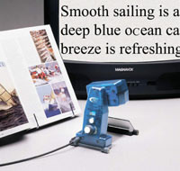

The Flipper, shown in Figure 2.1 (Royal Victorian Institute of the Blind, 2004), is manufactured by Enhanced Vision Products and is a camera-only unit. Due to the lack of a display, the flipper unit itself is light (around 500 grams) and highly portable, but has the downside of requiring an available television and mains power supply at each location. The Flipper can be used for viewing near to the user, for items such as books or medications, or for viewing subjects farther away, such as whiteboards. The device has 10 fixed levels of magnification which the user can select from, and will automatically focus on the subject to minimize the setup required from the user. The cost of the Flipper is approximately US$1400 new from Independent Living Aids Inc (2004). The Flipper can alter the contrast of the image displayed and can threshold the image to two colours (black on white or vice versa) but has no user ability to vary the threshold itself and has no other enhancements such as sharpening or focus lines to improve the interpretability of the subject material. The Flipper also features a built-in light source.

Figure 2.2: The Aladdin Classic
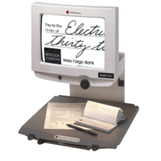

The Aladdin Classic, manufactured by Telesensory Corporation and shown in Figure 2.2 above (Royal Victorian Institute of the Blind, 2004), is a more common style of electronic magnifier incorporating a display into the unit itself. The display is a black and white CRT, with a viewable size of 32.5 cm (12.8 inches) diagonally. The camera in the Aladdin Classic is only able to magnify text or other subject matter which can be placed on its reading table, and is therefore unsuitable as the sole aid in a environment where a whiteboard is used. The 16.8 kilogram weight of the unit, which is largely due to the CRT, precludes it from easily being moved with the student, and so this unit is best suited to working in a fixed location such as an office or as a shared resource in a library. Like the Flipper, the Aladdin Classic can display the image as a high contrast black and white image but has no other enhancement options. The Aladdin Classic is available for US$1800, again from Independent Living Aids (2004).

There are other devices available which are more like the LoVIE in form and hence portability, though still without the enhancements which are the key part of the device. An example of this is the Liberty Solo, manufactured by Ash Technologies.
Figure 2.3: The Liberty Solo


The Liberty Solo, shown in Figure 2.3 (Ash Technologies, 2004), comprises two units: a display unit housing a 12.1” TFT screen, processing hardware and battery pack, and the camera unit. Although the device is primarily designed for reading texts, it can be used at up to 12 times distance magnification. The weight is similar to the weight of a laptop at 2.2 kg, making the device quite portable. The Liberty Solo can perform thresholding on the subject, and allows the user to apply their selection of colours for the foreground and background. Universal Vision Aids (2004) list the price of the unit as US$3300.

Discussion
This chapter outlined the prevalence and effects of visual impairment. There was broad justification of the LoVIE in light of the conditions in most classrooms, the types of aids available currently and their effectiveness. Specific examples were outlined of the equipment currently available and the limitations and costs which they suffer from.

Broad Requirements for a Portable Enhancer

Usability requirement outline
In its final form, the LoVIE must be as simple to operate as possible, with little or no user input necessary to get a useful enhancement immediately the device is switched on. To this effect, the device should be able to cope with a wide range of environmental conditions in terms of ambient lighting, glare, variations in contrast of the subject (for example pens of different age in different lecture theatres) and adapt its enhancements enough that the user need only fine tune the parameters. This avoids the user needing to spend large amounts of time at each venue configuring the device. The device needs also to be designed to reduce the likelihood of eye fatigue for the user when the device is employed for extended periods, and must have appropriate enhancements to counter the most common types of visual impacts experienced by sufferers.

Enhancements required
One of the key motivations for the LoVIE, apart from producing a less expensive image enhancer than those available, is to improve the range and efficacy of enhancements available to a low vision user. To this end, the device must include enhancements to the video stream which will counter the most common effects on vision experienced by the vision impaired. The research performed by James Beaumont-Field and Elankumaran Arulliah found that the most common effects can be categorised into three groupings: blurred vision, localised vision degradation and altered colour or contrast perception. The LoVIE must include enhancements to overcome as much as possible each of these problems. A broad overview of their findings and the impact of the enhancements developed on the rest of the system is detailed within this thesis, but more detail on this aspect is available in their respective theses.

Portability requirements
The LoVIE is intended as a portable device which can easily be moved from location to location by the user alone. The two main aspects which impact on the portability are the size and weight of the device. Given the wide use of laptop computers by students, and their frequent relocation, it is reasonable to use a laptop as a guide to the dimensions and weight of the LoVIE.

The weight of the LoVIE should be similar to, or slightly less than, that of a laptop with an equivalent size screen. As for a laptop, the major dimensions of the LoVIE would mainly be determined by the screen size. The electronics necessary for the device itself are mostly independent of the screen size, although a larger screen would require a larger battery for the same time, adding an additional weight penalty on top of the weight from the larger screen.

Cost requirement
A key requirement of this device is that it cost significantly less than those devices currently available with comparable portability and screen size. In terms of a final product, the cost recovery needed is essentially limited to the hardware used in the device itself and any hardware needed for the development phase. In comparison to a fully commercial development, there would be minimal labour costs for the design and development of the device thanks to the use of free student labour. Additionally, there would be minimal costs associated with providing laboratories and equipment, as those facilities are funded in the normal course of departmental operations. Finally, the devices could be sold at cost, or at a comparatively small profit.

Frame rate of enhanced video stream
In its ultimate form, the LoVIE would enhance and display the video stream quickly enough that no jerking or flickering would be evident, around 25 or 30 frames per second (fps). For the purpose of this project however, the outcome was intended as a proof of concept and the frame rate was a soft requirement – the aim was to work at as high a frame rate as possible. The limitations imposed by the available hardware made it clear that 25 fps was unlikely, so a more conservative but still useful frame rate of 15 fps was set as the target. This rate is high enough that the resultant video stream would be useful when shown to a vision impaired student for feedback.

Display size
The size of the display in the device was critical in making the complete device useful. There is no point providing a user with impaired vision with an enhanced image which either physically too small for them to see, or is large enough but only covers five or six letters. In addition to the fatigue which results from constant movement of the camera, studies have shown that best reading performance is achieved with at least 15 letters visible on the display (Larson, 2004), and so the user’s reading performance would be sub-optimal. The result would be similar in terms of useability to using a telescope or magnifying glass, the only difference being the ability to enhance. The need to build a mental image of the whole subject from many little pieces and for such constant readjustment of the camera would induce fatigue very quickly, so in this situation the larger the display the better. This does clash to some degree with the need of low weight for portability, so a compromise is necessary. For utility then, the display should be the largest possible which does not make the device unwieldy. It is reasonable to consider those size displays which are commonly used in laptops – the screens largely define the size of the machine, and should be easy to source and cheaper than displays of a less common size.

Display brightness
In order that the device be useful for as broad a range of users as possible in as wide a range of environments as possible, the display in the LoVIE should as bright as possible. If the device is being used in a dark environment, for example a lecture theatre, or by a user whose eyes are sensitive to bright light, it could be dimmed, but for most users the ability to use the device in areas with high ambient light would be advantageous. Ultimately it would be preferred that the device be useable in direct sunlight to increase its versatility when mobile.

User interface
For a user with low vision, the user interface of a device such as the LoVIE is critical, given the range of options available for adjustment. The user interface needs to be as logical and consistent as possible irrespective of the adjustment being made, and should be as self-explanatory as possible in terms of the controls. The controls should be physically large and well defined, and separated enough that the user cannot accidentally activate a control while pressing another.

Image acquisition requirements
The quality of the final enhanced image from the LoVIE would be largely determined by the quality of the image before the enhancements were applied. Given that one enhancement applied by the LoVIE is digital zoom, the greater the resolution of the original image, the greater the detail visible at high levels of digital zoom, or the higher the level of zoom which can be applied before the zoom interpolation results become unusable. This translates to a higher resolution being more useful for the camera used. The disadvantages are that a higher resolution image results in larger bandwidth needs for the transfer to the main processor, and an increase in the time necessary to perform the enhancements. A balance must therefore be found so that the camera resolution and frame rate are both satisfactory.

The camera need only be capable of outputting a greyscale image, as colour was considered likely to increase the visual complexity of the image. For a 24-bit colour camera compared to an 8-bit greyscale camera such as was used, avoiding colour also reduced by a factor of three the amount of bandwidth needed for the camera-processor interface, the space needed to store the images and the processing power needed for applying the enhancements.
Additional requirements imposed focussed on the hardware capabilities and ease of use of the camera module itself. In the interests of simplifying development of the system, the module used had to include all components necessary to drive it. As power usage would be a key concern in a final product, the camera was to be based on CMOS technology, which requires up to 100 times less power to operate than the alternative Charge-Coupled Device technology (HowStuffWorks, n.d.). CMOS-based cameras are more prone to noise than CCDs but in this application the noise should not be a problem. If is it, a CCD-based sensor could be retrofitted easily.

In the interests of simplifying the interface between the DSP and the camera module, the format of the pixel stream from the camera should be compatible with the interfaces available on the DSP as detailed in chapter 4.0. Thus the interface would require parallel movement of pixel information, preferably delivering a full pixel to the DSP each transfer. For a camera with 256 grey levels, this implies an 8-bit wide data bus from the camera. Synchronisation signals from the camera would be connected to the external interrupt pins on the DSP board to trigger receipt of each pixel when it became available. The logic levels used by the camera module also had to be compatible with those acceptable for the DSP – although the DSP itself uses 3.3 V signalling for its input-output interfaces, they are buffered, and so either 3.3 V or 5 V signals would be acceptable. The image sensors used in such camera modules are highly configurable, and so a lesser requirement was imposed that a control interface be available to give access to settings for frame rate, noise filtering and the like.

The lense abilities of the module would not be important, given the early stage of the development and the ability to fit alternate lense assemblies if required.

Discussion
This chapter gave an overview of the requirements of the system, at the level of the complete device and of the image acquisition subsystem. Consideration was given to the usability, portability and cost of the device in mind of the abilities and limitations of the users.

Discussion of Key DSP Features

Overview of C6711
The TMS320C6711 DSP used as the core of the LoVIE was selected for its suitability for complex image processing operations, as required by the image processing subsystem and outlined in (Beaumont-Field, 2004) and (Arulliah, 2004). The processor fairly cheap at is capable of 900 million floating point operations per second, and has a variety of integral interfaces which were used to connect to different aspects of the LoVIE, and are explained below.

EMIF
The EMIF is the C6711’s external memory interface. It is highly configurable and allows a wide variety of memory types, both synchronous and asynchronous to co-exist. The EMIF data bus is 32 bits wide, and is configurable to handle transfers of 8 or 16 bits as necessary. In this application it was only used for 32-bit transfers. The EMIF sports four separate address spaces, defined as CE0 to CE3. An external active-low pin is indicates which memory space is being accessed. The EMIF has twenty external addressing lines, which combine to give 64 MB per memory space, and a total address memory of 256 MB. As implemented on the DSP development board, access is available to CE1, CE2 and CE3 for externally connected memory devices. CE0 is dedicated to the 16 MB of onboard SDRAM used elsewhere in the project for image storage, and is therefore unavailable. The operations of the EMIF are synchronous within the DSP, based on a 100 MHz clock signal which can be used by synchronous memories such as the SDRAM. For asynchronous memory devices, delays are specified in terms of the number of EMIF clock cycles required. As explained in chapter 7.0, the external display logic interfaced with the DSP through the EMIF, appearing as asynchronous RAM. Hence the description of EMIF operation is limited to asynchronous mode.

When transferring data with an asynchronous memory device, the EMIF uses separate read and write strobe signals to indicate the type of access being performed and when it has completed. The key parameters, which can be separately configured for read and write accesses, are the setup, strobe and hold times. These delays are shown for a read access in Figure 4.4 (Texas Instruments, 2004a) and for a write access in Figure 4.5 (Texas Instruments, 2004a). Each of these parameters are specified in terms of EMIF clock cycles, which are 10 ns long in the case of a 100 MHz EMIF clock.

Figure 4.4: Asynchronous EMIF read timing
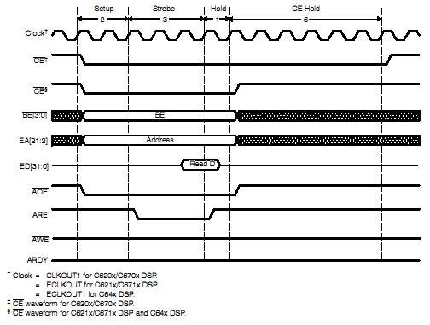
Figure 4.5: Asynchronous EMIF write timing
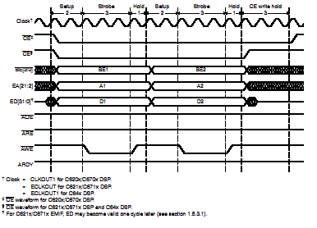

For any asynchronous access, the relevant memory space select line is asserted in combination with the relevant read or write strobe to activate the operation. The setup delay specifies the number of EMIF cycle between the assertion of the relevant memory address control line and the read or write strobe. The strobe delay specifies the period for which the strobe will be asserted, and the hold parameter defines the delay after the relevant strobe signal is de-asserted before the next access is started.

When performing a write, the data and address busses are set when the memory space select line is first asserted, and do not change until the end of the hold period. For a read, the address bus is set and does not change until the end of the hold period. When performing a read, the data bus is sampled at the deassertion of the read strobe.

EDMA
The EDMA controller built into the C6711 is a high performance data transfer engine incorporating 16 independent channels, and capable of triggering from internal or external sources, notably the external interrupt pins. The EDMA is used by both the image acquisition and display subsystem design to simplify implementation and reduce interruption to the CPU. The EDMA is highly configurable and can dynamically update both source and destination addresses, can transfer a defined number of element for each trigger event, can assert a ‘transfer complete’ interrupt after a predefined number of transfers, and can reset itself to a starting configuration, requiring no intervention from the CPU. There are many other features available within the EDMA controller, but only those mentioned were required for our purposes.

McBSP
The McBSP is a high speed buffered serial port featuring two independent channels capable of configuration for either serial operation or GPIO functionality. In the case of the LoVIE, the MsBSP is intended for use in its GPIO mode, due to the lack of other GPIO pins on the device. In this mode, Each McBSP offers pins available for input/output operations, with certain pins configurable as input or output, and others dedicated as one of the two.

External Interrupts
The C6711 features four pins which initiate hardware interrupts of the DSP. The interrupts can be configured to occur for positive or negative transitions on the line, or for any change. The external interrupt pins can also be used as triggers for specific EDMA channels. This allows external peripherals, in this case the camera module and LCD controller, to initiate data transfers without requiring CPU intervention.

Discussion
This chapter detailed the key features and interfaces of the C6711 DSP which were used for the systems developed later in this thesis. The general attributes of each were detailed, to give understanding of the explanations and concepts described later.

Display Subsystem Specific Requirements

Introduction
This chapter outlines the technical requirements of the display subsystem of the LoVIE, complementing the more qualitative nature of chapter 3.0. The LoVIE was considered by the project group as a modular design, and many of the technical requirements of the display subsystem result from the needs or characteristics of those other modules being developed. Although the display subsystem is independent of the other modules in an architectural sense, it is using some of the same resources in practise and hence must be designed to have as little impact as possible on the system as a whole.

Use existing hardware
The DSP to be used in the LoVIE was selected before any other parts of the system were obtained. The department possessed two mechatronics demonstration kits based on the Texas Instruments TMS320C6711 floating point digital signal processor, mounted on the matching development board. The C6711 is often used for realtime image and video processing, and was an ideal candidate for use for the image processing section of the project.

The selection of the C6711 defined the interfaces available and the general types of transfers which could be performed, thanks largely to EDMA controller detailed in chapter 4.3. By using the EDMA controller to perform data transfers between the DSP and the screen or the camera and the DSP, these regular actions could be performed without interrupting the image processing of the DSP. In addition to use of the DSP, it was hoped that other subsystems could be built using hardware already possessed by the department. The key reason that use of existing hardware was considered as a requirement was the ‘proof on concept’ nature of the device. It was intended to prove the viability of the project, at which time further resources could be applied to develop the design using higher performance components.

Functional panel requirements
The requirements of the panel are dictated by the ultimate design performance and functionality envisaged for the system. As outlined in chapter three, the LoVIE is intended to be portable and useable away from mains power, and sufficiently large to be effective for its low vision users. These requirements were then translated into more quantitative terms to assist in the design process.

A reasonable size for the display is approximately the size of an A4 piece of paper, given the portability needs of the LoVIE. This includes display panels with a diagonal dimension larger than 12.1 inches. The preference was made that the panel weigh less than 1.5 kilograms, though this was subject to variation if the module purchased had other desirable features. Given that some display types required multiple parts to work, specifically in the case of LCD panels which require a backlight and inverter in addition to the panel itself, it was preferred that the display panel be an ‘all-in-one’ unit which incorporated all parts needed to operate. While ensuring all necessary parts were supplied, this ‘single source’ approach simplified information chasing and would simplify warranty claims as well. Low power consumption for the display was an important consideration given the portability aims for the device.

Given the target enhancement rate of 25 fps, the display device had to display output frames at or above this rate so no enhanced frames were dropped. The further requirement was applied that the display be able to satisfactorily display a video stream at 25 fps without the video suffering any loss of quality, for example any blurring of the image. This was necessary so any further development of the device able to operate at the ideal frame rate could use the same screen. The resolution of the display must be of comparable or greater than that of the image capture device, to avoid any loss of information. Keeping in mind the minimum display size of 12.1 inches outlined above, this would equate to a minimum resolution of 800 pixels wide by 600 pixels high, based on a broad examination of those panels easily available.

Finally, the panel had to use a parallel digital interface to simplify communication with the DSP and reduce the amount of glue circuitry required. Most larger panels use an interface known as Low Voltage Differential Signalling, which allows higher data rates than over parallel interfaces, but would have required additional logic to encode the signal for no performance benefit. The use of an analog interface such as VGA would require additional Digital-to-Analog circuitry to convert the digital colour information for each pixel into an analog voltage, and to generate the synchronisation signals required. The requirement was that the display device accept colour information for each pixel on a parallel data bus, and that the other control signals required be limited to a pixel clock, a horizontal synchronisation signal and a vertical synchronisation signal. These signals were to be digital also, using logic levels compatible with the DSP (5 V or 3.3 V).

Comply with needs of other aspects of system
The display subsystem exists as an element of the LoVIE, and should have the minimum effect on the other systems in use. The central element of the LoVIE is the DSP performing the image enhancements, and all of the subsystem draw on the DSP resources. Certain restrictions are imposed on the display subsystem by the processing power and EMIF bandwidth requirements of the other subsystems, particularly the image processing and image acquisition subsystems. In particular, the restrictions affect the processing load and EMIF bandwidth usage of the display subsystem.

The image filtering algorithms used to perform the image enhancements within the LoVIE are computationally intensive, as detailed by Beaumont-Field (2004). The display subsystem should be designed to use as little CPU time as possible to allow the maximum rate of image enhancements. Furthermore, the pipelined approach of the LoVIE when applying multiple enhancements to the video stream, whereby a source image, an intermediate image from the end of each enhancement stage and a final image are all transferred to the DSP from external memory and back again for each frame points to the second area of concern; the EMIF bandwidth requirements. Assuming four intermediate frames, this equate to eight frames of data being transferred over the EMIF for each frame produced. At 15 fps and assuming an image resolution of 640 pixels wide by 480 pixels high, this equates to:

$$(\text{640}∗\text{480}∗\text{15})∗8=\text{40},\text{000}\text{KB}\text{/sec}$$

As the EMIF is the common memory bus which the display subsystem shares with the external memory store, the display subsystem should consume a minimum of bandwidth to reduce the impact on the image processing rate. Like the display subsystem , the image acquisition subsystem imposes a certain fixed load on the DSP. To acquire the image the DSP must receive and store a regular stream of data from the image sensor. For a constant camera frame rate the amount of bandwidth required will be constant, and will reduce the bandwidth available for the image processing and display subsystems. For each frame, assuming a 640x480 pixel image and 8 bit greyscale, the total data which must be transferred to the DSP and then moved to the external memory is:

$$\text{640}∗\text{480}=\text{300}\text{KB}$$

The effective bandwidth requirement is then 600 KB per frame. For a sub-optimal design which displays frames at 15 frames per second and only retrieves frames from the camera as needed, the total amount of data being transferred over the EMIF for the fresh image alone is:

$$\text{640}∗\text{480}∗\text{15}=\text{4500}\text{KB}$$

The effective bandwidth required from the EMIF would then be 9000 KB/second to transfer the fresh image alone. With these two other resource intensive subsystems in mind, the display subsystem should interrupt the processor as little as possible and use a minimum of EMIF bandwidth.

Discussion
This chapter gave a detailed overview of the requirements of the display subsystem. The broad system requirements were made more specific to the display subsystem, and the requirements implied by the hardware restrictions and needs of the other sections of the system were explained.

The High Level Design of the LoVIE

Design overview of complete system
At the start of this project, the work was separated into two broad areas: the display subsystem, which was the responsibility solely of the author, and the image enhancement aspect, which was jointly worked on by James Beaumont Field and Elankumaran Arulliah. The other areas of the system shown in figure 5.1, such as image acquisition and the hardware side of the user interface were worked on cooperatively by all group members. This chapter examines the designs for the image acquisition and display subsystems in detail and gives an overview of the user interface, and the image enhancements developed by the other project members.

Figure 6.6: Simplified Block Diagram of the LoVIE
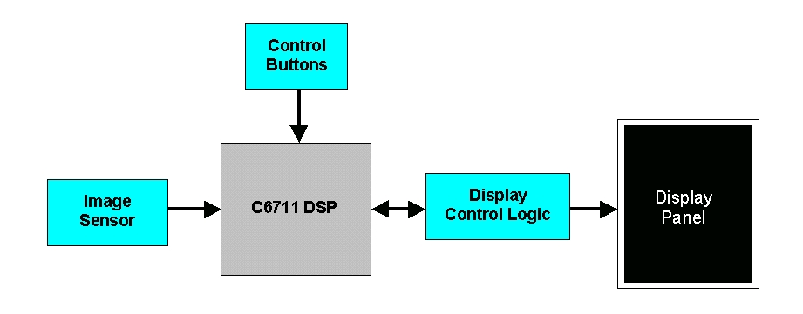

Image acquisition subsystem

Introduction
The image acquisition subsystem manages the capture of digital images of the subject, which are then enhanced and displayed on the screen. The design of the image acquisition subsystem was developed cooperatively by all group members.
Once the requirements for the camera were determined, a suitable module was purchased, and the interface design was developed. The general structure of the camera will be detailed and the interface designs considered will be explained.

Broad camera structure
The structure of the camera module needed was determined by the requirements outlined in chapter 3.9. It was decided that the camera should have a resolution of 640x480 pixels, as this is a common camera resolution and would imply data transfer rates within the ability of the C6711. Each pixel would be represented with 8 bits, giving 256 levels of grey, and vertical and horizontal synchronisation signals would be outputted and tied to the DSP’s external interrupts to allow the C6711 to track the start and end of a frame or line respectively. The frame rate of the camera was to be configurable up to a maximum of 30 fps, to give control over the load placed on the EMIF and the frequency of pixel reading.

In order that the bandwidth be most effectively used, the camera module would transfer the grey level of each pixel over an 8 bit wide data bus. The bandwidth requirements of the camera would therefore be up to (30*640*480)=9000 KB/s, with a new pixel value available every 1/9216000 seconds, or approximately every (150000000/921600)=16.3 clock cycles for the 150 MHz C6711. Clearly then the camera would require an interface which was fast, and could operate independently of the CPU to interrupt the image processing as little as possible. Figure 6.7 (Omnivision, 2001) below shows typical timing of the various synchronisation signals from the camera. All descriptions of timing and signalling refer to a camera delivering data in progressive mode rather than interlaced mode.

Figure 6.7: Timing for OV7120 CMOS sensor

The signalling from the camera used is composed of an 8-bit wide data bus, two synchronisation signals a pixel clock. In the case of the camera, a positive transition of the pixel clock indicates the signals on the data bus are valid and can be used by external logic to latch the pixel data into a register or to initiate a transfer, the application used in the LoVIE. As evident in Figure 6.7 the two synchronisation signals (one horizontal and one vertical) indicate to the logic receiving the pixel stream when a line begins and ends, and when a frame begins and ends respectively. As is outlined later in chapter 8.5.2, the vertical synchronisation signal was used to begin the pixel capture at the start of the frame, while the horizontal synchronisation signal was used in combination with the pixel clock to only perform transfers on those pixels which were valid.

Camera interface design
The data stream from the type of camera used is ideally suited to connection with a byte-wide GPIO port as found on most microcontrollers. Unfortunately the C6711 has no dedicated GPIO pins available at all, so this was not directly possible. For the camera to deliver images to the DSP, it needed to connect to one of the available external interfaces, either the EMIF or the Multichannel Buffered Serial Port (McBSP). In all designs attempted, the McBSP was selected as it can be reconfigured to work as GPIO, though only 6 bits wide per channel. The EMIF has much more complex signalling requirements and therefore glue logic would have been needed. By reconfiguring the Serial Port Control Register and Pin Control Register for each channel, each McBSP channel can be used as up to 6 input pins.

Two approaches were considered for the reading in of pixel data from the camera, either that the appropriate control signals from the camera trigger an interrupt which perform the transfer to the appropriate memory location, or alternatively to use the EDMA controller built into the C6711 and avoid interrupting the DSP. When the frequency of CPU interruption which occurs with interrupt based transfers and the inherent delay when servicing an interrupt are considered, it is clear that the DMA transfer is the preferable option.

In the interface approach ultimately used, the synchronisation and clock signals from the camera were connected to external interrupt pins on the C6711. The horizontal synchronisation signal was used to gate the clock signal to simplify the DSP setup. Since the horizontal synchronisation line is high whenever the pixels being clocked out is valid, and low at the blanking period at the end of each line when the data present on the bus is invalid, ANDing the two signals would produce a waveform which only oscillated while the data is valid results. The DSP could then use the gated clock signal to trigger a DMA transfer of the byte-wide pixel value to the appropriate memory location and to auto-increment the destination address. By terminating the DMA transfer when the (640*480)=307200th value is written, a full frame can be grabbed. The vertical synchronisation signal is used to reset and enable the DMA transfer only at the beginning of a frame, ensuring the first pixel captured is the first in the frame.

Design overview of other system elements

Image enhancements
The various image enhancements developed by James Beaumont-Field and Kumaran Arulliah were targeted to improve visibility for the categories of visual effects mentioned earlier. The visual effects and enhancements considered or developed for each are:

Blurred Vision
- Edge Enhancement
- Edge Outline
- Focus Lines

Localised Vision Degradation
- Digital Zoom

Altered colour/contrast perception
- Thresholding

For details on each, please refer to (Beaumont-Field, 2004) or (Arulliah, 2004).

User interface
A rudimentary hardware user interface was developed for the LoVIE, but control over the parameters of the device was not established. Details of the interface developments, please refer to (Beaumont-Field, 2004).

Discussion
This chapter outlined the high level design of the LoVIE, excluding the display subsystem which is covered in the following chapter. In particular, the requirements of the image acquisition subsystem was examined, in light of the subsystem’s further development later.

Design of the Display Subsystem

Introduction to display subsystem
The design of the display subsystem required design in both the hardware and software spheres, keeping in mind the need for design of the display subsystem hardware, and the DSP setup necessary to allow the controller to operate over the external memory bus in an way which minimised interruption to and intervention from the DSP.

The essential structure of the display subsystem was to have the DSP connected to a display panel through whatever glue logic was necessary to meet any requirements imposed from either end. The transfer of data from the freshest complete frame in the DSP to the screen was to occur with as little impact as possible on the other functions of the system.

Selecting the screen technology
Early in the project it was necessary to decide on the type of display panel to be used, both so the appropriate module could be acquired and so that further design could be done taking into account any specific requirements of the display technology used. Given the useability requirements of the final device, in particular the need for portability, it was clear that the display would need to incorporate a Liquid Crystal Display (LCD) panel. The alternative types of display technologies considered, being either plasma flat panels or Cathode Ray Tube (CRT) based displays, were inappropriate as they could not satisfy those useability requirements.

Table 7.1: Comparison of Display Technologies (NEC, 2004), (IBM, 2004)
 | Viewable Screen | Weight | Power Consumption
NEC  15” CRT Monitor | 35 cm (13.8inch) diagonal | 12.1 kg | 75 W
IBM 9514  14.1” LCD Monitor | 36 cm (14.1 inch)  diagonal | 5.3 kg | 30 W

The CRT approach suffered from high power consumption, analog signal inputs and very high weight for a given viewable area and so would not have allowed the device to be easily carried from location to location, or be used away from a mains power supply. The initial consideration included plasma display panels, but it was discounted immediately due to the relatively high power consumption and non-availability of panels in the size required for a truly portable device.

Within the range of LCD panels, it was decided that a Thin Film Transistor (TFT) based panel would be used, since in comparison to passive LCDs they have a fast response time and hence will not blur or smear any changing image on them, have a large viewing angle and better colour saturation than passive displays (Optoma Technology, n.d.).

Display interface requirements
A pixel in a TFT-LCD panel is generally comprised of three subpixels, one each of red, green and blue, as shown in Figure 7.8 (Toshiba Corporation, 2001) below. By varying the amount of light passes by each subpixel, the full range of colours can be reproduced. The panels considered allows six bits to specify the brightness of each subpixel, giving 64 possible intensities. With three subpixels, this allows 2¹⁸ possible colours overall, totalling 262,144 possibilities.

Figure 7.8: Physical pixel arrangement for TFT-LCD panel
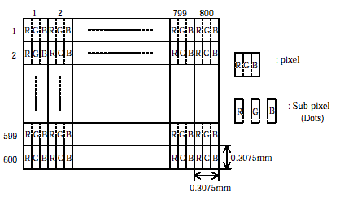

The input signals required by the panel are: an 18-bit wide data bus, a pixel clock, and a compound synchronisation signal. The colour for the pixel about to be stored is placed of the data bus by the controlling device. The compound synchronisation signal is used to indicate to the panel when a line begins and finishes, and likewise when a frame is beginning or ending. The pixel clock is used to latch colour data into the display, and regulates the operations of the panel.

Figure 7.9: TFT LCD vertical and horizontal timing
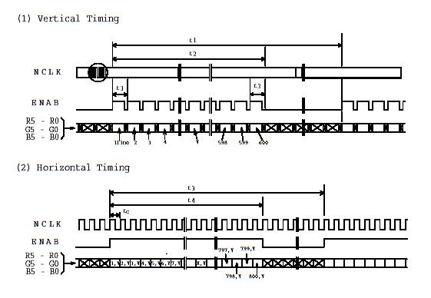

Table 7.2: LCD-TFT Timing Parameters
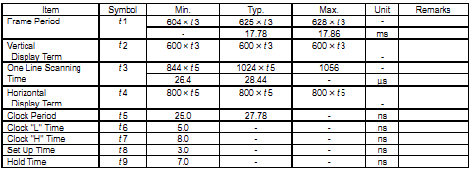

Figure 7.9 (Toshiba Corporation, 2001) shows the general arrangement of the timing signals, at a line-by-line level and a pixel-by-pixel level while Table 7.2 (Toshiba Corporation, 2001) outlines the values of those parameters. All the TFT-LCD display panels considered used a similar structure for the data input. Further, all had critical requirements as outlined in chapter 7.4.2 which had a major effect on the final architecture for the display subsystem. Additionally to latching colour information from the data bus into the panel, each negative transition on the external pixel clock triggers the addressing logic in the panel to move to the next pixel. In this way, the data bus can deliver data for the entire screen without requiring addressing signals as such. For the reasons outlined above, the 18-bit wide data bus is comprised of three 6-bit divisions, for the red, green and blue subpixels.

The compound synchronisation signal, termed the ‘Enable’ signal in the display used, is used to indicate to the screen when to start displaying pixels for a new line or for a new frame. The display has an active are of 800 pixels wide by 600 pixels high, but the pixel clock actually cycles more than 800 times for each line, and clocks in more than 600 lines for each frame. The additional clocking beyond the active display is termed the blanking period. The blanking periods, both in the horizontal and vertical cases, are a remnant of the way a CRT is driven, where the electron beam must have time to move back to the start of the next line from the end of the previous. To design the display sub-system, a total display area of 860 pixels wide by 615 pixels high was assumed, giving a horizontal blanking period of 60 pixels and a vertical blanking period of 15 lines. During either blanking period the combined synchronisation signal is low, and is taken high by the external controlling logic at the beginning of a new line or frame. In effect, a positive edge on the combined synchronisation line indicates to the display that either a new line or new frame has started, depending on the duration of its previous inactive phase.

Key Factors Influencing Design

Overview
The design of the display subsystem of the LoVIE was influenced by both technical and philosophical factors. The base intention was to get sufficient performance from the device that its utility could be established, essentially that it be a ‘proof of concept’, only purchasing the elements of the system without which the concept could not be proven. As the requirements came to light for other aspects of the device (specifically the microprocessor and display panel), the architecture of the display subsystem was revised to take them into account.

Screen driving requirements
The type of TFT LCD panels decided upon had strict timing requirements of the control signals used to drive them. The setup and hold times for the various data and synchronisation signals, and minimum period for the pixel clock were specified and had to be followed closely. Violation of the setup or hold times for the data signals requirements would lead to a jittery image, while a pixel clock which was absent or too slow would lead to permanent polarisation of the liquid crystal, damaging the display (Anon, 1993). For this reason, a key aspect of the display subsystem was guaranteeing the pixel clock signal. Furthermore, the TFT panels examined required that no high logic signals be applied to any panel inputs when the panel supply voltage was absent, in order to avoid damaging the panel electronics. In light of the high cost of the panel and the time which would be required to acquire a replacement, it was important that damage to any panel be avoided. This implied that independent control circuits would be required either to act as a watchdog if the pixel clock stopped, or to generate the critical control signals independently of the main processor. As the processor could potentially ‘hang’ during operation due to poor coding or system instability, and may pause during debugging, direct dependence on the main processor to safeguard the screen would most likely result in damage. Similarly, the fact that the main processor would be occupied with image processing algorithms and other interrupts could well mean that the system was unable to guarantee that it would meet those timing requirements to ensure a stable image.

Controller designs explored

External controller chipset
In a production Image Enhancer, the screen would be controlled by a commercially developed dedicated controller, whether in a separate chipset such as the Epson S1D13504/5/6 or perhaps built into the processor selected. The controller chipset resides on the memory bus of the processor to allow the DMA to facilitate buffer updating and to take advantage of the data path width. The controller operates with buffer memory independent of the general system memory.

Multiple complete frames are stored in this buffer memory, so that the image onscreen is always stable. In addition, all control signals are generated from within the chipset and therefore guarantee the safety of the screen independently of the operation of the main processor. The decision made not to use a dedicated controller chipset was based largely on the intention that a minimum of new purchasing occur until the concept had been proven. In addition, there was the concern that the decision to use such a chipset would necessitate the design, fabrication and testing of a PCB to suit the controller.

DSP generates all signals
In the hope of using the minimum ‘glue logic’, an early design for the display subsystem relied on the C6711 DSP to generate all timing and control signals for the display panel. In order that the correct data be latched into the LCD keeping in mind the common bus nature of the EMIF, a small amount of simple glue logic (DFF) would be required to ensure that only the intended information was written to the display, and no spurious writes could occur when the SDRAM was being accessed.

The most basic approach would see all control signals being generated by the DSP itself, with the attendant risks to the panel if the processor were to halt for any reason. A slightly more complex design involved the use of a watchdog to perform the necessary signal gating and shutdown in the absence of the pixel clock, however other issues saw this design disregarded anyway.

Apart from the need to implement a watchdog, this approach would have necessitated regular and frequent interruption to the CPU to force receipt of each pixel: for a display 860 pixel wide by 615 pixel high when blanking periods are included, at a frame rate of 15 fps, interruption would occur every:

$$\frac{1}{\text{860}×\text{615}×\text{15}}=\text{126}\text{ns}$$

As detailed in appendix C.2, this would consume approximately 24 percent of the EMIF’s effective bandwidth. More importantly however, the frequency of the interruption forces any other memory access to complete in the 95 ns (76 percent of 125 ns) between pixel transfers. This window will allow a single SDRAM transaction, but is too short for communication with any other slower types of asynchronous memory. Furthermore, any EDMA reaction latency of more than one or two EMIF memory cycles will stop any data being transmitted to the SDRAM, bringing the system to a halt. Hence the direct drive approach was unsuccessful.

M16C as external LCD controller
To address the need to guarantee the control signals, the LoVIE would require external logic to buffer the screen data and generate the control signals independently of the DSP. Among the equipment available in the school were development boards for the Mitsubishi M16C62 microcontroller. By using an M16 to generate the timing signals, it would be possible to ensure the panels safety in the case of a malfunction in the C6711. The M16C possesses 20 kilobytes of onboard memory (Mitsubishi Semiconductors, 1999), giving the opportunity to buffer a portion of the LCD image away from the DSP. This has the advantage that the image data transfer across the EMIF occurs in large blocks, but less frequently . The EDMA controller in the C6711 would be used to avoid interrupting the CPU. One downside to using an M16C is its slow clock speed of 16 MHz compared to the 150 MHz clock frequency of the C6711. The M16C would take a long time to transfer data to and from the C6711 and would have high EMIF bandwidth usage. The second issue is that like the C6711, an M16C could freeze and so an additional watchdog would still be required. Subsequently another architecture was considered, where the M16C was replaced by programmable logic, specifically an FPGA

FPGA as external LCD controller
The final architecture considered used a FPGA as a combination line buffer and control signal generator for the LCD, interfaced to the DSP through the EMIF. An FPGA allows greater flexibility in the logic of the controller, allows it to operate at a much higher clock speed than the M16C and is less likely to cause screen damage due to a malfunction. To interface with the EMIF, the FPGA needed to emulate the simplest type of memory.

This design allows the DSP to be interrupted just once for each line on the screen, when it would transfer the complete line (either 640 or 800 pixels) in one block. In comparison to the 126 ns interruption period with direct DSP connection, and assuming an video stream 640 pixels per line with 480 lines at 15 fps, the interruption would on average occur every:

$$T_{\text{Period}}=\frac{1}{\text{480}∗\text{15}}=\text{138}\text{.}9\text{us}$$

Independent control signal generation and screen safety logic would also be implemented in the one device, assuring the safety of the screen. If the DSP stopped sending data, the screen would show vertical lines as old data was displayed repeatedly, but no damage would occur. It was this option which was selected as the basis for the detailed design.

Design optimisations examined

Compressing data stream to screen
Optimisations for the LoVIE were examined in light of the need to minimise the amount of data transferred to an external controller and the amount of processor time spent processing display data. One method of effectively compressing the video stream was considered, based on the premise that when the thresholding feature was used, the video would consist of only two colours: a foreground colour and a background colour.

In this case, the colour of each pixel could be represented by a single bit, indicating that the pixel was the foreground colour if ‘1’, or the background colour if ‘0’. The colour combination for the foreground and background would be selected by the user to maximise their comfort and reading ability, and the appropriate bit pattern representing each colour would be written to a separate register within the external controller. Each time a pixel value was to be displayed, the bit representing that pixel would be used as the select input for a multiplexer which had the two colour registers as its inputs. The output from the multiplexer would then be placed on the data bus to the screen. By compressing the video stream in this way, a bandwidth reduction of 16 times could be achieved, assuming a non-compressed video stream delivered two the colour of two pixels in a single 32-bit wide transfer.

The downside of compression is that the DSP must perform the compression itself. If the compression could be incorporated into the thresholding operation, the impact on the DSP may be minor enough that it is worthwhile. If the compression is performed as a separate stage however, the processing load on the DSP could be major. Assuming the highly simplified compression sequence within the DSP of ‘test the pixel value, shift the previous result value along by one, set or clear the new least significant bit, repeat’, each pixel requires three operations performed to compress it. For video 640 pixels wide by 480 pixels high at 15 fps, the number of pixels required each second for the display would be:

$$\text{640}∗\text{480}∗\text{15}=4,\text{608},\text{000}\text{/sec}$$

This implies a minimum number of operations each second for compression alone as three times this value, or approximately 13,824,000 each second. At 150 MHz the C6711 is capable of approximately 1200 million instructions per second (Texas Instruments, 2004d), so the load on the CPU may be in the range of only a couple of percent. This would be acceptable, excepting that such a system is only capable of showing two colours on the screen. It would be unable to display greyscale images, as required if the LoVIE was used without thresholding applied. It was thus decided that this optimisation would not be applied. In a further development it might be possible to implement this compression selectively, such that the full pixel colour information is sent when thresholding is disabled, and a compressed version is used when only two colours are required.

Reduction of colour resolution
The second optimisation considered was to reduce the number of colours displayable on the screen by tying some of the least significant bit (LSB) lines on the screen’s data bus to ground. The advantages of this approach are that the colour information for multiple pixels can be transferred to the controller in one EMIF access, thereby increasing the effective bandwidth, and the amount of storage required for a given number of pixels is reduced. For example, using 16 bits of colour information per pixel and tying the LSB of the screen data bus low for two of the colours allows two pixels of information to be transferred at once over the 32 bit wide EMIF bus. This can be extended to perhaps 10 bits per pixel, tying the 3 LSBs low for two colours and the 2 LSBs low for the other, such that three pixels colour information can be transferred in a single EMIF transaction. Table 7.3 shows the effect of different values of bits per pixel for a 640 pixel wide by 480 pixel high image transferred over a 32-bit bus.

Table 7.3: Effect of colour depth on storage and transfer requirements
Colour depth  (bits) | Number of possible colours | Levels of grey | Number of transfers req’d | Storage space per frame
18 | 262144 | 64 | 4608000 | 675 KB
16 | 65536 | 32 | 2304000 | 600 KB
12 | 4096 | 16 | 2304000 | 450 KB
8 | 256 | 4 | 1152000 | 300 KB

The negative of this approach is the reduction in displayable colours. A pixel represented by an 18-bit number can have 262144 possible values, while that represented with a 16 bit number can have 65536 possibilities and a 10 bit number only 1024. For small reductions such as 18 to 16 bits this is not a major concern, as even 1024 colours is still ample choice given the low vision of the user. The concern was the reduction in available levels of grey. A solution to this is explored in chapter 7.6.3 below. For this reason, this optimisation was used, reducing the width of a pixel to 12 bits, giving a total of 4096 possible colour.

Separate handling of greyscale and colour modes
Whenever the LoVIE is used with thresholding enabled, the output will be a bi-colour image with two colours selected by the user. In any other case, the output will be an enhanced greyscale image. For maximum visibility to the user the number of levels of grey available must be maximised. For a display panel with an 18 bit colour selection bus, a maximum of 64 distinct levels of grey are displayable. This occurs because the brightness level must be the same for each of the red, green and blue subpixels, effectively giving a six bit selection. Sixty-four levels of grey is sufficient for the requirements of the LoVIE, but is only available when all eighteen bits are available on the panel’s data bus. This clashes with the hard-wired optimisation detailed in section 7.6.2 above, as the omission of any bits from the colour specification word has dramatic effects on the number of levels of grey which can be displayed and thence the utility of the device whenever thresholding is not used. Consider a twelve bit wide colour word as shown in Figure F.35, allowing four bits per subpixel. This restricts the number of available grey levels to 2^4 = 16 levels, which is insufficient for this application. To allow all 64 levels of grey to be displayed while reducing the bandwidth required when thresholding is enabled, two distinct modes were proposed. In the ‘colour’ mode, when thresholding is used, each element of pixel data contains three subfields of reduced width, for example four bits each. This gives a total colour space of 2^(4+4+4) = 4096 colours. The alternate ‘greyscale’ mode takes advantage of the equal brightness value for each subpixel to deliver 64 levels of grey. The desired level of grey is placed in the six least significant bits of the pixel data element, and by simply replicating these six bits onto the six data lines for each subpixel, the full range can be achieved.

Required data format for display subsystem
For the various data reformatting and conversion within the controller to be successful, the colour data for all pixels had to be consistent. For this reason, the two formats shown in Figure 7.10, necessary because of the choice of colour or greyscale image, were adopted.

Figure 7.10: Required pixel data structure

Ultimate control logic design selected (EMIF and FPGA)

Controller design overview
The decision to implement the controller within an FPGA allowed the design to be effectively modularised, as the major function areas of the design were largely independent of each other. The overall design was considered as 4 major areas: the EMIF interface, the buffer memory, the LCD timing signal generator and miscellaneous LCD control logic for aspects such as signal sequencing on power application or removal. The interconnection of the logic units can be seen in Figure 7.11 below.

Figure 7.11: Block Diagram of LCD Controller Design
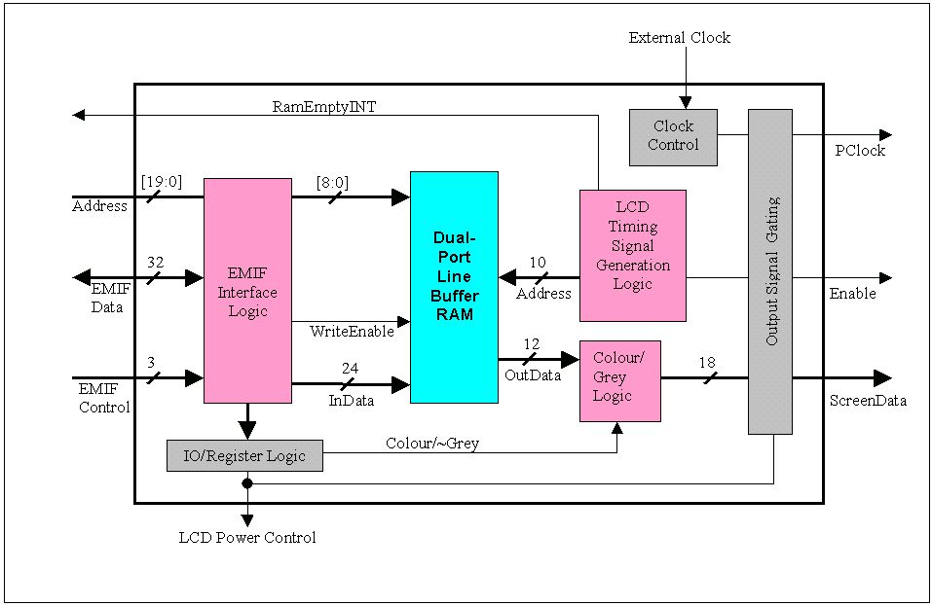

This separation of concerns simplified the design, implementation and testing of each section of the design as any problems with other modules would not impact. The inclusion of buffering with the controller required the existence of memory, either internal or external to the FPGA itself. This memory would be accessed by both the DSP to write new data for each line, and by the LCD interface logic to retrieve the next pixel’s colour value for transfer to the LCD.

EMIF interface logic
Figure 7.12: Simplified block diagram of EMIF interface logic
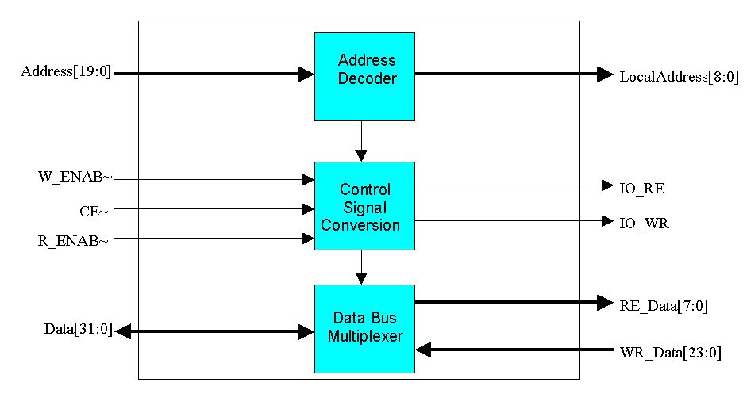

The signalling scheme used by the EMIF interface on the C6711 is not suitable for directly controlling the buffer memory of the controller without some manipulation. The EMIF is configured so that when addressing the memory space encompassing the LCD controller, it will operate as 32 bit asynchronous memory. The 32 bit wide EMIF data bus allows the transfer of two 12-bit pixels in one write as per Figure F.31, reducing the amount of time which the EMIF is busy. The asynchronous mode was employed because the FPGAs available were not capable of running at the full 100 MHz speed of the memory clock from the EMIF. In asynchronous mode the EMIF is configured to allow a fixed amount of time for a read access to the memory device, and a fixed amount of time for a write access. The control signals employed by the EMIF in this case are separate active low read and write strobes and a select signal for that memory space. By combining these signals with an enable signal derived from the address decoding logic, internal read and write signals are generated which are suitable for controlling the buffer memory. Internal to the controller, there are separate read and write data busses, but the EMIF uses a tristate data bus. For this reason, the EMIF interface logic also selects the routing of the EMIF and read and write busses as appropriate to avoid bus conflicts.

Buffering RAM
Figure 7.13: Structure of Buffer RAM
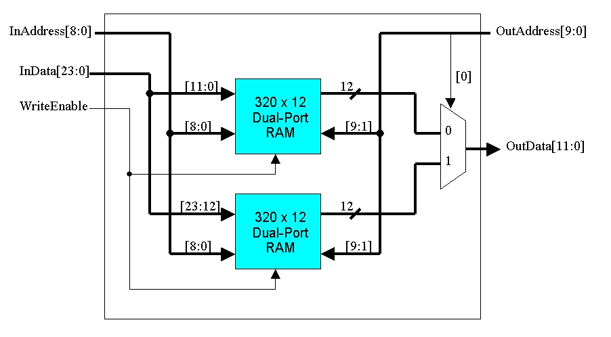

To maximise the independence of the logic sections in the LCD controller, the memory used for the line buffer had two independent interfaces, one from which the data can be read out to the LCD, and the other into which data can be written by the DSP.

Storage of one full line of pixels in buffer RAM required 640 separate 12-bit memory locations. When written from the DSP however, they needed to appear as 320 separate 24-bit locations. The memory was based on two blocks of DPRAM each with 320 12-bit memory locations within. As can be seen in Figure 7.13, a 24-bit write made by the EMIF sees the 12 least significant bits stored into the upper block, with the 12 most significant bits stored in the lower block. Through one port, both blocks have the same eight bit address applied to them – effectively the two pixels values are separated and stored to different memory blocks. When an read is made to clock data out to the display, a nine bit address is applied to the other port of the buffering RAM. The upper eight bits of this address are delivered to both memory blocks, and the least significant bit is used to switch a multiplexer between them. When the least significant bit is a zero, the pixel from the low end of the EMIF transfer is selected, or alternatively a one will lead to the pixel at the high end of the EMIF transfer being clocked out. The correlation between addressing from EMIF to LCD side is as follows:

$$\begin{aligned}\text{Address}(\text{LCD},\text{LowPixel})=2∗\text{Address}(\text{EMIF}) \\ \text{Address}(\text{LCD},\text{HighPixel})=(2∗\text{Address}(\text{EMIF}))+1\end{aligned}$$

LCD timing signal generation
Figure 7.14: LCD timing signal flowchart and timing diagrams
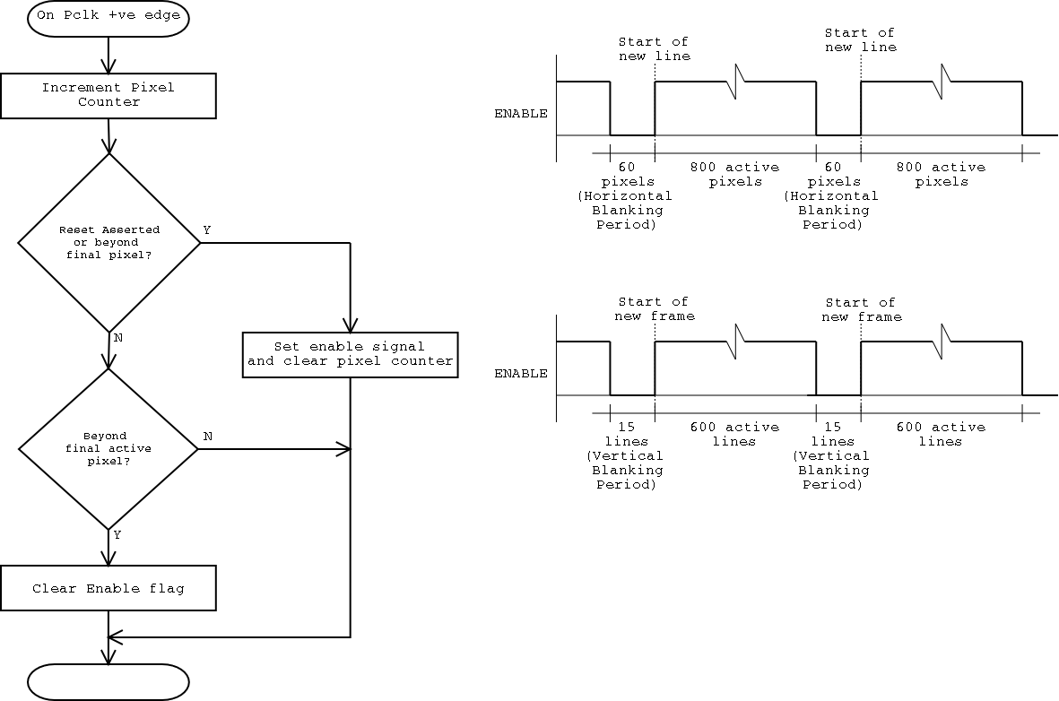

The timing signal generation logic generates the control signals for the LCD panel and the 9-bit address for the LCD side of the buffer RAM. Given the extremely sensitive nature of the screen to timing of its input signals, the timing signal generation logic operated using a separate clock to the DSP which operated irrespective of the validity of the data in the buffer.

The timing signal generation was based on two counters, both reset to zero when first powered up, and both incremented on the negative transition of the pixel clock signal generated elsewhere in the system. The first counter was modulo-860, and was used to generate a horizontal synchronisation signal. When the counter was started, an internal HEnable line would be set. When the counter reached 800, being the end of the active pixels on the display and the start of the horizontal blanking period, the HEnable signal would be cleared. When the counter reached 860 it would be reset to zero and the process would repeat. The second counter was responsible for generating a vertical synchronisation signal. When the counter was started an internal VEnable line would be set. When the counter reached 516000, after the final pixel of the 600th line, the VEnable signal was cleared. Then, when the counter reached 528900, on the final pixel of the 615th line, the counter would be reset to zero and VEnable taken high again. The two enable signals were then ANDed to produce the combined Enable signal delivered to the screen. An additional, inverted version of the Enable signal was made available as a ‘Clear to Write’ signal for use by the DSP in triggering transfers of data for the next line. After a complete line of 800 pixels had been clocked out to the display, the Enable would go low, producing a positive edge on the ‘Clear to Write’, or CTWrite, signal. This enabled the use of the horizontal blanking period to begin moving the next line of pixels into the buffer.

The address signal generation was based on a modulo-860 counter which operates one count ahead of the previously described modulo-860 counter. It is offset one count to counteract the one clock cycle delay inherent in retrieving a pixel from the buffer memory. The result is that the data for the current pixel is on the data bus as required, not one pixel clock afterwards.

LCD protection
Additional logic was used to ensure the signals to the panel met the strict sequence specified in its datasheet, to avoid damage. The conditions are as described in chapter 7.4.2, that no logic high signals could be applied to any of the inputs when the panel did not have power applied. To account for this, the LCD controller outputs a logic signal which is low for the power off and high for power on. This would control an external logic level MOSFET for the application of power to the panel. The controller also gates the control and data signals to the panel. This would allow the screen to be powered up before the control and data signals are enabled, or similarly to allow deactivation of the control and data signals before disabling power to the panel.

Colour mode selection
The approach detailed in section 7.6.3 was used to allow minimisation of both the EMIF bandwidth required and the amount of buffer memory required within the controller, while still allowing use of all 64 possible levels of grey on the LCD panel. Depending on the state of a control signal, the LCD controller treated the data within the line buffer as representing either a colour or greyscale image. When the control signal was low, data retrieved from the buffer is treated as greyscale, and when high the data was treated as colour. The restructuring applied to the data is shown in Figure F.35. The rationale was that any pixel in a greyscale image should have the same intensity for its red, green and blue components. Therefore, for a display panel with six bits of intensity data for each of those components, only a single six bit pattern is required to characterise the level of grey to be shown. If this pattern is replicated on the six data lines for each subpixel, the desired level of grey will be displayed. When colour data was being displayed, each subpixel intensity was padded with an additional two zeros in the least significant positions to provide an 18-bit wide bus in the format required by the LCD panel.

DSP-accessible control register
Within the LCD controller, some logic modules required DSP-set binary control signals. The LCD protection logic required an on/off signal to control the gating of signals to the screen and to enable power to the screen, and the colour mode selection logic needed a signal to determine the restructuring applied to the LCD data stream. Given the limited GPIO pins on the DSP, a memory-mapped control register was designed, using an address above that of the buffer memory. When the control register was written to, it latched the two least significant bits of the data bus into D flipflops, whose output remained constant until the register was next written. The output corresponding to the data bus’ LSB was then used for LCD power control, and the other used for colour mode selection.

C6711 operation

Transfer requirements
For the display subsystem to operate, new data is required in the line buffer before the controller begins to clock active pixels out to the display. For a screen frame rate of 23.6 frames per second, this translates to an average 23.6 x 480 = 11344 lines of pixels to be transferred each second. To minimise the impact of this transfer requirement, the display subsystem design employs the C6711’s flexible EDMA controller, configured to require no intervention once configured.

To achieve the target of no direct CPU processing interruptions, the system used the CTWrite signal detailed in chapter 7.8.4 above. At the beginning of the horizontal blanking period, when all 800 active pixels in a line had been clocked out to the display, the CTWrite signal would go high. By connecting this signal to a spare external interrupt pin, an EDMA transfer could be triggered. The transfer starts well before the new data is required, but the dual-ported buffer memory used in the FPGA allows for pixels at the start of the line to be displayed simultaneously while new data is being written for pixels towards the end of the line.

The EDMA controller would be configured to perform 320 32-bit transfers for each trigger event, transferring from a location within the output frame store to the buffer memory in the LCD controller. The base source address of the transfers, corresponding to the start of the output frame in the onboard SDRAM, is incremented by 1280 for each trigger event, since the addresses in the DSP’s memory are byte-wide, while the destination address would start at zero for every trigger event. Once 480 trigger events have been registered, the EDMA will reset the source address to the start of the output frame and zero the trigger counter. There is no need to stop the CPU at any point.

EMIF configuration
When transferring data to the LCD controller, the EMIF interface is configured to deliver asynchronous control signals. The data bus is set as 32 bits wide, to allow the transfer of two pixels in one write to the LCD controller. Only write timing parameters, as per Figure 4.5, need consideration, as no reading is performed from the LCD controller. According to the calculations in appendix C.3, the parameters are set as two cycles setup, nine strobe and two hold.

This ensures new data will always be available for the beginning of the next line. The dual-ported buffer memory used in the FPGA allows for pixels at the start of the line to be displayed simultaneously while new data is being written for pixels towards the end of the line, as occurs when the data transfer period exceeds the horizontal blanking period. This scenario is detailed in Figure 7.15.

Figure 7.15: Overlap of DMA Transfer and Pixel Display
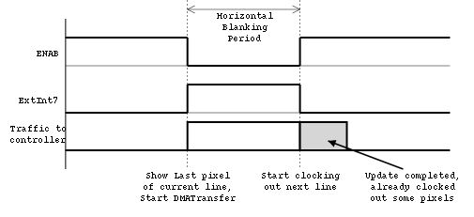

This situation will occur, due to the high frequency of the pixel clock and the 130 ns write time of the LCD controller. At 23.6 frames/second, the rate ultimately dictated by hardware, a new line would be required every 88.2 us with a pixel clock frequency of 12.572 MHz, as demonstrated in appendix C.3. The time required to transfer a single line (320 32-bit transfers), with a 130 ns write time would be 41.6 us. A horizontal blanking period of 60 pixels is only 4.8 us long, so clearly data will be written to the controller while pixels from earlier in the transfer are being displayed.

Discussion
This chapter described in detail the design of the display subsystem, and the options which were considered in deciding to use an FPGA as an external controller for the screen. The factors governing the selection were outlined and design of the hardware and software aspects was explained.

Implementation

Software tools used

Max+plusII IDE
Figure 8.16: Max+plus II screenshot
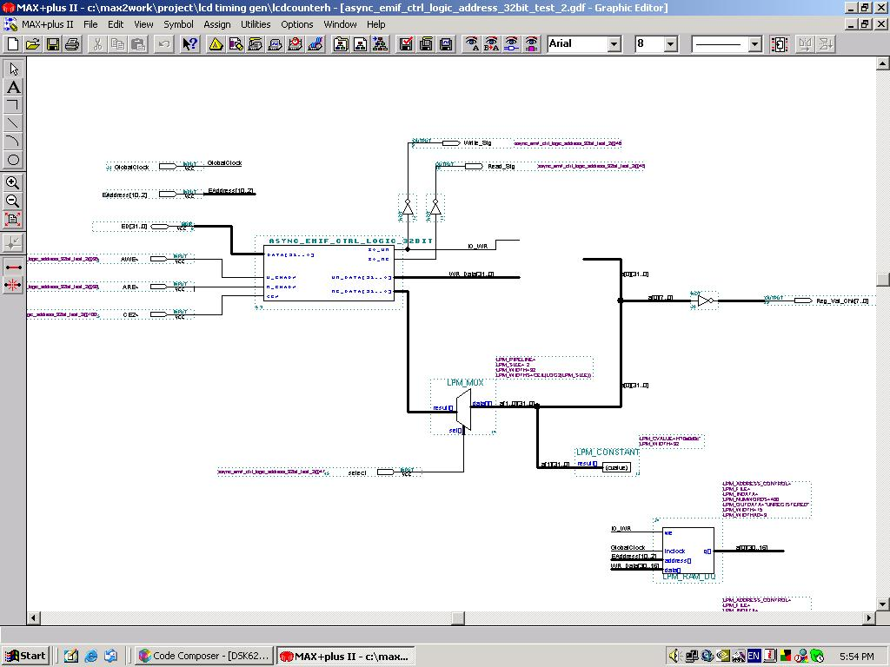

Max+plusII is the Integrated Development Environment (IDE) available from Altera for use with the older families of their programmable logic devices. A ‘Student Edition’ was used, which is capable of all functions, but is limited to the logic devices families used on Altera’s University Demonstration boards. It allows designs to be designed, compiled, simulated and programmed into those devices. There is a variety of entry methods for designs, both using graphical (schematic capture) approaches, and hardware description languages, including Verilog, VHDL or AHDL. Designs can be simulated and timing diagrams examined before the project is programmed into the hardware. Max+plusII supports JTAG programming for the devices as well, so all functionality is available in one application.

Max+plusII has been superseded by a newer IDE known as Quartus, however there were no ‘student’ editions of Quartus available which allowed compilation of designs into actual hardware, so Max+plusII was used. Please refer to appendix C for details on tool versions.

Code Composer Studio (CCS) IDE
Figure 8.17: Code Composer Studio Screenshot
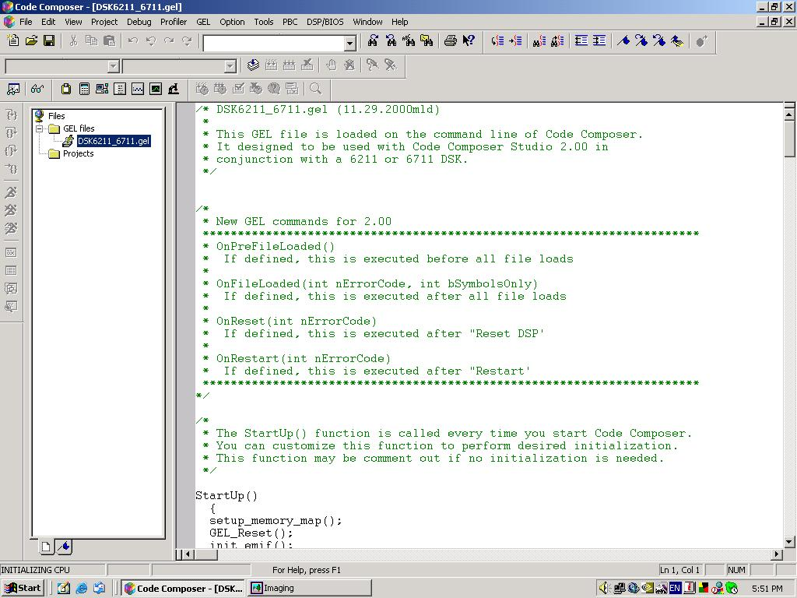

Code Composer is the IDE available from Texas Instruments for software development on many of their processors. The version used is specifically for the C67xx/C62xx series of DSPs, and is supplied with the evaluation board. CCS is capable of compiling code written in C, C++ and assembler. It also includes the simulating, programming and debugging functionality necessary for system development. CCS includes a Basic Input Output System (BIOS) such that settings for the DSP’s peripherals which will not vary during system operation can be manipulated graphically without needing to access the relevant registers directly. Although the functionality was not developed to the stage of needing to code in C, CCS was used when testing the interface between the DSP and FPGA, by directly modifying elements within the DSP’s memory.

Hardware overview
Although the LCD controller was ultimately not implemented in hardware in its entirety, various logic modules were loaded into the FPGA and tested using the DSP and FPGA boards. To achieve this, the two development boards were mounted on a baseboard, ensuring the security of the 56 individual wires whenever the device was moved. The final overall assembly, along with the screen module used, are displayed in Figure 8.18 below.

Figure 8.18: The final display hardware assembly
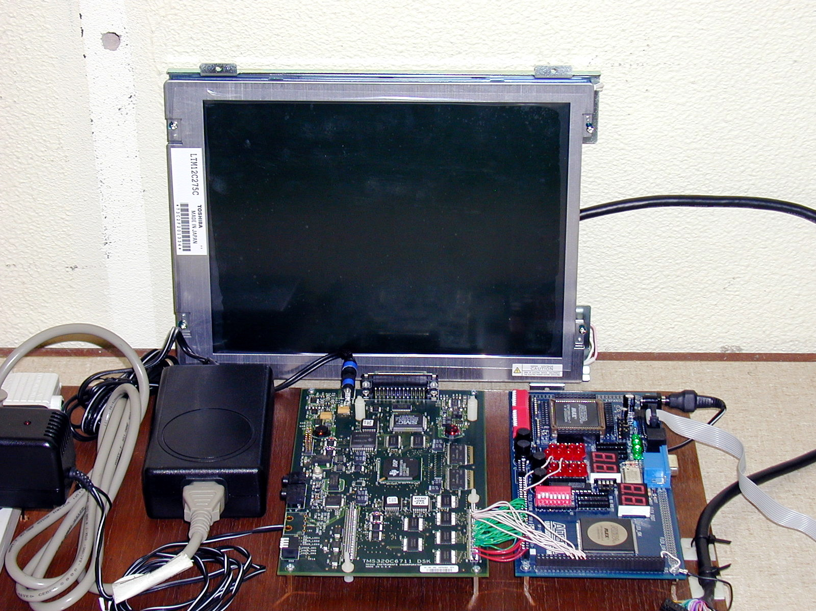

Screen selected
The panel ultimately selected was the LCD-Kit05 LCD Display Kit, purchased from ICP Australia and shown in Figure 8.18 above. The kit incorporated a 30.7 cm (12.1 inch) Toshiba LTM12C275C TFT display panel, two backlighting lamps and an inverter to drive them, mounted on a rigid steel chassis. The chassis provided protection for the components and allowed easier mounting of the module.

The LTM12C275C panel receives colour information using an 18 bit wide data bus, with 6 bits each for the red, green and blue sub-pixels, and requires a pixel clock and compound synchronisation signal, as described in chapter 7.3.

The LCD-Kit05 requires a dual voltage supply of 5 and 12 volts (to supply the TFT panel and backlight, respectively), and weighs 1.5 kilograms. The panel brightness is 250 cd/m2, which is sufficient for use indoors, and the response time of the screen is less than 40ms as confirmed by Chapman (2004) which makes it suitable for displaying video at 25 frames per second. The LCD-Kit05 therefore meets all the key requirements outlined in section 5.3.

Controller

Overview
Within this project, most of the implementation achieved occurred not in hardware, but in Max+plusII, the IDE used to create the logic to perform the operations required within the LCD controller. The LCD controller was implemented and simulated in its entirety within Max+plusII, as evidenced by the timing diagrams and logic schematics in the appendices. The design was not completely implemented in the FPGA, although some aspects of the controller were tested in hardware and found to perform as required. The failure to implement the complete controller in programmable logic was due to time constraints, and the reliance on further aspects of the LCD power control system which were not completed by the conclusion of the project.

The FPGA and DSP boards were connected however, and communications successfully established between them. The logic implementation of each of the design modules developed for the LCD controller are detailed in appendices F and G, as module descriptions and logic diagrams respectively.

FPGA hardware used
The LCD controller was designed to be implemental within an Altera Flex 10K20 FPGA. The department possessed many unused Altera UP1 development boards, each of which included a 10K20 FPGA. The 10K20 is a SRAM based FPGA with 20000 equivalent gates, and uses a 5 volt supply, making it directly compatible with both the screen and the DSP. The UP1 board obtained required the installation of header rows to allow simple connection and disconnection of wires to the DSP board.

The 10K20 has 12288 bits of dedicated internal RAM. The design was able to use this dedicated RAM, meaning that implementing a line buffer within the FPGA was possible, and allowed the creation of that buffer without reducing the other logic which could then be implemented. The UP1 development boards include an onboard oscillator used to provide a clock signal to the FPGA, with a frequency of 25.175 MHz.

Resource usage
When compiled in its final form for simulation, the final design of the implementation of the display subsystem required only 28 percent of the available logic within the FPGA, and used 62.5 percent of the internal memory. Throughout the design process, a shortage of resources within the FPGA was only encountered once. The shortage occurred when attempting to implement the buffer memory structure, and is due to a limitation with the 10K20 of the total number of data and address lines available in a single block of memory. By attempting to implement a 16-bit wide buffer, only eight address lines were available and only 256 memory locations could be implemented, rather than the 320 required. The shortage prompted a reduction in the buffer width to 12 bits, and in turn prompted the design of the dual colour/greyscale approach to data interpretation. Once these changes were made, the memory ceased to be a problem.

Screen usage
Although the enhanced images delivered by the DSP are 640 pixels wide by 480 pixels high, the physical screen selected has a resolution of 800pixels wide by 600 pixels high. As implemented, the image would appear in the top left-hand corner of the display, with a vertical strip 160 pixels wide and a horizontal strip 120 pixels high unused on the right and bottom edges of the display respectively. When connected, the display would likely show garbage along those two strips, as the addresses generated in the LCD signal generation logic do not stop when the end of the buffer is reached, they continue counting until the beginning of the next line is signalled. On these strips, as indicated in Figure 8.19 below, valid data is not retrieved from the line buffer memory. The pixel clock is still transitioning and the enable signal is still asserted however, so the screen will interpret any value on the data bus as a valid pixel colour.

Figure 8.19: Screen usage example
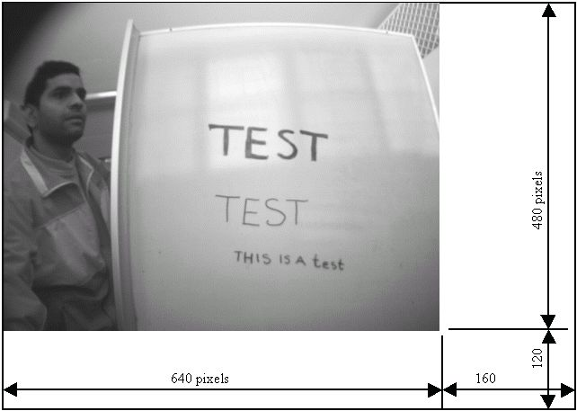

In a final product, scaling would need to be applied either in the LCD controller or in the DSP prior to being sent to the display subsystem. In this case, scaling was not explored due to the proof of concept nature of the project, and the fact that the DSP was unable to cope with the processing needs already placed on it, without imposing an additional and currently unnecessary burden.

Interface with DSP
In order to transfer data between the DSP and FPGA, the EMIF in the C6711 was configured to treat memory space two, which the FPGA was connected to, as asynchronous memory. As detailed in appendix C.3, the EMIF was configured to apply a write access time of 130ns, to guarantee that the buffer memory would successfully write every data element. The read parameter were left at their maximum duration, as no data would be read back from the FPGA via the EMIF in normal LCD controller operation. Although the LCD controller was not completed to a stage of receiving EDMA transfers or displaying output on the screen, the wiring connections were made between the DSP and FPGA in order to test the EMIF interface logic, which was completed successfully.

As detailed in appendix D, the 32 bit EMIF data bus and the lower 10 bits of its address bus, along with the memory control signals, were connected to the FPGA in memory space two. A basic design involving the EMIF interface logic and an internal block of single port RAM configured as 256 16-bit locations was implemented within Max+plusII and programmed into the FPGA. Using CCS, all 256 individual locations could be read from and written to successfully. For this reason, it is reasonable to assume little would be required to get the controller operative. The key operations would be to connecting the remaining address bits and CTwrite signal between the two boards, design and implement an external logic controlled power switch for the LCD panel’s power supply, and connecting the LCD panel.

Image acquisition

Camera module
The M3188A camera module used, shown in Figure 8.20 (Roboblock, 2004) below, is based on the OV7120 640x480 greyscale CMOS image sensor made by Omnivision.

Figure 8.20: M3188A CMOS camera module
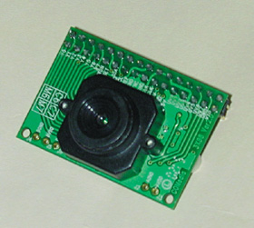

The module has an eight bit data bus, a pixel clock and vertical and horizontal synchronisation signals. Many internal parameters of the camera can be altered, including frame rate and scan type, both of which are important here. The control is performed using an I2C interface. The camera also has a composite video output which allowed an idea of an ‘expected’ picture, and allowed focussing to be performed.

Data interfacing betweeen the camera and the DSP
The data interface between the DSP and the camera was achieved using the McBSP available on the C6711, due to the lack of GPIO on the C6711. As outlined in chapter, the McBSP provides two high speed serial interfaces, with up to six bits available as input for each channel. After the appropriate configuration has been performed, the state of the pins can be reading by accessing the PCR register for the relevant McBSP channel. Within the PCR register, the six bits are not entirely contiguous, as shown in Figure 8.21 (Texas Instruments, 2004b) below. The pins available as inputs are circled.

Figure 8.21: Pin Control Register Structure

As the data bus from the camera was 8-bits wide, the approach used both McBSP channels, handling 4 data bits each and therefore allowing all eight bits to be captured. The respective nibbles were connected to the pins connected to the low four contiguous bits in the respective PCRs, as shown in Figure 8.22 below.

Figure 8.22: Camera Connection to both McBSP Channels
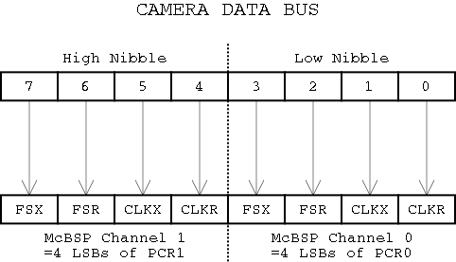

When the data became valid, as indicated by a positive transition on the pixel clocks and the synchronisation signals being high, the low byte of each PCR was stored by the EDMA into separate arrays. Once the complete frame was captured, post-processing was required to integrate the two arrays of half-pixels into a single array of valid pixels. Hence this arrangement resulted in twice the base amount of data being transferred, and additional processing to reassemble the pixel bytes. Unfortunately no alternative interfaces were available which were simple to connect to, so the McBSP was used.

The horizontal synchronisation signal from the camera, known as HREF, was used as described in chapter 6.2.3 to gate the pixel clock and ensure that the EDMA was triggered only when valid data required transferring, and not during either vertical or horizontal blanking periods. This gating was achieved by applying the pixel clock and HREF signals to the input of an AND gate within a standard 74HC08 quad AND gate IC. The only concern was the propagation delay of the IC, with too great a delay potentially resulting in invalid data being present when the gated clock signal reached the DSP. The propagation delay of the 74HC08 is approximately 7 ns (Philips Semiconductor, 2003) , which was acceptable at 30 fps when the pixel clock operates with a period of approximately 74 ns, and was therefore fine at any slower frame rate as well.

Figure 8.23: Synchronisation and control signals for camera

The gated version of the pixel clock signal was connected to the Ext_Int4 and Ext_Int5 pins on the DSP, with the DMA configured to use those pins as triggers for the transfers. It was not possible to assign the same external interrupt pin as a trigger for more than one EDMA channel, so both pins were required. In the final arrangement, the vertical sync signal was not required, due to the use of a mode of the camera which allowed delivery of a single frame rather than a stream.

The OV7120 is capable of outputting a continuous stream of images at a rate of 30 fps or less as specified, but is also capable of delivering a single frame on request and lying idle otherwise. After various other aborted configurations, this mode, known as SRAM mode for its use in transferring to external memory, was used. By either writing to a control register within the camera via I2C, or by delivering a pulse to one of the external pins of the OV7120, the transfer of a single frame could be started. With this configurations, there are no concerns with determining the start of the frame in the arrangement, and the EDMA can automatically disable itself after 307200 pixels due to the pixel clock gating. The pulse was delivered by using one of the McBSP pins configured as an output.

Problems were experienced when operating both McBSP channels simultaneously, as required for the above implementation. Irrespective of the connection and EDMA configuration used, the C6711 was unable to retrieve data at a rate higher than three fps. At higher rates, the EDMA would stop transferring information or would transfer rubbish shortly after first being triggered. It is thought that higher frame rates may have simply seem the EDMA being called to transfer data too frequently.

At a frame rate of 15 fps, retrieval of a 640 pixel wide by 480 pixel high image with this method would require 4608000 transfer per second for each channel. Therefore, as both channels need to operate, the total number of transfers required of the EDMA would have been 9216000 each second. The EDMA was incapable of this task at high frame rates, likely due to the short time between transfers at high frame rates and the transfer latency, described as the “time from event to the beginning of transfer at the source peripheral” (Texas Instruments, 2004c). The transfer delay from an on-chip peripheral such as the McBSP is specified as approximately 25 CPU clock cycles, equating to 167 ns at 150 MHz. In this case, the absolute maximum transfer rate achievable assuming an infinitesimally small transfer time would be approximately 6000000 transfers per second. Clearly frame rates beyond 20 frames per second are totally unachievable. Add to this the actual time required to perform the transfers to the external SDRAM and the poor frame rate is understandable.

Irrespective of the problems, the camera was successfully interfaced, the advantage of which is the ability to capture images and then process them. Figure 8.24 is an example image captured from the camera.

Figure 8.24: Greyscale image captured from camera
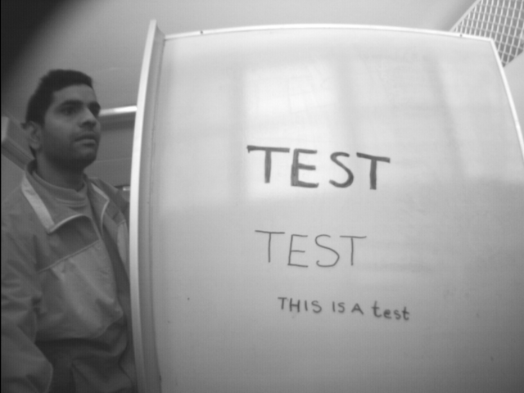

Controlling the camera
The default configuration of the M3188A was to output its data as a 60 Hz interlaced stream, to suit NTSC monitors connected to the analog output. To avoid unnecessary reordering the video required from the camera was progressive scan with a frame rate of 25 or 30 Hz, and preferably configurable to a range of lower rates for testing purposes. The M3188A was capable of this, but access to the internal registers required is only possible using an I2C interface. The C6711 has no I2C interface on board, and for development purposes a separate microcontroller with an I2C interface was used, the Zilog ZF6403. The result was unwieldy however, and a later version may use a McBSP channel as an I2C bus master, although this could not be explored in this case as both McBSP channels were in use to capture data from the camera.

Further developments to camera interface
As a development to the existing interface, thought has been given to using an external controller, perhaps implemented in an FPGA, to provide the DSP a memory mapped interface to the camera. A basic scheme could use an FPGA simply to provide access to the full 8-bit pixel value in a single transfer rather than the existing arrangement requiring two accesses and post-processing. A more advanced version could include buffering capability similar to the LCD controller, allowing a reduced number of discrete EDMA triggerings in a given timeframe, and reducing the impact of the transfer latency.

Discussion
This chapter examined the implementation of the display and image acquisition subsystems of the LoVIE, detailing the reasons for the particular hardware arrangements used.

Testing and Results

Overview of testing methods
The display subsystem required development in embedded logic, software and hardware arenas. The final architecture, an LCD controller implemented in an FPGA, implicitly determined the sequence of testing for the subsystem as a collection of modules. The display hardware and the servicing software within the DSP both rely on the controller to operate. The testing of the system therefore needed to start from the component modules within the controller, which were then incorporated and tested incrementally into a progressively more functional controller. Once the controller was operating, the connection to the DSP could be made, and the relevant software in the DSP could be tested. The final stage of testing would be to connect and test the display hardware. The sensitivity of the display required that all aspects of the controller be fully developed before any hardware testing occur.

The modular nature of the LCD controller design led to a multi-layered approach to logic testing, with each module separately subjected to ongoing simulation within Max+plusII during development, then being tested within the FPGA where possible, and finally integrated into the larger LCD controller design. Two levels of simulation were performed for each module developed; an initial simulation to ensure design functionality was achieved, and a secondary simulation to check the timing response of the module. Due to time constraints and the abortive controller architectures initially considered, the controller was not completed sufficiently to allow testing of the DSP software or screen hardware aspects of the display subsystem. Some aspects of the system were tested isolated from the other design modules, such as the EMIF interface detailed in chapter 8.4.5.

Logic Simulation Results
After creating the logic required for each module within Max+plusII, the modules were tested individually, with the results as per the timing diagrams in appendix G. The incremental approach used led to a minimum of errors at the module level, with all modules operating as designed. Only one issue was experienced when simulating logic within Max+plusII, relating to the program’s treatment of any input or output pins on the module being treated as external to the FPGA. The result was demonstrated as an apparently large delay for signals to progress through the first stage of logic. This problem is shown in Figure 9.25 below, where the ClockDivider module has an apparent propagation delay of 13.9 ns. Most of the delay is the simulated time from an external FPGA pin to the internal logic, with an actual propagation delay of only 6.1 ns through the clock divider.

Figure 9.25: Simulated FPGA input delay

The way to force Max+plusII to treat the signals to a module under test as coming from another module on-board the FPGA was not discovered, and so affected the appearance of all timing diagrams in appendix G.

Results of FPGA module testing

EMIF interface logic
As mentioned in earlier chapters, the EMIF interface logic was successfully tested in the FPGA. The FPGA was connected to the DSP’s EMIF, and the EMIF control registers for memory space two set to a setup time of two cycles, a strobe time of nine cycles and a hold time of two cycles, for the reasons detailed in appendix C.3. The EMIF interface logic converted the EMIF control signals correctly and multiplexed signals onto the EMIF’s bidirectional data bus as required, without any conflicts. Although no read functionality was applied in the final design, the testing in the FPGA allowed reading back values, an operation which was successfully completed.

LCD timing signal generation
The LCD timing signal module was implemented and tested within the FPGA, to examine the Enable waveform generated and ensure the timing requirements of the screen were being met. The enable signals produced performed as expected, and as per the timing simulation in appendix G.

Clock Dividing Logic
The ClockDivider module was successfully tested in the FPGA, when testing was underway to find the cause of the excessive delays indicated on the timing simulations and explained in chapter 9.2 above. To find the actual propagation delay for the module, the clock signal being halved was tapped internally and connected to an output pin. Hence the phase difference between the triggering clock and the halved clock could be observed and the actual delay determined. The delay was found to be 4.4 ns, corresponding reasonably with the simulated 6.1 ns from chapter 9.2 above.

Results of system-wide testing
Although testing could not be performed on the complete LCD controller logic when connected to the DSP, connections between the DSP and FPGA were made as per appendix C, and basic tests performed to verify the asynchronous configuration of the EMIF and elements of the EMIF interface logic. A 16-bit wide 256 location memory block was implemented in the FPGA, with address decoding and memory control logic. The register in the FPGA was successfully accessed as part of the DSP’s memory map. This verified the EMIF interface logic could control access to the EMIF data bus to avoid bus conflict, and that the address decoding logic was operating correctly, in isolation.

Discussion
This chapter detailed the testing processes used in the operational evaluation of the modules and overall controller. The small problem encountered with the simulation package was explained, and details given for the testing arrangements of those modules which were further tested within the FPGA.

Conclusions

Summary of overall system
The hardware development undertaken for this project has demonstrated the difficulty interfacing peripherals to the C6711 processor without external glue and buffering logic, especially for equipment which required the transmission or receipt of data in strict timeframes. In its current state, the components of the system are mostly developed, but are still distinct, and there is little interaction between them. The reasons for this relate particularly to the processing and bandwidth requirements of the display, image acquisition and image processing subsystems, which all individually load the system to an unusable level.

The development of the display subsystem was incomplete, due both to the susceptibility of the screen to damage, and the decision to develop a customised controller/buffer solution which needed to account for this. The limitations which have been discovered with this approach should encourage further development on the display subsystem to concentrate on using a commercial controller chipset, which would deliver bandwidth and utilisation advantages for relatively little cost. It is important that the bandwidth issues revealed when attempting to implement the LCD controller are addressed, as the EMIF is a critical juncture for the image processing and the display subsystems and excessive bandwidth usage by either aspect will heavily impact the overall system performance.

The image acquisition subsystem is operable, but hamstrung because of the limited GPIO inputs of the C6711 chip itself, and the image processing subsystem operates but at a very low throughput due to the many operations which must be performed. The control for the camera is currently handled by a separate external controller with an appropriate I2C controller built in, removing any direct control of the DSP over the camera.

The most immediately useful and extendable result from this project is the set of enhancements developed by the other project partners, which can be applied to images irrespective of source or destination, to make subject matter more interpretable for people with low vision, for example within enhancement software developed for use on a desktop computer.

Further developments to product
There are a range of improvements which could be made to the LoVIE in terms of the system architecture, the subsystem designs, and additional features which would extend the use of the device for relatively small effort.

For a releasable device intended to view subjects at a range of distances, incorporation of an autofocus method for the camera would be necessary and needs development. This would simplify setup and use of the device for a user who may not be able to judge the focus accurately, and would maximise image quality before enhancements were applied.

At the architectural level, it is important to consider the suitability of the C6711 as the heart of the device given the limited interfaces available which force contorted approaches to connect the various peripherals. Other processors exist which have a much wider variety of interfaces built in, and DSP capabilities onboard. Of particular interest is the dual-core Texas Instruments OMAP5910, which has a 150 MHz c55x DSP and 197 MHz ARM processor in a single package. The onboard LCD controller and keypad and CMOS camera interfaces would meet all the requirements of the LoVIE’s peripherals, and the inbuilt I2C controller would allow camera configuration. If the processing power of the c55x DSP was insufficient, a separate C671x floating point DSP could be employed as a coprocessor. The mobile power supply aspect of the LoVIE would require development, having been disregarded in this proof-of-concept stage.

Improvements can be made at a lower level for each subsystem, beyond selecting more appropriate hardware to condense the device around. The image processing subsystem has issues with the processing time required for each frame (Beaumont-Field, 2004), (Arulliah, 2004). Optimisations for the algorithms used must therefore be explored and the throughput increased as much as possible. The image acquisition subsystem is also limited in its capture rate, due to the implementation required by the C6711’s interface limitations. Other than using a processor with a dedicated camera interface such as the OMAP5910, it may be possible to use an external controller to capture the pixels as 8 bit values rather than two 4 bit values, and to buffer the pixels received. This would allow retrieval by the main processor in a more efficient way, with less constrictive timing requirements. The user interface subsystem requires development, particularly in the software aspect and ideally with the extension to a large on-screen display to simplify changing parameters. Future developments for the display subsystem are detailed in the following section.

Improvements to design of subsystem
If the current FPGA-based display subsystem design is extended, there are a number of changes which could be made to improve the update rate to the screen, decrease bandwidth requirements and reduce the frequency of buffer refreshes. As most of the EMIF bandwidth consumed when writing to the screen occurs because of the slow nature of the buffer RAM in the FPGA, using external higher speed memory could alleviate this bottleneck. The current design requires 13 EMIF clock cycles for a write access which, as shown in appendix C.3, suggests an effective EMIF bandwidth utilisation of 47.2 percent at 23.6 frames per second. Any reduction in access time, and hence increase in transfer rate, would be mirrored by an equivalent reduction in EMIF use. For example, if the access time could be reduced to 5 EMIF cycles, the effective bandwidth used would drop to 18.2 percent. If a memory large enough to hold an entire frame, or preferably two, was used, the DSP would only need to perform a single DMA transfer every 42 ms (at 23.6 fps), much less than the 11344 times/second currently required. Unfortunately, the only way to reduce the access time and increase the frame rate in the current implementation is to supply the FPGA a clock signal faster than that from the onboard 25.144 MHz oscillator.

If the C6711 remained the central processor, the preferred approach would be to use a dedicated external LCD controller chipset, such as the Epson SED1356. The controller uses dedicated frame buffer memory capable of storing two frames, one to be displayed while the other is updated.

Future enhancements to increase utility
Further to the future developments of the LoVIE outlined above, many broad improvements are possible to increase the utility and ease of use of the device for users with low vision.

A set of individually customisable profiles could be stored, for users who used the device in a limited set of fairly environments which are each different, but individually vary little between visits. Any modifications to parameters could be stored in a profile, for example a specific lecture theatre, and the appropriate profile selected on startup. This tuning for a number of environments would reduce the effort required by the user when using the LoVIE.

The potential need to constantly re-aim the camera from textbook to lecturer when in a class may be distracting for some users, as well as fellow classmates. A possibility could be to connect an optional second camera, allowing one camera to be dedicated to the distant subject and the builtin camera to be aimed at any near subjects, such as a textbook or notepad. The change between the two distances would then require simply pressing a button.

Further to the development of a large onscreen display for the User Interface, some limited form of voice command may be possible to further simplify changing of parameters is important, given the range of parameters within the system and the low vision of the users.

Finally, the inclusion of a light source with the LoVIE, perhaps consisting of an LED array, would allow use in low light. The greyscale camera module selected is sensitive to infrared light, so the inclusion of white and infrared LEDs would make the device would be useful for reading even in environments where white light may distract others, such as at night on an aircraft or bus.

References

Anon. (1993). LCD Frequently Asked Questions (compiled Bruck, S.). Retrieved in August 2004 from http://margo.student.utwente.nl/el/misc/lcd_faq.htm

Arulliah, E. (2004). Image Acquisition and Processing in the Low Vision Image Enhancer. Undergraduate thesis, Curtin University of Technology, Bentley

Ash Technologies (2004). Liberty Solo – Battery Operated, Big Screen. Ash Technologies. Retrieved in October 2004 from http://www.ashtech.ie/site1/libsolo.htm

Association for the Blind of Western Australia (2004). Understanding Blindness: Understanding blindness and eye conditions. Association for the Blind of Western Australia. Retrieved in July 2004 from http://www.abwa.asn.au/understandingblindness.html

Beaumont-Field, J. (2004) Image Acquisition and Processing in the Low Vision Image Enhancer. Undergraduate thesis, Curtin University of Technology, Bentley

Chapman, E. (marketing@icp-australia.com.au) (9th March 2004). RE: LCD Video Quality? Personal email to J. Lowe (joshua.lowe@student.curtin.edu.au)

Corn, A. L., Wall, R. S., Jose, R. T., Bell, K. B., Wilcox, K. & Perez, A. (2002), An Initial Study of Reading and Comprehension Rates for Students Who Received Optical Devices. Journal of Visual Impairment & Blindness, 96, 322-334.

De Leo, D., Hickey, P.A., Meneghel, G., Cantor, C.H. (1999). Blindness, fear of sight loss, and suicide. Psychosomatics, 40, 339-44. Retrieved in 2004 from ProQuest database.

Freedom Vision. (2003). Freedom Vision Low Vision Products. Freedom Vision. Retrieved in September 2004 from http://www.freedomvision.net/

Goodrich, G. L. (2003). Available and Emerging Technologies for People with Visual Impairment. Generations, 27, 64-70. Retrieved in 2004 from ProQuest database.

HealthInsite (2004). Low Vision Conditions. Retrieved in May 2004 from http://www.healthinsite.gov.au/topics/Low_Vision_Conditions

Henry, G. (2004). Improve efficiency for compact CCFLs. PennWell Corporation.
Retrieved in October 2004 from http://pd.pennnet.com/Articles/Article_Display.cfm?Section=Articles&Subsection=Display&ARTICLE_ID=213622

Horowitz, A. (2003). Depression and Vision and Hearing Impairments in Later Life. Generations, 27, 32-38. Retrieved in 2004 from ProQuest database.

HowStuffWorks Inc. (n.d.). What is the difference between CCD and CMOS image sensors in a digital camera? HSW Network. Retrieved in October 2004 from http://electronics.howstuffworks.com/question362.htm

Independent Living Aids Inc (2004). Enhanced Vision Systems Cameras, Flipper Camera. Independent Living Aids Inc. Retrieved in October 2004 from http://www.independentliving.com/products.asp?dept=151&deptname=

International Business Machines (2004). 14.1-inch TFT LCD Color Monitor (9514) – Overview. International Business Machines. Retrieved in October 2004 from
http://www-1.ibm.com/cgi-bin/pc/support/supportR5lite/pagegen/qtechinfo/en_US/MIGR-43535.html?lang=it_IT&page=brand&brand=IBM+Monitors&family=&machineType=&doctype=Product+information&subtype=All&up=login944070707

LaGrow, S. J. (1981). Effects of Training on CCTV Reading Rates of Visually Impaired Students. Journal of Visual Impairment & Blindness, 75, 368-372

Larson, K. (2004). The Science of Word Recognition. Microsoft Corporation. Retrieved in October 2004 from http://www.microsoft.com/typography/ctfonts/WordRecognition.aspx#win

Lussenhop, K. & Corn, A. L. (2002). Comparative Studies of the Reading Performance of Students with Low Vision. RE:view, 34, 57-69. Retrieved in 2004 from ProQuest database.

Mitsubishi Semiconductor (1999). M16C/62 Group Single Chip 16-Bit CMOS Microcomputer Datasheet. Mitsubishi Semiconductor. Retrieved in May 2004 from http://www.m16canz.com

NEC-Mitsubishi Electronics Display (2003). NEC CRT Desktop Displays. NEC-Mitsubishi Electronics Display. Retrieved in October 2004 from http://www.necmitsubishi.com/products/matrices/NEC_CRT_matrix_July2003.pdf

Omnivision (2001). OV7120 SINGLE-CHIP CMOS VGA B&W DIGITAL CAMERA. Omnivision. Retrieved in May 2004 from http://www.electronic-kits-and-projects.com/kit-files/ovt/OV7620_OV7120_v1.2whole.pdf

Optoma Technology (n.d.). Technical Support: Glossary. Optoma Technology. Retrieved in September 2004 from http://www.optomausa.com/marketing/glossary.asp

Philips Electronics (1998). 74HC/HCT174 Hex D-type flip-flop with reset; positive-edge trigger. Philips Electronics N.V. Retrieved in October 2004 from http://www.standardproducts.philips.com/products/hc/pdf/74hc174.pdf

Philips Electronics (2003). 74HC/HCT08 Quad 2-input AND gate. Philips Electronics N.V. Retrieved in October 2004 from http://www.semiconductors.philips.com/acrobat_download/datasheets/74HC_HCT08_3.pdf

Roboblock (2004). Robot Venture. Roboblock. Retrieved in October 2004 from http://www.roboblock.com.kr

Royal Victorian Institute for the Blind (2002). Aladdin CCTV’s. Royal Victorian Institute for the Blind. Retrieved in September 2004 from http://www.rvib.org.au/vistech/products/cctv/aladdin.shtml

Sharp Electronics Corporation (n.d.). LCD vs. Plasma. Sharp Electronics Corporation. Retrieved in October 2004 from http://www.sharpusa.com/products/lcd_vs_plasma/0,2340,,00.html

Texas Instruments (2004a). TMS320C6000 DSP External Memory Interface (EMIF) Reference Guide. Texas Instruments. Retrieved April 2004 from http://www.ti.com

Texas Instruments (2004b). TMS320C6000 McBSP: UART. Texas Instruments. Retrieved October 2004 from http://www.ti.com

Texas Instruments (2004c). TMS320C671x/TMS320C621x EDMA Performance Data. Texas Instruments. Retrieved October 2004 from http://www.ti.com

Texas Instruments (2004d). TMS320C6711, TMS320C6711B, TMS320C6711C, TMS320C6711D FLOATING POINT DIGITAL SIGNAL PROCESSORS. Texas Instruments. Retrieved in March 2004 from http://www.ti.com

Toshiba Corporation (2001). Specification for Toshiba TFT-LCD module LTM12C275C. Received via email from ICP Australia, 16 March 2004

.

Appendix A – Project Plan
Figure A.26: Project plan page one
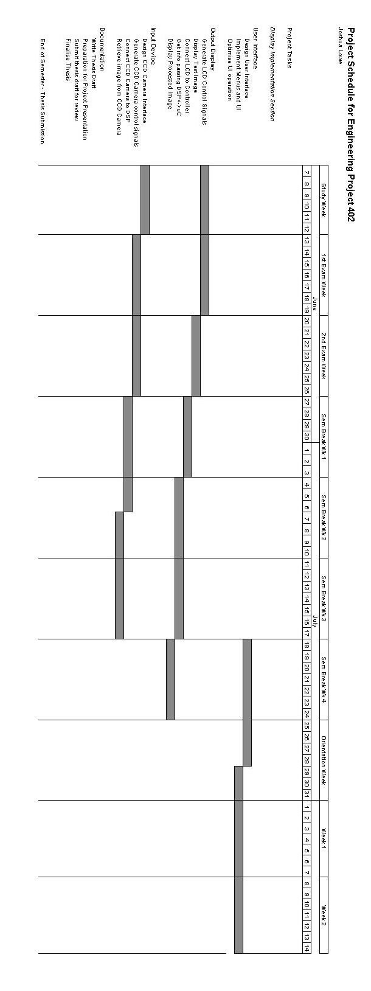
Figure A.27: Project plan page two
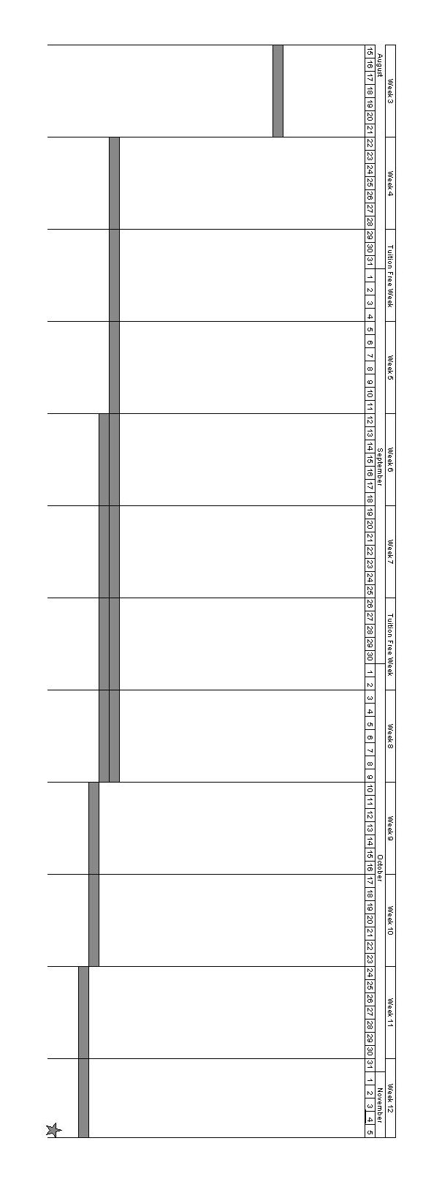

Appendix B – Project Cost Estimation

Please note that only the items with a price marked were actually purchased for this project. Unpriced items were borrowed from the technical store.

Item | Price
M3188A Camera module (Price retrieved from www.electronics123.com, 2004) | US$61.70
LCD_Kit05 12.1” TFT LCD Kit (Price from ICP Australia Quote, 2004) | AU$1100
Texas Instruments TMS320C6711-150 DSK
Altera UP1 Development Board

AppeNDIX C: SOFTWARE TOOL VERsions

Altera Max+plusII: version 10.2
Texas Instruments Code Composer Studio: 2.00

Appendix D - Effective Bandwidth Usage Calculations

Derivation
For a stream of data with a consistent inter-transfer period, a constant amount of data transferred and a known transfer speed, the percentage used of total time available on the medium can be calculated. These calculations are primarily relevant to traffic due to the display, and so calculations are in terms of pixels rather than bits. The figure below gives a graphical representation of the stream.

Figure D.28: Bandwidth usage of a Periodic Transfer
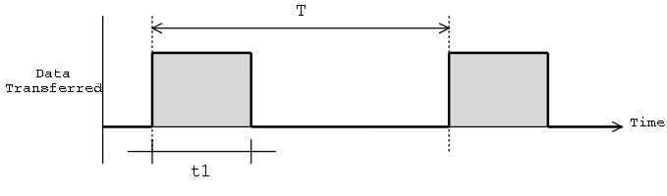

For the purpose of this derivation, the following terms are defined:

Term | Definition
Block transfer | A transfer of multiple pixels in a single block.
Access | A single read or write event on the data bus.

Furthermore, parameters are defined:

Parameter | Definition
T | Period in seconds between the starts of consecutive block transfers.
t1 | Time in seconds required to complete the block transfer
A | Number of pixels transferred in a one access
B | The total number of pixels in a block transfer
C | The time required per access.

To find the time spent for a given block transfer, the total number of accesses required to move all pixels is multiplied by the time per access:
$$t1=\left(\frac{B}{A}\right)×C$$
The effective bandwidth usage can then be found as a percentage :

$$\text{Bandwidth}\text{\%}=\frac{t1}{T}×\text{100}=\frac{B×C}{A×T}×\text{100}$$

Case 1: Direct Connection of DSP to LCD
When the LCD is directly driven by the DSP, it must transfer one pixel of data every pixel clock transition. To achieve an LCD update rate of 15 frames per second, with an overall LCD frame of 860 pixels wide by 615 pixels high, the pixel clock will need to transition at a frequency of:

$$f_{\text{PClock}}=\text{860}×\text{615}×\text{15}=\text{7933500}\text{Hz}$$

In actual fact, an eight megahertz crystal would be used to generate the pixel clock, so that is assumed for these calculations. The interval between pixel data being required then is the period of that crystal:

$$T=\frac{1}{\text{8000000}}=\text{125}\text{ns}$$

The data to the screen is a single pixel wide, and only one pixel is delivered each cycle of the pixel clock. The parameters A and B are both one.

Parameter C, the time required per access, is determined by the setup and hold times of the D flipflop used to maintain the pixel colour data to the screen between updates. The EMIF is configured to treat the screen as asynchronous memory, and has a defined setup and strobe time for the data transferred as per Figure 4.5.

Assuming the use of a 74HC174 hex D flipflop, the setup and hold times would be 12 ns and 3 ns respectively (Philips Electronics, 1998) . An additional 7 ns hold time is allowed for the propagation delay of the write pulse though the memory control decoding logic. The setup and strobe (equivalent to hold) periods allowed by the EMIF are in 10 ns increments. The setup and hold times are rounded up to 20 ns and 10 ns respectively. The C parameter is the total of the setup and hold times, 30 ns.

The percentage of effective bandwidth used is then:

$$\text{Bandwidth}\text{\%}=\frac{B×C}{A×T}×\text{100}=\frac{1×(\text{30}×{\text{10}}^{−9})}{1×(\text{125}×{\text{10}}^{−9})}×\text{100}=\text{24}\text{\%}$$

Case 2: FPGA Used as an LCD controller
In this case the FPGA acts as a line buffer, storing one full line of pixels from the DSP at a time and clocking them out to the screen until the line is complete. A full new line is then requested. For these calculations, the image received from the DSP is 640 pixels wide by 480 pixels high and is displayed at 23.6 frames per second. At this rate, a new line is required 11344 times per second, and so parameter T is (1/11344). The EMIF data bus is 32 bits wide, while an individual pixel element is 12 bits wide. Two such pixels can be transferred every EMIF access, so parameter A is two. As 640 pixels pixels in total are required each block transfer, parameter B is 640.

Due to the synchronous nature of the dual-port memory in the FPGA, a transfer requires the write strobe be asserted for at least one full pixel clock cycle to ensure it will be detected. The data and address lines must be setup before, and be held after, the strobe occurs, so they can stabilise before being latched into the memory. The pixel clock operates at 12.5875 MHz, half the frequency of the 25.175 MHz oscillator onboard the FPGA development board. Hence the strobe must be active for a minimum of 79 ns – to be sure of success, this was extended to 90 ns. The setup and hold times were selected as 20 ns each on the assumption that this would be fast enough. Hence parameter C is 130 ns, which corresponding to 13 EMIF clock cycles.

The percentage of effective bandwidth used is then:
$$\text{Bandwidth}\text{\%}=\frac{B×C}{A×T}×\text{100}=\frac{\text{640}×(\text{130}×{\text{10}}^{−9})}{2×(1/{\text{11344}})}×\text{100}=\text{47}\text{.}2\text{\%}$$

However, if C could be reduced to 50 ns, the bandwidth use would drop to:

$$\text{Bandwidth}\text{\%}=\frac{B×C}{A×T}×\text{100}=\frac{\text{640}×(\text{50}×{\text{10}}^{−9})}{2×(1/{\text{11344}})}×\text{100}=\text{18}\text{.}2\text{\%}$$

Appendix E – Table of Wiring Connections between DSP and FPGA

DSP Signal Name | J1 Header Pin No | EXPAN_A Header Pin Number | EXPAN_B Header Pin Number | 10K20 Pin Number
AWE~ | 74 | 51 |  | 95
ARE~ | 73 | 53 |  | 98
CE2~ | 78 | 55 |  | 100
ED0 | 70 | 50 |  | 94
ED1 | 69 | 49 |  | 88
ED2 | 68 | 48 |  | 87
ED3 | 67 | 47 |  | 86
ED4 | 66 | 46 |  | 84
ED5 | 65 | 45 |  | 83
ED6 | 64 | 44 |  | 82
ED7 | 63 | 43 |  | 81
ED8 | 60 | 42 |  | 80
ED9 | 59 | 41 |  | 79
ED10 | 58 | 40 |  | 78
ED11 | 57 | 39 |  | 76
ED12 | 56 | 38 |  | 75
ED13 | 55 | 37 |  | 74
ED14 | 54 | 36 |  | 73
ED15 | 53 | 35 |  | 72
ED16 | 50 | 34 |  | 71
ED17 | 49 | 33 |  | 70
ED18 | 48 | 32 |  | 68
ED19 | 47 | 31 |  | 67
ED20 | 46 | 30 |  | 66
ED21 | 45 | 29 |  | 65
ED22 | 44 | 28 |  | 64
ED23 | 43 | 27 |  | 63
ED24 | 40 | 26 |  | 62
ED25 | 39 | 25 |  | 61
ED26 | 38 | 24 |  | 56
ED27 | 37 | 23 |  | 55
ED28 | 36 | 22 |  | 54
ED29 | 35 | 21 |  | 53
ED30 | 34 | 20 |  | 51
ED31 | 33 | 19 |  | 50
EA2 | 26 |  | 24 | 119
EA3 | 25 |  | 23 | 118
EA4 | 24 |  | 22 | 117
EA5 | 23 |  | 21 | 116
EA6 | 20 |  | 20 | 115
EA7 | 19 |  | 19 | 114
EA8 | 18 |  | 18 | 113
EA9 | 17 |  | 17 | 111
EA10 | 16 |  | 16 | 110
Ground | 80 |  | 60

Appendix F – Description of Logic Modules

ClockDivider

Figure F.29: ClockDivider module symbol
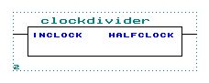

Description
The clock divider module accepts an input clock signal and provides an output clock signal at half the frequency. The divided clock changes state on each positive edge of the input clock.

Input Connections
Name | Width (bits) | Description
InClock | 1 | The clock signal to be divided by two.

Output Connections
Name | Width (bits) | Description
HalfClock | 1 | The clock signal running at half the speed of InClock.

AsyncEMIFInterface

Figure F.30: AsyncEMIFInterface module symbol
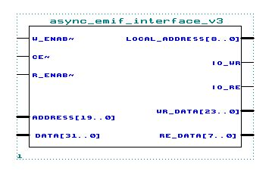

Description
The AsyncEMIFInterface module interfaces the signalling used by the EMIF with that used by the logic in the LCD Controller. It performs multiplexing and demultiplexing to interface the tristate data bus used for the EMIF with the separate binary read and write busses used in the controller. It performs address decoding from the EMIF address bus and generates read and write pulses for other system logic. In its current implementation the upper 11 bits of the EMIF address must all be zero for the read or write signals to be enabled.

Input Connections
Name | Width (bits) | Description
~W_Enab | 1 | This active low signal is the EMIF asynchronous write strobe. It pulses low when the EMIF writes to a location in asynchronous memory.
~R_Enab | 1 | This active low signal is the EMIF asynchronous read strobe. It pulses low when the EMIF reads from a location in asynchronous memory.
~CE | 1 | The EMIF has four memory spaces it can access, each with a separate active low CE line. When this line goes low, a read or write may be imminent. It will be held low for the duration of the access.
Address | 20 | The EMIF’s address bus connects to this input.
Data | 32 | Data is connected to the EMIF’s bidirectional data bus.
RE_Data | 8 | RE_Data is a byte-wide bus onto which values are placed when the DSP is performing a read. It is connected to the EMIF data bus through a tristate buffer so it is only placed on the EMIF bus when the DSP expects it, and bus conflicts are avoided.

Output Connections
Name | Width (bits) | Description
Local_Address | 9 | The Local_Address output is just the least significant nine bits of the EMIF address bus. It is decoded by the buffer memory and IO register to determine if they are being addressed, after which they will wait for a write strobe before taking action.
IO_WR | 1 | IO_WR is the write strobe, and is high whenever both ~CE and ~W_Enab are low and the EMIF memory address is relevant. It strobes once per write from the EMIF.
IO_RE | 1 | IO_RE is the read strobe, and is high whenever both ~CE and ~R_Enab are low and the EMIF memory address is relevant. It strobes once per read from the EMIF.
WR_Data | 24 | WR_Data is a condensed version of the EMIF data bus, as detailed in the diagram below. It is used by both the buffer memory and the IO register.

Figure F.31: EMIF – WR_Data Restructuring
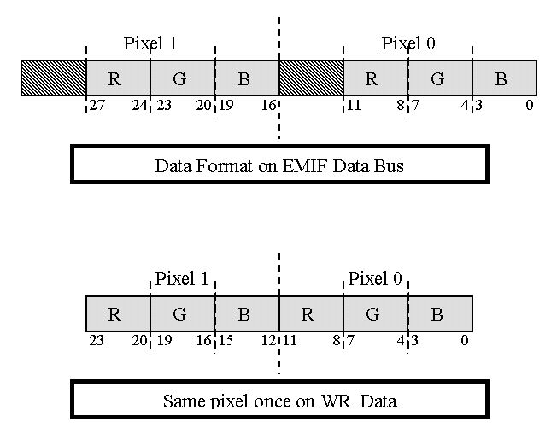

IO_Register_Logic

Figure F.32: IO_Register_Logic module symbol
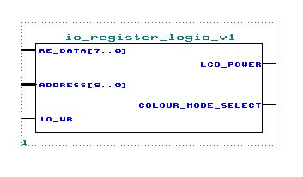

Description
The IO_Register_Logic module provides a mechanism to select between colour and greyscale data handling modes, and to control the external power enable pin for the display. The lowest two bits of the data bus are latched into flipflops, and their output used to drive the LCD_Power and Colour_Mode_Select outputs. In its current implementation, the register exists at an offset of 0x180 from the controllers base address, with the LCD_Power bit at RE_Data0, and the Colour_Mode_Select bit at RE_Data1.

Input Connections
Name | Width (bits) | Description
RE_Data | 8 | RE_Data is the data bus, of which bit 0 is latched in as the LCD_Power bit, and bit 1 is latched in as the Colour_Mode_Select bit.
Address | 9 | This is the address bus. To write a value to the register, an address of 0x180 is required.
IO_WR | 1 | The IO_WR line is the write strobe, used to clock data into the register. Data is latched in on the positive edge of this strobe.

Output Connections
Name | Width (bits) | Description
LCD_Power | 1 | This line is used to control the gating of signals to the display, and to control the switch or FET controlling power to the LCD. It will assume the state of RE_Data bit 0 when the register is written to.
Colour_Mode_Select | 1 | This line is used to control the logic which restructures data from the buffer depending on whether it is for colour or greyscale display. It will assume the state of RE_Data bit 1 when the register is written to.

Output_Signal_Gating
Figure F.33: Output_Signal_Gating module symbol
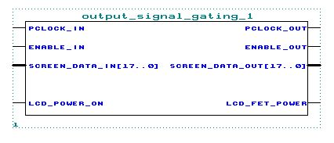

Description
The Output_Signal_Gating module is used to protect the LCD module used, by gating all signals to the LCD display to ensure they are at a low logic level when power is disabled. The external switching logic, assumed to be a MOSFET, is connected to this module also.

Input Connections
Name | Width (bits) | Description
PClock_In | 1 | PClock_In connects to the always-running pixel clock signal.
Enable_In | 1 | Enable_In is the input for the ungated enable signal.
Screen_Data_In | 18 | Screen_Data_In is the input for the ungated data signal .
LCD_Power_On | 1 | The appropriate signal from the IO_Register_logic signal is connected to LCD_Power_On. When it is low the pixel clock, enable and data signals are all pulled to ground for the display’s safety.

Output Connections
Name | Width (bits) | Description
PClock_Out | 1 | PClock_Out is the gated pixel clock, and connects to the display. When LCD_Power_On is low, PClock_Out will be a logical zero and when high it will follow PClock_In.
Enable_Out | 1 | Enable_Out is the gated enable (combined sync) signal, and connects to the display. When LCD_Power_On is low, Enable_Out will be a logical zero and when high it will follow Enable_In.
Screen_Data_Out | 18 | Screen_Data_Out is the gated pixel data signal, and connects to the display. When LCD_Power_On is low, Screen_Data_Out will be a logical zero and when high it will follow Screen_Data_In.
LCD_FET_Power | 1 | LCD_FET_Power replicates the LCD_Power_On input, and is used to drive the external LCD power switch or FET.

BW_Colour_Selector

Figure F.34: BW_Colour_Selector module symbol
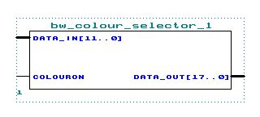

Description
The BW_Colour_Selector is used to reformat the data from the buffer RAM, depending on whether it is going to display a colour image or greyscale. When the ColourOn signal is low, the data is treated as greyscale and the bit pattern in the lowest six bits of Data_In are repeated in bits 6 to 11 and bits 12 to 17 for Data_Out. This corresponds to the red, green and blue subgroups for the display all having the same values. When ColourOn is high, the four bit red, green and blue sub-pixel values making up Data_In are each padded with two additional zeros in the least significant positions and concatenated to be delivered to the display.

Input Connections
Name | Width (bits) | Description
Data_In | 12 | Data_In is the input for pixel data received from the buffer memory.
ColourOn | 1 | When ColourOn is low, the pixel data is treated as greyscale while when high it is treated as colour. See below for details of the restructuring in either case.

Output Connections
Name | Width (bits) | Description
Data_Out | 18 | Data_Out is the output for the re-structured pixel data.

Figure F.35: Data Restructuring Detail
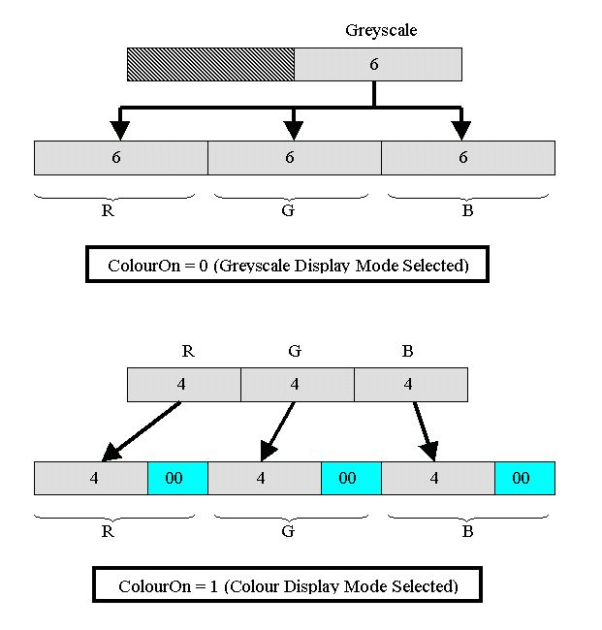

DPRAM_Buffer

Figure F.36: DPRAM_Buffer module symbol
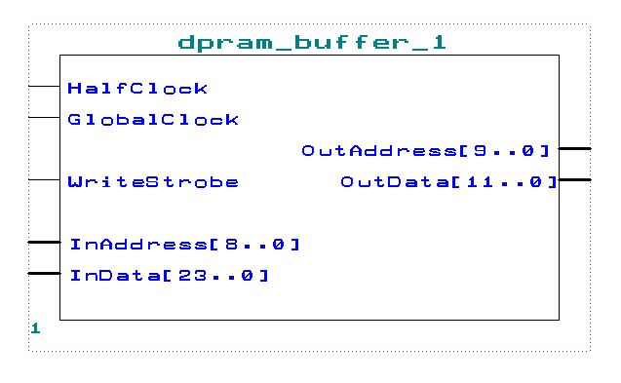

Description
The DPRAM_Buffer module provides storage for 640 pixels of image data at 12 bits per pixel. It is dual-port, and so can be simultaneously written to by the DSP and read from by the LCD timing generator. Data is put into the module on a 24-bit wide bus, with 320 separate memory addresses. It is retrieved on a 12-bit wide bus, with 640 separate addresses. When a 24 bit value is placed at arbitrary address X, it can be retrieved from addresses 2X for the low 12 bits and 2X+1 for the high twelve bits.

Input Connections
Name | Width (bits) | Description
HalfClock | 1 | The HalfClock input is used to coordinate the operation of the dual-port RAM.
GlobalClock | 1 | In this application, the GlobalClock input is connected to the FPGA development board’s 25.144 MHz oscillator. It is used to coordinate the dual-port behaviour of the RAM.
WriteStrobe | 1 | The dual-port RAM will write data into the location pointed to by InAddress when WriteStrobe is high. The dual-port RAM is synchronous and so this input must be held high for at least one HalfClock cycle to ensure success.
InData | 24 | The InData bus accepts two 12-bit pixels in parallel for writing into the memory, at the location given by InAddress.
InAddress | 9 | InAddress specifies the memory location to which the 24-bit value on the InData input is written on a HalfClock positive edge, if WriteStrobe is asserted. As such, the address must be maintained for at least one entire HalfClock cycle.
OutAddress | 10 | OutAddress specifies the memory location from which a 12-bit value is read on the next HalfClock negative edge. As such, the address must be maintained for at least one entire HalfClock cycle.

Output Connections
Name | Width (bits) | Description
OutData | 12 | The OutData bus will hold one 12-bit pixel, read from the memory at the location given by OutAddress.

LCDCounterH

Figure F.37: LCDCounterH module symbol
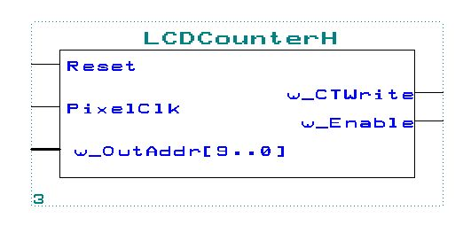

Description
The LCDCounterH module generates the combined synchronisation signal required by the LCD panel. The module also generates the 10-bit address of the pixels to be displayed, and provides a ‘Clear To Write’ signal which transitions high when the entire line of pixels has been displayed, to allow the DSP to begin transferring the following line. An active display area of 800 pixels wide by 600 pixels high is assumed, with an effective number of pixels per frame, including the vertical and horizontal blanking periods, of 860 pixels wide by 615 pixels high.

Input Connections
Name | Width (bits) | Description
Reset | 1 | The Reset input is used to force the counters within the LCDCounterH module to a known state before a new frame is started. When Reset is high, the Enable line is also held high.
PixelClock | 1 | The PixelClock input is used to clock the counters used to generate the enable waveform and the addresses for the pixel retrieval side of the buffer.

Output Connections
Name | Width (bits) | Description
w_OutAddr | 10 | w_OutAddr is connected to a modulo 860 counter internally to the LCDCounterH module. The address generated here is one pixel ahead of that immediately to be clocked out to the display, as there is a once pixel-clock latency in retrieving data from the buffer.
w_CTWrite | 1 | When a full line of data has been displayed and the display is within the horizontal blanking period, the w_CTWrite signal is asserted. In a more complete implementation this would trigger the DSP’s EDMA transfer of the next line of pixels.
w_Enable | 1 | w_Enable is the combined horizontal and vertical synchronisation signal used by the LCD to coordinate its displaying. It is high when data is present for the active pixels on the display, and low in the horizontal or vertical blanking periods. As mentioned above, it is high when Reset is asserted.

Appendix G – Max+plus II Sources for LCD Controller Elements

Figure G.38: Overall Controller logic schematic

Figure G.39: AsyncEMIFInterface logic schematic
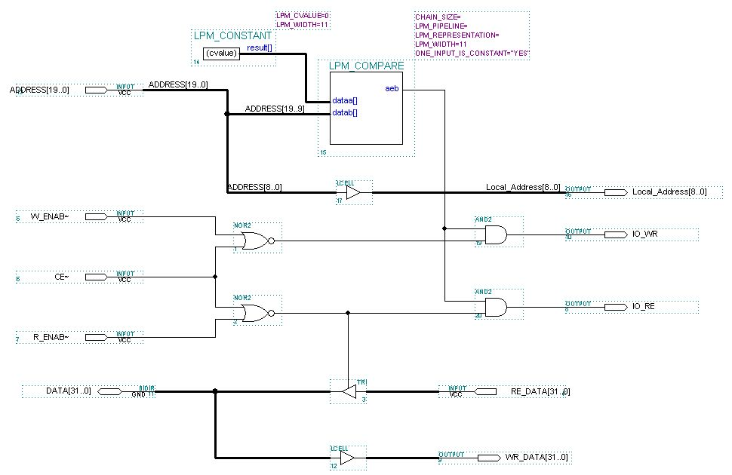

Figure G.40: DPRAM_Buffer logic schematic
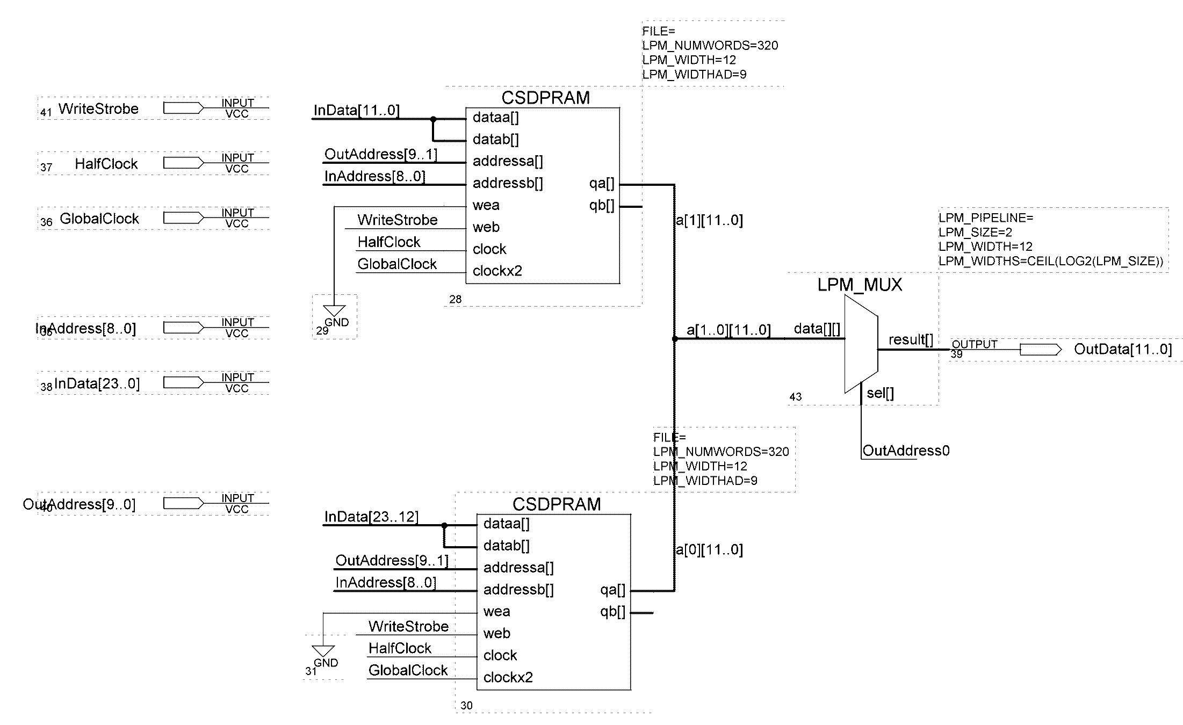

Figure G.41: IO_Register_Logic logic schematic
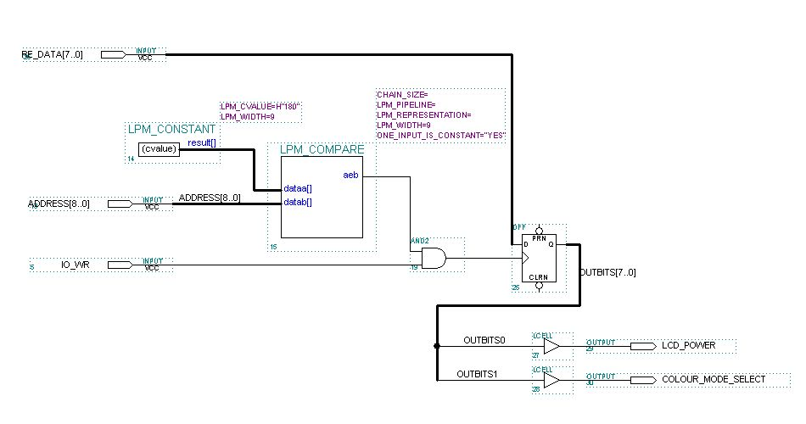

Figure G.42: Output_Signal_Gating logic schematic
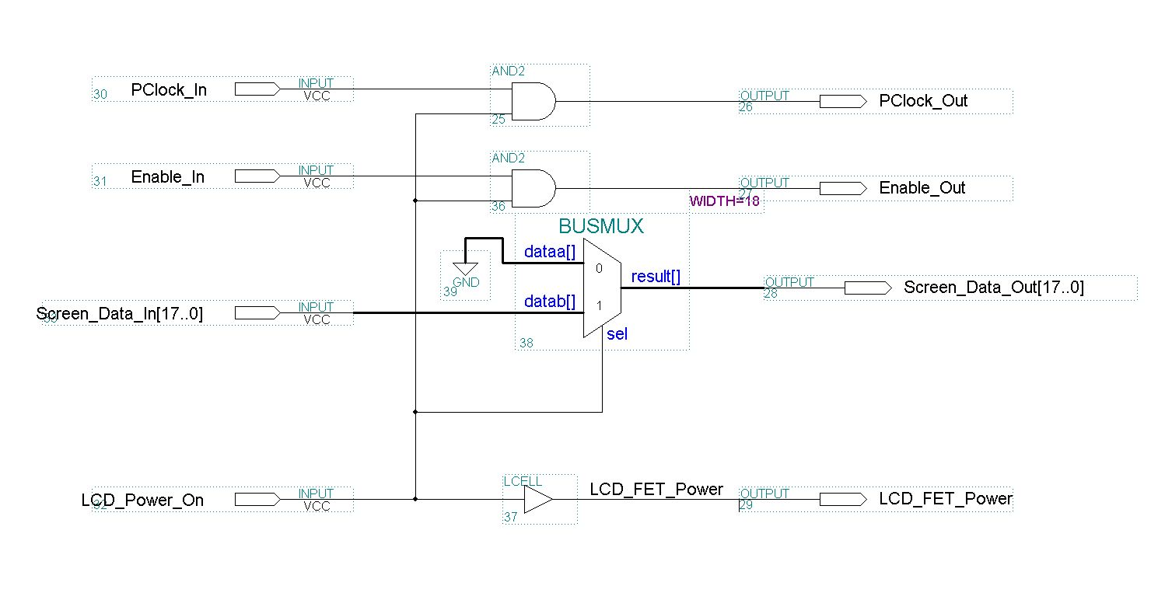

Figure G.43: ClockDivider logic schematic
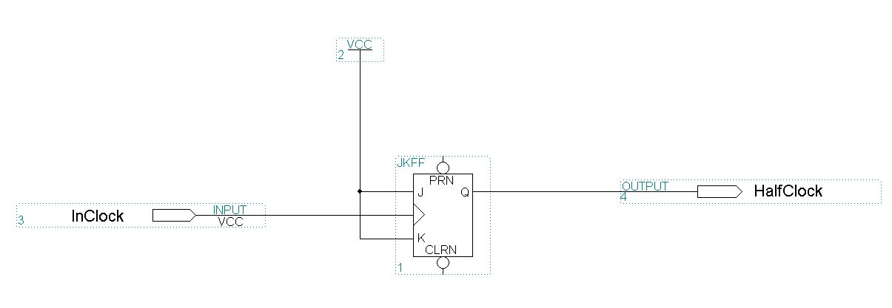

Figure G.44: BW_Colour_Selector logic schematic
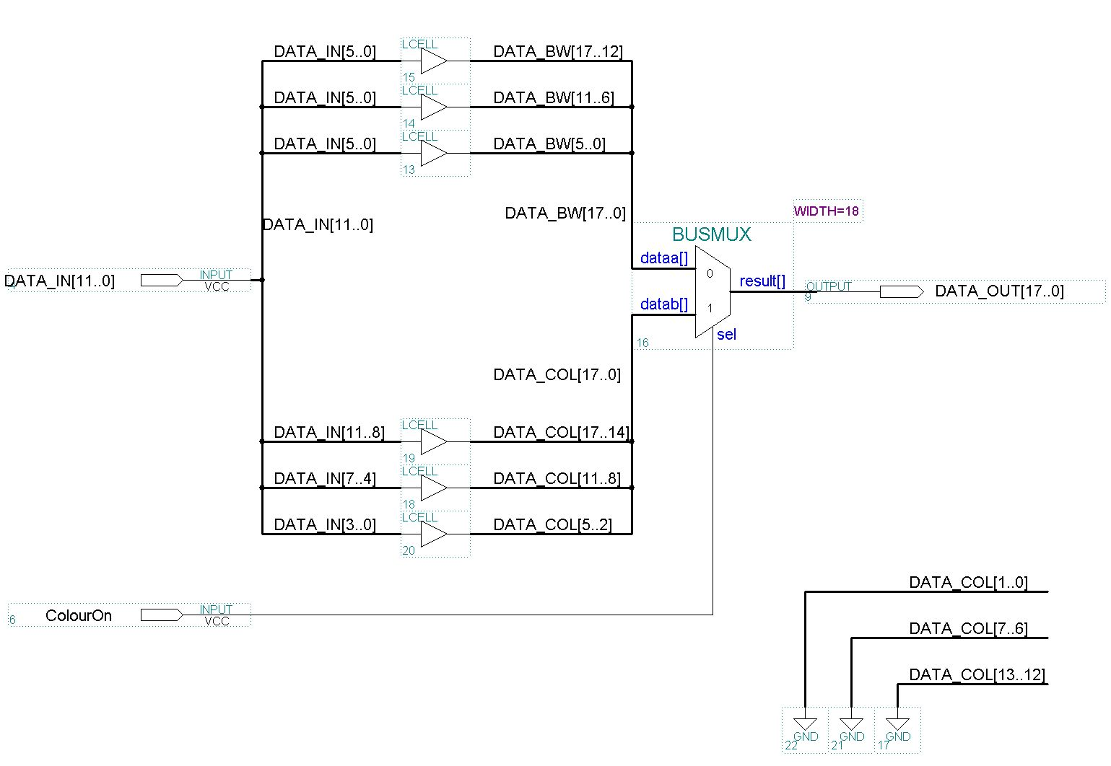

Figure G.45: Verilog listing for LCDCounterH module
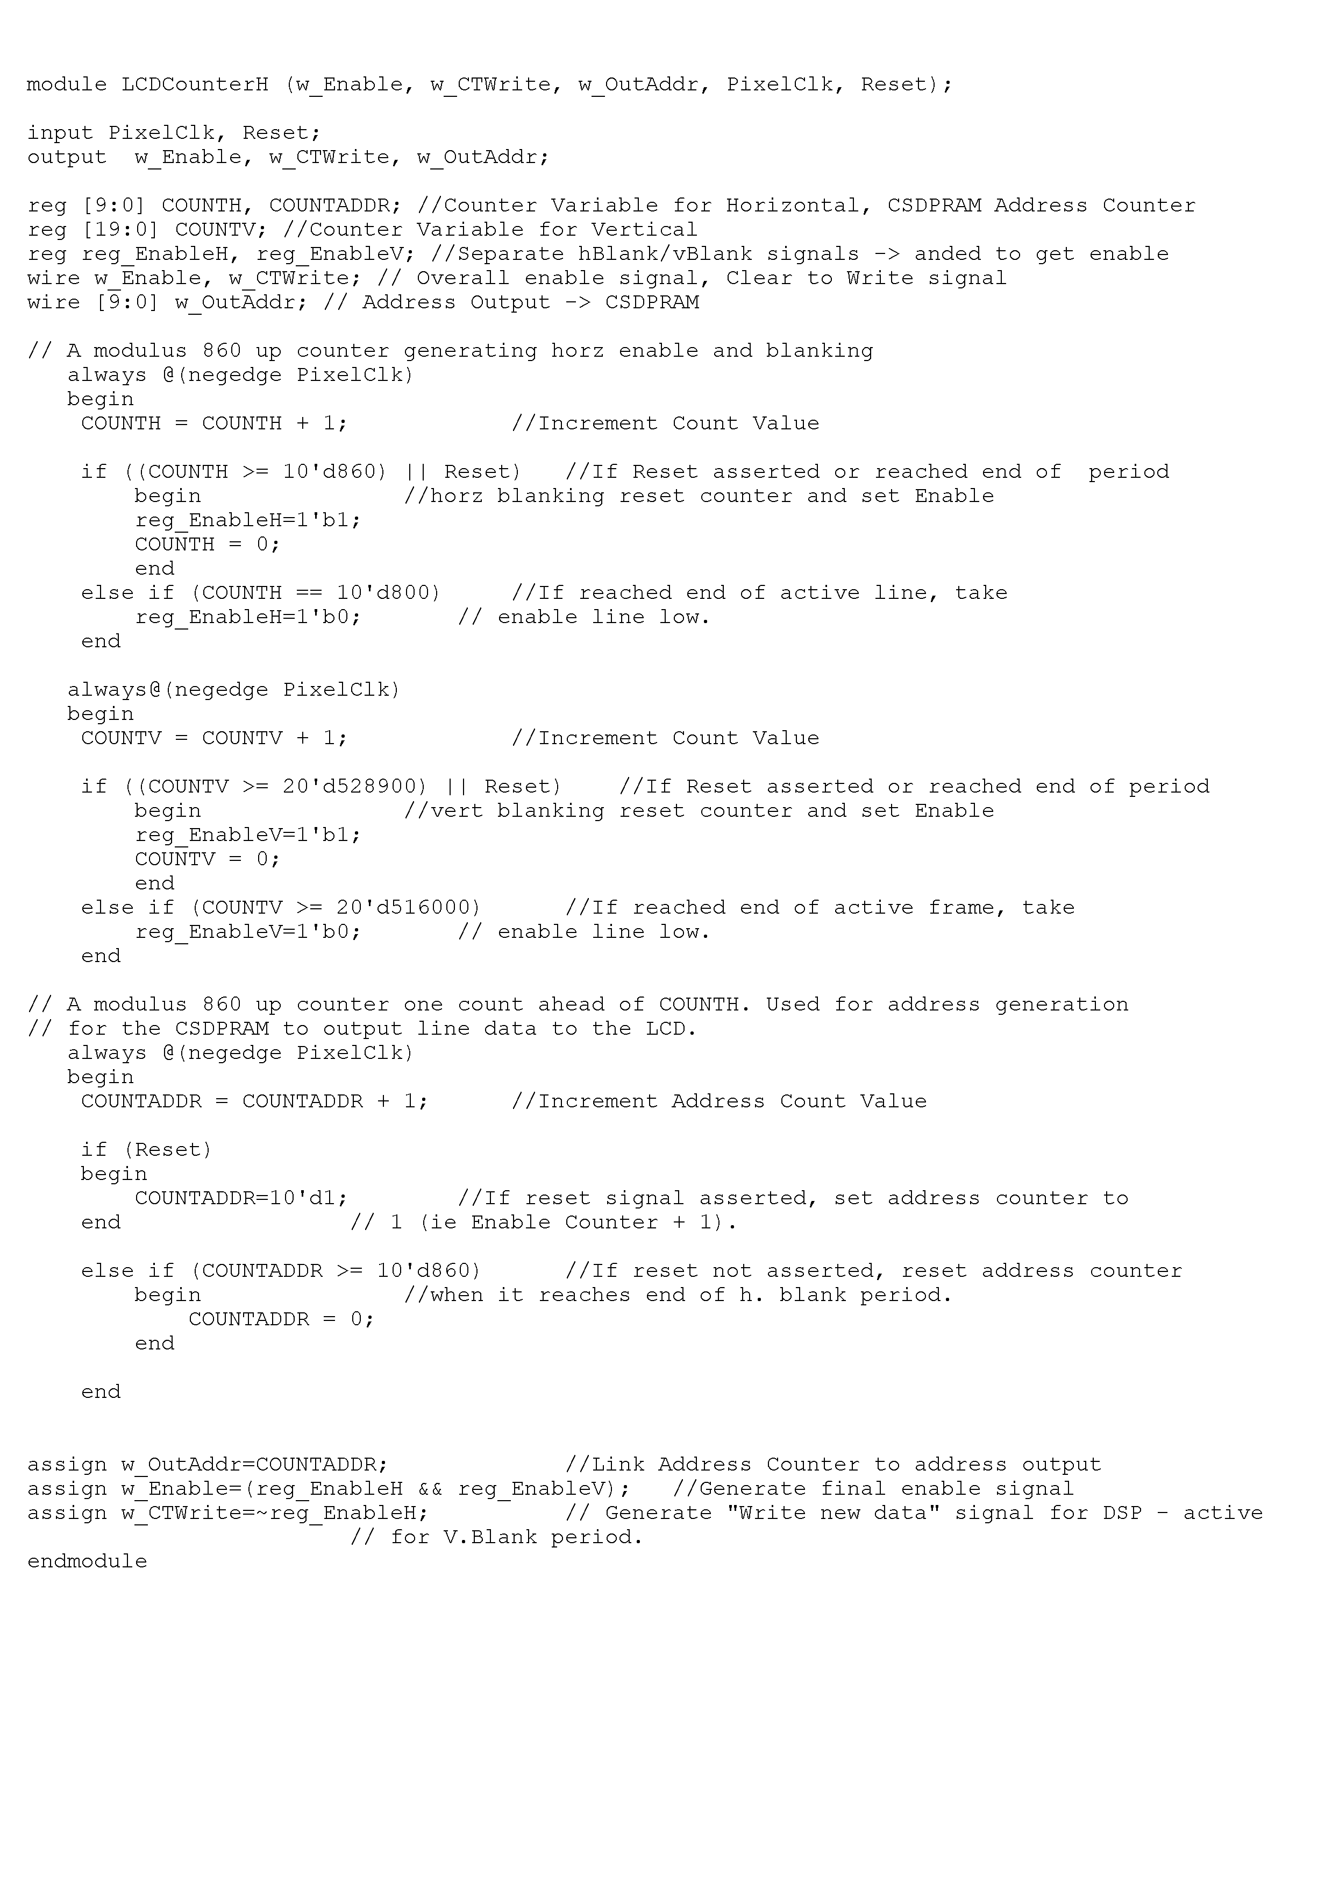

Appendix H - Max+plusII Simulation Timing Diagrams

Figure H.46: Overall controller simulation at pixel level
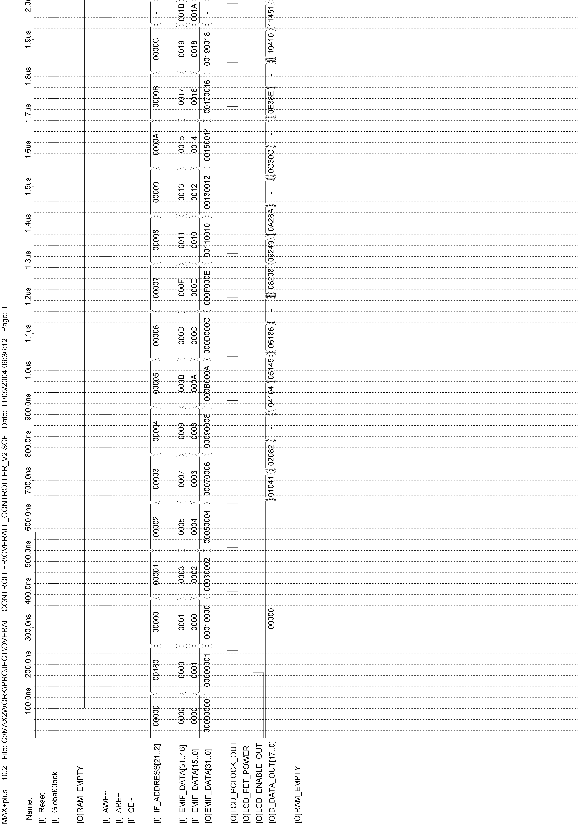

Figure H.47: Overall controller simulation at line level
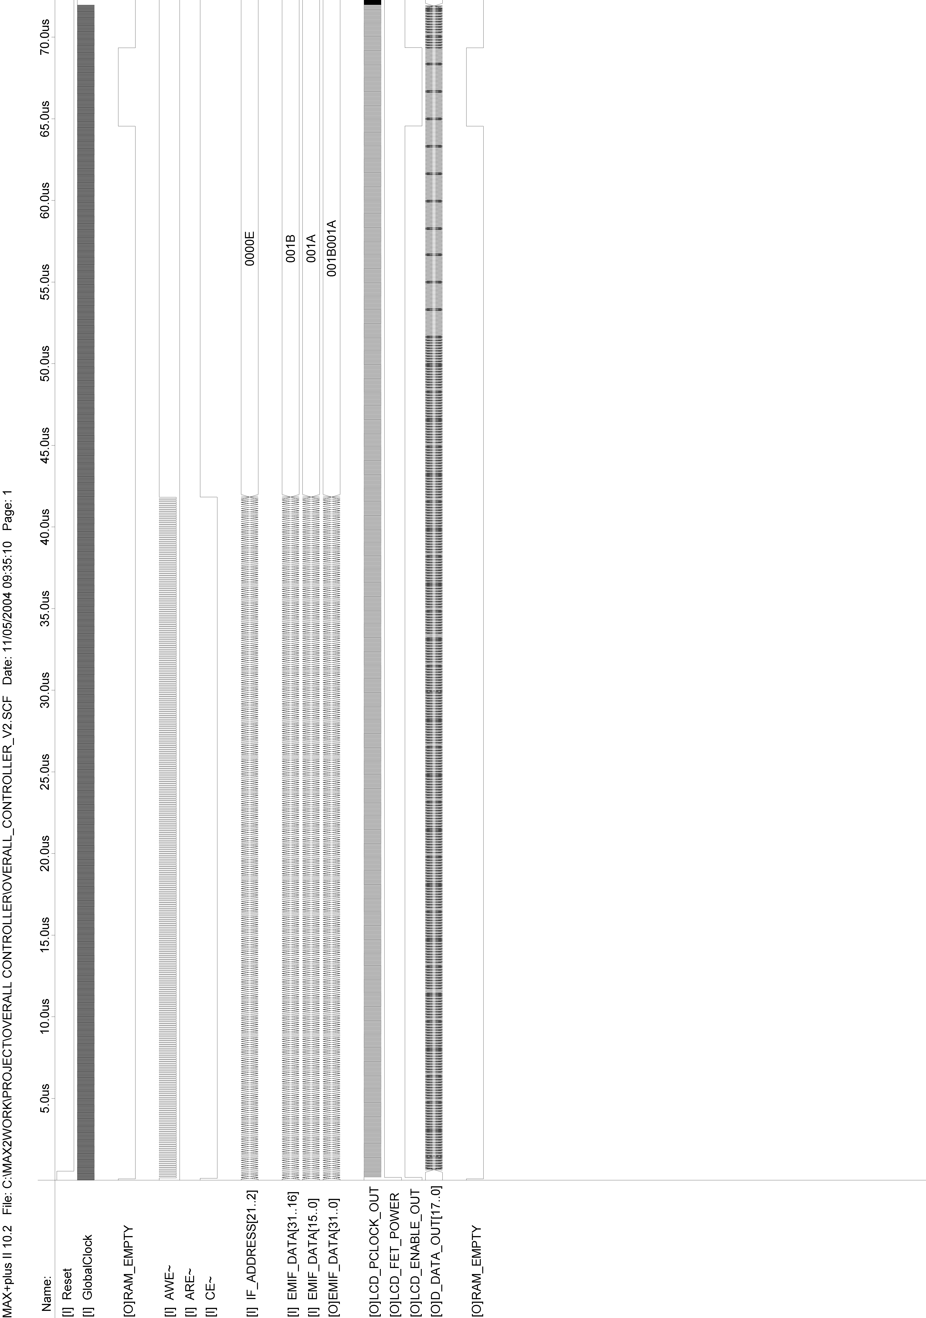

Figure H.48: ClockDivider Logic Timing Simulation
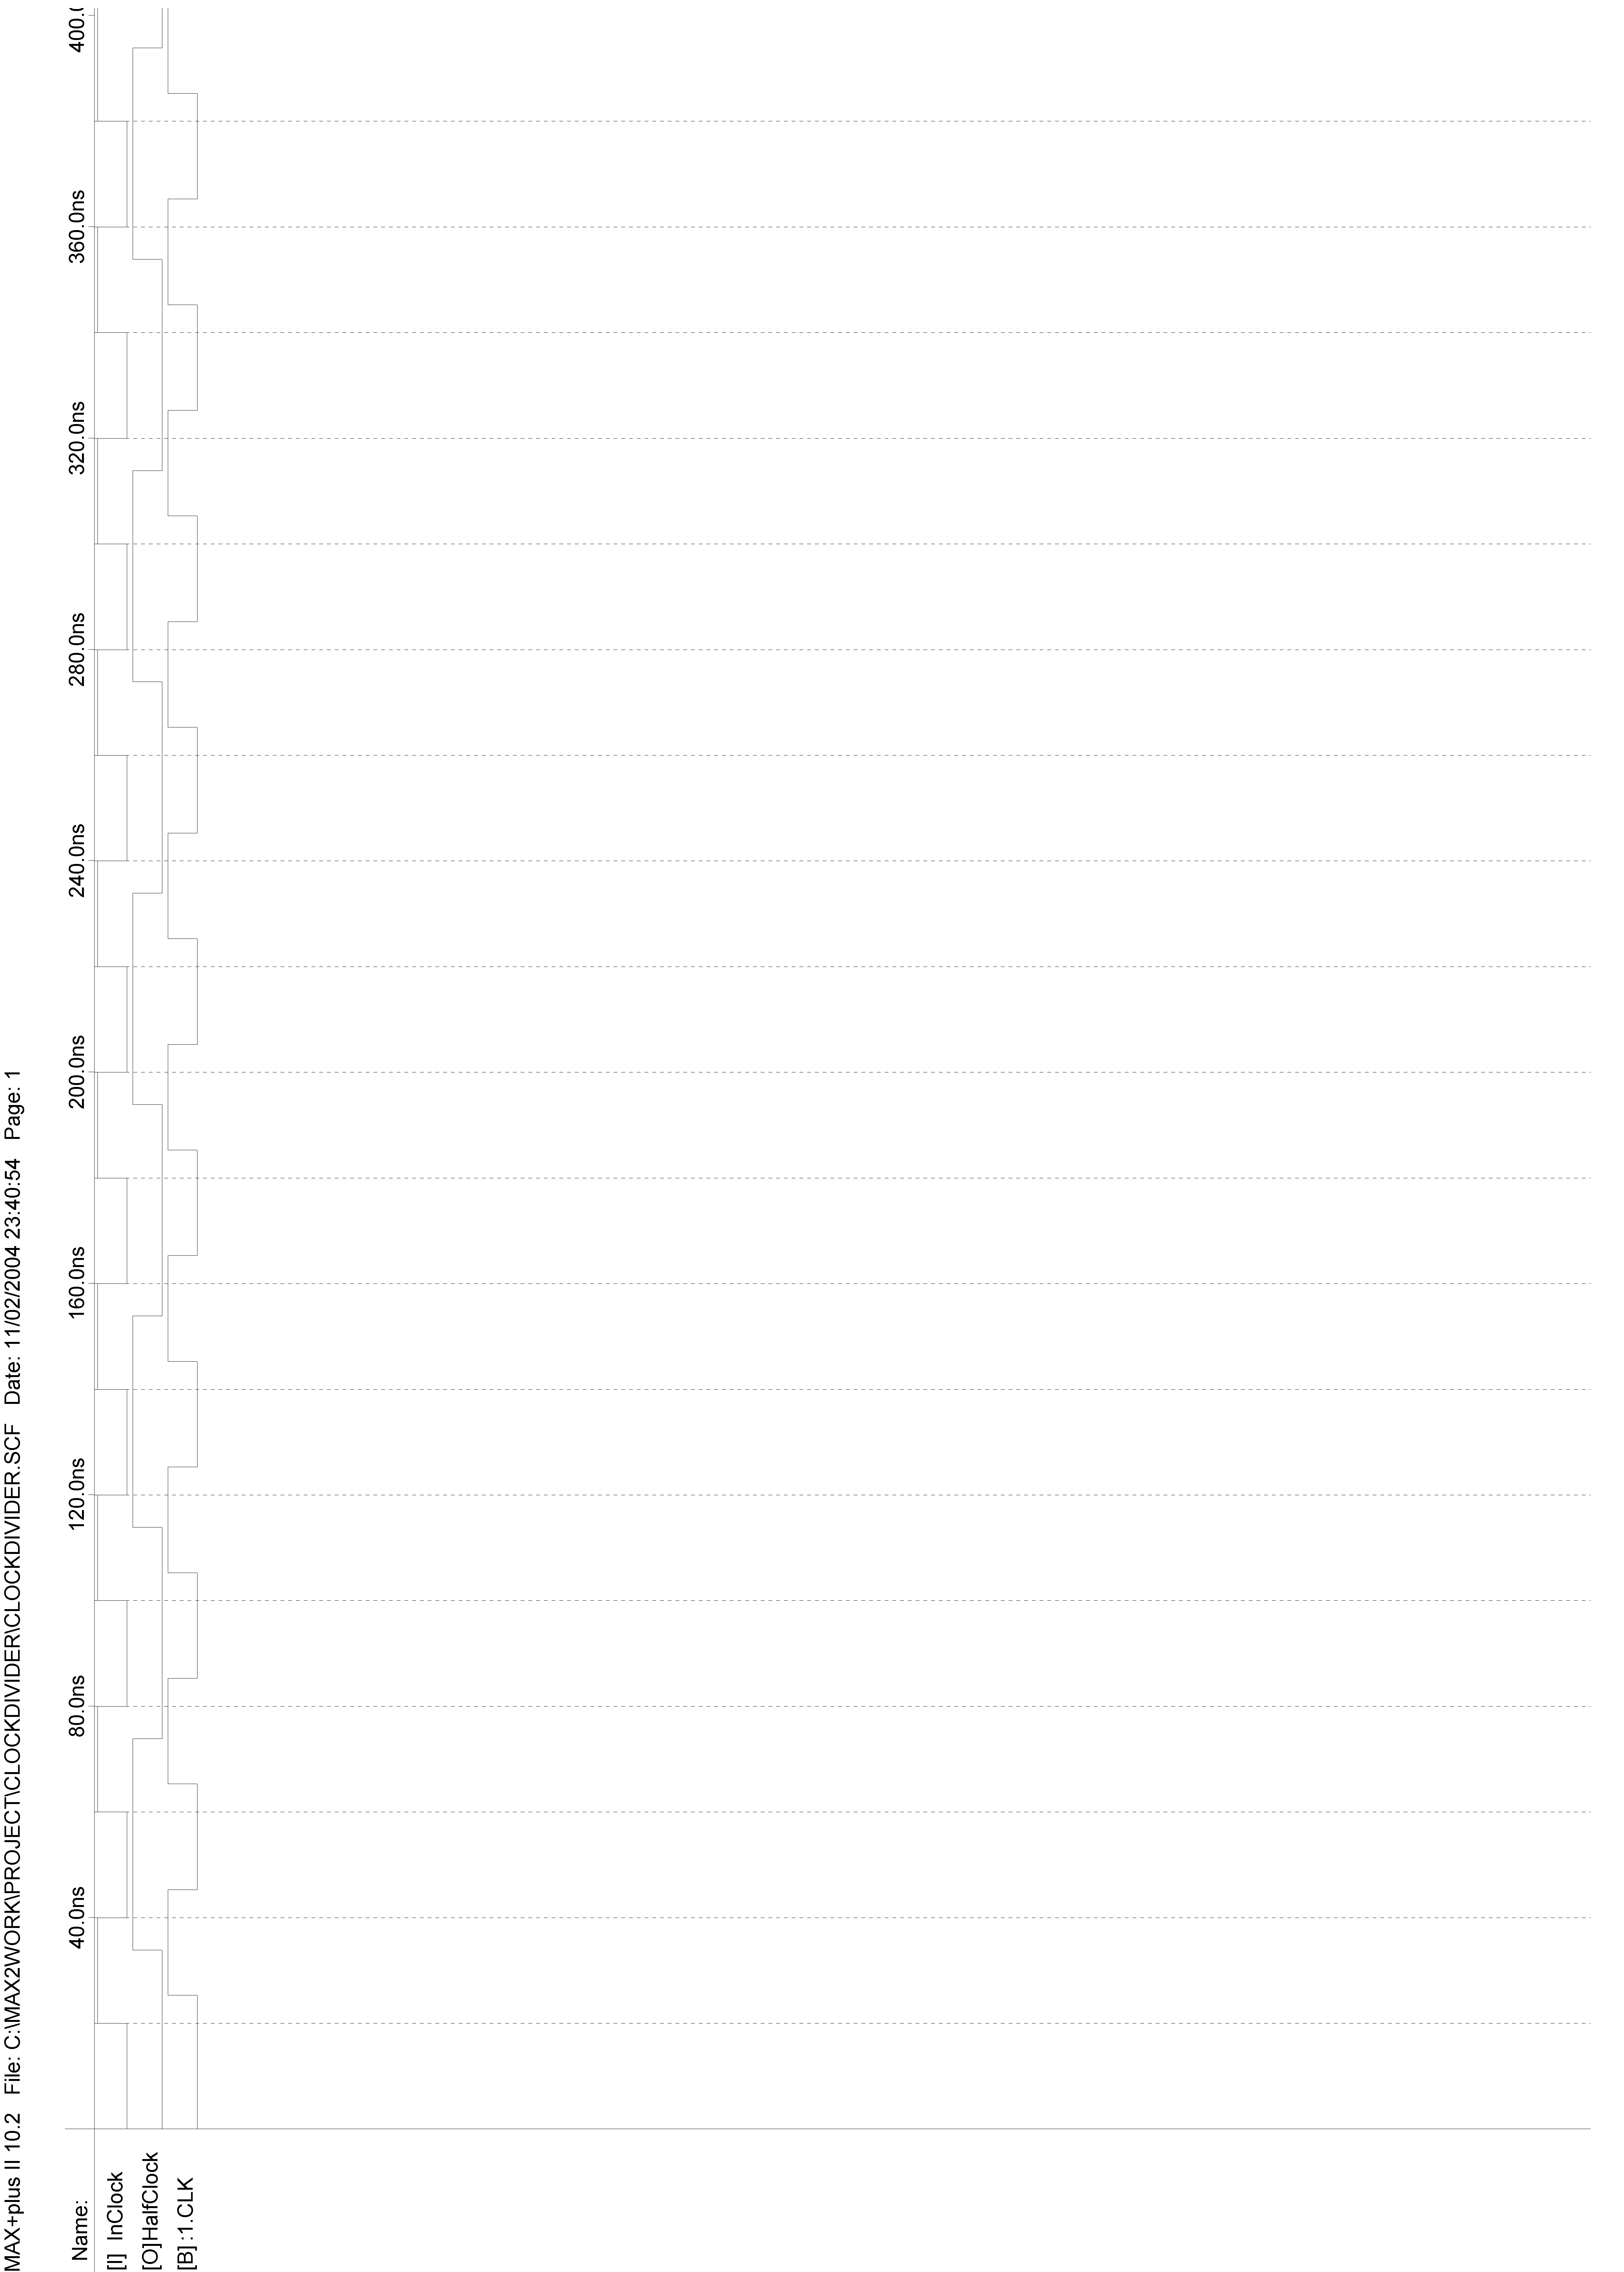

Figure H.49: AsyncEMIFInterface Timing Simulation
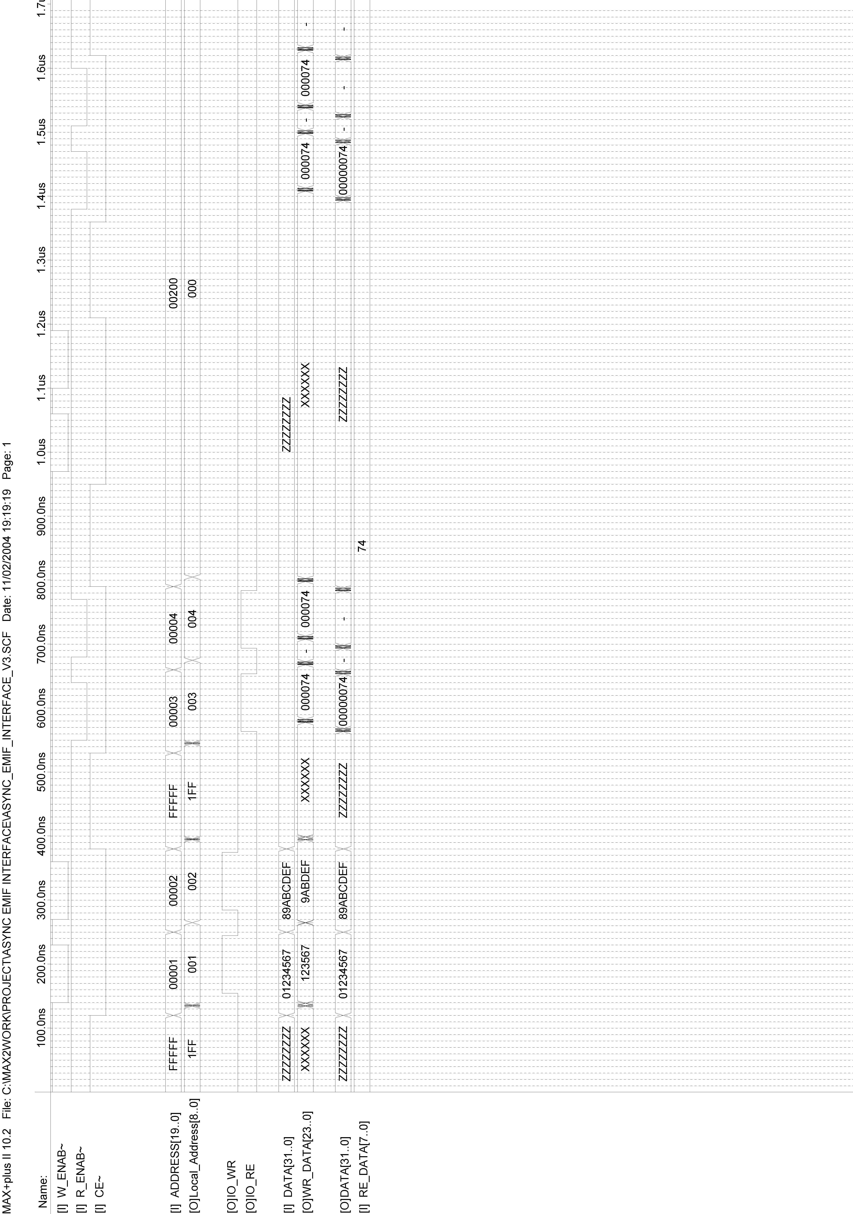

Figure H.50: IO_Register_Logic Timing Simulation
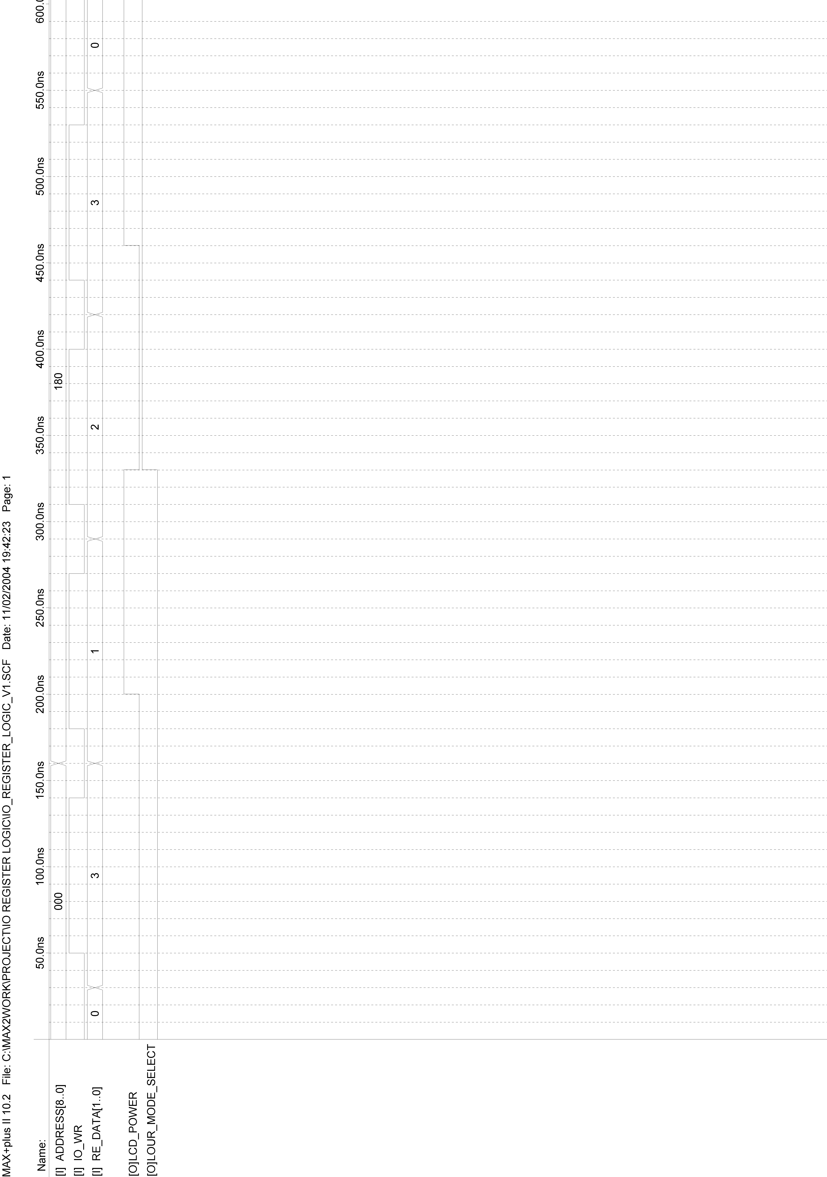

Figure H.51: Output_Signal_Gating Timing Simulation
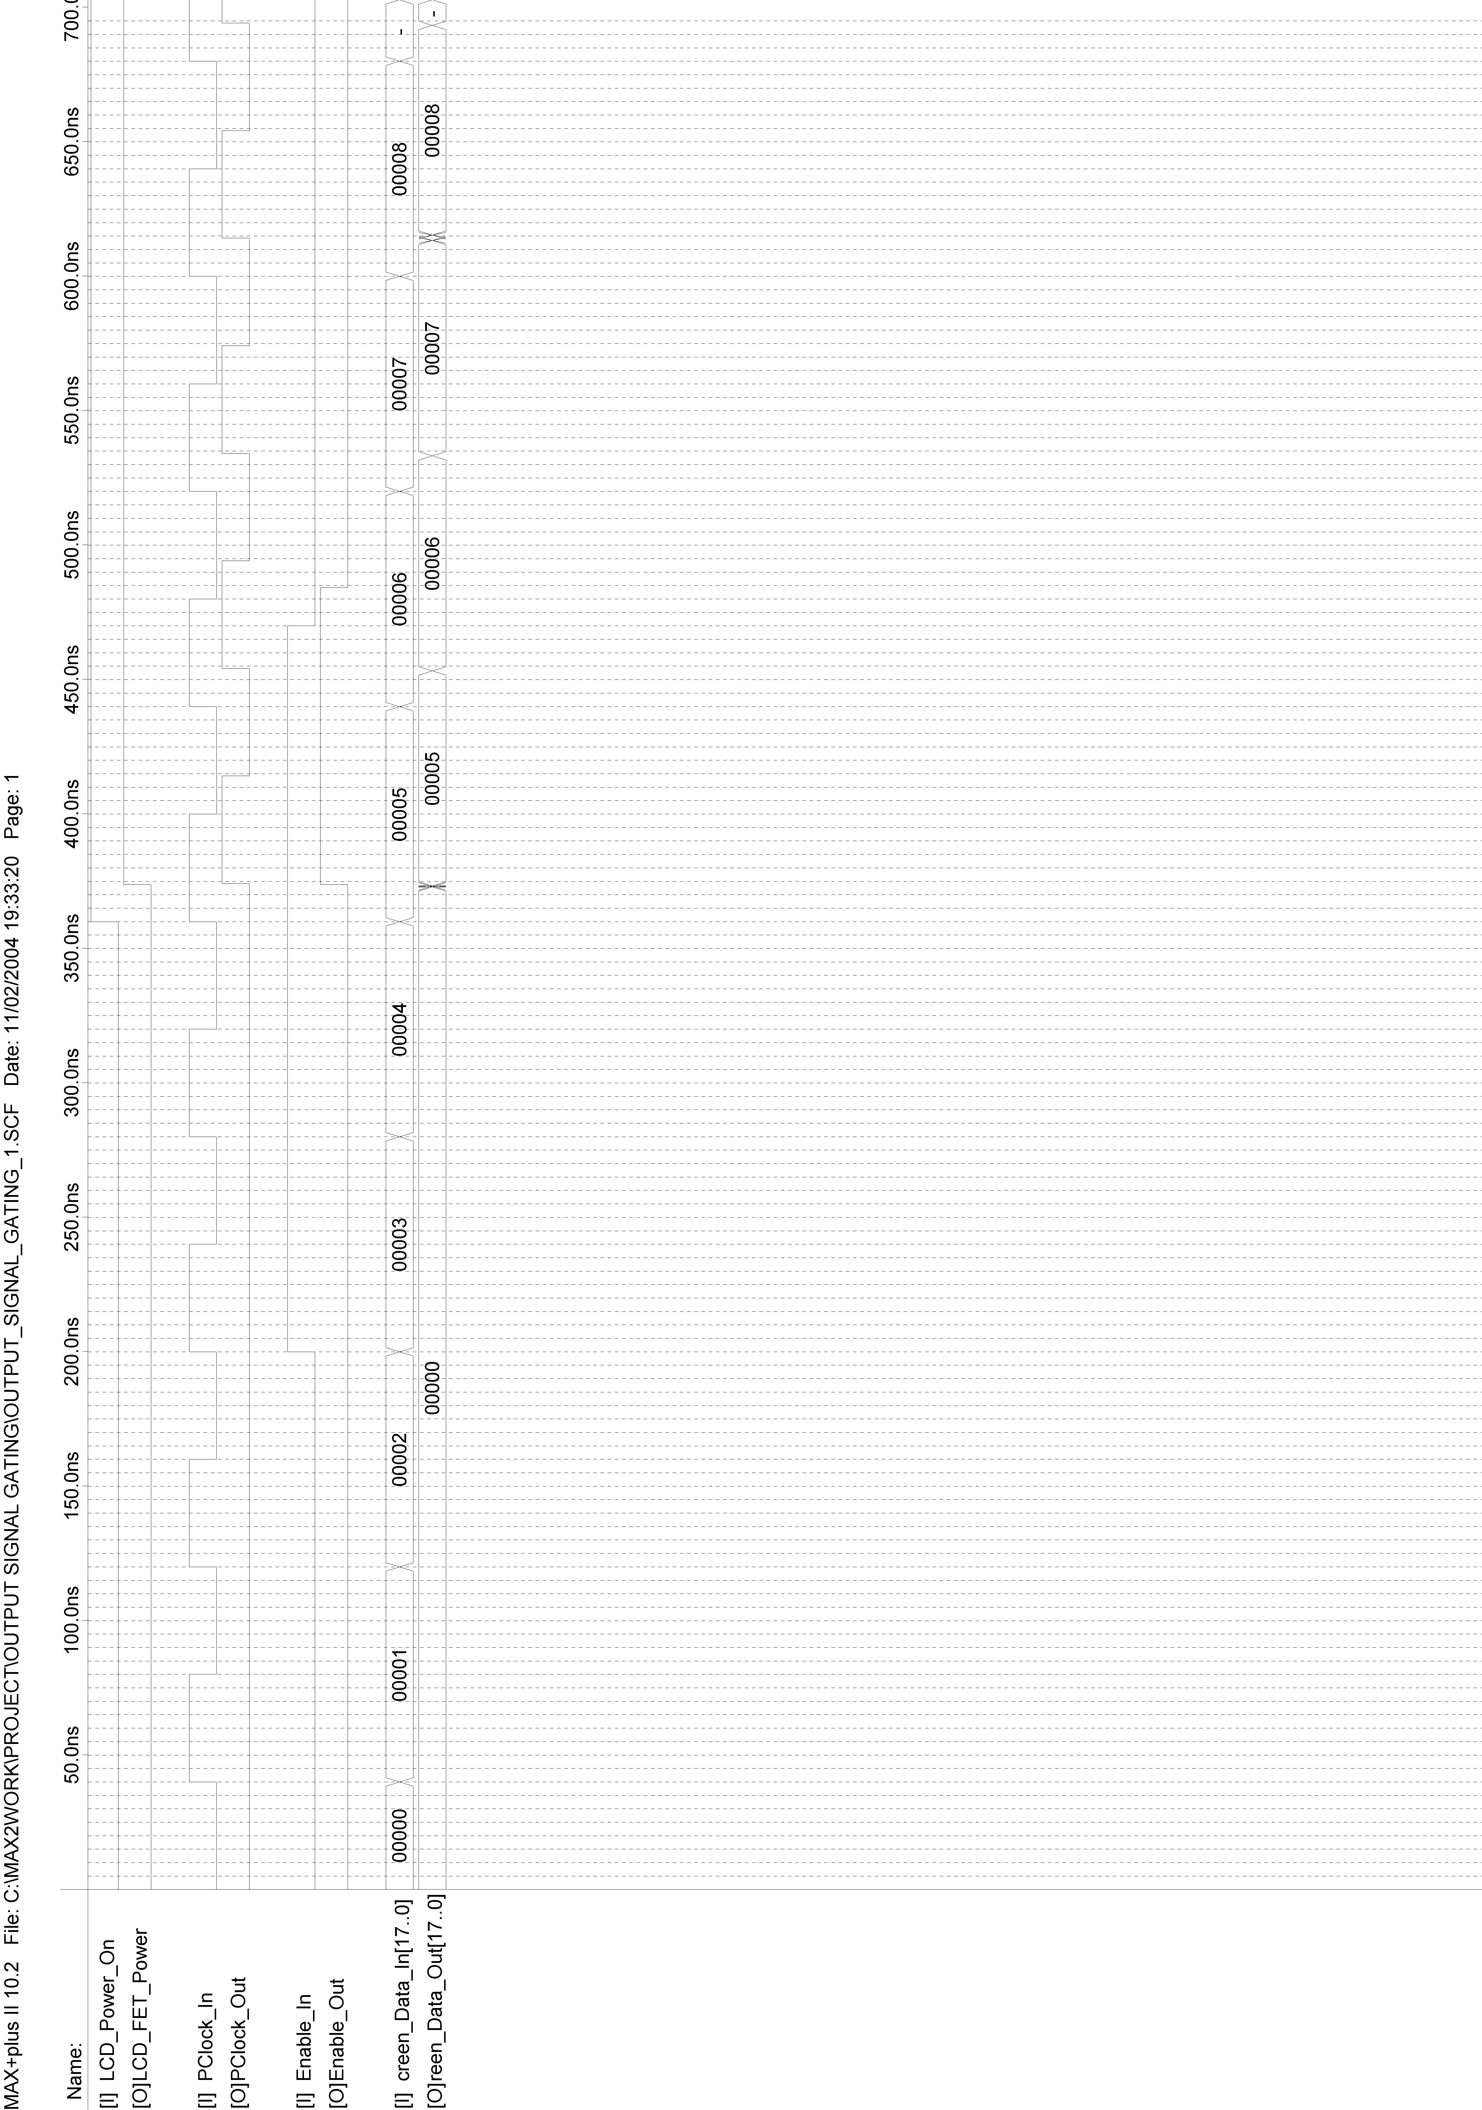

Figure H.52: BW_Colour_Selector Timing Simulation
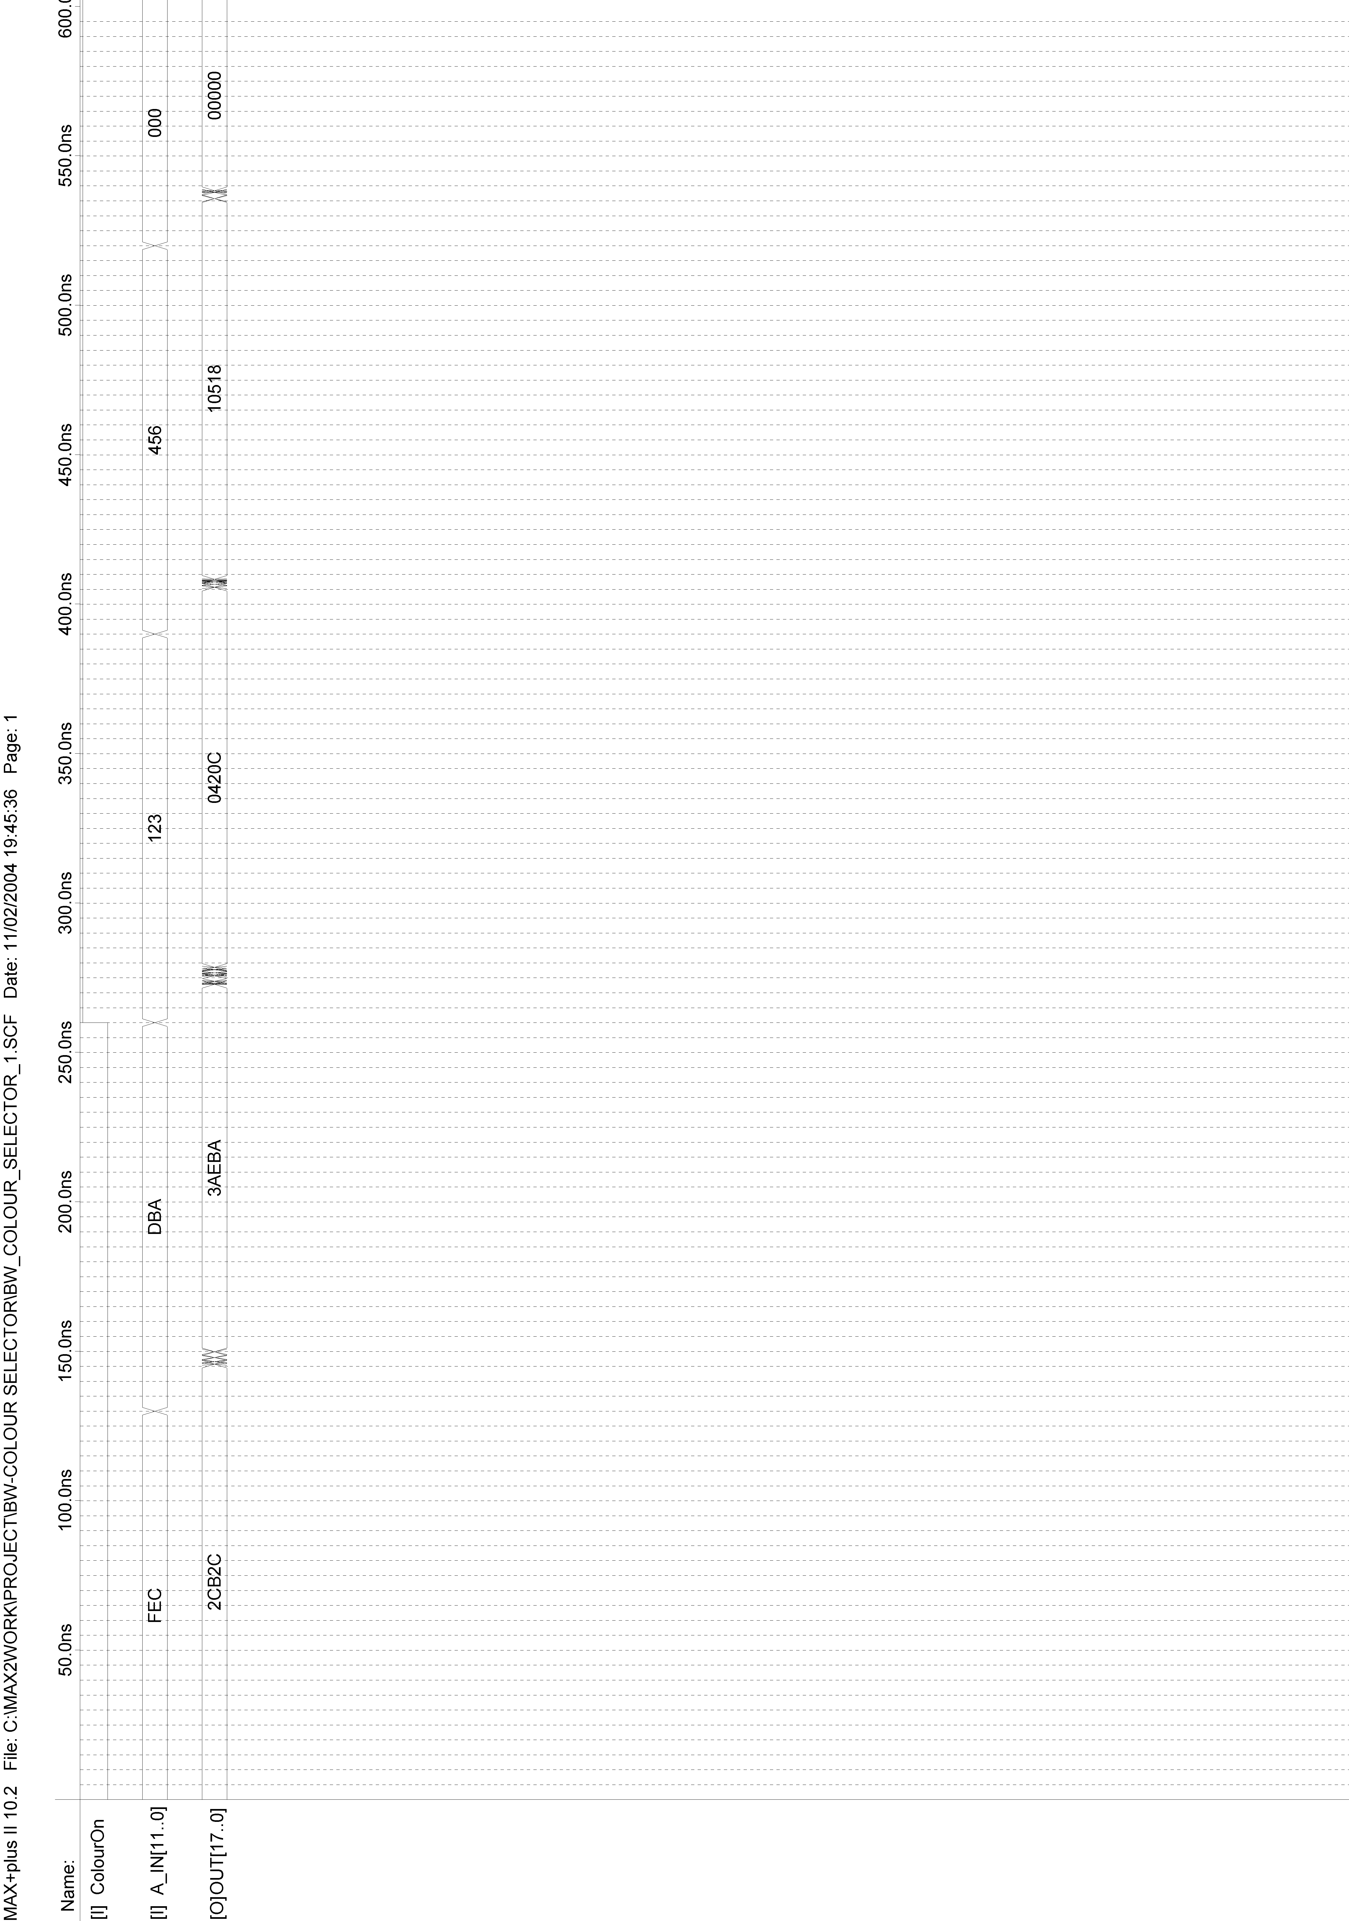

Figure H.53: DPRAM_Buffer Timing Simulation
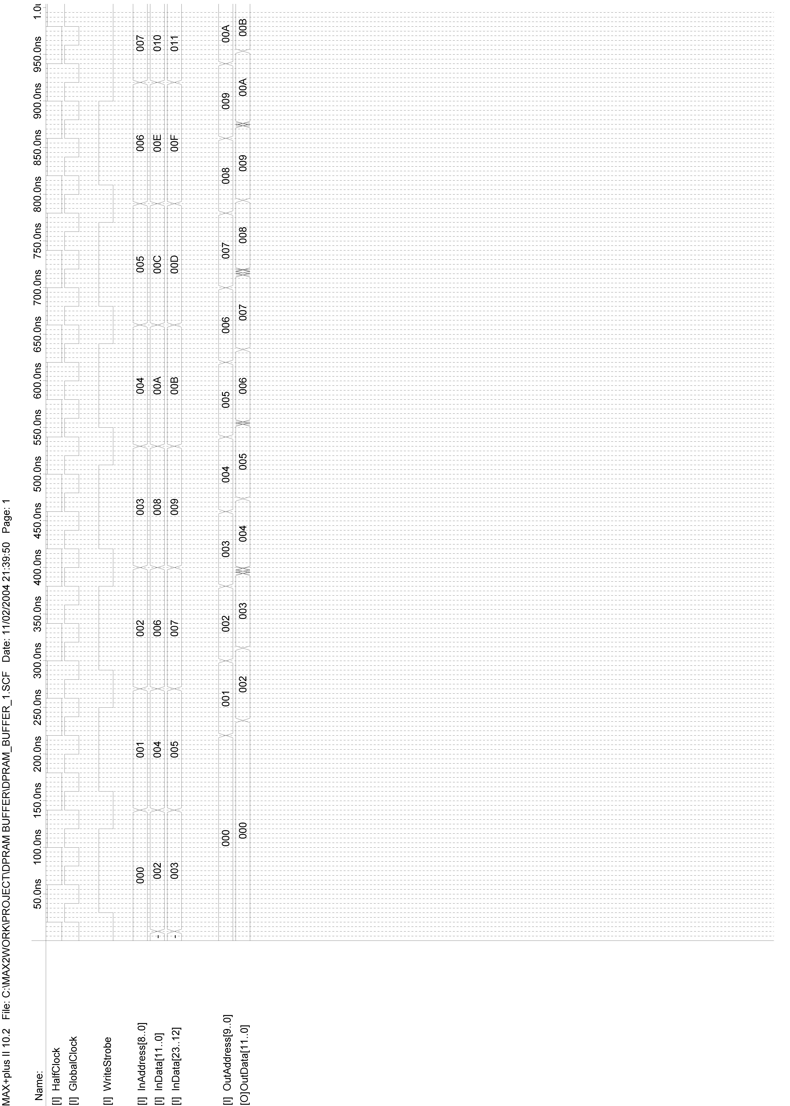

Figure H.54: LCDCounterH timing simulation at pixel level
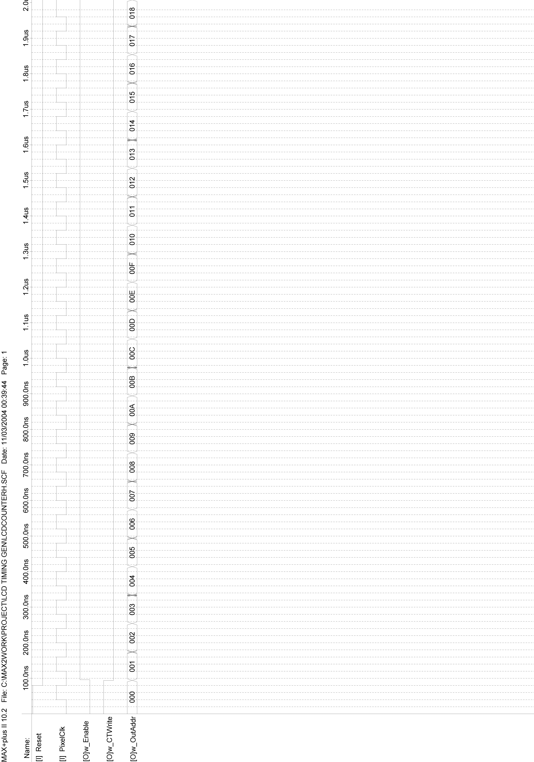

Figure H.55: LCDCounterH timing simulation at line level
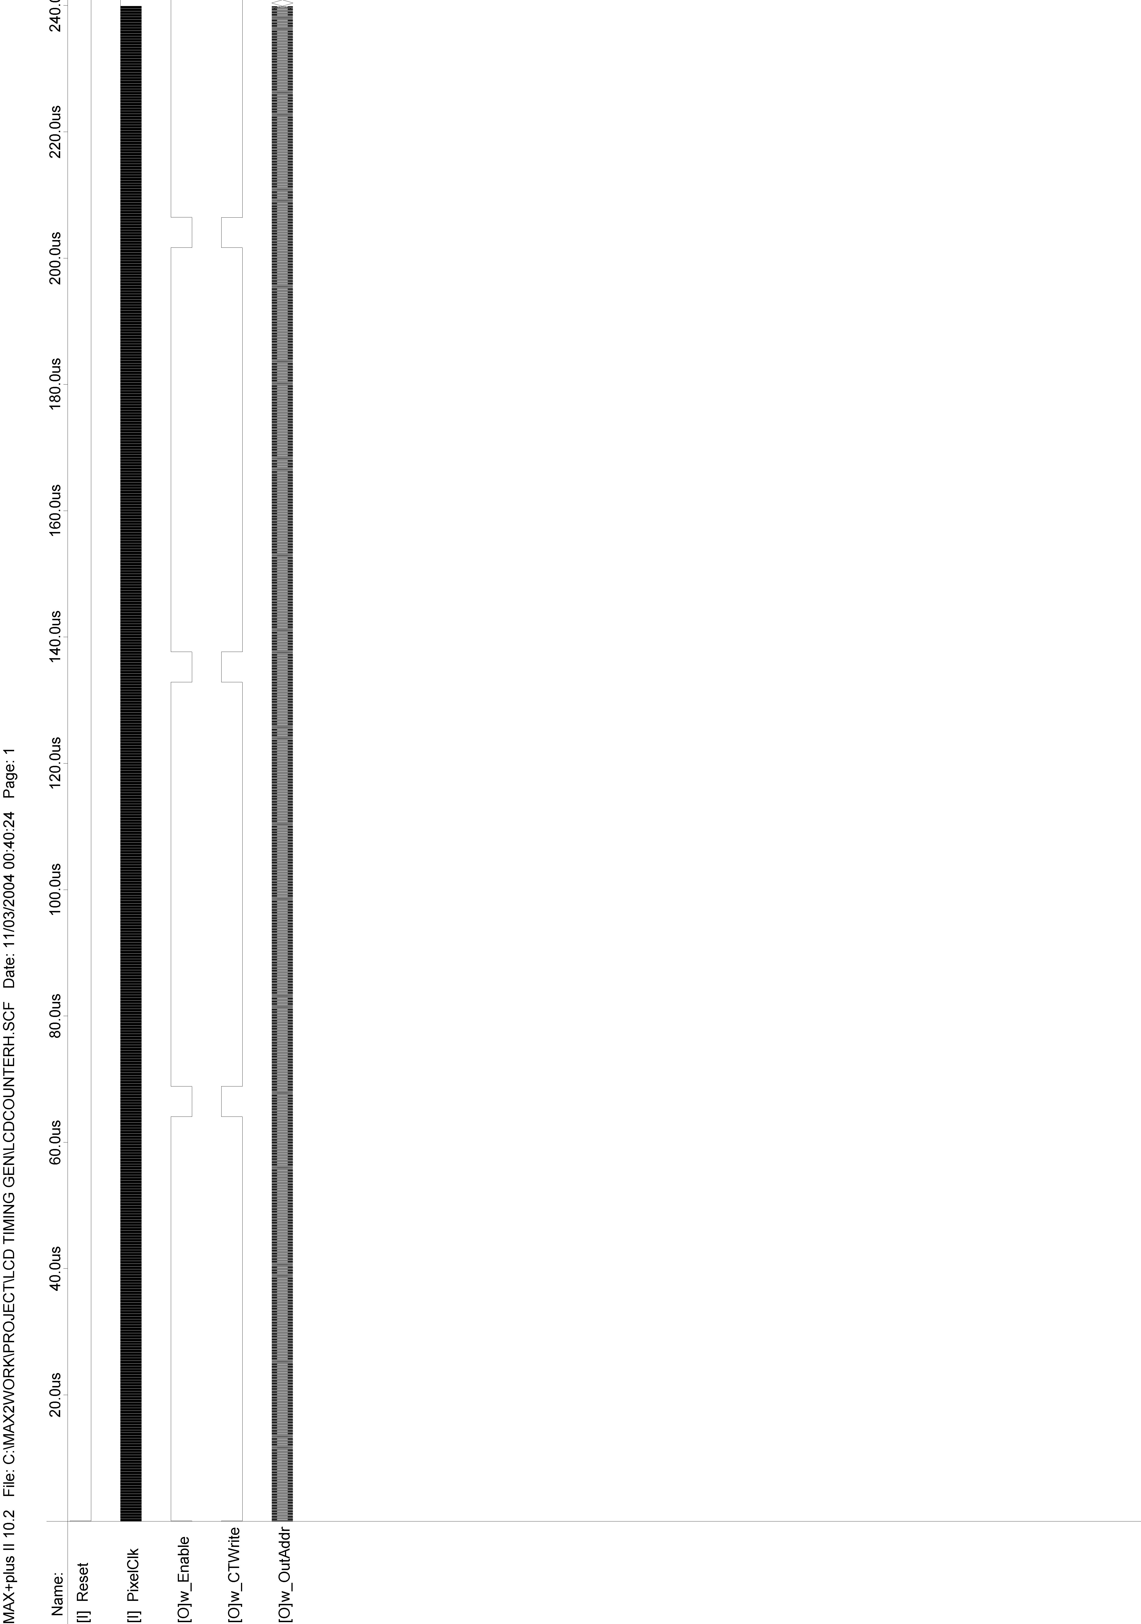

Figure H.56: LCDCounterH timing simulation at frame level
