Department Of Electrical And Computer Engineering

Currency Identification for the Blind

by

Siang Jin Ting

A thesis submitted for the degree of

Bachelor of Engineering in Electronics and Communication Engineering
Department Of Electrical And Computer Engineering
TITLE: Currency Identification for the Blind
AUTHOR

FAMILY NAME: TING

GIVEN NAME: Siang Jin
DATE: 5th November 2004
SUPERVISOR: Mr Iain Murray
DEGREE: Bachelor of Engineering
OPTION: Electronics and Communications
ABSTRACT:

The shift from paper based notes to polymer based notes by the Reserve Bank of Australia was mainly motivated due to the fact that polymer based notes are highly resistant to wear and tear. The Reserve Bank of Australia maintains a strong relationship with Blind Citizens Australia and has come up with various solutions to help vision impaired and the blind to recognize the Australian Currency. Even with the introduction of these features on the notes, it still remains a very difficult task for a person with visual impairment to differentiate the notes from each other. Therefore, the objective of this project was to create a prototype device that will able to relieve the task of recognizing currency for people with visual impairment.
GOOD
AVERAGE
POOR
EXAMINER
CO-EXAMINER
TECHNICAL WORK

REPORT PRESENTATION
INDEXING TERMS

Currency Identification, Blind, Image recognition, Image rotation, Frequency Domain Correlation, Illumination, Accuracy
Abstract
The shift from paper based notes to polymer based notes by the Reserve Bank of Australia was mainly motivated due to the fact that polymer based notes are highly resistant to wear and tear. The Reserve Bank of Australia maintains a strong relationship with Blind Citizens Australia and has come up with various solutions to help vision impaired and the blind to recognize the Australian Currency. Several methods that were implemented are:
- Maintaining length differentials between denominations - in fact these differentials were increased in the new series of notes from 5mm to 7mm. While the representative groups would have preferred greater differentials, they considered 7mm acceptable.
- Maintain strong colour contrasts between denominations.
- The use of bolder numerals.
Even with the introduction of these features on the notes, it still remains a very difficult task for a person with visual impairment to differentiate the notes from each other. Therefore, the objective of this project was to create a prototype device that will able to relieve the task of recognizing currency for people with visual impairment.
30 July 2026
Siang Jin Ting
13 Purser Cove
Murdoch WA 6150
Dr Syed Islam
Department of Electrical and Computer Engineering
Curtin university of Technology
GPO box U1987
Perth WA 6845

Dear Dr Islam,

I am submitting the following thesis titled “Currency Identification for the Blind” to partially satisfy the requirements for the Bachelor of Engineering (Electronics and Communication) degree.

I hereby declare that this thesis is entirely of my own work except where acknowledgment is given.

Yours Sincerely,
Siang Jin Ting

Acknowledgements
I would like to take this opportunity to express my sincere gratitude to the following people:
- Mr Iain Murray who was my supervisor for his help and wisdom in guiding me through the problems encountered throughout the project lifetime. Moreover he also proof read my draft thesis and provided insights to how to further improve it for my final copy.
- Mr Andrew Pasquale who was always there when there was any problem using the Texas Instrument C5510 DSK.
- Mr John Heppell who provide the keys to the project room and for processing the orders for parts.
Nomenclature
CCD Charged Coupled Device
CMOS Complementary Metal Oxide Semiconductor
DSP Digital Signal Processor
DSK DSP Starter Kit
LED Light Emitting Diode
FFT Fast Fourier Transform
IR Infrared
GRIN Gradient Index
SELFOC Self Focusing

Table of Contents
1.0 Introduction 1
1.1 Justification 1
1.2 Current Solutions 2
1.3 Proposed Solutions and Achievements 3
1.4 Thesis Outline 4
2.0 Project Overview 6
2.1 Introduction 6
2.2 Image Capture 6
2.3 Illumination 7
2.4 Hardware Platform 7
2.5 Image Recognition 8
2.6 Output 10
3.0 Design Issues and Solutions 11
3.1 Introduction 11
3.2 Image Capture 11
3.2.1 Imaging Device 11
3.2.2 Illumination 12
3.3 Image Recognition 15
3.3.1 Introduction 15
3.3.2 Cross-Correlation Technique 15
3.3.3 Discrete Fourier Transform Technique 17
3.4 Accuracy 20
3.4.1 Introduction 20
3.4.2 Number of Scans 20
3.4.3 Maximum Correlation Value 22
3.4.4 Ratio Values 23
3.5 Rotation & Orientation of Image 26
3.5.1 Introduction 26
3.5.2 Template Matching Based Object Recognition with Unknown Geometric Parameters 26
3.5.2 Rotating of the template 27
3.6 Output 31
4.0 Software Description 33
4.1 Image Recognition Program 33
4.1.1 Corr.m 33
4.1.2 FFTtemplates.m 34
4.1.3 Identification.m 34
4.1.4 Skewtemplates.m 35
4.2 Output.m 36
5.0 Testing 37
6.0 Conclusion 39
6.1 Achievements 39
6.2 Future Implementations 39
6.2.1 Introduction 39
6.2.2 Translation of MATLAB programs 40
6.2.3 Reduction in RAM needed for storing templates 40
6.2.4 Counterfeit Detection 41
6.2.5 Further reduction in computational time 41
7.0 Bibliography 43
Appendix A Project Plan 46
Appendix B Simulation Results 48
B.1 Simulation Results with ideal conditions 48
B.2 Simulation Results with Salt & Pepper noise 52
B.3 Simulation Results with multiple inputs 56
Appendix C Program Listings 57
C.1 FFTemplates.m 57
C.2 FFTtemp.m 59
C.3 Corr.m 60
C.4 Maxcorr11.m 61
C.5 Indentification.m 61
C.6 Skewtemplates.m 63
C.7 Output.m 65

List of Figure
Figure 1.1: Indentation on a Ringgit Malaysia 10 and 50 respectively 2
Figure 1.2: Cash Test Australia 3
Figure 2.1: Flipside up of a 10 dollar note 8
Figure 2.2: Upside down of a 10 dollar note 9
Figure 2.3: The note is partially scanned 9
Figure 2.4: The note is rotated clock wise by 10 degrees 9
Figure 3.1: LED Bar 14
Figure 3.2: (a) Original image, (b) Orignal Image corrupted by noise 19
Figure 3.3: Output using the Frequency Domain Correlation 19
Figure 3.4: Line number 75 on a $50 with 0° rotation 21
Figure 3.5: Line number 20 on a $100 with 0° rotation 21
Figure 3.6: Frequency Spectrum of the line images above 21
Figure 3.7: Comparison in accuracy between 1 input and 2 inputs for $100 22
Figure 3.8: $10 rotated by 5° 27
Figure 3.9: $10 rotated by 15° 28
Figure 3.10: $50 rotated by 15° and put through the noise reduction algorithm 29
Figure 3.11: $20 rotated by 15° and put through the noise reduction algorithm 29
Figure 3.12: $10 rotated by 15° and put through the noise reduction algorithm 30
Figure 3.13: $5 rotated by 15° and put through the noise reduction algorithm 30
Figure 3.14: $10 rotated by 15° and the extra rows has been discarded 31
Figure B.1: Test sets without noise 48
Figure B.2: $5 with all possible combination and 5 degree of rotation 49
Figure B.3: $10 with all possible combination and 5 degree of rotation 49
Figure B.4: $20 with all possible combination and 5 degree of rotation 50
Figure B.5: $50 with all possible combination and 5 degree of rotation 50
Figure B.6: $100 with all possible combination and 5 degree of rotation 51
Figure B.7: Tests sets with salt & pepper noise introduced 52
Figure B.8: $5 all possible combination, 5 degree of rotation with noise 53
Figure B.9: $10 all possible combination, 5 degree of rotation with noise 53
Figure B.10: $20 all possible combination, 5 degree of rotation with noise 54
Figure B.11: $50 all possible combination, 5 degree of rotation with noise 54
Figure B.12: $100 all possible combination, 5 degree of rotation with noise 55
Figure B.13: Comparison between 1 input and 2 inputs for $100 56

List of Tables
Table 3.1: Comparison of accuracy between correlation and ratio 24
Table 3.2: Table of normalising factors 25

Introduction

Justification
Since the introduction of polymer notes into the Australian monetary system, note identification has been a huge problem for the vision impaired. There are around 50 million blind and vision impaired people around the world and 380,000 of them are in Australia itself and the number are growing at an alarming rate (Vision Australia Foundation, 2003). These numbers are expected to double in the next two years due to the ageing population and also recent research linking vegetable oil with “trans” fatty acid as a main cause of Macular Degeneration (CSIRO, 2004).

Some monetary system includes Braille indentations on the note to ease the identification of each note. However since the notes may be subjected to a high degree of wear and tear the Braille indentations maybe be erased or other contours on the note may mislead a person with visual impairment. There are no major features of the current Australian bank notes that will help the identification of the denominator to a vision impaired or blind person. The Reserve Bank of Australia with the help of Blind Citizens Australia came up with several solutions that will aid people with vision impairment to recognize the Australian dollar note such as the use of irregular corners on the notes, and notches or holes in the notes. However these were deem to be too hard to implement during production of the notes and may reduce the lifespan of the notes. Therefore the only way to identify each note is by the length of each note. The notes have varying lengths from 131mm for the five dollar note to 158mm for the 100 dollar note. The difference between each note was changed from 5mm in the older notes to 7mm for the newer versions (Reserve Bank of Australia, 2004). However, for a person who is vision impaired it is still hard to differentiate between them. Moreover, diabetes is one of the most common cause of blindness and can also cause the lost of tactile feedback which makes it almost impossible to feel the difference in the lengths of the notes. This also eliminates the advantage of other monetary system that provides Braille indentations on the notes itself.
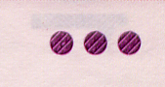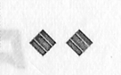
Figure 1.1: Indentation on a Ringgit Malaysia 10 and 50 respectively

Current Solutions
The Royal Blind Society of Australia has come up with a small tactile device that can be used to identify notes by their length called Cash Test Australia as shown in Figure 1.2 (Reserve Bank of Australia, 2004). This device however is very inaccurate and is of little use to people with low tactile feedback. The user has to slip the note into a slit in the device and the length of the note will align with the Braille indentations on the device. This can be especially hard to operate when the note is creased and persons suffering from low tactile feedback. There are other great devices such as Note Teller 2 - Talking Money identifier by Brytech Inc. which is a compact (1 inch wide x 3 long x 6 high), lightweight (8 ounce) portable talking money identifier that will verbally announce the denomination of ALL bills from a one dollar bill to a one hundred dollar bill, including all 5's, 10's, 20's, 50's and 100's. It operates using a 9V battery and is able to do at least 5000 scans before the battery needs to be replaced. The device will output a male voice that can be changed from English to Spanish with a flick of a switch. This device however is only catered for the United States of America and Canadian dollar bills (Brytech Inc, 2004).
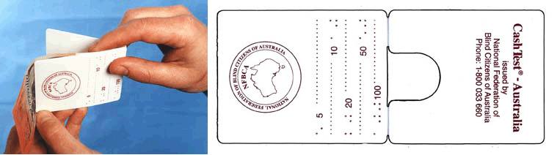
Figure 1.2: Cash Test Australia

Proposed Solutions and Achievements
What is needed is a small credit card size device that is easy to operate and is capable of identifying the Australian Bank notes accurately. The device has to be accurate, cheap to manufacture and has to be able to do at least a couple of hundred identifications on a single charge of batteries. The objective of this project is to produce a working prototype of such a device that allows the user to swipe a note at arbitrary speed and orientation through an optical device. Several pitfalls that were encountered during the course of the project are suitable lighting for scanning, the recognition algorithm and power consumption. The lighting problem was easily solved by producing a light bar and power issues were solved using low power consumption component. The hardest part of the project was the recognition algorithm which used simple signal processing techniques and only concentrating on the clear window and its contents of the note which is more resistant to wear and tear. However due to several hardware constraints, the image recognition algorithm was partially converted to C programming language. Majority of the code are still in MATLAB code.

Thesis Outline
This thesis was separated into 6 main sections and they are;
- Introduction
  - This section provides the overall picture for the project. It defines the current solutions to the problem as well as the solutions proposed to better the current methods. It also highlights in general what was achieved for the duration of the project.
- Project Overview
  - The project overview defines the problems faced in general as well as provides some insight to the problems that were solved.
- Design Issues and Solutions
  - This section highlights the proposed solutions for a particular problem and why a particular solution was picked over the other. It provides in-depth coverage of all the solutions researched and insights to why a particular solution was picked.
- Software Description
  - This section details the implementation of the solutions proposed. Since this was mainly software based project, most of the implementations were software based.
- Testing
  - Testing was the most vital part of the project. This section details the testing that was done for the project. The main testing was done on the accuracy of the program as well as its efficiency.
- Conclusion
  - This section wraps up the whole project and it details all the objectives that were met and also those that were not met. It also provides future implementations and also several suggestions to improve the image recognition program even further.

Project Overview

Introduction
The main objective of the project was to build a prototype handheld device that will be able to scan any Australian dollar note and recognize it with 90% accuracy. Moreover, it had to be power efficient, cheap to manufacture and also robust in the sense that it should be able to recognize any Australian dollar note that is scanned in an arbitrary direction. The main project was split into three major parts, which are the image recognition, the programming of the DSP board and also the hardware implementation.

Image Capture

Image capture was the basis of this project as it was the component where data was acquired and used as inputs to the image recognition software. There were several methods of image capture such as the use of a CMOS camera or a CCD linear array and the cheapest and most compact solution was picked. The CCD linear array offered the best flexibility and also took up the least amount of space. However, there was a trade-off in accuracy. Several simple techniques were implemented in the image recognition program to minimize the inaccuracy of the image capture device chosen.

Illumination
Illumination is an important part of the image capture. In order for a good scan to be obtained with relatively low distortion, the illumination of the note being scanned had to be constant throughout and also possibly collimated. At present there are two techniques being used and they are using one LED or using two LEDs separated by a certain distance. These two techniques are power efficient, space efficient and cost efficient. However it does not provide constant intensity as well as collimated light. Therefore, a simple acrylic bar was created to solve the problem of constant intensity but it did not address the problem of collimated light. As it turns out collimated light was not needed if the lighting element is position directly over the scanner. However, one of the biggest problems faced was to set the intensity of the LEDs used. This problem surfaced due to the fact that IR LEDs were used instead of conventional visible spectrum LEDs. In the near IR spectrum, the wavelength of the note was sufficient enough to penetrate even the non-window parts of the note. Therefore the intensity of the LEDs as well as the wavelength of the LEDs used was chosen carefully.

Hardware Platform
The hardware platform will be used as the main processor and will be the intermediate device between the scanner and the image recognition software. Since the main objective of this project was to design a portable and power efficient device, a general purpose PC could not be used. Therefore a smaller, more specialized platform was sought. Two hardware platforms were considered and they were a Microcontroller Unit and also a Digital Signal Processor. These specialized platforms are small, power efficient and also cost effective. Moreover one of them possesses very specialized capabilities well suited to the application (Yati Indra Hong, 2004).

Image Recognition

The image recognition program was the most vital part of the project. The program had to be robust and also fairly accurate. There were several objectives the image recognition program had to achieve and they were:
- 90% accurate
- Robust
- Computationally Efficient
The image recognition program had to be able to recognize a note that had been scanned through the CCD liner array with arbitrary speed and orientation. This addressed the robustness objective stated above. This posed a very difficult problem as only the window of the note was being scanned. The window could be scanned flipside or upside down as in Figure 2.1 and Figure 2.2. Moreover, the window could be rotated along an axis and also partially scanned leading to the window being in the middle of the scanned image as in Figure 2.3 and Figure 2.4 respectively, which made the image recognition program slightly more complex. These problems were dealt with in order to ensure that the recognition program was able to tolerate the various different conditions.
Figure 2.3: Flipside up of a 10 dollar note

Figure 2.4: Upside down of a 10 dollar note
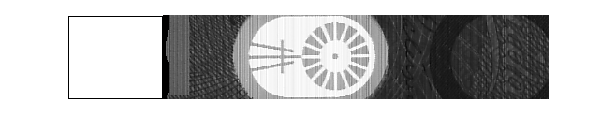
Figure 2.5: The note is partially scanned


Figure 2.6: The note is rotated clock wise by 10 degrees

The solution to the problems stated in the previous page had to be simple and should not consume too much processing time in order to meet the third objective that is computational efficiency. The definition of computational efficiency with respect to this project was that all outputs should be obtained within one second. This constraint was implemented as a delay of one second or less will not be realized by the user.

Another major problem that was tackled by the image recognition program was accuracy. Depending of the means of obtaining a scan the accuracy was increased or decreased. In this case, a CCD linear array was used and only one line of data could be taken at any one time. This posed a huge problem as there could only be so much information contained in a single line of data and in some cases one line from one note could resemble another line on another note. Providing multiple inputs to the recognition program solved this problem. It is not only the way the lines look alike, but what was more important was its frequency content. Several methods were used to tackle these problems such as the use of ratio values instead of the maximum correlation values and also rotating the templates to suit the scanned image.

Current methods for image recognition were to use simple image correlation technique to differentiate one slice of a note from another. This technique was very susceptible to noise and created many false positives. Therefore, instead of analyzing the data in the discrete time domain, the incoming data was transformed into the frequency domain that made it less susceptible to noise. Moreover, the frequency domain correlation technique was more accurate compared to the time domain correlation as it only depended on the frequency content of the scanned image which is less influenced by noise.

Output
The output of the device was fairly simple. Since this device is targeted at people with low vision, the output on the device could not make use of a person’s sense of sight. Therefore the best thing was to take advantage of a person’s sense of hearing. The device outputs audio signals to alert the user that the device is ready to scan and also notify the user of the results of the scans. The output system will consist of a simple speaker and amplifier unit.

Design Issues and Solutions

3.1 Introduction
The simplest way to identify and differentiate the notes was by means of optical capture. It is essentially using an imaging device such as a camera or a liner array as the eyes of a vision impaired or blind person. The clear window was chosen as the main recognition feature due to the high resistance to wear and tear and it was easy to illuminate. Moreover, with some additional upgrades to the system, the device may also be able to detect counterfeits. The counterfeit detection should include scanning such features as micro printing on certain areas of the notes and also the embossing on the clear window.

3.2 Image Capture

3.2.1 Imaging Device
Image capture was the first and foremost important part in the project. The image captured had to contain enough features that it could be used to identify the specific note. There were two different types of imagers that were considered and they were:
- CMOS Camera
- CCD Linear Array
The CCD linear array was chosen over the CMOS camera due to inferiorities in the CMOS camera such as cost and complex lighting conditions. The CMOS camera allowed better image capture however it was not able take a picture of the whole width of the note without significant distance between the note and the camera. Bearing in mind that only the clear window of the notes was used for identification, this implied that the user had to insert the note in a specific orientation for the device to work. Moreover, the CMOS camera needed a lighting area equivalent to the largest width of the window that was much larger then the one line needed for the linear array. This therefore increased the power consumption.

Furthermore, one of the objectives of the project was to develop a cheap device to identify the Australian dollar note. A simple CMOS CCD camera will cost around USD50-USD80. Comparing to the cost of a CCD linear array at AUD20, the CCD linear array posed as a better solution for the application.

In addition, the CCD linear array would allow a 512-pixel array of data to be taken at one time which would allow the note to be taken in any orientation. In addition, a simple lighting solution was implemented when a CCD linear array was used and it directly impacted on the power consumption of the unit. The CCD linear array was also very compact and light which lead to a smaller device.

3.2.2 Illumination
In order for a good image capture to be taken, illumination of the clear window was vital. There are a couple of factors that was considered when deciding on how the window was to be illuminated. The factors were power consumption, cost, size, intensity, evenness and collimation. Several methods had been explored and they were:
- Single LED – This was the most simple design solution to the problem. It was cheap, simple and even produces collimated light. Unfortunately, it did not provide evenness throughout the whole width of the note. The intensity of the light tapered of at the ends even when a wide angle LED was used.
- LED Bars – This was an extension to the single LED solution. The LED bar consisted of 4 LEDs, which were put together in close proximity encased in plastic. This improved on the single LED solution as it created evenness throughout the note and the intensity could be maintained by combining several of these LED bars together. However the power consumption went up and after some research it was found that the edges of the plastic interfered with the evenness of the produced light.
- GRIN/SELFOC lens array – The GRIN (GRadient INdex) lens is a lens where the refractive index within the lens changes. By gradually varying the index of refraction within the lens material, light rays can be smoothly and continually redirected towards a point of focus (NSG Europe, 2004). This produced collimated light and also improved the evenness of the light.
- 2 LEDs coupled with an acrylic bar – This was the best solution found as it created good evenness and intensity. Moreover, it only used two LEDs, which reduced the power consumption. Three sides of the bar were polished and coated with aluminum foil and one side was slightly sanded to ensure that light only propagates through one side of the bar as shown in Figure 3.1.
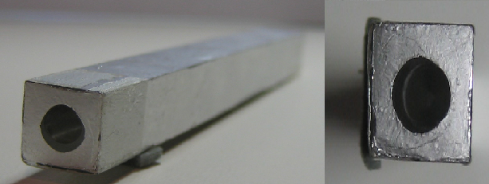
Figure 3.7: LED Bar

The two best options for the application were the LED bar and the SELFOC. The SELFOC lens, produced very good collimated light and evenness, however it was relatively more expansive compared to that of the LED bar. The LED bar however did not produced collimated light. Fortunately if the LED bar is position directly above the note being scanned and the note is position directly above the scanner, collimated light will not be needed. Just on the cost alone the LED bar was chosen instead of the SELFOC linear lens.

Another important part of the illumination problem was the choice of LED. Instead of a visible spectrum LED, an IR LED was used to illuminate the note. This was because the peak spectral sensitivity of the CCD linear array being used was at around 750nm – 800nm. The visible light spectrum only spans from 400nm – 700nm and did not achieve the peak spectral sensitivity of the linear array. Therefore in order to achieve peak spectral sensitivity, it was critical that an IR LED was used as the IR region is from 1mm – 700nm. However, the wavelength of the IR LED was chosen very carefully to ensure that it did not penetrate the non-transparent part of the note. The note may appear non-transparent, but that is only with visible light. In the IR region it may appear transparent. Therefore IR LED with a wavelength in the near IR field was chosen instead.

3.3 Image Recognition

Introduction

The image recognition for the device had to be robust and also close to fault free. The accuracy of the device had to be at least 90% and above and also if possible it needed to be able to return a false positive output (i.e note not recognised). Robustness of the program included the ability to recognize inputs where the note is rotated by ten degrees both clockwise and anti-clock wise. Furthermore, it also had to be able to produce an output within a second of the note being scanned. This constraint was put in-place because a delay of more then one second would be realised by the person using the device.

3.3.2 Cross-Correlation Technique
The most fundamental technique of image recognition was the use of cross-correlation technique. This method is very similar to performing a convolution of two sequences or a matched filter. Essentially, the system is trying to match the image acquired from the CCD linear array with a template that has been stored in memory. The cross-correlation method would compare two number sequences and calculate the highest correlation coefficient. The cross-correlation technique was implemented using the following equations (Soliman, Sarinath,1998).

$${\text{Corr}}_{x,y}(t)=\int_{−∞}^{∞}{x(t)y(t+τ)dτ}$$
Equation 3.1: Cross Correlation Equation
$${\text{Corr}}_{x,y}\left[n\right]=\sum_{−∞}^{∞}{x\left[n\right]y\left[n+k\right]}$$
Equation 3.2: Discrete Time Cross Correlation Equation

This method was favored because it did not require the use of feature extraction that increased the complexity of the system and processing time. Moreover, the image acquired could be in binary representation, which suited the digital system that was used in the project.

The downside to this method of image recognition was that was it very susceptible to noise during image capture. When an image is captured using the CCD linear array, noise could be introduced by electronic noise in transmission, dust in the optics and the most influential is blemishes in the object to be scanned. This type of noise is commonly called speckle noise or salt-and-pepper noise. This type of noise could easily corrupt the acquired image, which made it more difficult to match it up with its template.

The cross-correlation technique would only be effective if the template and the acquired image are similar to each other. The device had to be able to recognize a note scanned with arbitrary orientation. That means that the note could be scanned flipside up or upside down. With the cross-correlation technique a new template for the flipside up and upside down template had to be stored. There are ways of course where only the flipside up or the upside down template is stored and later manipulated to look like the other. This however would take up processing time and slowed down the process.

3.3.3 Discrete Fourier Transform Technique
This method is essentially an extension to the cross-correlation technique. Instead of using the raw data that was acquired from the A/D converter, the DFT was performed on the raw data to obtain the power spectrum of the image. The power spectrum is a representation of the power (or intensity) of the image at each spatial frequency. These intensity peaks are less influenced by noise that made the image recognition more accurate. The DFT and the inverse DFT was performed using the equations below (Soliman, Sarinath, 1998).
$$ℑ(x\left[n\right])=X\left[k\right]=\sum{x\left[n\right]e^{j\frac{2π\text{nk}}{N}}}$$
Equation 3.3: Discrete Fourier Transform Equation

$ℑ^{−1}\left(X\left[k\right]\right)≡x\left[n\right]=\frac{1}{N}\sum_{k=0}^{N−1}{X\left[k\right]e^{−j\frac{2π\text{nk}}{N}}}$
Equation 3.4: Inverse Discrete Fourier Transform Equation

Once the DFT was performed on the raw data, the frequency domain cross-correlation technique was performed on the acquired image and the template to find the maximum correlation according to the equation below (Soliman, Sarinath, 1998).
$${\text{Corr}}_{x,y}\left[n\right]=ℑ^{−1}\left(ℑ\left(x\left[n\right]\right)⋅ℑ{\left(y\left[n\right]\right)}^{}\right)$$
Equation 3.5: Frequency Domain Correlation Equation

Moreover, the frequency domain correlation method allowed the user to scan the note flipside up or upside down. This was done easily using the following conjugate DFT property (Soliman, 1998).
$$ℑ[−y]=ℑ^{}[y]$$
Equation 3.6: Conjugate function property if the Fourier Transform

Equation 3.5 was used and applying the property above, the maximum correlation for the upside down scan was calculated as below (Soliman, Sarinath, 1998).
$${\text{Corr}}_{x,y}\left[n\right]=ℑ^{−1}\left(ℑ\left(x\left[n\right]\right)⋅ℑ\left(y\left[n\right]\right)\right)$$
Equation 3.7: Frequency Domain Correlation for flipside up

The frequency domain correlation method solves many problems posed by the cross-correlation technique. The most important problem solved by using the frequency domain correlation was the fact that it was not so susceptible to noise. This was because the power spectrum represents the intensity of the image at any one point. Even with moderate levels of noise, the frequency domain correlation was able to obtain an accurate output. This is illustrated in the example on the following page.

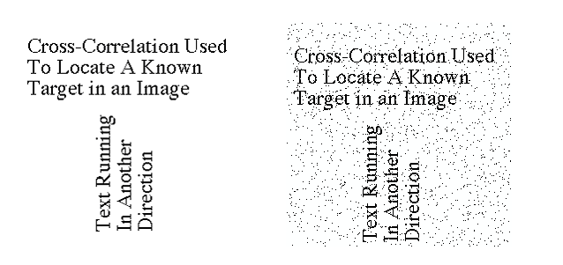
(a)
(b)
Figure 3.8: (a) Original image, (b) Orignal Image corrupted by noise

Figure 3.9: Output using the Frequency Domain Correlation

In the example above, the letter “a” was being located in the image as shown in Figure 3.1(a) (MATLAB 6.5, 2002). In Figure 3.2(b) the image was corrupted by salt & pepper noise. However the output of frequency domain correlation was the same for both the corrupted and non-corrupted image as could be seen in Figure 3.3 (MATLAB 6.5, 2002). This shows that the frequency domain correlation technique was less susceptible to noise.

The DFT method stated in the previous pages was very useful. However it required a large amount of computation. There is however an efficient implementation of this transform called the Fast Fourier Transform (FFT). The FFT has a computational advantage of ten to one in favor of the FFT.

Accuracy

Introduction
Since a CCD linear array was used instead of a CMOS camera, the amount of information that extracted from a scanned image was very limited. This reduced the accuracy of the recognition program dramatically. Furthermore, many slices on notes looked alike physically as well a spectrally (refer to Figure 3.3 & 3.4). The target accuracy for the recognition program was set at 90% and above. This strict constraint was put in place to ensure that each scan can be recognized reliably and reduce the false output rate to only 10% of the time.

Number of Scans

The accuracy of 90% for each output was obtained using the recognition technique chosen. However, it does not reliably produce such a result. This was due to the fact that one line on one note can look very similar to that of another both physically as well as spectrally. This is shown in Figure 3.3 and Figure 3.4 where the example lines for two different notes were taken and it looks very similar physically. Looking at Figure 3.5, the similarity does not end by how they look physically but also spectrally.

Figure 3.10: Line number 75 on a $50 with 0° rotation

Figure 3.11: Line number 20 on a $100 with 0° rotation
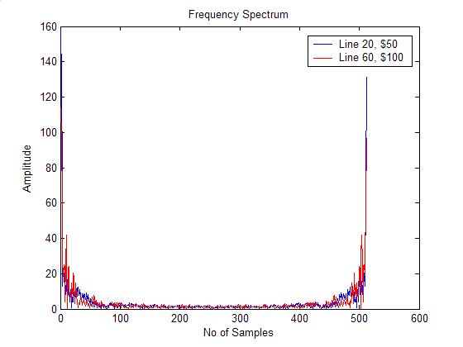
Figure 3.12: Frequency Spectrum of the line images above

In order to overcome this problem, multiple scans or inputs were used to produce a more accurate result. With each increase in input to the program the accuracy of the system increased dramatically. This can be clearly shown in Figure 3.6 where the accuracy jumps from about 30% to above 90% for a $100 note with 2 inputs to the system. In Figure 3.6, two simulations were conducted on a $100, where all possible combinations using one input and two inputs for the note were tested and a histogram of the accuracy was plotted. It can be see that for the single input, the program only recognized the $100 correctly about 30% of the time and it recognized the $10 about 57% of the time. However, with the two inputs simulation, the accuracy of the program increased significantly and it recognized the $100 about 95%.
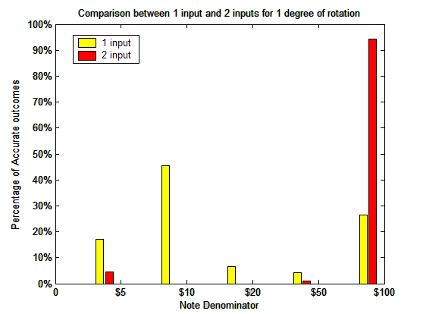
Figure 3.13: Comparison in accuracy between 1 input and 2 inputs for $100

Maximum Correlation Value

As stated in previous pages, the frequency domain correlation technique was used as the basis of the image recognition program. This method relied heavily of the fact that if the scanned image was compared with its template it yields a high correlation value. However there were situations where the correlation values were very close to each other and in some cases the wrong note had a higher correlation value. There are several causes for this inaccuracy such as the template had a large number of ones and because the maximum correlation value was obtained by summing across the rows a high maximum correlation value was obtained.

$$\text{Correlation}=\sum_{j=1}^{n}{x[n]×y[i][n]}$$
Where: x[n] represents the scanned image
y[i][n] represents the template

In-order to determine which row had the highest correlation value; the elements within the matrix were summed across the rows. This was one of the causes for the decrease in accuracy. When the FFT is preformed on a digital signal, the first element of each row is always the numbers of ones in the signal. Therefore, a line with a high number of ones and when summed across the row may yield a high correlation result. This decreased the accuracy of the overall program.

Ratio Values

To further increase the accuracy of the program and also to counter the problems faced by using maximum correlation value, the ratio between the correlation value and the absolute maximum correlation value were used to determine the output of the recognition program. By using the ratio instead of maximum correlation value, each note was on a “similar playing field.” The ratio essentially normalizes all the notes with each other. The use of ratio values increased the accuracy dramatically. This is shown in the following table

 | $5 | $10 | $20 | $50 | $100
Correlation | 25088 | 46080 | 29696 | 37888 | 42496
Ratio | 58% | 88% | 62% | 42% | 47%
Table 3.1: Comparison of accuracy between correlation and ratio

As can be seen from the above table, the correlation values between the $10 and $100 dollar notes are very similar to each other. Line number 50 on a non-rotated $10 was used for this example. Moreover, ideal conditions were used to obtain this result. Therefore with the introduction of noise into the system especially in the image acquiring stage may bring the correlation values even nearer to each other. However, when the ratio was used, it can be clearly seen that it was a $10 note being scanned and not a $100 note. Not only that with the ratio value, the system was also able to let the user know how confident the system was when it outputs the result and what was its second closest match. Furthermore, a threshold could be set into the system where if the maximum ratio value was below 80%, then the system may notify the user that it could not recognize the note and prompt the user to scan the same note again.

Unfortunately a mathematical formulation for the absolute maximum correlation value for each note and each degree of rotation could not be found. Therefore, experimental data was used instead. Testing all possible combination of each note with itself and looking for the maximum correlation value collected the experimental data. Once the absolute correlation value was found, it was used to calculate the ratio values. The normalizing factors are table below.

 |  | Note Denominator
 | Angle | $5 | $10 | $20 | $50 | $100
 | 0 | 43008 | 52224 | 47616 | 91136 | 90624
Anti Clock-Wise Rotation | 1 | 43520 | 60928 | 47104 | 91648 | 91136
Anti Clock-Wise Rotation | 2 | 44544 | 55296 | 46592 | 91648 | 91136
Anti Clock-Wise Rotation | 3 | 45056 | 54272 | 46592 | 92160 | 91136
Anti Clock-Wise Rotation | 4 | 46080 | 52736 | 46592 | 91648 | 91136
Anti Clock-Wise Rotation | 5 | 46592 | 52736 | 45568 | 92160 | 91648
Anti Clock-Wise Rotation | 6 | 47616 | 54272 | 46080 | 92160 | 91136
Anti Clock-Wise Rotation | 7 | 48128 | 57344 | 44544 | 92160 | 90624
Anti Clock-Wise Rotation | 8 | 49152 | 59904 | 45056 | 92160 | 91136
Anti Clock-Wise Rotation | 9 | 50176 | 61952 | 44544 | 92160 | 89600
Anti Clock-Wise Rotation | 10 | 51200 | 65024 | 43520 | 91648 | 89088
Clock-Wise Rotation | 1 | 41984 | 51200 | 49152 | 90624 | 90112
Clock-Wise Rotation | 2 | 41472 | 60416 | 49664 | 90624 | 91136
Clock-Wise Rotation | 3 | 39936 | 61952 | 52736 | 90112 | 91136
Clock-Wise Rotation | 4 | 39424 | 57856 | 53248 | 90624 | 92160
Clock-Wise Rotation | 5 | 38400 | 53760 | 54272 | 89088 | 92672
Clock-Wise Rotation | 6 | 38400 | 54272 | 54784 | 88064 | 95232
Clock-Wise Rotation | 7 | 38400 | 54272 | 55296 | 88064 | 97792
Clock-Wise Rotation | 8 | 38912 | 55296 | 54784 | 87552 | 98304
Clock-Wise Rotation | 9 | 37888 | 58880 | 55808 | 86528 | 99328
Clock-Wise Rotation | 10 | 39424 | 60928 | 56832 | 86528 | 99328
Table 3.2: Table of normalising factors

Rotation & Orientation of Image

Introduction
In order for the image recognition software to be robust, the software had to be able to tolerate an image scanned with arbitrary direction. Since a guide will be used to align the notes before scanning, a ±10° rotation limit is introduced. There are several methods that could be employed to determine the rotation and orientation of the scanned image and correlate it with a template. Two main methods were selected and later one was omitted due to the complexity.

Template Matching Based Object Recognition with Unknown Geometric Parameters
This method was very useful when geometric parameters such as rotation and size of the image were not known. It used parameter estimation to estimate the degree of rotation as well as the size of the image. The algorithm was very robust to noise, accurate across a wide range of object configurations and computationally efficient.

However, to obtain an outcome using this method was not trivial and involved lots of mathematical manipulation and recursive algorithms. Moreover, the method required a full image to be scanned and not only a single line. Since a CCD linear array was used and it was not guaranteed that each and every line of the window was scanned, therefore this method cannot be used. Instead a simpler method was employed as detailed next.

3.5.2 Rotating of the template
One simple method used to allow for rotation of a scanned image was to rotate the template as well. It is quite simple in theory and involved very little computation. An object can be rotated along the origin using the following equations.
$$\begin{aligned}x(i)=x\text{cos}(θ)−y\text{sin}(θ) \\ y(i)=x\text{sin}(θ)+y\text{cos}(θ)\end{aligned}$$
Equation 3.8: Counter-clock wise rotation along point (0,0)
$$\begin{aligned}x(i)=x\text{cos}(θ)+y\text{sin}(θ) \\ y(i)=−x\text{sin}(θ)+y\text{cos}(θ)\end{aligned}$$
Equation 3.9: Clockwise rotation along point (0,0)
The above equation was used and the template could be rotated in any direction and also to any degree. However the equation above posed a different set of problems during implementation. First off all since most computers work with integer numbers and using Equation 3.8 and 3.9 would not always produce an integer number. Therefore, the rotated coordinates calculated had to be rounded up or down and it introduced imperfections or quantization errors in the rotated image.

Figure 3.14: $10 rotated by 5°

Figure 3.15: $10 rotated by 15°

It is clearly evident from the Figure 3.7 and Figure 3.8 that the higher the degree of rotation the higher the amount of imperfections. These imperfections hampered the accuracy of the image recognition program. Therefore, a simple imperfection reduction technique was implemented. The program would look through the image and when it detects a sequence of “1”, “0”, “1”, it would flag it as an error and would change the bit “0” to “1”. The imperfection reduction algorithm yielded a rotate image that was far better and clearer. The only problem that surfaced from this simple algorithm was that if a true pattern of “1”, “0”, “1” was detected; it was also flagged as an error and was corrected. The program may flag a couple of features of the note as an error and they are:
- Edges of stars on $50
- Edges of star and spikes on $20
- Supports for the windmill on the $10
- Filaments of the gum nut flower on the $5
This however, was not such a big influence as show in Figure 3.9, 3.10, 3.11 and 3.12 where most of the original features on the notes were not removed by the imperfection reduction algorithm. Unfortunately though the spike on the $20 note was removed slightly but it was still within acceptable limits.


Figure 3.16: $50 rotated by 15° and put through the noise reduction algorithm

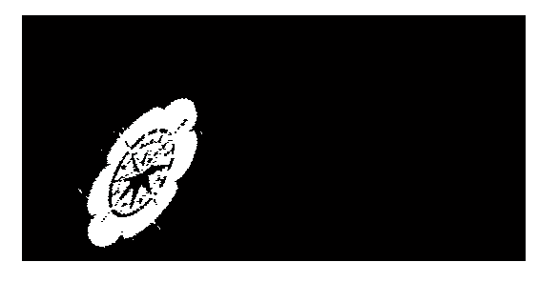
Figure 3.17: $20 rotated by 15° and put through the noise reduction algorithm


Figure 3.18: $10 rotated by 15° and put through the noise reduction algorithm

Figure 3.19: $5 rotated by 15° and put through the noise reduction algorithm

The second problem faced while trying to rotate a template was that, every time the template was rotated the image size became bigger and bigger until the rotation reached about 45°. This is clearly proven in Figure 3.7 and 3.8, where Figure 3.8 has more number of rows and columns due to the fact it had a higher degree of rotation. It was not such a big problem, as it did not reduce the accuracy of the program. However it did slow down the process, take up more processing time as well as increased the memory space needed to store the templates. This was because the scanned image had to be compared with more rows of data.

Since the extra lines do not contain any data, omitting them did not affect the outcome of the program in anyway. Therefore, a simple algorithm was written to eliminate the extra lines of zeros that were created. The algorithm simply had to identify when the image starts and when it ends. It takes each row of the rotated template and checks if there was a white pixel (bit 1) present or not. If a white pixel is not present then that line is discarded and it went on to the next line. Once the start of the image had been detected then the program proceeded instead to look for the end of the image and this was done by the same principles as finding for the start of the image. It once again went through the image row by row until it detected a row where there was no white pixel present. Once it had detected the end of the image it discarded all rows after that.

Figure 3.20: $10 rotated by 15° and the extra rows has been discarded

Output
As stated many times, this device was targeted at users with vision impairment. Therefore, the most sensible means of output was to make use of the other four working senses. The first thing considered was a refreshable Braille cell that took advantage of the sense of touch of a person. However, Braille cell devices were very expansive and it required added programming and also consumed more power. The best thing was to use audible voice such as speech that made use of a person’s sense of hearing. This was a simple solution as because a small and cheap speaker amplifier package could be used. The audible speech does not have to be of very high quality as long as it was understandable. The advantage was that the speaker and amplifier unit does not need to be of very high quality or have high sampling rate and this reduced the cost of the system. Furthermore, speaker units as well as an amplifier unit nowadays come in very small packages that would reduce the size of the overall device.

4.0 Software Description

4.1 Image Recognition Program

4.1.1 Corr.m
This was a simple program that calculated the maximum correlation between the scanned image and the specific template that had been sent in to the function. The pseudocode for the program is stated below
- Perform FFT on scanned image
- Multiply scanner image with each set of templates
- Perform inverse FFT and extracting real part only
- Find the maximum value

The function took a 512-bit array as the scanned image and performed the FFT on it and stored it as input. Then input was multiplied with every line of the template and summed across the row. The highest value indicated that the frequency content of the scanned image was similar to the frequency content in that row.

The input was also multiplied with the conjugate of the template to account for the fact that the note may be scanned upside down. Once again the highest value was acquired and it was compared to the maximum value found using the non-conjugate template. The highest value between the both was output by the program. This program was called multiple times with different templates for the five dollars, ten dollars and so on a so forth.

4.1.2 FFTtemplates.m
The Texas Instrument DSK5510 had some standard DSP libraries that also included the FFT functions. There are 2 main functions in that library that was used. The rfft function was used to compute the real part of the FFT and the cfft was used to compute the complex part of the FFT.

The reason the standard libraries that comes with the DSP board was used was that the functions were hand written in assembly language and it was optimized for the DSP board. This sped up the process even further. It was estimated that the program would have to perform up to 13580 rows of FFT to account for all the rows of the notes and also for the rotation of 10º clockwise and anti clockwise. Therefore, the FFT function was handy to speed up the FFT process.

However due to the hardware limitation of the DSK5510, the image recognition program was not implemented on the DSP board, but instead in MATLAB. The FFTtemplates.m program will perform the FFT on the templates from zero degree of rotation to ten degrees of clockwise rotation.

4.1.3 Identification.m
This program invoked corr.m to test the scanned image with all the templates stored in memory. It sends the scanned image and also one template at a time into the corr.m program. The corr.m program calculated the maximum correlation value between the input and the specific template that was sent in. The output of the correlation program was stored in an array and the next template was sent in. Once all the templates have been sent in one by one and all the correlation value were obtained, the program will determine the maximum percentage value that corresponded to the specific note and also the specific rotation. The pseudocode for this program is as below
- Find and store the correlation value between scanned image and template for 5 dollars
- Find and store the correlation value between scanned image and template for 10 dollars
- Find and store the correlation value between scanned image and template for 20 dollars
- Find and store the correlation value between scanned image and template for 50 dollars
- Find and store the correlation value between scanned image and template for 100 dollars
- The program will repeat the first 5 steps for 1 degree of rotation clock wise and anti-clock wise and continue until 10 degrees of rotation is covered
- The maximum percentage value is obtained and the corresponding dollar note is stored.

The correlation value obtained using the correlation program was stored in a 2 dimension array where the x-index corresponded to the degree of rotation and the y-index corresponded to the denomination. The maximum value was obtained and the corresponding denomination value was return to the main driver program.

4.1.4 Skewtemplates.m

This program performed rotation of the templates. The inputs to the program were the template that needed to be rotated, the degree of rotation and the direction of rotation. It also performed all necessary corrections such as imperfection reduction and reduction of template size before sending the output to the main driver program. The pseudocode for this program is as below
- Calculate mid-point of image
- Create artificial coordinates
- Calculate the coordinates for rotation
- Offset the coordinates to the positive quadrant
- Correlate the rotated coordinates with the original image
- Perform noise reduction algorithm
- Perform template size reduction algorithm

Output.m

Output.m was a simple MATLAB program that output an audible speech after a note has been recognized. It obtained the results of the image recognition software and determines which audio file to play.

Testing
The testing of the image recognition program mainly involved the testing of the accuracy and the efficiency of the program. As the accuracy of the program was very critical, severe testing was performed on the program to ensure that it met the objectives set. The first set of test was conducted on ideal results without the introduction of noise to measure the level of accuracy of the program. The testing program took each and every line from all the notes including five degree of rotation and used it as an input the image recognition program. Data was collected and histograms of the accuracy were plotted (Appendix B.1). It was found that the accuracy for the $5, $10, and $20 notes were satisfactory however the $50 and $100 notes failed the accuracy test.

The second set of testing involved more practical situation where salt & pepper noise was introduced to the inputs of the program (Appendix B.2). The accuracy for the program was reduced but only by a small margin. On average a 10 percent drop in accuracy was experienced on all notes except the $20 note where an increase in accuracy was observed. Last but not least was the third set of test, where two inputs to the recognition program were used. Since the $100 note did not pass any of the accuracy tests, it was chosen to conduct the third set of test (Appendix B.3). A dramatic increase in accuracy for the $100 was observed where the accuracy jumped from about 30% to 95%. Due to time constraints, only the $100 was simulated with two inputs and it was safe to assume that the result carried forward for all the other notes.

The last set of test was used to ascertain the efficiency of the program. Ten inputs were used for the recognition program and it was observed that it took about ten seconds to produce a result. This was unacceptable, however it was tested in MATLAB and if the code was tested in C, it may yield a more efficient program.

Conclusion

6.1 Achievements
The 2 main objectives for the image recognition software were met. The program was able to recognize a note that had been scanned with arbitrary direction. The program was able to tolerate a ±10° of rotation. Moreover, the accuracy of the program was above 90% for each of the notes.

The only objective not met in this thesis was the computational time factor. Due to the hardware limitation of the DSK5510 DSP board, the MATLAB programs were not translated into C. This problem surfaced from the fact that the DSK5510 was a 16-bit processor and since the program had to deal with arrays as big as 262X534, a great deal of work had to be done to incorporate the program with a 16-bit processor. There are several methods that were used to overcome this problem, but it involved many more lines of code and recursive loops that increased the computational time. Since the image recognition program was not translated into C and not running on the DSK5510, the actual computational time for the program was not tested.

Future Implementations

Introduction
All the testing and development of the image recognition software was done in MATLAB. The ultimate goal was to translate the program into C to increase the computational time efficiency of the program. However due to the hardware constraints stated above, the MATLAB programs were not implemented in C. Therefore, a couple of future implementations for the image recognition program can be considered.

Translation of MATLAB programs

In order to produce a device which was portable and power efficient, the image recognition program had to be implemented of specialized processors and not general purpose PC. This automatically meant that the image recognition program had to either be in C programming language or Assembly language. However, these programming languages were very hard to use during the development and testing of the image recognition program. Therefore MATLAB was used, but MATLAB only runs on general purpose PCs. As a result the MATLAB programs have to be converted into C and with the current hardware limitations; it was counter productive to do so. Therefore a 32-bit processor such as the C6000 series DSP chips should be considered in any further work.

Reduction in RAM needed for storing templates

At the moment, since the DSP board cannot read image files such as bitmap and JPEG, the templates were converted to binary files. This resulted in an increase of memory space needed to store the templates. At the moment, 1.3Mb is needed to store the five different note denominations in a binary file and this did not fit in the flash memory on the DSK5510. Worst still was that with ±10° of rotation, the amount of RAM needed just to store the templates would further increased to 26Mb. Therefore either a better solution is found to store the templates or a better recognition algorithm is used to predict the amount of rotation. Increasing the amount of flash and well as RAM on the hardware platform can also be considered.

Counterfeit Detection

It will be a worthwhile task to try and introduce some form of counterfeit detection into the program. However, a new scanner maybe needed and also a different type of lighting needs to be considered. Moreover, to include counterfeit detection the device may also need to scan a different part of the note to pick up special counterfeit deterrence method implemented by the Royal Bank of Australia such micro printings and watermarks.

Further reduction in computational time

There are several methods that were thought about during the duration of the project to reduce computation time of the program, however due to several constraints they were not implemented. First method was to check if the scan was valid; the simplest method was to go through the scanned image looking for white pixel. However, since the frequency domain correlation was used for the image recognition program, and the FFT has to be performed on the scanned image. Since the image arrived as a binary signal, the FFT can be performed on the scanned image and the first element of the array will correspond to the number of bit “1” (white pixel) in the array. This method will combine the valid scan procedure and performing the FFT on the scanned image into one process and therefore saving computation time.

The second method thought was to perform the FFT on all the templates including rotated templates before notifying the user that it is ready for a scan. When the device is powered on, it will initialize all the ports and proceed to performing the FFT on all the templates before notifying the user that it is ready for scanning. This will reduce the amount of time needed once the scan is obtained and further reducing the delay between the time of scanning and the time of output.

Bibliography

Burke M. W., Image Acquisition, vol. 1, Oxford: Chapman & Hall, 1996.
Currency Notes, [online], Available: http://www.rba.gov.au/CurrencyNotes/ [2001-2004].

Fat and Macular Degeneration, [Online], Available : http://www.csiro.au/proprietaryDocuments/fat_and_macular_degeneration.pdf [July 2004].

Hayes, T. C, Horowits P., 1991, Student Manual for The Art of Electronics, Cambridge University Press, Cambridge.

Hayes, T. C, Horowits P., 1991, The Art of Electronics, Cambridge University Press, Cambridge

Holst G. C., CCD Arrays, Cameras and Displays, 2nd Ed., Winter Park: JCD Publishing, 1998.

Note Teller 2: Financial Security that fits your pocket, [Online], Available: http://www.brytech.com/noteteller/ [2004].

Press, W. et al., Numerical Recipes in C, 2nd Ed., New York: Cambridge University Press, 1997.

SELFOC® Lens Array (SLA), [Online], Available: http://www.nsgeurope.com/sla.shtml [2004].

Seul, Micheal, O’Gorman,Lawrence, Sammon, M.J. 2000, Practical Algorithms for Image Analysis Description, Examples and Code, Cambridge University Press, Cambridge.

Soliman, S.S, Srinath, M.D, Continuous and Discrete Signals and System, 2nd Ed., Prentice Hall, New Jersey, 1998.

Statistics on eye health in Australia, [Online], Available: http://www.visionaustralia.org.au/index.asp?inc=&parentnav=vision&childnav=stats&subsection=intro&topnav=&float= [2002-2003]

TMS320C55x DSP Library Programmers Reference [Online], Available: http://focus.ti.com/docs/toolsw/folders/print/sprc100.html [Nov 2003]

Willie. D Jones, 2004, Sight for Sore Ears, IEEE Spectrum Feb 2004, pp11-12.

Yati, I Hong, Currency Identification for the Blind, Curtin University of Technology, 2004.

Appendix A Project Plan

CURRENCY IDENTIFICATION FOR THE VISUALLY IMPAIRED
 |  |  | March |  |  |  |  | April |  |  |  | May |  |  |  |  | June |  |  |  | July |  |  |  | August |  |  |  |  | September |  |  |  | October |  |  |  | Novermber
Task | Start date | End date | 1 | 8 | 15 | 22 | 29 | 5 | 12 | 19 | 26 | 3 | 10 | 17 | 24 | 31 | 7 | 14 | 21 | 28 | 5 | 12 | 19 | 26 | 2 | 9 | 16 | 23 | 30 | 6 | 13 | 20 | 27 | 4 | 11 | 18 | 25 | 1 | 8
PLANNING | 1/03/2004 | 19/03/2004 |  |  | ●
RESEARCH | 1/03/2004 | 5/05/2003
CONCEPT DESIGN
Requirements Specification | 15/03/2004 | 19/03/2004 |  |  | ●
Brainstorming Session(s) | 1/03/2004 | 13/04/2003
CONCEPT SELECTION
Decide on design (Hardware) | 23/03/2004 | 24/03/2004 |  |  |  | ●
Order & fabricate parts | 22/03/2004 | 15/06/2004 |  |  |  | ●
DESIGN IMPLEMENTATION
Image Recognition Algorithm | 29/03/2004 | 21/05/2004
Implement algo on new platform | 29/03/2004 | 30/07/2004
Hardware Interfacing | 12/04/2004 | 8/06/2004
Completion of Initial Design | 31/05/2004 | 31/05/2004 |  |  |  |  |  |  |  |  |  |  |  |  |  | ●
PROTOOTYPE FABRICATION
Assemble parts | 10/05/2004 | 5/07/2004
Testing | 2/08/2004 | 12/09/2004
Alpha prototype complete | 13/09/2004 | 13/09/2004 |  |  |  |  |  |  |  |  |  |  |  |  |  |  |  |  |  |  |  |  |  |  |  |  |  |  |  | ●
Refine, build beta version | 9/09/2004 | 27/09/2004
THESIS
Write draft sections | 17/05/2004 | 25/10/2004
Edit draft | 30/10/2004 | 8/11/2004
Produce final thesis | 10/11/2004 | 10/11/2004 |  |  |  |  |  |  |  |  |  |  |  |  |  |  |  |  |  |  |  |  |  |  |  |  |  |  |  |  |  |  |  |  |  |  | ● |  | ●
Thesis Due | 11/11/2004 | 11/11/2004 |  |  |  |  |  |  |  |  |  |  |  |  |  |  |  |  |  |  |  |  |  |  |  |  |  |  |  |  |  |  |  |  |  |  |  | ● | ●
PRESENTATION
Create presentation materials | 18/10/2004 | 25/10/2004
Rehearse presentation | 18/10/2004 | 25/10/2004
Modify presentation materials | 25/10/2004 | 1/11/2004
Presentation | 5/11/2004 | 5/11/2004 |  |  |  |  |  |  |  |  |  |  |  |  |  |  |  |  |  |  |  |  |  |  |  |  |  |  |  |  |  |  |  |  |  |  |  | ●
KEY
● MILESTONE |  |  |  | Changes/Extensions to the original schedule

Appendix B Simulation Results

B.1 Simulation Results with ideal conditions
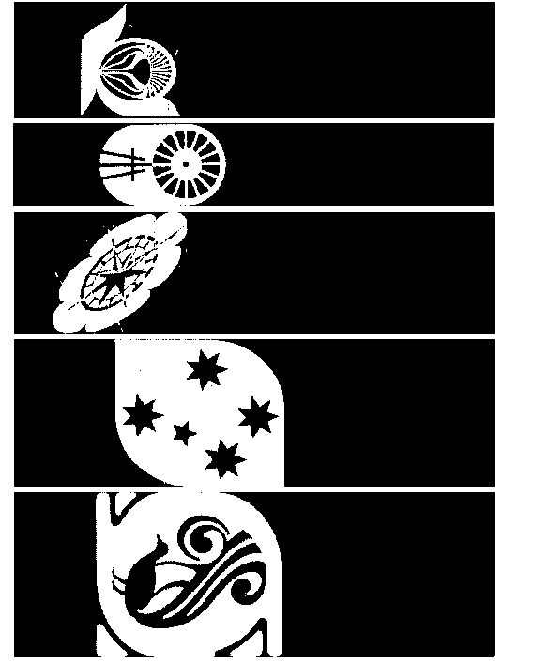
Figure B.21: Test sets without noise
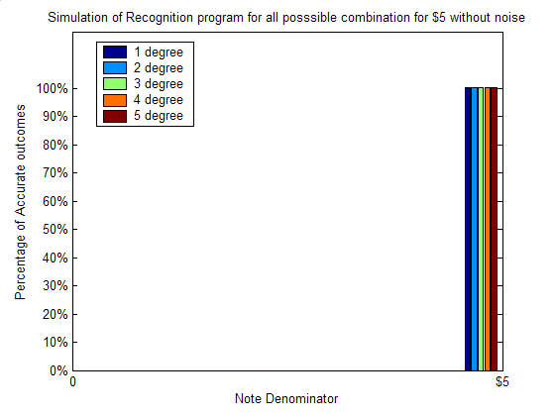
Figure B.22: $5 with all possible combination and 5 degree of rotation

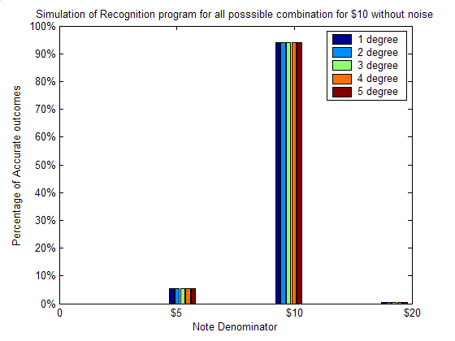
Figure B.23: $10 with all possible combination and 5 degree of rotation
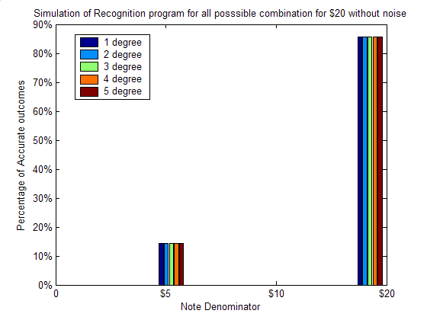
Figure B.24: $20 with all possible combination and 5 degree of rotation

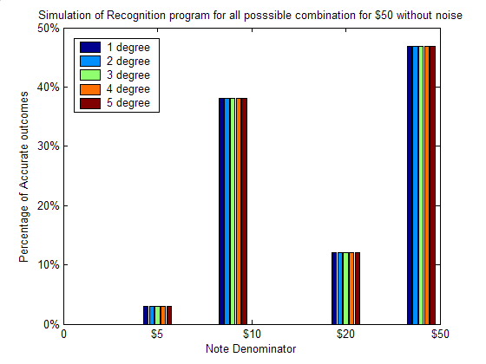
Figure B.25: $50 with all possible combination and 5 degree of rotation
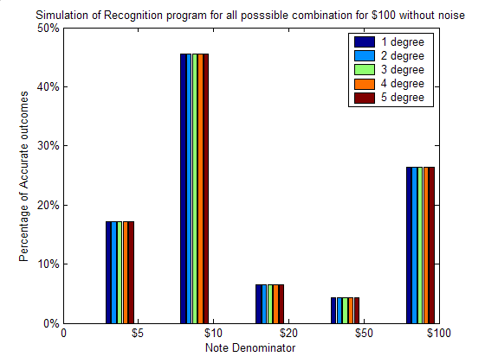
Figure B.26: $100 with all possible combination and 5 degree of rotation

B.2 Simulation Results with Salt & Pepper noise

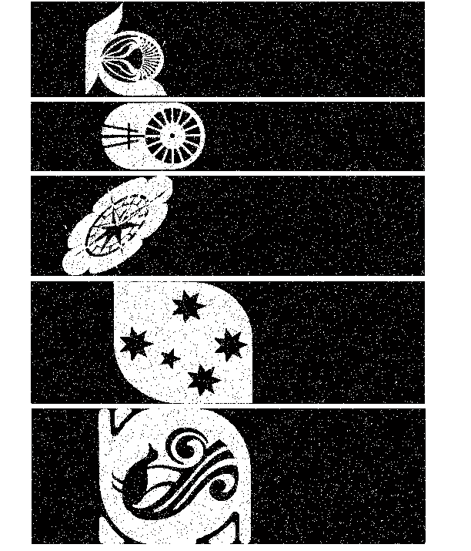
Figure B.27: Tests sets with salt & pepper noise introduced

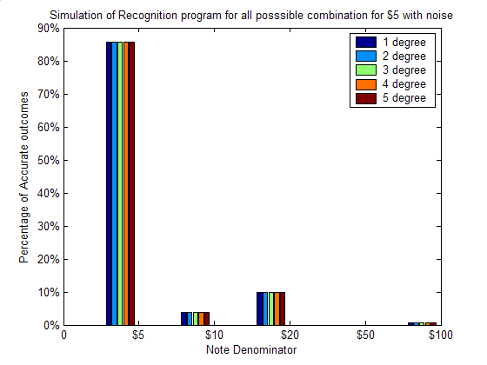
Figure B.28: $5 all possible combination, 5 degree of rotation with noise

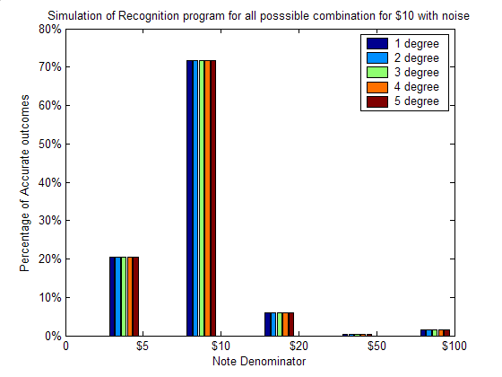
Figure B.29: $10 all possible combination, 5 degree of rotation with noise

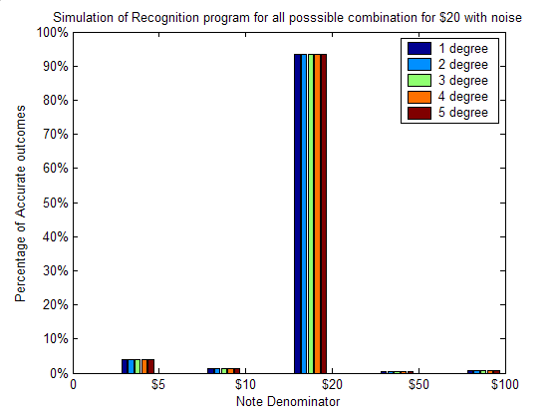
Figure B.30: $20 all possible combination, 5 degree of rotation with noise

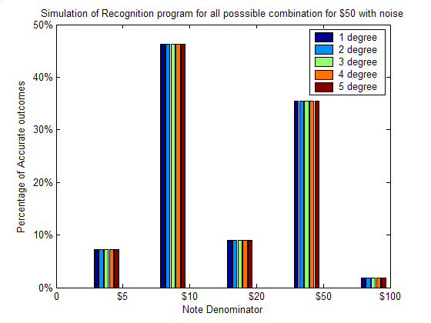
Figure B.31: $50 all possible combination, 5 degree of rotation with noise

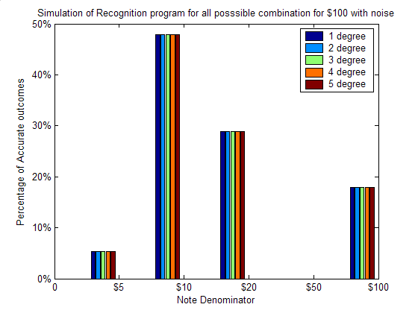
Figure B.32: $100 all possible combination, 5 degree of rotation with noise

B.3 Simulation Results with multiple inputs

Figure B.33: Comparison between 1 input and 2 inputs for $100

Appendix C Program Listings

C.1 FFTemplates.m
function[dollar5,dollar10,dollar20,dollar50,dollar100,d5deg1,d10deg1,d20deg1,d50deg1,d100deg1,d5deg2,d10deg2,d20deg2,d50deg2,d100deg2,d5deg3,d10deg3,d20deg3,d50deg3,d100deg3,d5deg4,d10deg4,d20deg4,d50deg4,d100deg4,d5deg5,d10deg5,d20deg5,d50deg5,d100deg5,d5deg6,d10deg6,d20deg6,d50deg6,d100deg6,d5deg7,d10deg7,d20deg7,d50deg7,d100deg7,d5deg8,d10deg8,d20deg8,d50deg8,d100deg8,d5deg9,d10deg9,d20deg9,d50deg9,d100deg9,d5deg10,d10deg10,d20deg10,d50deg10,d100deg10] = fftemplates()
% This function performs the FFT for all the templates. The outputs of the
% program are:
% dollar5 to dollar100 is for 0 degree of rotation
% d5deg1 to d100deg1 is for 1 degree rotation
% d5deg2 to d100deg2 is for 2 degree rotation
% d5deg3 to d100deg3 is for 3 degree rotation
% d5deg4 to d100deg4 is for 4 degree rotation
% d5deg5 to d100deg5 is for 5 degree rotation
% d5deg6 to d100deg6 is for 6 degree rotation
% d5deg7 to d100deg7 is for 7 degree rotation
% d5deg8 to d100deg8 is for 8 degree rotation
% d5deg9 to d100deg9 is for 9 degree rotation
% d5deg10 to d100deg10 is for 10 degree rotation

% Reading in all the images and performing the treshold function on it
I = imread('5_1.bmp');
I1 = imread('10.bmp');
I2 = imread('20.bmp');
I3 = imread('50.bmp');
I4 = imread('100.bmp');
bw = tresh(0.85,I);
bw1 = tresh(0.85,I1);
bw2 = tresh(0.85,I2);
bw3 = tresh(0.85,I3);
bw4 = tresh(0.85,I4);

% Performing the FFT on the $5 - $100 with 0 degree of rotation
[dollar5 dollar10 dollar20 dollar50 dollar100] = ffttemp(bw,bw1,bw2,bw3,bw4);

% Performing the FFT on the $5 - $100 with 1 degree of rotation
y = skewtemplates(bw,1,1);
y1 = skewtemplates(bw1,1,1);
y2 = skewtemplates(bw2,1,1);
y3 = skewtemplates(bw3,1,1);
y4 = skewtemplates(bw4,1,1);

[d5deg1 d10deg1 d20deg1 d50deg1 d100deg1] =ffttemp(y,y1,y2,y3,y4);

% Performing the FFT on the $5 - $100 with 2 degree of rotation
y = skewtemplates(bw,2,1);
y1 = skewtemplates(bw1,2,1);
y2 = skewtemplates(bw2,2,1);
y3 = skewtemplates(bw3,2,1);
y4 = skewtemplates(bw4,2,1);

[d5deg2 d10deg2 d20deg2 d50deg2 d100deg2] =ffttemp(y,y1,y2,y3,y4);

% Performing the FFT on the $5 - $100 with 3 degree of rotation
y = skewtemplates(bw,3,1);
y1 = skewtemplates(bw1,3,1);
y2 = skewtemplates(bw2,3,1);
y3 = skewtemplates(bw3,3,1);
y4 = skewtemplates(bw4,3,1);

[d5deg3 d10deg3 d20deg3 d50deg3 d100deg3] =ffttemp(y,y1,y2,y3,y4);

% Performing the FFT on the $5 - $100 with 4 degree of rotation
y = skewtemplates(bw,4,1);
y1 = skewtemplates(bw1,4,1);
y2 = skewtemplates(bw2,4,1);
y3 = skewtemplates(bw3,4,1);
y4 = skewtemplates(bw4,4,1);

[d5deg4 d10deg4 d20deg4 d50deg4 d100deg4] =ffttemp(y,y1,y2,y3,y4);

% Performing the FFT on the $5 - $100 with 5 degree of rotation
y = skewtemplates(bw,5,1);
y1 = skewtemplates(bw1,5,1);
y2 = skewtemplates(bw2,5,1);
y3 = skewtemplates(bw3,5,1);
y4 = skewtemplates(bw4,5,1);

[d5deg5 d10deg5 d20deg5 d50deg5 d100deg5] =ffttemp(y,y1,y2,y3,y4);

% Performing the FFT on the $5 - $100 with 6 degree of rotation
y = skewtemplates(bw,6,1);
y1 = skewtemplates(bw1,6,1);
y2 = skewtemplates(bw2,6,1);
y3 = skewtemplates(bw3,6,1);
y4 = skewtemplates(bw4,6,1);

[d5deg6 d10deg6 d20deg6 d50deg6 d100deg6] =ffttemp(y,y1,y2,y3,y4);

% Performing the FFT on the $5 - $100 with 7 degree of rotation
y = skewtemplates(bw,7,1);
y1 = skewtemplates(bw1,7,1);
y2 = skewtemplates(bw2,7,1);
y3 = skewtemplates(bw3,7,1);
y4 = skewtemplates(bw4,7,1);

[d5deg7 d10deg7 d20deg7 d50deg7 d100deg7] =ffttemp(y,y1,y2,y3,y4);

% Performing the FFT on the $5 - $100 with 8 degree of rotation
y = skewtemplates(bw,8,1);
y1 = skewtemplates(bw1,8,1);
y2 = skewtemplates(bw2,8,1);
y3 = skewtemplates(bw3,8,1);
y4 = skewtemplates(bw4,8,1);

[d5deg8 d10deg8 d20deg8 d50deg8 d100deg8] =ffttemp(y,y1,y2,y3,y4);

% Performing the FFT on the $5 - $100 with 9 degree of rotation
y = skewtemplates(bw,9,1);
y1 = skewtemplates(bw1,9,1);
y2 = skewtemplates(bw2,9,1);
y3 = skewtemplates(bw3,9,1);
y4 = skewtemplates(bw4,9,1);

[d5deg9 d10deg9 d20deg9 d50deg9 d100deg9] =ffttemp(y,y1,y2,y3,y4);

% Performing the FFT on the $5 - $100 with 10 degree of rotation
y = skewtemplates(bw,10,1);
y1 = skewtemplates(bw1,10,1);
y2 = skewtemplates(bw2,10,1);
y3 = skewtemplates(bw3,10,1);
y4 = skewtemplates(bw4,10,1);

[d5deg10 d10deg10 d20deg10 d50deg10 d100deg10] =ffttemp(y,y1,y2,y3,y4);

% Note to increase the degree of rotation or to include the anticlockwise
% direction, just repeat the skewtemplates with different values.

C.2 FFTtemp.m
function[dollar5fft,dollar10fft,dollar20fft,dollar50fft,dollar100fft] = ffttemp(dollar5t,dollar10t,dollar20t,dollar50t,dollar100t)
% This function will perform the FFT on all incoming templates. Note the
% templates that is coming in should be threshold to 1's and 0's. Also note
% that instead of using the FFT function, FFT2 function can be used to
% perform a 2-D fft. This will speed up the process, however FFT was used
% because the program has to be converted to C and a 2-D fft prgoram for C
% was not available.

% Performing the fft on all the templates

[row col] = size(dollar5t);

for i =1:row
dollar5fft(i,:) = fft(dollar5t(i,:));
end

[row col] = size(dollar10t);

for i =1:row
dollar10fft(i,:) = fft(dollar10t(i,:));
end

[row col] = size(dollar20t);

for i =1:row
dollar20fft(i,:) = fft(dollar20t(i,:));
end

[row col] = size(dollar50t);

for i =1:row
dollar50fft(i,:) = fft(dollar50t(i,:));
end

[row col] = size(dollar100t);

for i =1:row
dollar100fft(i,:) = fft(dollar100t(i,:));
end

C.3 Corr.m
function[maximumcorrelation] = corr(templates,input);

[row col] = size(templates);
input = fft(input);

% This is to find correlation when the note is right side up

for i = 1:row
output(i,:) = input*templates(i,:)';
output(i,:) = ifft(output(i,:));
output(i,:) = real(output(i,:));
end

[maximumcorrelationup index] = max(output);

% This is to find the correlation when the note is flipside up
for i = 1:row
output1(i,:) = input*conj(templates(i,:))';
output1(i,:) = ifft(output1(i,:));
output1(i,:) = real(output1(i,:));
end

[maximumcorrelationdown index1] = max(output1);

% Output the maximum correlation between the right side up or the flipside
% up.
if maximumcorrelationup > maximumcorrelationdown
maximumcorrelation = maximumcorrelationup;
else
maximumcorrelation = maximumcorrelationdown;
end

C.4 Maxcorr11.m
function[correlation,ratio] = maxcorr11(dollar5,dollar10,dollar20,dollar50,dollar100,d,input);
% This program is used to calculate the correlation between then input and
% the respective templates. The templates are passed into the function is
% dollar5, dollar10, dollar20, dollar50 and dollar100. The input in this
% case can be a matrix with any number of rows but has to be 512 columns.
% d is the normalising factor that will be used to calculate the ratio for
% each note.
%

[row col] = size(input);

% Calculating the correlation value for all the inputs compared to the
% templates
for i = 1:row
output(i) = corr(dollar5,input(i,:));
output1(i) = corr(dollar10,input(i,:));
output2(i) = corr(dollar20,input(i,:));
output3(i) = corr(dollar50,input(i,:));
output4(i) = corr(dollar100,input(i,:));
end

% Obtaining the mean of the inputs to get a better correlation value
output = mean(output);
output1 = mean(output1);
output2 = mean(output2);
output3 = mean(output3);
output4 = mean(output4);

% Calculating the ratio
correlation = [output output1 output2 output3 output4];
ratio = (correlation./d)*100;

C.5 Indentification.m
function[index] = identification(dollar5,dollar10,dollar20,dollar50,dollar100,input,d5deg1,d10deg1,d20deg1,d50deg1,d100deg1,d5deg2,d10deg2,d20deg2,d50deg2,d100deg2,d5deg3,d10deg3,d20deg3,d50deg3,d100deg3,d5deg4,d10deg4,d20deg4,d50deg4,d100deg4,d5deg5,d10deg5,d20deg5,d50deg5,d100deg5,d5deg6,d10deg6,d20deg6,d50deg6,d100deg6,d5deg7,d10deg7,d20deg7,d50deg7,d100deg7,d5deg8,d10deg8,d20deg8,d50deg8,d100deg8,d5deg9,d10deg9,d20deg9,d50deg9,d100deg9,d5deg10,d10deg10,d20deg10,d50deg10,d100deg10)
% This program will test the inputs with all the templates stored. It will
% also determine which is the most likely note.

% Maximum Value to calculate the ratio
ratiofactor = [43008 52224 47616 91136 90624;
43520 60928 47104 91648 91136;
44544 55296 46592 91648 91136;
45056 54272 46592 92160 91136;
46080 52736 46592 91648 91136;
46592 52736 45568 92160 91648;
47616 54272 46080 92160 91136;
48128 57344 44544 92160 90624;
49152 59904 45056 92160 91136;
50176 61952 44544 92160 89600;
51200 65024 43520 91648 89088];

% Obtaining maximum correlation and maximum ratio values for all the
% templates and up to 10 degree of skew
[maxcorrelation(1,:) maxratio(1,:)] = maxcorr11(dollar5,dollar10,dollar20,dollar50,dollar100,ratiofactor(1,:),input);
[maxcorrelation(2,:) maxratio(2,:)] = maxcorr11(d5deg1,d10deg1,d20deg1,d50deg1,d100deg1,ratiofactor(2,:),input);
[maxcorrelation(3,:) maxratio(3,:)] = maxcorr11(d5deg2,d10deg2,d20deg2,d50deg2,d100deg2,ratiofactor(3,:),input);
[maxcorrelation(4,:) maxratio(4,:)] = maxcorr11(d5deg3,d10deg3,d20deg3,d50deg3,d100deg3,ratiofactor(4,:),input);
[maxcorrelation(5,:) maxratio(5,:)] = maxcorr11(d5deg4,d10deg4,d20deg4,d50deg4,d100deg4,ratiofactor(5,:),input);
[maxcorrelation(6,:) maxratio(6,:)] = maxcorr11(d5deg5,d10deg5,d20deg5,d50deg5,d100deg5,ratiofactor(6,:),input);
[maxcorrelation(7,:) maxratio(7,:)] = maxcorr11(d5deg6,d10deg6,d20deg6,d50deg6,d100deg6,ratiofactor(7,:),input);
[maxcorrelation(8,:) maxratio(8,:)] = maxcorr11(d5deg7,d10deg7,d20deg7,d50deg7,d100deg7,ratiofactor(8,:),input);
[maxcorrelation(9,:) maxratio(9,:)] = maxcorr11(d5deg8,d10deg8,d20deg8,d50deg8,d100deg8,ratiofactor(9,:),input);
[maxcorrelation(10,:) maxratio(10,:)] = maxcorr11(d5deg9,d10deg9,d20deg9,d50deg9,d100deg9,ratiofactor(10,:),input);
[maxcorrelation(11,:) maxratio(11,:)] = maxcorr11(d5deg10,d10deg10,d20deg10,d50deg10,d100deg10,ratiofactor(11,:),input);

% Obtaining the index of the maximum ratio value.
% index of 1 = $5
% index of 2 = $10
% index of 3 = $20
% index of 4 = $50
% index of 5 = $100
[c index] = max(max(maxratio));

C.6 Skewtemplates.m
function[output] = skewtemplates(bw,theta,direction);
% This function is to perform rotation of the inputs.
% bw = image to be rotatio. (has to be treshold)
% theta = degree of rotation
% direction = direction of rotation (1 = anti clockwise, -1 = clockwise)

[row col] = size(bw);

% Trying to pinpoint the exact center of the image
row1 = round(row/2);
col1 = round(col/2);

% Creating aritifical coordinates and shifting it to (0,0)
for i = 1:row
ycord(i,:) = row1 - ones(1,col)*i;
end

for i = 1:col
xcord(:,i) = col1 - ones(row,1)*i;
end

% Calculating the coordinates after a shift. Note that the shifted position
% of the coordinates are not intergers, but intergers for coordinates are
% used. Therefore there is a rounding function for the x and y coordinates
% which will impose imperfections on the rotated image. The direction of
% rotation can also be specified. "-1" for clock wise and "1" for
% anti clockwise

theta = (theta/180)*pi;
if direction == 1
for i = 1:row
for j = 1:col
xcord1(i,j) = floor(xcord(i,j)*cos(theta) + ycord(i,j)*sin(theta));
ycord1(i,j) = floor(-xcord(i,j)*sin(theta) + ycord(i,j)*cos(theta));
end
end
elseif direction == -1
for i = 1:row
for j = 1:col
xcord1(i,j) = floor(xcord(i,j)*cos(theta) - ycord(i,j)*sin(theta));
ycord1(i,j) = floor(xcord(i,j)*sin(theta) + ycord(i,j)*cos(theta));
end
end
else
disp('Please input the right direction');
end

% Offsetting the image again because we cannot use negative coordinates.
% The method used is to find the max negative value for both coordinates
% and shift it by that amount +1
minx = min(min(xcord1));
miny = min(min(ycord1));

if minx <= 0
xcord1 = xcord1 - (minx -1);
end

if miny <= 0
ycord1 = ycord1 - (miny -1);
end

% Correlation the rotated coordinates to the original image to be rotated

for i = 1:row
for j = 1:col
output(ycord1(i,j),xcord1(i,j)) = bw((row-i+1),(col-j+1));
end
end

% Because of the imperfections imposed from rotating, a simple method is
% used to counter the imperfections. All it does is to check 3 bits in a
% row. If it detects a "1", "0", "1", then most likely an error has
% occoured. Therefore we replace the "0" with a "1"
[row col] = size(output);
for i = 1:row
for j = 1:col-3
temp = output(i,j);
temp1 = output(i,j+1);
temp2 = output(i,j+2);
if (temp == 1) & (temp1 == 0) & (temp2 == 1)
output(i,j+1) = 1;
else
output(i,j+1) = temp1;
end
end
end

for i = 1:row
output1 = nnz(output(i,:));
if output1 >= 1
temp = i;
break
end
end
output = output(i:end,1:512);
[row col] = size(output);
for i = 1:row
output1 = nnz(output(i,:));
if output1 <= 0
temp = i;
break
end
end
output = output(1:i,:);

% figure;
% imshow(output);

C.7 Output.m
function[] = output(index)

% Reading the wavefile for all the notes
y = wavread('5.wav');
y1 = wavread('10.wav');
y2 = wavread('20.wav');
y3 = wavread('50.wav');
y4 = wavread('100.wav');
y5 = wavread('notrecognized.wav');

% Displaying as well as have a voiseoutput
if index == 1
disp('note5');
wavplay(y,21025)
elseif index == 2
disp('note10');
wavplay(y1,21025)
elseif index == 3
disp('note20');
wavplay(y2,21025)
elseif index == 4
disp('note50');
wavplay(y3,21025)
elseif index == 5
disp('note100');
wavplay(y4,21025)
else
disp('not recognised');
wavplay(y5,21025)
end

