Department Of Electrical And Computer Engineering

Currency Identification for the Vision Impaired

by

SinYing Lim

A thesis submitted for the degree of
Bachelor of Engineering in Electronic and Communications Engineering

Department Of Electrical And Computer Engineering

Synopsis
This thesis describes the hardware aspects of an automated currency identification device that will be useful for providing Australians with visual disability full access to currency handling. Specifically created to identify Australian denominations, the device recognises the unique image within the transparent window in the corner of the banknotes.

Scans across the width of notes were taken by a charged coupled device linear array. The image sensor was supported by an illumination system which consisted of infra red light emitting diodes, an acrylic light concentration bar and a flashing circuit. System circuitry also included a comparator circuit to perform 1 bit analogue to digital conversion externally to the DSP board.

SinYing Lim
24 Little Rush Close
Southlake WA 6164

30 July 2026

Professor Syed Islam
Head of Department
Department of Electrical and Computer Engineering
Curtin University of Technology
Bentley WA 6102

Dear Professor Islam,

I hereby submit the following thesis entitled “Currency Identification for the Vision Impaired” in partial satisfaction of the requirements for the Bachelor of Engineering (Electronics & Communications) degree.

Yours Sincerely,

SinYing Lim

Acknowledgment
Thank you to Mr Iain Murray, the supervisor of this project, whose guidance and help is much appreciated.

To Ben Groth, for generously taking time out from his own studies to proof read this thesis, I am most grateful and thank you.

I would like to acknowledge and extend my sincerest thanks to Winston Lim his help in editing this thesis and Mr Alex Correia for his support in allowing me to take time off work.

Index
List of Figures iv
List of Tables v
1.0 Introduction 1
1.1 Vision impairment in Australia 1
1.2 Problem Statement 1
1.3 Thesis Outline 2
2.0 Need for Currency Identification Device 3
2.1 Overview of Australian Polymer Notes 3
2.2 Existing Means of Currency Identification 4
2.3 Target Users 8
3.0 Requirements Specifications 9
4.0 Hardware Design and Implementation 10
4.1 Overview 10
4.2 Image Acquisition Device 11
4.2.1 System Design - Issues and Selection 11
4.2.2 Operation 14
4.3 Illumination 16
4.3.1 Overview 16
4.3.2 Lighting Arrangement 16
4.3.3 Illumination Source 18
4.3.4 Flash Circuitry 19
4.4 Analogue to Digital Converter 21
5.0 Testing and Analysis 24
5.1 Sample Sets 24
5.2 Performance of the image acquisition device without illumination 24
5.3 Performance of the image acquisition device with illumination 25
5.4 Comparator Performance 26
6.0 Conclusion 27
6.1 Project achievements 27
6.2 Difficulties encountered 27
6.3 Recommendations for future development 28
6.3.1 Alternative identification techniques 28
6.3.2 Improvements to the illumination system 30
6.3.3 Completion of the system output system 30
6.3.4 Power management 31
6.3.5 Counterfeit detection 31
6.3.6 Convey bill orientation 32
7.0 Reference List 33
Appendix I Project Plan 35
Appendix II Australian Polymer Notes 36
Appendix III Colour Contrast 38
Appendix IV Length Differentials 39
Appendix V Test Scans 40

List of Figures
Figure 2-1 Optical Magnifier 5
Figure 2-2 Closed circuit television - PocketViewer 6
Figure 2-3 CashTest Australia 6
Figure 2-4 Cash Test Australia in use 7
Figure 4-1 Overall Block Diagram of System 10
Figure 4-2 Illustration of TSL208 Linear Array 13
Figure 4-3 CCD Responsivity 14
Figure 4-4 TSL 208 Read out timing diagram 14
Figure 4-5 CCD Linear Array Block Diagram 15
Figure 4-6 Ideal collimated back lighting 16
Figure 4-7 Diffused back lighting 17
Figure 4-8 Size dimensions of Acrylic Bar 18
Figure 4-9 HSDL Intensity vs Wavelength 19
Figure 4-10 Flash Circuit Schematic 19
Figure 4-11 HSDL 4220 DC Forward Current vs Forward Voltage 20
Figure 4-12 ADC Schematic 22
Figure V-1 Fifty Dollar Scan without illumination 40
Figure V-2 Fifty Dollar Scan under illumination 40
Figure V-3 Digitised Fifty Dollar Scan 41

List of Tables
Table 1: Printed Images within Transparent Window 4
Table 2: Colour Contrast between denominations and Bold Numerals 38
Table 3: Size of Notes 39

Introduction

Vision impairment in Australia
Vision loss can mean isolation in a world that relies heavily on sight for information and communication (Vision Australia, 2004). Visual impairment is defined as “limitation in one or more functions of the eye or visual system, most commonly impairment of visual acuity (sharpness or clarity of vision), visual fields (the ability to detect objects to either side, or above or below the direction in which they are looking) and colour vision.” (2004).

In this thesis, low vision and visual impairment will refer to vision less than that required by Australian driving laws (<6/12). Similarly, in accordance to the legal definition, blindness is defined as <6/60, or a visual field of less than 10°, or both.

In Australia, there are an estimated 480,000 people who are currently visually impaired in both eyes, including over 50,000 who are legally blind (Economic Impact and Cost of Vision Loss in Australia, 2004).

Problem Statement
An important aspect of a person's ability to fully participate in modern society is the ability to confidently exchange currency in everyday transactions. Australian polymer currency offers those suffering from low vision and blindness minimal support in differentiating between denominations. There currently exist no commercially available specialist device in Australia that performs automated currency identification.

This project is motivated by the opportunity, provided by advancements in technology, to offer the vision-impaired community an increased level of confidence and independence. The objective of this present project is to improve and update the currency identification device (CID) prototypes developed from the independent work of I. Siewert (1998) and R. Binns (2002).

Thesis Outline
This thesis describes the design of an assistive device that performs identification of Australian banknotes. Subsequent sections of this paper present an overview of Australian polymer notes, together with a brief study of existing currency identification methods and target consumers of the CID.

Chapter three describes the expected qualitative demands of the device. The first subsection in the next chapter gives a general overview of the device’s architecture. Design and implementation details of the major CID hardware components – namely the image acquisition device, the illumination system and the analogue to digital converter - complete chapter four.

An examination of system flaws and limitations is accomplished through the analysis of the CID test results. The thesis concludes with a summary of project achievements, as well as suggestions for future development.

Need for Currency Identification Device

Overview of Australian Polymer Notes
Presently, Australia uses polymer (plastic) substrate notes which replaced traditional paper notes in mainstream circulation. The new polymer notes have many advantages over paper notes such as, better counterfeiting measures, are highly durable, more hygienic and can be recycled at the end of their useful life into a range of plastic products.

Features of Australian polymer notes to assist the vision impaired differentiate between the denominations include:
- strong colour contrasts between denominations (Table 2);
- the use of bold numerals (Table 2); and
- 7mm length differentials between denominations (Table 3).

The denomination numerals, portraits and some other design elements on the new (and old) notes are printed with raised ink. Raised printing is primarily used as a security feature because it gives the notes a distinctive feel. The height of such printing is much less than conventional Braille. Therefore, this feature does not allow identification by touch.

At the corner of every Australian banknote, there is a transparent window within which a unique printed image is printed for each denomination. This window is an easily recognisable authentication feature and acts as an anti-counterfeiting measure because replication is difficult. Furthermore, it is highly durable, as well as being resistant to grime and tearing. The following table (Table 1) gives the printed images in the windows where a dark background is used to highlight the intricate image details:
$5 | $5 | $10 | $20 | $50 | $100
Stylised gum flower | Wave | Windmill | Compass | Southern Cross | Lyrebird
Table 1: Printed Images within Transparent Window

Existing Means of Currency Identification
The following section is an overview of current means by which currency is identified. Until recently, no device that is automated, portable, and cost effectively, has been specifically created to identify Australian banknotes.

Many visually disabled people must trust others to inform them about the denomination of bills received. This creates an opportunity for unscrupulous people to take advantage or deceive, and so is highly unreliable.

Identified bills may be folded in different ways (diagonally, crosswise, etc.) according to the denomination allowing various notes to be distinguished by the fold crease. Alternatively, bill or coin organisers can be used to set apart the different values of money in known compartments. These systematic procedures allow a vision impaired person to store and retrieve various denominations reliably, but they do not resolve the problem of identifying currency.

Under good lighting conditions, persons with low vision may identify bills by holding them close to the eye. Optical magnifiers may be necessary for focus (Figure 2-1). In this case, correct identification is dependent on factors such as the nature of the visual impairment and the level and direction of available lighting. Dark environments such as cinema theatres and night clubs, may not be conducive to the use of optical magnifiers.
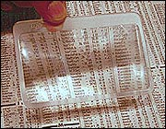
Figure 2-1 Optical Magnifier

Video magnifiers, also known as closed circuit television (CCTV) use cameras to magnify printed text and images onto a screen or monitor. CCTVs vary in price and features. An extensive CCTV products and styles is available in Australia. These include the PocketViewer (as seen in Figure 2-2), VideoFlex, Jordy, and Flipper which have dual near viewing and distance viewing capabilities, “wrap-around goggle” styled systems and portable models such as the Traveller, Pocket Viewer and QuickLook. The cheapest CCTV system amongst catalogued items at Vision Technolgy is the TViZoom at a A$1,095 per unit. The portable units are generally very expensive and may cost as much as A$8000 per unit for premium models.
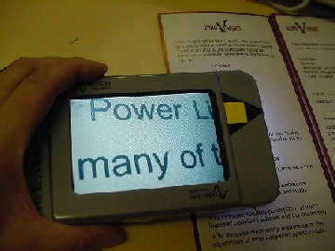
Figure 2-2 Closed circuit television - PocketViewer

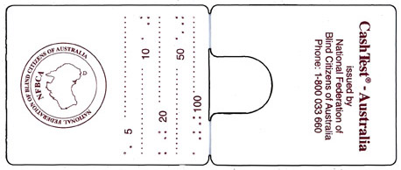
Figure 2-3 CashTest Australia

The CashTest Australia (illustrated in Figure 2-3) is a lightweight and portable plastic instrument that uses length differentials to distinguish notes. As depicted in Figure 2-4, the device folds over one end of a note, so the length of the remaining portion of the bill can be measured. Braille inscriptions mark the length of the note accurately identifying note denomination. Blind Citizens Australia provides the CashTest free of charge to those in need. The CashTest Australia may be hard to use due to the manual manipulation of the notes that is required. This is especially true for people suffering from low tactile functionality such as diabetics who with diabetic neuropathy and the elderly who have arthritis.
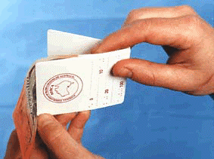
Figure 2-4 Cash Test Australia in use

A range of generic text-to-speech scanners are available commercially that may be used to differentiate the various Australian denominations. These devices use a scanner, optical character recognition software and a speech synthesiser to reproduce printed text as spoken words. Stand alone system available in Australia include the Galileo, ScannaR, Pronto Reading Machine and POET Compact. Among these, the POET Compact is the cheapest system (Vision Technology, 2004) at $2,995 per unit. A majority of the systems currently existing text-to-speech scanners are not built for portability and hence, are bulky and cannot be used as a portable CID.

It has been advertised that the Universal Bank Note Reader (UBR.) is a patented design that may be adapted to many international currencies. The UBR is a portable device which identifies American and Canadian currency. Further information was unavailable to confirm if the UBR had a design for identifying Australian banknotes. It is assumed that the UBR is not applicable in Australia.

In July 2004, Aimee Hinwood from the University of New South Wales was accredited with the creation of a portable currency identification device. The device created by Hinwood uses the colour differentials of Australian notes for identification. Besides an interview transcript that featured this CID, no further information could be found on this device.

Target Users
Access Economics Pty Limited (2004) found the following statistics. The leading causes of low vision and blindness are diseases that are common in old age; cataracts, macular degeneration, glaucoma, and diabetic retinopathy. Due to the high age correlation to eye diseases, “visual impairment is projected to increase from 5.4% of the over-40 population today to 6.5% - nearly 800,000 people - by 2024. Blindness is set to increase by 73% over the next two decades to more than 87,000 people over 40.” It was also estimated that the prevalence of vision loss trebles with each decade over the age of 40. The number of Australians with blindness or visual impairment is expected to nearly double over the next 20 years.

For people with low vision, needs vary according to the nature of the visual deficit and the ambient lighting conditions. An older person with macular degeneration may have relatively little difficulty in identifying bills at a well lit checkout counter but may be unable to identify bills in a dimly lit restaurant or a taxi at night.

This device was created primarily to offer the low vision and blind community reliable and independent means of identifying notes. Due to the increasing number of older individuals with impaired vision due to minor eye disease or the normal aging process, this device may be of great benefit to a far wider population than that represented by the current statistics on blindness and low vision.

Requirements Specifications
Many of the design and implementation decisions were motivated by a list of project priorities that make up the CID requirements specification. This requirements specification was drawn up in consideration of the nature of problem, the existing means by which currency identification is made, as well as budgetary and time constraints imposed on the project.

Primarily, the CID should recognise and denominate Australian banknotes so the number of false positives and false negatives is very low. The accuracy of identification was of foremost importance to this project.

The device should be fully automated so as to make the CID easy to use, and require minimum manipulation from the user. The orientation of the note will not be important so the device will be user-friendly.

The CID was created within the mindset that the commercial product would be handheld and portable. Therefore, weight and size considerations were included in its designs. Additionally, to facilitate the daily use of the CID, the power consumption of the device would be low whilst the response time should be fast. To create an affordable product, manufacturing costs of the device should be kept to a minimum.

Hardware Design and Implementation

Overview
After careful consideration of the various features of Australian banknotes as described in Chapter 2.1, it was decided that banknotes could be reliable identified through verification of the transparent window. A note requiring identification would be inserted into the CID, the window would then be detected, and the image within the window would validate the denomination. This identification was supported by two sources, Binns (2002) and Siewert (1998) who wrote: “The clear windows were chosen as the method of distinguishing between the various notes because they are different sizes for different denominations, as well as having great variation in internal detail.”

Figure 4-5 Overall Block Diagram of System

The architecture of the CID is depicted in the block diagram Figure 4-5. The imaging system is driven by controlled clock signals from the digital signal processing (DSP) board. During the developmental stage of the CID prototype, the DSP board was the central control unit. It is envisaged that the DSP board functions would be transferred into a microcontroller unit if a commercial product were manufactured.

The primary component of this project, the imaging system, acquired the data necessary to correctly identify denominations. It consisted of an image acquisition device and an assembly of illumination components. Analogue outputs, which represented scans taken by the imaging system, were digitised via an external comparator prior to processing operations in the DSP board.

The image recognition algorithm is able to tolerate a maximum skew of 10° regardless of the note orientation. Image recognition was processed using a fast fourier transform (FFT) correlation technique. The images captured via the imaging system are correlated to a series of templates. The closest matching data-template pair, therefore the template with which the data has the highest correlation factor, was the most probable denomination.

Image Acquisition Device

System Design - Issues and Selection
As described in the preceding section, identification of Australian banknotes was made possible through optical verification of the image within the window segment. This process requires image sensors to extract adequate and accurate information from the window segment.

Two possible systems that satisfy the fast image acquisition purposes of the CID are the charged coupled device (CCD) and complementary metal oxide semiconductors (CMOS) image sensors. Both CCD and CMOS image sensors measure light intensity on a grid of pixels on their surfaces and convert this into an electrical charge. CMOS photodiode based sensors use built-in electric fields, unlike CCD devices which rely on externally applied electric fields to initiate the transfer energy.

The advantages of CMOS technology are that they generally operate at lower voltages than CCDs, thus reducing power consumption for portable applications. Furthermore, analogue and digital processing functions can be integrated readily onto the CMOS chip, reducing system package size and overall cost. Whilst noise performances of CCDs are far superior to CMOS cameras, the major disadvantage of CMOS sensors is the requirement for suitable focusing distances between the camera and the image. This requirement was assessed to be impractical in this application where significant emphasis was placed on creating a unit of minimal size.

CCD image sensors are available in one- or two- dimensional architectures. Linear arrays are one-dimensional array of pixels, whilst area arrays are two dimensional arrays capable of simultaneous capturing a two-dimensional image. Area CCDs would involve very large amounts of data processing to verify the window images as required by the CID would have make real time processing difficult. Linear arrays offer a simple but effective means of image sensing, and are highly recommended in various literature for line scanning applications, not unlike the operation the CID. Consequently, CCD linear arrays were chosen as the CID image sensor.

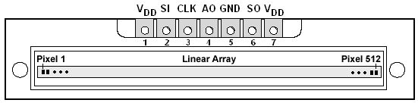
Figure 4-6 Illustration of TSL208 Linear Array

The Texas Instruments TSL208 CCD linear array, illustrated in Figure 4-6, was chosen for its 518 by 1 photodiode array with pixels of dimensions measuring of 120μm by 70μm with 125μm center to center spacing. Scans would be taken as banknotes are slid horizontally over the top of the linear array. Measuring 7.5 cm in length, the linear array is capable of taking scans of the whole width of notes. The linear array has fast scanning capabilities, where output may be serially clocked out to the DSP board at the frequency of 2000kHz.

The TSL208 datasheet calculated the voltage output developed for each pixel according to the following relationship:
$$V_{\text{out}}=K⋅E⋅t$$
Equation 1 Voltage per pixel

where V_{out} is the voltage output for each pixel, K is the responsivity of the pixel at a given wavelength, E is the light intensity at the pixel and t is the integration time. Responsivity, the amount of signal the sensor delivers per unit of the input optical energy. Figure 4-7 shows the varying level of responsivity of the TSL208 linear array with wavelength of incident light. This was found to be a significant parameter in the design stages for the illumination system for the CID.
Figure 4-7 CCD Responsivity

Operation
The linear array has two input (Clock, Signal Input) and an output signal (Analogue Output) as seen on Figure 4-8. The charge transfer, picture pixel output and reset switches are controlled by the clock (CLK) signal whilst the signal input (SI) pulse initiates the transfer of pixel data to the output port.
Figure 4-8 TSL 208 Read out timing diagram

The clock must have high or low pulse duration of t_{w} or 50ns. The SI setup time t_{SU(SI)} must be high for a minimum of 20 ns before the rising CLK edge. The SI hold time t_{h(SI)} indicates that the SI line must be low prior to the next falling CLK edge. These necessary timing characteristics will result in the initiation of the AO line to output the 512 pixels out through the output port. The AO voltage is nominally zero volts for no light input and two volts for the full-scale output. The integration period begins at each reset of the pixel integrator. The end of the read out cycle is indicated by the serial output (SO) pulse on the 513th clock rising edge. The linear array is ready for the next scanning operation at the next rising CLK edge.

As indicated in Figure 4-9, the TSL208 receives power at input pin 1, and the SI and CLK signals are transmitted through pins 2 and 3 respectively. Nominally 5V of power is supplied whilst the CLK runs at a nominal frequency of f_{clock} Hz from 5kHz to a maximum of 200kHz.
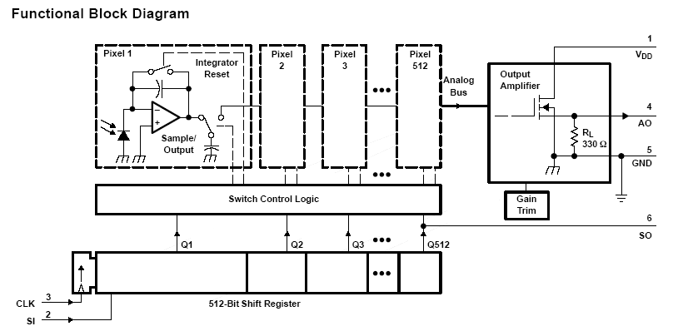
Figure 4-9 CCD Linear Array Block Diagram

Illumination

Overview
A fully enclosed currency identification unit will require internal illumination in order for the image sensor to operate. Illuminating banknotes onto the image sensor will result in the imager receiving light through the transparent window and darkness elsewhere.

An ideal lighting system will provide even illumination with adequate intensity across the length of the linear array. The dark and light contrast should be distinct and the distortion due to shadowing and blurred edges should be minimised. The illumination system should be compatible to the other design aspects of the CID. The subsequent sections describe the approach taken to find an optimal solution to the illumination problem.

Lighting Arrangement
Due to the flat dull surface of polymer notes and the high contrast between the transparent window and printed regions, back lighting was found to be ideal for illuminating the note to check for the presence or absence of printed images.

Figure 4-10 Ideal collimated back lighting

As depicted in Figure 4-10, illumination with collimated light where rays propagate parallel to one another, will produce images with sharp edges. This lighting arrangement is obtained using specially manufactured focusing lenses such as SelFoc lenses. Although highly efficient, the collimated lighting design was rejected due to time and budgetary restrictions.

The CID prototype used diffused back lighting to effectively illuminate notes onto the linear array as illustrated in Figure 4-11.

Figure 4-11 Diffused back lighting

The back lighting effect was successfully achieved by diffusing light through an acrylic bar. This acrylic bar is cut to specification with wells of width and length to adequately fit LEDs (illustrated in Figure 4-12). This lighting arrangement is simple and low cost because this particular illumination solution can be self-manufactured using common materials.

Figure 4-12 Size dimensions of Acrylic Bar

All but one surface of the acrylic bar is covered in aluminium foil. Incident light rays on these reflective surfaces are rebound back into the bar, creating the necessary diffusive effect. A strong concentration of light exits through the surface that is uncovered in foil. This results in an even distribution of illumination.

The disadvantage to this is that it fails to properly produce images with sharp edges because of the scattering effect of the light overlapping onto the adjacent array pixel resulting in blurred edges.

Illumination Source
Illumination of the imaging system is by means of infra red radiation light emitting diodes (IREDs) and in particular, from HSDL 4220 LEDs. The coupling of these 30° wide angle emission IREDs with the back lighting arrangement, as designed in the preceding section, produced concentrated and even illumination onto the linear array as required. The IREDs are very high intensity, and high speed, with a rise time of 40ns.

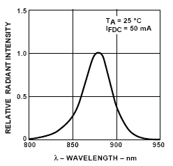
Figure 4-13 HSDL Intensity vs Wavelength

Figure 4-13 shows that the radiant intensity of the HSDL-4220 peaks when the wavelength is approximately at 875nm. At the wavelength of 875nm, the linear array exhibits over 80% of responsivity (Figure 4-7). In comparison, super bright red LEDs which typically have the highest wavelength of 660nm amongst visible LEDs, the linear array has only slightly better responsivity at 90%.

Flash Circuitry
Figure 4-14 Flash Circuit Schematic

The IREDs, driven by the circuit of Figure 4-14, produce a strobed lighting effect. Flashes of illumination create the optical illusion of momentarily frozen motion. In the instant that motion appears to have halted, sharp image scans may be attained regardless of the speed at which banknotes are drawn across the linear array.

The series connection of the two IREDs is power efficient as it draws the same amount of current as one diode. When supplied voltage exceeds the diode forward voltage, the current through the diode rises exponentially. The current-voltage relationship of the HSDL4220, depicted in Figure 4-15, shows that a forward voltage of 1.25V is sufficient to drive the IRED.

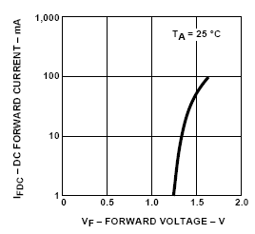
Figure 4-15 HSDL 4220 DC Forward Current vs Forward Voltage

Figure 4-15 further shows a small voltage increase can produce a large current increase. Excessive current through the IRED is damaging, and for the case of the HSDL 4220, current in excess of 100mA will blow out the LED. Thus, the design of the flash circuit included a current limiting resistor R2 of 150 ohms. The RC connection in the power-supply line further improves the circuit immunity to voltage transience and transmitted noise as the high impedance bypass capacitor absorbs the transience.

The two inverters in series have the purpose of boosting a weak signal source that otherwise is incapable of sourcing or sinking much current to a load. The capacitor C1 charges during high buffer output periods. At the instance that the buffer output is low, the charged capacitor will discharge. The transistor has a dual purpose of amplifying current and has the capacity to act as a fast switch to enable C1 to discharge at a faster rate delivering current to drive the IREDs.

The DSP board controlled the operation of the flash circuitry through data port D14. The inverter and signal input ports enter into a high impedance state when unused. This results in induced currents which cause unnecessary power dissipation. This impedance effect was resolved by connecting pull resistor R1 which diverted induced voltages to the ground.

Analogue to Digital Converter
A dedicated comparator circuit was used to carry out the required 1 bit analogue to digital conversion (ADC). The function of the comparator was to convert an analogue input signal into an output with two-possible states by comparing voltages as follows:
$$v_{\text{out}}=\left\{\begin{matrix}+V_{\text{max}} \\ −\left|V_{\text{min}}\right|\end{matrix}\right.\begin{matrix}, \\ ,\end{matrix}\begin{matrix}{\text{ for v}}_{+}>v_{−} \\ {\text{ for v}}_{−}<v_{+}\end{matrix}$$
Equation 2 Theoretical comparator output voltages

The comparator circuit is implemented using the schematic Figure 4-16:
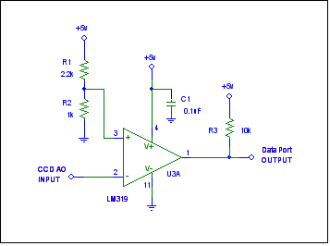
Figure 4-16 ADC Schematic

The comparator circuit has two input and one output port. The + and - input ports will be known as the reference and signal inputs respectively. The output goes to one of its two possible states depending on whether the analogue voltage at the signal input is greater or less than the “threshold” set by the voltages divider v_{h} at the reference input. For the schematic in Figure 4-16, the output will have the following characteristics:
$$v_{\text{out}}=\left\{\begin{matrix}\text{5 V} \\ \text{0 V}\end{matrix}\right.\begin{matrix}, \\ ,\end{matrix}\begin{matrix}{\text{ for v}}_{−}<1\text{.}\text{56 V} \\ {\text{ for v}}_{−}>1\text{.}\text{56 V}\end{matrix}$$
Equation 3 Implementated comparator output voltages

Delegating the ADC processes from the DSP board to the external comparator as provided by the LM319 proved to be highly cost effective and intelligent solution. This device is configured to operate within a low voltage range of 5V and 0 without suffering any loss of processing capacity. Furthermore, this high speed with typical response time of 80ns is ideal for the fast responses as required by the CID.

The capacitor C1 stores a small amount of power so the comparator has a stable power supply. In this application, the C1 functions as a decoupling capacitor supplying a low impedance path to ground to shunt unwanted high-frequency energy and low frequency ripples.

The resistor R5 is a necessary component in order to pull the output up to an acceptable voltage level (+5V) when the input voltage than the reference voltage. It is also necessary to limit the current for when the output of comparator goes low. Other logic gates can now be connected to the output port.

Testing and Analysis

Sample Sets
Two sample sets of banknotes in mainstream circulation ($5, $10, $20, $50 and $100) were used throughout for testing. The first test set of banknotes, test set A, were in pristine condition and were unmarked and uncreased. Test set B were of worn notes that were faded and creased.

The process of collecting test samples confirmed the durability and hardiness of polymer banknotes. Test set A was quickly accumulated unlike Test set B because the notes were generally found to be in very good condition.

Performance of the image acquisition device without illumination
The performance of the linear array was initially tested without the supporting illumination system. This process was necessary to verify the significance of illumination in the acquisition of quality image scans.

The test scans were required to satisfactorily represent an backlit image across the note width. With the exception of the fifty dollar note, the image scans for all of test samples A and B did not accurately show the transition from light to dark pixels and vice versa. Overall, the test results are poor due to inadequate resolution and accuracy.

The fifty dollar note from Sample Set A was the best performer under the deficient illumination scenario. Clearly this was due to the simplicity of the images within the fifty dollar note window compared to the intricacies of the other denominations. These test results showed that under weak illumination, intricate images are obscured and the linear array does not distinguish the finer image details correctly.

The test results exemplify the corruptive effects of ambient light. The high inaccuracies of the test results are most likely due to the large amounts of ambient light present in the brightly lit test environment. It is expected that a darker environment would produce scans of better resolution and accuracy. The high corruptibility of the linear array due to ambient light reinforces the necessity of proper illumination within the imaging system.

Performance of the image acquisition device with illumination
Following the poor performance of the linear array without adequate illumination, this test set was expected to provide much better image scans to confirm the necessary illumination factor within the CID.

Encased at the ends of the acrylic bar, the IREDs illuminated banknotes onto the CCD linear array. These results at Figure V-18 show that the overall linear array performance is much better compared to the performance from the previous test condition. This confirms that illumination is a necessary system for the CID.

However, it is significant to note that maintaining a fixed illumination height does not necessarily attain uniformly good scan results. Even though the same test conditions were maintained throughout the testing period, the illumination that provided the acceptable scan for the fifty dollars was not replicated the result in the other denominations.

The inversion of the scans as seen in Figure V-17 and Figure V-19 was a result of the reconfiguration of the logic.

Comparator Performance
The comparator performance Figure V-19 showed that the 1 bit ADC circuit was optimally designed. It may be difficult to judge from analogue figures where the light and dark pixels are but the digitised view clarifies these discrepancies very well.

Conclusion

Project achievements
A device that optically scanned banknotes and recognised denomination was successfully developed. The necessary system circuitry was implemented and several good test scans were obtained. The imaging system is capable of obtaining signals of a suitable quality and level to enable identification processing of the image with a high degree of accuracy.

Many of the requirements specification were adhered to. The device gives optimal performances and fast scanning at low power and cost.

The method of capturing the image of the window image by back light illumination, using the acrylic bar to concentrate the light onto the CCD linear array provided adequate imaging and allowed for a much reduced level of processing when compared to area arrays and CMOS camera. The feature detection design of the CID achieved the required goals of currency identification.

Difficulties encountered
The task of finding a common height and position to hold illumination above the linear array to obtain adequate scans was frustrating. This task was made even more difficult by the inability to see IR illumination.

The trial and error method and dependence on illumination means results are not easily duplicated and therefore introduce unreliability.

Recommendations for future development

Alternative identification techniques
It would be interesting to combine colour and image recognition techniques in one prototype. The accuracy of currency identification of such a system is predicted to be extremely high. Furthermore, no extra imaging component may be necessary. A colour sensing linear arrays could replace the monochrome array used in this project. The increased hardware cost of such a device may be acceptable in consideration of the increased accuracy of the dual identification system that is proposed. The feasibility of such a system will need to be investigated much more thoroughly. Although this idea has lost its originality since a working CID was developed recently, this proposal still offers some validity to create a highly accurate system.

A further recommendation is to use dimensional measure as a means of currency identification. By placing a note flat onto a plate that slides into an enclosed unit, an image sensor could be used to detect the edges of the note and measure the distance from one edge to the other. Measurements of the length and width of note can successfully identify currency because the length differentials of each denomination are unique (as indicated by Table 3: Size of Notes). By taking a suitable number of measurements, factors such as the skew of the note can be measured by geometry. Hence, this proposal has a very strong mathematical grounding.
Measurements a, b and c are taken across the length of the plate and measurements x, y and z are taken across the width of the plate. The measurements b and y will verify that the note placed on the plate is authentic if the length differentials are one that the set length differentials as given in Table 3.
Note that the length ( a + b + c ) is known as this would be the length of the plate, similarly the width ( x + y + z ) would be known as this is the width of the plate. So the measurements b and y have a verification point. In other words, the measurements b and y are accurate if ( a + b + c ) – b and ( x + y + z ) – y both equal zero.

This identification technique would be highly user friendly as the orientation of the notes into the unit would not be an issue. The skew of the note can be taken into account by the measurements.

In this proposal, the accuracy of the image recognition is no longer affected by the skew factor. Adequate measurements and simple geometry can be used to calculate the skew so the skew factor can either be corrected or worked around.

Improvements to the illumination system
In consideration of some of the poor test results, an infra red filter used be laid over the top of the scanner to allow only infra red light to pass through. This would effectively reject ambient light rejection and is envisaged to improve the system performance dramatically.

Completion of the system output system
Due to time constraints of the project, the design of the voice output system was not set as a major priority. It is envisaged that future development of the device could include implementation of a voice output system. To offer the users more privacy, the speech output system should have the option of attaching headphone features.

Power management
The illumination is required only during the integration time of the CCD. By switching the illumination system on when a note is ready to be scanned and turning the system off when the scans are complete will make the CID more power efficient.

Counterfeit detection
The ability to better authenticate the notes could be a luxury feature that may appeal to a sections of the target users who would appreciate the peace of mind of having a high quality and multi purpose product.

Note authentication is possible in various ways:
- Checking the colour,
- Ensure the length differentials are correct
- Use optical character recognition to ensure the presence of microprinted words on the notes
- Examined the notes under ultraviolet light at specific spots (the serial number and a small area on the back of the notes except the $10) that fluoresces

For a small portable device such as this, the application of anti counterfeit measures appears to be infeasible.

Convey bill orientation
Some money changing machines requires specific orientation of bills. A feature that conveys bill orientation would be useful for such purposes. The device could achieve this by detecting the position of the image window relative to length of the note

Reference List
Access Economics Pty Limited, 2004, The Economic Impact and Cost of Vision Loss in Australia. Retrieved September 21, 2004 from Clear Insight.

Agilent HSDL 4220 (N.D.) retrieved March 22 2004 http://we.home.agilent.com/USeng/nav/-536893560.536885258/HSDL4220.pdf

Australian Bureau of Statistics 2001, Census of population and housing: B01 selected characteristics (First release processing) postal area 6050. Retrieved November 20, 2002, from AusStats database.

Binns, R. 2002, Currency Identification for the Vision Impaired, Undergraduate thesis, Curtin University of Technology.
Able data <http://www.abledata.com/Site_2/blind_and_low_vision_gen.htm>
CSIRO Australia (19 Feb 2004), Polymer Banknotes [Online], Available from:
<http://www.csiro.au/index.asp?id=Chemicals%20and%20Plastics_Polymers%20and%20Composites_Banknotes&type=researchProject&xml=relatedResearchProjects>

Horowitz, Paul. 1980, The Art of Electronics, Cambridge University Press, Cambridge

Note Printing Australia (6 March 1997), Billionth polymer banknote issued [Online], Available from: <http://www.noteprinting.com/articles/mar6th1997.html>

Reserve Bank of Australia (4 June 2004), Reserve Bank of Australia [Online],
Available from: <http://www.rba.gov.au >

Sedra A S an Smith K C, 1998, Microelectronic Circuits, 4th edition, Oxfrod University Press, New York.

Siewart, I. 1998, Australian Currency Note Identifier for the Vision Impaired, Undergraduate thesis, Curtin University of Technology.

STMicroelectronics LM319 (N.D.) retrieved March 22 2004 http://www.semiconductors.philips.com/acrobat_download/datasheets/LM219_LM319_2.pdf

Texas Instruments SN7404 (N.D.) retrieved March 22 2004
http://www.priory.bromley.sch.uk/students/electronics/pdf/74hc04.pdf

Texas Instruments TSL 208 (N.D.) retrieved March 22 2004 www.eureca.de/pdf/taos/TSL208R.pdf

Vision Australia, 2004 Retrieved: August 9, 2004 from http://www.visionaustralia.org.au/

Vision Technology, 2004 retrieved November 1, 2004 from http://www.visiontech.svrc.vic.edu.au/magnifiers.htm

Project Plan

Australian Polymer Notes

 | 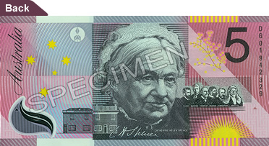
Figure 2 – Federation 5 dollar note
 | 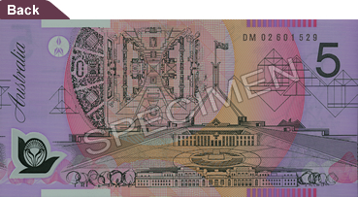
Figure 3 – 5 dollar note
 | 
Figure 4 – 10 dollar note
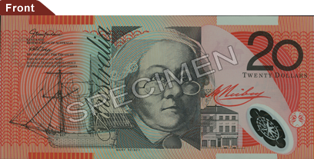 | 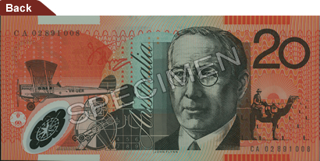
Figure 5 – 20 dollar note
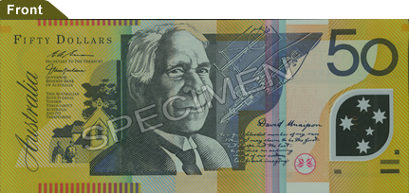 | 
Figure 6 – 50 dollar note
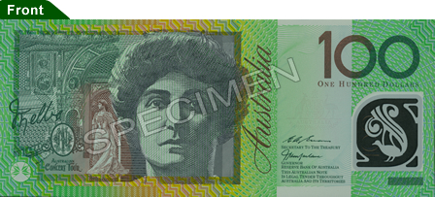 | 
Figure 7 – 100 dollar note

Colour Contrast

Denomination | Colour contrast and Bold Numerals
$5 | 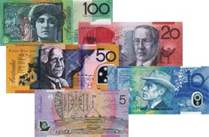
$5 (Centenary of Federation Issue) | 
$10
$20
$50
$100
Table 2: Colour Contrast between denominations and Bold Numerals

Length Differentials

Denomination | Size (mm)
$5 | 130 x 65
$5 (Centenary of Federation Issue) | 130 x 65
$10 | 137 x 65
$20 | 144 x 65
$50 | 151 x 65
$100 | 158 x 65
Table 3: Size of Notes

Test Scans

Fifty Dollar Scan without illumination

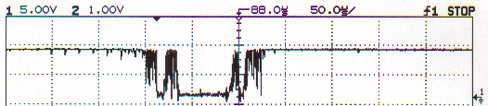
Figure V-17 Fifty Dollar Scan without illumination

Fifty Dollar Scan with illumination
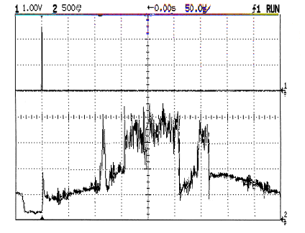
Figure V-18 Fifty Dollar Scan under illumination

Digitised fifty dollar scan
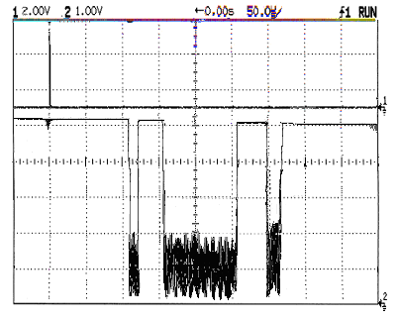
Figure V-19 Digitised Fifty Dollar Scan

