DEPARTMENT OF ELECTRICAL AND COMPUTER ENGINEERING

Cisco Router Simulation
by
Matthew Albert Roff

A thesis submitted for the degree of
Bachelor of Engineering in Computer Systems Engineering
DEPARTMENT OF ELECTRICAL AND COMPUTER ENGINEERING

TITLE: Cisco Router Simulation
AUTHOR:

FAMILY NAME: Roff

GIVEN NAME: Matthew Albert
DATE: 3rd November, 2006 |  |  | SUPERVISOR: Iain Murray
DEGREE: Bachelor of Engineering |  |  | OPTION: Computer Systems Engineering
ABSTRACT:

This project focused on developing two tools for vision impaired students to complete the Cisco Certified Network Associate courses. The first is a translation of the e-Labs into a form that the students can use to complete the CCNA2 course. The second was designing how CDP could be implemented in the networking simulator, iNetSim, developed by previous students.

INDEXING TERMS:

Cisco Routers, iNetSim network simulator, router simulation, assistive technology, vision impairment, Mac OS X

TECHNICAL WORK  REPORT PRESENTATION | GOOD AVERAGE POOR
EXAMINER: |  | CO-EXAMINER:
Synopsis
The methods for vision impaired students to learn networking have been improved by basing the learning environment around router simulation software. The current assistive technology available to vision impaired individuals studying networking has been inadequate, due to its inability to interact with critical network learning tools. This project aimed to make these critical e-Lab exercises more readily available to vision impaired students and to continue the development of the powerful network simulation tool, iNetSim. The complete set of e-Lab exercises from one of Cisco’s networking courses was transferred into a form that could be readily used by vision impaired students and a design to extend the iNetSim network simulator was developed.
Matthew Roff
48 Sail Terrace
Heathridge W.A. 6027

3rd November, 2006

Professor Syed Islam
Head of Department
School of Electrical and Computer Engineering
Curtin University of Technology
Bentley W.A. 6102

Dear Professor Islam,

I hereby submit my thesis entitled “Cisco Router Simulator” as part of my requirements for completing the Bachelor of Engineering (Computer Systems Engineering).

I declare that the content of this final year project thesis is entirely my own work except where acknowledgement is given.

Yours Sincerely,

Matthew Roff

Acknowledgements

The author would like to thank his project supervisor, Mr. Iain Murray, for his guidance, patience, motivation, help and valuable input throughout this project, without whom this thesis would not have been possible.

Also, the author would like to thank one of the vision impaired students, Ian Blackburn, whose guidance, feedback and help with testing was particularly beneficial, since he is totally blind.
INDEX PAGE
1.0 INTRODUCTION 1
1.1 Vision Impairment and Employment 1
1.2 Overview of the iNetSim network simulator 3
1.3 Thesis Outline 3

2.0 IMPORTANT TECHNOLOGIES 5
2.1 Current Problem Solutions 5
2.2 Cisco Certified Networking Course 6
2.3 Cisco Discovery Protocol 8
2.4 VoiceOver Technology 9
2.5 Cocoa Programming Environment 11
2.6 Objective-C Language 12
2.7 Core Data 13
2.8 Previous Work 14
2.9 Objectives 17
2.10 Alterations to Objective 17

3.0 SIMULATOR DESIGN CONSIDERATIONS 19
3.1 CCNA2 Course 19
3.2 Learning the e-Labs 20
3.3 Instructions Transfer 22
3.4 Router Configurations 24

PAGE
3.5 VoiceOver 27
3.6 Learning the System 27
3.7 Designing CDP 28
3.7.1 Outline of the design of CDP 28
3.7.2 Implementing ‘cdp run’ command 29
3.7.3 Implementing ‘cdp enable’ command 31
3.7.4 Implementing ‘clear cdp counters’ command 32
3.7.5 Implementing ‘show cdp’ command 33
3.7.6 Implementing ‘show cdp entry’ command 35
3.7.7 Implementing ‘show cdp interface’ command 37
3.7.8 Implementing ‘show cdp neighbors’ command 38
3.7.9 Implementing ‘clear cdp table’ command 40
3.7.10 Implementing ‘show cdp traffic’ command 41
3.7.11 Implementing ‘show debugging’ command 42
3.7.12 Implementing ‘debug cdp packets’ command 43
3.7.13 Implementing the other ‘debug cdp’ commands 43
3.7.14 Implementing ‘cdp timer’ and ‘cdp holdtime’ commands 44

4.0 IMPLEMENTATION 46
4.1 Implementing the e-Labs 46
4.1.1 Overview of adapting the e-Labs 46
4.1.2 Creating the instruction files 46

PAGE
4.1.3 Creating the router configuration files 48
4.1.4 Implementation Issues 50
4.2 Implementing CDP 51

5.0 VERIFICATION 56
5.1 Testing the e-Labs 56
5.1.1 Syntax and format testing 56
5.1.2 Accuracy testing 57
5.1.3 System testing 59
5.1.4 Vision impaired testing 60
5.2 Testing the iNetSim network simulator 61
5.2.1 Overview of the testing procedure 61
5.2.2 Graphical User Interface (GUI) Testing 62
5.2.3 Router Interface Testing 63
5.3 Issues within the iNetSim network simulator 64
5.3.1 Features not implemented 64
5.3.2 Errors within the simulator 65

6.0 CONCLUSIONS 67
6.1 Accomplishments 67
6.2 Contributions 69
6.2.1 Transferring e-Lab exercises 69
6.2.2 Designing CDP 69
PAGE
6.3 Limitations on the solution 71
6.4 Future Development 72
6.4.1 Transferring e-Labs exercises 72
6.4.2 Extending the iNetSim network simulator 74
6.4.3 Improving the iNetSim network simulator 76
6.5 Conclusion 77

7.0 REFERENCES 78

APPENDICES 79
Appendix A – Project Plan 79
Original Project Plan 79
Project Plan Adjustments 79
Appendix B – The tailored CCNA2 e-Lab exercises 80
Module 2 e-Labs 80
Module 3 e-Labs 87
Module 4 e-Labs 97
Module 5 e-Labs 107
Module 6 e-Labs 111
Module 7 e-Labs 125
Module 9 e-Labs 158
Module 11 e-Labs 167

List of Figures Page
Figure 2.1: The LookOUT interface 5
Figure 2.2: CCNA CDP e-lab Exercise 7
Figure 2.3: CDP Representation 9
Figure 2.4: VoiceOver on iNetSim 10
Figure 2.5: Xcode and Cocoa 11
Figure 2.6: Interface Builder and Cocoa 12
Figure 2.7: The iNetSim Network Simulator 15

Figure 3.1: A CCNA2 e-Lab exercise 20
Figure 3.2: The e-Lab network diagram 25
Figure 3.3: The ‘cdp run’ command 29
Figure 3.4: The ‘clear cdp counters’ command 32
Figure 3.5: The ‘show cdp’ command 34
Figure 3.6: The ‘show cdp entry’ command 35
Figure 3.7: The ‘show cdp interface’ command 37
Figure 3.8: The ‘show cdp neighbors’ command 39
Figure 3.9: The ‘show cdp traffic’ command 41

Figure 4.1: The original e-Lab exercise interface 46
Figure 4.2: An e-Lab Instruction File 47
Figure 4.3: A Router Configuration File 48
Figure 4.4: The interface of the iNetSim network simulator 51
Figure 4.5: Information about the Sydney router 52
Figure 4.6: The Sydney router interface 53

Figure 6.1: A CCNA3 e-Lab exercise 72
Figure 6.2: A CCNA4 e-Lab exercise 73

1.0 INTRODUCTION
1.1 Vision Impairment and Employment
Blindness and vision impairment are disabilities that limit a person’s ability to find employment. According to the Association for the Blind of WA (2004), the number of people who are blind or vision impaired in Australia is approximately 300, 000 or 1.5 percent of the population.

The Australia Bureau of Statistics (1997), states that the labour force participation for people with eye disorders is 61.5 percent compared with the 77 percent participation from people without a disability. A more troubling statistic presented by Blind Citizens Australia (2003) states, “Surveys suggest that while people who are blind or vision impaired are eager to work (62% participation rate, which is high relative to other disability groups), only 21 % are able to find work”. It seems that although vision impaired people are willing to work they are unable to gain employment.

Improving the employment opportunities for vision impaired people is a complex problem that has no simple solution. Although vision impaired people are restricted from performing tasks requiring good eyesight, they are suitable applicants for most other positions and often provide their employer with a stronger work ethic and a higher commitment level than a person without a disability. There have been many solutions put forward to solve this community issue including the government employing vision impaired people, in addition to encouraging other employers to employ these individuals and increasing the skill level of vision impaired people.
Education is a common solution to reducing the unemployment rate for vision impaired people. The reasoning behind this solution is that a highly skilled, vision impaired person has a better opportunity to find employment than an unskilled vision impaired person. This reasoning is no different to the case of a person without any disability who is skilled compared to an unskilled person. However the difference is the relative difficulty of a vision impaired person studying and completing a course or degree.

Education is catered for sighted students due to the amount of reading, computer use and visual learning techniques that are common in most courses. Universities and some other learning environments have attempted to make learning easier for disabled students by providing access to Braille resources and expensive computer equipment that reads documents to the user. Through these resources vision impaired students have a greater opportunity to succeed and gain employment in the industry they desire.

Networking has been a particularly difficult area for vision impaired people to obtain employment because networking courses involve students completing networking exercises using cables and connecting them to small connections. Methods of making networking easier for vision impaired students need to be developed.

A solution to this problem is the development of a network simulator that makes use of the integrated screen reading technologies built into the operating system of Apple computers. Therefore vision impaired students can participate in networking courses such as the Cisco networking course and obtain qualifications that will greatly improve their employment opportunities.
1.2 Overview of the iNetSim network simulator
This project extended on the work started by Leong Cheng Chew, James Hope and J. Ben Farrugia on the iNetSim network simulator in 2005 (Hope et al. 2006). The previous development had established the graphical user interfaces, device interfaces, and a great detail of the background implementations.

The particular area of extension that was planned was implementing Cisco Discovery Protocol (CDP) in the router interface of the system. The internal configuration of the router terminal was extended, so that when the user typed commands relating to CDP instructions, that the CDP method would run and output CDP related results. Also minor areas of the router implementation were adapted to improve performance and ensure that the implementation correctly represented an actual Cisco router.

The other focus of this project was on translating the current e-Lab exercises within the Cisco Certified Network Associate second course (CCNA2) into a form that could be readily used by vision impaired students.

1.3 Thesis Outline
The organization of this thesis is as follows:

2.0 Important Technologies – A description of the information and reasoning behind network simulation. It presents the technologies and methods that are critical to developing a network simulator for the vision impaired and an outline of the current application developed by previous students.
3.0 Simulator Design Considerations – The defining of the problem and solutions to the problem. The process adopted to design new elements of the network simulator and refinements to the existing solution.

4.0 Implementation – Presents the implementation of the design in the objective-C language and the refinement of the existing application. Determining any other minor improvements that can be made with small alterations within the application.

5.0 Verification – The description of the thorough testing procedure carried out on the implemented solution. The results obtained from the testing procedure and a judgement of the appropriateness of the solution.

6.0 Conclusions – The main achievements of the project described in detail as well as the major problems that occurred in the process of implementing the solution. A discussion of future improvements that could be made to the iNetSim application.

2.0 IMPORTANT TECHNOLOGIES
2.1 Current Problem Solutions
Developing applications to help vision impaired people is not a new concept. There have been companies designing products for vision impaired and other disabled people for several years. The applications that have been produced have ranged from Braille displays to screen readers. Although these technologies have improved the vision impaired person’s ability to interact with computers they certainly are not complete solutions.

This project focuses mainly on screen readers as the networking course involves reading a large amount from the computer screen and interacting with different activities on the screen. Current screen readers available include Job Access with Speech (JAWS), Window-Eyes and LookOUT. Although these applications are helpful to the vision impaired student they come with some limitations including price and quality of the solution
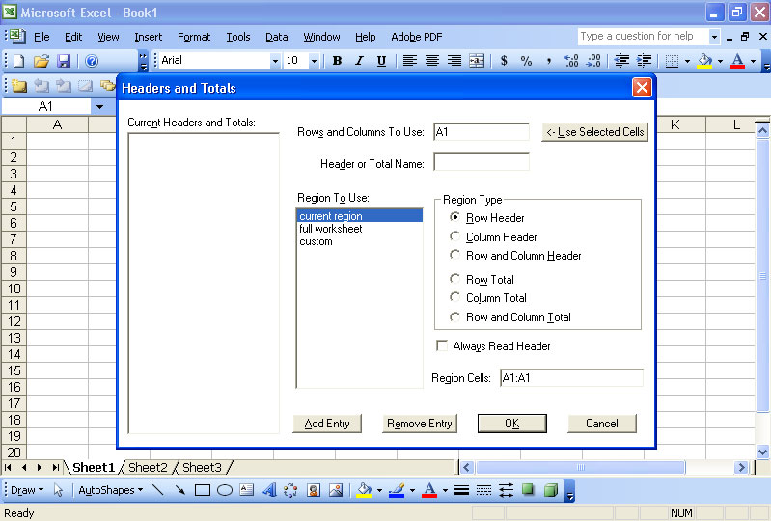
Figure 2.1: The LookOUT interface (Choice Technology UK 2005)
Price is an important issue when it comes to vision impaired students because the solutions are often quite expensive and their monetary resources are restricted. The software packages mentioned above are several hundred dollars each and that is without buying the computer or any necessary devices to make the solution workable. The cost of these commercial screen reading packages limits the number of vision impaired people who can afford to purchase them.

The quality of the solution is another fault of these products. Although some of the commercial solutions are getting closer to producing a quality screen reader, the majority of these screen readers struggle to operate with important learning environments such as flash presentations and PDF documents. These screen readers have excellent results on standard text documents and most office applications but more complex documents cause mixed results. Therefore the quality of the screen reading applications limits their usefulness to vision impaired students.

These applications provide vision impaired students with solid screen reading applications but the cost of these applications and their failure to accurately read complex documents limits their use by vision impaired people.

2.2 Cisco Certified Networking Course
The Cisco certified networking courses provide students with the necessary networking skills, so that they will be highly desired employees in the area of networking. These networking courses are desired by employers because the students are being trained by one of the leaders in the field of networking, Cisco Systems, Inc.
Cisco offers a number of courses in networking including basic IT courses, basic
networking courses and professional networking courses. The focus of this project is on the Cisco Certified Network Associate (CCNA) series of courses. In particular the second course of CCNA (CCNA2) contains the Cisco Discovery Protocol (CDP), which is the protocol that will be implemented in the network simulator.

The CCNA2 course is a course devoted to examining the Cisco router structure, operating system and interfaces. It is a fairly difficult course due to the amount of new concepts presented and vast amount of details that must be remembered. It is difficult enough without any restriction on sight but the course is particularly difficult for vision impaired students. All of the online router programming exercises (e-labs) are Flash presentations that require interaction with the student. Due to the before mentioned problems with screen readers and Flash presentations, it is unrealistic for the vision impaired student to be able to complete these exercises in their current form.
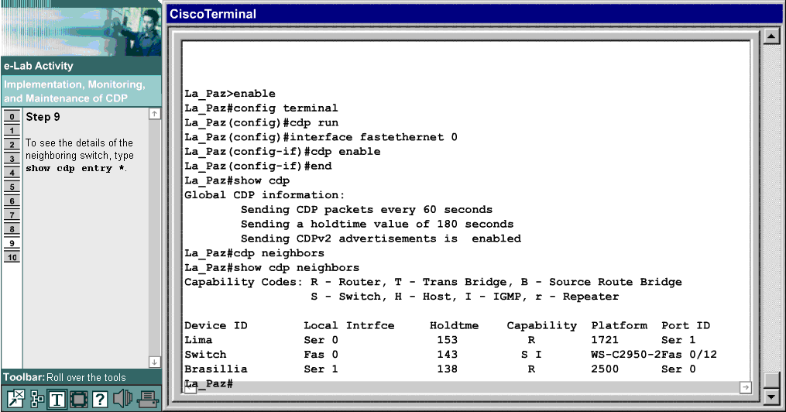
Figure 2.2: CCNA CDP e-lab Exercise (Cisco Systems, Inc. 2006)
Therefore a solution was proposed in 2005 by a group of software engineers for developing an application that would simulate the Cisco network environment. This application was developed, so that vision impaired students were able to complete the e-labs and gain valuable experience at programming a router interface. The details of the previous development efforts are located in section 2.8.

2.3 Cisco Discovery Protocol
The Cisco Discovery Protocol (CDP) is defined as “a proprietary network protocol at layer 2 developed by Cisco Systems which runs on most Cisco equipment and is used to share information about other directly connected Cisco equipment such as the operating system version and IP address.” (Wikipedia, 2006)

CDP is an important protocol to implement in the network simulator because it is very useful in learning environments. It provides the user with a series of commands that can obtain information about every other device in the network. This gives the student an overall view of the system, which helps them to understand how each of the devices fit together and interact.

CDP does have some security issues because any user can type in a few simple CDP commands and find out a lot of information about all the other Cisco devices connected to the current device in the system. However the positives of helping the student to learn the networking structure far outweigh the negative security aspects.

Figure 2.3 represents how CDP works within a network of Cisco devices.
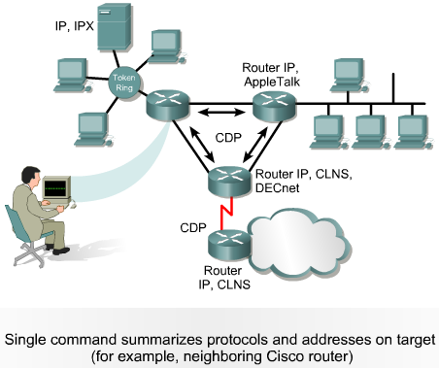
Figure 2.3: CDP Representation (Cisco Systems, Inc. 2006)

2.4 VoiceOver Technology
Apple Macintosh computers run on the Mac OS X operating system and most modern Macintosh computers use version 10.4.6. This operating system has been described as one of the most advanced operating systems and one of these areas of advancement was in accessibility functions. The Apple developers have added a variety of accessibility features, one of the more important features being VoiceOver.

VoiceOver is a feature directly aimed at vision impaired users, which is a screen reader of a high quality but is included in the standard operating system present on any recently purchased Macintosh computer. It has all the abilities of its expensive counterparts such as reading documents and web pages but it also caters for those people who have partial sight or hearing difficulties by displaying what is being said on the screen as well.
VoiceOver is one of the most critical parts of the solution to the project as it is the tool that is used to read the information present within the network simulator application. It provides the vision impaired student with a variety of options and is accurate at reading the information. Figure 2.4 below shows the VoiceOver function working on the network simulator application.

VoiceOver and the Apple environment were chosen to be the environment where the network simulator would operate because of the built-in VoiceOver feature meaning that no costly screen reader needed to be purchased. Also the vision impaired student would just have to buy a small Apple Macintosh computer and they could get straight into using the network simulator.
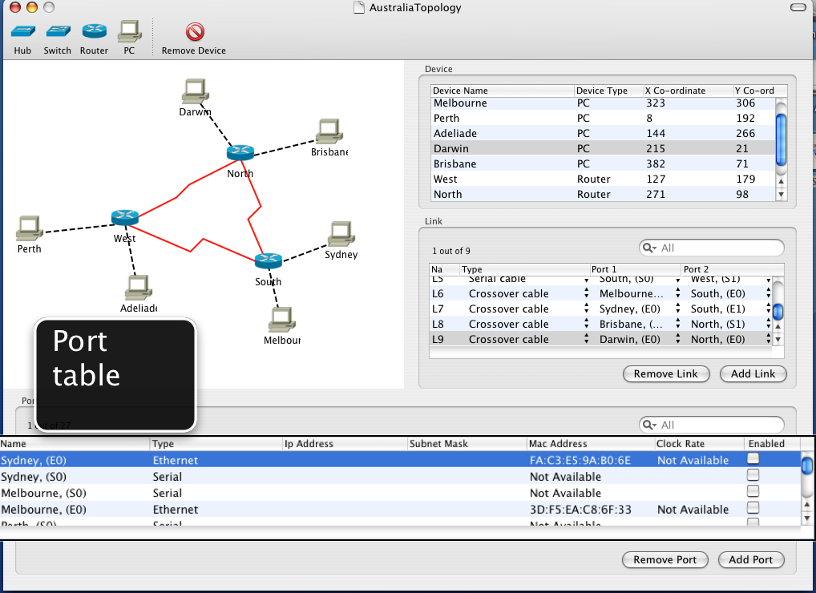
Figure 2.4: VoiceOver on iNetSim
2.5 Cocoa Programming Environment
The Mac OS X operating system comes with an integrated development environment (IDE) consisting of Xcode and Interface Builder. Xcode, shown in Figure 2.5, is responsible for implementing the code that performs the operations initiated by the user through the graphical user interface. The graphical user interface is designed using Interface Builder, shown in Figure 2.6. Both these applications work together to produce the overall application.

This IDE caters for several different programming environments namely Carbon and Cocoa. Each has its own different use but the environment that was decided for this project was Cocoa mainly because of its relationship with the Objective-C language.
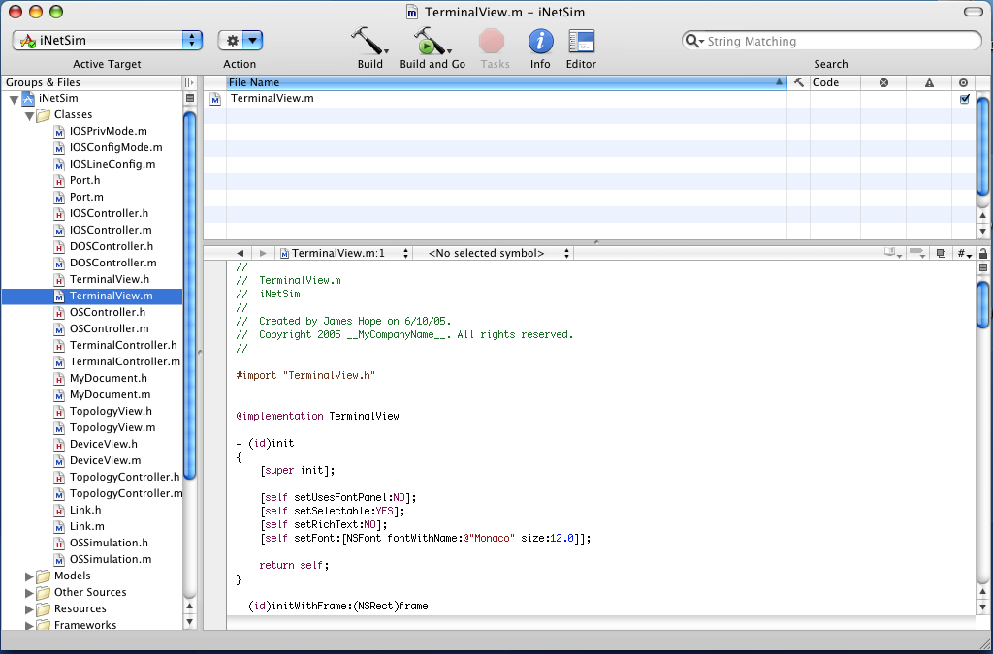
Figure 2.5: Xcode and Cocoa
Cocoa is an object-orientated environment that is made up of a collection of classes (frameworks) that form a library of reusable code. Its use in this project is due mainly to the fact that Cocoa acts as the link between the window server and the application. It enables the application to receive events from the window server and then receives commands from the application to draw results on the screen. This is especially useful due to the importance of the GUI in the network simulator design.
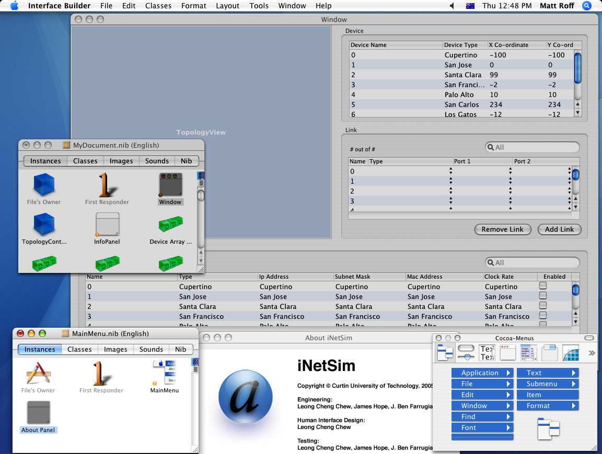
Figure 2.6: Interface Builder and Cocoa

2.6 Objective-C Language
Objective-C is an object-orientated extension of the C programming language, which is similar to C++ but differs in that it is weakly typed and extremely powerful. The purpose of Objective-C in this project is to implement the rather complex behind the scenes work that keeps the application running and operating correctly.
Each of the events triggered on the GUI of the network simulator refers to an Objective-C method that processes the event and responds to the user’s requests. Objective-C is the engine room for the project, it does all the hard work while the display outputs the results of the computations. In terms of implementing CDP in the network simulator, the majority of the work is involved with writing CDP code that will cause the router terminal to output the CDP information to the user.

2.7 Core Data
Core Data is a feature of the Mac OS X v10.4 Tiger operating system, which has the task of organising the application’s model layer, so that it can be expressed as a set of defined data objects that reside in memory.

Core Data is used extensively within the structure of the iNetSim network simulator to create data objects that store information about each device as well as links between devices and ports of the devices. Core Data is an important part of the network simulator, since information can be saved to files to be retrieved at a later date and changes within the network simulator can be reflected within the data objects.

Core Data simplifies the task of storing and manipulating large amounts of data within the application, thus reducing the time and effort required by the developer. The iNetSim network simulator uses this very useful technology to store the large amounts of information that are required to effectively model the operation of a Cisco router.

2.8 Previous Work
Three Software Engineers from Curtin University of Technology commenced this project in 2005 as part of their final year Software Engineering project. The three students designed the network simulator and then started to implement the solution in Cocoa with Objective-C. The finished network simulator application was named iNetSim.

The finished application contained a fully implemented GUI that allowed the user to add devices such as routers, switches, hubs and PCs. The added devices are put into the topology area, which is at the left hand side of the GUI. The user can choose names and locations for the devices as well as a description for the device. These devices can be connected together by links by clicking the add link button.

Choices can be made of the type of cable, source and destination ports. The port’s details are automatically added to the port section when the devices are added. Devices and links can also be removed by clicking the appropriate button and choosing the component to remove. This completes the implementation of the GUI. The remainder of the system is operations within terminals and windows. A representation of a network implemented in the GUI is shown in Figure 2.7.
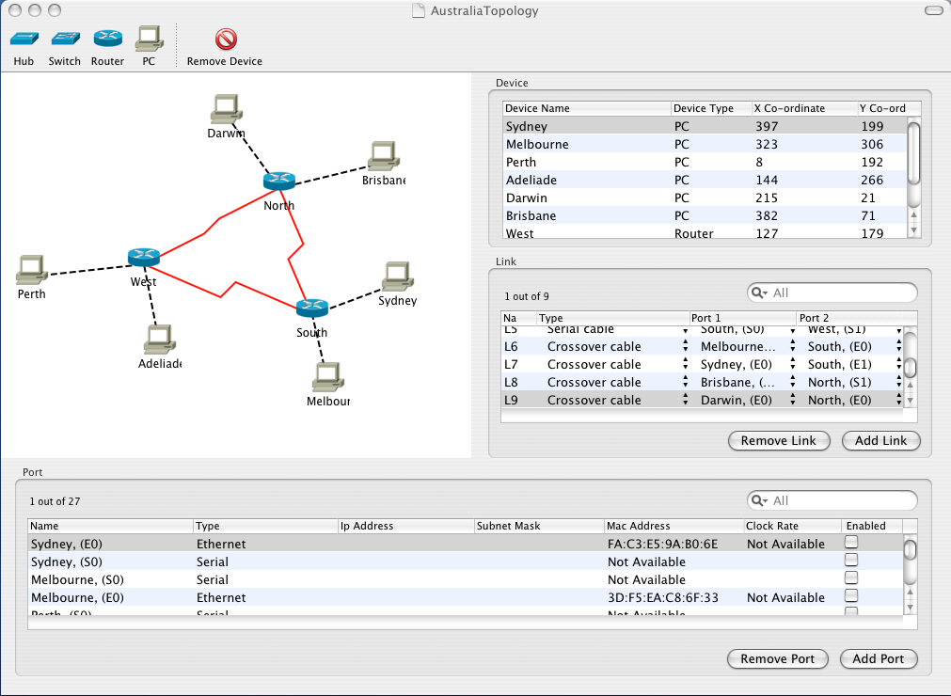
Figure 2.7: The iNetSim Network Simulator

Each of the devices has a window that allows elements of the device to be altered to change the implementation of the device. The router, switch and PC windows have a terminal button that can be clicked to bring up a terminal that simulates the operating system running on those devices.

The switch terminal is not implemented at all; therefore when the terminal button is clicked on the switch window, the application will crash. If the implementation of CDP goes smoothly then this switch terminal could be implemented as part of this project. The PC terminal has a basic structure that resembles the router terminal described below. It has a very limited set of commands that the user can enter in order to receive accurate responses. Instructions such as ping have a reference attached to them but they are not totally implemented. They just return information that a call to that instruction would return had it been implemented.

The router terminal is the largest method in the whole implementation of the network simulator. The whole of the CCNA2 course is dedicated to the router device, operating system and interfaces; therefore a great amount of detail is needed within the router terminal. Within the router there are several modes, which are user mode, privileged mode, line configuration mode and interface configuration mode.

Several instructions in each of the modes have been completely implemented, which consist of the navigational instructions to change modes, set passwords and perform simple instructions. The majority of the complex instructions such as the implementation of routing protocols have not been implemented but the framework to implement them has been developed.

This project will focus on implementing the Cisco Discovery Protocol (CDP) within the privileged mode of the router terminal. This will involve correctly implementing the protocol and any other related instructions that refer to CDP. If there is time left over after correctly implementing CDP, other minor adjustments can be made to the network simulator to improve its quality.

2.9 Objectives
The main purpose of this project was to extend the iNetSim network simulator created by Leong Cheng Chew, James Hope and J. Ben Farrugia in 2005 (Hope et al. 2006). They implemented the basic structure of network simulator that allowed the vision impaired students to perform limited networking activities.

The particular area of extension that was planned was implementing Cisco Discovery Protocol (CDP) in the router interface of the system. The purpose of implementing CDP in the network simulator was to enable the vision impaired students to perform the Cisco Certified Networking Associate (CCNA) network course laboratory exercises on CDP. Another aim of this project included making minor improvements to errors within the application and increasing the amount and quality of documentation in the application.

The secondary purpose of this project was to represent the existing CCNA2 e-Lab exercises in an alternate form, so that vision impaired students can complete them. The form of the e-Labs is in the Flash document format but an alternate form had to be used, so that every vision impaired student could utilise these helpful networking exercises.

2.10 Alterations to Objective
The objective above was carefully set out through consultations with the project supervisor based on the assumption that several Software Engineering students would be assisting in extending the functionality of the iNetSim network simulator. It was understood that these students would provide design support and ensure that a finished product could be achieved in the form of a working extension to the network simulator.
Unfortunately when the time came for the Software Engineers to decide on their final year project none decided to work on the iNetSim network simulator. Therefore instead of having three or four engineering students working on the same project there was just one. This meant that the original objectives would be extremely difficult to fulfill in the given timeframe.

Therefore the objective was refined to place a higher importance on transferring the e-Lab exercises into a form that could be utilized by the vision impaired students. Also the planned extension to the iNetSim network simulator was refined to focus on the design of implementing CDP rather than actually implementing and testing it.

The refined objective still focuses on the same subject matter and has the same aims but due to the lack of support in completing the project the extent of the original objectives cannot be realised. These alterations were required to ensure that the project was effectively completed with the given timeframe.
3.0 SIMULATOR DESIGN CONSIDERATIONS
3.1 CCNA2 Course
The CCNA2 course is devoted to the Cisco router, its operating system and its interfaces. The content of the course included eleven modules covering all aspects relating to the Cisco router from router hardware through to routing protocols used within Cisco networks.

The first section of chapter 4 of the CCNA2 course is dedicated to the Cisco Discovery Protocol, which is described in detail in Section 2.3. It outlined the definition of CDP, the information obtained with CDP and the implementation, monitoring and maintenance of CDP.

The first design technique to completing this project involved completing the CCNA1 course followed by the CCNA2 course to better understand the principles of networking. Each of the modules within the two courses the details were examined, and laboratory exercises and e-Lab exercises were completed.

Once both courses were completed, it was decided in consultation with the project supervisor, Iain Murray, that CDP would be a good protocol to implement in the iNetSim network simulator. After this decision was made, revision of Chapter 4 of the CCNA2 course provided a solid representation of what CDP is and what its instructions involved. Other sources were also consulted ranging from web pages to books in order to gain a greater understanding of the protocol.
3.2 Learning the e-Labs
The e-Labs from the CCNA2 course were selected to be adapted into a form that could be used by vision impaired students. These e-Labs were chosen, in consultation with the projector supervisor, due to the authors recent completion of the CCNA2 course and consequently the knowledge accumulated. The CCNA1 course was not considered in the decision making due to the fact that there are no e-Lab exercises within that course. The other two CCNA courses had not been completed by the author therefore it would have been difficult to adapt these e-Labs.

Once the decision to implement the CCNA2 e-Labs was made, the e-Lab exercises were revised to refresh the content and format of them. The format of the current e-Lab exercises is shown in Figure 3.1.

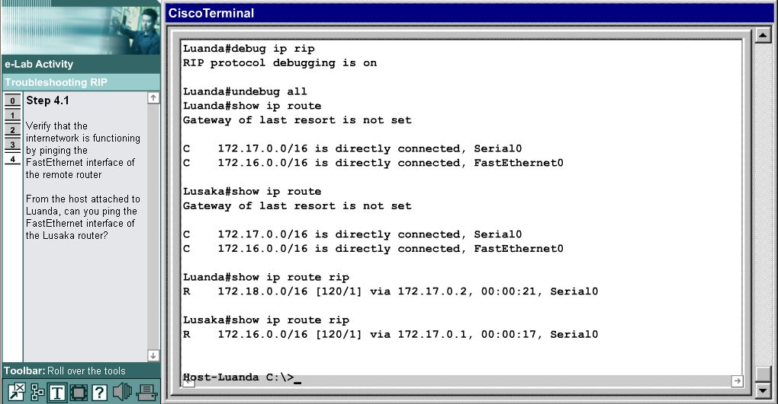
Figure 3.1: A CCNA2 e-Lab exercise (Cisco Systems, Inc. 2006)
It was determined that the e-Lab exercises were in the Flash document format with two main panels. The first was an instruction panel that contained the detailed instructions that the student had to follow to complete the exercises effectively. The other panel could either contain the simulation of the router interface, a diagram of the network structure or other helpful information about the exercise.

The problem with the current e-Lab exercises was that vision impaired students had major difficulties interacting with the exercises because they were in the Flash document format, which as stated earlier causes difficulties for screen reading applications. Therefore the e-Lab exercises had to be transferred into a form that would be easiest for the vision impaired students to use to complete the exercises.

The e-Lab exercises are used as a quick and easy way to attempt routing configurations on a piece of software that simulates the operation of a Cisco router and practice the skills that vision impaired students have been learning throughout the course. Therefore the alterative had to be efficient and simple enough to use, so that the vision impaired student could practice their skills without spending hours configuring files and sorting out hardware.

The best solution was a network simulator, such as the iNetSim network simulator, which could perform the same simulation activities as the Flash document versions but have a format that could be read by the screen reader applications. Unfortunately, the iNetSim network simulator is still in a development stage and could not effectively simulate all the required functions that the e-Lab exercises required. Other router simulation tools were researched but none of them were suitable to precisely correspond to the information examined in the e-Lab exercises.

The second best solution was to transfer the instructions into a file that could be read by the screen readers and create another file that could be downloaded into an actual Cisco router, which exactly models the router simulation tool featured in the e-Lab exercises. Although this solution meant that actual hardware had to be used instead of a simulation tool, the student still has the ability to practice the theory and skills that they are learning.

This solution is not as simple and efficient as a router simulation tool but it has the added advantage of the students gaining valuable experience working with actual routers, which will be utilized in their future employment in the networking industry. Although router simulation tools are very close representations of actual routers they can never totally depict what happens in every situation.

This solution was discussed with the project supervisor and it was determined to be the best solution from the available options. Therefore the process of adapting the CCNA2 e-Lab exercises was started and the design of the solution had to be determined.

3.3 Instructions Transfer
The first part of the solution that had to be designed was the instruction files that would replace the instructions panel in the Flash version of the e-Lab exercises. There were many different types of documents that could have been used ranging from common formats such as Word documents or Rich Text Format but the Text format was the adopted format due to its simplicity. The reason behind the decision to use Text documents rather than the more structured documents was the instruction file was required to be highly portable and simple to use without any need for change. The purpose behind this decision was to make the instruction file as easy as possible to use no matter where the student was or what operating system they were using.

The format used within the file was also simplistic. The format involved the file being called the ‘e-Lab SectionNumber (instructions)’, where SectionNumber was the number of the corresponding section of the course that the e-Lab is examining. Therefore the vision impaired students learn the theory relating to a particular section of the course and open the corresponding e-Lab exercise’s instruction file efficiently.

Inside the file, the first line states the section number of the course that the exercise is focused on, as well as the title of the e-Lab exercise. The next sentence or two describe what the exercise is aiming to achieve, followed by each of the steps involved in the e-Lab exercise. Each step number is placed on a new line and each instruction is started on a new line.

This simple formatting of the text files, that contain the instructions for the e-Lab exercises, aim to provide the most effective manner for the vision impaired students to access and use the files to complete the exercises.

3.4 Router Configurations
The second part of the solution to adapt the CCNA2 e-Lab exercises into a form that can be effectively used by vision impaired students is designing the configuration files that can be downloaded into a Cisco router to model the actual router simulation contained in the corresponding e-Lab exercises. Since the configuration file is employed to operate a Cisco router the format of the document must conform to the format and syntax that Cisco sets out for its configuration files.

Learning to create router configuration files involved studying some of the e-Lab exercises that printed out their router configuration via the command “show running-config”. The project supervisor supplied a couple of router configuration file that related to a couple of the e-Lab exercises, which helped to show correlation between the details in the router configuration file and the instructions in the exercises. The “show running-config” command was used on actual Cisco routers that had just been formatted to see the basic structure of the router configuration file and determine the minimum requirements of the router configuration file.

These router configurations were closely studied and attempts were made to change different aspects of them to see how the router could correspond to the changes. Once the format and syntax of the router configuration files were understood the router configurations could be designed.

Every router has a configuration file that runs its interfaces, holds information about itself and routes to other devices. It is important to get the router configurations correct otherwise the vision impaired students will attempt to follow the e-Lab instructions and the router will behave in a manner not intended in the original e-Lab exercise. Ensuring that the router configuration files match the instructions given for the task involves a careful process of creating the router configuration in a structured manner so that each instruction will manipulate the router in exactly the same way as it did to the simulated router in the original e-Lab exercises.

Designing the router configuration files for each of the e-Lab exercises involved determining from the instructions and network diagrams how many routers were present in the system. Each e-Lab exercise featured in the CCNA2 course had to have one, two or possibly even three router configuration files because each router had to have it own unique configuration file. Figure 3.2 shows a network diagram for one of the e-Lab exercises showing the connection between the two routers involved in the router simulation.
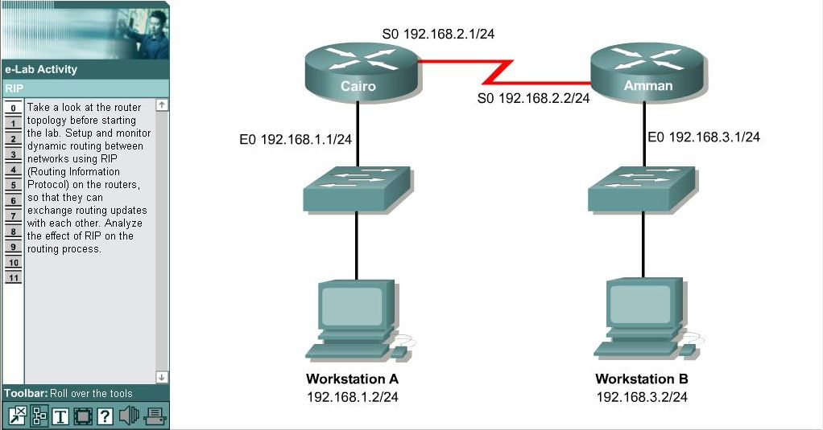
Figure 3.2: The e-Lab network diagram (Cisco Systems, Inc. 2006)
The network diagram for each e-Lab exercise had to be examined to determine the connections existing in the system. If there is only one router present in the system it is less important since addresses will not be used, as frequently but with multiple routers the connections are important especially if the e-Lab is focusing on a routing protocol.

The most important information that can be retrieved from the network diagram is the IP address of each device within the system. The router’s address and the addresses of its connected neighbours must be put into the router’s configuration file, so that when the student attempts to implement an instruction involving communication with neighbouring routers or devices on the actual router that it will perform the communication since it knows the addresses of the other devices in the system.

The problem with designing the router configuration files was that every e-Lab exercise was unique in its interaction with the router simulation tool. For example, one e-Lab exercise may require the full set of addresses to be present in the router configuration file because the exercise will involve a lot of routing instructions but a similar exercise may require the student to configure the addresses so the address should not be included in the configuration file. Also some of the configuration files were required to contain complex instructions that were only briefly referred to in the instructions, making it difficult to determine exactly what should be present in the router configuration file for each router involved in the exercise. Therefore designing the router configuration file involved checking the instruction file and network diagram carefully to make sure that the correct router configuration file was designed.

3.5 VoiceOver
Since the role of the Apple technology VoiceOver has such importance to the iNetSim network simulator a great deal of time was spent reading about it, learning the keyboard commands and performing exercises to test out the features of VoiceOver.

Resources were obtained from the Apple Developer website that described in great detail the features and functions of VoiceOver as well as its use with applications. In particular a 90 page VoiceOver Getting Started manual was obtained that went through each function of VoiceOver in a logical manner with examples and exercises to ensure that the functions were understood.

Learning about the VoiceOver technology greatly assisted in implementing CDP and being able to test the solution in manner to simulate a vision impaired student using the application.

3.6 Learning the System
The greatest learning curve of implementing CDP in the iNetSim network simulator was understanding exactly how the application operated. It was already a very large application with sixteen independent class files ranging from one page to twenty pages in length. Also several of the class files shared header files making it difficult to trace the value of constants used in the class files.

Many hours were spent learning about Objective-C and Cocoa through books such as Cocoa programming for Mac OS X. These books were very helpful in understanding how the application was implemented and resolved many of the issues that occurred with tracing through the program to find solutions.

Once the learning of the system was complete, a design began to be produced to implement CDP within the router terminal of the iNetSim network simulator. This design involved using a delegate to inform the CDP class every time a new device was created, so that the details of the device could be including in the CDP information referenced by the router terminal.

Once this delegate was in place the design was expanded to simulate the calling of CDP instructions from the router terminal and simulate the expected CDP output from the command. Then the CDP class was joined up to the router terminal to make sure the output was actually the values obtained from running the instruction on the network and not just a generated response.

After refinements to this design were made, the design could be implemented in the application to ensure that the CDP functions were correctly implemented. The design of the CDP implementation in the iNetSim network simulator has been completed.

3.7 Designing CDP
3.7.1 Outline of the design of CDP
Implementing CDP was not possible due to the time constraints and unexpected lack of support from the Software Engineers, however a design of how a future student could implement it is detailed in the following sections.
Each of the commands involved with CDP, featured in the CCNA2 course, are detailed below with brief definitions of what the command achieves and possible ways to implement it in the iNetSim network simulator. The design is presented so that student who know a little about the iNetSim network simulator and a reasonably amount about networking theory can easily implement it in the network simulator.

3.7.2 Implementing ‘cdp run’ command
The ‘cdp run’ command is the most effortless CDP command to implement, since its only purpose is to enable CDP globally on the router, as Figure 3.3 clearly demonstrates.
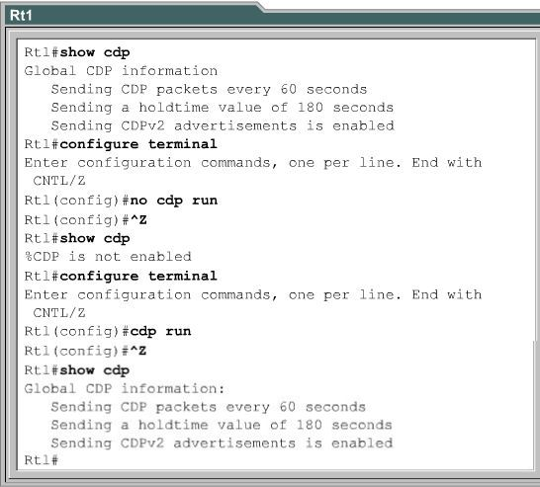
Figure 3.3: The ‘cdp run’ command (Cisco Systems, Inc. 2006)
When the router starts up CDP is automatically running since its default setting is being active, therefore the use of this command is quite limited. It will only be needed if the user has entered the command ‘no cdp run’, which turns CDP off for the device on which it is called.

Implementing this command within the iNetSim would be a simple case of having a state variable that defines the current state of CDP. This variable could be set to one or active when the router starts and change states when the user enters the ‘cdp run’ and ‘no cdp run’ commands.

The commands ‘cdp run’ and ‘no cdp run’ can only be used from the global configuration mode on the router, since the commands affect global features of the router. Therefore, when this command is entered the state of the router must be in the global configuration mode for the changes to be made to the router’s global state. This means that the implementation of this command must ensure that the user can only change the CDP global state from inside the global configuration mode of the router.

All the other commands depend on whether CDP is running, therefore it is important to ensure that this command is correctly designed. All the other methods that respond to the other CDP commands entered by the user will check the CDP state variable to determine if CDP is active on the device.

3.7.3 Implementing ‘cdp enable’ command
The ‘cdp enable’ command is very similar to the ‘cdp run’ command, as it also enables CDP within the router but not globally, only in the interface on which the command is used. Therefore if the user wants one interface to use CDP but all the rest not to use CDP, they will call ‘cdp enable’ on only the interface they want CDP to run.

Since this command is similar to ‘cdp run’ a lot of the information presented in that section is also required to implement this command within the network simulator. A state variable would be required for each interface of the router that states whether CDP is active on the interface and this command would be used to alter the state of that variable.

The command ‘cdp enable’ can only be used in the interface configuration mode since the purpose of the command is to enable CDP on one of the router’s interfaces. Therefore this command must be implemented such that it can only be effectively used when the router is configuring one of its interfaces.

The most popular method of ensuring that a command is not used outside of its proper context is to use a conditional statement at the start of the command’s method. This conditional statement ensures that only when the router is in the interface configuration mode will the command request proceed to the stage where the router’s features are altered. Both the ‘cdp run’ and ‘cdp enable’ commands can be implemented by using this method along with the other design recommendations outlined above.

3.7.4 Implementing ‘clear cdp counters’ command
The ‘clear cdp counters’ command is effectively a reset command, which returns the state of the router back to when it was first started. When a router has CDP enabled on it, CDP maintains a set of traffic counters that detail the numbers of CDP advertisements sent to neighbouring devices, as well as, the number of advertisements received from neighbouring devices. When the user calls the ‘clear cdp counters’ command these traffic counters are reset to their original state, which is zero. Figure 3.4 shows the CDP traffic counters before and after the ‘clear cdp counters’ command is entered.

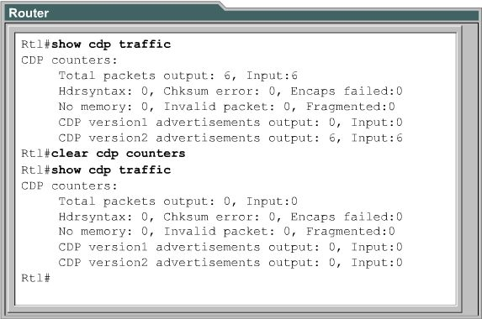
Figure 3.4: The ‘clear cdp counters’ command (Cisco Systems, Inc. 2006)

Implementing this command would involve a method that would set all the CDP traffic counters in the system to zero when the user called the command. Since the CDP traffic counters will be variables of the router, all the method needs to do is to set all these traffic counter variables to zero.

The restriction that is placed on this command is that it can only be used from the privileged EXEC mode of the router. Therefore, the user can only clear the CDP traffic counters when they are in the privileged EXEC mode of the router. The same technique that was suggested in the previous two commands could be used to only allow users in the privileged EXEC mode to clear the CDP traffic counters.

3.7.5 Implementing ‘show cdp’ command
The ‘show cdp’ command is the first of many CDP commands that output information about the router and its directly connected neighbours. The purpose of this command is to display information about the CDP advertisements that the router is sending out to its directly connected neighbours.

This command displays three attributes of the CDP advertisement, which are the interval between transmissions, the number of seconds the advertisements is valid for at a given port, and the version number of the advertisement. Each of these values will be stored in a global dictionary structure for the router that can be read and then output to the router interface.

Since this is the first of command that has caused the router interface to output any information the process of displaying information must be addressed. The previous students who implemented the existing structure of the iNetSim network simulator have already created the methods that are needed to output information to the screen using very simple output commands. Thus, when the command is called the method can easily retrieve the information about the CDP advertisements from the router’s global dictionary structure and use the existing methods to output this information to the router interface. The output of this command should appear in the form shown in Figure 3.5.
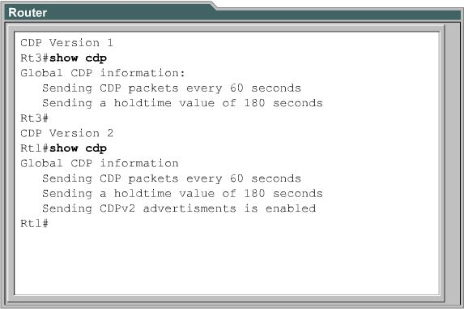
Figure 3.5: The ‘show cdp’ command (Cisco Systems, Inc. 2006)

Since no manipulation of system is required with this command, the user can apply this command in either the user or privileged EXEC modes. Therefore the techniques used in the previous commands to prevent users from entering commands in the incorrect mode of the router can be applied here once again.

3.7.6 Implementing ‘show cdp entry’ command
The ‘show cdp entry’ command displays specific information about the router’s directly connected neighbours. The actual form of the command can be expressed in the following manner, ‘show cdp entry {* | device-name [*] [protocol | version] }’, and it is quite complex in nature. The basic form of the command, ‘show cdp entry *’ displays all the information the router has on all its directly connected devices.

This command can be called to display information about a specific neighbour, which is demonstrated in Figure 3.6, and refined further to display particular protocol or version information about a device, by appending the protocol or version number after the device-name. It is quite a powerful command and when used correctly it can give the user very helpful information about a particular section of a neighbouring device.
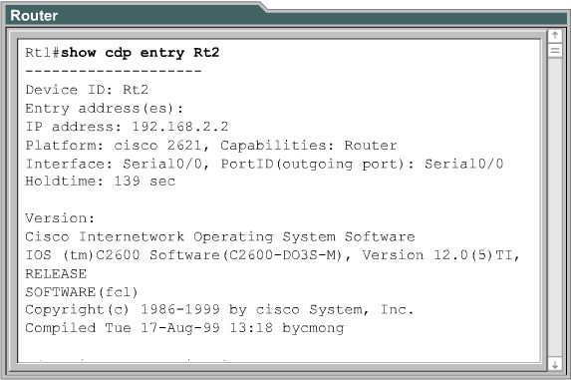
Figure 3.6: The ‘show cdp entry’ command (Cisco Systems, Inc. 2006)
Implementing this method is similar in some respects to the ‘show cdp’ command, as the same technique of reading information from dictionary structures is used to obtain the information that is displayed on the router interface. The main differences are the complexity of the command and the retrieving of information from other router’s dictionaries.

The complexity of the command dictates that control structures must be setup inside the method to determine, which form the ‘show cdp entry’ command has be specified. These control structures will determine the format of the command by determining the number of arguments in the command and the type of the arguments. Also helpful error message should be output for incorrect formatting of the command.

Retrieving of information about other devices in the system is possible since all the information about every device in the system is stored in a series of dictionaries, which are global to the system. Once the information has been retrieved from the dictionaries the output method is once again used to output the information to the router interface.

Since no manipulation of system is required with this command, the user can apply this command in either the user or privileged EXEC modes. Therefore the techniques used in the previous commands to prevent users from entering commands in the incorrect mode of the router can be applied here once again.

3.7.7 Implementing ‘show cdp interface’ command
The ‘show cdp interface’ command displays information about the interfaces on which CDP is enabled. The command has one option that can be specified and that is the type number of the interface. If the type number is specified the information about that particular interface on which CDP is enable will be displayed, otherwise all the interfaces on which CDP is enabled will be displayed.

The command displays the name of the interface, state of the interface, the encapsulation method, the time period between updates and the hold time of the advertisements. Figure 3.7 shows the format of the command and the results of its operation on both the serial0/0 interface and the fastethernet0/0 interface.

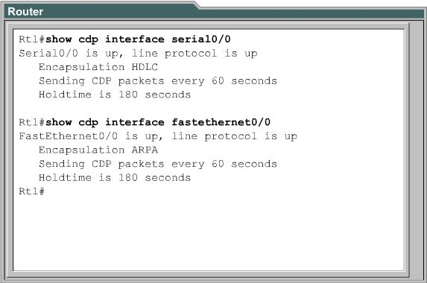
Figure 3.7: The ‘show cdp interface’ command (Cisco Systems, Inc. 2006)
Implementation of the ‘show cdp interface’ command within the iNetSim network simulator is very similar to the implementation of the other ‘show cdp’ commands, as it retrieves the interface information from a dictionary structure. The difference is the dictionary structure that it retrieves its information from is the interface dictionary that holds all the important information about each of the interfaces on the router.

Since no manipulation of system is required with this command, the user can apply this command in either the user or privileged EXEC modes. Therefore the techniques used in the previous commands to prevent users from entering commands in the incorrect mode of the router can be applied here once again.

3.7.8 Implementing ‘show cdp neighbors’ command
The ‘show cdp neighbors’ command is one of the most popular CDP commands, since it displays detailed information about the router’s directly connected devices in a tabular form. The command has two options that can be specified, which are the ‘type number’ of a device and the word ‘detail’. The ‘type number’ option is used to display information about one particular device. If the user supplies the word ‘detail’, the router will return a lot more information about the devices, including the native VLAN ID, the duplex mode, and the VTP domain name associated with the neighbouring devices.

The command displays a number of attributes about each of the directly connected devices. These attributes are the type of device, the name of the device, the number and type of the port, the number of seconds the CDP advertisement is valid for that port, the device product number and the port ID. Figure 3.8 demonstrates the operation of the ‘show cdp neighbors’ command on a Cisco router.
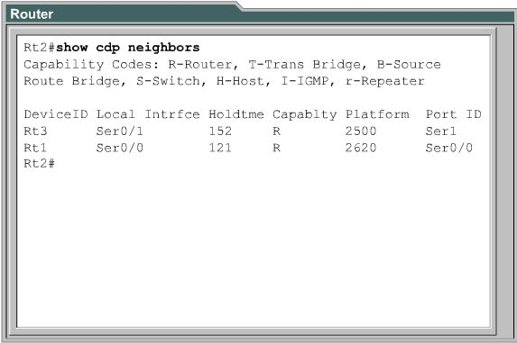
Figure 3.8: The ‘show cdp neighbors’ command (Cisco Systems, Inc. 2006)

Implementation of the ‘show cdp neighbors’ command within the iNetSim network simulator is very similar to the implementation of the other ‘show cdp’ commands, as it retrieves the information about the directly connected devices from a dictionary structure. This command may actually refer to several dictionaries to retrieve the information, since information for several different devices is required and dictionary structure is used to store all this information for future use. Therefore these multiple dictionary structure accesses need to be correctly implemented with this command’s method and a CDP table created to hold all this information.

This command displays a lot of information about the router’s directly connected devices and it is more detailed than most of the other ‘show cdp’ commands. Therefore the privileged EXEC mode is the only mode of the router in which this command can be used. Therefore the techniques used in the previous commands to prevent users from entering commands in the incorrect mode of the router can be applied here once again.

3.7.9 Implementing ‘clear cdp table’ command
The ‘clear cdp table’ command has one purpose, which is to delete the contents of the CDP table containing information about directly connected neighbours. All the information that is displayed in the previous command is stored in a dictionary structure that represents the CDP table.

Implementing this command would basically be a process of creating a method that would systematically erase everything from the CDP table one step at a time. The resulting CDP table would just contain blank values and would only be filled again when the user calls the command ‘show cdp neighbors’.

The restriction that is placed on this command is that it can only be used from the privileged EXEC mode of the router. Therefore, the user can only clear the CDP table when they are in the privileged EXEC mode of the router. Therefore the techniques used in the previous commands to prevent users from entering commands in the incorrect mode of the router can be applied here once again.

3.7.10 Implementing ‘show cdp traffic’ command
The ‘show cdp traffic’ command displays information about the sending and receiving of CDP advertisements within the network. It is used to determine the number of CDP advertisements that are being sent and received by the router along with any errors that may have occurred such as checksum errors. It also displays the number of each version of CDP advertisements that were sent or received by the router. Figure 3.7.10 displays the format of the output of the ‘show cdp traffic’ command.
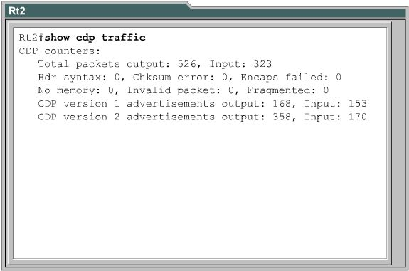
Figure 3.9: The ‘show cdp traffic’ command (Cisco Systems, Inc. 2006)

Implementing this command would involve a series of variables that will be updated each time the router sends or receives a CDP advertisement. In the iNetSim network simulator these values will have to be made up using random numbers or another technique as the devices do not actually send or receive CDP advertisements.
Since no manipulation of system is required with this command, the user can apply this command in either the user or privileged EXEC modes. Therefore the techniques used in the previous commands to prevent users from entering commands in the incorrect mode of the router can be applied here once again.

3.7.11 Implementing ‘show debugging’ command
The ‘show debugging’ command is used to determine the types of debugging that are enabled on the router. It is related to the debugging aspects of the router and is not specific to CDP but there are several CDP debugging values, hence this command is needed to display the state of these CDP debugging values.

Since this command is not specific to CDP, this method could be placed in another class of the system but to enhance the modularity of the design it would be better if the method was placed in the same class as the other CDP related commands. This method would maintain a dictionary structure that has all the debugging attributes of the router with their associated states being either enabled or disabled. When the user enters the ‘show debugging’ command, the method will read the values from this dictionary structure and display the information to the router interface in the required form.

Since no manipulation of system is required with this command, the user can apply this command in either the user or privileged EXEC modes. Therefore the techniques used in the previous commands to prevent users from entering commands in the incorrect mode of the router can be applied here once again.

3.7.12 Implementing ‘debug cdp packets’ command
The ‘debug cdp packets’ command is a debugging command that gives the user some idea of how advertisements are sent and received by the router. It provides information about packets as they are sent and received from the router.

The iNetSim network simulator can only simulate the operation of an actual router, so some of the commands use random numbers or other techniques to simulate some of the values within the router. The ‘debug cdp packets’ command is one of these methods, since information about packets being sent and received needs to be displayed to the router interface. Since no packets are actually sent in the simulator this command’s method must output a series of random values in the format that the router does, to simulate what the actual command would look like on a router interface.

Since no manipulation of system is required with this command, the user can apply this command in either the user or privileged EXEC modes. Therefore the techniques used in the previous commands to prevent users from entering commands in the incorrect mode of the router can be applied here once again.

3.7.13 Implementing the other ‘debug cdp’ commands
There are three other ‘debug cdp’ commands that relate to CDP within the router interface, which have a very similar structure and operation, thus they can be grouped together in terms of designing the solution. The first command is ‘debug cdp adjacency’, which displays CDP information about the router’s directly connected neighbours. The second command is ‘debug cdp events’, which displays information about the CDP events that happen within the router. The last command is ‘debug cdp ip’, which displays information about the router’s CDP IP configuration.

These three commands can all be implemented in a similar manner, since they are all commands that output information to the router interface about CDP aspects of the router. The router’s dictionary structures would again be read to determine the information that needs to be displayed to the user and the formatting of the output would have to be built into the method to ensure it matches the output of an actual Cisco router.

Since no manipulation of system is required with these commands, the user can apply these commands in either the user or privileged EXEC modes. Therefore the techniques used in the previous commands to prevent users from entering commands in the incorrect mode of the router can be applied here once again.

3.7.14 Implementing ‘cdp timer’ and ‘cdp holdtime’ commands
The ‘cdp timer’ and ‘cdp holdtime’ commands specify the two important parameters relating to the sending of CDP advertisements. The ‘cdp timer’ command specifies how often the router sends CDP update packets and the ‘cdp holdtime’ command specifies the hold time to be sent in the CDP update packet. This hold time determines the period of time the CDP advertisement is valid on the port on which it is received.

Implementing these commands can be achieved by simply reading the values of these variables from the router’s dictionary structure and outputting these values to the router interface.
The restriction that is placed on these commands is that they can only be used from the privileged EXEC mode of the router. Therefore, the user can only alter the timer and holdtime settings when they are in the privileged EXEC mode of the router. Therefore the techniques used in the previous commands to prevent users from entering commands in the incorrect mode of the router can be applied here once again.

4.0 IMPLEMENTATION
4.1 Implementing the e-Labs
4.1.1 Overview of adapting the e-Labs
The actual process of implementing the tailored CCNA2 e-Lab exercises was very time consuming but reasonably simple. It involved creating an instruction file and several router configuration files for each of the CCNA2 e-Lab exercises. The implementation was made quite easy because of the time spent designing the solution and thinking through the complexities of the solution.

4.1.2 Creating the instruction files
The instruction files for each of the CCNA2 e-Lab exercises were created by retyping all of the instruction steps given in the original’s instruction panel. Each command had to be retyped because the original e-Lab exercises, shown in Figure 4.1, are Flash documents and copying the data from them was not possible.
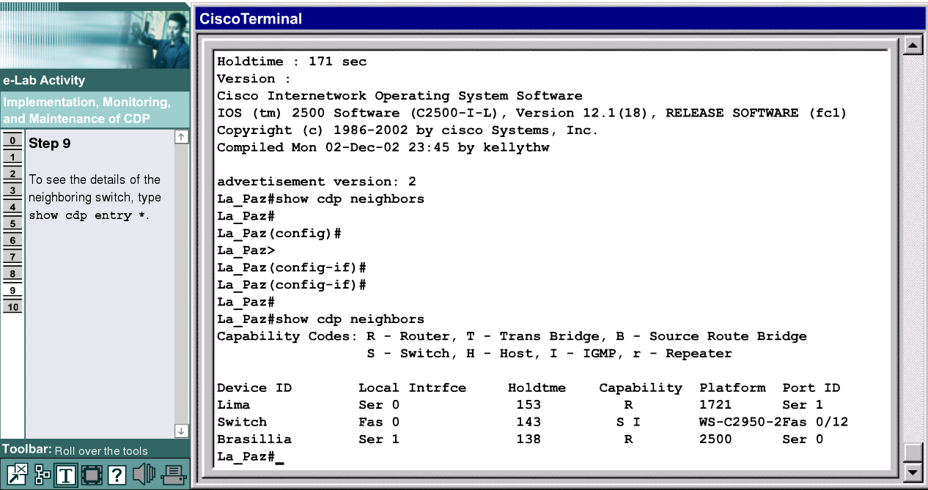
Figure 4.1: The original e-Lab exercise interface (Cisco Systems, Inc. 2006)
Each e-Lab exercise required a separate text instruction file and was given the file name corresponding to its section name, so that the vision impaired student could quickly find the exercise that they wanted to complete.

The content of the exercises are an exact replication of the instructions given in the original e-Lab exercises’ instruction panels. Therefore, the instruction file for each e-Lab exercise was completed when all the instructions and information featured in the original exercises was transferred into the instruction files, as shown in Figure 4.2.
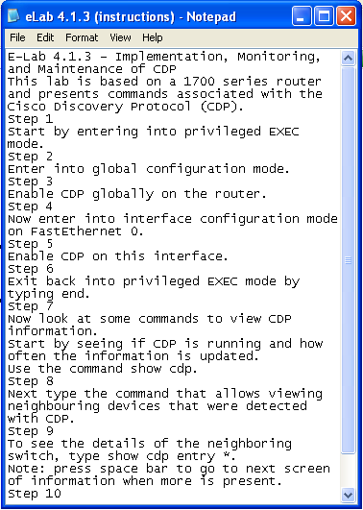
Figure 4.2: An e-Lab Instruction File
4.1.3 Creating the router configuration files
The router configuration files for each of the CCNA2 e-Lab exercises were created by modifying existing router configuration files into the form, which was required for each of the exercises to correspond to the commands that were being entered by the vision impaired student. The instruction file and network diagram had to be closely examined to determine the attributes that the router configuration required and the correct values for these attributes. An example router configuration file corresponding to the above instruction file is shown in Figure 4.3.
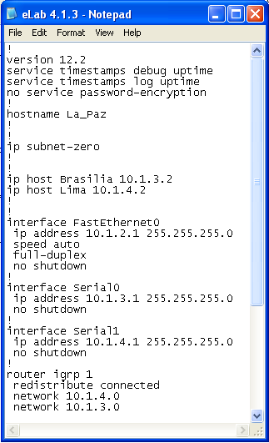
Figure 4.3: A Router Configuration File
Each e-Lab exercise had at least one router configuration file, but more likely two or three router configuration files were required for each e-Lab exercise. Therefore the same naming convention as the instruction files was used except that in the situations were two or three router configuration files were present the router name was attached to the end of the file name. This convention was used so that the vision impaired students could easily find the router configuration files and differentiate between the two or three router configuration files that may have been present for the e-Lab exercise.

The most important parts of the router configuration files to implement are discussed in the next few paragraphs. The first is the hostname, which is shown when the router first boots up. It is used often in the instruction files to instruct the student, which router they will use to execute the commands. This is very easy to determine as the original e-Lab exercises display the name when the exercise is first opened. The implementation of the hostname in the router configuration is just as simple since it only requires one line of the form, ‘hostname RouterName’. In the CCNA2 course the routers are generally named after cities of the world, with the exception being if setting the hostname is part of the exercise, in which case the hostname is set to ‘Router’.

Another important part of the router configuration files are the interfaces used to communicate with other devices in the system. There are four ports on a router, two serial ports and two Ethernet or Fast Ethernet ports, and each of these ports require an interface that describes the attributes of the port. Most of the e-Lab exercises only have two ports operating, an Ethernet port to communicate with a computer and a serial port to communicate with a neighbouring router. Therefore only two interfaces are required in the file in these situations, since the other two are not used.

The most important aspect of creating the interface is determining its IP address, which can be obtained from the network diagram given as part of the original e-Lab exercises. This IP address is crucial to communication with other devices, it needs to be set correctly or other devices will not know what address to use to contact the router. Once these IP addresses have been correctly added to the router configuration files the file is almost ready for use in the router.

There are other important elements of the router that need to be implemented but they vary depending on the topic of the e-Lab exercise. These important elements include passwords on interfaces, access lists and the use of routing protocols. These elements had to be implemented carefully with reference to similar router configuration files that had these elements implemented already.

4.1.4 Implementation Issues
There was no problem implementing the instruction files because they were an exact representation of the instructions featured in the original e-Lab exercise. However, implementing the router configuration files caused a few problems. The main problem was what to include in the configuration file and what should be left out. Attributes such as the hostname and IP addresses could be easily determined but other attributes were not stated in the instructions but were still required. Other issues included how to implement more advanced features such as access lists and routing protocols.
4.2 Implementing CDP
Since the original objective of the project could not be completed due to a lack of Software Engineering support, the implementation of CDP within the iNetSim network simulator could not be completed. Therefore this section will briefly outline how the design of CDP, developed as part of this project, can be implemented by students in future years.

The main focus of implementing CDP within the iNetSim network simulator is the router interface part of the simulator. Therefore the following three figures demonstrate where in the simulator the router interface is located. Figure 4.4 shows the main GUI of the application with a network topology implemented in the display window.
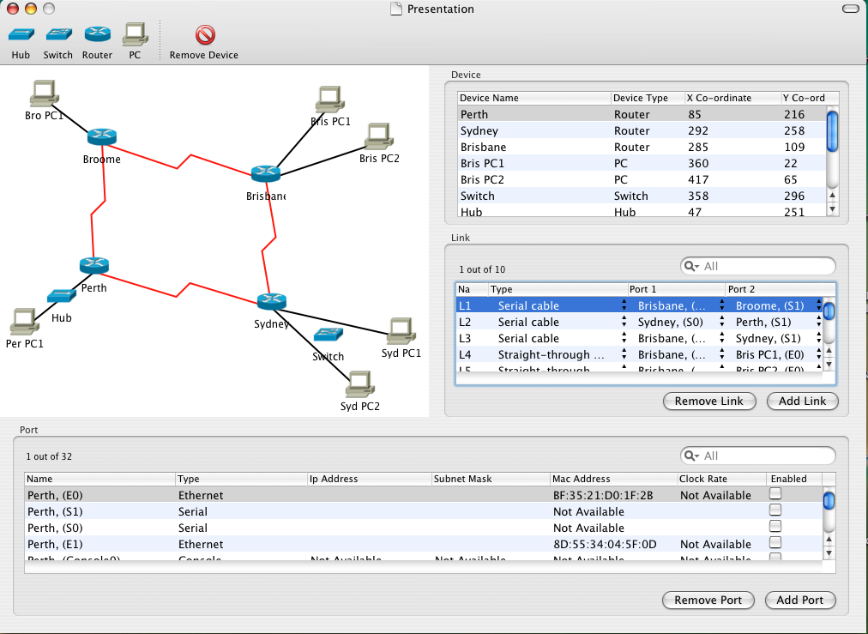
Figure 4.4: The interface of the iNetSim network simulator
The main GUI is useful for creating network topologies by adding devices into the display window and linking them all together to create a network. However this main interface only displays the network, it cannot communicate with other devices or program devices, these tasks are allocated to the device interfaces.

CDP can be used within both the switch and router interfaces but since the switch interface is not currently implemented the focus of this project was implementing CDP in the router interface. Therefore to get to the router interface the user must double click, using with the mouse or use the VoiceOver command, on one of the routers present and the system to open the device inspector window. Figure 4.5 shows the Sydney router’s device inspector window.
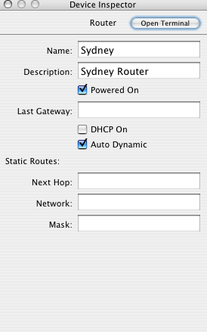
Figure 4.5: Information about the Sydney router
The actual router interface can be opened by selecting the ‘Open Terminal’ button and an interface similar to Figure 4.2c will be displayed. This router interface should be exactly the same as the interface of a Cisco router and very similar to the router simulator used in the CCNA2 e-Lab exercises. Currently the router interface of the iNetSim only has a few basic networking commands implemented but when it is totally finished it will accurately model the operation of an actual Cisco router.
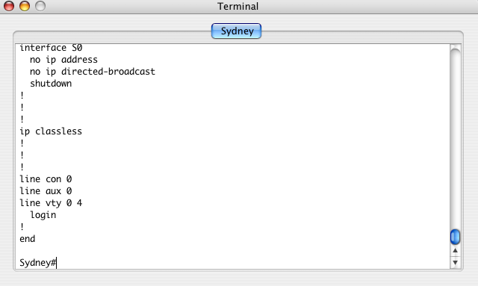
Figure 4.6: The Sydney router interface

Implementing CDP within the iNetSim network simulator means that when a student enters a CDP related command into the router interface of a router on the network simulator, the application will respond correctly to the command. The application will display useful information about the directly connected, neighbouring devices to the router. Therefore the code framework behind the router interface section of the application needs to be developed in order that it can respond to CDP related commands.
The Xcode and Interface Builder programming applications are used to develop the iNetSim network simulator, with the majority of the implementation taking place in Xcode. Xcode is used to create the class files that manipulate data and do all the hard processing work, whereas Interface Builder is used to display the information obtained to the GUI router interface.

Since the iNetSim network simulator is currently in a developmental stage, and will be for several more years, the implementation must be completed in a modular manner. Each new protocol that is to implemented in the network simulator should be implemented in a module that can be fitted into the application without dramatically affecting the other parts of the system that are already operating correctly.

Therefore a new class has to be created to implement CDP, which will contain the processes to follow when the student enters one of the sixteen CDP commands. There is already a class that reads the input from the user and decides which method to call that will process the user’s command. Thus this class needs to be changed, so that commands involving CDP will be directed to the correct method within the CDP class.

The iNetSim network simulator uses a state based implementation that is global to the application. Therefore, the application has a global state variable, which dictates the state of the system. If the router has just booted up the state of the router will be in the user mode and when the ‘enable’ command is entered the state will change to the privileged EXEC mode. Each mode has its own set of commands that are allowable and only these commands can be used in this mode.
The design developed as part of this project, defines the mode of the router that each of the CDP commands can be used. Therefore each of the CDP commands featured in the design can be implemented into methods within the CDP class, which perform their correct operation when in the mode of the router that uses that command, otherwise a helpful error message is output.

Since the iNetSim application is a network simulation tool it does not actually send and receive packets. Therefore the operation of the sending and receiving CDP advertisements will be simulated in the form of random numbers, or another similar technique, to display CDP advertisement information that appears to be the same as an actual router.

The iNetSim network simulator utilises Core Data techniques to create a series of dictionary structures that hold the information about the devices in the network. These series of dictionary structures are read by the CDP related methods to retrieve information about the router and its directly connected neighbours, so that the information can be displayed on the router interface.

The last part of the implementation of CDP within the iNetSim network simulator is the presenting of the information that has been retrieved on the router interface. The previous students have already implemented methods that output text to the router interface. Therefore, the information needs to be formatted in the correct manner and then the pre-existing methods are used to output the information to the router interface.

5.0 VERIFICATION
5.1 Testing the e-Labs
5.1.1 Syntax and format testing
There were three forms of testing that were applied throughout the creation of the adapted e-Lab exercise files. The first was syntax and format checking to determine whether the created router configuration files, in particular, matched the syntax and format used by the router in its configuration files. The syntax of the router configuration language appears to be reasonably straight forward, given that it is quite human readable and the basic structure of it does not alter very often. However small changes of syntax could result in totally different results when used within the router.

Testing the router configuration files required a strong knowledge of networking theory and some experience with the routing syntax. Some parts of the file could be interpreted by anybody, such as a statement like “hostname Perth”, which most people could figure out to mean that the router’s name is Perth. However other syntax requires knowledge of the structure of IP addresses and the subnet masks that can be applied to them and how to describe the features of each of the router’s interfaces.

Testing the syntax of the router’s configuration language was fundamentally a case of comparing the configuration files created with example router configuration files that had be obtained from actual routers by using the “show running-config” command on the router terminal. A lot of the e-Lab exercises used similar router configuration files, so the basic syntax of the files was learnt making testing a lot less difficult.
A small amount of testing was completed on the instruction files to make sure that they all had the same format. This was mainly done for presentation purposes, so that the files all had the same structure, meaning the vision impaired student could get used to hearing the instructions in a particular sequence. Although not vitally important, anything that will improve the vision impaired student’s ability to learn is worthwhile.

5.1.2 Accuracy testing
Guaranteeing that the syntax and format of the router simulation files were correct was not enough to test the created e-Lab exercises because the files could have correct syntax and format but be totally different to the original exercise. Therefore the second focus of testing was on the accuracy of the files compared to the original exercises.

The first part of the accuracy testing phase was comparing the instructions given in the original e-Lab exercises with the instructions files that were created. The instructions files were created by directly copying the instructions given in the e-Lab exercises, thus over the 58 instruction files created there were only a few minor errors, such as an incorrectly spelled word or the wrong word used in a particular context. Resolving these minor errors may seem trivial but using the wrong word in a sentence can totally change the purpose of the sentence and could confuse the vision impaired student.

The main focus of the accuracy testing phase was focused on determining if the router configuration files created for each of the e-Lab exercises would actually work with the instruction file and respond correctly to the user’s input. The router configuration files may be totally correct in terms of their syntax and format, but if the vision impaired student follows the instructions, enters a correct command and receives an error message or incorrect information there is a problem with these adapted exercises.

The students use the e-Lab exercises to reinforce the theory that they have been learning, consequently if the adapted exercises do not operate correctly the student will start to doubt they have understood the theory causing confusion and resulting in errors being made in the CCNA2 exams. Thus the very difficult task of ensuring the tailored e-Lab exercises perform exactly the same as the original e-Lab exercises had to be undertaken.

Each e-Lab had to be thoroughly tested to make sure that the combination of the instruction file and router configuration file produced the same results as the router simulation tool used in the original e-Lab exercises. Some of the exercises were unproblematic because as part of the exercise the running router configuration was displayed, so the router configuration file could be compared to the file displayed in the router simulation. Other exercises required very little to be implemented in the router configuration because the student was expected to program large portions of the router’s attributes. Generally the larger the instruction file the less that was implemented in the router configuration file meaning it is easier to test.

The router configuration files that needed a lot of information put into them required carefully analysis and comparison to the original documents, so that all the information required for the vision impaired student to complete the exercise is present. Often the hardest part of the testing was the unmentioned attributes, such as two devices want to communicate and it is assumed that all the addresses are correct and in place, so that the communication can take place.

Testing the accuracy of the solution was a long and labour intensive process that involved going through the 58 e-Lab exercises and comparing them to the 58 instruction files and 93 configuration files with the purpose of finding any inconsistencies and resolving them. Several inconsistencies were detected and the files were changed to correctly model the original exercises.

5.1.3 System testing
The third phase of testing was an overall checking of the system on the actual hardware to locate any errors that may have survived the early testing phases. If the earlier testing phases are working perfectly, this phase should just be a demonstration of the adapted e-Lab exercises to see how they work.

The router configuration file is downloaded into the router and the instruction file is read from the screen, so that the e-Lab exercises can be performed on actual hardware. The tester will read the instructions from the file, enter the correct commands into the router terminal and wait for the response from the router. If all the instructions from all the e-Lab exercises featured in the CCNA2 course produce the same response as the instruction does on the original e-Lab exercise, the system has past the third phase of testing.

Unfortunately, due to time constraints, not all the e-Lab exercises created were system tested but several exercises from each module were tested and the exercises performed in the same manner as the original exercises.

5.1.4 Vision impaired testing
The first three phases of testing were performed by a sighted person, while creating the modified CCNA2 e-Lab exercises. The whole purpose of tailoring the original Flash based e-Lab exercises into the instruction files and router configuration files was so that the vision impaired students can use them to further their knowledge of the CCNA2 course. Therefore to completely test the validity of the solution, the exercises had to be tested by vision-impaired students.

Once the adapted CCNA2 e-Lab exercises had passed the majority of the testing described in the above sections, the files were sent to the project supervisor who gave them to some of the vision impaired students for them to use. These students has a reasonably sound knowledge of networking theory and quite a lot of experience with routers, so they did not have too much trouble using the files. In particular, Ian Blackburn, who is totally blind, tested a lot of the tailored e-Lab exercises and found that he was able to complete the exercises by following the instruction file and executing the commands on the actual router interface quite easily.

These vision impaired students have used quite a few of the adapted e-Lab exercises already and the feedback through the project supervisor has been positive. Although no formal testing results have been achieved, if the vision impaired students are happy with the adapted e-Lab exercises, the testing is successful because they are the main focus of adapting the e-Lab exercises.
The main purpose of testing the solution with vision impaired students was to ensure that the exercises adequately addressed the requirements of the vision impaired students because they are people who are going to be using the files. It also gives the vision impaired students a chance to give feedback on the exercises, so that improvements can be made in the future.

Vision impaired students often approach a problem differently to other students, therefore it is important to obtain their views on the solution and any ideas they may have for future projects. At present, little feedback has been provided but if problems do occur in the future the feedback from these vision impaired students will be helpful in improving the current solution or any future projects.

5.2 Testing the iNetSim network simulator
5.2.1 Overview of the testing procedure
One of the initial objectives of this project was to totally implement CDP within the iNetSim network simulator. Due to lack of Software Engineering support and time constraints the project objective was altered to focus on the designing of implementing CDP within the iNetSim network simulator. Therefore only a small amount of code was produced and that code was not implemented within the system making testing of the solution very difficult.

The main focus of testing in this project was on determining the improvements that can be made to the existing iNetSim network simulator in the future. The testing procedures conducted to determine these improvements within the iNetSim network simulator are outlined in the following few sections. The following two testing procedures were carried out twice, once normally as a sighted student using a mouse and once using VoiceOver to simulate being a vision impaired student.

5.2.2 Graphical User Interface (GUI) Testing
The graphical user interface of the iNetSim network simulator was thoroughly tested to determine the elements of the GUI that need to be improved by students in the future. A sample network was created on the network simulator’s interface and each of the tools on the GUI interface were tested to determine the areas of the GUI that need to be improved in the future.

The first part of the testing the GUI was to start a new network topology and add networking devices to the topology. At least one of each of the networking devices were added to the topology to test that all the add devices buttons were working correctly. The remove device button was used to determine if it could remove one of the devices from the topology. The devices can be moved around the display window by clicking and dragging the device to the new position, this was tested by moving some of the devices around to see the results.

The other two important parts of the GUI are the panels to add links and ports to the devices on the network topology. Testing these features meant adding links between devices on the network topology and noticing the ports that were available on each of the devices. Removing links and altering the type of links used were also tested.

5.2.3 Router Interface Testing
The router interface of the iNetSim network simulator was tested to a high standard, as it was the focus of implementing CDP within the network simulator. Although every command that is featured within the CCNA2 course was not attempted on the router interface due to time restrictions a great majority were attempted and areas of failing were identified.

The first part of the testing the router interface was determining if the student could move through the different modes of the router easily and exactly like they would on an actual Cisco router. Entering commands like ‘enable’ and ‘configure terminal’ were used to change the router from the user EXEC mode to privileged EXEC mode to the Global configuration mode. Each of the interfaces were checked to determine if they were operating correctly.

Various commands were entered in each of the modes to determine if the router interface had placed restrictions on certain commands that should only be used from inside a certain mode of the router. The scope of the testing of commands was refined to focus on the protocols that were implemented in the router interface, rather than wasting time entering commands about protocols that were not even implemented.

The last part of the testing was determining the areas of the iNetSim network simulator that need to be developed in the future. The network simulator is quite a new project, so there were a lot of protocols and commands that are yet to be implemented in the system. Therefore only a small amount of them were tested and appear in the next few sections.
5.3 Issues within the iNetSim network simulator
5.3.1 Features not implemented
The list of features that are not currently implemented in the iNetSim network simulator is quite long, therefore only two features will be addressed in this section. The focus was on the features that would make the greatest improvement to the network simulator in the short term.

The two features that need to be implemented are the interfaces for the switch and hub. The switch interface is implemented to some extend, since it opens the switch interface terminal, but when anything is entered into the terminal the whole application crashes, which is a problem if the student had not saved their configuration. Therefore altering the current switch interface so that it will work correctly will greatly improve the application. Although an interface for the hub would be very simplistic, since it is a low level networking device, its implementation would greatly improve the overall application.

Currently the switches and hubs play no role in the operation of the network simulator. They can be added to the network topology but they cannot be linked to other devices or used in any way. Implementing the ability for the switches and hubs to be connected to other devices would greatly improve the usability of the network simulator and it would mean that the students could start to create realistic network topologies that include switches and hubs.

5.3.2 Errors within the simulator
The iNetSim network simulator is a developing application, so it is expected that errors will exist within this application. The following few paragraph highlight a mixture of minor and major problems within the application.

The major problems with the links section of the application’s GUI, is that the student can use the wrong cable type to connect two devices together. There are four types of cable used in networking and each has its own application in connecting two devices together. Therefore, the student should not be able to connect two devices with the wrong cable because this would cause major problems if the same connecting were used in an actual network. Currently a student can use any of the types of links to connect two devices, therefore connecting a cross-over cable to the serial port of a router is possible, something that can not happen in a real network. Therefore this error needs to be corrected, so that students do not learn wrong concepts about linking two devices together in a network.

The lack of helpful error messages within the router interface means that when a user enters the wrong command or a command that is not implemented, the message returned does not help them to understand what they did wrong. Creating more helpful error messages may be quite hard to implement but it would be very helpful for the students who are using the router interface for educational purposes.

There are a number of minor errors that exist within the interfaces of the system. One example is that the PC can output a ‘running-config’ output in the form of a router’s output, something that is not very common in most PCs. The command ‘config terminal’, which is a shortened version of the command ‘configure terminal’, does not work at all. This command is used extensively throughout the e-Lab exercises and most people use this command over its longer equivalent.

The last minor error that will be discussed is that the output of a command like ‘show running-config’, will just be displayed directly to the screen no matter how much information is contained in the response to the command. This differs from the actual Cisco router interface that displays the output to the command one screen at a time. Altering the application to remove these minor errors, along with the more major issues described above, will greatly improve the iNetSim network simulator for future vision impaired students to use.

6.0 CONCLUSIONS
6.1 Accomplishments
The objective of undertaking a final year engineering project is to demonstrate the final year engineering student’s ability to act as a professional engineer in the form of working on a major practical task in a professional manner. This engineering project gives the student an opportunity to experience how their future chosen profession will be when the graduate and determine if they are have the skills necessary to excel in the future.

A major component of a student demonstrating their ability as a professional engineer is their ability to learn new skills and adapt to different working environments. Therefore the following are some of the new skills that have been developed and different working environments that have been explored in the process of completing this project.

Learning a totally new operating system, Apple Macintosh’s OS X, to program under with built-in tools such as Xcode and Interface Builder was challenging but very informative. Within this programming interface the Cocoa API and the Objective-C programming language were learnt to the degree that a quality application could be produced given a suitable amount of time. Lastly the OS X feature, VoiceOver, was examined carefully and used to test the accuracy of the existing interface for the iNetSim network simulator.

The improvement in networking skills achieved through completing this project has been enormous. Since beginning this project with relatively little knowledge of networking and only a basic understanding of the purpose of a router, this knowledge has been significantly improved. Difficult networking techniques and procedures are now fully understood to the extend that many complex router configurations have been developed to assist the vision impaired students.

The skill of managing time was quickly learnt while progressing through this project. It was a critical skill vital to the success of the project and involved a lot of careful planning to ensure that everything was allocated sufficient time for it to be completed. The greatest time management tool that was learnt was the project plan that was determined in the early stages of the project. It helped to plan effectively for each stage of the project and guarantee that everything was completed by the due date.

The last accomplishment achieved by completing this project was a better understanding of the requirements of vision impaired students. Having very little interaction with vision impaired students in the past, it was amazing to watch how they overcame their disability through a lot of hard work and obtained a vital education that would help them in the future. Designing programs and exercises for the vision impaired students meant that their requirements had to be fully understood and the solutions designed in a manner that would be more helpful to them.

6.2 Contributions
6.2.1 Transferring e-Lab exercises
One of the objectives of the project was to adapt the e-Lab exercises from the CCNA2 course into a form that could be used by vision impaired students quickly and easily to assist their training and revision for examinations. This was completely achieved in the form of a series of instruction text files and matching router configurations.

There was 58 e-Lab exercises over the eleven modules featured in the CCNA2 course that needed to be adapted into instruction files and router configurations. All these e-Lab exercises were transferred into 58 e-Lab instruction files and 93 corresponding router configurations.

Some of the students in the vision impaired networking class have started to use these adapted e-Lab exercises to prepare for the examinations involved in the CCNA2 course. The response from the students who are using these e-Lab exercises is very positive and it seems that they are an accurate representation of the original e-Lab exercises.

6.2.2 Designing CDP
The original objective of this project was to implement the Cisco routing protocol, CDP, within the iNetSim network simulator. Unfortunately, only the design of implementing the protocol could be achieved due to no assistance being available to decrease the amount of work required.

The procedure to implement the Cisco routing protocol, CDP, within the iNetSim network simulator was carefully designed and documented, so that future final year project students could take the design and implement it within the network simulation tool. Although some knowledge of the system and programming environment will be required to implement the solution, the majority of the work required to implement CDP within the iNetSim network simulator has been completed.

Each of the commands related to CDP that are featured in the CCNA2 course are examined in a very methodical manner and a strategy has been developed to implement them within the network simulator. Links to parts of the existing network simulator have been identified, so that the CDP module created can be quickly and easily slotted into the application.

Lastly, some of the improvements that could be made within the iNetSim network simulator were identified, so that future students can improve the network simulator and make it more useful as an educational tool. These improvement cover both errors within the system and parts of the simulation that simply do not work at all.

The enhancements that could be made to improve the iNetSim network simulator were outlined in great detail and will be very helpful for future students to quickly resolve them given enough time to complete the task.

6.3 Limitations on the solution
The adapted CCNA2 e-Lab exercises that were created are very helpful to vision impaired students who were unable to use the original e-Lab exercises. However there are some limitations created in the modified e-Lab exercise that could decrease the student’s ability to learn and obtain the correct answers to problems.

In the original e-Lab exercises, if the student attempted to enter the command they thought was the correct command relating to the given instruction and they got the command wrong, an error message would appear. This message would state the first part of the command that was in error. Therefore the student could try again given the helpful message and the messages will continue after each incorrect attempt until the student gets the command correct.

The limitation with the adapted e-Lab exercises is that the e-Lab exercise is run on an actual router meaning that the error messages built into the router will be used to respond to an incorrect command. Since the router has no idea that the student is trying to complete an e-Lab exercise, the router will not know the command that the student is trying to enter. Therefore if the user gets the command totally wrong, the router will not be able to helpfully direct the student to try another command like the router simulator does on the original e-Lab exercises.

Therefore the solution of creating a set of instruction files and router configuration files does make it more difficult to complete than the original e-Lab exercises but it is better than the vision impaired students having no form of revision for the course exams.
6.4 Future Development
6.4.1 Transferring e-Labs exercises
This project has completely implemented the e-Labs from the CCNA2 course to the extend that no future modifications can be made to these adapted e-Lab exercises. The 58 e-Lab instruction files and 93 router configuration files can not be extended or changed in any way that could increase their educational benefit to the vision impaired students. The only situation that would require future development is if the CCNA2 course was modified in the future. The adapted versions of these e-Lab exercises would need to be altered to match the changes in the original exercises.

The major area of future development in regard to the e-Lab exercises is transferring the e-Lab exercises featured in the other CCNA courses, which are CCNA3 and CCNA4. In the CCNA3 course there are 28 e-Lab exercises and that need to be adapted to a form that vision impaired students can use to apply the theory they have learnt. These e-Lab exercises are quite similar to the exercises found in the CCNA2 course.
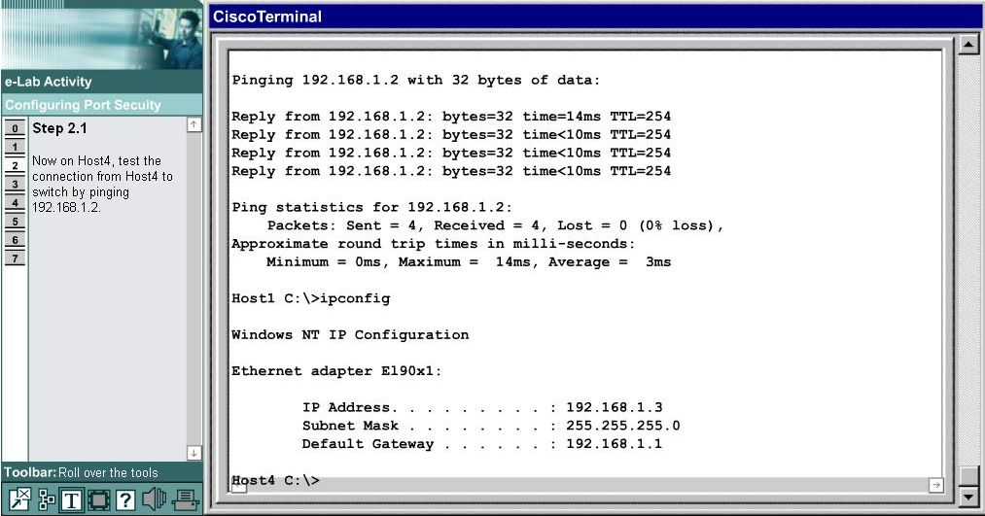
Figure 6.1: A CCNA3 e-Lab exercise (Cisco Systems, Inc. 2006)
The CCNA4 course has 23 e-Lab exercises that must be tailored to suit the requirements of the vision impaired students. These e-Lab exercises are also very similar to the e-Lab exercises in the CCNA2 course. The major difference between the CCNA3 and CCNA4 e-Labs and the CCNA2 e-Labs is the complexity of them. Since they are more advanced courses the content of the exercises is more complicated and therefore the router configurations will be much harder to complete.
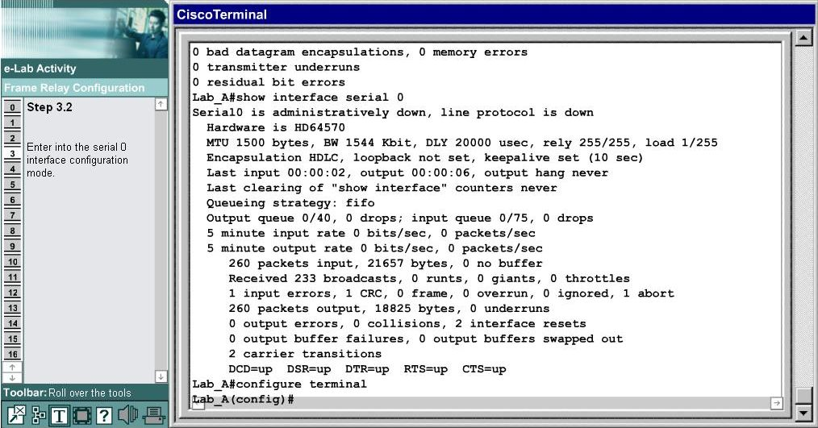
Figure 6.2: A CCNA4 e-Lab exercise (Cisco Systems, Inc. 2006)

The other main consideration that needs to be taken into account when these courses are adapted is the body of knowledge required. Transferring the CCNA2 e-Lab exercises required knowledge of both the CCNA1 and CCNA2 courses, whereas transferring the CCNA3 or CCNA4 e-Lab exercises would require the designer to know three or four of the CCNA courses, which may not be possible given the time restrictions. Therefore there is future development opportunities available to implement more of the e-Lab exercises from the CCNA courses.

6.4.2 Extending the iNetSim network simulator
The iNetSim network simulator is quite a new project with the application only being created last year. Therefore there is a lot of work still to be done to transform the simulator into an educational tool that can be used for vision impaired students to learn networking. Currently the network simulator basically is just a shell of a simulator with some very basic networking functions, thus the future developments are enormous.

The most obvious future development that could be made is implementing the design of CDP, which was developed in this project within the network simulator. This would involve taking the design outlined, coding it in Objective-C and slotting it into the system. The CDP module would have to be tested to verify that it matches the CDP instructions used in the e-Lab exercises and that it does not produce any unexpected results. The system would need to be tested thoroughly to ensure that implementing the CDP module has not caused any problems.

In the CCNA2 course alone there are 10 to 15 other networking protocols that are used that are not present in the iNetSim network simulator. This means that if one networking protocol was implemented each year it would take 10 to 15 years before the network simulator could model the whole of the CCNA2 course and there are still the CCNA3 and CCNA4 course that need to be simulated. Some of the more important networking protocols and features that need to be implemented in the future are the briefly detailed in the following paragraph.

The routing protocols, such RIP and IGRP, are vital network protocols that need to be learnt well because they are very popular protocols used in the transmitting of data over a network, which is one of the main purposes of a network. They are used to transmit the data is the most efficient manner by making use of networking theory. They are quite complex protocols, therefore a large amount of time will have to be spent implementing these routing protocols.

Access control lists (ACLs) are valuable security tools used within a network. They are part of the router’s configuration file and they monitor the traveling going in or out of the router. These lists can be configured to allow traffic from one address only, multiple addresses or all but one address in the standard form. The extended form of ACLs takes into account the port of the router that is being used, the type of data being sent and many others factors to determine whether the router wants to accept the data. ACLs are used to restrict the flow of information that is confidential, damaging or just unnecessary. Implementing ACLs in the iNetSim network simulator is necessary to the vision impaired students completely understanding what is often a very difficult networking feature to understand.

There are several other minor networking features such as static routing and debugging features that would advance the vision impaired student’s knowledge of networking and help them greatly in completing the CCNA2 course. These features would be less problematic to implement due to the size and complexity of them not being as great. Overall the extensions that could be made to the iNetSim network simulator are vast and will require large amounts of time and effort to complete over the coming years.
6.4.3 Improving the iNetSim network simulator
The iNetSim network simulator contains several errors or parts of the application that do not work as they are expected to work. These problems need to be resolved before the network simulator can be used for useful educational purposes.

A future development that could greatly increase the usability of the limited features of the existing iNetSim network simulator would be to resolve these issues, so that vision impaired students can at least use the limited features that are available without having problems with the application. The details of the errors and parts of the application that simply do not work are discussed in an earlier section of this thesis but the major problems that need to be improved are mentioned in the following paragraphs.

The major problem is that some parts of the application have not be developed, so their representation on the diagram is purely to show what will be implemented in the future. An example is the switches and hubs that can be added to the network diagram, which do absolutely nothing except look like the real devices. This problem can be fixed without any difficulty by actually implementing these devices within the application.

The other main problem is errors within the application. An example is that the user can select any networking cable and connect two devices that should only be connected by one particular type of cable. Improving the accuracy and usability of the iNetSim network simulator would be a great future development that could be undertaken as part of another student’s final year project.

6.5 Conclusion
This project set out to implement CDP within the iNetSim network but due to unforeseen circumstances this could not be completed to the degree originally intended. However, the CCNA2 e-Lab exercises were converted to a form that enabled the vision impaired students to complete them in an effective manner and the design of implementing CDP within the network simulator was developed. Overall the project completely accomplished one of its objectives and partially completed the other due to a lack of Software Engineering support.

7.0 REFERENCES
Association for the Blind of WA 2004, Understanding blindness and eye conditions. Retrieved May 29, 2006, from http://www.abwa.asn.au/understandingblindness.html
Australian Bureau of Statistics 1997, Australian social trends. Retrieved May 29, 2006, from http://www.abs.gov.au/Ausstats/abs@.nsf/94713ad445ff1425ca2568200019 2af2/F546AF4B392068CCCA2570EC001B1F54?opendocument
Blind Citizens Australia 2003, Submission to the house of representatives standing committee on employment and workplace relations inquiry into increasing participation in paid work. Retrieved May 29, 2006, from www.aph.gov.au/house/committee/ewr/emp/subs/sub67.pdf
Choice Technology UK 2005, The lookOUT screenreader. Retrieved May 27, 2006, from http://www.screenreader.co.uk/products/lookout.htm
Cisco Systems, Inc. 2006, Cisco networking academy program. Retrieved October 15, 2006, from http://www.cisco.com/web/learning/netacad/index.html
Hope, J, von Konsky, BR, Murray, I, Chew, LC, Farrugia, B 2006, ‘A Cisco education tool accessible to the vision impaired’, Proceedings of the eighth international ACM SIGACCESS conference on computers and accessibility, Association of Computing Machinery, Inc., Portland, Oregon, pp. 235-6.
Wikipedia 2006, Cisco discovery protocol. Retrieved May 31, 2006, from http://en.wikipedia.org/wiki/Cisco_Discovery_Protocol

APPENDICES
Appendix A – Project Plan
Original Project Plan
The original project plan was created right at the very start of the year when the objective of the project was to implement CDP within the iNetSim network simulator. Therefore, the actual project plan used is a little different as shown in the Project Plan Adjustments section. Refer to the next few pages for the full project plan.

Project Plan Adjustments
Although the basic structure of the project plan that was followed is the same as the original project plan, some of the activities that were completed were different. The original focus was on implementing CDP within the iNetSim network simulator but this become a minor design task due to a lack of Software Engineering support.

Adapting the CCNA2 e-Lab exercises became the major focus of the project, meaning a lot of the time set aside to implement CDP was redirected to adapting these exercises. Therefore a lot of sections that refer to implementing and testing CDP where in fact dedicated to implementing and testing the CCNA2 e-Lab exercises.

Overall, the project plan was closely followed and each of the stages was completed within a week of when it was supposed to be completed.
Appendix B – The tailored CCNA2 e-Lab exercises

Module 2 e-Labs
2.1.3a
E-Lab 2.1.3a - Logging into the router:
Access the router command line interface (CLI) user EXEC mode and then use the enable command to enter privileged EXEC mode.

Step 1.1
Enter privileged EXEC mode.
Step 1.2
Now that the router is in privileged EXEC mode, it is possible to administer the router configuration. This is the starting point for any router configuration task. For now, log out of the router with the exit command.

Beirut Router Configuration:
!
version 12.2
service timestamps debug uptime
service timestamps log uptime
no service password-encryption
!
hostname Beirut
!
!
!
ip subnet-zero
!
!
ip host Damascus 192.168.15.2
!
!
interface FastEthernet0
ip address 192.168.14.1 255.255.255.0
speed auto
full-duplex
no shutdown
!
interface Serial0
ip address 192.168.15.1 255.255.255.0
no shutdown
!
interface Serial1
no ip address
shutdown
!
router igrp 1
redistribute connected
network 192.168.14.0
network 192.168.15.0
!
ip classless
no ip http server
!
!
dialer-list 1 protocol ip permit
dialer-list 1 protocol ipx permit
!
line con 0
line aux 0
line vty 0 4
!
end

2.1.3b
E-Lab 2.1.3b - Router User Interface Modes:
In this lab, you will view available command options in both user and privileged EXEC modes by using the ?.
The privileged EXEC mode accesses all router commands.
It can be protected by requiring a password, or user ID and password.
This allows only authorized users to access the router.
Configuration and management commands require that the network administrator be at the privileged EXEC level.
Global configuration mode and all other more specific configuration modes can only be reached from the privileged EXEC mode.
The privileged EXEC mode can be identified from the CLI session by the # prompt.

Step 1
You are currently on the router console port in the user EXEC mode.
This mode is denoted by the > symbol.
View the commands available in this mode by entering ?.
From this mode, enter into privileged EXEC mode.
Step 2
The router is now in the privileged EXEC mode, denoted by the # sign.
All show and debug commands are available in this mode.
View the various commands available in this mode by entering ?.
Remember to use the space bar to scroll through multiple screens of information.
Then use the show version command to display the configuration of the system hardware (including available interfaces), the software version, the names and sources of configuration files and the boot images.

Tegucigalpa Router Configuration:
!
version 12.2
service timestamps debug uptime
service timestamps log uptime
no service password-encryption
!
hostname Tegucigalpa
!
!
!
ip subnet-zero
!
!
ip host Guatemala_City 10.0.0.2
!
!
interface FastEthernet0
ip address 10.0.3.1 255.255.255.0
speed auto
full-duplex
no shutdown
!
interface Serial0
ip address 10.0.0.1 255.255.255.0
no shutdown
!
interface Serial1
no ip address
shutdown
!
router igrp 1
redistribute connected
network 10.0.3.0
network 10.0.0.0
!
ip classless
no ip http server
!
!
dialer-list 1 protocol ip permit
dialer-list 1 protocol ipx permit
!
line con 0
line aux 0
line vty 0 4
!
end

2.1.5
E-Lab 2.1.5 - Operation of the Cisco IOS:
This lab demostrates how to upgrade the Cisco IOS image on the router. In order for this method of router upgrade to work, the router must be avle to access a TFTP server.
This lab will assume that the router has access to such a server.
There are other advanced ways to upgrade or restore a router image, but this is the most common method used in normal situations.

Step 1
Enter into privileged EXEC mode.
No changes to the router can be performed in user EXEC mode.
Step 2
View the current Cisco IOS version.
Step 3
The current Cisco IOS image is version 11.2(1)T.
The next step loads the new image into the router.
Before loading the image, check the capacity of the router flash memory --
Does the router have enough room for the new image? (The new image is 4MB).
Use the correct show command to view the flash memory.
Step 4
Examine the output and notice the current IOS version.
This router has been configured to access the TFTP server already.
When upgrading the IOS, the router will erase the old version and replace it with the new version.
Enter the command copy tftp flash to begin copying the new IOS from the server to the router.
Step 5
The remote TFTP server is located on IP address 172.16.9.11.
Step 6
The new Cisco IOS version to download from the TFTP server is 12.2(8)T and its filename is c1700-y-mz.122-8.T.bin.
Step 7
The next step requires the user to indicate the name of the image to use on the router.
It is possible to enter a name different from the original name, however, that is not recommended.
If the Enter key is pressed the filename within the brackets will be used.
Step 8
Now check the image in flash memory again.
Notice the file has changed.
All that remains is for the router to be rebooted and the new image will be started.

Managua Router Configuration:
!
version 12.2
service timestamps debug uptime
service timestamps log uptime
no service password-encryption
!
hostname Managua
!
!
!
ip subnet-zero
!
!
ip host San_Salvador 10.0.1.2
!
!
interface FastEthernet0
ip address 10.0.3.1 255.255.255.0
speed auto
full-duplex
no shutdown
!
interface Serial0
ip address 10.0.1.1 255.255.255.0
no shutdown
!
interface Serial1
no ip address
shutdown
!
router igrp 1
redistribute connected
network 10.0.3.0
network 10.0.1.0
!
ip classless
no ip http server
!
!
dialer-list 1 protocol ip permit
dialer-list 1 protocol ipx permit
!
line con 0
line aux 0
line vty 0 4
!
end

San Salvador Router Configuration:
!
version 12.2
service timestamps debug uptime
service timestamps log uptime
no service password-encryption
!
hostname San_Salvador
!
!
!
ip subnet-zero
!
!
ip host Managua 10.0.1.1
!
!
interface FastEthernet0
ip address 172.16.9.1 255.255.255.0
speed auto
full-duplex
no shutdown
!
interface Serial0
ip address 10.0.1.2 255.255.255.0
no shutdown
!
interface Serial1
no ip address
shutdown
!
router igrp 1
redistribute connected
network 172.16.9.0
network 10.0.1.0
!
ip classless
no ip http server
!
!
dialer-list 1 protocol ip permit
dialer-list 1 protocol ipx permit
!
line con 0
line aux 0
line vty 0 4
!
end

2.2.6a
E-Lab 2.2.6a - Keyboard Help in the CLI:
In this lab, you will learn the help system in the Cisco IOS.
The Cisco IOS has an interactive help system that will display all possible commands and parameters in each mode.
Entering the ? symbol anytime, anywhere will display the current possible usage options.
The ^ symbol displays the first location where invalid input has occurred.
There are also hidden commands that are available but are not shown in the help.

Step 1
Enter a ? to view a list of available commands in privileged EXEC mode.
One of the most important and useful commands in the Cisco IOS is the show command.
It is used to display a snapshot of the router's status.
Check the available variations of the show command. Enter a ? after the command show.
Currently, the most widely used routed protocol is the Internet Protocol (IP).
Enter the command to view the available options for the IP Protocol.
Routers build routing tables of IP network addresses to determine the best path to send data.
Now that you have seen the possible IP options, enter the show ip route command to display the routers IP routing table.

San Jose Router Configuration:
!
version 12.2
service timestamps debug uptime
service timestamps log uptime
no service password-encryption
!
hostname Panama_City
!
!
!
ip subnet-zero
!
!
ip host San_Jose 192.168.1.2
!
!
interface FastEthernet0
ip address 192.168.10.1 255.255.255.0
speed auto
full-duplex
no shutdown
!
interface Serial0
ip address 192.168.1.1 255.255.255.0
no shutdown
!
interface Serial1
no ip address
shutdown
!
router igrp 1
redistribute connected
network 192.168.1.0
network 192.168.10.0
!
ip classless
no ip http server
!
!
dialer-list 1 protocol ip permit
dialer-list 1 protocol ipx permit
!
line con 0
line aux 0
line vty 0 4
!
end

2.2.6b
E-Lab 2.2.6b IOS Auto-Completion:
In this lab, you will learn to use the router auto-completion feature (TAB key) and the history buffer.
The router is smart enough to complete commands for the user if the user enters enough of a command or parameter to make it unique.
It also keeps a history of the commands used in that mode so they can be accessed quickly without retyping the command.
Note: The Tab button may move the cursor from the HyperTerminal window to another part of the activity depending on the operating system, browser type, and version in use.
If the student is unable to enter commands into the HyperTerminal Window adter the Tab button is pressed, click the mouse button within the HyperTerminal window to continue.

Step 1
Learn to use the auto-completion feature of the IOS.
Enter the letter s and press the TAB key.
Notice what happens.
Now enter ? immediately after the s without any space.
Also notice what happens.
Now add a space between the s and the ?.
Now enter sh?.
What happens now?
Enter sh and press the TAB key (without a space after h).
Notice that the whole command is typed out.
Enter the command sh pro.
What do you receive?
Enter the command sh prot.
What do you receive now?
When typing sh prot, what command where you actually entering?

Buenos Aires Router Configuration:
!
version 12.2
service timestamps debug uptime
service timestamps log uptime
no service password-encryption
!
hostname Buenos_Aires
!
!
!
ip subnet-zero
!
!
ip host Santiago 192.168.2.2
!
!
interface FastEthernet0
ip address 192.168.1.1 255.255.255.0
speed auto
full-duplex
no shutdown
!
interface Serial0
ip address 192.168.2.1 255.255.255.0
no shutdown
!
interface Serial1
no ip address
shutdown
!
router igrp 1
redistribute connected
network 192.168.2.0
network 192.168.1.0
!
ip classless
no ip http server
!
!
dialer-list 1 protocol ip permit
dialer-list 1 protocol ipx permit
!
line con 0
line aux 0
line vty 0 4
!
end

Module 3 e-Labs
3.1.3a
E-Lab 3.1.3a - Configuring Router Passwords:
In this lab, you will configure passwords for the console, virtual terminals, and a secret password.

Step 1.1
Login to the router in privileged EXEC mode.
Step 1.2
Enter global configuration mode.
Step 2
Enter a hostname of Riga
Step 3.1
Configure the console password on the router.
Start the process by entering line configuration mode for console 0.
Step 3.2
Create console password cisco.
Step 3.3
Enter the command login.
Step 3.4
Exit line configuration mode.
Step 4.1
Enter line configuration mode for virtual terminals 0 through 4.
Step 4.2
Set the virtual terminal login password to be cisco.
Step 4.3
Enter the command login.
Step 4.4
Exit line configuration mode.
Step 5
Configure the enable password as cisco
Step 6
Configure the enable secret password class.
Step 7
Exit global configuration mode.
Step 8
View the running configuration.

Riga Router Configuration:
!
version 12.2
service timestamps debug uptime
service timestamps log uptime
no service password-encryption
!
hostname Riga
!
!
ip subnet-zero
!
!
ip host Helsinki 192.168.15.2
!
!
interface FastEthernet0
ip address 192.168.14.1 255.255.255.0
speed auto
full-duplex
no shutdown
!
interface Serial0
ip address 192.168.15.1 255.255.255.0
no shutdown
!
interface Serial1
no ip address
shutdown
!
router igrp 1
redistribute connected
network 192.168.14.0
network 192.168.15.0
!
ip classless
no ip http server
!
!
dialer-list 1 protocol ip permit
dialer-list 1 protocol ipx permit
!
line con 0
line aux 0
line vty 0 4
!
end

3.1.3b
E-Lab 3.1.3b - Command-line Interface Command Modes
In this lab, you will learn to enter some of the most common modes the router supports.
These include privileged EXEC, global configuration, interface configuration, line configuration, and router configuration modes.
You will learn many other configuration modes as your IOS knowledge increases.

Step 1
Enter into privileged EXEC mode.
Step 2
In privileged EXEC mode, you have full access to the router.
Enter into global configuration mode where configuration of the router occurs.
Step 3
Once in global configuration mode, there are many other configuration modes that can be accessed.
You will practice some of the common ones that are used.
First, start by entering into interface configuration mode on port serial 0.
Step 4
Interface configuration mode is used to configure interface specific information such as IP addressing.
Now that you've entered interface configuration mode, exit back into global configuration mode.
Step 5
Another common mode you will encounter when configuring a router is the router configuration mode.
In that mode you configure the process by which the router builds a routing table of network addresses.
Enter into router configuration mode using the RIP protocol.
Step 6
You've learned to exit one mode in step 4, now you will learn to exit into privileged EXEC mode directly without using multiple exit commands.
Can you figure out the command on your first try?
(A keyboard command -- which is not supported in this version of eLabs -- to immediately switch from any configuration mode into privileged EXEC mode is Ctrl-Z).
Step 7
Enter back into global configuration mode.
Step 8
Because privileged EXEC mode gives the user so much access, set a password so that only the administrator of the router can gain access to this mode.
This password is stored as an encrypted one way hash.
Use the command enable secret class.
This sets the privileged EXEC password to be class.
Note: In the field of networking, it is good to practice creating passwords using not only letters but numbers and other characters to improve security.
It is equally important to remember the passwords and store them in a secure location.
Step 9
Now that you've set the privileged EXEC password, you can also set a password for anyone who tries to connect to the router through the console port.
To do this, you must enter another configuration mode, the line configuration mode.
Step 10
Setting the password on the console line is more straightforward than the privileged EXEC password.
Use the command password cisco.
The command is password and cisco is the password.
Note: In the field of networking, it is good to practice creating passwords using not only letters but numbers and other characters to improve security.
It is equally important to remember the passwords and store them in a secure location.
Step 11
Now that you've set the password, you also need to let the router know that it should check for a password.
Use the command login.

Asuncion Router Configuration:
!
version 12.2
service timestamps debug uptime
service timestamps log uptime
no service password-encryption
!
hostname Asuncion
!
!
ip subnet-zero
!
!
ip host Montevideo 10.2.2.2
!
!
interface FastEthernet0
ip address 10.1.1.1 255.255.255.0
speed auto
full-duplex
no shutdown
!
interface Serial0
ip address 10.2.2.1 255.255.255.0
no shutdown
!
interface Serial1
no ip address
shutdown
!
router igrp 1
redistribute connected
network 10.2.2.0
network 10.1.1.0
!
ip classless
no ip http server
!
!
dialer-list 1 protocol ip permit
dialer-list 1 protocol ipx permit
!
line con 0
line aux 0
line vty 0 4
!
end

3.1.4
E-Lab 3.1.4 - Router Default Settings:
The current router possesses a clean, unaltered running-configuration.
View the basic configuration and interface details to see the router defaults.

Step 1
View the current running-configuration to look at the default settings.
Note: Use the spacebar to scroll through the screen of information when there are more that one.
Step 2
Enter the command to view interface information

Router Router Configuration:
!
version 12.2
service timestamps debug uptime
service timestamps log uptime
no service password-encryption
!
hostname Router
!
!
memory-size iomem 25
ip subnet-zero
!
!
!
process-max-time 200
!
interface FastEthernet0
no ip address
no ip directed-broadcast
shutdown
!
interface Serial0
no ip address
no ip directed-broadcast
no shutdown
!
interface Serial1
no ip address
no ip directed-broadcast
shutdown
!
ip classless
no ip http server
!
!
line con 0
transport input none
line aux 0
line vty 0 4
!
no scheduler allocate
end

3.1.5
E-Lab 3.1.5 - Configuring a Serial Interface:
In this lab, you will configure a serial interface on the Lilongwe and Dar Es Salaam routers so they can communicate.

Step 1.1
Enter into privileged EXEC mode
Step 1.2
Enter global configuration mode.
Step 2
Set the hostname to Lilongwe.
Step 3
Set the enable password to class.
Step 4.1
Enter interface configuration mode for serial interface 0/0.
Step 4.2
Enter the IP address 192.168.15.1 255.255.255.0 for interface S0/0.
Step 4.3
This serial interface will require a clockrate of 56000.
Step 4.4
Issue the no shutdown command to bring the interface up.
Step 4.5
Use the command end to exit into privileged EXEC mode.
Step 5
Save your configuration.
Step 6
Now perform basic configuration of the adjacent router.
Begin by entering global configuration mode.
Step 7
Set the hostname to Dar_Es_Salaam.
Step 8
Set the enable password to class.
Step 9.1
On router Dar Es Salaam, Enter interface configuration mode for serial interface 0/0.
Step 9.2
Enter the IP address 192.168.15.2 255.255.255.0 for interface S0/0.
Step 9.3
Issue the no shutdown command to bring the interface up.
Step 9.4
Use the command end to exit into privileged EXEC mode.
Step 10
Save your configuration.
Step 11
Enter the command show interfaces serial 0/0 to show details about the interface on Lilongwe#.
Step 12.1
Verify that the serial connection is functioning by pinging the serial interface of Dar_Es_Salaam.
Step 12.2
Enter the command show interfaces serial 0/0 to show details about the interface on Dar_es_Salaam.
Step 13
Verify that the serial connection is functioning by pinging the serial interface of Lilongwe.

Lilongwe Router Configuration:
!
version 12.2
service timestamps debug uptime
service timestamps log uptime
no service password-encryption
!
hostname Lilongwe
!
!
ip subnet-zero
!
!
ip host Dar_Es_Salaam 192.168.15.2
!
!
interface FastEthernet0
ip address 192.168.1.1 255.255.255.0
speed auto
full-duplex
no shutdown
!
interface Serial0
ip address 192.168.15.1 255.255.255.0
no shutdown
!
interface Serial1
no ip address
shutdown
!
router igrp 1
redistribute connected
network 192.168.15.0
network 192.168.1.0
!
ip classless
no ip http server
!
!
dialer-list 1 protocol ip permit
dialer-list 1 protocol ipx permit
!
line con 0
line aux 0
line vty 0 4
!
end
3.1.7
E-Lab 3.1.7 - Configuring an Ethernet Interface:
In this lab you will configure an Ethernet interface on the router.

Step 1.1
Enter privileged EXEC mode.
Step 1.2
Enter global configuration mode to begin the configuration process.
Step 2.1
Configure the hostname of the current router to be Riyadh.
Step 2.2
Now configure an enable password of cisco.
Step 3
Enter interface configuration mode for the fastethernet 0 interface.
Step 4.1
Configure an ip address of 192.168.14.1 and a subnet mask of 255.255.255.0 for the current interface.
Step 4.2
Now activate the interface.
Step 5
Use the command end to exit into privileged EXEC mode.
Step 6.1
Now view the running configuration.
Step 6.2
Finally, save the running configuration.

RouterA Router Configuration:
!
version 12.2
service timestamps debug uptime
service timestamps log uptime
no service password-encryption
!
hostname RouterA
!
!
ip subnet-zero
!
!
!
interface FastEthernet0
no ip address
no ip directed-broadcast
shutdown
!
interface Serial0
ip address 192.168.14.1 255.255.255.0
no ip directed-broadcast
!
interface Serial0
ip address 10.0.0.1 255.255.255.0
no ip directed-broadcast
no fair-queue
service-module 56k clock source line
service-module 56k network-type dds
shutdown
!
interface Serial1
ip address 12.0.0.1 255.255.255.0
ip access-group 2 out
no ip directed-broadcast
!
ip classless
!
line con 0
transport input none
line vty 0 4
!
end

3.2.5
E-Lab 3.2.5 – Housekeeping:
Implement basic configuration settings on a router.
This includes tasks such as setting the router clock settings, interface descriptions and the message-of-the-day.

Step 1
Configure the router timezone for WAT (West Africa Standard Time) which is 1 hour later than UTC universal coordinated time.
Use the command clock timezone wat 1.
Step 2
Now enter interface configuration mode to enter a description for the wan interface (serial 0).
Step 3
Now add a description stating Connection_to_N_Djamena.
Step 4
Type exit to exit interface configuration mode.
Step 5
Add a message-of-the-day (MOTD) by using the banner motd command with a # sign as the start delimiter and end delimiter.
Use the message "Hello World" without the quotes.
Step 6
Type end to return to privileged EXEC mode.
Step 7
Set the date and time of the router to 14:45:00 12 February 2002.
Step 8
View the running configuration to see the description line.
Step 9
Display the clock setting.

Yaounde Router Configuration:
!
version 12.2
service timestamps debug uptime
service timestamps log uptime
no service password-encryption
!
hostname Yaounde
!
!
ip subnet-zero
!
!
ip host N_Djamena 192.168.2.2
!
!
interface FastEthernet0
ip address 192.168.1.1 255.255.255.0
speed auto
full-duplex
no shutdown
!
interface Serial0
ip address 192.168.2.1 255.255.255.0
no shutdown
!
interface Serial1
no ip address
shutdown
!
router igrp 1
redistribute connected
network 192.168.1.0
network 192.168.2.0
!
ip classless
no ip http server
!
dialer-list 1 protocol ip permit
dialer-list 1 protocol ipx permit
!
line con 0
transport input none
line aux 0
line vty 0 4
!
end

3.2.7
E-Lab 3.2.7 - Configuring Host Tables:
In this lab, IP host tables will be created that allow a router to use names to identify all of the attached interfaces on that router.
These names can be used in place of IP addresses in commands that use IP addresses to identify a location.

Step 1
Enter into global configuration mode.
Step 2
Create an IP host table for the Kigali router that will provide host name resolution for IP addresses on the Kampala router.
The interface IP addresses on the Kampala router are 172.17.0.2 and 172.18.0.1 using the command ip host kampala 172.17.0.2 172.18.0.1.
Step 3
Exit into privileged EXEC mode.
Step 4
Save the configuration.
Step 5
Enter global configuration mode in router Kampala.
Step 6
Create an IP host table for the Kampala router that will provide host name resolution for IP addresses on the Kigali router.
The interface IP addresses on the Kigali router are 172.16.0.1 and 172.17.0.1 using the command ip host kigali 172.16.0.1 172.17.0.1.
Step 7
Exit into privileged EXEC mode.
Step 8
Save the configuration.
Step 9
Test the configuration from kampala to kigali by pinging the name kigali
Step 10
Test the configuration from kigali to kampala by pinging the name kampala.

Kigali Router Configuration:
!
version 12.2
service timestamps debug uptime
service timestamps log uptime
no service password-encryption
!
hostname Kigali
!
!
ip subnet-zero
!
!
ip host Kampala 172.17.0.2
!
!
interface FastEthernet0
ip address 172.16.0.1 255.255.0.0
speed auto
full-duplex
no shutdown
!
interface Serial0
ip address 172.17.0.1 255.255.0.0
no shutdown
!
interface Serial1
no ip address
shutdown
!
router igrp 1
redistribute connected
network 172.16.0.0
network 172.17.0.0
!
ip classless
no ip http server
!
dialer-list 1 protocol ip permit
dialer-list 1 protocol ipx permit
!
line con 0
transport input none
line aux 0
line vty 0 4
!
end

Module 4 e-Labs
4.1.3
E-Lab 4.1.3 - Implementation, Monitoring, and Maintenance of CDP
This lab is based on a 1700 series router and presents commands associated with the Cisco Discovery Protocol (CDP).

Step 1
Start by entering into privileged EXEC mode.
Step 2
Enter into global configuration mode.
Step 3
Enable CDP globally on the router.
Step 4
Now enter into interface configuration mode on FastEthernet 0.
Step 5
Enable CDP on this interface.
Step 6
Exit back into privileged EXEC mode by typing end.
Step 7
Now look at some commands to view CDP information.
Start by seeing if CDP is running and how often the information is updated.
Use the command show cdp.
Step 8
Next type the command that allows viewing neighbouring devices that were detected with CDP.
Step 9
To see the details of the neighboring switch, type show cdp entry *.
Note: press space bar to go to next screen of information when more is present.
Step 10
To see how often CDP packets are sent and if the interfaces are up or down, use the show cdp interface command.

La Paz Router Configuration:
!
version 12.2
service timestamps debug uptime
service timestamps log uptime
no service password-encryption
!
hostname La_Paz
!
!
ip subnet-zero
!
!
ip host Brasilia 10.1.3.2
ip host Lima 10.1.4.2
!
!
interface FastEthernet0
ip address 10.1.2.1 255.255.255.0
speed auto
full-duplex
no shutdown
!
interface Serial0
ip address 10.1.3.1 255.255.255.0
no shutdown
!
interface Serial1
ip address 10.1.4.1 255.255.255.0
no shutdown
!
router igrp 1
redistribute connected
network 10.1.4.0
network 10.1.3.0
network 10.1.2.0
!
ip classless
no ip http server
!
dialer-list 1 protocol ip permit
dialer-list 1 protocol ipx permit
!
line con 0
transport input none
line aux 0
line vty 0 4
!
end

4.1.6a
E-Lab 4.1.6a - Address Resolution Protocol:
Address Resolution Protocol (ARP) is a protocol for mapping an IP address to a physical device address in a local area network.
When an incoming packet destined for a host machine on a particular local area network arrives at a gateway, the gateway asks the ARP program to find a physical host or MAC address that matches the IP address.
The ARP program looks in the ARP cache and, if it finds the address, provides it so that the packet can be converted to the right packet length and format and sent to the machine.
If no entry is found for the IP address, ARP broadcasts a request (ARP Request) packet in a special format to all the machines on the LAN to see if one machine knows that it has that IP address associated with it.
A machine that recognizes the IP address as its own returns a reply (ARP Reply).
ARP updates the ARP cache for future reference and then sends the packet to the MAC address that replied.
Assume all IP addresses, host names, passwords and static routing has been set.

Step 1
Enter into privileged EXEC mode.
Step 2.1
A serial interface on a router does not have a MAC address associated with it.
However, Ethernet interfaces do.
Use the show interfaces command to display the MAC address of interface Ethernet 0.
Step 2.2
Now display the same information for the second ethernet interface.
Step 2.3
Notice here each interface has two MAC addresses.
The first MAC address displayed is the configurable MAC address and the second address is the burned in MAC address.
The default timeout value for ARP is set to four hours.
The amount of time before ARP entries are aged and removed from the ARP table can be changed on interface basis by using the arp timeout command.
Using the command show arp, view the ARP table.
Step 3.1
Notice that Hanoi only contains two entries, one for each of its Ethernet interfaces.
Type the debug aro command to view the ARP message being sent.
Step 3.2
Run a ping from Workstation A to Hanoi (192.168.1.1).
Step 3.3
View the ARP table on Hanoi to view the new entries.
Step 3.4
To communicate between Hanoi and Workstation A, both devices require the MAC address of the other.
In these examples the ping command is used to initiate ARP requests and replies.
Keep in mind that any communication between applications of different nodes require the source node to have knowledge of the MAC address of the destination node or the MAC address of the gateway before any successful communication can occur.
Type arp -a to view the workstation ARP table.

Hanoi Router Configuration:
!
version 12.2
service timestamps debug uptime
service timestamps log uptime
no service password-encryption
!
hostname Hanoi
!
!
ip subnet-zero
!
!
ip host Phnom_Penh 192.168.3.2
!
!
interface FastEthernet0
ip address 192.168.1.1 255.255.255.0
speed auto
full-duplex
no shutdown
!
interface Serial0
ip address 192.168.3.1 255.255.255.0
no shutdown
!
interface Serial1
ip address 192.168.2.1 255.255.255.0
no shutdown
!
router igrp 1
redistribute connected
network 192.168.1.0
network 192.168.2.0
network 192.168.3.0
!
ip classless
no ip http server
!
dialer-list 1 protocol ip permit
dialer-list 1 protocol ipx permit
!
line con 0
transport input none
line aux 0
line vty 0 4
!
end

4.1.6b
E-Lab 4.1.6b - CDP Neighbors:
In this lab, the Cisco Discovery Protocol (CDP) commands will be used.
CDP discovers and shows information about directly connected Cisco devices.
CDP commands will be used to get information about neighboring networks and routers.
Step 1.1
Enter into privileged EXEC mode
Step 1.2
Enter into global configuration mode.
Step 2
Set the hostname to Warsaw.
Step 3.1
Enter line configuration mode for the console.
Step 3.2
Set the password to cisco.
Step 3.3
Use the command login.
Step 3.4
Exit to global configuration mode.
Step 4.1
Enter line configuration mode for virtual terminals 0 through 4.
Step 4.2
Set the vty password to cisco.
Step 4.3
Use the command login
Step 4.4
Exit to global configuration mode.
Step 5.1
Set the enable password to class.
Step 5.2
Exit to privileged EXEC mode.
Step 6
Save the configuration.
Step 7
Now configure the adjacent router.
Enter into privileged EXEC mode.
Step 8
Enter into global configuration mode.
Step 9
Set the hostname to Budapest
Step 10.1
Enter line configuration mode for the console.
Step 10.2
Set the password to cisco.
Step 10.3
Use the command login.
Step 10.4
Exit to global configuration mode.
Step 11.1
Enter line configuration mode for the virtual terminals 0 through 4.
Step 11.2
Set the vty password to cisco.
Step 11.3
Use the command login.
Step 11.4
Exit to global configuration mode.
Step 12.1
Set the enable password to class.
Step 12.2
Exit to privileged EXEC mode.
Step 13
Gather information about the Warsaw router interfaces by issuing the show interfaces command.
Step 14
Enter global configuration mode on Warsaw.
Step 15.1
Enter interface configuration mode for serial 0.
Step 15.2
Configure a clock rate of 56000 for this interface.
Step 15.3
Bring the interface up.
Step 15.4
Exit into global configuration mode.
Step 16.1
Enter interface configuration mode for interface fastethernet 0.
Step 16.2
Bring up the interface.
Step 17
Use the command end to return to privileged EXEC mode.
Step 18
Save the configuration.
Step 19
Use the show cdp command to view global CDP information.
Step 20
Display the values of the CDP timers, the interface status, and the encapsulation used.
Step 21
Display the CDP updates received on the local router using the show cdp neighbors command.
Step 22
Enter global configuration mode on the Budapest router.
Step 23.1
Enter interface configuration mode for serial 0
Step 23.2
Bring up the interface.
Step 23.3
Use the command end to return to privileged EXEC mode.
Step 24
Display details about CDP updates received on the local router.
Step 25
Observe the CDP packets being sent and received on the router by entering the debug cdp packets command.
Step 26
Turn off all possible debugging.
Step 27
Observe the CDP packet traffic.
Use the show cdp traffic command to do so.
Step 28
Clear the CDP counters using the clear cdp counters command.
Step 29
Now use the show cdp traffic command again to view the results of the clear cdp counters command.

Router(1) Router Configuration:
!
version 12.2
service timestamps debug uptime
service timestamps log uptime
no service password-encryption
!
hostname Router
!
!
ip subnet-zero
!
!
ip host Router 192.168.1.1
!
!
interface FastEthernet0
no ip address
speed auto
full-duplex
shutdown
!
interface Serial0
no ip address
shutdown
!
interface Serial1
no ip address
shutdown
!
router rip 1
redistribute connected
network 192.168.1.0
network 192.168.2.0
!
ip classless
no ip http server
!
dialer-list 1 protocol ip permit
dialer-list 1 protocol ipx permit
!
line con 0
transport input none
line aux 0
line vty 0 4
!
end

Router(2) Router Configuration:
!
version 12.2
service timestamps debug uptime
service timestamps log uptime
no service password-encryption
!
hostname Router
!
!
ip subnet-zero
!
!
ip host Router 192.168.2.1
!
!
interface FastEthernet0
no ip address
speed auto
full-duplex
shutdown
!
interface Serial0
no ip address
shutdown
!
interface Serial1
no ip address
shutdown
!
router rip 1
redistribute connected
network 192.168.1.0
network 192.168.3.0
!
ip classless
no ip http server
!
dialer-list 1 protocol ip permit
dialer-list 1 protocol ipx permit
!
line con 0
transport input none
line aux 0
line vty 0 4
!
end

4.2.5
E-Lab 4.2.5 - Alternate Connectivity Tests - Ping
This lab uses the ping command to send ICMP datagrams to a target host.
Using the information retrieved, accomplish the following tasks:
- Verify that the network layer between source and destination is working properly.
- Evaluate the path-to-host reliability.
- Determine delays over the path and whether the host can be reached or is functioning.
Use the extended ping command to increase the number of packets.

Step 1
Enter privileged EXEC mode.
Step 2
Test connectivity between Dakar and Nouakchott by pinging 192.168.15.2.
Step 3
Display information about host to Layer 3 address mappings.
Step 4
Try to ping the first address listed in the output of show host.
Step 5
Try to ping the third address listed in the output of show host.
Step 6
Now try to ping from workstation A to Dakar's serial interface.
Step 7
Telnet into Dakar (use the address on Dakar fastethernet interface).
Step 8
Login to the router using the password cisco.
Step 9.1
This is the Dakar router.
Enter privileged EXEC mode.
Step 9.2
Perform an extended ping.
Step 10
Use the keyword ip to specify IP information and press Enter.
Step 11
Enter the IP address of Nouakchott FastEthernet interface.
Step 12
Enter a repeat count of 5.
Step 13
Enter 100 as the datagram size.
Step 14
Enter a 3 second timeout.
Step 15
To skip extended commands type the letter n.
Step 16
To keep the datagram size the same for each successive ping attempt, type the letter n.
Step 17
Perform an extended ping from the workstation to Dakar serial interface.
Use a repeat count of 25 echoes.

Dakar Router Configuration:
!
version 12.2
service timestamps debug uptime
service timestamps log uptime
no service password-encryption
!
hostname Dakar
!
!
ip subnet-zero
!
!
ip host Nouakchott 192.168.15.2
!
!
interface FastEthernet0
ip address 192.168.14.1 255.255.255.0
speed auto
full-duplex
no shutdown
!
interface Serial0
ip address 192.168.15.1 255.255.255.0
no shutdown
!
interface Serial1
no ip address
shutdown
!
router igrp 1
redistribute connected
network 192.168.14.0
network 192.168.15.0
!
ip classless
no ip http server
!
dialer-list 1 protocol ip permit
dialer-list 1 protocol ipx permit
!
line con 0
transport input none
line aux 0
line vty 0 4
!
end

Nouakchott Router Configuration:
!
version 12.2
service timestamps debug uptime
service timestamps log uptime
no service password-encryption
!
hostname Nouakchott
!
!
ip subnet-zero
!
!
ip host Dakar 192.168.15.1
!
!
interface FastEthernet0
ip address 192.168.16.1 255.255.255.0
speed auto
full-duplex
no shutdown
!
interface Serial0
ip address 192.168.15.2 255.255.255.0
no shutdown
!
interface Serial1
no ip address
shutdown
!
router igrp 1
redistribute connected
network 192.168.15.0
network 192.168.16.0
!
ip classless
no ip http server
!
dialer-list 1 protocol ip permit
dialer-list 1 protocol ipx permit
!
line con 0
password cisco
line aux 0
line vty 0 4
!
end

Module 5 e-Labs
5.1.3
E-Lab 5.1.3 - Preparing for Boot System Commands
This lab will display information relating to the router boot procedure using the appropriate show commands.

Step 1
Enter privileged EXEC mode.
Step 2
Enter into global configuration mode.
Step 3
Specify the system file image from flash using the boot command.
Step 4
Exit into privileged EXEC mode.
Step 5
Save the current configuration.
Step 6
Enter the command to display the current configuration.
Step 7
Show information about the backup configuration file.
Step 8
Display the IOS version and related information.
Step 9
Display the status of the flash memory.

Helsinki Router Configuration:
!
version 12.2
service timestamps debug uptime
service timestamps log uptime
no service password-encryption
!
hostname Helsinki
!
!
ip subnet-zero
!
!
!
interface FastEthernet0
no ip address
speed auto
full-duplex
shutdown
!
interface Serial0
no ip address
shutdown
!
interface Serial1
no ip address
shutdown
!
!
!
ip classless
no ip http server
!
dialer-list 1 protocol ip permit
dialer-list 1 protocol ipx permit
!
line con 0
transport input none
line aux 0
line vty 0 4
!
end

5.1.4
E-Lab 5.1.4 - Configuration Register
In this lab, changing the boot procedure of the router will be examined.

Step 1
Start by entering into privileged EXEC mode.
Step 2
Examine the current configuration of the router.
The configuration register tells the router where to look for bootup information such as the IOS.
This can be done using the show version command.
Step 3
Examine the output and determine where the configuration register (the configuration register setting) is located.
Once it has been located, enter into global configuration mode.
Step 4
To change the configuration register information, use the command config-register.
The register is a 16-bit hexadecimal value.
Different values mean different things.
For example, a value of 0xnnn0 means to boot into the ROM monitor.
A value of 0xnnn2 to 0xnnnF means to use the boot system commands stored in NVRAM.
For this exercise, set the router to boot into ROM monitor mode with the hexadecimal string of 0x2100.
Since a boot into ROM monitor mode occurs before the full IOS software is loaded, only the most basic functionality will be available.

Quito Router Configuration:
!
version 12.2
service timestamps debug uptime
service timestamps log uptime
no service password-encryption
!
hostname Quito
!
!
ip subnet-zero
!
!
!
interface FastEthernet0
ip address 10.1.2.1 255.255.255.0
speed auto
full-duplex
no shutdown
!
interface Serial0
ip address 192.168.1.1 255.255.255.0
no shutdown
!
interface Serial1
no ip address
shutdown
!
!
!
ip classless
no ip http server
!
dialer-list 1 protocol ip permit
dialer-list 1 protocol ipx permit
!
line con 0
transport input none
line aux 0
line vty 0 4
!
end

5.1.5
E-Lab 5.1.5 - Troubleshooting IOS Boot Failure
This lab will check and document the configuration register settings related to boot method, configure the router to boot from NVRAM, and reload the router.

Step 1
Enter privileged EXEC mode.
Step 2
Enter into global configuration mode.
Step 3
Set the hostname to Oslo.
Step 4
Enter the configuration register setting of 0x2142 to tell the router to ignore the router configuration at boot time.
Step 5
Go (exit) to privileged EXEC mode.
Step 6
Save the current configuration.
Step 7.1
Reload the router.
Step 7.2
Type n and press Enter to skip the setup dialog.
Step 8.1
Enter privileged EXEC mode.
Step 8.2
View the running configuration file.
Step 9
Reload the saved configuration using the copy command.
Step 10
Enter show version at the command prompt.
The router will return information about the IOS that is running in RAM.
Once the command is entered, examine the config-register setting at the end of the output.
It shows a configuration setting of 0x2142.
This is password recovery mode and is why the router started with an empty configuration.
Step 11
To set the configuration register to specify normal operation, enter global configuration mode.
Step 12
Enter a configuration register setting of 0x2102 to direct the router to load the startup configuration from NVRAM as usual.
Step 13
Go (exit) to privileged EXEC mode.
Step 14
Save the current configuration.
Step 15.1
Reload the router.
Step 15.2
Enter privileged EXEC mode.
Step 16
Verify the configuration register setting.

Router Router Configuration:
!
version 12.2
service timestamps debug uptime
service timestamps log uptime
no service password-encryption
!
hostname Router
!
!
ip subnet-zero
!
!
!
interface FastEthernet0
no ip address
speed auto
full-duplex
shutdown
!
interface Serial0
no ip address
shutdown
!
interface Serial1
no ip address
shutdown
!
!
!
ip classless
no ip http server
!
dialer-list 1 protocol ip permit
dialer-list 1 protocol ipx permit
!
line con 0
transport input none
line aux 0
line vty 0 4
!
end

Module 6 e-Labs
6.1.2a
E-Lab 6.1.2a - Static Route Operation
In this lab, creating a static route will be examined.
Static routes are used in many networks for a variety of reasons including less CPU overhead and routes of last resort.

Step 1
Enter into privileged EXEC mode.
Step 2
Now enter into global configuration mode.
Step 3
Configuration of static routes is done in global configuration mode.
In this lab, create a static route to direct all traffic destined for network 172.16.3.0/24 to use the next hop address of 192.168.2.1 with a distance value of 255.
The 255 will make this route the least desirable so that it will only be used when all other routes are unavailiable.
This type of route is called a floating static route.
It floats in the router memory, but is not added to the routing table until all other toutes are unavailable.
Use the ip route command to configure this static route.

Bangkok Router Configuration:
!
version 12.2
service timestamps debug uptime
service timestamps log uptime
no service password-encryption
!
hostname Bangkok
!
!
ip subnet-zero
!
!
!
interface FastEthernet0
ip address 172.16.2.0 255.255.255.0
speed auto
full-duplex
no shutdown
!
interface Serial0
ip address 192.168.2.1 255.255.255.0
no shutdown
!
interface Serial1
no ip address
shutdown
!
!
!
ip classless
no ip http server
!
dialer-list 1 protocol ip permit
dialer-list 1 protocol ipx permit
!
line con 0
transport input none
line aux 0
line vty 0 4
!
end

6.1.2b
E-Lab 6.1.2b - Static Routes
Practice using static routes by troubleshooting a network connected in the fashion outlined in the topology map.
The Madrid router is unable to reach hosts on the adjacent router ethernet segment.
Trace connectivity through the network and solve it.

Step 1
Try pinging the FastEthernet interface of the adjacent router (192.168.3.1).
Step 2.1
Since the ping failed, begin to diagnose the source of the reachability problem.
Check the brief status information for interfaces running IP.
Step 2.2
Do a show ip route to check the routing table.
Step 2.3
Notice that the route to the network 192.168.3.0 is not present, and there is no default route.
This is the source of the problem.
The router is not configured with a rule that tells it what to do with packets sent to that network.
We need to configure the router to forward packets destined for 192.168.3.0 to the adjacent router.
Enter global configuration mode to add a static route.
Step 2.4
Add a static route to direct these packets to the neighbor's serial interface at 192.168.2.2
Step 2.5
Type end to exit configuration mode.
Step 2.6
Check the routing table to review changes.
Step 2.7
Try to ping to the Rabat Ethernet segment at 192.168.3.1.
The ping should be successful since the route has been added.

Madrid Router Configuration:
!
version 12.2
service timestamps debug uptime
service timestamps log uptime
no service password-encryption
!
hostname Madrid
!
!
ip subnet-zero
!
!
!
interface FastEthernet0
ip address 192.168.1.1 255.255.255.0
speed auto
full-duplex
no shutdown
!
interface Serial0
ip address 192.168.2.1 255.255.255.0
no shutdown
!
interface Serial1
no ip address
shutdown
!
!
!
ip classless
no ip http server
!
dialer-list 1 protocol ip permit
dialer-list 1 protocol ipx permit
!
line con 0
transport input none
line aux 0
line vty 0 4
!
end

Rabat Router Configuration:
!
version 12.2
service timestamps debug uptime
service timestamps log uptime
no service password-encryption
!
hostname Rabat
!
!
ip subnet-zero
!
!
!
interface FastEthernet0
ip address 192.168.3.1 255.255.255.0
speed auto
full-duplex
no shutdown
!
interface Serial0
ip address 192.168.2.2 255.255.255.0
no shutdown
!
interface Serial1
no ip address
shutdown
!
!
!
ip classless
no ip http server
!
dialer-list 1 protocol ip permit
dialer-list 1 protocol ipx permit
!
line con 0
transport input none
line aux 0
line vty 0 4
!
end

6.1.3
E-Lab 6.1.3 - Configuring Static Routes
In this lab examine how to configure static routes.
The routes in this lab allow the routers on the topology to communicate with each other.

Step 1
Enter into privileged EXEC mode.
Step 2
Now enter into global configuration mode.
Step 3
You are on the router Santo Domingo, create a route to send all traffic heading to the network 172.16.1.0/24 to the next hop address at 172.16.2.1.
Step 4
Now create a route to send all traffic heading to the network 172.16.5.0/24 to the next hop address at 172.16.4.2.
Now the router Santo Domingo can send traffic to the networks 172.16.1.0 and 172.16.5.0.
Step 5
Exit into privileged EXEC mode.
Step 6
Save the current configuration to memory.
Use the copy running-config startup-config or write memory commands.

Kingston Router Configuration:
!
version 12.2
service timestamps debug uptime
service timestamps log uptime
no service password-encryption
!
hostname Kingston
!
!
ip subnet-zero
!
!
!
interface FastEthernet0
ip address 172.16.1.1 255.255.255.0
speed auto
full-duplex
no shutdown
!
interface Serial0
ip address 172.16.2.1 255.255.255.0
no shutdown
!
interface Serial1
no ip address
shutdown
!
!
!
ip classless
no ip http server
!
dialer-list 1 protocol ip permit
dialer-list 1 protocol ipx permit
!
line con 0
transport input none
line aux 0
line vty 0 4
!
end

Port Au Prince Router Configuration:
!
version 12.2
service timestamps debug uptime
service timestamps log uptime
no service password-encryption
!
hostname Port_Au_Prince
!
!
ip subnet-zero
!
!
!
interface FastEthernet0
ip address 172.16.5.1 255.255.255.0
speed auto
full-duplex
no shutdown
!
interface Serial0
ip address 172.16.4.2 255.255.255.0
no shutdown
!
interface Serial1
no ip address
shutdown
!
!
!
ip classless
no ip http server
!
dialer-list 1 protocol ip permit
dialer-list 1 protocol ipx permit
!
line con 0
transport input none
line aux 0
line vty 0 4
!
end

Santo Domingo Router Configuration:
!
version 12.2
service timestamps debug uptime
service timestamps log uptime
no service password-encryption
!
hostname Santo_Domingo
!
!
ip subnet-zero
!
!
!
interface FastEthernet0
ip address 10.1.1.1 255.255.255.0
speed auto
full-duplex
no shutdown
!
interface Serial0
ip address 172.16.2.2 255.255.255.0
no shutdown
!
interface Serial1
ip address 172.16.4.1 255.255.255.0
no shutdown
!
!
!
ip classless
no ip http server
!
dialer-list 1 protocol ip permit
dialer-list 1 protocol ipx permit
!
line con 0
transport input none
line aux 0
line vty 0 4
!
end

6.1.4
E-Lab 6.1.4 - Configuring Default Route Forwarding
In this lab, configuring a default static route will be examined.
Default static routes are used as a last resort when there is no know entry in the routing table.

Step 1
Enter into privileged EXEC mode.
Step 2
Enter into global configuration mode.
Step 3
Use the command ip route to create a default static route that tells the router to send all unknown traffic to the serial 0 interface.
A default static route consists of a destination network of 0.0.0.0 with subnetmask of 0.0.0.0.
This subnetmask means it does not have to match any of the network portion.
Step 4
Exit back into privileged EXEC mode.
Step 5
Now save the configuration you have just created using the copy command.

Colombo Router Configuration:
!
version 12.2
service timestamps debug uptime
service timestamps log uptime
no service password-encryption
!
hostname Colombo
!
!
ip subnet-zero
!
!
!
interface FastEthernet0
ip address 192.168.3.1 255.255.255.0
speed auto
full-duplex
no shutdown
!
interface Serial0
ip address 192.168.1.2 255.255.255.0
no shutdown
!
interface Serial1
no ip address
shutdown
!
!
!
ip classless
no ip http server
!
dialer-list 1 protocol ip permit
dialer-list 1 protocol ipx permit
!
line con 0
transport input none
line aux 0
line vty 0 4
!
end

Delhi Router Configuration:
!
version 12.2
service timestamps debug uptime
service timestamps log uptime
no service password-encryption
!
hostname Delhi
!
!
ip subnet-zero
!
!
!
interface FastEthernet0
ip address 192.168.2.1 255.255.255.0
speed auto
full-duplex
no shutdown
!
interface Serial0
ip address 192.168.1.1 255.255.255.0
no shutdown
!
interface Serial1
no ip address
shutdown
!
!
!
ip classless
no ip http server
!
dialer-list 1 protocol ip permit
dialer-list 1 protocol ipx permit
!
line con 0
transport input none
line aux 0
line vty 0 4
!
end

6.1.5
E-Lab 6.1.5 - Verifying Static Route Configuration
In this lab, the student will use some show commands to verify the default static route configuration from the previous lab.

Step 1
Enter into privileged EXEC mode.
Step 2
View the current running configuration file.
Use a variation of the show command.
Step 3
Now examine the current routing table with a variation of the show command.
Note that the static routes are shown as directly connected even though they are routes to networks that are not actually directly connected.
This is because these routes were configured using an interface as a gateway instead of the next-hop router address.

Bogota Router Configuration:
!
version 12.2
service timestamps debug uptime
service timestamps log uptime
no service password-encryption
!
hostname Bogota
!
!
ip subnet-zero
!
!
!
interface FastEthernet0
no ip address
speed auto
shutdown
!
interface Serial0
ip address 172.16.1.2 255.255.255.0
no shutdown
!
interface Serial1
no ip address
shutdown
!
!
!
ip classless
ip route 0.0.0.0 0.0.0.0 Serial0
no ip http server
!
!
line con 0
speed 115200
line aux 0
line vty 0 4
!
no scheduler allocate
end

Caracas Router Configuration:
!
version 12.2
service timestamps debug uptime
service timestamps log uptime
no service password-encryption
!
hostname Caracas
!
!
ip subnet-zero
!
!
!
interface FastEthernet0
ip address 172.16.3.0 255.255.255.0
speed auto
full-duplex
no shutdown
!
interface Serial0
ip address 172.16.1.1 255.255.255.0
no shutdown
!
interface Serial1
no ip address
shutdown
!
!
!
ip classless
no ip http server
!
dialer-list 1 protocol ip permit
dialer-list 1 protocol ipx permit
!
line con 0
transport input none
line aux 0
line vty 0 4
!
end

6.1.6
E-Lab 6.1.6 - Static Routes
Configure static routes between routers to allow data transfer between routers without the use of dynamic routing protocols.

Step 1
Ping from Workstation_a to Workstation_b (172.18.0.2).
Step 2
Since the ping failed we want to try to find a solution.
Start by checking the router Lome.
Enter privileged EXEC mode.
Step 3
Check interface status.
Step 4
Switch to the Porto_Novo Router before doing the following step.
The output showed no problem with Lome's interfaces.
Next check the interfaces for Porto_Novo.
Enter privileged EXEC mode.
Step 5
Check interface status.
Step 6
Porto_Novo also has no interface related problems.
Now Check the routing table entries.
Step 7
Notice that the routing table for Porto_Novo has no route to the network 172.16.0.0. Since the router has no rule that specifies an output interface for packets bound for 172.16.0.0, such packets are dropped.
This explains why the ping failed.
One way to fix this is to add a static route.
Enter into global configuration mode.
Step 8
Add a static route that tells Porto_Novo that it needs to send packets destined for 172.16.0.0/16 to a next hop address of 172.17.0.1 (the neighbour router).
Step 9
Switch back to the Lome Router before doing the following step.
Configure a static route on the Lome router, except send packets destined for 172.18.0.0/16 to the next hop at 172.17.0.2.
Step 10
Use the command end to return to privileged EXEC mode.
Step 11
Now view the routing table to see the changes.
The entry tagged by an S is the static route entry.
Step 12
Try a ping now that both routers have a route to each other's ethernet networks.
Ping Workstation_b at 172.18.0.2.

Lome Router Configuration:
!
version 12.2
service timestamps debug uptime
service timestamps log uptime
no service password-encryption
!
hostname Lome
!
!
ip subnet-zero
!
!
!
interface FastEthernet0
ip address 172.16.0.1 255.255.255.0
speed auto
full-duplex
no shutdown
!
interface Serial0
ip address 172.17.0.1 255.255.255.0
no shutdown
!
interface Serial1
no ip address
shutdown
!
!
!
ip classless
no ip http server
!
dialer-list 1 protocol ip permit
dialer-list 1 protocol ipx permit
!
line con 0
transport input none
line aux 0
line vty 0 4
!
end

Porto Novo Router Configuration:
!
version 12.2
service timestamps debug uptime
service timestamps log uptime
no service password-encryption
!
hostname Porto_Novo
!
!
ip subnet-zero
!
!
!
interface FastEthernet0
ip address 172.18.0.1 255.255.255.0
speed auto
full-duplex
no shutdown
!
interface Serial0
ip address 172.17.0.2 255.255.255.0
no shutdown
!
interface Serial1
no ip address
shutdown
!
!
!
ip classless
no ip http server
!
dialer-list 1 protocol ip permit
dialer-list 1 protocol ipx permit
!
line con 0
transport input none
line aux 0
line vty 0 4
!
end

6.3.2
E-Lab 6.3.2 - Routing Configuration
In this lab, you will configure the routers to start a routing process, then add the networks that will be advertised.

Step 1
Enter into privileged EXEC mode.
Step 2
Enter into global configuration mode.
Step 3
Now enter into router configuration mode for the RIP routing process.
Step 4
Use the network command to add networks into the routing process.
Add the network 172.16.0.0 into the routing process.
Add the network 172.18.0.0 into the routing process.

Beijing Router Configuration:
!
version 12.2
service timestamps debug uptime
service timestamps log uptime
no service password-encryption
!
hostname Beijing
!
!
ip subnet-zero
!
!
!
interface FastEthernet0
ip address 172.18.5.1 255.255.255.0
speed auto
full-duplex
no shutdown
!
interface Serial0
ip address 172.16.1.1 255.255.255.0
no shutdown
!
interface Serial1
no ip address
shutdown
!
!
!
ip classless
no ip http server
!
dialer-list 1 protocol ip permit
dialer-list 1 protocol ipx permit
!
line con 0
transport input none
line aux 0
line vty 0 4
!
end

UlaanBaatar Router Configuration:
!
version 12.2
service timestamps debug uptime
service timestamps log uptime
no service password-encryption
!
hostname UlaanBaatar
!
!
ip subnet-zero
!
!
!
interface FastEthernet0
ip address 172.17.0.1 255.255.255.0
speed auto
full-duplex
no shutdown
!
interface Serial0
ip address 172.16.1.2 255.255.255.0
no shutdown
!
interface Serial1
no ip address
shutdown
!
!
!
ip classless
no ip http server
!
dialer-list 1 protocol ip permit
dialer-list 1 protocol ipx permit
!
line con 0
transport input none
line aux 0
line vty 0 4
!
end

Module 7 e-Labs
7.2.2
E-Lab 7.2.2 - RIP
Take a look at the router topology before starting the lab.
Setup and monitor dynamic routing between networks using RIP (Routing Information Protocol) on the routers, so that they can exchange routing updates with each other.
Analyze the effect of RIP on the routing process.

Step 1
The network should be cabled together and IP addresses configured.
Use a ping command from the workstation 192.168.1.2 to the workstation at 192.168.3.2.
Step 2
Since the ping failed, start troubleshooting.
Check the IP configuration of the local workstation.
Step 3.1
The ipconfig command output shows that the workstation is configured correctly.
Now check the brief interface status information for Cairo.
Step 3.2
The output indicates no problem with interface connectivity on the Cairo router.
Check the brief interface status information for Amman.
Step 4.1
Once again, the interfaces are up and active.
Now check the routing table for Amman.
Step 4.2
Notice that the routing table for Amman has no route to the Ethernet segment 192.168.1.0 on Cairo.
Now check the routing table for Cairo.
Step 5
Likewise, Cairo has no route to the Ethernet segment 192.168.3.0 on Amman.
In order to install these routes into the routing table and enable end-to-end connectivity, we will use RIP.
Enter configuration mode to begin the configuration process.
Step 6.1
Enter router configuration mode to configure RIP.
Step 6.2
Now that RIP is enabled, specify that RIP will send update information about the following networks:
192.168.1.0
192.168.2.0
Step 6.3
Type end to end the config session.
Step 7
Verify RIP configuration with show ip protocols.
Step 8
Enter configuration mode to begin the configuration process for router Amman.
Step 9.1
Enter router configuration mode to configure RIP.
Step 9.2
Now that RIP is enabled, specify that RIP will send update information about the following networks:
192.168.3.0
192.168.2.0
Step 9.3
Type end to end the configuration session.
Step 10.1
Verify RIP configuration with show ip protocols.
Step 10.2
Now check the routing table for Cairo.
Step 10.3
Check the routing table for Amman as well.
Step 11
Try the ping from WorkstationA to 192.168.3.2, now that the routes are in place.

Amman Router Configuration:
!
version 12.2
service timestamps debug uptime
service timestamps log uptime
no service password-encryption
!
hostname Amman
!
!
ip subnet-zero
!
!
!
interface FastEthernet0
ip address 192.168.3.1 255.255.255.0
speed auto
full-duplex
no shutdown
!
interface Serial0
ip address 192.168.2.2 255.255.255.0
no shutdown
!
interface Serial1
no ip address
shutdown
!
!
!
ip classless
no ip http server
!
dialer-list 1 protocol ip permit
dialer-list 1 protocol ipx permit
!
line con 0
transport input none
line aux 0
line vty 0 4
!
end

Cairo Router Configuration:
!
version 12.2
service timestamps debug uptime
service timestamps log uptime
no service password-encryption
!
hostname Cairo
!
!
ip subnet-zero
!
!
!
interface FastEthernet0
ip address 192.168.1.1 255.255.255.0
speed auto
full-duplex
no shutdown
!
interface Serial0
ip address 192.168.2.1 255.255.255.0
no shutdown
!
interface Serial1
no ip address
shutdown
!
!
!
ip classless
no ip http server
!
dialer-list 1 protocol ip permit
dialer-list 1 protocol ipx permit
!
line con 0
transport input none
line aux 0
line vty 0 4
!
end

7.2.3
E-Lab 7.2.3 - Using Classless IP Routing
This drill will configure the router to use classless routing when forwarding packets.
This will allow the router to successfully forward a packet through the default route without requiring an explicit routing table entry for the destination subnet.

Step 1
Enable classless ip routing on the router.

Paris Router Configuration:
!
version 12.2
service timestamps debug uptime
service timestamps log uptime
no service password-encryption
!
hostname Paris
!
!
ip subnet-zero
!
!
!
interface FastEthernet0
ip address 192.168.1.1 255.255.255.0
speed auto
full-duplex
no shutdown
!
interface Serial0
ip address 192.168.2.1 255.255.255.0
no shutdown
!
interface Serial1
no ip address
shutdown
!
!
!
ip classless
no ip http server
!
dialer-list 1 protocol ip permit
dialer-list 1 protocol ipx permit
!
line con 0
transport input none
line aux 0
line vty 0 4
!
end

7.2.5
E-Lab 7.2.5 - Verifying RIP Configuration
Use IOS show commands to verify the operation of a router running RIP.

Step 1.1
First, verify that the router is configured for RIP by checking the running-config.
Step 1.2
Verify that the interfaces are up.
Step 1.3
Review the IP features configured on the interfaces.
Step 1.4
Show the IP routing protocols running on the router to verify the RIP process.
Step 1.5
Now check that the router is receiving its neighbor's advertised routes by reviewing the routing table.

Dublin Router Configuration:
!
version 12.2
service timestamps debug uptime
service timestamps log uptime
no service password-encryption
!
hostname Dublin
!
!
ip subnet-zero
!
!
!
interface FastEthernet0
ip address 12.0.0.1 255.255.255.0
speed auto
!
interface Serial0
ip address 11.0.0.1 255.255.255.0
no ip directed-broadcast
no ip mroute-cache
no fair-queue
!
interface Serial1
no ip address
shutdown
!
!
router rip
version 2
network 11.0.0.0
network 12.0.0.0
!
ip classless
no ip http server
!
!
!
line con 0
line aux 0
line vty 0
password cisco
login
line vty 1 4
login
!
end

Reykjavik Router Configuration:
!
version 12.2
service timestamps debug uptime
service timestamps log uptime
no service password-encryption
!
hostname Reykjavik
!
!
ip subnet-zero
!
!
!
interface FastEthernet0
ip address 10.0.0.1 255.255.255.0
speed auto
!
interface Serial0
ip address 11.0.0.2 255.255.255.0
no ip directed-broadcast
no ip mroute-cache
no fair-queue
!
interface Serial1
no ip address
shutdown
!
!
router rip
version 2
network 10.0.0.0
network 11.0.0.0
!
ip classless
no ip http server
!
!
!
line con 0
line aux 0
line vty 0
password cisco
login
line vty 1 4
login
!
end

7.2.6a
E-Lab 7.2.6a - Troubleshooting RIP Update Issues
Perform a basic configuration of the router Pretoria.
Then configure RIP for the networks 192.168.14.0 and 192.168.15.0 and verify the configuration.

Step 1
Enter privileged EXEC mode.
Step 2
Enter into global configuration mode.
Step 3
Set the hostname to Pretoria.
Step 4
Enter line configuration mode for the console.
Step 5
Set the console password to cisco.
Step 6
Enter the login command.
Step 7
Enter the exit command to return to global configuration mode.
Step 8
Enter line configuration mode for virtual terminals 0 through 4.
Step 9
Set the vty password to cisco.
Step 10
Enter the login command.
Step 11
Exit to global configuration mode.
Step 12
Set the enable password to class.
Step 13
Enter router configuration mode for RIP.
Step 14
Add a network entry for 192.168.15.0.
Step 15
Add a network entry for 192.168.14.0.
Step 16
Use the command end to exit into privileged EXEC mode.
Step 17
Save your configuration.
Step 18
Check that routing updates are being sent using the appropriate debug command.
Step 19
View the routing table.
Note that there is a routing table entry to the FastEthernet network of the neighbouring router, 192.168.16.0.
This shows that the adjacent router is running RIP and advertising the 192.168.16.0 network address.
Step 20
Test the routing by issuing a ping from workstation A to workstation B at 192.168.16.2.
This verifies routing backwards and forwards through the network, because the ping would not be able to return unless there was a route to the ping originator.

Pretoria Router Configuration:
!
version 12.2
service timestamps debug uptime
service timestamps log uptime
no service password-encryption
!
hostname Pretoria
!
!
ip subnet-zero
!
!
!
interface FastEthernet0
ip address 192.168.14.1 255.255.255.0
speed auto
full-duplex
no shutdown
!
interface Serial0
ip address 192.168.15.1 255.255.255.0
no shutdown
!
interface Serial1
no ip address
shutdown
!
!
!
ip classless
no ip http server
!
dialer-list 1 protocol ip permit
dialer-list 1 protocol ipx permit
!
line con 0
transport input none
line aux 0
line vty 0 4
!
end

Windhoek Router Configuration:
!
version 12.2
service timestamps debug uptime
service timestamps log uptime
no service password-encryption
!
hostname Windhoek
!
!
ip subnet-zero
!
!
!
interface FastEthernet0
ip address 192.168.16.1 255.255.255.0
speed auto
full-duplex
no shutdown
!
interface Serial0
ip address 192.168.15.2 255.255.255.0
no shutdown
!
interface Serial1
no ip address
shutdown
!
!
!
ip classless
no ip http server
!
dialer-list 1 protocol ip permit
dialer-list 1 protocol ipx permit
!
line con 0
transport input none
line aux 0
line vty 0 4
!
end

7.2.6b
E-Lab 7.2.6b - Troubleshooting RIP
In this exercise, you will be troubleshooting the Routing Information Protocol on the routers Luanda and Lusaka.

Step 1.1
In this step, make sure routing updates are being sent.
Type the command debug ip rip at the privileged EXEC mode prompt.
Step 1.2
Disable all debugging commands.
Step 2.1
In this step you will show the routing tables for each router.
From the privileged EXEC mode, show the routing table for the Luanda Router.
Step 2.2
Show the routing table for the Lusaka Router.
Step 3.1
In this step you will show the RIP routing table entries for each router.
Show the IP routing table for the Luanda router.
Step 3.2
Show the IP routing table for the Lusaka router.
Step 4.1
Verify that the internetwork is functioning by pinging the FastEthernet interface of the remote router.
From the host attached to Luanda, can you ping the FastEthernet interface of the Lusaka router?
Step 4.2
From the host attached to Lusaka, can you ping the FastEthernet interface of the Luanda router?

Luanda Router Configuration:
!
version 12.2
service timestamps debug uptime
service timestamps log uptime
no service password-encryption
!
hostname Luanda
!
!
ip subnet-zero
!
!
!
interface FastEthernet0
ip address 172.16.0.1 255.255.0.0
speed auto
full-duplex
no shutdown
!
interface Serial0
ip address 172.17.0.1 255.255.0.0
no shutdown
!
interface Serial1
no ip address
shutdown
!
!
!
ip classless
no ip http server
!
dialer-list 1 protocol ip permit
dialer-list 1 protocol ipx permit
!
line con 0
transport input none
line aux 0
line vty 0 4
!
end

Lusaka Router Configuration:
!
version 12.2
service timestamps debug uptime
service timestamps log uptime
no service password-encryption
!
hostname Lusaka
!
!
ip subnet-zero
!
!
!
interface FastEthernet0
ip address 172.18.0.1 255.255.0.0
speed auto
full-duplex
no shutdown
!
interface Serial0
ip address 172.17.0.2 255.255.0.0
no shutdown
!
interface Serial1
no ip address
shutdown
!
!
!
ip classless
no ip http server
!
dialer-list 1 protocol ip permit
dialer-list 1 protocol ipx permit
!
line con 0
transport input none
line aux 0
line vty 0 4
!
end

7.2.7
E-Lab 7.2.7 - Preventing Routing Updates Through an Interface
In this lab, you will learn to prevent routing updates through an interface to regulate advertised routes and observe the results.

Step 1.1
Enter into privileged EXEC mode.
Step 1.2
Enter into global configuration mode.
Step 2
Set the hostname to Doha.
Step 3.1
Enter line configuration mode for the console.
Step 3.2
Set the console password to cisco.
Step 3.3
Use the login command.
Step 3.4
Go back to global configuration mode using the exit command.
Step 4.1
Enter line configuration mode for virtual terminals 0 through 4.
Step 4.2
Enter password for virtual terminals to cisco.
Step 4.3
Enter the login command.
Step 4.4
Go back to global configuration mode using the exit command.
Step 5
Set enable password class.
Step 6.1
Enter router configuration mode for RIP.
Step 6.2
Add network address 192.168.15.0.
Step 6.3
Add network address 192.168.14.0.
Step 6.4
Use the command end to exit into privileged EXEC mode.
Step 7
Enter global configuration mode.
Step 8.1
Enter interface configuration mode for serial 0.
Step 8.2
Configure the IP address for Serial 0 as 192.168.15.1 255.255.255.0.
Step 8.3
Set the clockrate to 56000.
Step 8.4
Bring the interface up.
Step 8.5
Use the command end to exit into privileged EXEC mode.
Step 9
Save your configuration.
Step 10.1
Change over to the second router.
Enter privileged EXEC mode on Manama.
Step 10.2
Enter into global configuration mode.
Step 11
Enter hostname Manama.
Step 12.1
Enter line configuration mode for the console.
Step 12.2
Enter password for console cisco.
Step 12.3
Enter the login command.
Step 12.4
Go back to global configuration mode using the exit command.
Step 13.1
Enter line configuration mode for virtual terminals 0 through 4.
Step 13.2
Enter password for virtual terminal cisco.
Step 13.3
Enter the login command.
Step 13.4
Go back to global configuration mode using the exit command.
Step 14
Set the enable password to class.
Step 15.1
Enter router configuration mode for RIP.
Step 15.2
Add network address 192.168.15.0
Step 15.3
Add network address 192.168.16.0
Step 15.4
Use the command end to exit into privileged EXEC mode.
Step 16
Enter global configuration mode.
Step 17.1
Enter interface configuration mode for serial 0.
Step 17.2
Configure the IP address for Serial 0 as 192.168.15.2 255.255.255.0.
Step 17.3
Bring the interface up.
Step 17.4
Use the command end to exit into privileged EXEC mode.
Step 18
Save your configuration.
Step 19
Check the basic routing configuration.
Enter the show ip protocol command on each router.
Step 20
Use the show ip route command to see directly connected networks and also routes learned through RIP.
Step 21
From the Doha router, use the debug ip rip command to verify that the router is sending updates out the interface to the Manama router.
Step 22
Turn off all debugging
Step 23
On the console session for the Doha router, enter global configuration mode.
Step 24.1
Enter router configuration mode by entering the command router rip.
Step 24.2
Enter the command passive-interface serial 0.
This will prevent the Doha router from advertising its routes to the Manama router.
Step 24.3
Use the command end to exit into privileged EXEC mode.
Step 25
To confirm the routing updates have been stopped, use the debug ip rip events command on the Doha router.
Verify from the output that the router is not sending updates out the interface to the Manama router.
Step 26
Notice that no updates were sent over serial 0.
Now disable the debug output with the undebug all command.
Step 27
From the Manama router, issue the show ip route command.
Step 28
Confirm that the Manama router is still sending updates to Doha.
To do this, use the debug ip rip events command on the Manama router.
Verify from the output that the router is sending updates out the interface to the Doha router.
Step 29
Disable the debug output with the undebug all command.
Step 30
Since Manama is not getting routing updates, it does not have a router the outside world.
It needs to be provided with a default route.
A default route is the route that data is sent out if the routing table does not have a specific route to use.
First enter global configuration mode.
Step 31.1
Enter a default static route to router Doha with the command ip route 0.0.0.0 0.0.0.0 192.168.15.1.
Step 31.2
Exit to privileged EXEC mode.
Step 32
Verify the default route is in the Manama routing table by issuing the show ip route command.

RouterA Router Configuration:
!
version 12.2
service timestamps debug uptime
service timestamps log uptime
no service password-encryption
!
hostname RouterA
!
!
ip subnet-zero
!
!
!
interface FastEthernet0
no ip address
speed auto
full-duplex
shutdown
!
interface Serial0
no ip address
shutdown
!
interface Serial1
no ip address
shutdown
!
!
!
ip classless
no ip http server
!
dialer-list 1 protocol ip permit
dialer-list 1 protocol ipx permit
!
line con 0
transport input none
line aux 0
line vty 0 4
!
end

RouterB Router Configuration:
!
version 12.2
service timestamps debug uptime
service timestamps log uptime
no service password-encryption
!
hostname RouterB
!
!
ip subnet-zero
!
!
!
interface FastEthernet0
no ip address
speed auto
full-duplex
shutdown
!
interface Serial0
no ip address
shutdown
!
interface Serial1
no ip address
shutdown
!
!
!
ip classless
no ip http server
!
dialer-list 1 protocol ip permit
dialer-list 1 protocol ipx permit
!
line con 0
transport input none
line aux 0
line vty 0 4
!
end

7.2.9
E-Lab 7.2.9 - Load Balancing Across Multiple Paths
Load balance across multiple paths and observe load balancing.
Router Abu_Dhabi and the physical network topology have already been configured.

Step 1
Enter into global configuration mode.
Step 2
Give this router a hostname of Muscat.
Step 3.1
Enter into interface configuration mode on serial 0/0.
Step 3.2
Give this interface an IP address of 192.168.13.1 255.255.255.0.
Step 3.3
Set the clockrate to be 56000.
Step 3.4
Activate this interface.
Step 3.5
Configure the router to load balance on a per-packet basis.
Both serial interfaces must use process switching.
Process switching forces the router to look in the routing table for the destination network of each routed packet.
In contrast, fast-switching (default) stores the initial table lookup in a high-speed cache and use the info to route packets to the same destination.
To accomplish this step, disable route-cacheing.
Step 3.6
Exit into global configuration mode.
Step 4.1
Enter into interface configuration mode on serial 0/1.
Step 4.2
Give this interface an IP address of 192.168.15.1 255.255.255.0.
Step 4.3
Activate this interface.
Step 4.4
Disable route-cacheing on this interface also.
Step 4.5
Exit into global configuration mode.
Step 5.1
Enter into interface configuration mode for Fastethernet 0/0.
Step 5.2
Give this interface an IP address of 192.168.14.1 255.255.255.0.
Step 5.3
Activate this interface.
Step 6.1
Enter into router configuration mode for RIP.
Step 6.2
Add the network 192.168.13.0 into the routing process.
Step 6.3
Add the network 192.168.14.0 into the routing process.
Step 6.4
Add the network 192.168.15.0 into the routing process.
Step 6.5
Exit into privileged EXEC mode with end.
Step 7.1
Verify that fast switching is disabled by using the show ip interface command.
Step 7.2
Set the router to debug ip packet to view their routes.
Step 8
Issue a ping to WorkstationB at 192.168.16.2 (from WorkstationA).
Step 9
Now examine the debugging information just received.
What is the evidence of load balancing in the output?
Now enable fast switching again.
Start by entering into global configuration mode.
Step 10.1
Enter into interface configuration mode for serial 0/0.
Step 10.2
Enable fast switching by using the command ip route-cache.
Step 10.3
Exit into global configuration mode.
Step 11.1
Enter into interface configuration mode for serial 0/1.
Step 11.2
Enable fast switching by using the command ip route-cache.
Step 11.3
Exit into privileged EXEC mode with end.
Step 12
Verify that fast switching is enabled with show ip interface.
Step 13
Issue a ping to WorkstationB again at 192.168.16.2 (from WorkstationA).
Step 14
The routing table is consulted only once per destination, therefore, packets that are part of a packet train to a specific host will all follow the same path.
Only when a second destination forces another table lookup or when the cached entry expires will the alternate path be used.
Note which serial interface the packet was sent out?
Examine and record part of the debug output.
Which serial interface was the packet sent out?
Stop all debugging with undebug all.

Abu Dhabi Router Configuration:
!
version 12.2
service timestamps debug uptime
service timestamps log uptime
no service password-encryption
!
hostname Abu_Dhabi
!
!
ip subnet-zero
!
!
!
interface FastEthernet0
ip address 192.168.16.1 255.255.255.0
speed auto
full-duplex
no shutdown
!
interface Serial0
ip address 192.168.13.2 255.255.255.0
clock rate 56000
no shutdown
!
interface Serial1
ip address 192.168.15.2 255.255.255.0
clock rate 56000
no shutdown
!
!
router rip
version 2
network 192.168.13.0
network 192.168.15.0
network 192.168.16.0
!
!
ip classless
no ip http server
!
dialer-list 1 protocol ip permit
dialer-list 1 protocol ipx permit
!
line con 0
transport input none
line aux 0
line vty 0 4
!
end

Router Router Configuration:
!
version 12.2
service timestamps debug uptime
service timestamps log uptime
no service password-encryption
!
hostname Router
!
!
ip subnet-zero
!
!
!
interface FastEthernet0
no ip address
speed auto
full-duplex
shutdown
!
interface Serial0
no ip address
shutdown
!
interface Serial1
no ip address
shutdown
!
!
!
ip classless
no ip http server
!
dialer-list 1 protocol ip permit
dialer-list 1 protocol ipx permit
!
line con 0
transport input none
line aux 0
line vty 0 4
!
end

7.2.10
E-Lab 7.2.10 - Integrating Static Routes with RIP
In this lab you will enable RIP to propagate static routes.
In this scenario Vienna is directly connected to network 172.25.0.0/24, but is not advertising it.
However, the administrator of Berlin wishes to advertise a route to 172.25.0.0/24.

Step 1.1
The router is currently in the global configuration mode.
Define a static route to the network 172.25.0.0/24 through the interface with address 172.31.0.2.
Step 1.2
Now enter router configuration mode for RIP.
Step 1.3
Configure the router to propagate the route to 172.25.0.0 by allowing static redistribution.

Berlin Router Configuration:
!
version 12.2
service timestamps debug uptime
service timestamps log uptime
no service password-encryption
!
hostname Berlin
!
!
ip subnet-zero
!
!
!
interface FastEthernet0
ip address 172.31.0.0 255.255.255.0
speed auto
full-duplex
no shutdown
!
interface Serial0
ip address 172.31.0.1 255.255.255.0
clock rate 56000
no shutdown
!
interface Serial1
no ip address
shutdown
!
!
router rip
version 2
network 172.31.0.0
network 172.31.0.1
!
!
ip classless
no ip http server
!
dialer-list 1 protocol ip permit
dialer-list 1 protocol ipx permit
!
line con 0
transport input none
line aux 0
line vty 0 4
!
end

Vienna Router Configuration:
!
version 12.2
service timestamps debug uptime
service timestamps log uptime
no service password-encryption
!
hostname Vienna
!
!
ip subnet-zero
!
!
!
interface FastEthernet0
ip address 172.25.0.1 255.255.255.0
speed auto
full-duplex
no shutdown
!
interface Serial0
ip address 172.31.0.2 255.255.255.0
clock rate 56000
no shutdown
!
interface Serial1
no ip address
shutdown
!
!
router rip
version 2
network 172.31.0.2
!
!
ip classless
no ip http server
!
dialer-list 1 protocol ip permit
dialer-list 1 protocol ipx permit
!
line con 0
transport input none
line aux 0
line vty 0 4
!
end

7.3.5
E-Lab 7.3.5 - Configuring IGRP
In this lab, you will learn to configure IGRP, a proprietary network protocol developed by Cisco Systems.
IGRP is designed to work on autonomous systems, and is a distance vector routing protocol.
This means that each router sends all or a portion of its routing table in a routing message update, at regular intervals, to each of its neighboring routers.

Step 1.1
Enter into privileged EXEC mode.
Step 1.2
Enter into global configuration mode.
Step 2
Enter hostname Kabul.
Step 3.1
Enter line configuration mode for the console.
Step 3.2
Enter password for console as cisco.
Step 3.3
Enter the login command.
Step 3.4
Enter the exit command to return to global configuration mode.
Step 4.1
Enter line configuration mode for virtual terminals 0 through 4.
Step 4.2
Enter password for virtual terminal cisco.
Step 4.3
Use the command login.
Step 4.4
Go back to global configuration mode.
Step 4.5
Set enable secret password to class.
Step 4.6
Enter router configuration mode for IGRP AS 101.
Step 4.7
Enter network address 192.168.15.0 for IGRP.
Step 4.8
Enter network address 192.168.14.0 for IGRP.
Step 5
Exit to global configuration mode.
Step 6.1
Enter interface configuration mode for Serial 0/0.
Step 6.2
Configure the IP address for Serial 0/0 as 192.168.15.1 255.255.255.0.
Step 6.3
Set the clockrate to 56000.
Step 6.4
Bring the interface up.
Step 6.5
Use the command end to exit into privileged EXEC mode.
Step 7
Save your configuration.
Step 8.1
(Switch to other router)
Enter privileged EXEC mode for Islamabad.
Step 8.2
Enter into global configuration mode.
Step 9
Enter hostname Islamabad.
Step 10.1
Enter line configuration mode for the console.
Step 10.2
Enter password for console as cisco.
Step 10.3
Enter the login command.
Step 10.4
Enter the exit command to return to global configuration mode.
Step 11.1
Configure the virtual terminal 0 to 4.
Step 11.2
Enter password for virtual terminal cisco.
Step 11.3
Use the command login.
Step 11.4
Go back to global configuration mode.
Step 11.5
Set enable secret password to class.
Step 11.6
Enter router configuration mode for IGRP using AS 101.
Step 11.7
Enter network address 192.168.15.0 for IGRP.
Step 11.8
Enter network address 192.168.16.0 for IGRP.
Step 11.9
Go back to global configuration mode.
Step 12.1
Enter interface configuration mode for Serial 0/0.
Step 12.2
Configure the IP address for Serial 0/0 as 192.168.15.2 255.255.255.0.
Step 12.3
Bring the interface up.
Step 12.4
Use the command end to exit into privileged EXEC mode.
Step 13
Save your configuration.
Step 14
Verify that the internetwork is functioning by pinging the serial interface of Kabul (192.168.15.1).
Step 15.1
Examine the routing table entries, using the show ip route command on router Islamabad.
Step 15.2
Verify the routing protocol for Islamabad using the command show ip protocols.
Step 15.3
Verify IGRP statements in the running configuration of this router.
Use the show run | begin igrp command to do so.
Step 16.1
Examine the routing table entries, using show ip route command on router Kabul.
Step 16.2
Verify the routing protocol for Kabul using the command show ip protocols.
Step 17
Verify IGRP statements in the running configuration of this router.
Use the show run | begin igrp command to do so.
Step 18.1
Verify IGRP routing updates by using the command debug ip igrp events.
Step 18.2
Verify IGRP routing updates by using the command debug ip igrp transactions.
Notice the differences between this debug command and the one used in the step before.
Step 19
Analyze, specifically, the 192.168.15.0 route using the show ip route command.

Router Router Configuration: (will become Islamabad)
!
version 12.2
service timestamps debug uptime
service timestamps log uptime
no service password-encryption
!
hostname Router
!
!
!
!
!
!
memory-size iomem 25
ip subnet-zero
!
!
!
process-max-time 200
!
interface FastEthernet0
no ip address
no ip directed-broadcast
shutdown
!
interface Serial0
no ip address
no ip directed-broadcast
no shutdown
!
interface Serial1
no ip address
no ip directed-broadcast
shutdown
!
ip classless
no ip http server
!
!
line con 0
transport input none
line aux 0
line vty 0 4
!
no scheduler allocate
end

Router Router Configuration (will become Kabul)
!
version 12.2
service timestamps debug uptime
service timestamps log uptime
no service password-encryption
!
hostname Router
!
!
!
!
!
!
memory-size iomem 25
ip subnet-zero
!
!
!
process-max-time 200
!
interface FastEthernet0
no ip address
no ip directed-broadcast
shutdown
!
interface Serial0
no ip address
no ip directed-broadcast
no shutdown
!
interface Serial1
no ip address
no ip directed-broadcast
shutdown
!
ip classless
no ip http server
!
!
line con 0
transport input none
line aux 0
line vty 0 4
!
no scheduler allocate
end

7.3.6
E-Lab 7.3.6 - Configuring Default Routing with RIP and IGRP
In this lab, configure a default route and use RIP to propagate default route information to other routers.
When this configuration is working, migrate the network from RIP to IGRP.
Default routing will be configured to work with IGRP protocol as well.

Step 1.1
Enter privileged EXEC mode.
Step 1.2
Enter into global configuration mode.
Step 1.3
Enter hostname Maputo.
Step 2.1
Enter line configuration mode for the console.
Step 2.2
Enter password for console as cisco.
Step 2.3
Use the command login.
Step 2.4
Exit to global configuration mode.
Step 3.1
Enter line configuration mode for virtual terminals 0 through 4.
Step 3.2
Enter password for virtual terminal cisco.
Step 3.3
Use the command login.
Step 3.4
Exit to global configuration mode.
Step 4
Set enable secret password to cisco
Step 5.1
Enter router configuration mode for RIP.
Step 5.2
Add network address 192.168.2.0.
Step 5.3
Add network address 192.168.3.0.
Step 5.4
Use the command end to exit into privileged EXEC mode.
Step 6
Enter global configuration mode.
Step 7.1
Enter interface configuration mode for serial 0/0.
Step 7.2
Configure the IP address for Serial 0/0 as 192.168.1.2 255.255.255.0.
Step 7.3
Set the clockrate to 56000.
Step 7.4
Bring the interface up.
Step 7.5
Use the command end to exit into privileged EXEC mode.
Step 8
Save your configuration.
Step 9.1
Enter privileged EXEC mode for the router Antananarivo.
Step 9.2
Enter global configuration mode.
Step 9.3
Enter hostname Antananarivo.
Step 10.1
Configure the console.
Step 10.2
Enter password for console as cisco.
Step 10.3
Use the command login.
Step 10.4
Exit to global configuration mode.
Step 11.1
Configure virtual terminal.
Step 11.2
Enter password for virtual terminal cisco.
Step 11.3
Use the command login.
Step 11.4
Exit to global configuration mode.
Step 12
Set enable secret password to cisco.
Step 13
Next, configure Antananarivo with a 0.0.0.0/0 default route pointed at the simulated ISP.
Use the command ip route 0.0.0.0 0.0.0.0 loopback0.
Step 14.1
Enter router config mode for Antananarivo using RIP.
Step 14.2
Add network address 192.168.2.0.
Step 14.3
Exit into global configuration mode.
Step 15.1
Enter the interface configuration mode for loopback 0.
Step 15.2
Configure the IP address as 172.16.1.1 255.255.0.0.
Step 15.3
Type exit to return to global configuration mode.
Step 16.1
Enter interface configuration mode for serial 0/0.
Step 16.2
Configure the IP address for Serial 0 as 192.168.2.2 255.255.255.0.
Step 16.3
Bring the interface up.
Step 16.4
Use the command end to exit into privileged EXEC mode.
Step 17
Save your configuration.
Step 18.1
Enter privileged EXEC mode for the router Port-Louis.
Step 18.2
Enter global configuration mode.
Step 18.3
Enter hostname Port-Louis.
Step 19.1
Enter line configuration mode for the console.
Step 19.2
Enter password for console as cisco.
Step 19.3
Use the command login.
Step 19.4
Exit to global config mode.
Step 20.1
Configure virtual terminal.
Step 20.2
Enter password for virtual terminal cisco.
Step 20.3
Use the command login.
Step 20.4
Exit to global config mode.
Step 21
Set enable secret password to cisco.
Step 22.1
Enter router config mode for Port-Louis using RIP.
Step 22.2
Add network address 192.168.1.0.
Step 22.3
Add network address 192.168.2.0.
Step 22.4
Exit into global configuration mode.
Step 23.1
Enter interface configuration mode for serial 0/0.
Step 23.2
Configure the IP address for Serial 0 as 192.168.1.2 255.255.255.0.
Step 23.3
Set the clockrate to 56000.
Step 23.4
Bring the interface up.
Step 23.5
Use the command end to exit into privileged EXEC mode.
Step 24
Save your configuration.
Step 25.1
Check the routing table of Maputo.
Step 25.2
Check the routing table of Antananarivo.
Step 26.1
With default routing now working, you must migrate the network from RIP to IGRP for testing purposes.
Issue the 'no router rip' command.
Step 26.2
Issue the no router rip command for Antananarivo.
Step 26.3
Issue the no router rip command for Port-Louis.
Step 27.1
With RIP removed from each router's configuration, configure IGRP using AS 24.
Step 27.2
Enter the information for network 192.168.1.0.
Step 27.3
Enter the information for network 192.168.2.0.
Step 27.4
Exit from router configuration mode.
Step 28.1
With RIP removed from each router's configuration, configure IGRP using AS 24 for Antananarivo.
Step 28.2
Enter the information for network 192.168.2.0.
Step 28.3
Exit out of router configuration mode.
Step 29.1
With RIP removed from each router's configuration, configure IGRP using AS 24 for Maputo.
Step 29.2
Enter the information for network 192.168.1.0.
Step 29.3
If you were to check the routing table on Antananarivo, the static default route to 0.0.0.0/0 would still be there.
To propogate this route with RIP, the default-information originate command was used.
However, the default-information originate command is not available in an IGRP configuration.
Thus, you must use a different method to propogate default information in IGRP.
First, type exit from Maputo, then the console will switch to Antananarivo.
Step 30
Next you will issue the ip default-network 192.168.0.0 command.
This command configures IGRP to update its neighbor routers about the network 172.16.0.0, which includes the simulated ISP link (loopback 0).
Not only will IGRP advertise this network, but the ip default-network command also will flag this network as a candidate default route (denoted by an asterisk in the routing table).
When a network is flagged as a default, that flag stays with the route as it passed from neighbor to neighbor by IGRP.
Step 31
Exit into privileged EXEC mode.
Step 32.1
Issue the ip router command to check the routing table.
Step 32.2
Issue the show ip router command to check the routing table.
Step 32.3
Issue the ip router command to check the routing table.
Step 33
Enter into global configuration mode.
Step 34.1
In order to test the default-route to the ISP, you must create a Loopback address on Port-Louis.
Enter into interface configuration mode for loopback 1.
Step 34.2
Use the ip address 10.0.0.1 255.0.0.0 for loopback1.
Step 34.3
Use the command end to exit into privileged EXEC mode.
Step 35
From Maputo, ping to the ISP.

Router Router Configuration (will become Antananarivo)
!
version 12.2
service timestamps debug uptime
service timestamps log uptime
no service password-encryption
!
hostname Router
!
!
!
!
!
!
memory-size iomem 25
ip subnet-zero
!
!
!
process-max-time 200
!
interface FastEthernet0
no ip address
no ip directed-broadcast
shutdown
!
interface Serial0
no ip address
no ip directed-broadcast
no shutdown
!
interface Serial1
no ip address
no ip directed-broadcast
shutdown
!
ip classless
no ip http server
!
!
line con 0
transport input none
line aux 0
line vty 0 4
!
no scheduler allocate
end

Router Router Configuration (will become Maputo)
!
version 12.2
service timestamps debug uptime
service timestamps log uptime
no service password-encryption
!
hostname Router
!
!
!
!
!
!
memory-size iomem 25
ip subnet-zero
!
!
!
process-max-time 200
!
interface FastEthernet0
no ip address
no ip directed-broadcast
shutdown
!
interface Serial0
no ip address
no ip directed-broadcast
no shutdown
!
interface Serial1
no ip address
no ip directed-broadcast
shutdown
!
ip classless
no ip http server
!
!
line con 0
transport input none
line aux 0
line vty 0 4
!
no scheduler allocate
end

Router Router Configuration (will become Port-Louis)
!
version 12.2
service timestamps debug uptime
service timestamps log uptime
no service password-encryption
!
hostname Router
!
!
!
!
!
!
memory-size iomem 25
ip subnet-zero
!
!
!
process-max-time 200
!
interface FastEthernet0
no ip address
no ip directed-broadcast
shutdown
!
interface Serial0
no ip address
no ip directed-broadcast
no shutdown
!
interface Serial1
no ip address
no ip directed-broadcast
shutdown
!
ip classless
no ip http server
!
!
line con 0
transport input none
line aux 0
line vty 0 4
!
no scheduler allocate
end

7.3.7a
E-Lab 7.3.7a - Verifying IGRP Configuration
Use IOS show commands to verify the operation of a router running IGRP.
Step 1
First, verify that the router is configured for IGRP by checking the running-configuration.
Step 2
Verify that the interfaces are up.
Step 3
Show the IP routing protocols running on the router to verify the IGRP process is active.
Step 4
Now check that the router is receiving the advertised routes of its neighbors by reviewing the routing table.

Copenhagen Router Configuration:
!
version 12.2
service timestamps debug uptime
service timestamps log uptime
no service password-encryption
!
hostname Copenhagen
!
!
ip subnet-zero
!
!
!
interface FastEthernet0
ip address 172.18.0.1 255.255.255.0
speed auto
!
interface Serial0/0
ip address 172.17.0.2 255.255.255.252
no ip directed-broadcast
no ip mroute-cache
no fair-queue
!
router igrp 100
network 172.18.0.0
network 172.17.0.0
!
ip classless
no ip http server
!
!
!
line con 0
line aux 0
line vty 0
password cisco
login
line vty 1 4
login
!
end

London Router Configuration:
!
version 12.2
service timestamps debug uptime
service timestamps log uptime
no service password-encryption
!
hostname London
!
!
ip subnet-zero
!
!
!
interface FastEthernet0
ip address 172.16.0.1 255.255.255.0
speed auto
!
interface Serial0/0
ip address 172.17.0.1 255.255.255.252
no ip directed-broadcast
no ip mroute-cache
no fair-queue
!
router igrp 100
network 172.17.0.0
network 172.16.0.0
!
ip classless
no ip http server
!
!
!
line con 0
line aux 0
line vty 0
password cisco
login
line vty 1 4
login
!
end

7.3.7b
E-Lab 7.3.7b - IGRP
Set up dynamic routing between networks using IGRP.
Assume all IP addressing, hostnames, and basic connectivity have been configured.

Step 1
Enter into global configuration mode.
Step 2
Enable IGRP as the routing protocol on this router.
Enter into router configuration mode for IGRP AS 1.
Step 3.1
Add the network 192.168.1.0 into the routing process.
Step 3.2
Add the network 192.168.2.0 into the routing process.
Step 3.3
Exit into privileged EXEC mode with the command end.
Step 4.1
Canberra configuration is complete.
Wellington will now be configured for IGRP routing.
Note the Wellington router command prompt.
Now enter into global configuration mode.
Step 4.2
Enable IGRP as the routing protocol on this router.
Enter into router configuration mode for IGRP AS 1.
Step 4.3
Add the network 192.168.2.0 into the routing process.
Step 4.4
Add the network 192.168.3.0 into the routing process.
Step 4.5
Exit into privileged EXEC mode with the command end.
Step 5.1
Verify IGRP is setup properly.
Which show command would be best used to do this?
Step 5.2
View the IP routing table entries.
Which command would display the routing table?
Step 6.1
Test connectivity with ping between this router and WorkstationB.
Is the ping successful?
Step 6.2
Test connectivity with ping between this router and WorkstationA.
Is the ping successful?
Step 7
Now test connectivity between both workstations.
Is this successful?

Canberra Router Configuration:
!
version 12.2
service timestamps debug uptime
service timestamps log uptime
no service password-encryption
!
hostname Canberra
!
!
ip subnet-zero
!
!
!
interface FastEthernet0
ip address 192.168.1.1 255.255.255.0
speed auto
!
interface Serial0/0
ip address 192.168.2.1 255.255.255.0
no ip directed-broadcast
no ip mroute-cache
no fair-queue
!
ip classless
no ip http server
!
!
!
line con 0
line aux 0
line vty 0
password cisco
login
line vty 1 4
login
!
end

Wellington Router Configuration:
!
version 12.2
service timestamps debug uptime
service timestamps log uptime
no service password-encryption
!
hostname Wellington
!
!
ip subnet-zero
!
!
!
interface FastEthernet0
ip address 192.168.3.1 255.255.255.0
speed auto
!
interface Serial0/0
ip address 192.168.2.2 255.255.255.0
no ip directed-broadcast
no ip mroute-cache
no fair-queue
!
ip classless
no ip http server
!
!
!
line con 0
line aux 0
line vty 0
password cisco
login
line vty 1 4
login
!
end

Module 9 e-Labs
9.1.5
E-Lab 9.1.5 - Administrative Distance
In this lab, you will analyze the effects of using two routing protocols.
Assume that IP addressing, hostnames, and the RIP routing protocol are configured according to the topology, and that basic connectivity has been established.

Step 1
Login to the router in privileged EXEC mode.
Step 2
Using the show ip protocols command, verify that RIP is configured properly.
Step 3
What is the administrative distance for RIP?
What would happen if both IGRP and RIP were used?
Why does this happen?
To enable IGRP, first enter global configuration mode.
Step 4.1
Add IGRP to both routers using AS 1.
Enter into router configuration mode for IGRP AS 1.
Step 4.2
Add the network 192.168.1.0 into the routing process.
Step 4.3
Add the network 192.168.2.0 into the routing process.
Step 4.4
Exit into privileged EXEC mode with the command end.
Step 5.1
Login to the router in privileged EXEC mode.
Step 5.2
Enter global configuration mode.
Step 5.3
Now do the same thing on router Apia.
Enter into router configuration mode for IGRP AS 1.
Step 5.4
Add the network 192.168.2.0 into the routing process.
Step 5.5
Add the network 192.168.3.0 into the routing process.
Step 5.6
Exit into privileged EXEC mode with the command end.
Step 6
Using the command show ip protocols, check if IGRP is correctly configured on both routers.
Step 7
View the routing table.
Step 8
Consider the following question:
Routes from which routing protocol were placed in the routing table?
Due to network migration reasons, Suva needs to use and advertise RIP routes as the preferred routing protocol.
Modify RIP on Suva to have an administrative distance of 75.
Enter into global configuration mode.
Step 9.1
Enter into router configuration mode for RIP.
Step 9.2
Specify the administrative distance of this routing protocol to be 75.
Step 9.3
Exit into privileged EXEC mode with the command end.
Step 10.1
View the routing table and notice the changes.
Why did the RIP route replace the IGRP route in the routing table?
Step 10.2
Enter the command that proves that RIP administrative distance changes are in effect.

Apia Router Configuration:
!
version 12.2
service timestamps debug uptime
service timestamps log uptime
no service password-encryption
!
hostname Apia
!
!
ip subnet-zero
!
!
!
interface FastEthernet0
ip address 192.168.3.1 255.255.255.0
speed auto
!
interface Serial0/0
ip address 192.168.2.2 255.255.255.0
no ip directed-broadcast
no ip mroute-cache
no fair-queue
!
ip classless
no ip http server
!
!
!
line con 0
line aux 0
line vty 0
password cisco
login
line vty 1 4
login
!
end

Suva Router Configuration:
!
version 12.2
service timestamps debug uptime
service timestamps log uptime
no service password-encryption
!
hostname Suva
!
!
ip subnet-zero
!
!
!
interface FastEthernet0
ip address 192.168.1.1 255.255.255.0
speed auto
!
interface Serial0/0
ip address 192.168.2.1 255.255.255.0
no ip directed-broadcast
no ip mroute-cache
no fair-queue
!
ip classless
no ip http server
!
!
!
line con 0
line aux 0
line vty 0
password cisco
login
line vty 1 4
login
!
end

9.2.5
E-Lab 9.2.5 - Layer 3 Troubleshooting using ping
In this lab, the students will use the ping command to send an ICMP echo request to an adjacent router.
The ping will verify that the link and line protocol over which the ping travels are up and able to send and receive data.

Step 1
Login to the router in privileged EXEC mode.
Step 2
Issue a standard ping to the Serial 0/0 interface on the Bratislava router.

Bratislava Router Configuration:
!
version 12.2
service timestamps debug uptime
service timestamps log uptime
no service password-encryption
!
hostname Bratislava
!
!
ip subnet-zero
!
!
!
interface FastEthernet0
ip address 11.0.0.1 255.255.255.0
speed auto
!
interface Serial0/0
ip address 10.0.0.1 255.255.255.0
no ip directed-broadcast
no ip mroute-cache
no fair-queue
!
ip classless
no ip http server
!
!
!
line con 0
line aux 0
line vty 0
password cisco
login
line vty 1 4
login
!
end

Prague Router Configuration:
!
version 12.2
service timestamps debug uptime
service timestamps log uptime
no service password-encryption
!
hostname Prague
!
!
ip subnet-zero
!
!
!
interface FastEthernet0
ip address 10.1.1.1 255.255.255.0
speed auto
!
interface Serial0/0
ip address 10.0.0.2 255.255.255.0
no ip directed-broadcast
no ip mroute-cache
no fair-queue
!
ip classless
no ip http server
!
!
!
line con 0
line aux 0
line vty 0
password cisco
login
line vty 1 4
login
!
end

9.3.1
E-Lab 9.3.1 - Troubleshooting Layer 1: Using show interfaces
The purpose of this exercise is to verify that the physical Serial 0/0 interface is up, reset the interface counters, and check the interface again to see what happens after a counter reset.

Step 1
Login to the router in the privileged EXEC mode.
Step 2
View the status of interface serial 0/0.
Step 3.1
Clear the counters on interface serial 0/0.
Step 3.2
Type 'y' or press Enter to clear the counters.
Step 4
Now view the status of interface serial 0/0.

Kiev Router Configuration:
!
version 12.2
service timestamps debug uptime
service timestamps log uptime
no service password-encryption
!
hostname Kiev
!
!
ip subnet-zero
!
!
!
interface FastEthernet0
ip address 12.1.1.1 255.255.255.0
speed auto
!
interface Serial0/0
ip address 11.0.0.2 255.255.255.0
no ip directed-broadcast
no ip mroute-cache
no fair-queue
!
ip classless
no ip http server
!
!
!
line con 0
line aux 0
line vty 0
password cisco
login
line vty 1 4
login
!
end

Moscow Router Configuration:
!
version 12.2
service timestamps debug uptime
service timestamps log uptime
no service password-encryption
!
hostname Moscow
!
!
ip subnet-zero
!
!
!
interface FastEthernet0
ip address 10.1.1.1 255.255.255.0
speed auto
!
interface Serial0/0
ip address 11.0.0.1 255.255.255.0
no ip directed-broadcast
no ip mroute-cache
no fair-queue
!
ip classless
no ip http server
!
!
!
line con 0
line aux 0
line vty 0
password cisco
login
line vty 1 4
login
!
end

9.3.3
E-Lab 9.3.3 - Cisco Discovery Protocol
Use CDP to obtain information about neighboring Cisco devices.
CDP can be used as a troubleshooting tool.
Cisco devices use CDP to retrieve information including the capability, version, basic configuration, and ip address of neighboring Cisco devices which are also running the CDP protocol.

Step 1
Login to the router in privileged EXEC mode.
Step 2
Display CDP neighbor statistics for the current router.
Step 3
Use CDP to display version information and statistics about the directly connected neighbors of the Amsterdam router.

Amsterdam Router Configuration:
!
version 12.2
service timestamps debug uptime
service timestamps log uptime
no service password-encryption
!
hostname Amsterdam
!
!
ip subnet-zero
!
!
!
interface FastEthernet0
ip address 10.1.1.1 255.255.255.0
speed auto
!
interface Serial0/0
ip address 11.0.0.1 255.255.255.0
no ip directed-broadcast
no ip mroute-cache
no fair-queue
!
ip classless
no ip http server
!
!
!
line con 0
line aux 0
line vty 0
password cisco
login
line vty 1 4
login
!
end

Brussels Router Configuration:
!
version 12.2
service timestamps debug uptime
service timestamps log uptime
no service password-encryption
!
hostname Brussels
!
!
ip subnet-zero
!
!
!
interface FastEthernet0
ip address 12.1.1.1 255.255.255.0
speed auto
!
interface Serial0/0
ip address 11.0.0.2 255.255.255.0
no ip directed-broadcast
no ip mroute-cache
no fair-queue
!
ip classless
no ip http server
!
!
!
line con 0
line aux 0
line vty 0
password cisco
login
line vty 1 4
login
!
end

9.3.6
E-Lab 9.3.6 - Troubleshooting using show controllers serial
In this lab you will use the show controllers command to see what cable is attached to the Serial interface.
By examining the show controllers command output, the type of cable that the controller detects can be determined.
This is useful for finding a Serial interface with no cable, the wrong type of cable, or a defective cable.

Step 1
Login to the router in privileged EXEC mode.
Step 2
Use the command show controllers on Serial 0/0 to see what cable is attached to the serial 0/0 interface.
Can you find where it says which end, DTE or DCE, is attached to the interface?

Seoul Router Configuration:
!
version 12.2
service timestamps debug uptime
service timestamps log uptime
no service password-encryption
!
hostname Seoul
!
!
ip subnet-zero
!
!
!
interface FastEthernet0
ip address 10.1.1.1 255.255.255.0
speed auto
!
interface Serial0/0
ip address 11.0.0.1 255.255.255.0
no ip directed-broadcast
no ip mroute-cache
no fair-queue
!
ip classless
no ip http server
!
!
!
line con 0
line aux 0
line vty 0
password cisco
login
line vty 1 4
login
!
end

Tokyo Router Configuration:
!
version 12.2
service timestamps debug uptime
service timestamps log uptime
no service password-encryption
!
hostname Tokyo
!
!
ip subnet-zero
!
!
!
interface FastEthernet0
ip address 12.1.1.1 255.255.255.0
speed auto
!
interface Serial0/0
ip address 11.0.0.2 255.255.255.0
no ip directed-broadcast
no ip mroute-cache
no fair-queue
!
ip classless
no ip http server
!
!
!
line con 0
line aux 0
line vty 0
password cisco
login
line vty 1 4
login
!
end

Module 11 e-Labs
11.1.3
E-Lab 11.1.3 - Creating ACLs
Explore the syntax for creating standard and extended access-lists.

Step 1
Enter into privileged EXEC mode.
Step 2
Enter global configuration mode.
Step 3.1
Check the syntax for standard access-lists by using the ? command after each field of the access-list 1 permit 11.0.0.0 0.255.255.255.
For example first try access-list ?, then access-list 1 ?, and so on.
For this exercise use the command access-list 1 permit 11.0.0.0 0.255.255.255 to continue.
Step 3.2
Now observe the difference in syntax by exploring the structure of an extended access list.
Use the ? command in the same manner as before.
For this exercise use the command access-list 101 deny tcp any any gt 1000.

Bangui Router Configuration:
!
version 12.2
service timestamps debug uptime
service timestamps log uptime
no service password-encryption
!
hostname Bangui
!
!
ip subnet-zero
!
!
!
interface FastEthernet0
ip address 12.0.0.1 255.255.255.0
speed auto
!
interface Serial0/0
ip address 10.0.0.1 255.255.255.0
no ip directed-broadcast
no ip mroute-cache
no fair-queue
!
ip classless
no ip http server
!
!
!
line con 0
line aux 0
line vty 0
password cisco
login
line vty 1 4
login
!
end

Kinshasa Router Configuration:
!
version 12.2
service timestamps debug uptime
service timestamps log uptime
no service password-encryption
!
hostname Kinshasa
!
!
ip subnet-zero
!
!
!
interface FastEthernet0
ip address 11.0.0.1 255.255.255.0
speed auto
!
interface Serial0/0
ip address 10.0.0.2 255.255.255.0
no ip directed-broadcast
no ip mroute-cache
no fair-queue
!
ip classless
no ip http server
!
!
!
line con 0
line aux 0
line vty 0
password cisco
login
line vty 1 4
login
!
end

11.1.5
E-Lab 11.1.5 - Verifying ACLs
In this lab, you will verify configured access-lists on the router.
The commands used are show ip interface, show access-lists, and show running-config.

Step 1.1
First lets examine what access-lists are configured and their statements.
Use a form of the show command to view it.
Step 1.2
Now examine where the access-lists are applied with the show ip interface command.
Can you find where the access-list statements are listed?
Step 2
The access-lists can also be viewed in the running-configuration.
The configuration file lists all the access-list statements and to which interfaces they have been applied.

Manilla Router Configuration:
!
version 12.2
service timestamps debug uptime
service timestamps log uptime
no service password-encryption
!
hostname Manilla
!
!
ip subnet-zero
!
!
!
interface FastEthernet0
ip address 13.0.0.1 255.255.255.0
speed auto
!
interface Serial0/0
ip address 10.0.0.1 255.255.255.0
no ip directed-broadcast
no ip mroute-cache
no fair-queue
!
ip classless
no ip http server
!
!
!
line con 0
line aux 0
line vty 0
password cisco
login
line vty 1 4
login
!
end

Taipei Router Configuration:
!
version 12.2
service timestamps debug uptime
service timestamps log uptime
no service password-encryption
!
hostname Taipei
!
!
ip subnet-zero
!
!
!
interface Ethernet0
ip address 172.16.1.1 255.255.255.0
ip access-group 101 in
no ip directed-broadcast
!
interface Serial0
ip address 10.0.0.2 255.255.255.0
ip access-group 1 in
no ip directed-broadcast
no fair-queue
service-module 56k clock source line
service-module 56k network-type dds
!
interface Serial1
ip address 192.168.1.1 255.255.255.0
ip access-group 2 out
no ip directed-broadcast
!
ip classless
!
!
access-list 1 permit 13.0.0.0 0.0.0.255
access-list 1 permit 145.18.0.0 0.0.255.255
access-list 1 deny any
access-list 2 deny 192.15.1.0 0.0.0.255
access-list 2 deny 125.233.1.9 0.0.0.240
access-list 2 permit any
access-list 101 permit tcp host 172.16.1.2 host 13.0.0.2 eq telnet
!
line con 0
line aux 0
line vty 0
password cisco
login
line vty 1 4
login
!
end

11.2.1a
E-Lab 11.2.1a - Configuring a Standard Access List
The purpose of this exercise is to create and apply a standard ACL to filter traffic, and to test the ACL to determine if the desired results were achieved.
Assume that the FastEthernet 0/0 interface on the Zagreb router has been configured.
It is decided that Workstation A must be prevented from reaching Tirane.
A CCNA student suggests trying a standard access list inbound on Zagreb's Fast Ethernet port and blocking the entire subnet.

Step 1
Ping the Zagreb 192.168.14.1 router from Workstation A to test Layer 3 connectivity.
Step 2
Telnet to the router Zagreb 192.168.14.1.
Step 3.1
Enter into privileged EXEC mode on the Zagreb router.
Step 3.2
Enter into global configuration mode.
Step 4.1
Create a standard access-list statement that will deny all traffic from the network 192.168.14.0 /24 on access-list number 1.
Step 4.2
All access-lists end with an implicit deny any.
So to allow all other traffic that has not matched any access-list statements, add an explicit permit any at the end to allow all traffic.
Step 5
Enter into interface configuration mode for fastethernet 0/0.
Step 6
Apply the access-list 1 for incoming traffic to this interface.
Step 7
Issue a ping to the fastethernet 0/0 interface (192.168.14.1) on Zagreb.
Is the ping successful?
Why or why not?
How would you write the wildcard mask to block only workstation A?
Do you agree with the placement of the access list?

Zagreb Router Configuration:
!
version 12.2
service timestamps debug uptime
service timestamps log uptime
no service password-encryption
!
hostname Zagreb
!
!
ip subnet-zero
!
!
!
interface FastEthernet0
ip address 192.168.14.1 255.255.255.0
speed auto
!
interface Serial0/0
ip address 10.0.0.1 255.255.255.0
no ip directed-broadcast
no ip mroute-cache
no fair-queue
!
ip classless
no ip http server
!
!
!
line con 0
line aux 0
line vty 0
password cisco
login
line vty 1 4
login
!
end

11.2.1b
E-Lab 11.2.1b - Standard ACL
Configure a standard access list for the local router Rome.
The access-list will filter traffic from the external host at 198.77.116.7.
Rome does not want this host to access either of its Ethernet LANs.

Step 1
Activate privileged EXEC mode.
Step 2
Enter global configuration mode.
Step 3.1
Using the host keyword, create a standard access-list 1 that denies traffic from the host at address 198.77.116.7.
Step 3.2
To allow traffic from hosts other than 198.77.116.7, add a second line to access list 1 that permits all IP traffic.
Step 4
Now enter interface configuration mode for Serial 0/0 to apply the access-list.
Step 5
Apply access-list 1 to the serial interface such that filtering occurs on inbound traffic.
Step 6
Type end to exit the configuration session.
Step 7
Type show access-lists to view the access-list that was created.
Step 8
View the ip interface information for Serial 0/0 to verify that the list is being applied.

Rome Router Configuration:
!
version 12.2
service timestamps debug uptime
service timestamps log uptime
no service password-encryption
!
hostname Rome
!
!
ip subnet-zero
!
!
!
interface FastEthernet0
ip address 192.168.14.1 255.255.255.0
speed auto
!
interface Serial0/0
ip address 11.0.0.1 255.255.255.0
no ip directed-broadcast
no ip mroute-cache
no fair-queue
!
ip classless
no ip http server
!
!
!
line con 0
line aux 0
line vty 0
password cisco
login
line vty 1 4
login
!
end

Valletta Router Configuration:
!
version 12.2
service timestamps debug uptime
service timestamps log uptime
no service password-encryption
!
hostname Valletta
!
!
ip subnet-zero
!
!
!
interface FastEthernet0
ip address 198.77.116.1 255.255.255.0
speed auto
!
interface Serial0/0
ip address 11.0.0.2 255.255.255.0
no ip directed-broadcast
no ip mroute-cache
no fair-queue
!
ip classless
no ip http server
!
!
!
line con 0
line aux 0
line vty 0
password cisco
login
line vty 1 4
login
!
end

11.2.1c
E-Lab 11.2.1c - Standard ACL
Configure a standard access list for the local router Athens.
The access-list will filter traffic from the internal host at 12.0.0.201.
Athens wants to prevent a specific host, workstation A, from accessing Athens' external WAN connection through the Serial 0/0 interface.

Step 1
Activate privileged EXEC mode.
Step 2
Enter global configuration mode.
Step 3.1
Create a standard access-list 1 that denies traffic from the host at address 12.0.0.201.
Step 3.2
To allow traffic from all hosts other than 12.0.0.201, add a second line to access list 1 that permits all other traffic.
Type access-list 1 permit 0.0.0.0 255.255.255.255.
Step 4
Now enter interface configuration mode for serial 0/0 to apply the access-list.
Step 5
Apply access-list 1 to the serial interface such that filtering occurs on outbound traffic.
Step 6
Type end to exit the configuration session.
Step 7
Type show access-lists to view the access-list that was created.
Step 8
View the ip interface information for Serial 0/0 to verify that the list is being applied.

Athens Router Configuration:
!
version 12.2
service timestamps debug uptime
service timestamps log uptime
no service password-encryption
!
hostname Athens
!
!
ip subnet-zero
!
!
!
interface FastEthernet0
ip address 12.0.0.1 255.0.0.0
speed auto
!
interface Serial0/0
ip address 11.0.0.1 255.255.255.0
no ip directed-broadcast
no ip mroute-cache
no fair-queue
!
ip classless
no ip http server
!
!
!
line con 0
line aux 0
line vty 0
password cisco
login
line vty 1 4
login
!
end

11.2.1d
E-Lab 11.2.1d - Standard ACL
Configure a standard access list for the local router Bucharest.
The access-list will filter traffic from the internal network at 12.0.0.0.
Bucharest wants to prevent all users on the 12.0.0.0/24 network from accessing the external WAN connection to Vilnius, but still allow connections to the 13.0.0.0/24 network.

Step 1
Activate privileged EXEC mode.
Step 2
Enter global configuration mode.
Step 3.1
Create a standard access-list 1 that denies traffic from the local class A network address 12.0.0.0.
Step 3.2
To allow traffic from networks other than 12.0.0.0, add a second line to access list 1 that permits all IP traffic.
Step 4
Now enter interface configuration mode for Serial 0/0 to apply the access-list.
Step 5
Apply access-list 1 to the serial interface such that filtering occurs on outbound traffic.
Step 6
Type end to exit the configuration session.
Step 7
Type show access-lists to view the access-list that was created.
Step 8
View the ip interface information for Serial 0/0 to verify that the list is being applied.

Bucharest Router Configuration:
!
version 12.2
service timestamps debug uptime
service timestamps log uptime
no service password-encryption
!
hostname Bucharest
!
!
ip subnet-zero
!
!
!
interface FastEthernet0
ip address 12.0.0.1 255.0.0.0
speed auto
!
interface FastEthernet1
ip address 13.0.0.1 255.0.0.0
speed auto
!
interface Serial0/0
ip address 11.0.0.1 255.255.255.0
no ip directed-broadcast
no ip mroute-cache
no fair-queue
!
ip classless
no ip http server
!
!
!
line con 0
line aux 0
line vty 0
password cisco
login
line vty 1 4
login
!
end

11.2.1e
E-Lab 11.2.1e - Standard ACL
Configure a standard access list for the local router Sofia.
Create an entry that permits access only to the internal 12.0.0.0 network.
Sofia wants to permit access from the outside world to inside network 12.0.0.0, but not 13.0.0.0.
A CCNA student suggests placing an ACL on Serial 0.

Step 1
Activate privileged EXEC mode.
Step 2
Enter global configuration mode.
Step 3
Create a standard access-list 1 that permits traffic from the local class A network address 12.0.0.0.
Due to the implicit deny at the end of the access-list, network 13.0.0.0 will not be able to exit the Sofia router.
Step 4
Now enter interface configuration mode for serial 0 to apply the access-list.
Step 5
Apply access-list 1 to the serial interface such that filtering occurs on inbound traffic.
Step 6
Type end to exit the configuration session.
Step 7
Type show access-lists to view the access-list that was created.
Step 8
View the ip interface information for Serial 0 to verify that the list is being applied.
Explain where else the CCNA student might have placed the access-list.

Sofia Router Configuration:
!
version 12.2
service timestamps debug uptime
service timestamps log uptime
no service password-encryption
!
hostname Sofia
!
!
ip subnet-zero
!
!
!
interface FastEthernet0
ip address 12.0.0.1 255.0.0.0
speed auto
!
interface FastEthernet1
ip address 13.0.0.1 255.0.0.0
speed auto
!
interface Serial0/0
ip address 11.0.0.1 255.255.255.0
no ip directed-broadcast
no ip mroute-cache
no fair-queue
!
ip classless
no ip http server
!
!
!
line con 0
line aux 0
line vty 0
password cisco
login
line vty 1 4
login
!
end

11.2.2a
E-Lab 11.2.2a - Configuring an Extended Access List
Plan, configure, and apply an extended ACL to permit or deny specific traffic.
When finished, test the ACL to determine if the desired results were achieved.
Sarajevo wants to prevent any workstations on the 192.168.14.0 subnet from telnetting to anywhere outside the subnet.
All other traffic should be allowed.

Step 1
Test the connectivity from WorkstationA to the router Sarajevo.
The IP address of the interface is 192.168.14.1.
Sarajevo wants to prevent Workstation A from telnetting to anywhere outside its own subnet.
All other traffic should be allowed.
Step 2
Telnet into Sarajevo (192.168.14.1) to check that the telnet function is active.
Step 3.1
Now you are on the terminal window of Workstation A connected to the console port on Sarajevo.
Enter into privileged EXEC mode.
Step 3.2
Enter into global configuration mode.
Step 4.1
Create an extended access-list 101 that will deny traffic from the 192.168.14.0 /24 network with a TCP destination port of 23.
Step 4.2
By default, all access-lists end with an implicit deny any.
Any traffic that is not specifically permitted will be denied.
So to allow all other traffic, put a permit any statement at the end of the access-list.
Add a statement to permit all IP traffic to access-list 101.
Step 5
Enter into interface configuration mode on fastethernet 0/0.
Step 6
Apply the access-list 101 to the fastethernet interface for incoming traffic.
Step 7
Test the connectivity from WorkstationA to the router Sarajevo again.
Step 8
Did the ping succeed?
Now try to telnet into Sarajevo.
Did you succeed?

Sarajevo Router Configuration:
!
version 12.2
service timestamps debug uptime
service timestamps log uptime
no service password-encryption
!
hostname Sarajevo
!
!
ip subnet-zero
!
!
!
interface FastEthernet0
ip address 192.168.14.1 255.255.255.0
speed auto
!
interface Serial0/0
ip address 11.0.0.1 255.255.255.0
no ip directed-broadcast
no ip mroute-cache
no fair-queue
!
ip classless
no ip http server
!
!
!
line con 0
line aux 0
line vty 0
password cisco
login
line vty 1 4
login
!
end

11.2.2b
E-Lab 11.2.2b - Extended ACL
Configure an extended access-control list for the local router Mexico_City.
A network administrator wants to block access from host 198.77.116.7 to host 12.0.0.3.
She decides to place the access list inbound on the Fast Ethernet port of the Mexico_City router, to place the extended access list as close to the source as possible.

Step 1
Activate privileged EXEC mode.
Step 2
Enter global configuration mode.
Step 3.1
Create an extended access-list 101 that denies ip traffic to the host at address 12.0.0.3 from the host at 198.77.116.7.
Use the host keyword to specify end systems.
Step 3.2
Add a line to the access-list so that any other traffic can pass through the interface.
Step 4
Now enter interface configuration mode for fastethernet 0/0 to apply the access-list.
Step 5
Apply access-list 101 to the fastethernet interface such that filtering occurs on inbound traffic.
Step 6
Type end to exit the configuration session.
Step 7
Type show access-lists to view the access-list that was created.
Step 8
View the ip interface information for fastethernet 0/0 to verify that the list is being applied.

Mexico City Router Configuration:
!
version 12.2
service timestamps debug uptime
service timestamps log uptime
no service password-encryption
!
hostname Mexico_City
!
!
ip subnet-zero
!
!
!
interface FastEthernet0
ip address 198.77.116.1 255.255.255.0
speed auto
!
interface Serial0/0
ip address 11.0.0.1 255.255.255.0
no ip directed-broadcast
no ip mroute-cache
no fair-queue
!
ip classless
no ip http server
!
!
!
line con 0
line aux 0
line vty 0
password cisco
login
line vty 1 4
login
!
end

Ottawa Router Configuration:
!
version 12.2
service timestamps debug uptime
service timestamps log uptime
no service password-encryption
!
hostname Ottawa
!
!
ip subnet-zero
!
!
!
interface FastEthernet0
ip address 12.0.0.1 255.255.255.0
speed auto
!
interface Serial0/0
ip address 11.0.0.2 255.255.255.0
no ip directed-broadcast
no ip mroute-cache
no fair-queue
!
ip classless
no ip http server
!
!
!
line con 0
line aux 0
line vty 0
password cisco
login
line vty 1 4
login
!
end

11.2.2c
E-Lab 11.2.2c - Extended ACL
Configure an extended access-control list for the local router Jakarta.

Step 1
Activate privileged EXEC mode.
Step 2
Enter global configuration mode.
Step 3
Create an extended access-list 101 that permits access to the local telnet server at address 12.0.0.14 from the administrator's desktop which is located at 13.0.0.5.
Permit no other traffic to either of Jakarta's LANs from any of the other routers.
Step 4
Now enter interface configuration mode for serial 0 to apply the access-list.
Step 5
Apply access-list 101 to the serial interface such that filtering occurs on inbound traffic.
Step 6
Type end to exit the configuration session.
Step 7
Type show access-lists to view the access-list that was created.
Step 8
View the ip interface information for serial 0 to verify that the list is being applied.

Jakarta Router Configuration:
!
version 12.2
service timestamps debug uptime
service timestamps log uptime
no service password-encryption
!
hostname Jakarta
!
!
ip subnet-zero
!
!
!
interface FastEthernet0
ip address 12.0.0.1 255.255.255.0
speed auto
!
interface Serial0/0
ip address 11.0.0.1 255.255.255.0
no ip directed-broadcast
no ip mroute-cache
no fair-queue
!
ip classless
no ip http server
!
!
!
line con 0
line aux 0
line vty 0
password cisco
login
line vty 1 4
login
!
end

Palikir Router Configuration:
!
version 12.2
service timestamps debug uptime
service timestamps log uptime
no service password-encryption
!
hostname Palikir
!
!
ip subnet-zero
!
!
!
interface FastEthernet0
ip address 13.0.0.1 255.255.255.0
speed auto
!
interface Serial0/0
ip address 11.0.0.2 255.255.255.0
no ip directed-broadcast
no ip mroute-cache
no fair-queue
!
ip classless
no ip http server
!
!
!
line con 0
line aux 0
line vty 0
password cisco
login
line vty 1 4
login
!
end

11.2.2d
E-Lab 11.2.2d - Extended ACL
Configure an extended access list for the local router Kuwait.

Step 1
Activate privileged EXEC mode.
Step 2
Enter global configuration mode.
Step 3.1
A CCNA student suggests an access-list on serial 0 outbound.
Create an extended access-list, 101, that denies tcp traffic to the 192.168.13.0 network from hosts on the 192.168.12.0 network.
Step 3.2
Add a line to the access list so that any other traffic can pass through the interface.
Step 4
Now enter interface configuration mode for Serial 0/0 to apply the access list.
Step 5
Apply access-list 101 to the serial interface such that filtering occurs on outbound traffic.
Step 6
Type end to exit the configuration session.
Step 7
Type show access-lists to view the access-list that was created.
Step 8
View the ip interface information for serial 0/0 to verify that the list is being applied.
Where would be a better place to put this access-list?
Write out the appropriate IOS command.

Djbouti Router Configuration:
!
version 12.2
service timestamps debug uptime
service timestamps log uptime
no service password-encryption
!
hostname Djbouti
!
!
ip subnet-zero
!
!
!
interface FastEthernet0
ip address 192.168.13.1 255.255.255.0
speed auto
!
interface Serial0/0
ip address 11.0.0.2 255.255.255.0
no ip directed-broadcast
no ip mroute-cache
no fair-queue
!
ip classless
no ip http server
!
!
!
line con 0
line aux 0
line vty 0
password cisco
login
line vty 1 4
login
!
end

Kuwait Router Configuration:
!
version 12.2
service timestamps debug uptime
service timestamps log uptime
no service password-encryption
!
hostname Kuwait
!
!
ip subnet-zero
!
!
!
interface FastEthernet0
ip address 192.168.12.1 255.255.255.0
speed auto
!
interface FastEthernet1
ip address 192.168.11.1 255.255.255.0
speed auto
!
interface Serial0/0
ip address 11.0.0.1 255.255.255.0
no ip directed-broadcast
no ip mroute-cache
no fair-queue
!
ip classless
no ip http server
!
!
!
line con 0
line aux 0
line vty 0
password cisco
login
line vty 1 4
login
!
end

11.2.2e
E-Lab 11.2.2e - Extended ACL
Configure an extended access list for the local router Abuja.

Step 1
Activate privileged EXEC mode.
Step 2
Enter global configuration mode.
Step 3.1
Create an extended access-list, 101, that prevents local requests for ftp traffic from 192.168.12.0 to anywhere other than 192.168.11.0, but permits all other traffic.
A CCNA student suggests that one way to do this is to block all ftp traffic requests from leaving Abuja through the serial interface.
Configure this list.
Step 3.2
Add a line to the access list so that any other traffic can pass through the interface.
Step 4
Now enter interface config mode for Serial 0/0 to apply the access-list.
Step 5
Apply access-list 101 to the serial interface such that filtering occurs on outbound traffic.
Step 6
Type end to exit the configuration session.
Step 7
Type show access-lists to view the access-list that was created.
Step 8
View the ip interface information for serial 0/0 to verify that the list is being applied.
Where else might this access list be placed?
Write out the appropriate IOS command.

Abuja Router Configuration:
!
version 12.2
service timestamps debug uptime
service timestamps log uptime
no service password-encryption
!
hostname Abuja
!
!
ip subnet-zero
!
!
interface FastEthernet0
ip address 192.168.12.1 255.255.255.0
speed auto
!
interface FastEthernet1
ip address 192.168.11.1 255.255.255.0
speed auto
!
interface Serial0/0
ip address 11.0.0.1 255.255.255.0
no ip directed-broadcast
no ip mroute-cache
no fair-queue
!
ip classless
no ip http server
!
!
line con 0
line aux 0
line vty 0
password cisco
login
line vty 1 4
login
!
end

Niamey Router Configuration:
!
version 12.2
service timestamps debug uptime
service timestamps log uptime
no service password-encryption
!
hostname Niamey
!
!
ip subnet-zero
!
!
interface FastEthernet0
ip address 192.168.13.1 255.255.255.0
speed auto
!
interface Serial0/0
ip address 11.0.0.2 255.255.255.0
no ip directed-broadcast
no ip mroute-cache
no fair-queue
!
ip classless
no ip http server
!
!
!
line con 0
line aux 0
line vty 0
password cisco
login
line vty 1 4
login
!
end

11.2.3a
E-Lab 11.2.3a - Named ACL
Configure a named access-control list for the local router Ouagadougou.
Use the established keyword to maximize client system security.
It will allow host clients to receive traffic only from sources that were sent a TCP request.

Step 1
Activate privileged EXEC mode.
Step 2
Enter global configuration mode.
Step 3
Create a named extended access-list with name myacl.
Step 4
Add an entry to the list that specifies that TCP traffic from any external source to a host on the 192.168.12.0/24 subnet must be initiated by an internal host.
Do not use the any keyword.
Step 5
Exit to the global configuration mode.
Step 6
Now enter interface configuration mode for Serial 0 to apply the access list.
Step 7
Apply access-list myacl to the serial interface such that filtering occurs on inbound traffic.
Step 8
Type end to exit the configuration session.
Step 9
Type show access-lists to view the access list that was created.
Step 10
View the ip interface information for serial 0 to verify that the list is being applied.

Ouagadougou Router Configuration:
!
version 12.2
service timestamps debug uptime
service timestamps log uptime
no service password-encryption
!
hostname Ouagadougou
!
!
ip subnet-zero
!
!
interface FastEthernet0
ip address 192.168.12.1 255.255.255.0
speed auto
!
interface FastEthernet1
ip address 192.168.11.1 255.255.255.0
speed auto
!
interface Serial0/0
ip address 12.0.0.1 255.255.255.0
no ip directed-broadcast
no ip mroute-cache
no fair-queue
!
ip classless
no ip http server
!
!
line con 0
line aux 0
line vty 0
password cisco
login
line vty 1 4
login
!
end

11.2.3b
E-Lab 11.2.3b - Configuring a Named Access List
Create a named ACL to permit or deny specific traffic and test the ACL to determine if the desired results were achieved.
Assume the basic interface configurations have been made.
The IP address for the Fastethernet 0/0 interface is 192.168.14.1.

Step 1
Issue a ping to 192.168.14.1 to test the Layer 3 connectivity.
Step 2.1
On the Tashkent router, enter into privileged EXEC mode.
Step 2.2
Enter into global configuration mode.
Step 3.1
Create a named standard access list called no_access.
Use the command ip access-list standard no_access.
Step 3.2
Create a deny statement to deny traffic from network 192.168.14.0/24.
Step 3.3
At the end of every access-list is an implicit deny any.
To permit all traffic, an explicit permit any statement must be made to allow all traffic.
Step 3.4
Exit to the global configuration mode.
Step 4
Enter into interface configuration mode for the Fastethernet 0/0.
Step 5
Apply the access-list no_access to this interface for incoming traffic.
Step 6
From Workstation A, issue a ping to Tashkent's Fastethernet interface 192.168.14.1.
Did it succeed?
Why or why not?

Tashkent Router Configuration:
!
version 12.2
service timestamps debug uptime
service timestamps log uptime
no service password-encryption
!
hostname Tashkent
!
!
ip subnet-zero
!
!
interface FastEthernet0
ip address 192.168.14.1 255.255.255.0
speed auto
!
interface FastEthernet1
ip address 192.168.11.1 255.255.255.0
speed auto
!
interface Serial0/0
ip address 12.0.0.1 255.255.255.0
no ip directed-broadcast
no ip mroute-cache
no fair-queue
!
ip classless
no ip http server
!
!
line con 0
line aux 0
line vty 0
password cisco
login
line vty 1 4
login
!
end

11.2.6
E-Lab 11.2.6 - Access Control Lists
Practice using ACLs to filter IP traffic.
Configure a standard access list and an extended access list.

Step 1
Enter into privileged EXEC mode.
Step 2.1
Enter global configuration mode.
Step 2.2
Configure a standard access list entry numbered 1 to allow traffic from the 11.0.0.0 network.
Due to the implicit deny at the end of the access list, this will permit only users from 11.0.0.0 to access the network.
Step 3
Build an extended access list entry numbered 101 to deny traffic from the local 12.0.0.0 network to access any destination FTP server.
Step 4
Now add an entry to access list 101 to permit all other IP traffic from any source to any destination.
Step 5
Return to privileged EXEC mode.
Step 6
View the currently defined access list.
Step 7
Enter global configuration mode.
Step 8
Change to interface configuration mode for serial 0 to apply an access list.
Step 9
Apply extended access list 101 to Serial 0 to filter outgoing packets.
Step 10
Return to privileged EXEC mode.
Step 11
Verify that the access list has been applied to serial 0.
Step 12
Enter global configuration mode.
Step 13
Now use access list to secure telnet access into the router.
Enter line configuration mode for vty lines 0 through 4.
Step 14
Apply standard access list 1 to the vty lines for the incoming direction.

Addis Ababa Router Configuration:
!
version 12.2
service timestamps debug uptime
service timestamps log uptime
no service password-encryption
!
hostname Addis_Ababa
!
!
ip subnet-zero
!
!
interface FastEthernet0
ip address 12.0.0.1 255.0.0.0
speed auto
!
interface FastEthernet1
ip address 11.0.0.1 255.0.0.0
speed auto
!
interface Serial0/0
ip address 13.0.0.1 255.0.0.0
no ip directed-broadcast
no ip mroute-cache
no fair-queue
!
ip classless
no ip http server
!
!
line con 0
line aux 0
line vty 0
password cisco
login
line vty 1 4
login
!
end

