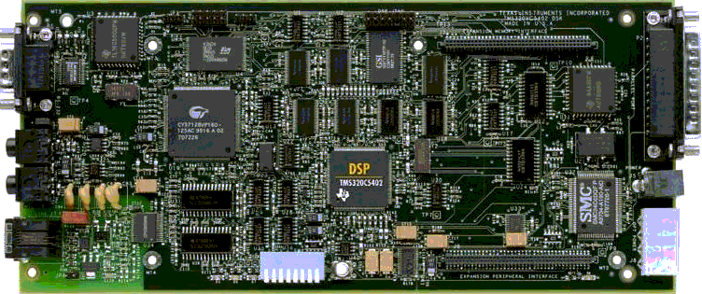

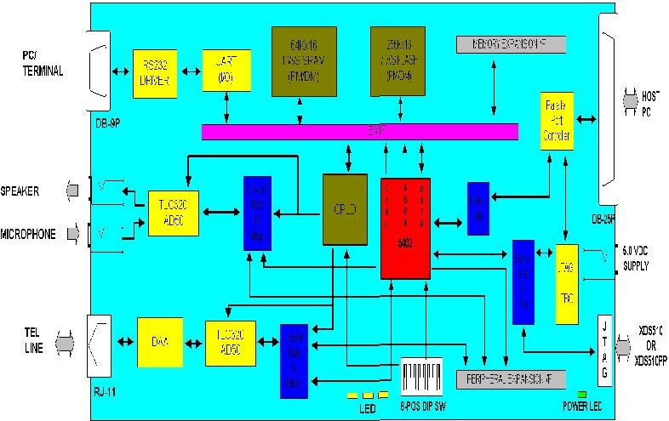
TMS320C5402 DSK Help (SPRH075A) Copyright© 1998-1999 Texas Instruments

Peripheral Interface.
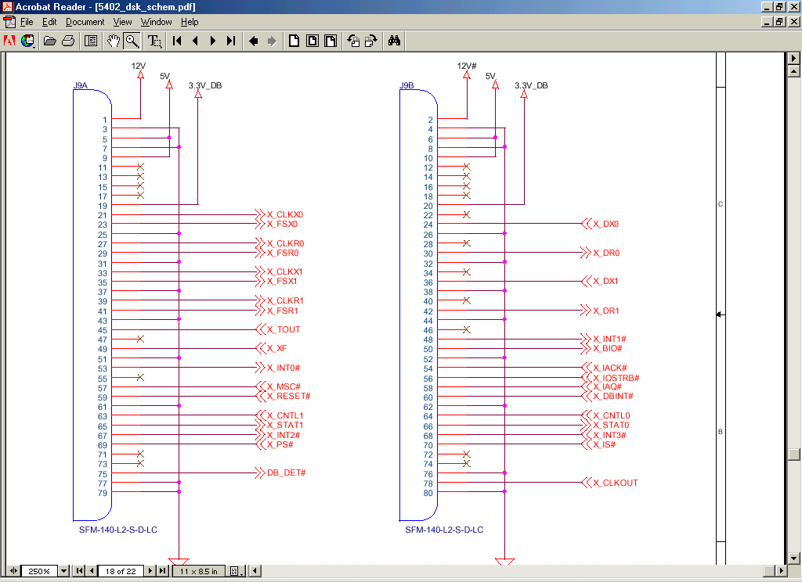

J8Pin# Signal Name Type J8Pin# Signal Name Type
1 +12V O 2 +12V O
3 GND - 4 GND -
5 +5V O 6 +5V O
7 GND - 8 GND -
9 +5V O 10 +5V O
11 SPARE (N/C) - 12 SPARE (N/C) -
13 SPARE (N/C) - 14 SPARE (N/C) -
15 SPARE (N/C) - 16 SPARE (N/C) -
17 SPARE (N/C) - 18 SPARE (N/C) -
19 +3.3V O 20 +3.3V O
21 X_CLKX0 I/O/Z 22 SPARE (N/C) -
23 X_FSX0 I/O/Z 24 X_DX0 O
25 GND - 26 GND -
27 X_CLKR- I/O/Z 28 SPARE (N/C) -
29 X_FSR0 I/O/Z 30 X_DR0 I
31 GND - 32 GND -
33 X_CLKX1 I/O/Z 34 SPARE (N/C) -
35 X_FSX1 I/O/Z 36 X_DX1 O
37 GND - 38 GND -
39 X_CLKR1 I/O/Z 40 SPARE (N/C) -
41 X_FSR1 I/O/Z 42 X_DR1 I
43 GND - 44 GND -
45 X_TOUT O 46 SPARE (N/C) -
47 SPARE (N/C) - 48 X_INT1# I
49 X_XF O 50 X_BIO# I
51 GND - 52 GND -
53 X_INT0# I 54 X_IACK# O
55 SPARE (N/C) O 56 X_IOSTRB# O
57 X_MSC# O 58 X_IAQ# O
59 X_RESET# O 60 X_DBINT# O
61 GND - 62 GND -
63 X_DNTL1 O 64 X_CNTL0 O
65 X_STAT1 I 66 X_STAT0 I
67 X_INT2# I 68 X_INT3# I
69 X_PS# O 70 X_IS# O
71 SPARE (N/C) O 72 SPARE (N/C) -
73 SPARE (N/C) O 74 SPARE (N/C) -
75 DB_DET# I 76 GND -
77 GND - 78 X_CLKOUT O
79 GND - 80 GND I

TMS320C5402 DSK Help (SPRH075A) Copyright© 1998-1999 Texas Instruments

What does n/c mean?

The expansion peripheral interface provides the DSP’s peripheral signals to a daughterboard. This peripheral expansion capability allows serial devices (such as other codecs and communication devices) to be added to the DSK via a daughterboard.

The expansion peripheral interface includes:

· Six signals for each of the serial ports - The DSP's six McBSP signals for McBSP0 and McBSP1 are available on the expansion peripheral interface. These signals are buffered on the DSK to support both 5-V and 3.3-V serial devices. Each McBSP has CLKX, FSX, DX, XLKR, FSR and DR signals.

· Timer output signal - The DSP's timer output signal, TOUT, is available on the expansion peripheral interface.

· Interrupts and interrupt acknowledge - Four external DSP interrupts (INT0#, INT1#, INT2#, and INT3#), a DSP-to-daughterboard interrupt (X_DBINT#), and the DSP's interrupt acknowledge (IACK#) are available on the expansion peripheral interface.

· DSP general-purpose I/O signals - The DSP's XF and BIO# signals are available on the expansion peripheral connector.

· Three asynchronous memory control signals. Asynchronous memory control signals that are from the DSP are available on the expansion memory interface. The signals include X_PS#, X_IS#, and X_IOSTRB#.

· Reset signal - The expansion peripheral interface also provides a reset signal that is active low when the board is in the reset state. This allows the circuitry on the daughterboard to be set to a known state. The reset signal is asserted for a minimum of 140 milliseconds upon power-up, via a manual reset push button or under software control. A CPLD register bit (DB_RST) allows DSP software to directly control this reset signal when the DSP is not held in reset.

· CLKOUT/2 signal for the synchronization clock - The DSP's CLKOUT is divided-by-two and is brought out to the expansion peripheral interface for synchronization needs on daughterboards.

· Daughterboard detect - Pin 75 on the expansion peripheral connector should be grounded on the daughterboard to indicate that the daughterboard is present.

· Two miscellaneous signals - The DSP's MSC# and IAQ# signals are also provided on the expansion peripheral interface.

· Power signals - The expansion peripheral interface also provides ground, 12V, -12V, 5V, and 3.3V power signals to the daughterboard.

TMS320C5402 DSK Help (SPRH075A) Copyright© 1998-1999 Texas Instruments

