A Portable Device for the Translation of Braille to Literary Text

Roughly 324 000 Australians (or 1.8 % of the population (Australian Bureau of Statistics 1998)) suffer from vision impairment, many of whom must rely on embossed braille as a means for written communication. The objective of the device developed in this project is to provide a written communications gateway between visually impaired, braille literate persons, and the seeing, braille illiterate social majority. This is achieved by providing seeing, braille illiterate persons with a portable handheld scanner which rolls over braille medium and in real time translates the equivalent literary text for output to a LCD display, text to speech converter etc depending on the application. The device will also allow blind persons who exhibit Diabetic Peripheral Polyneuropathy (diabetes is the major cause of blindness in Australia) and have lost sensitivity in their fingers, to still be able to communicate through their preferred written medium. The device differs from existing research in braille to text translation (no commercial products exist as yet) in that it is portable and translates braille to text in real time, which greatly increases its practical application in schooling and employment situations.
The developed handheld device uses a linear pixel array and camera assembly to optically detect the presence of embossed braille dots when rolled over the braille medium. In real time, fuzzy logic fundamentals then determine the position of braille dots within the braille cell from the camera output. This is accomplished using a Texas Instruments TMS320VC5402 digital signal processor, which subsequently converts the located braille dots into a computer braille code to be then translated, depending on braille type and the associated rules, into literary text
A device that rolls over embossed braille and converts the written medium into literary text in real time was successfully developed. Useability and accuracy were adequate as a prototype model and the device has potential for practical application when fully developed.

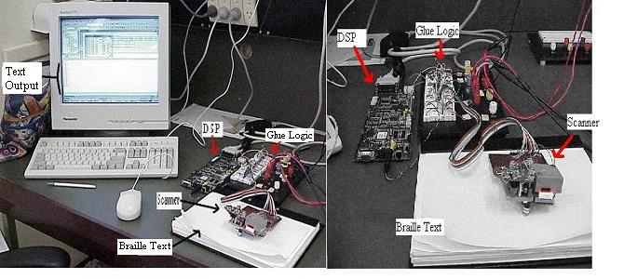
Figure 1: The Prototype System
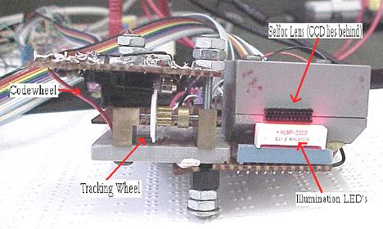
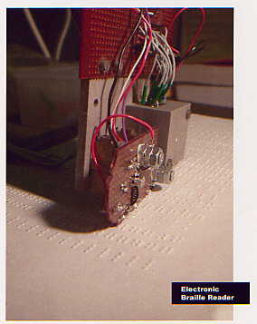
Figure 2: The scanner prototype, in operation and close up view.

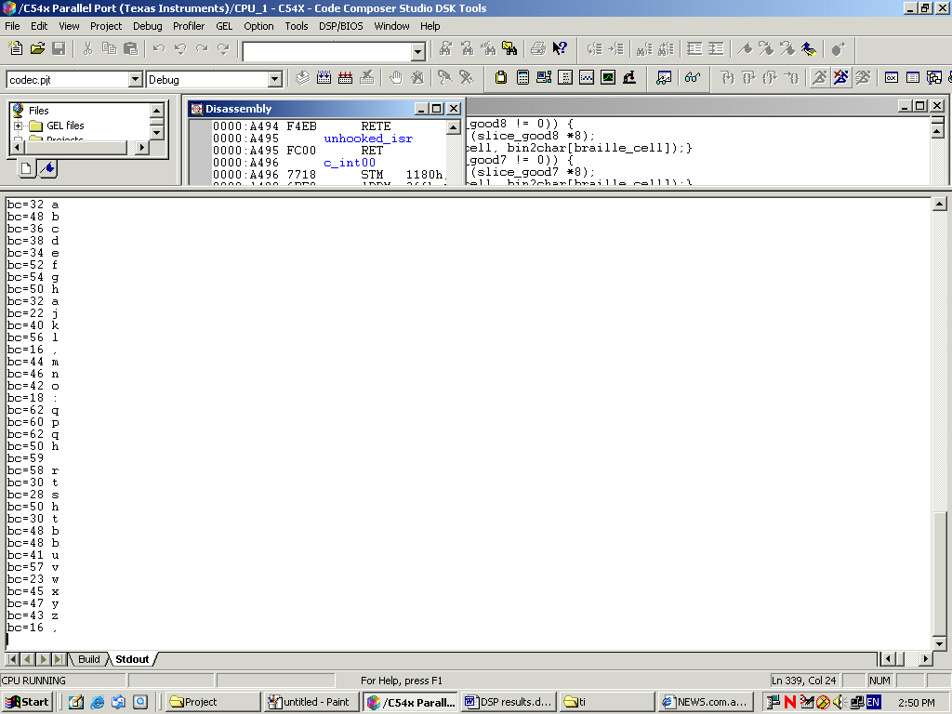
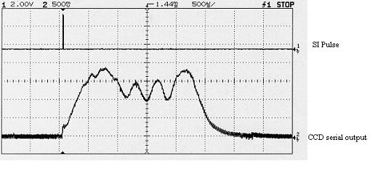
Figure 3: Oscilloscope display of linear pixel array (ccd) output of three braille dot shadows
Figure 4: Prototype system output of braille alphabet scan

Currently the translated braille text is output in real time to a host computer for display . When developed however, the output can be displayed on a LCD or spoken through a text to speech converter (depending on the specific application), allowing the system to be truly portable.
The accuracy of the device also at present is limited to about 80 % by the fact that the scanner rests on one tracking wheel in its prototype state. This causes great difficulty in keeping the scanner on the braille line and roughly straight, and stretches the abilities of the scanner misalignment software correction techniques (100 % correct operation does exists when scanned correctly). Once developed, with a stable four-wheel tracking system the device should be of practical application.
The basic scanner ideology and applications were of my academic supervisor, Iain Murray’s invention. Assistance from himself and my college was always available in the event of any problems. Clive Maynard (Department Head of Computer Systems Engineering at Curtin University) and Iain Murray, who works in concert with the Blind Association of Western Australia, should also be contacted for knowledgable details and comments on the device.

Contact Details

Clive Maynard :
Location: Building 207:121, Curtin University of Western Australia, GPO Box U1987, Perth WA 6845
Telephone: +618 9266 7905
Facsimile: +618 9266 2584
E-mail: c.maynard@ece.curtin.edu.au]

Iain Murray :
Location: Building 207:324, Curtin University of Western Australia, GPO Box U1987, Perth WA 6845
Telephone: +618 9266 4540
Facsimile: +618 9266 2584
E-mail: i.murray@ece.curtin.edu.au

