Sample data for 3 dots (shadows) #1
Matlab input;
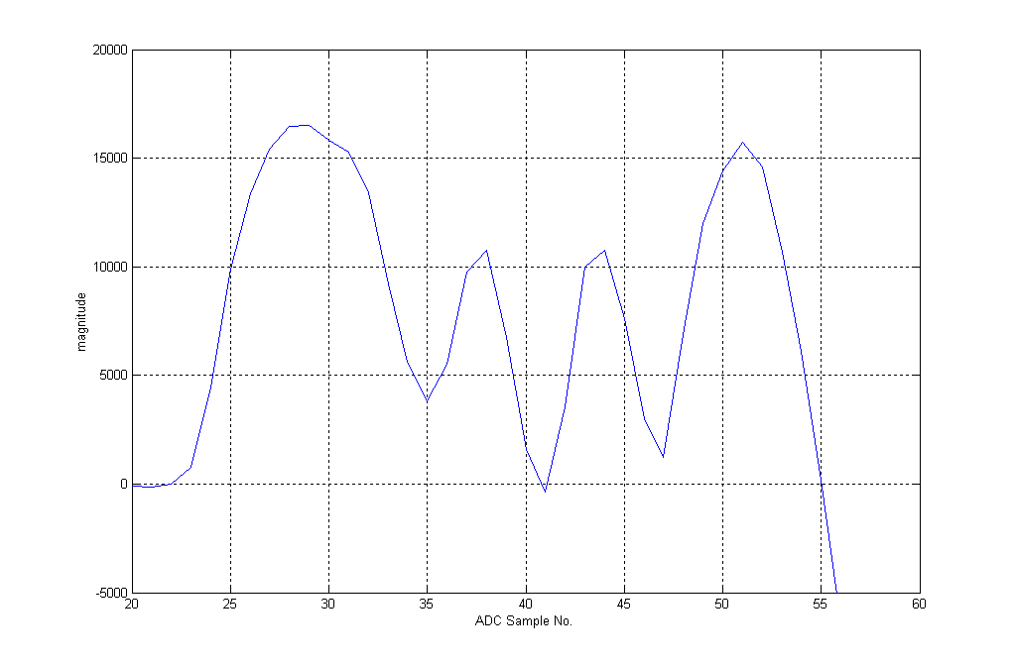
Figure X: DSP samples of ccd output representing 3 dots (shadows), SI driven
Sample data for 3 dots (shadows) #2
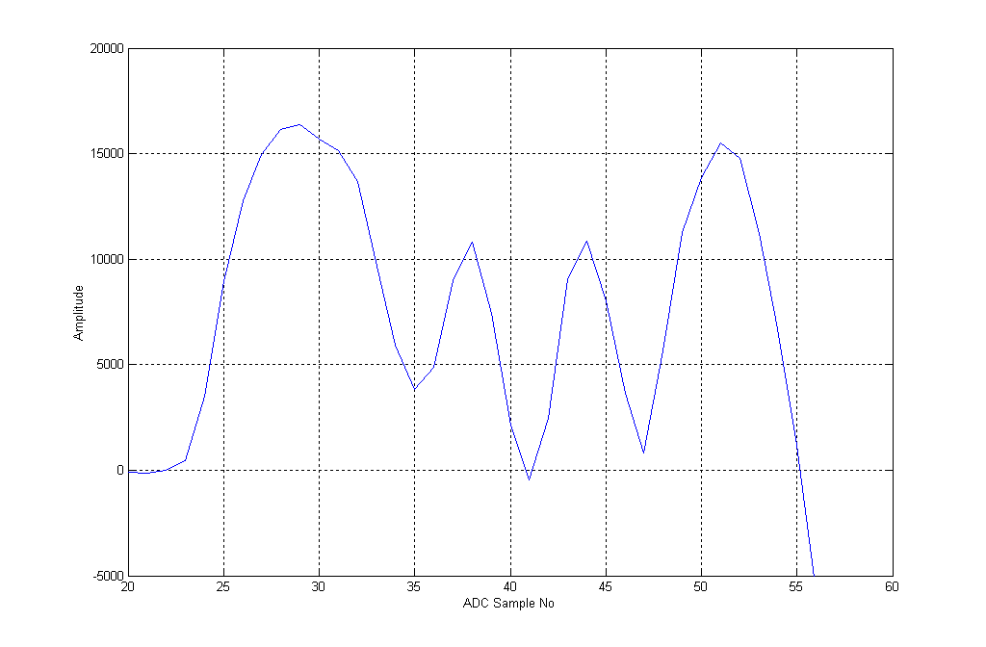

Figure X: DSP samples of ccd output representing 3 dots (shadows), SI driven,
Figure X: DSP samples of ccd output representing 2 dots (shadows)
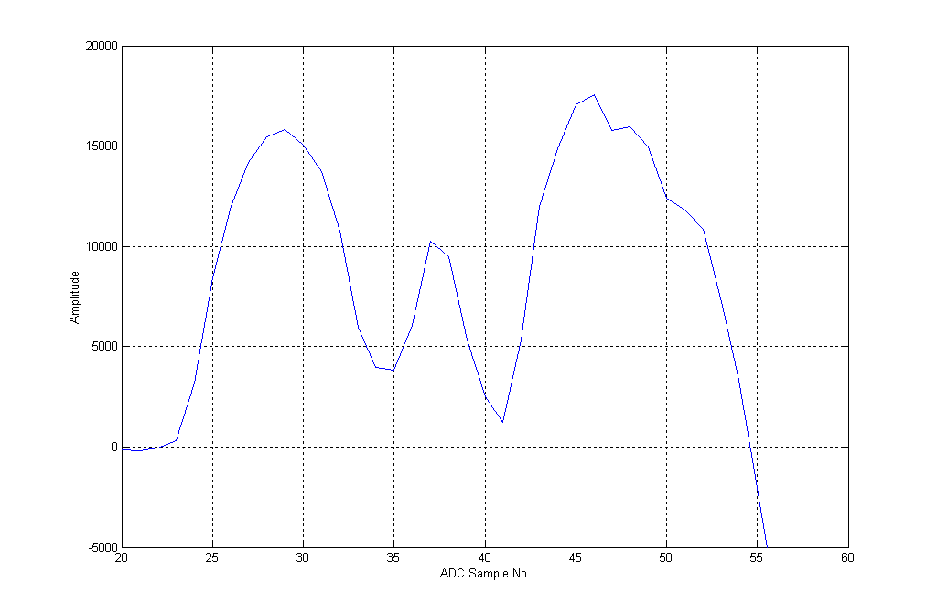
Figure X: DSP samples of ccd output representing 1-0-1dots (shadows)

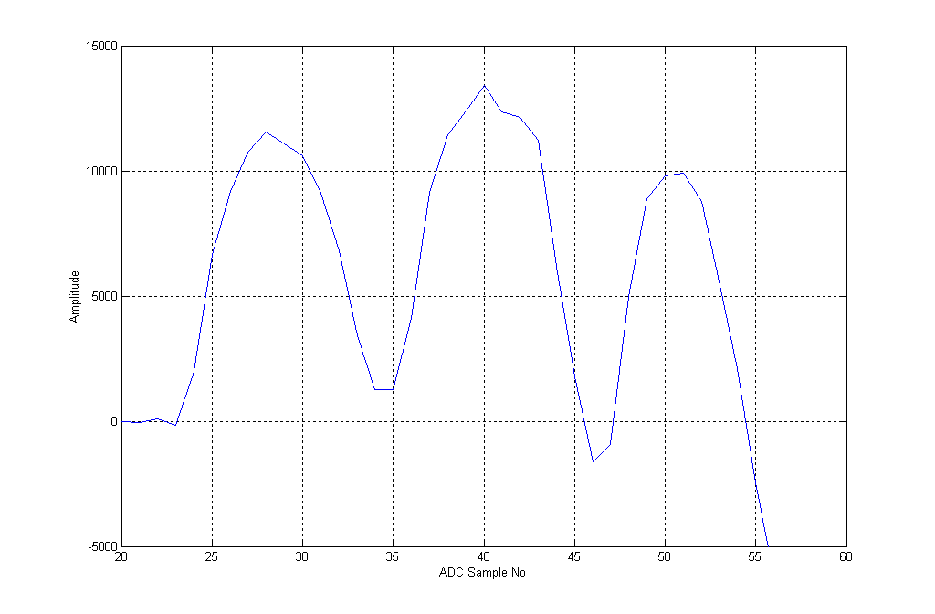
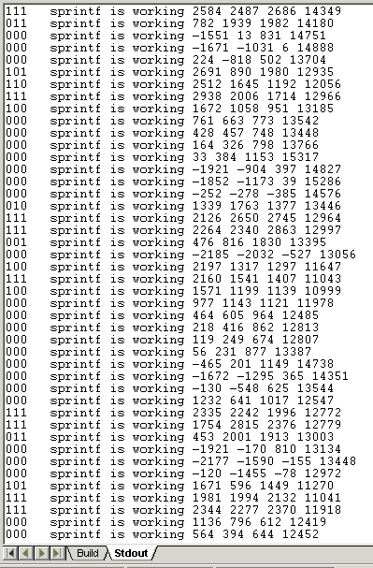
Figure X: a line of 3 dot’s (1-1-1-1-1-1) as seen by the dsp

Notice that dots within a braille cell are only 5-7 slices apart (depending on codewheel interrupt timing with respect to braille dots on page). Braille between braille cells are 10-11 slices apart . This coincides with braille print where dots within a braille cell are 2mm apart, and dots between braille cell are at least 4mm apart. This difference allows for dots within a braille cell to be associated with each other and dots from different braille cells to be determined separate.

Braille Misalignment Technique Failure with ‘ \n ’
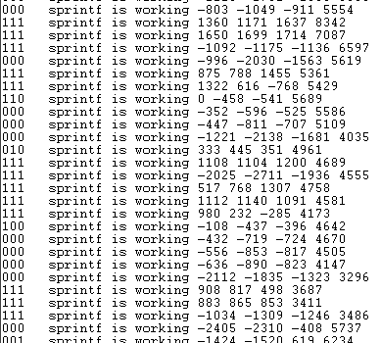
Figure X: Why multiple samples cannot correct vertical misalignment., (1-1-1-1-1-1)

Notice that in the 1-1-1-1-1-1 cell for the slices around the middle, how the 3 dots for the first side of the Braille cell is interfering with the computation of the second 3 dots with the “compensation for misalignment technique” following,

“if ((dot1 == 1) || (dot1_old1 == 1)) {dot1 = 1;}
if ((dot2 == 2) || (dot2_old1 == 1)) {dot2 = 1;}
if ((dot3 == 1) || (dot3_old1 == 1)) {dot3 = 1;}

dot1_old1 = dot1_new; //to fix vertical misaligment of braille dots, make
dot2_old1 = dot2_new; //determined slice a culmination of a few horizontal slices
dot3_old1 = dot3_new;”

This is due to the fact that the ‘ \n’ (new line command) used in the original text takes (for unknown reasons) a lot of processing and communication cycles, which slowed the DSP program enormously. Reducing the number of new line commands greatly increased program speed of operation and allowed many more slices that were present to be actually processed, as seen below there is now sufficient gaps between the dots in a Braille cell to compensated for vertical misalignment, as seen below
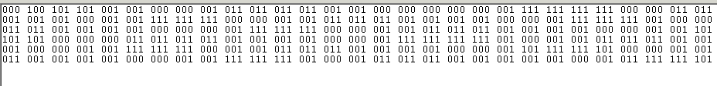 Figure X: 1-1-1-0-1-1 cell with vertical misalignment correction
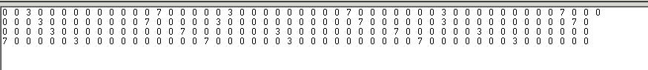 Figure X: 1-1-1-0-1-1 cell with vertical misalignment correction

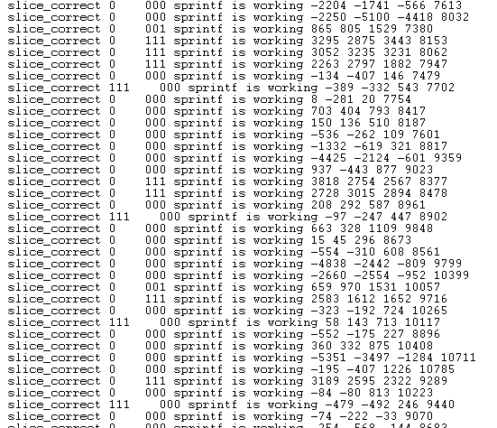
Figure X: “Get only one correct slice” procedure proof of operation

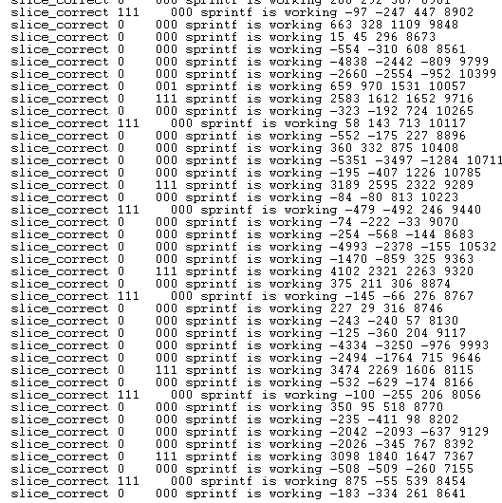 Figure X: Slices’s between 1-1-1-0-0-0 cell

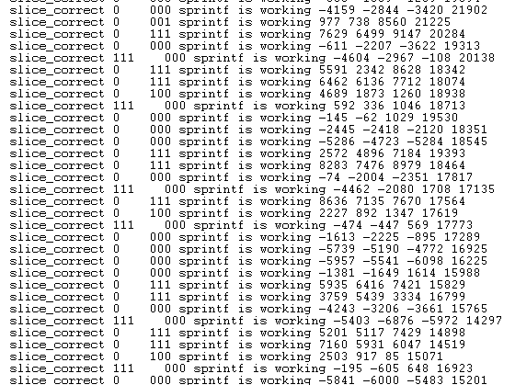
Figure X: Slices between a 1-1-1-1-1-1 cell
From the results it can be concluded that dots on either side of a Braille cell are at most 4 slices apart. Slices from different Braille cells are at least 6 slices apart. Hence distinction can be mad for different Braille cells.

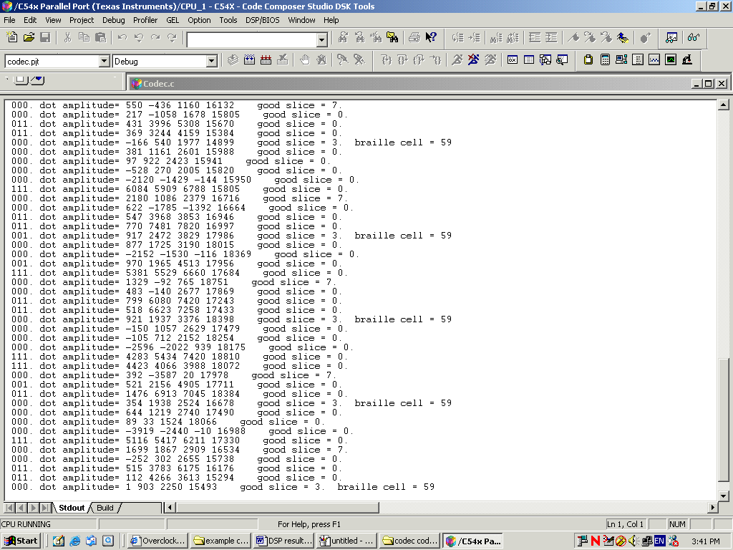
Figure X: determining a 1-1-1-0-1-1 braille cell (59 = 0x3B = 111011 binary)
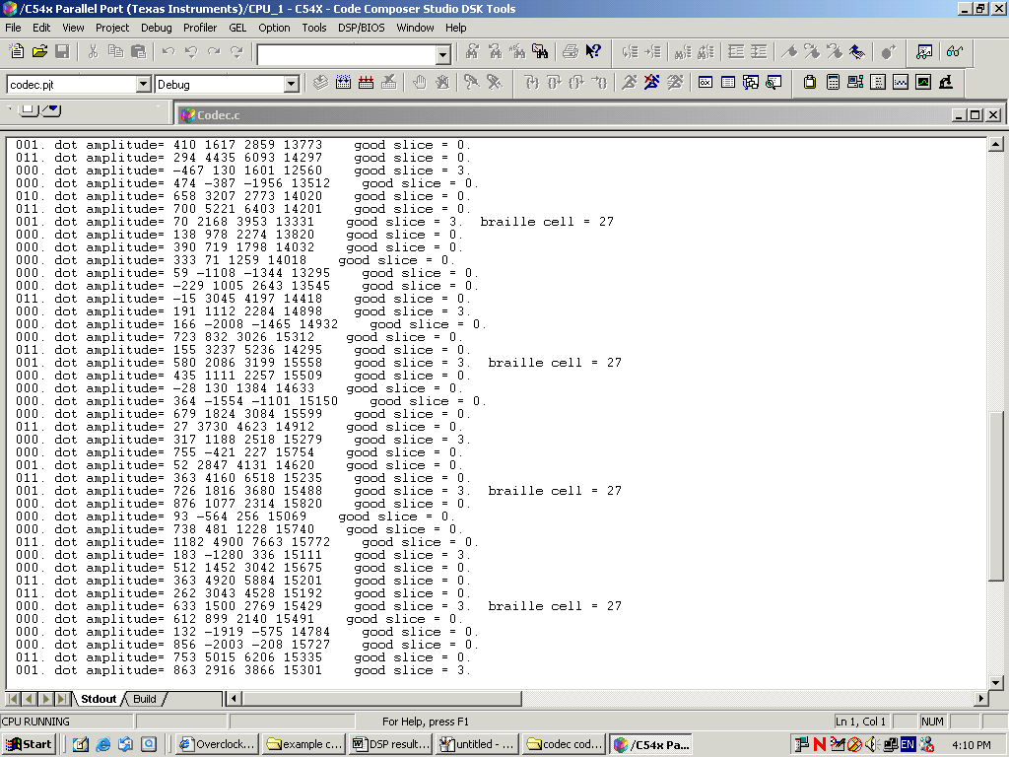
Figure X: determining a 0-1-1-0-1-1 braille cell (27 = 0x1B = 011011 binary)
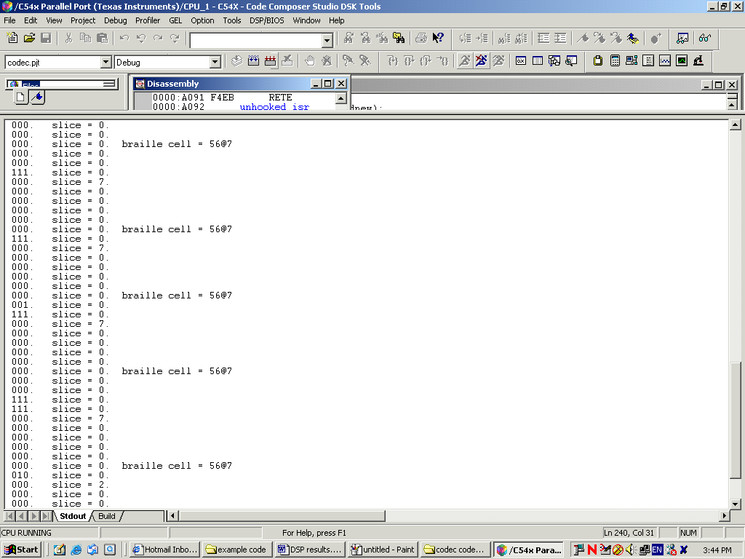
Figure X: single sided Braille determination proof of operation

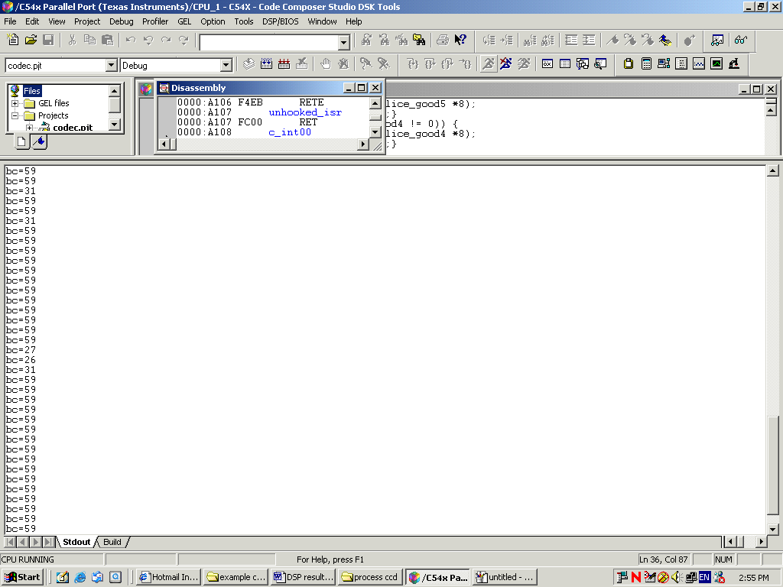
Figure X: System1-1-1-0-1-1 cell correctness accuracy (repeated)
In the line of 1-1-1-0-1-1 (=59) characters 32 were found correctly, while 5 were incorrectly. Gives 85% accuracy.
Decimal  (* = single sided) | Braille Dots | Grade 2 Literary Braille meaning | North American ASCII equivalent
0 | 000 000 | space
1* | 000 001 | capital indicator, prefix for certain contractions | ,
2* | 000 010 | prefix for certain contractions | “
3* | 000 011 | letter indicator, prefix for certain contractions | ;
4* | 000 100 | accent indicator | @
5* | 000 101 | decimal point, emphasis indicator, prefix for certain contractions | .
6* | 000 110 | prefix for certain contractions | ^
7* | 000 111 | prefix for certain contraction | _
8* | 001 000 | apostrophe (') | ‘
9 | 001 001 | hyphen (-), contraction "com" | -
10 | 001 010 | contraction "in" | 9
11 | 001 011 | closing quote, contraction "was" | 0
12 | 001 100 | slash (/), contraction "st" | /
13 | 001 101 | contraction "ing" | +
14 | 001 110 | contraction "ar" | >
15 | 001 111 | numeric indicator, contraction "ble" | #
16* | 010 000 | comma (,), contraction "ea" | 1
17 | 010 001 | contraction "en" | 5
18 | 010 010 | colon (:), contraction "cc" | 3
19 | 010 011 | period (.), contraction "dis" | 4
20 | 010 100 | i, 9 | i
21 | 010 101 | contraction "ow" | [
22 | 010 110 | j, 0, contraction "just" | j
23 | 010 111 | w, contraction "will" | w
24* | 011 000 | semicolon (;), contraction "bb" | 2
25 | 011 001 | opening quote, contraction "his" | 8
26 | 011 010 | exclamation (!), contraction "to" | 6
27 | 011 011 | opening or closing round parenthesis, contraction "gg" | 7
28 | 011 100 | s, contraction "so" | s
29 | 011 101 | contraction "the" | !
30 | 011 110 | t, contraction "that" | t
31 | 011 111 | contraction "with" | )
32* | 100 000 | letter a, digit 1 | a
33 | 100 001 | contraction "ch" | *
34 | 100 010 | e, 5, contraction "every" | e
35 | 100 011 | contraction "wh" | :
36 | 100 100 | c, 3, contraction "can" | c
37 | 100 101 | contraction "sh" | %
38 | 100 110 | d, 4, contraction "do" | d
39 | 100 111 | contraction "th" | ?
40* | 101 000 | k, contraction "knowledge" | k
41 | 101 001 | u, contraction "us" | u
42 | 101 010 | o | o
43 | 101 011 | z, contraction "as" | z
44 | 101 100 | m, contraction "more" | m
45 | 101 101 | x, contraction "it" | x
46 | 101 110 | n, contraction "not" | n
47 | 101 111 | y, contraction "you" | y
48* | 110 000 | b, 2, contraction "but" | b
49 | 110 001 | contraction "gh" | <
50 | 110 010 | h, 8, contraction "have" | h
51 | 110 011 | contraction "ou" | \
52 | 110 100 | f, 6, contraction "from" | f
53 | 110 101 | contraction "ed" | $
54 | 110 110 | g, 7, contraction "go" | g
55 | 110 111 | contraction "er" | ]
56* | 111 000 | l, contraction "like | l
57 | 111 001 | v, contraction "very" | v
58 | 111 010 | r, contraction "rather" | r
59 | 111 011 | contraction "of" | (
60 | 111 100 | p, contraction "people" | p
61 | 111 101 | contraction "and" | &
62 | 111 110 | q, contraction "quite" | q
63 | 111 111 | contraction "for" | =
Braille Table: Binary code to text

Simplified Rules : For single sided cell to text determination
switch(bin2char)
{
case 1@4: //is either a(1) or accent indicator
{
break;
}

case 2@5: //is either comma (“ea”) or prefix
{
if (is inbetween letter and space) { //is comma}
break;
}
case 3@6: // apostrophe or capital indicator
{
if (is inbetween two letters) { //is apostrophe}
if (is inbetween space and letter ) { //is capital indicator}
break;
}

case 48@6: //(1-2/4-5) is b(2) or prefix
{

break;
}

case 40@5: //(1-3/4-6) is k or decimal point
{
if (is not between 2 numbers) { //is k}
if (is between 2 numbers) { //is decimal point}
break;
}
case 24@3: //(2-3/5-6) is semicolon or letter indicator
{
if (is between letter and space) { //is semicolon}
if () { //letter indicator}
break;
}
case 56@7: //(1-2-3/4-5-6) is l or prefix
{
if () { //is }
if () { //is }
break;
}

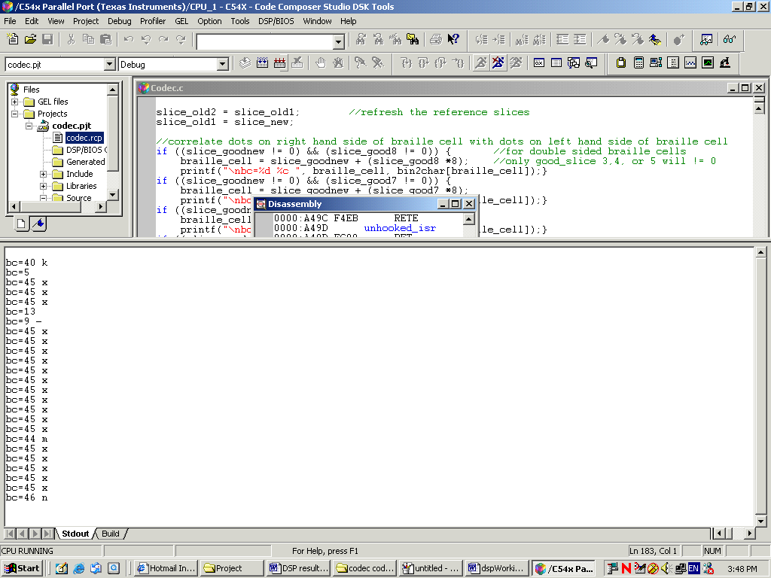
Figure X: proof of operation
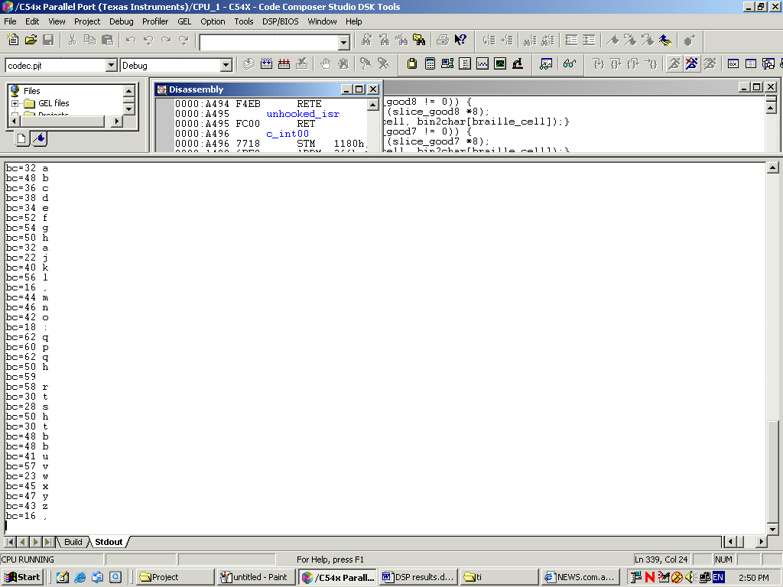
Figure X: Alphabet recognition
Recognised 21 out of 26 letters in one hit, giving 80.7% accuracy. Totally independent of hand jitter.

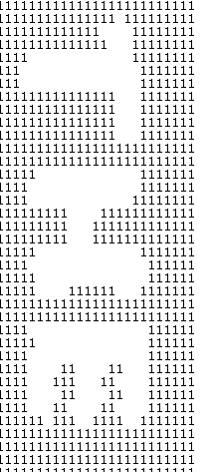
Figure X: text reader ccd , proof of operation

