A Secure Dual Channel Wireless Headset for Multi-User Environments

Summary of Proposed Research Program

1. Abstract

This summary outlines the structure of a research project for a Doctor of Philosophy Degree. The objective of the research is to investigate, design, construct, and test a Secure Dual Channel Wireless Headset for Multi-User Environments that will increase labor market opportunities for people blind or vision impaired. The project is part of a collaborative effort between the Association for the Blind of Western Australia (ABWA), Elearn.WA, RAC and Curtin University.
A study conducted by the West Australian Department of Training found that Vision Impaired Persons (VIP’s) are particularly suited to employment in call center environments, and make reliable, and committed employees (Department of Training (2002)). However, VIP’s have prevailing difficulties (due to their condition) with audio headsets cables due to entanglement and cable jack damage.
The research engaged in this project will investigate the development of a secure, dual channel wireless headset for multi-user environments, not currently available on the commercial market, to alleviate these problems and ultimately improve employment opportunities for persons with vision impairment.
A dual channel headset system is required for vision impaired persons (VIP’s) in call centre applications so that they may receive voice output from screen reading software for computer interaction on one channel, and a telephone output for human interaction on the other. The secure dual channel wireless headset will also have application for persons not suffering visual disabilities, both in call centres and in the defence forces.

2. Objectives

The aim of this project is to research relevant technologies related to the design of a wireless headset for multi-user environments and subsequently develop working prototype’s that fulfil the following criteria:
  - Duplex communications with high quality, real time dual channel audio
    - Stereo Headphones input, microphone output
  - Secure communications between base and headset
    - Call centres often deal with sensitive information such as credit card number’s, personal information, defence etc
  - Robust operation in environments with a large number of users
    - The RAC Joondalup call centre, one of the sponsor’s of the project, has over 300 employees
  - System flexibility for security, communications medium upgrades
    - The system must be able accommodate onboard software upgrades for protocol, encryption updates.
    - The system must be able to accommodate hardware upgrades, in line with developments in the communications field.
  - Ergonomic Operation
    - light weight (subject to regulations)
    - low power for full day (> 8 hours) operation on single battery charge
      - a battery mAh/weight compromise that can only be overcome by minimising power consumption
    - small form
  - Economically feasible development and per unit cost
3. Background

The literature review for this project required investigation into communication mediums for wireless data transfer and signal processing architectures. Once completed, the development of a proof of concept prototype and infrared-audio communications protocol was undertaken. A method of providing “Practically Un-Crackable” encryption to infrared and other line of sight communication mediums was also identified.

3.1Communications Medium

Two communications mediums were identified that could possibly satisfy the project criteria: radio frequencies (RF) in the unlicensed range of 2 to 5 GHz and infrared light.

3.1.1
RF / 802.1x

The most obvious choice identified for a RF wireless protocol was the IEEE 802.1x standard due to its large industry support and market acceptance. The suitability of 802.1x is described following.
The highest bandwidth supported by any of the 802.1x standards is 54 Mbps, or roughly 22 Mbps in practice due to protocol overhead. Now considering there are 300 employee’s in the RAC call center, each requiring 3 channels (stereo headphone and microphone return), only 24.4 Kbps (22Mbps / 300*3) is therefore available for each audio channel. Speech compression algorithms do exist that will transfer voice quality audio at this rate, however they require a constant, error free bit stream, which due to the lack of QoS protocols in 802.1x, cannot be assured. (the greater the speech compression, the less robust the algorithm). Thus correct operation of current 802.1x protocols in a call center environment cannot be guaranteed. There are 802.1x standards, such as 802.15.3, that do support QoS, but they are yet to be published.
RF signals, in the 2 to 5 GHz license free frequencies, are characterized by long-range signal propagation (>100m) and boundary penetration (i.e. walls and ceilings). These characteristics allow for unknown parties to discretely eavesdrop on the signal, causing grave security concerns for institutions such as banks, governments, defense forces etc (Xydis and Wilson, 2002). Standard encryption protocols can be implemented, such as AES, that may provide enough security for most environments, however they are suitable for unclassified data only.(Nist, 2000) For situations however where absolute security is required, a One-Time-Pad System would need to be implemented(Spectrum IEEE, 2003). One-Time-Pad systems use a stored key cipher that can be used only once, and whose length is as long as the data to be transmitted. Thus for a full day’s operation with at an audio rate of 40 Kbps (G.726 standard), the One-Time-Pad solution would require a headset with at least,
, 40_{Kbps} x 3_{channels} x 60_{seconds} x 60_{minutes} x 8_{hours} = 3.456 Gb or 432 MB
, of memory. 4Gb flash memories are available but they are quite expensive, i.e. > $159 US, Sandisk. The base station, which can serve up to 256 users, would also require at least,
, 40_{Kbps} x 3_{channels} x 60_{seconds} x 60_{minutes} x 8_{hours} x 256_{users} = 110.5 GB
, of storage space.

3.1.2 Infrared Communications

The Infrared Data Association (IrDA) specifies a infrared communications standard that allows 4Mbps bandwidth on a 300GHz low power signal that does not propagate more than 2m in a 30 degree cone path. These characteristics serve to make infrared particularly suited to the call center environment for the following reasons (Refer to Figure 1).
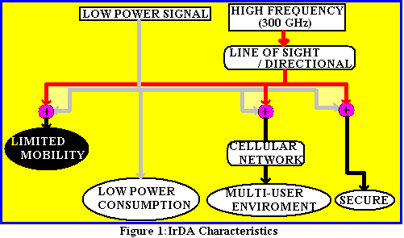
  - Because of the low power signal, infrared transmissions inherently use very little power.
  - 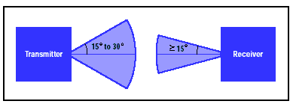The high frequency (300 GHz) of infrared communications prevents significant diffusion (does not bend around corners) and allows it to be easily blocked by walls (line of sight). Combined with the low power of transmission, infrared becomes a inherently very secure communications medium since the signal is confined to its enclosure (i.e. the wall boundary of the call center). Thus anyone not inside the enclosure has no access to the signal.
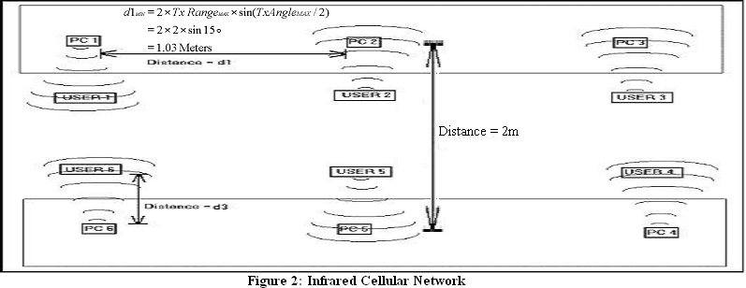
  - Due to the fact that the infrared signal does not propagate more than about 2 meters, and is blocked by boundaries, infrared ideally suits itself to be used as a cellular network (see figure 2). Thus the issue of throughput in multi-user environments is avoided since each user has their own cell, and no sharing of bandwidth is required.
However due to the to short propagation distance and line of sight characteristics, infrared does place limits on user mobility, i.e. they cannot venture more than 2m from the base or turn around, and continue to communicate.
The infrared system will also be more expensive than a respective RF headset, besides the fact that infrared chipsets are considerably cheaper than RF chipsets. This is due to the fact that in the RF system, one base station may serve up to 256 headsets, while for infrared there must be one base station per headset.

3.1.3 Research Conclusions

The communications research undertaken found that the 802.15.3 protocol will provide the ideal medium for a call centre wireless headset due to the roaming ability provided to user, and potentially the lesser cost. However it is not yet published.
The infrared medium was found to be less ergonomic than RF due to the user mobility restriction. However, infrared is inherently secure, can provide robust operation in multi-user environments, exhibits very low power consumption, and at this time is the only medium that satisfies the wireless headset requirements. Hence IR was subsequently chosen as the communications method for this project.

3.2 Signal Processing Architecture

The overlying controller system required for the wireless headset must handle the base-headset communications (including encryption/decryption, data encoding/decoding and error detection) and perform the audio sampling and playback. While performing theses tasks the controller system must have consume very little power, be reasonably cheap, and have the flexibility to accommodate future communications upgrades (i.e. computational redundancy).
After researching potential architecture’s, a Texas Instruments C55xx Digital Signal Processor was chosen for its high suitability in performing audio communications. Described following are some of its key features:
  - Low Cost ~ $8.85 US at 1KU
  - Low Power ~ 0.33mA/MHz
    - Highly Flexible Architecture for maximum energy efficiency, including
      - Dynamic CPU Voltage scaling, 0.9-1.6V
      - Dynamic CPU Frequency scaling, 6 to 300 MHz
      - Peripheral Powerdown control
  - 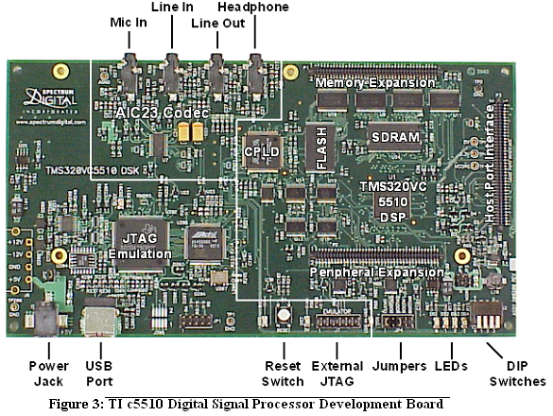Fast Development Cycle
    - Integrated Development Environment for real time, onboard configuration and test of DSP software and hardware
  - High Flexibility
    - JTAG interface allows onboard in-field reprogramming
  - High Performance: up to 300 MHz with pipelined architecture

3.4 Proof of Concept Prototype

As proof of concept for a infrared wireless headset, a dual channel, two-way, high quality audio prototype was developed (see figure 3). The prototype has been field tested by the ABWA and certified for call centre use.
The prototype uses all the low power features of the C55xx DSP, including dynamic frequency scaling (24 to 200 MHz), dynamic voltage scaling (1.1.to 1.6V) and threaded operation (to send the headset into sleep mode when it is idle) to minimise the power consumption of the system.
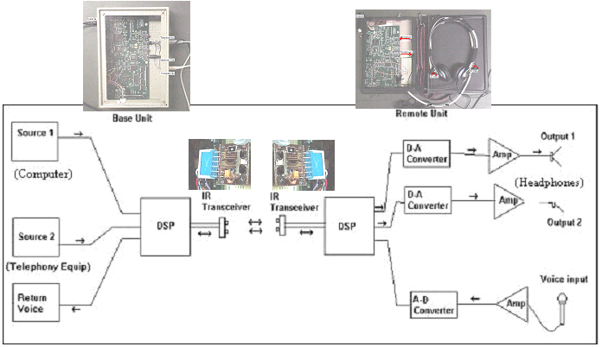
Figure 4: Infrared Headset Prototype block diagram and implementation.

In the development of the prototype, a need for a custom protocol for infrared audio communications was identified due to the inadequacies of the available IrDA standard. This is due to the fact that the IrDA protocols were tailored to deal with file transfer type communications and hence do not meet the real time requirements of interactive conversations.
Hence a protocol was developed which follows the IrDA physical layer, but has custom upper layers that suit real time audio communications. The protocol specifies a lossy type master / slave communication that satisfies the real time audio requirements and also results in reduced transmission power consumption and system memory requirements.

3.5 “Practically Un-Crackable Encryption” (PUE) Protocol

While the use of the infrared medium inherently provides very secure communications, it can be made vulnerable via a window which allows the IR signal to escape the confining environment. A potential eavesdropper could then use a telescope to focus in on a IR transceiver, and by placing their own IR transceiver on the telescope eyepiece would be able to pick up the communicated data.
To overcome this problem, encryption techniques were researched and evaluated, and a subsequent secure protocol based on the unique line of sight and low diffusion characteristics of infrared was identified. The protocol is based on a key self retrieval algorithm and is summarised as follows:
  - Initially,
    - The base station sends the headphones sample to the headset along with a key (keyA^{n}).
    - the headset then sends its microphone sample encrypted with keyA^{n} (sent by the base), along with it own key, keyB^{n} to the base.,
  - Then repetitively,
    - The base uses keyB^{n} to encrypt the headphones sample and sends it to the headset along with a new key, keyA^{n+1}, and decrypts the microphone sample sent by the headset with keyA^{n}.
    - The headset uses keyA^{n} to encrypt the microphone sample and sends it to the base along with a new key, keyB^{n+1}, and decrypts the headphone samples sent by the base with keyB^{n}.
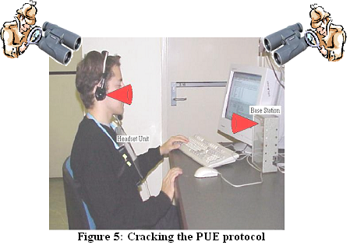Thus, if the keys are random numbers (i.e. generated randomly), then the only way a eavesdropper can interpret the communications is if they can view both the base and headset infrared signals. But due to the line of sight properties of IR and the 30° propagation path, this is practically impossible as the eavesdropper would need to be view both transceivers through window’s directly behind the user and computer at the same time (see figure 4). Within the call centre environment this is practically impossible, and thus there presents a method where uncrackable security within a call centre can be implemented.

The protocol does reduce the effective throughput of the IR transmission to 50% (since as many keys as audio samples are sent), but it does represent pseudo One-Time-Pad security without the memory cost and time window limitation inherent to a RF OTP implementation. Such a system novel attraction’s in that it has application for all IrDA (or line of sight) communications where security is paramount.

4. Significance

The significance of this thesis, can be described simply as follows:

  - The development of a Secure Dual Channel Wireless Headset design, not available commercially, will act as proof of concept for a wireless headset design that will increase labor market opportunities for people blind or vision impaired within call center environments.

  - The identification and development of a “Practically Un-Crackable Encryption” (PUE) protocol will provide security to communications of sensitive information with infrared (and other line sight) mediums.

5. Research Method

The research required of this project will be undertaken with the following methodology:

- Investigation of client requirements and subsequent specification development.
- Research necessary topics in wireless headset design to ensure fulfilment of required specifications. Topics for literature review include:
          - Communication Mediums
          - System and Signal Processing Architecture’s
          - Security
- Proof of Concept prototype design and development
- Prototype field testing and subsequent deficiencies noted or corrected.
- Stand Alone integrated system development (alpha version)
- Alpha System review and subsequent deficiencies noted or corrected.
- Release to Client
6. Ethical Issues

There are no foreseeable ethical issues that may be related to this project due to the research and/or development involved.

7. Facilities and Resources

Facilities Required
- Laboratory Room Access
  - Two PC’s (for simultaneous Base and Headset Development)
  - Oscilloscope Rack (ECE standard)
Resources Required
- Texas Instruments TMS320VC5510 DSK x 2
- Digital Signal Processor Emulator
- Code Composer Studio Software
- Protel PCB Design Software

8. Data Storage

Due to the development nature and subsequent commercial viability of the project, data pertaining to the thesis will be held at the School of Electrical and Computer Engineering and will be subject to limited access. For reference, the data will be available for a minimum of 5 years from the date of submission.
For backup purposes, the ECE departments Novell Server will be used to preserve data in case of accidental loss.

9. Time Line:

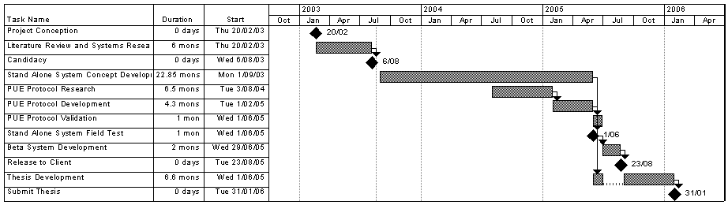

References:

- Infrared Data Association (2001), “Infrared Data Association Serial Infrared Physical Layer Specification”, Version 1.4, Infrared Data Association, California U.S.A

- McCullen Melanie (1992), Wireless Network Security, [Online], Network Magazine, http://www.networkmagazine.com/article/NMG20000724S0062

- Moran Joseph (2002), Wireless Home Networking, Part II - Wi-Fi Standards, [Online], http://www.80211-planet.com/tutorials/article.php/1495031,

- Xydis Thomas, Wilson Simon Blake (2002), “Security Comparison: BluetoothTM Communications vs. 802.11”, Bluetooth Security Experts Group

- Department of Training (2002), “Fund fosters Expertise through Innovation & Collaboration”, p6, Western Australia

- Spectrum IEEE (2003), “Making Unbreakable Code”, [Online], Available: http://www.spectrum.ieee.org/WEBONLY/publicfeature/may02/code.html, IEEE, New Jersey USA

- Ortiz, Luis (2001), “Solving QoS in VoIP: A Formula for Explosive Growth”, p3, Brookout Technology, Needham MA USA

- Infrared Data Association (2001), “Infrared Data Association Serial Infrared Physical Layer Specification”, Version 1.4, Infrared Data Association, California U.S.A

- Nist (2000), “Commerce Department Announces Winner of Global Information Security Competition”, [Online] Available: http://www.nist.gov/public_affairs/releases/g00-176.htm, NIST, MD USA

Illustrative References:

Figure 1: Andrew Pasquale (2003), Curtin University of Technology, Perth Western Australia

Figure 2: DallaVolta, Christopher Robert (2001), “Digital Audio Communications over an IrDA Link”, p12, Curtin University of Technology, Perth Western Australia

Figure 3: Texas Instruments (2002), “TMS320C55x Code Composer Studio Help (SPRH038C)”, Texas Instruments Incorporated, Texas USA

Figure 4: DallaVolta, Christopher Robert (2001), “Digital Audio Communications over an IrDA Link”, p64, Curtin University of Technology, Perth Western Australia

Figure 5: Andrew Pasquale (2003), Curtin University of Technology, Perth Western Australia

