Design Details: Secure Dual Channel Headset for Multi-User Environments

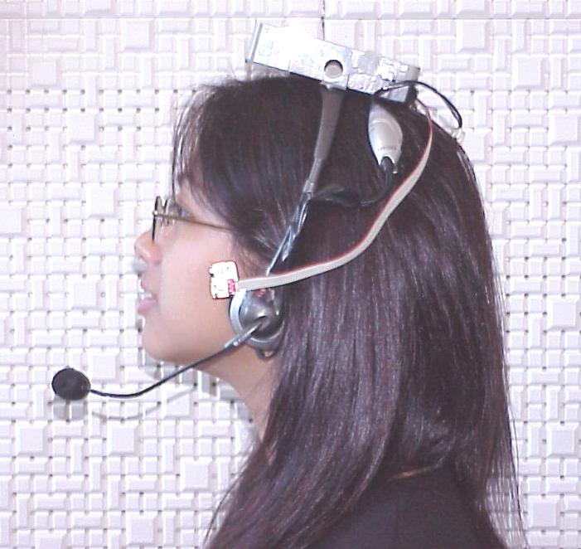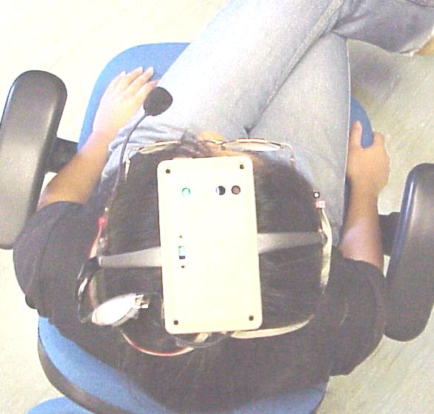
Figure 1: Prototype Headset in Use

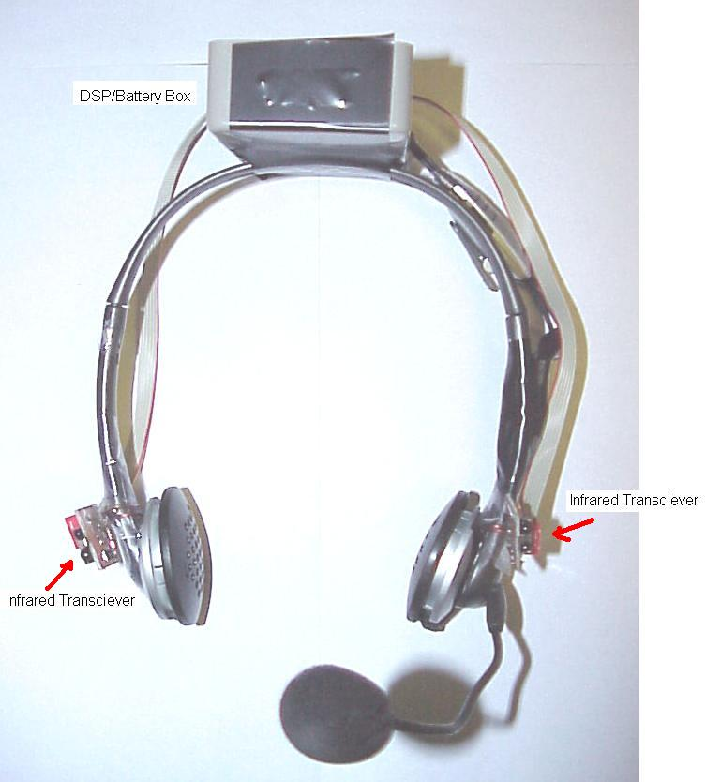

The DSP and battery box need not necessarily be located on the top of the headset band. Ie, DSP board could be located around left headphone and battery box located around right headphone.
Headset balance must be taken into account however.

Figure 2: Headset Frontal View

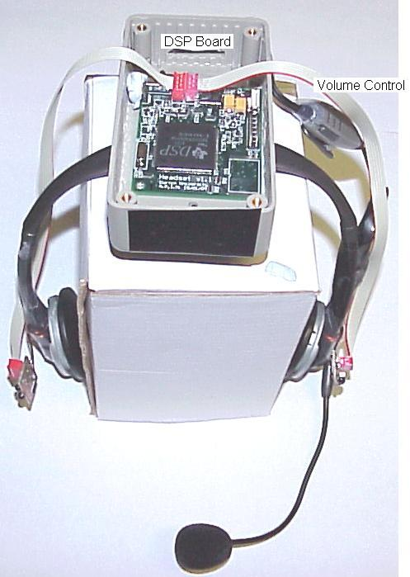

Figure 3: Headset Angled View

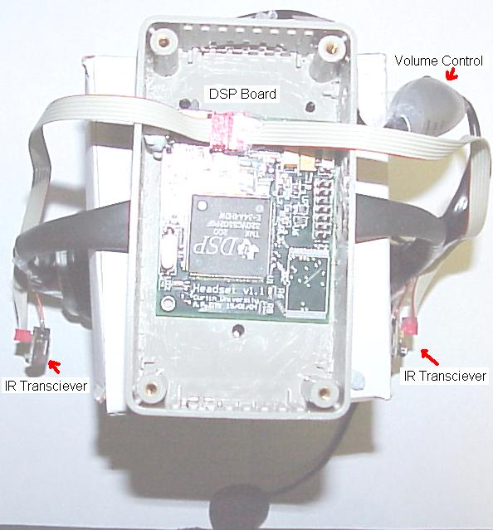

Quite clearly the DSP box is oversized for the current PCB board and can be reduced signifcantly.

Figure 4: Headset Top view
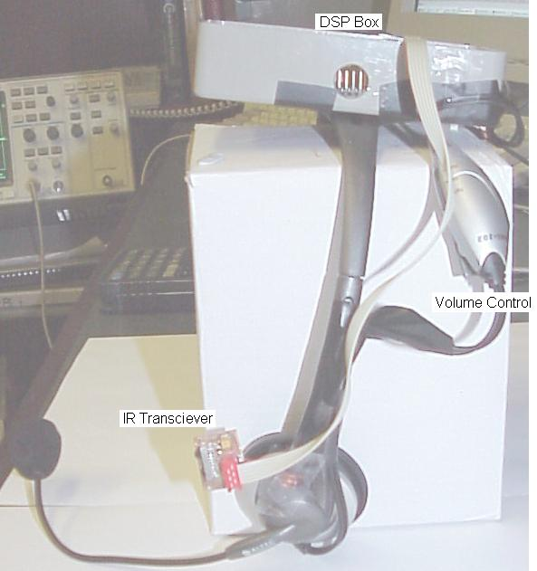
Figure 5: Headset Profile view

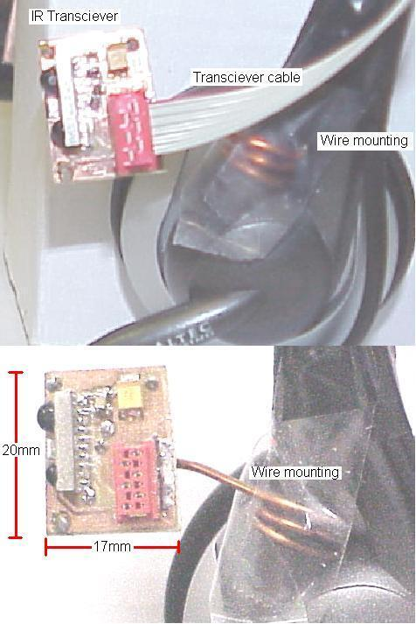

The Infrared transceiver’s must be located on pivoted supports so that the user may orientate the pointed direction as they see fit.
Required Axis:
Left Right: at least 120 degrees
Up Down: at least 90 degrees
Currently stiff wire provides the user with a method of adjusting the angle.

Figure 6: Infrared Transceiver Close up View
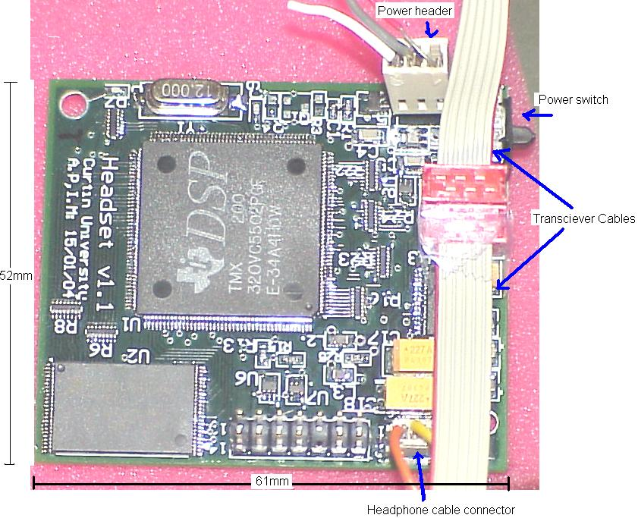

The transceiver cables are currently ribbon cable, but may be replaced with multiwire twisted pairs which should increase flexibility.

The Power switch is a 3 position sliding switch, ie Off, Low Power, High Power.

The Power header interfaces to the battery supply terminals. It will not be required in production versions as the battery wires can be simply soldered straight to the board.

Figure 7: DSP Board Close up Top View

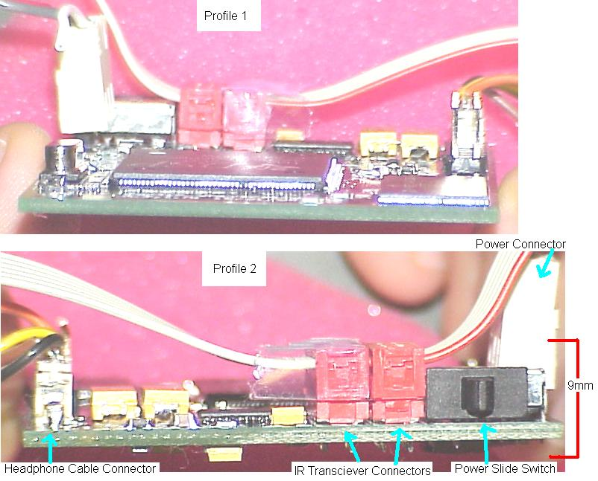
Figure 8: DSP Board Profile Views
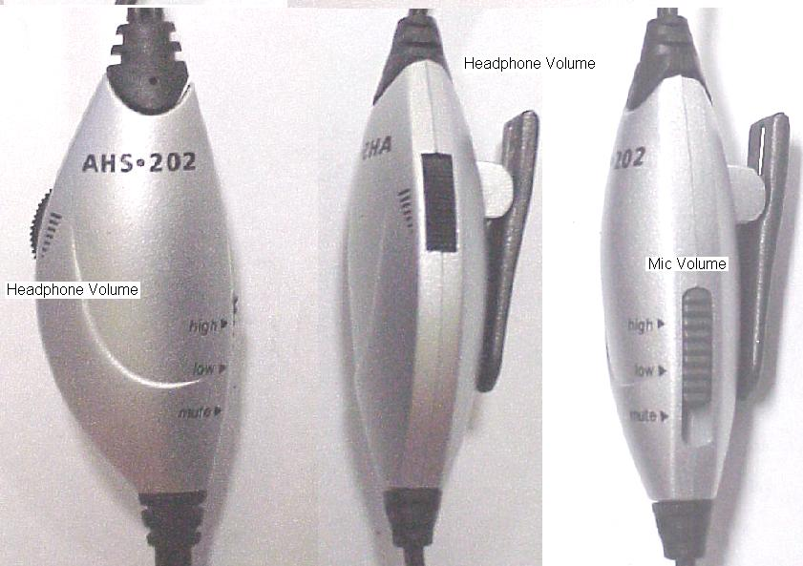

The current method of volume control comes from the control box supplied with the headphones. A custom control box or simple controls will be integrated into the commercial device. So details of the current box are not necessary, only the functional requirements,
Ie – Sliding volume control
- mic volume control, three level or sliding are applicable

Figure 9: Volume Controller Top and Profile Views
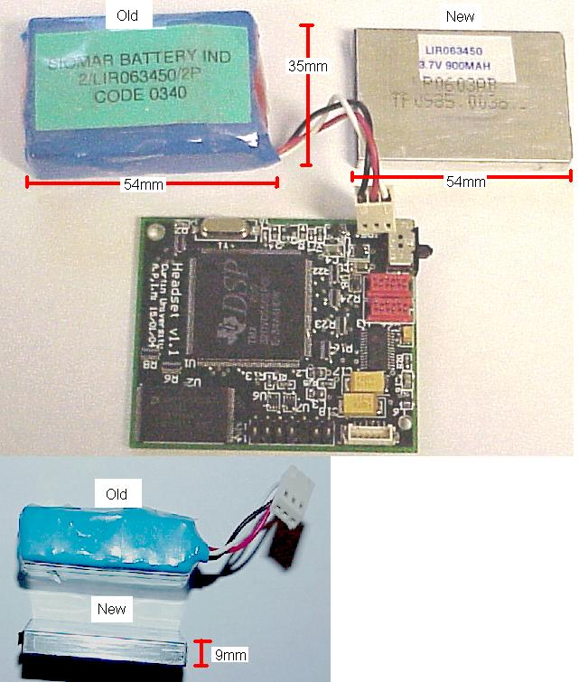

The current battery is oversized for the application and can be reduced in size as indicated by the new battery.
(The old battery is simple two of the new battery put together)

Figure 10: Battery connections and views

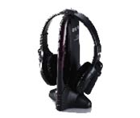
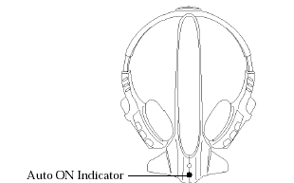
Figure 11: Possible functional form 1.

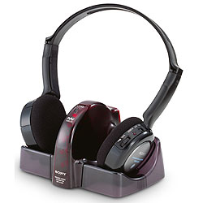
Figure 12: Possible functional form 2.

The final form of the commercial headset must take into account its docking station. Figure 11 and Figure 12 give two possible solutions.
Both forms take into account that two electrical contacts on the headset and docking station must make contact while the headset is docked for battery charging purposes. The form of these contacts is open to design format.

(The Association for the Blind has a number of units shown in Figure 12, and as such design format and ideas could be meticulously “borrowed”… if need be.)

