Name: Andrew Pasquale
Company: Curtin University of Technology
Category: Student

Secure Wireless Headset

The objective of this student project was to investigate, design, construct, and test a Secure Dual Channel Wireless Headset for Multi-User Environments that will increase labor market opportunities for people blind or vision impaired. The project is part of a collaborative effort between the Association for the Blind of Western Australia (ABWA), Elearn.WA, RAC and Curtin University.
A study conducted by the West Australian Department of Training found that Vision Impaired Persons (VIP’s) are particularly suited to employment in call center environments, and make reliable, and committed employees (Department of Training (2002)). However, VIP’s have prevailing difficulties (due to their condition) with audio headsets cables due to entanglement and cable jack damage.
The responsibilities engaged in this project involved the investigation, and the development of a secure, dual channel wireless headset for multi-user environments, not currently available on the commercial market, to alleviate these problems and ultimately improve employment opportunities for persons with vision impairment. Refer to (1) for more details.
A dual channel headset system is required for vision impaired persons (VIP’s) in call centre applications so that they may receive voice output from screen reading software for computer interaction on one channel, and a telephone output for human interaction on the other. The secure dual channel wireless headset will also have application for persons not suffering visual disabilities, both in call centres and in the defence forces.

The project required investigation into relevant technologies related to the design of a wireless headset that could fulfill the following criteria:
- Duplex communications with high quality, real time dual channel audio
  - Stereo Headphones input, microphone output
- Secure communications between base and headset
  - Call centres often deal with sensitive information such as credit card number’s, personal information etc and given the increasing rate at which financial banks are employing call centre services, the requirements of the market should be considered.
- Robust operation in environments with a large number of users
  - The RAC Joondalup call centre, one of the sponsor’s of the project, has over 300 employees
- System flexibility for security, communications medium upgrades
  - The system must be able accommodate onboard software upgrades for protocol, encryption updates.
  - The system must be able to accommodate hardware upgrades, in line with developments in the communications field.
- Ergonomic Operation
  - light weight (subject to regulations)
  - low power for full day (> 8 hours) operation on single battery charge
    - a battery mAh/weight compromise that can only be overcome by minimising power consumption
  - small form, VIP users need to be comfortable in their appearance when wearing the headset
- Economically feasible development and per unit cost

To satisfy these criteria the choice of communications was lent towards the infrared medium, notably for the following reasons,
- Because of the low power signal, infrared transmissions inherently use very little power.
- The high frequency (300 GHz) of infrared communications prevents significant diffusion (does not bend around corners) and allows it to be easily blocked by walls (line of sight). Combined with the low power of transmission, infrared becomes a inherently very secure communications medium since the signal is confined to its enclosure (i.e. the wall boundary of the call center). Thus anyone not inside the enclosure has no access to the signal.
- Due to the fact that the infrared signal can be utilized with low output power thus limiting transmission to a few meters, and the fact that it is blocked by boundaries, infrared ideally suits itself to be used as a cellular network (see figure 2). Thus the issue of throughput in multi-user environments is avoided since each user has their own cell, and no sharing of bandwidth is required.

In deciding the overlying controller system required for the wireless headset, the controller must efficiently be able to handle tasks such as the base-headset communications (including encryption/decryption, data encoding/decoding and error detection) and audio recording and playback simultaneously. While performing theses tasks the controller system must also consume very little power, be reasonably cheap, and have the flexibility to accommodate future communications upgrades (i.e. computational redundancy).
After researching potential architecture’s, a Texas Instruments C5502 Digital Signal Processor was chosen for its high suitability in performing audio communications. Described following are some of its key features:
- Low Cost ~ $8.85 US at 1KU for a 300MHz Dual MAC 16-bit DSP
- Low Power
  - Harvard architecture enabling 2 MACS per cycle provides exceptional power efficiency per clock cycle in a system where repetitive communications style calculations are the norm.
  - Dynamic frequency and voltage scaling let the system to tailor its power use to the current exact computational requirements, important in a bursty communications medium where the data rate is significantly higher than required. (384Kbps audio over a 2Mbps medium)
- Fast Development Cycle
  - Integrated Development Environment for real time, onboard configuration and test of DSP software and hardware
- High Flexibility
  - Software programmable DSP communications and JTAG interface allows onboard in-field reprogramming.

To meet the requirements of the project the student undertook responsibility for the following tasks,
- High level system design
- DSP software coding, including
  - Designing a custom duplex infrared audio protocol involving encryption, error checking/handling and audio delta softening.
  - Pre-production DSP debugging (urhh!)
- Protel PCB design for a complete system, with analogue audio and high-speed digital componentry.
- Component sourcing and board population. (Many hours under the microscope with a soldering iron and a 176 pin quad flat LQFP DSP! see pictures)
- Prototype base station and headset fashioning. Refer to pictures.

As a result of the project undertakings a functional headset system has been created, which has then been live tested by VIP users in a call center environment. The system operates as to expectations and is currently undergoing commercialization viability. Please refer to the following pictures for an idea of system operation.
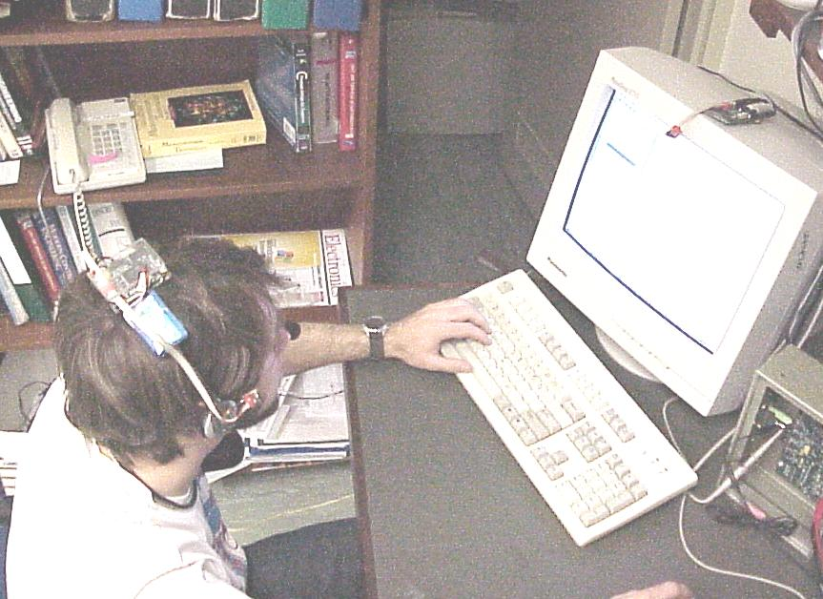
Figure 1: System in use, with headset mounted unit and base station mounted on PC monitor.
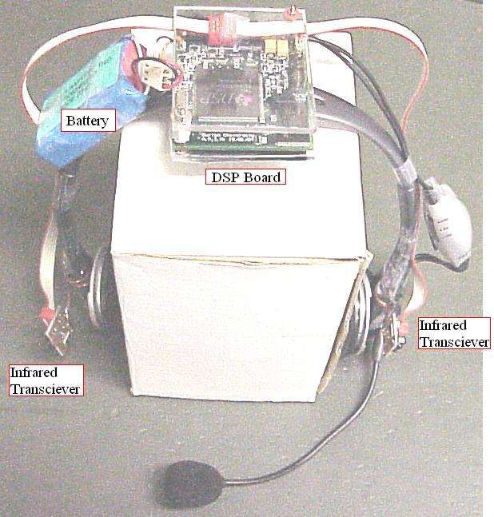
Figure 2: Close up view of headset unit.
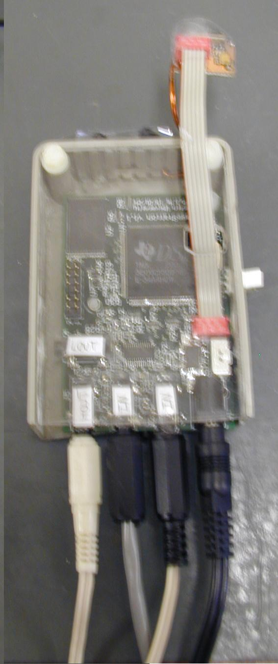
Figure 3: Close up view of base station unit, with audio in/out, and power cables.
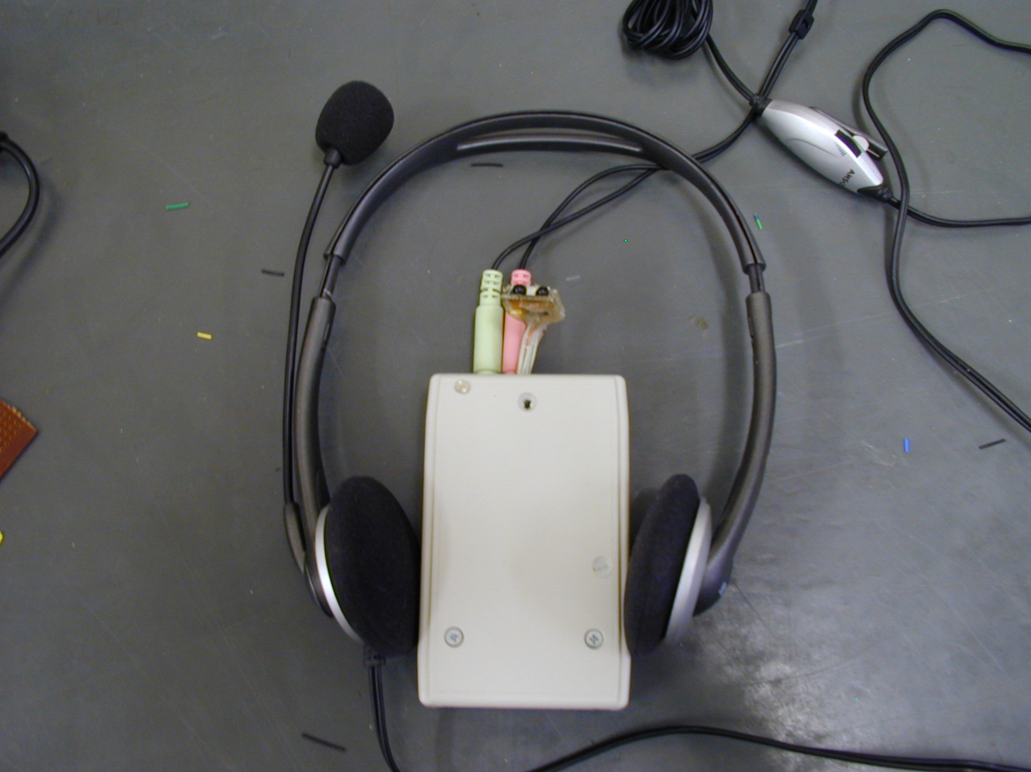
Figure 4: Close up view of pocket version of headset unit.
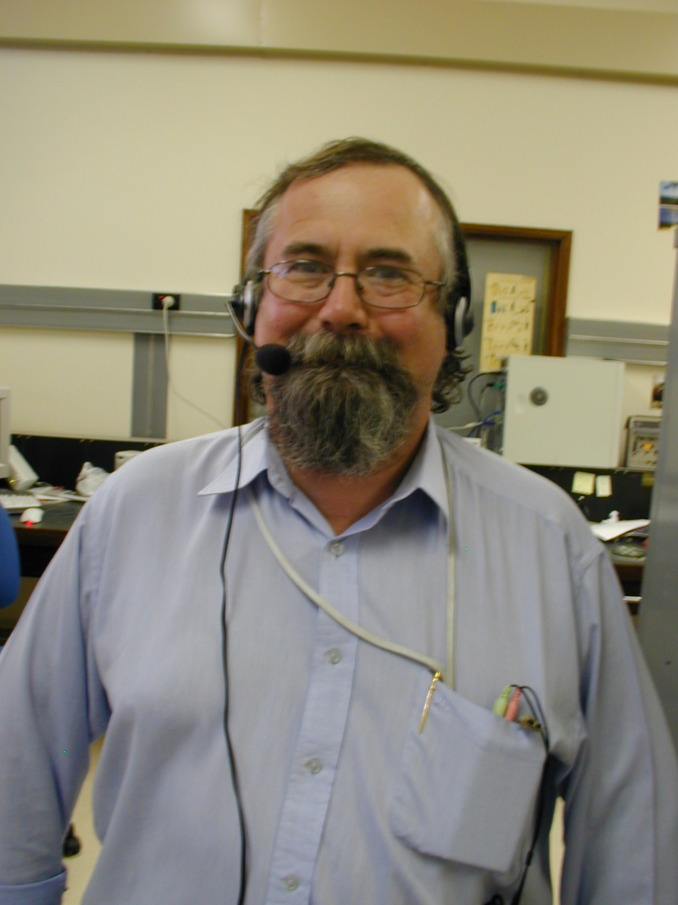
Figure 5: Pocket version of headset unit in use. (Modeling courtesy of Iain Murrey)

Appendix: Supporting Information

- The West Headset Article.tif (The West Australian, p 36, 24th July 2002)
- Research Summary.doc
- Headset Design.doc

