[SHOW TEXT: translating Auslan into speech]
Good evening ladies and gentleman, this evening I will be presenting my efforts toward translating Australian Sign Language into speech. I would like to direct your attention to the screen for a short introduction.
[SHOW: intro clip]

[SHOW TEXT: About Auslan ]
Although there are different spoken languages, generally we are able to communicate verbally across the communities with whom we associate. This however is not true for the 0.1% of Australians who use sign language as their equivalent form of communication. Outside their immediate community and without an interpreter, a person who sign’s is essentially isolated from conversation, hence the necessity to break down this communication barrier.

Today, Auslan has more than 4000 commonly used signs and is expanding rapidly to accommodate the requirement of interpreter services in the fields of secondary and tertiary education, and governmental, legal and medical services. To facilitate this, new signs are being developed and others borrowed almost exclusively from American Sign Language.

In generating the concept to be conveyed, signs associated with the content are strung together and when necessary, their meanings augmented by the speed of execution, facial expressions, movement of the head or by performing another sign in quick succession. For example;
- The movement associated with the sign for intelligence is performed at a quicker rate to denote genius as opposed to smart.
- ‘Saw’, as in I saw a particular thing, is conveyed by the sign for ‘see’ followed by the ‘finish’ sign, as in having, finished seeing.

[SHOW FIGURE]
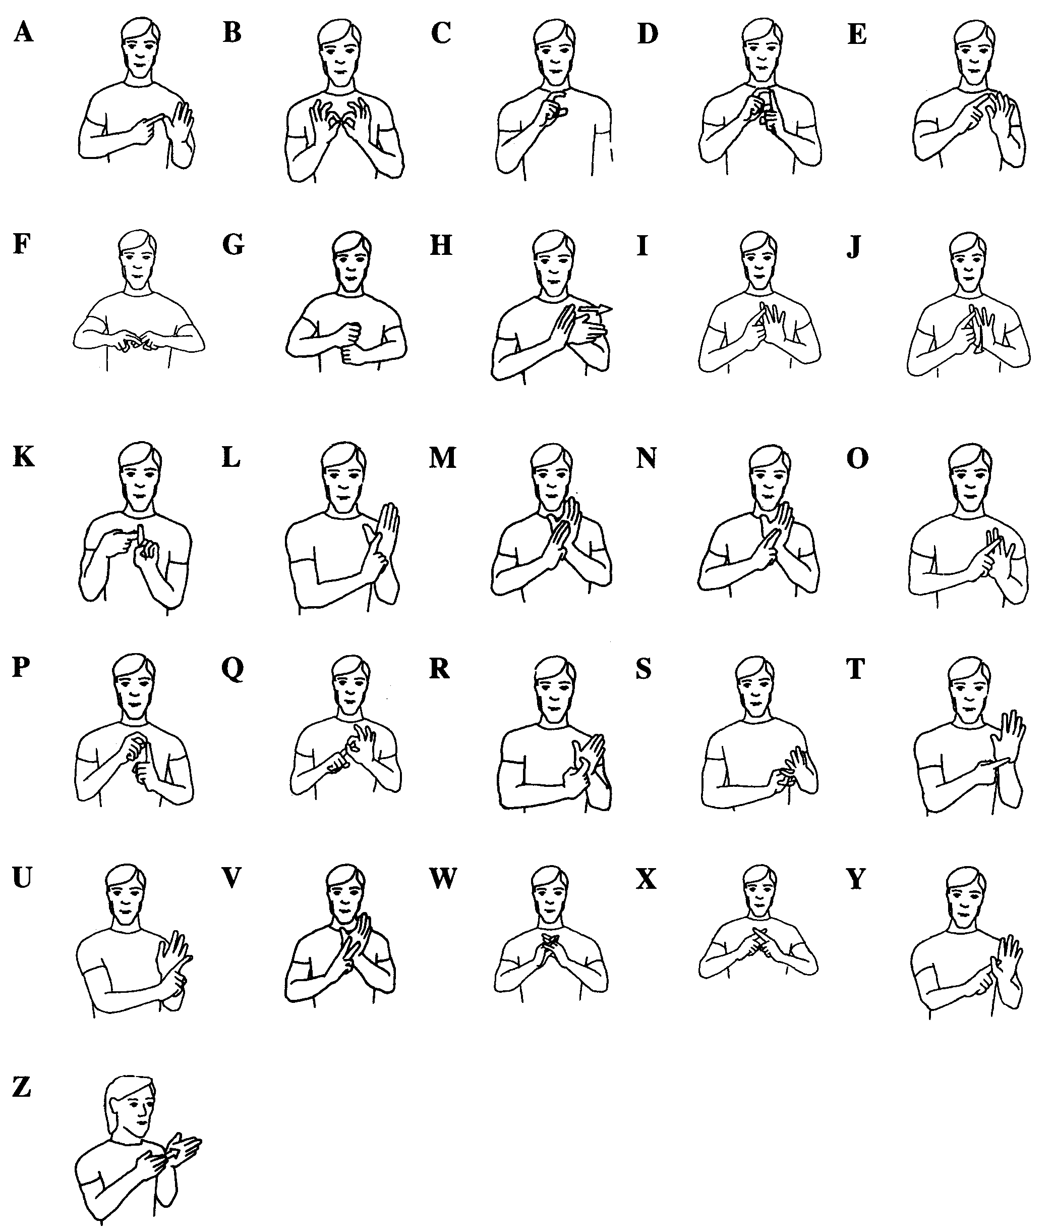
In the case where signs cannot convey the desired information, they are supplemented by the two-handed alphabet. The vowels A, E, I, O and U are indicated by touching the thumb, index, middle, ring and little (or pinky) fingers respectively. The remaining letters of the alphabet are indicated by physically imitating the structure of the letter itself.

[SHOW TEXT: Auslan Signs comprise: handshapes, locations, orientation, movement and expression]
Individual signs are determined by the handshapes and locations used, the orientation of the handshapes and the type of movement performed during the sign. Expression has little importance when determining signs however is fundamental to the construction of phrases. Most signs use the same handshape throughout the duration of the sign, however for some signs there is a transition from one handshape into another. Signs are classified into three types: the first is one-handed where the handshape and movement are made by the dominant hand, the second is double-handed where the handshape and movement made by the dominant hand are mirrored by the other, and the final type is two-handed where different handshapes and movements are made by each hand.

[SHOW FIGURE]
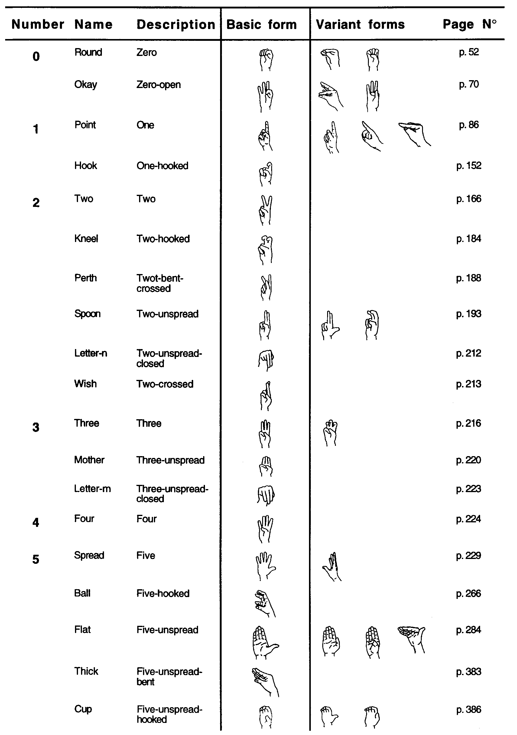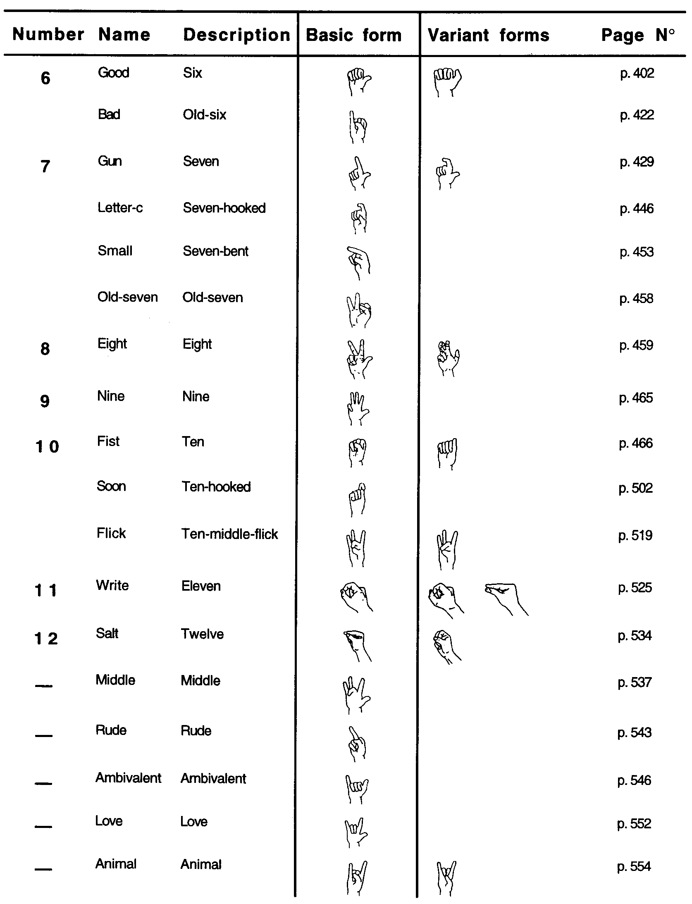
Auslan uses 37 base handshapes, some with several variants. In many cases the name and function of the handshape could be considered very logical, as those of us whom are not deaf use them in context as visual aids during normal day to day conversation.
[DEMONSTRATE]
For example ‘okay’, ‘wish’, ‘good’, ‘gun’.

Each of the handshapes used can be differentiated from one another by three distinct attributes of the hand condition.

[SHOW FIGURE]
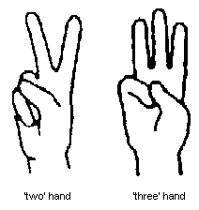
The first attribute is the combination of fingers bent and the degree to which they are bent. Considering the combination of fingers bent, the ‘two’ hand has the index and middle fingers straight and the remaining fingers and thumb bent, whereas the ‘three’ hand has the index, middle and ring finger straight and the pinky finger and thumb bent.

[SHOW FIGURE]
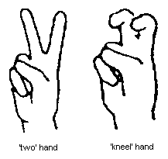
Alternatively, considering the degree to which the fingers are bent, the ‘kneel’ hand (described as ‘two-hooked’) is the same as the ‘two’ hand except that the index and middle fingers are both bent halfway down the finger.

[SHOW FIGURE]
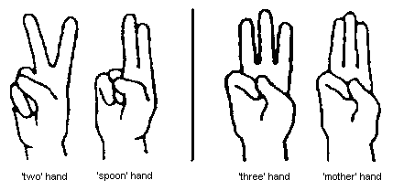
The second attribute is concerned with which fingers are touching. There are two levels to this, the first of which is whether the straight fingers are ‘spread’ or ‘unspread’. Examples of this are the ‘two’ or ‘three’ hands (all straight fingers are spread) as opposed to the ‘spoon’ (described as ‘two-unspead’) or ‘mother’ (described as ‘three unspread’) hands respectively.

[SHOW FIGURE]
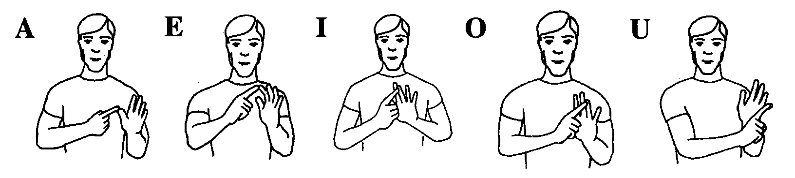
The second level is most prominent in fingerspelling where nonadjacent fingers (including thumbs) are touching each other. Examples of this are the vowels of the two-handed fingerspelling alphabet.

[SHOW FIGURE]
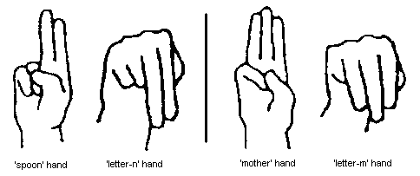
Pitch is the final attribute required for the recognition of handshapes. Pitch would determine whether the fingers were pointing up or down. This information would be required to differentiate between handshapes essentially identical, except for the pitch of the straight fingers, such as the ‘spoon’ and ‘letter-n’ hands, or the ‘mother’ and ‘letter-m’ hands.

[SHOW TEXT: location of handshapes: neutral space, primary locations (body), secondary locations (hands)]
Different signs can originate, be maintained, or terminate at: the position or proximity of a ‘primary location’, or in ‘neutral space’.

Neutral space is located in front of the signer, generally at chest height. Two-handed and double-handed signs use neutral space only, as the points of contact are located on the hands themselves these are known as secondary locations. This is also true when using some one-handed signs where the meaning is conveyed simply by the sign itself, for example the number one is conveyed by the ‘point’ hand in neutral space.

[SHOW FIGURE]
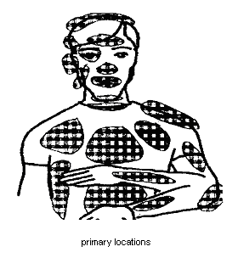
Primary locations usually reside on the right side of the head and left side of the body. This convention assumes the signer is right-hand dominant, hence to avoid crossing over the face, or the physical impossibility of touching the right arm with the right hand, this convention has been adopted (note though that the converse is true for left-hand dominant signers). Examples utilising location are the signs for Indian, German and I/ME given by the ‘point’ hand on the: top of head, forehead, and chest respectively.

[SHOW FIGURE]
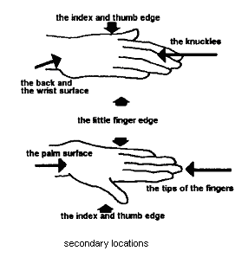

Double-handed and two-handed signs are performed in neutral space and therefore never contact or are in the proximity of primary locations. The hands can however contact with each other and these points of contact are known as secondary locations. In the case of double-handed signs, contact if made, is on the same part of the hands, in the case of two-handed signs it is generally different parts of the hands that contact.

[SHOW TEXT AND FIGURE: orientation]
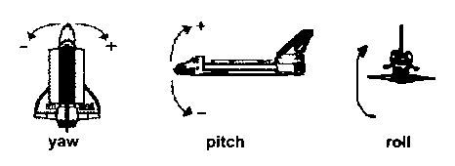
Orientation is important as it differentiates between signs with the same handshape, location, and movement. All three elements of orientation are required to uniquely recognise signs. These elements are roll, pitch and yaw.

[SHOW FIGURE]
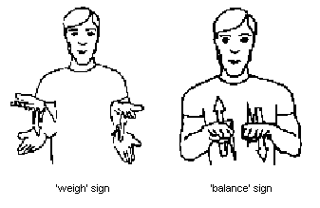
An example illustrating the need for roll data is the differentiation between the signs for weigh and balance. Both are double-handed signs using the ‘flat’ hand, the fingertips point away from the body, and the hands move alternately up and down, however weigh has palms up and balance palms down.

[SHOW FIGURE]
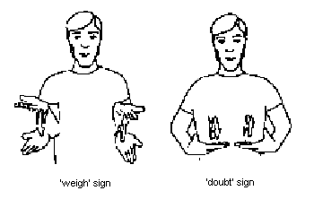
Alternatively, an example requiring yaw data is in the differentiation between the signs for weigh and doubt, these also are double-handed signs using the ‘flat’ hand, both move alternatively up and down and both have palms up, however the fingertips point away for weigh and at each other for doubt.

[SHOW TEXT: movement: large scale, small scale]
Movement is conducted in two general forms, the first of which is where the movement is large scale and the hand is moved through the signing space either originating and / or terminating at a primary or secondary location or in neutral space, in which case the movement is in a straight line, a series of straight lines, arcs or circles. The second type is concerned with small scale movement where the hands could have a change in orientation or fingers move, generally resulting in another handshape.

[SHOW TEXT: expression: head, eyebrows, eyes, mouth, cheeks]
Expression is used to shape a phrase by changing the mood or context of the signs, however it carries little bearing on the formation of the sign itself. As examples of expressions used
- A statement is turned into a question by raising the eyebrows.
- The opposite meaning of a sign is conveyed by shaking the head.

[SHOW FIGURE AND TEXT: p5 virtual reality glove by essential reality]
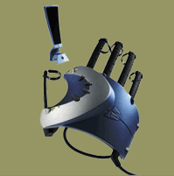
The criteria at this stage in development was essentially offering ‘proof of concept’ so the P5 virtual reality glove designed by Essential Reality was used as the primary source of data from the hand. At that time the glove only came right handed, consequently only one-handed signs could be recognised although the assumption was made that both gloves would be available. The P5 glove is cheap and light weight. The position and orientation of the glove are determined using optical tracking technologies and each finger has a flexion sensor to measure the degree to which it is bent. The glove when polled for data returns an x, y and z coordinate relative to the receptor indicating position in 3D space. It also indicates the absolute roll, pitch and yaw of the glove and the extent to which fingers are bent over 90 degrees. An important point to note is that the data is refreshed at a rate of 60Hz or every 17ms.

The position and orientation of the hand was now known and patterns of movement could be filtered from the position data assessed dynamically. In recognising handshapes the finger bend data was also known, data was then required about the combination of fingers touching.
It was decided that future design would include position trackers on the head, shoulders and recessive arm, enabling the changing positions of primary locations on the body to be extrapolated when required for the one-handed signs not using neutral space.
To recognise all double-handed and two-handed signs, knowledge of not only which fingers were touching, but all the secondary locations on the hand were required.
The knuckles only contact when the fingers are fully bent, this means that they could use the same contact as the fingertips and be differentiated by whether the fingers were bent or not. Also the palm and back of the hand could use the same contact and be differentiated by orientation of the hand. These assumptions allowed for a reduction in the number of contacts to six per hand.

[SHOW FIGURE]
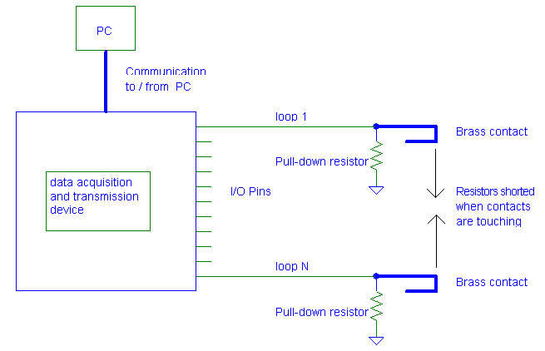
The most logical way to determine which contacts were touching was by making each contact out of a strip of thin rolled brass, a flexible and conductive material, then by putting a voltage on a particular contact and reading the voltages of the other contacts you could determine which were touching. By repeating the process for all contacts you would know what combinations of contacts were touching. An important requirement was that each contact had a pull-down resistor so that voltages read were not floating, possibly resulting in an incorrect decision. Also the resistors value needed to be large enough such that it would only sink a small current and the path to ground appeared as an open-circuit when contacts were touching.

A device would be required that could preform the process of testing the contacts and transmitting the information back to the PC for further processing with the data from the P5 glove.

[SHOW FIGURE]
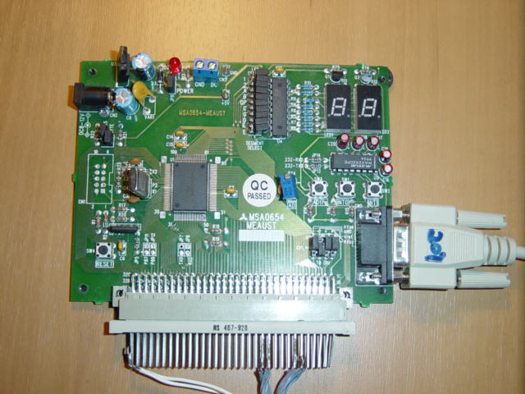
A series of PICs or peripheral interface controllers could have been used for this task, however the M16C/62 single chip microcomputer was available and although it could be considered overkill, it had the functionality required for the job. The functionality required was I/O ports, timers, UARTS for serial transmission back to the PC, interrupts with different priority levels for the timers and receive buffer of the UART and that it was easily programmed and debugged. With a clock frequency of 16MHz, real-time data would not be an issue.

[SHOW FIGURE]
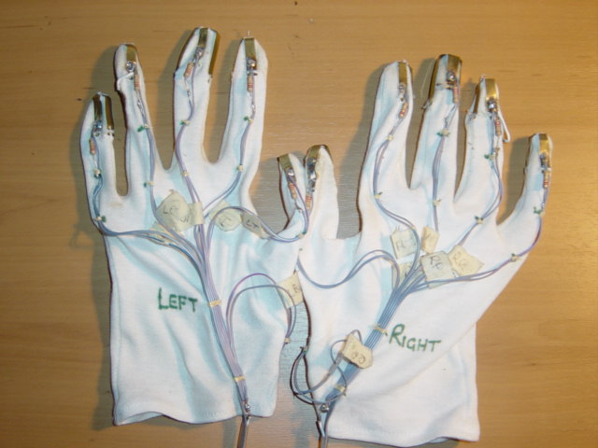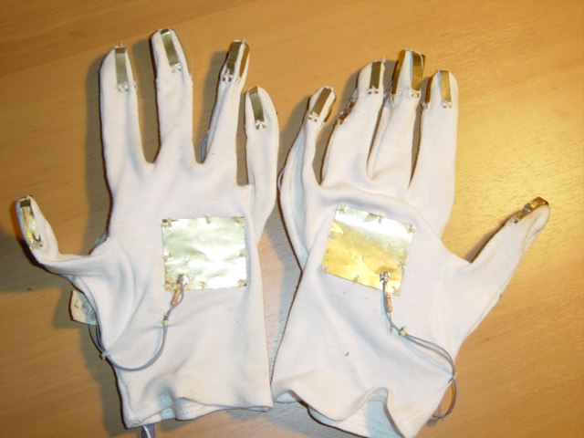
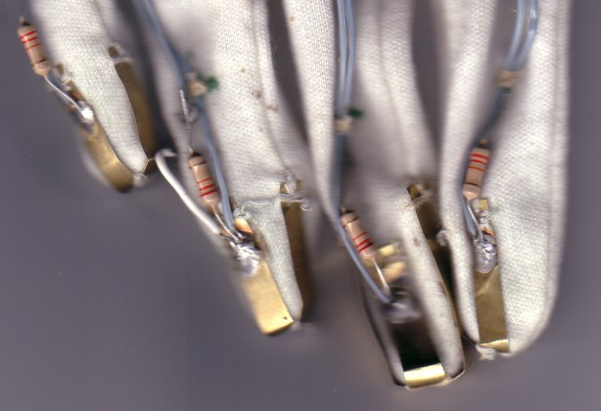
Two cotton gloves were used as a trial framework for the contacts. Rolled brass sheet was cut into cross shaped strips and folded symmetrically around the fingers and thumbs, and a rectangular strip placed on the palms. Each contact had a 22kohm resistor and a strand of ribbon cable soldered to it. The ribbon cable was connected to the I/O pins and the resistors to ground on the microcomputer.

[SHOW TEXT: contact sensor algorithm]
At this stage the contact sensor algorithm needed to be developed. The first step was to set two timers, one to 17ms and the other to 5ms for reasons I will explain in a moment. Next I setup the I/O ports my contacts were connected to so that I could correctly write to and read from them. Then I setup the UART assigning baud rate, parity bits, stop bits etc and put it in receive mode. Finally I started my 17ms timer and entered the program into an endless, taskless loop.

As programs executes different things occur, such as a timer reaching its maximum value or a character being received in the buffer of a UART. When you want to perform a given action as a particular event occurs, you define an interrupt for that event. When that event occurs, your program is interrupted and a routine is performed that services your interrupt, known as an interrupt service routine.
The 17ms timer had an interrupt set so that when it timed out get_data its’ interrupt service routine would interrupt the programs endless loop and execute. This meant that get_data would run at 60Hz, the same refresh rate as the P5 glove, aiding in synchronisation of their data.

Get_data was the routine that determined which contacts were touching. Get_data started at the first pin a contact was connected to and checked its first log to see if that pin was recorded as connected to another. This was done so that results wouldn’t be duplicated. If it wasn’t recorded as connected to another, the pin was written high, taking its contact to 5 volts, consequently any contact touching the first would also be at 5 volts. Next the pins of the remaining contacts were read, and those that were high were recorded as touching the first. This process was repeated until all contacts were accounted for.
To ensure that the data recorded was intended, the process needed to be repeated after a short delay. To do this a flag was cleared, the 5ms timer started and get_data instructed to do nothing while the flag was cleared. When 5ms elapsed an interrupt service routine set the flag allowing get_data to continue, at which point it repeated the process of determining which contacts were touching using its second log. Upon completion of this, the two logs were compared, if consistent, the data was prepared for transmission. Finally the logs were erased, get_data had completed and the program went back into its endless loop.

Since a real-time system is required, the amount of data transmitted back to the PC needs to be minimised, so the data was prepared for transmission in the following manner. The contacts were numbered 1 to 12, since an integer has 16 bits, for each combination of contact’s touching, the bits of an integer corresponding to those contact numbers were set. Three more integers were generated: one representing the start of transmission so that if the PC received unwanted characters it would know where the real data began. The second represented the end of transmission, since the number of combinations of contacts touching was unknown so would be the data length. The third integer, known as a sum-check, was the sum of all the integers so that the received data could be checked for corruption. Finally, since a UART only transmits 8 bit characters, all the integers were put in order, broken in half and assigned to an array of characters.

At any time, the PC could transmit a polling character to the microcomputer. As the character arrived in the UART receive buffer an interrupt was generated with higher priority than the other two. The interrupt service routine checked that the received character was the designated polling one, if so it changed the UART to transmission mode, transmitted each element of the array of characters and finally changed the UART back to receiving mode before ending. Note that this interrupt was disabled whilst the array of characters was being updated so that the information wouldn’t be corrupted.

[SHOW TEXT: from the PC: polling for the contact data, receiving, translating and validating]
Now it was required that the PC could poll the microcomputer for data, and receive, translate and validate it, a function named get_connections was written to do this.
Get_connections had 4 main components, firstly the serial port needed to be setup for transmission and reception as was the microcomputers UART.
Secondly to stop the protocol from freezing in the case of transmission errors, a timeout needed to be defined. To do this a maximum allowable time was determined by doubling the maximum expected transmission time and adding it to the current time, this figure could then be checked against the current time to determine if it hand elapsed. This was then followed by transmitting the polling character to the microcomputer.
The next step was to repeatedly collect the received characters in pairs and reconstitute the integers they represented. After the start of transmission was received and until the end of transmission was received, the integers were stored as the contact data.
Finally, following this, the sum-check was received and compared against the sum of the contact data. If they were consistent the data was released and the function terminated. If the data wasn’t consistent with the sum-check, or at any time the protocol timed out, the entire process was repeated until successful.

For diagnostic purposes a function was also written to translate the received data into letters representing the contacts touching. I would like to show a short example of retrieving the contact sensor data.
[SHOW CLIP: contact sensor data]

[SHOW TEXT: when was the hand considered stopped?]
I was now able to know which fingers were bent and which contacts were touching, consequently I could determine the handshapes, but at what point in time do you evaluate the handshape?
By looking at the mechanics of Auslan, it was observed that the handshape is formed, there is a slight pause and if that doesn’t constitute a sign, movement is involved. Therefore you at least needed to know when the hand had stopped moving, so I wrote a function called stopped.
Over a quarter of a second, stopped collected 3 samples of the x, y and z, roll, pitch and yaw, finger bend and contact sensor data storing them in what I called the stop buffer. The contact sensor samples were tested for consistency, and since the hand is not going to be absolutely stationary, the last two samples of the position, orientation and finger bend data were tested to see if they were within a small range of their first sample. If all test results were positive, stopped returned true, otherwise false.

[SHOW TEXT: identifying handshapes]
To identify the handshapes, the stopped function was called until it was true, meaning that useful data was now stored in the stop buffer. A function called IDhandshape was written to take the contact sensor and finger bend data and sift it through an if /else structure until the correct combination was found, in which case that handshape was returned.
The contact sensor data was required to be an exact match, however the 90 degrees over which a finger could bend was broken into thirds corresponding to straight, half bent and completely bent, therefore requiring that the finger bend data was only within the correct range.
I would now like to show some handshapes being recognised.
[SHOW CLIPS: ambivalent, gun, mother, cup]

[SHOW TEXT: identifying the location]
By initially recording the position of the P5 glove when placed on the head, and shoulder, bicep and forearm of the recessive arm, the primary locations were able to be extrapolated. A function called location was written to generate a small sphere around each position, from which it checked whether the glove was within a particular sphere and hence at a primary location or otherwise in neutral space.
The problem with this is that as simple as a change in posture would result in false recognition. This illustrates the need for the primary locations to be tracked independently.

[SHOW TEXT: identifying movement type]
In order to identify the type of movement performed, data needed to be recorded whilst the hand was moving, the data then had to be filtered and a movement type recognised.
To do this a function called IDmovement was written.
The first task of IDmovement was to wait until stopped was false indicating that the glove was moving. Whilst stopped was false IDmovement stored the samples of position, orientation and finger bend data from the stop buffer in what I called the movement buffer. Since some movements can have slight pauses associated with them, the data was recorded until stopped was true more that two times consecutively.
Currently 3 types of filters have been developed. The first detects the bend of the fingers, increasing, then decreasing and finally increasing again, this type of movement is associated with signs such as welcome. The second detects rolling of the wrists by looking for a decrease in pitch followed by an increasing in roll. The third type detects linear movement, this was done by generating a cylinder with central axis starting at the first recorded location and finishing at the last recorded location. As long as the recorded movement increased along the axis and within the cylinder then the movement was recognised as linear. The direction, as in left to right or top to bottom and so on was determined by initial and final points of the axis.
Currently there isn’t a working filter for movements following an arc or circle.
I would like to show a clip of some movements being recognised.
[SHOW CLIPS: roll wrists, fingersIncDecInc, leftToRight, awayRightUp]

[SHOW TEXT: putting it all together: Recognising signs]
All the logical components required to recognise the signs were now designed, it remained to link them together.
A function called detectSign was written for this purpose. DetectSign waited until stopped was true, then IDHandshape was used to acquire the initial handshape and the orientation was noted, this was followed by the function: location, to determine the initial position of the handshape.
These data were then applied to an if / else structure to determine if this combination constituted a sign. If so, the sign was output and the function repeated. If not, IDmovement was used to determine the movement type that followed, the final handshape and position were then evaluated. The composite data was again applied to as if / else structure. When the right combination was located, the relevant sign was output and the function repeated.

Finally, an off the shelf text to speech chip could be used to synthesise the recognised signs as a basic output. Ideally, several signs would need to be recognised and the context translated to English sentences from which the words would then be synthesised.

This concludes my presentation and I would like to leave you with a final clip.
[SHOW CLIP: conclusion]

[SHOW CLIP: braught to you by…Q&A]

