High Speed Audio Streaming

To

Universal Serial Bus (USB)

Project Requirement specification

Version 1.0

12929 Computer Technology Project 391
By Simon Dunn
Student ID 12561010

Version History

Rev No | Rev Date | Name | Description
1.0 | 11/1/2006 | S.Dunn | Initial Release

Approvals

Iain Murray_____________________________ Date__________________________

Simon Dunn_____________________________ Date__________________________
Contents

Version History 2
1. Introduction 4
1.1 Purpose 4
1.2 Scope 4
1.3 References 4
1.4 Definitions, Acronyms & Abbreviations 5
2. Overall Description 6
2.1 Product perspective 6
2.1.1 Concept of operations 6
2.1.2 Interface block diagram 7
2.2 Equipment proposed 8
2.2.1 Analogue to digital converter 8
2.2.2 Buffer Memory 8
2.2.3 High and Low pass filter 9
2.2.4 Timer clock 9
2.2.5 Logic 10
2.2.6 Audio source 13
2.2.7 USB Module 13
2.2.8 Host requirements 16
3. USB programming and advanced communication port 17

1. Introduction

1.1 Purpose
This document contains information on the requirements of the design and implementation of a universal serial bus (USB) audio stream used to capture the audio level signal derived from a high speed tape drive, and convert to a digital stream file, for future play back or archiving on ether a Mac OS or windows based personal computer. Section 1 will focus on the design aspects and section 2 will focus on the impetration and testing of the interface

1.2 Scope
This document covers the requirements for release version 1.1 high-speed audio interface References will be accounted in Section 1.4 for future releases.

1.3 References
Project Design Specification version 1.1
FTDI web site

1.4 Definitions, Acronyms & Abbreviations

Acronym or term | Definition
ADC | Analogue to Digital Conversion
dB | Decibels
COM | Communications Port
FIFO | First in First Out
MHZ | Mega Hertz (mega cycles per second)
Hz | Hertz (cycles per second)
IC | Integrated Circuit (Silicon Chip)
KHz | Kilohertz (thousand cycles per second).
NRZI | Non-Return-to-Zero Inverted
OS | Operating System
PC | Personnel Computer
PIC | Programmable Integrated Circuit
PLD | Programmable Logic device
V | Volts
USB | Universal Serial Bus

2. Overall Description
Curtin University has a large amount of audio files stored on tapes, and audio cassettes. The content of those archives is, by and large, speech. The primary purpose of this audio digitization project is preservation and play back of the audio contents.

2.1 Product perspective
High-speed audio to universal serial bus (USB) interface, will be intended to fulfill the requirements of digitizing an analogue audio stream, of the purpose of achieving and future play back. The audio stream will be recorded at a maximum compression factor of 20, this is to ensure that a 90min cassette can be recorded in approx 4min to a host computer.

2.1.1 Concept of operations
The high-speed audio interface, is based on simple continues stream of raw data sent from interface to the host via a USB 2.0 full speed format. The analogue waveform will be digitized in to 8 bit binary value, via the use of analogue to digital converter (ADC). Due to the speed requirements, the ADC shall be of high performance 8-bit parallel bus type, compatible with logic or microcontrollers

2.1.2 Interface block diagram
Detailed below in figure 1 is a block diagram for the audio interface

Band Filter

ADC

Buffer

USB Driver

Host Computer
Max 500ksps
Max 1Mhz
Figure 1

2.2 Equipment proposed
The following equipment was selected for the project based on performance detailed in the design specification

2.2.1 Analogue to digital converter
TheAD7820 analogue to digital converter (ADC) is an 8 bit 1Msps (conversion time of 660ns) liner compatible CMOS (LC² MOS) device providing 100 KHz of bandwidth by utilizing half flash conversion technique, this techniques eliminates the need for a clock signal to perform the conversion. The device features a unipolar or bipolar input, which covers a 5-volt range; this enables the analogue to digital converter to be powered from a single 5volt supply rail. The analogue to digital converter can interfaces to any microprocessor, or logic circuit via the chip(CS) select and write enable(RD) pins. The digitized approximation of the waveform is written out to memory via the data bus lines D0 through to D7, in an 8 bit unsigned binary value.

2.2.2 Buffer Memory
A volatile memory buffer is to be used to provide a temporary storage of the raw data whilst the USB interface is being serviced the host during data transfer. The type of memory required will need to be accessed at regular intervals by the AD,C and at unregular intervals by the USB module. A simple first in first out (FIFO) device from cypress is ideally suited for this application. Due the speed at which the audio is arriving, a buffer of 64k x 9 bits will be used this will provide maximum buffering of 0.128 seconds of 8 bit unsigned mono audio stream sampled at maximum of 500,000 samples per second.
The USB module, will provide a maximum through put of 8Mbits per second, this is twice the rate at which the ADC can sample, process and deliver data to the buffer. By transferring data to the host at the higher rate, this will ensure that even with the USB overheads added to the encapsulated package that no loss in audio data or buffer over run would occur.
Note
Some critical setup and time constraints must be adhered to when using this type of memory device, check data sheet for details.

High and Low pass filter
The first device required in the A/D conversion process is an analogue low-pass and high pass filter whose sole function is to band-limit the input signal without introducing excessive linear or nonlinear distortion and without generating excessive noise. Any noise generated at this stage will be treated as genuine audio stream and will be digitized. For this project normal voice audio will be in the range of 150hz through to 3200hz since the compression factor of 20 is used this audio range is now extended to 3000hz through to 64000hz as a minimum this will require the use of a high pass filter to eliminate frequency below 3000hz, and a low pass filter to eliminate frequency above 80,000hz, with a 0dB loss of signal audio signal in between.

2.2.4 Timer clock
A dipswitch selectable programmable crystal oscillator is to provide timing for both the ADC converter and USB interface. The USB interface will be clocked at 1 MHz whilst the ADC will be clock at a maximum of 500 KHz. Other frequency that can be selected are 250Khz, 200Khz, 100Khz, 50Khz, 25Khz, 20Khz, 10Khz, 1Khz, 100hz,10hz,1hz

2.2.5 Logic
The high-speed audio interface is a simple audio to raw data device with some time critical switching and buffering. The logic control interface required between the ADC, Buffer, USB may be controlled with the use of microcontroller, PIC, PLD, Logic gates may be used to pulse the control line with respect to the clock and feed back signals generated from the USB module.

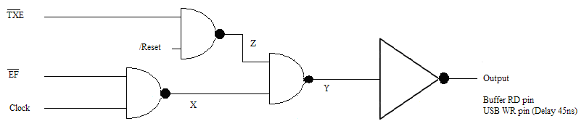

/TXE = 0 Send more Data
/TXE = 1 after data has been latch in
/EF = 0 No data to read
/EF = 1 10ns after data is latched in
/Reset = 0 Inhibit or USB Suspend signal from host
/Reset = 1 Continue or USB active

Note
The reset line will be held low whilst the USB is been configured by host and the drivers are loading up

/TXE | /EF | CLOCK | X | Y | Z | OUT
0 | 0 | 0 | 1 | 0 | 1 | 1
0 | 0 | 1 | 1 | 0 | 1 | 1
0 | 1 | 0 | 1 | 0 | 1 | 1
0 | 1 | 1 | 0 | 1 | 1 | 0
1 | 0 | 0 | 1 | 1 | 0 | 0
1 | 0 | 1 | 1 | 1 | 0 | 0
1 | 1 | 0 | 1 | 1 | 0 | 0
1 | 1 | 1 | 0 | 1 | 0 | 0

The following time show a write sequence from the ADC to audio buffer

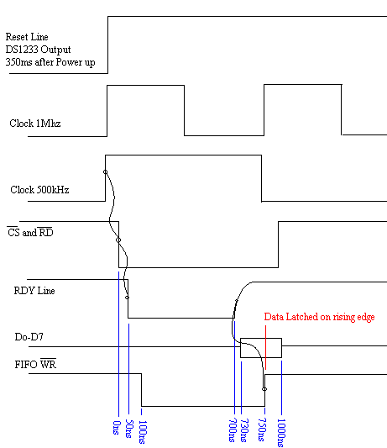

The following time show a read sequence from the buffer to the USB driver

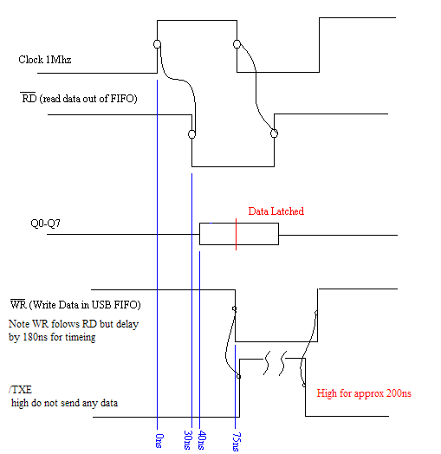

2.2.6 Audio source
The common line audio output from audio equipment may fall anywhere from 300mv to 2.0V RMS. Due to this inconsistency with different audio equipment, the audio interface shall incorporate a small gain amplifier with an offset control, both of which can be set with the use of trimmer pots. The ideal voltage to be presented to the ADC is a 2.5volt DC with a 2.5volt peak to peak AC superimposed on top. This will ensure that the ADC uses the full 256 steps are utilized to represent the required digitized waveform. A DC blocking capacitor will be required on the input stage of the interface this is to ensure that audio that swing ether side of the ground rail can be used.

2.2.7 USB Module
The FT245BM provides an easy method transferring data to / from a peripheral and a host P.C. at up to 8 Million bits (1 Megabyte) per second. Its simple, FIFO-like design makes it easy to interface to any microcontroller or microprocessor via IO ports.To send data from the peripheral to the host computer, simply write the byte-wide data into the module when TXE# is low. If the (384-byte) transmit buffer fills up or is busy storing the previously written byte, the device keeps TXE# high in order to stop further data from being written until some of the FIFO data has been transferred over USB to the host. TXE# goes high after every byte written. By using FTDI’s virtual COM port drivers, the peripheral looks like a standard COM port to the application software. Commands to set the baud rate are ignored - the device always transfers data at its fastest rate regardless of the application’s baud-rate setting. Alternatively, FTDI’s D2XX drivers allow application software to access the device “directly” through a published DLL based API.

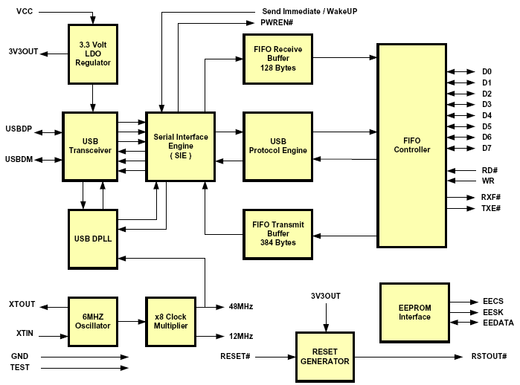

• USB Transceiver
The USB Transceiver Cell provides the USB 1.1 / USB 2.0 full-speed physical interface to the USB cable. The output drivers provide 3.3 volt level slew rate control signalling, whilst a differential receiver and two single ended receivers provide USB data in, SEO and USB Reset condition detection.

• Serial Interface Engine (SIE)
The Serial Interface Engine (SIE) block performs the Parallel to Serial and Serial to Parallel conversion of the USB data. In accordance to the USB 2.0 specification, it performs bit stuffing / un-stuffing and CRC5 / CRC16 generation / checking on the USB data stream.

• USB Protocol Engine
The USB Protocol Engine manages the data stream from the device USB control endpoint. It handles the low level USB protocol (Chapter 9) requests generated by the USB host controller and the commands for controlling the functional parameters of the FIFO.

• FIFO Receive Buffer (128 bytes)
Data sent from the USB Host to the FIFO via the USB data out endpoint is stored in the FIFO Receive Buffer and is removed from the buffer by reading the FIFO contents using RD#.

• FIFO Transmit Buffer (384 bytes)
Data written into the FIFO using WR# is stored in the FIFO Transmit Buffer. The Host removes Data from the FIFO Transmit Data by sending a USB request for data from the device data in endpoint.

• FIFO Controller
The FIFO Controller handles the transfer of data between the external FIFO interface pins and the FIFO Transmit and Receive buffers

2.2.8 Host requirements
The manufacture web page contains driver for the following operating systems

VIRTUAL COM PORT (VCP) DRIVERS for
- Windows 98 and Windows 98 SE
- Windows 2000 / ME / Server 2003 / XP
- Windows XP 64 Bit
- Windows XP Embedded
- Windows CE 4.2
- MAC OS-8 and OS-9
- MAC OS-X
- Linux 2.40 and greater

D2XX (USB Direct Drivers + DLL S/W Interface)
- Windows 98 and Windows 98 SE
- Windows 2000 / ME / Server 2003 / XP
- Windows XP 64 Bit
- Windows XP Embedded
- Windows CE 4.2
- Linux 2.4 and Greater

3. USB programming and advanced communication port
The following information has been downloaded from the Future Technology Devices International Ltd to aide in the programming of the host machine for this project.

