
Department of Electrical and Computer Engineering

Optical Recognition of Seven-Segment Displays

by

Wei Chou, Han

A thesis submitted for the degree of

Bachelor of Engineering in Computer Systems Engineering
Prof Syed Islam
Head of Department
Department of Electrical and Computer Engineering
Curtin University of Technology
Kent Street
PERTH WA 6001

Dear Prof Syed Islam,

I hereby offer this thesis entitled “Optical Recognition of Seven-Segment Displays” as partially satisfying the requirements for graduation in a Bachelor of Engineering degree.

Thank you.

Yours sincerely,

Wei Chou, Han
12327487
Computer Systems Engineering
ACKNOWLEDGEMENTS

I would like to thank the following people for their help and support during the development of this project.

My project supervisor, Mr Iain Murray for his guidance and advices.

Mr John Heppel, store technician for his technical support.
SYNOPSIS

This report details the development of a prototype portable device designed to scan 7-segment displays, identify the digit scanned and produces a speech output. Methods and ideas of implementations as well as problems encountered and solutions are also cover. The prototype device employs a 512 x 1 linear CCD array for scanning, an ISD1420 chip for speech output, electronic components (voltage comparator, voltage regulator, and 555 timer) for power supply and the Mitsubishi M16C/62 microcontroller for recognition process. The device is limited to scan numerical digits and used as an aid for visually impaired people and the blind.

NOMENCLATURE

AO | Analogue Output
CA | Common Anode
CC | Common Cathode
CCD | Charge Coupled Device
CLK | Clock
dpi | Dots per inch
EOM | End of Message
F | Farads
Hz | Hertz
IC | Integrated Circuit
ISD | Information Storage Devices
LCD | Liquid Crystal Display
LED | Light Emitting Diode
PLAYE | Edge-Activated Play
PLAYL | Level-Activated Play
REC | Record
SI | Serial Input
STN | Supertwisted Nematic
TAOS | Texas Advanced Optoelectric Solutions
TN | Twisted Nematic
VCD | Video Compact Disc

INDEX
CHAPTER | PAGE
1.0 INTRODUCTION 1
2.0 DISPLAY TYPES 3
2.1 Light Emitting Diode Display 3
2.2 Liquid Crystal Display (LCD) 5
3.0 HARDWARE 7
3.1 7-Segment Displays 7
3.1.1 Overview 7
3.1.2 Displays Dimensions 8
3.1.3 Displays Recognition 9
3.2 Sensor 12
3.2.1 Overview 12
3.2.2 TSL208R Linear Sensor Array 13
3.2.3 TSL208R Operation 14
3.3 Speech Output 18
3.3.1 Overview 18
3.3.2 ISD1420 Speech Device 19
3.3.3 ISD1420 Operation 20
3.3.4 Playback and Recording Configuration 23
3.4 Power Source 25
3.5 MICROCONTROLLER 27
4.0 SOFTWARE 28
4.1 Overview 28
4.2 Initialisation 29
4.3 Data Retrieval 31
4.4 Data Processing 36
4.5 Output 45
5.0 RESULTS 46
5.1 Frequency Selection 46
5.2 Testing 47
5.2.1 Single digit testing 50
5.2.2 Double digits testing 51
6.0 CONCLUSION 52
6.1 Achievements 52
6.2 Future Recommendations 53
7.0 BIBLIOGRAPHY 54
APPENDIX A: M16C Port Allocations 57
APPENDIX B: Speech Chip Addressing Chart 58
APPENDIX C: Ledspkrdata.h Code Listing 59

LIST OF FIGURES
FIGURE | PAGE
Figure 1: Depletion region 3
Figure 2: Forward biased PN junction. 4
Figure 3: LED displays 5
Figure 4: LCD structure. 6
Figure 5: Naming convention of a 7-segment display. 7
Figure 6: Lighting aid structure. 8
Figure 7: Scan of LED display digit 3. 10
Figure 8: Scan of LCD digit 3. 11
Figure 9: Scan of LED display digit 9. 12
Figure 10: TSL208R layout (Top view) 14
Figure 11: Output voltages of AO (Channel 1) and SI pulse (Channel 2). 15
Figure 12: TSL208R timing waveforms. 16
Figure 13: Gltich in A0 (Channel 1) occurs at positive CLK edge (Channel 2). 17
Figure 14: ISD1420 speech output circuit. 21
Figure 15: ISD1420 IC. 22
Figure 16: Playback and recording circuit. 23
Figure 17: Power supply circuit. 26
Figure 18: Main flow diagram. 28
Figure 19: Initialisation stages flow diagram. 29
Figure 20: Data retrieval flow diagram. 31
Figure 21: Drop in AO (Channel 1) at positive CLK edge (Channel 2). 33
Figure 22: AO with threshold voltage of 2.5V. 34
Figure 23: Data processing flow diagram. 36
Figure 24: Numerical digit height variations. 37
Figure 25: KingBright 25.4mm display. 38
Figure 26: Mid point markers. 39
Figure 27: Imperfect scanning. 41
Figure 28: Output flow diagram. 45
Figure 29: Frequency test 1. 46
Figure 30: Frequency test 2. 47
Figure 31: Scanner (Top View). 48
Figure 32: Scanner (Bottom View). 48
Figure 33: A view of the prototype. 49

LIST OF TABLES
TABLE | PAGE
Table 1: Status number. 40
Table 2: Status combination. 42
Table 3: Number identification. 44
Table 4: Single digit testing results. 50
Table 5: Double digits testing results. 51

1.0 INTRODUCTION

Technology has been upgrading throughout the past few decades. Digital technology has taken over analogue technology for its efficiency, reliability and economical. The improvement of technology causes the prices of electronic components to drop dramatically and greatly reduced their sizes too. It is common that more and more applications have been digitized and compact.

Nowadays, digital numerical displays (LED display or LCD) are available in household applications such as rice cookers, microwaves, ovens, as well as electronic devices such as alarm clocks, stereos and VCD (Video Compact Disc) players. In workplace, they can be found on applications such as photocopiers, fax machines, clocks. They can also be seen on mobile phones, telephones and lifts.

The popularity use of digital numerical displays is due to the easy integration with the applications and their compact size. For example, an analogue clock needs a number of moving parts for it to work. The working parts must be reduced first in order to reduce the size of the analogue clock. There is a limit to the reduction of the parts hence limiting the reduction of the analogue clock. A digital clock has a lower failure rate, as it requires no moving parts to operate. It can be reduced to a small extent, and its functionalities are not affected.

Technology plays a very important part in helping blind and visually impaired people live and function independently. The reading of these displays can be very difficult and in the case of total blindness, it is impossible. In the market, there are devices available with built in speech capabilities. However, they cost more than a standard device and it is even more expensive to buy a number of household items all with speech functions. It would be sensible to seek other means to overcome this problem.

This project entails the design and prototyping of an aiding device for the visually impaired and the blind. It should be portable, economical, able to scan digital numerical displays and produces speech output. Mitsubishi M16C/62 is used to process the information, communicate and control external devices such as the linear sensor, speech output and power supply regulator. The program is written in ANSI C due to its portability.

The main source of information of this project is the digital displays. They are either LED display or LCD and they function in a very different way. It is best to find out how they work, as the way of processing them are different. Chapter 3 describes the hardware devices used in this project. The devices are 7-segment displays, scanner, speech output and power supply. Chapter 5 explains the structure and method of coding the software. Chapter 6 deals with the results obtained during testing. Chapter 7 states the current progress of the prototype, its limitations and future improvements.

2.0 DISPLAY TYPES

2.1 Light Emitting Diode Display
An intrinsic semiconductor has no conductivity hence an extrinsic (N-type or P-type) semiconductor can be created by ‘doping’. Doping is a process of adding small amounts of selected impurities to the pure semiconductor. When an N-type impurity is added, the number of free electrons increases and an N-type semiconductor is created. Similarly, a P-type semiconductor is created when a P-type impurity is added as the number of free electrons decreases causing more holes.

Most semiconductor devices contain at least two extrinsic semiconductors (N-type and P-type). Diode is one of them, which is a combination of an N-type semiconductor with a P-type semiconductor. At the area where both semiconductors meet (PN Junction), the electrons from the n-region diffuse into the p-region while the holes from the p-region diffuse into the n-region, creating a depletion region, which inhibits any further electron transfer.

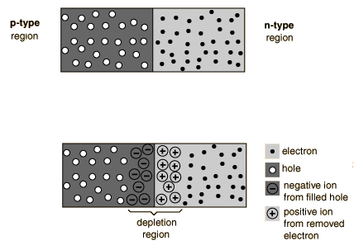
Electrons diffusion
Holes diffusion
P N
Figure 1: Depletion region.
By applying a forward bias on the junction, the depletion region is reduced and electron transfer is allowed. In order to acquire forward bias, an external voltage (battery) must be applied to the junction. The positive voltage of the battery at the P-type semiconductor repels holes towards the junction. Meanwhile, the negative voltage of the battery at the N-type semiconductor also repels electrons towards the junction. Both the holes and electrons started to neutralize the negative and positive ions in the depletion region. Due to the neutralization of ions, the depletion region begins to shrink. Without the strong obstruction from the depletion region, current is able to flow through the diode easily.

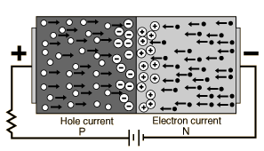
Figure 2: Forward biased PN junction.

Energy is released in the form of photons when the electrons drop from a high orbital to a low orbital. This happens when electrons move across the depletion region to join with holes. The photons released are in frequency band is visible to the human eye hence a LED is able to emit light.

Each of the seven segments (and the decimal point) in a LED display, contains an individual LED. When a suitable voltage is applied to a specific segment LED, current flows through and illuminates. Numerical digits (0 to 9) can be shown by selecting which segments to illuminate. Seven segment displays come in two varieties - common anode (CA) and common cathode (CC). In a CA display, the anodes for the seven segments and the decimal point are joined into a single circuit node while all the cathodes are joined together for a CC display. The anode voltage must be higher (about 7V) than the cathode to illuminate a segment in both displays.

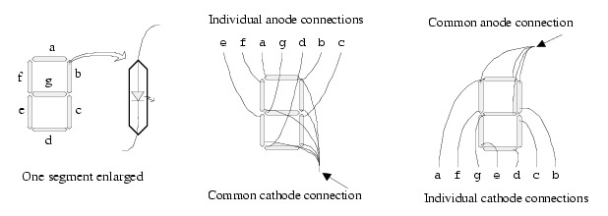
Figure 3: LED displays.

2.2 Liquid Crystal Display (LCD)
A liquid crystal is a substance that can exist in both liquid and solid state. In solid state, molecules always maintain their orientation and stay in the same position with respect to one another. In liquid state, molecules can change their orientation and move to other positions. With the ability to move molecules to different positions and stay in that orientation after the changes, liquid crystal is used in many applications. Different types of liquid crystal substances may react to temperature, pressure or magnetic fields.
A basic LCD design:
I. A mirror (reflection).
II. A piece of glass with a polarizing film on its bottom.
III. A common electrode plane (made of indium-tin oxide on top).
IV. A layer of liquid crystal substance.
V. A piece of glass with an electrode in the shape of the rectangle on the bottom.
VI. Another polarizing film at a right angle to the first one.

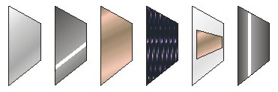
I II III IV V VI

Figure 4: LCD structure.

The electrode of layers II and V is connected to a power source. When there is no current, light entering through the front of the LCD will simply hit the mirror and bounce right back out. When a current is applied to the electrodes, the liquid crystals between layer II and the electrode shaped like a rectangle of layer V untwist. Light is blocked from passing through in that region and a black area of rectangle is shown on the LCD.

3.0 HARDWARE

3.1 7-Segment Displays

3.1.1 Overview
The light intensity of the displays is gathered and interpreted as data. A scanner collects the corresponding light intensity and converts it into a voltage. The light intensity and its location are vital as they are used to determine the scanned digit. Information about the labels of each segment on a 7-segment display is needed. The naming of each individual section is as following:

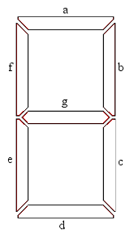
Figure 5: Naming convention of a 7-segment display.

There are many different kinds of 7-segment display and they are not always in the form shown above. Some of the displays may be in different angles, which may produce difficulties in decoding of the digit. This problem is covered more in detail in the software section of this report.

3.1.2 Displays Dimensions
The height of the display posts different problem for the hardware and software during implementation. The main problem is that the digit size is of small calibre, which may cause the scanner unable to detect the difference in light intensities. For example, the number 0 is scanned and the two points in the middle of the digit are of low light intensities. As the scanner is unable to pick the low light intensities, the data may identify the digit as a 1 instead of a 0 when decoding.

A polyethylene lighting aid is created to supply additional light for the scanner to pick up the low light intensities. The polyethylene its acrylic actually is wrapped with aluminium foil with the bright surface facing inwards except the bottom, which is sanded with sandpaper. Each end of the polyethylene is attached with a clear white LED, producing the light source. The light is reflected by the aluminium foil within the polyethylene and only comes out from the sanded bottom side. Figure 7 shows the structure of the lighting aid.

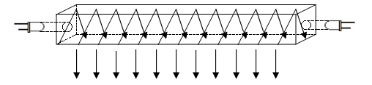
LED
LED
Light Output

Figure 6: Lighting aid structure.

For the software part, the coding has to deal with varying height of displays. Although they have different heights, their lengths of displaying the numerical digits are fixed. When the whole digit is scanned, the length can be segmented into parts through normalizing (refer to Figure 6). Normalizing the digit ensures the correct segments of information allocated to the correct areas regardless of the varying heights.

One drawback of this method is that it only works with LED display and not LCD. The height of the LED displays can be found as light occurs at the maximum and minimum positions of the displays. However, the maximum and minimum positions of the LCD are at the areas where light is blocked.

3.1.3 Displays Recognition
Both LED displays and LCD are commonly use in appliances, thus the scanning of both displays should be made possible. They work on completely different principles and produce different outputs. A way to handle both outputs must be found.

The information that both displays produce are in terms of light intensity, one display emits light while the other reflects and blocks light. This causes problems as the distinguishing between display types during gathering of information may become unclear. It should be noted that a linear CCD is used to gather the information from the displays.
When a scanner scans an LED display, the active segments of the display will produce high peaks in the output. Figure 8 shows the scanning of first part of LED display digit 3. Ideally, the three peaks of data correspond to the active segments ‘a’, ‘g’ and ‘d’ can be seen in the output.

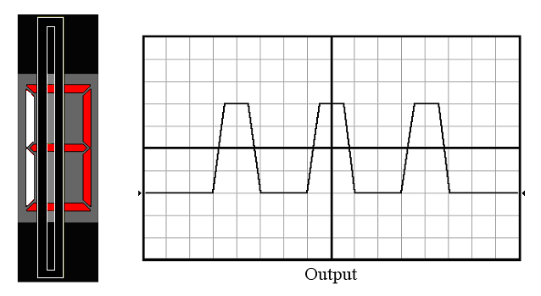
Figure 7: Scan of LED display digit 3.

When the scanner scans a LCD, the areas to show the digits will block light while the background reflect the light. Figure 9 shows four peaks correspond to the area of the background reflecting light. Starting from left of Figure 9, the three depressions correspond to segments ‘a’, ‘g’ and ‘d’ respectively.
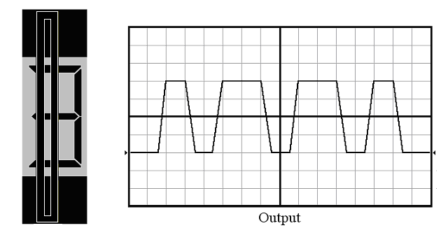
Figure 8: Scan of LCD digit 3.

Since the output of the LED displays and LCD are exact opposites of each other, the amount of light and dark areas can be use to distinguish the displays. It is done by comparing the high peaks of LED displays with the low gutters of LCD and vice versa. The method of comparison states that more dark areas correspond to a LED display while more light areas indicate a LCD. This is true only in the ideal case but not in the situations where extra information or noise is introduced.

Figure 10 shows the scanning of a small LED display digit 9. As the scanner is too large for the small display, additional information occurs on the edges of the scanner. With the additional information, there are more light areas than dark areas in the output. If the method of comparison was used, the scanned display would be identified as LCD, which is incorrect.
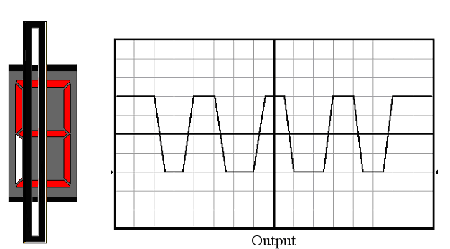

Figure 9: Scan of LED display digit 9.

Currently, there is no foolproof way to determine the type of the display yet. Processing and decoding the information of LED display is much easier and more straightforward than the LCD. Thus, LED display is used and prototyped for the remaining of this report. Ideas on scanning the LCD will be stated in the conclusion section.

3.2 Sensor

3.2.1 Overview
Charged Coupled Device (CCD) sensor collects light from moving labels, thus it is to process the light emitted from a 7-segment display. There are two types of CCD sensor to chose from, either a linear array CCD or an area array CCD. Linear array CCD has its photo sensors (pixels) arranged in a single line while area array CCD’s photo sensors are arranged in columns and rows.
Linear array CCD senses a line of pixels during a single exposure and captures a two-dimensional image through scanning across the picture frame. Area array CCD captures an entire image at once with a single exposure but are more expensive to manufacture. The pixels used to form an area array CDD are typically four times larger than those used in a linear array CCD. Since area array CCD has more pixels to process, its decoding rate is slower. In conclusion, Linear array CCD is more economical, faster and usually in a smaller package.

3.2.2 TSL208R Linear Sensor Array
Texas Advanced Optoelectric Solutions TSL208R linear sensor array (TAOS, 2002) is used because of its height, high frequency, high resolution and low power consuming. It has a height of about 7.5 cm, which is suitable to scan the digits of different lengths of 7-segment displays. One scanner will be enough since the different ranges of 7-segment displays have been covered.

The TSL208R has a linear arrangement of a 512 x 1 array of photodiodes. Each pixel has a height of 120μm, a width of 70μm and a spacing of 55μm in between. With a 125μm centre-to-centre spacing, its 200 Dot-Per-Inch (dpi) resolution is enough for scanning small displays. It allows a high refresh or scanning rate due to its high frequency of 5MHz. A single 5V supply is required for it to operate, which can be provided by a portable battery system.

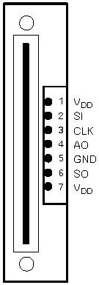
Figure 10: TSL208R layout (Top view)
(TAOS, 2002)

3.2.3 TSL208R Operation
Two input pulses, a serial input (SI) and a clock (CLK) are necessary in order for the TSL208R to function. SI must be ‘high’ for one clock rising edge for an output cycle to begin. It should become ‘low’ before the next incoming clock rising edge to ensure proper operation after meeting the minimum hold time condition (Figure 13). Each clock pulse is correspond to the charge of the sampling capacitor of each pixel connected to a charge-coupled output amplifier. An output voltage, AO is generated by the output amplifier after 512 clock pulses. AO ranges from 0 for no light input, 2V for normal white-level and 3.4V for saturation light level.

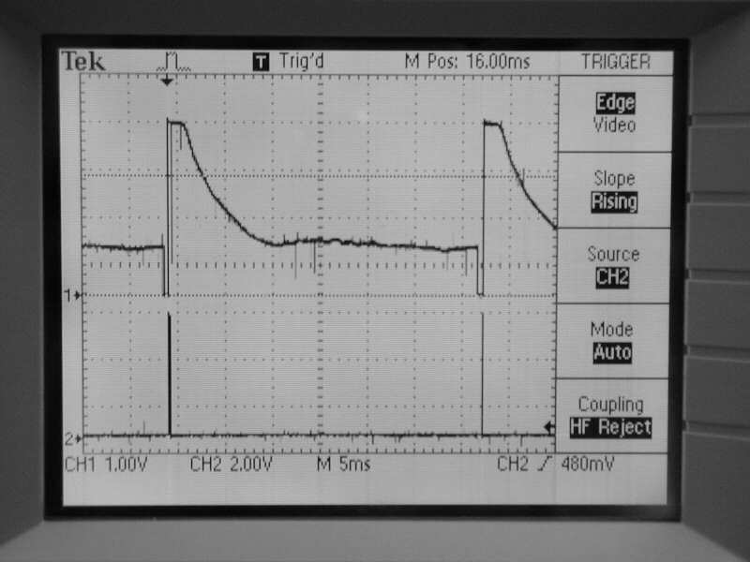

Figure 11: Output voltages of AO (Channel 1) and SI pulse (Channel 2).

From Figure 13, the pixel 1 in the AO waveform is the location of the bottom edge of the TSL208R and the pixel 512 is the location of the top edge. On the 513th clock rising edge, SI pulse is terminated, as the 513th clock pulse is needed to stop the output of the 512th pixel and return to a known state waiting for the next SI pulse. At the same time, AO is set to high impedance. A SI pulse can be input as early as the 514th clock rising pulse, starting another output cycle.

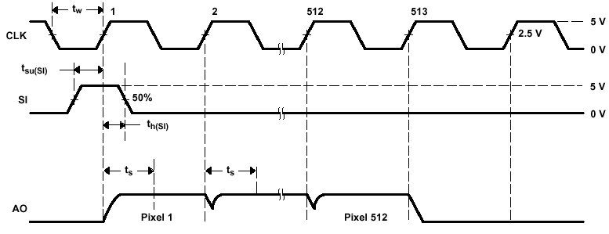
Figure 12: TSL208R timing waveforms.
(TAOS, 2002)

Originally, two dual retriggerable monostable multivibrators and a 555 timer respectively produced the SI and CLK pulses. They provide reliable and accurate output, however their amplitudes and frequencies tend to change with power supply variations. The changes greatly affected the amplitudes and frequencies of the AO, which are unacceptable as unexpected results would be obtained. Another problem is that a small glitch in the AO of the TSL208R occurred when the 555 timer was used to generate the CLK pulse (refer to Figure 14). The disadvantages are eliminated by using the M16C to generate the SI and CLK pulses.
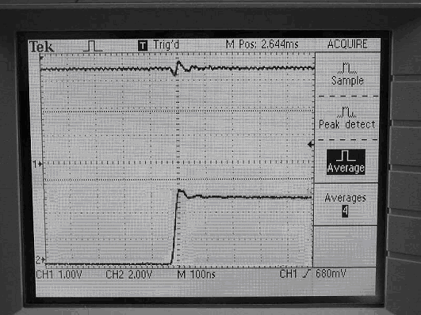
Figure 13: Gltich in A0 (Channel 1) occurs at positive CLK edge (Channel 2).
The TSL208R has a smooth transparent plastic screen use for scanning the 7-segment displays. The device is flushed across the 7-segment displays and smooth scanning is possible as all the covers of the 7-segment displays are either plastic or glass. Scanning flat surface 7-segment displays proved to be no troubles at all but not with convex surface. A slight curvature of the surface allows light to overflow onto adjacent pixels, causing inaccurate, or error scanning.

Speech Output

3.3.1 Overview
Nowadays, 7-segment displays are usually to display the elapse clock time or operation time for appliances. The clock time can switch over to be displayed when the appliances are idling or not in use. For example, the operation time of a microwave is displayed when the user enters the time duration. If there is no input for a certain period, the clock time will be displayed.

The device of this project should be design to cater for both situations. One common thing about both of them is that numerical digits are used for the display and this reduces speech output to the range “one” to “fifty nine”. The word “o’clock” comes in handy for the representation of the clock time. One consideration is that the operating time of some cooking appliances may go beyond 59 minutes into 100 minutes or even more. This collides with the interpretation for the clock time as the scanning of 100 minutes may be recognised and output as “one o’clock”, which is incorrect. This will be confusing as the user keys in the time duration and the speech output turns out to be in terms of time.

It is better that the scanning of 100 minutes is output singly as “one”, “zero” and “zero”. This way, it is less misleading as the previous speech output. Useful speech such as “low battery” or “please re-scan” should be included to aid the user. Not forgetting about other representations (Dot, dash, colon), use by different manufacturers to indicate break in between digits.
Multiple digits interpretation and output are replaced by single digit interpretation and output. The interpretation of the digit is faster and reduction in memory storage of the speeches. Since there is no fix standard, different manufacturers have different standard of sizes and types of 7-segment displays. Simplifying the speech output allows the usage of the device on different types and sizes of 7-segment displays.

Although the device should be flexible and use in all situations consisting of 7-segment displays, it should operate more as an aid to appliances rather on its own. It is assumed that visually impaired people and the blind should already have a general understanding of the appliances that they are handling and use the device as an aid for reassurance. Reassurance in that they have keyed in the right input, if not they could correct it.

3.3.2 ISD1420 Speech Device
Information Storage Devices 1420 (ISD, 2004) is selected to provide the speech output for the system. In the 1400 series, ISD1420 is the most economical and has longer speech duration (20 seconds) storage. It is integrated with an on-chip oscillator, microphone preamplifier, automatic gain control, anti-aliasing filter, smooth filter and speaker amplifier. With these features on board, the complexity of the circuitry to operate the ISD1420 is further simplified.

ISD1420 only requires a 5V supply to operate and has two extra power saving functions. The first function is that the memory storages of speeches need zero power to maintain and the other one is the automatic power off after every play or record session. Since only a single speech output is required after each scan, the two functions ensure that the overall power supply of the system will not be wasted by the ISD1420.

3.3.3 ISD1420 Operation
Activating the respective individual switch enables Recording and playback operations of the ISD1420. Recording has a higher priority than the playback, thus recording operation will take precedence over playback operation. Any current playback operation in process is overwritten by the recording operation when it is run. To initiate a record cycle, the$\overline{\text{REC}}$signal must be pull ‘low’ and this can be done by pressing the Record switch. Holding the Record switch makes the recording continuous until the memory space is filled up. With the memory space being full or the$\overline{\text{REC}}$signal is pull ‘high’, the recording terminates. An “End of Message” (EOM) marker is placed at the end of the recorded message and ISD1420 is power down, waiting for another recording or playback.

The playback operation is similar to the recoding operation, a ‘low’ signal starts the process and a ‘high’ signal ends it. There are two different types of playback, the edge-activated play, PLAYE and the level-activated play, PLAYL. The difference between of them is that PLAYL switch needs to be continually depressed to play one entire recorded message from the beginning or a certain location of the memory space while the PLAYE switch just needs to be hold onto.

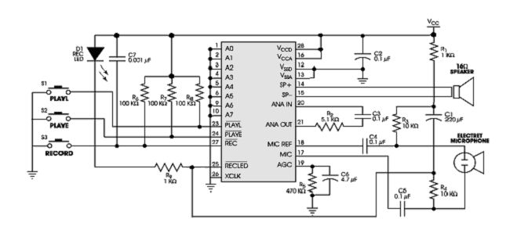
Figure 14: ISD1420 speech output circuit.
(ISD, 2004)

There are several builit-in operational modes providing additional functionalities for ISD1420. The pins 1 to 6 (A0 to A5) and the pins 9 to 10 (A6 and A7) have dual functions and they provide extra features for recording and playback operation. The operational modes of the lower six bits A0 to A5, are decided by the two most significants bit (MSB) of the ISD1420 (A6 and A7). Both bits configure the rest of the bits as addressing or operational mode.

When either one of both pins is ‘low’, all the bits act as the addressing bits of the memory space. Addressing must starts from the least significant bit (LSB) of ISD1420 (A0) to the MSB (A7). By toggling the pins (A0 to A7), the contents in different location of the memory space can be chosen to play. For example, setting the pins as 01010000 allows the message from 10 seconds in the memory space to be played. After deciding the location of the memory space, pressing any of the PLAY switches plays the contents until an EOM marker occurred.
Only when both pins are ‘high’, the rest of bits A0 to A5 act as operational mode expect bit A2 and bit A5. The functionalities are as follow:
- A0 is used to skip from through messages by moving from one EOM maker to the next. This mode is only used for playback and together with A4 mode.
- A1 is used to delete EOM markers. This mode allows message to be record sequentially and a single message to playback with one EOM marker position at the end of the last message. It can also be use with A3 and/or A4 mode.
- A2 and A5 are used.
- A3 is used to play a message from the beginning of the memory space continuously and use with A1 mode. Pressing the PLAYE switch begins the playback and pressing the PLAYL ends it.
- A4 is used to record or play multiple messages and use with A0 and/or A1 mode. In this mode, the address pointer reset is stop and the messages are able to be record or playback consecutively.

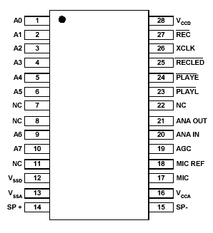
ISD1420
Figure 15: ISD1420 IC.
(ISD, 2004)

3.3.4 Playback and Recording Configuration
It is ideal if different sections of the contents in the memory space could be playback whenever it is needed and multiple messages could be recorded. Figure 17 shows the configuration for the playback and multiple recording mode. Three pins (A4, A6 and A7) are set to ‘high’, ISD1420 is in operational mode and functionality of A4 mode is activated.
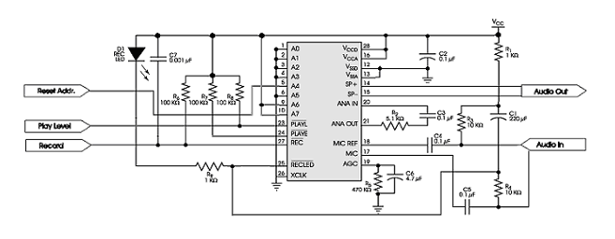
Figure 16: Playback and recording circuit.
(ISD, 2004)

To understand and show the functionality of the A4 mode, two situations are described. The first situation is with A4 mode disable, an EOM marker is position at the end of the message after each recording session. The address pointer is set back to the beginning of the memory space. With the address pointer at the start of the message, which has been recorded, another recording will record over the previous message and marker. This way, only one message will be able to store in the memory space and the address pointer is reset to the beginning of the memory space. Playback of the message is the same as recording, it will play the message until an EOM marker occurred, and the address pointer is reset to the beginning of the memory space. The next message is not able to be playback as the previous message will be playback instead.

The second situation is with the A4 mode enable, the address pointer is stopped from resetting to the beginning of the memory space. This means that recording of multiple messages is possible without overwriting each other. An EOM maker is position at the end of each recorded message and the next recorded message will be stored directly after the EOM marker. The message space will contain multiple EOM markers denoting the beginning and ending of each recorded message. Playback of multiple messages is possible compare to the previous situation. A message is playback until an EOM marker occurred and the next message after the EOM marker is able to be playback.

This method of recording is the most efficient as no memory space is wasted between each recorded message. The messages of numerical digits ‘zero’ to ‘nine’ and others such as ‘point’, ‘low battery’ and ‘please re-scan’ are recorded in the ISD1420 using the abovementioned way. Finding the actual addressing of each message is tedious as each message is of different duration. Only by thoroughly scanning through the address of the memory space, the start of each message can be found. Refer to Appendix B for the addressing of the start of each message.

3.4 Power Source
The power supply should be portable in order to integrate with the other circuities of the device. Electronic components such as resistors, capacitors and ICs are of small shape and size allows the design of a portable power supply. 5V is a common source for the other circuities of the device to operate, thus a 9V battery would be the most suitable portable power supply. A voltage regulator is necessary to regulate the 9V, as it is too ‘rich’ for some of the ICs to operate. A LM7805 voltage regulator (National Semiconductor, 1995) is used because it can output a voltage between 4.8V to 5.2V when the input voltage is between 7V to 20V. There is no guarantee that the voltage regulator will maintain the same output voltage range if the input voltage drops below 7V. This will cause insufficient power to be supplied to the other circuities of the device.

To prevent insufficient power from happening, a voltage comparator (Phillips Semiconductors, 2001) and a 555 timer (Phillips Semiconductors, 2003) are used to keep the input voltage in range. Figure 18 shows the integrated power supply circuit with the voltage regulator, voltage comparator and a 555 timer. The 555 timer is operating in astable mode and the LM311 voltage comparator can operate on a power supply of 5V to 36V.

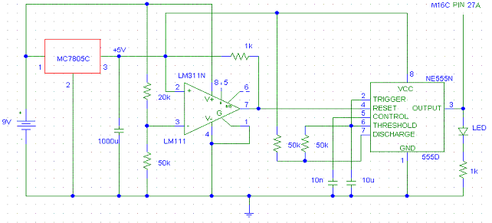
Figure 17: Power supply circuit.

The LM7805 outputs 5V to pin 2 of LM311 when the battery voltage is greater or equal to 7V. Meanwhile, the voltage into pin 3 of LM311 is greater than 5V. Having a higher voltage at pin 3 makes the output of the comparator ‘low’ and the 555 timer is not activated. As the battery voltage drops below 7V, pin 2 still receive a voltage close to 5V however the voltage into pin 3 is less than 5V. The comparator will output a ‘high’ to turn on the 555 timer. When the 555 timer starts to operate, the LED connected to its output starts to flash. The flashing of LED is to inform bystandes that the battery is getting weaker.

The output of the 555 timer connected to pin 27A of M16C will cause an interrupt and activates the speech output device. A ‘low battery’ speech is played and if the speech is playback continously, the battery will drain faster. The LED only requires small amount of power, so it is use to flash continously and the speech will be playback after a few interval. The flashing of LED is another form of notification if the user missed the ‘low battery’ speech.

3.5 MICROCONTROLLER
Mitsubishi M16C/62 microcontroller (Mitsubishi, 2003) is chosen to process information and coordinate the rest of the hardware. It is economical, portable, and popular among the other microcontrollers in the market. It is commonly used in several accessibility projects for the visually impaired people and the blind.

The model of the Mitsubishi controller is M30624FGPFP; it offers 256Kbytes of ROM and 20Kbytes of RAM. It has on board components such ADC, DAC, programmable timers and three-phase motor control. There are 87 programmable I/O ports available for the M16C to handle many peripheral devices. Having a 5V power requirement makes things easier as the power source output is the same. Both C-language and assembly language can be used in the coding of the software.

4.0 SOFTWARE

4.1 Overview
Control software was needed to coordinate and run all the hardware as one device. It was important to consider the behaviour, requirements and limitations of all the hardware when designing and developing the code. An overlook or miscalculation of the hardware will affect the code to run properly. The main input device, TSL208R linear sensor array requires more attention as the data is scanned and collected from there. The considerations for the TSL208R will be discussed further in this section.

The main operation of the software is as follow:

Initialize System
Collect Data
Analyze Data
Output

Figure 18: Main flow diagram.

4.2 Initialisation

Initialize I/O Ports
Initialize Interrupt, Clock, and SI Timers

Clear Data Array
Initialize Variables

Figure 19: Initialisation stages flow diagram.

Initialisation of Ports and Variables: The M16C ports need to be configured as input or output for different usage. The ports in use are:

Port 0 – All the 8 bits are configured as output. The port is used to display digits on the on board 7-segment displays for debugging and confirmation purposes.

Port 1 – All the 8 bits are configured as output. It is used for selecting which 7-segment displays to use.
Port 2 – Two bits are configured as output and the rest as input. The inputs are for the activation button, Clock, SI and output of the scanner. The outputs are for the control of firing speech chip and the addition lighting for the device. The last two bits are not in use.

Port 3 – All the 8 bits are configured as output. It is used for the addressing of the speech chip.

Port 7 – All the 8 bits are configured as output. It is used for the timers, which are providing the SI and CLK pulses. Only bits 3 to 6 are in use.

All the ports are initialised with the necessary variables after the configuration.

Clear Arrays: The data in the storage array are wiped out for the new incoming data. It also prevents the old data from affecting the new ones.

Initialisation of Timers: The M16C timers are configured as pulse wave modulation (PWM) mode to provide for the SI and CLK pulses. Timer A1 is set with 30.16Hz frequency for the SI pulse and timer A2 is set with 15.686 kHz frequency for the CLK pulse.

4.3 Data Retrieval
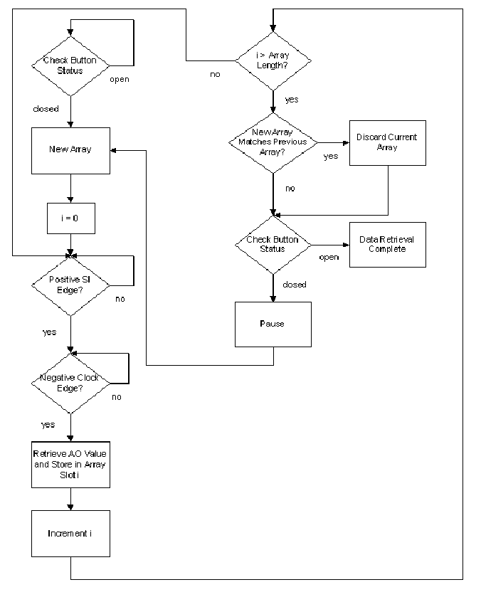
Figure 20: Data retrieval flow diagram.
Wait for initialisation button: A simple push-button is implemented, as a user input is to start the scanning of the displays. To commence the scan, the push-button must be pressed, hold down during the scanning and released when the scan is finished. This implementation is to indicate the beginning and ending of the scanning and avoid the constant data retrieval when the scanner is not operating. Another reason is that light or noise could be mistaken as input for the scanner, causing the device to process the data. This would cause the device to play recorded messages if the data are matched with the requirements set for data recognition. The program will only proceed if the status of the button is closed otherwise the status of the button will checked continuously.

Wait for SI pulse: The SI and CLK pulses run continuously regardless if the initialisation button is pressed. Once the button is activated, any point along the array of the TSL208R could be the starting point of the AO. It is better to start data retrieval at the beginning of an array burst, occurring at the positive edge of SI pulse. This is done by checking the SI output and waiting for the next pulse. To detect a positive edge of the SI pulses, the status of SI output will be constantly checked. The program will process only if the previous status is a ‘low’ and the current state is a ‘high’. Timer A1 is generating the SI pulse, which is also configured as an output port. In order to read the SI pulse, another input port has to be connected to the output of the timer.

Wait for CLK pulse: Data retrieval starts on the following positive CLK edge after the SI is ‘high’ for a minimum holding time. A shortly drop in AO occurs on the positive CLK edge (refer to Figure 22) because of the generated potential switching from previous bit to the current bit (refer to Figure 13). The representation of intensity of the light captured at that particular bit in the linear array is inaccurate. A more accurate reading of the current bit is obtained when it is taken at the negative CLK edge. Data retrieval is therefore change to start on the negative CLK edge.

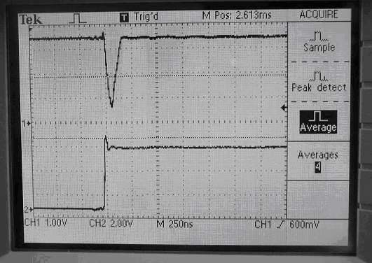
Figure 21: Drop in AO (Channel 1) at positive CLK edge (Channel 2).

Retrieve AO Value: The stored value in the data arrays are converted to 0’s and 1’s to make data processing easier. All the unique bit-data needs to be collected during the whole process of scanning. Information of each individual bit stores as ‘on’ or ‘off’ is sufficient. If the full potential information is store, it will take up more memory space and limit the operation of the device.
The AO is connected directly to an input port of M16C instead of using the Analogue to Digital converter of the M16C. There are two reasons for using the input port. The first reason is that the input port has a threshold voltage of 2.5V, which is a good threshold for a common 7-segment display. The other reason is that the sensitivity of the device is adjustable by using a voltage comparator together with a variable resistor. The light sensitivity of the device can be raise or lower according to the light intensity of the displays.

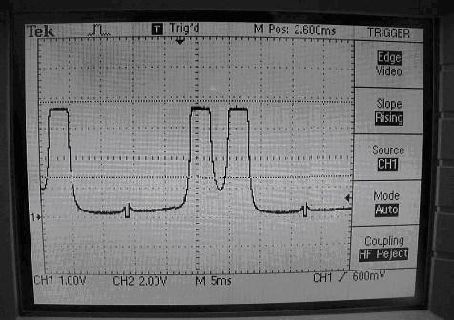
Figure 22: AO with threshold voltage of 2.5V.

Store binary digit: Data is collected from every second bit in the linear CCD array (256 bits) giving 50% resolution. This percentage of resolution is enough for an accurate scan. The resolution can be further increase to 100% by storing data from every bit (512 bits).
Store completed array: The fully filled array is checked for unique and non-zero data and stored them into the data array for further processing. If the array contains all zeros, indicating that it is empty thus it will be discarded. This happens when information was not stored or the user has not scanned any part of the display. If the current array is same as the previous array up to an accuracy of 2 bits, it will also be discarded.

Pause: Not every SI pulse-initiated scan refresh needs to be captured and one may not require such a high refresh rate. After each completed scan, a pause is inserted before the next scan is engaged.

SI has a 30.16 Hz frequency, which corresponds to a period of 33.16ms. By waiting n SI pulses in between scans, the refresh rate of the scanner can be change according to the following formula:
Refresh Rate = $\frac{\text{30}\text{.}\text{16}}{n}$ times per second
Maximum refresh rate could be achieved by choosing the value of n to be 1, in turn accommodating faster scan sweeps.

Check button: After a complete array has been stored in the memory, the program will check the condition of the initialization button to either continue collecting data or start processing collected data. If the button is found to be closed, data retrieval will continue with a new array of data. Otherwise, if the button is found to be open the program will start to analysis the data.

4.4 Data Processing

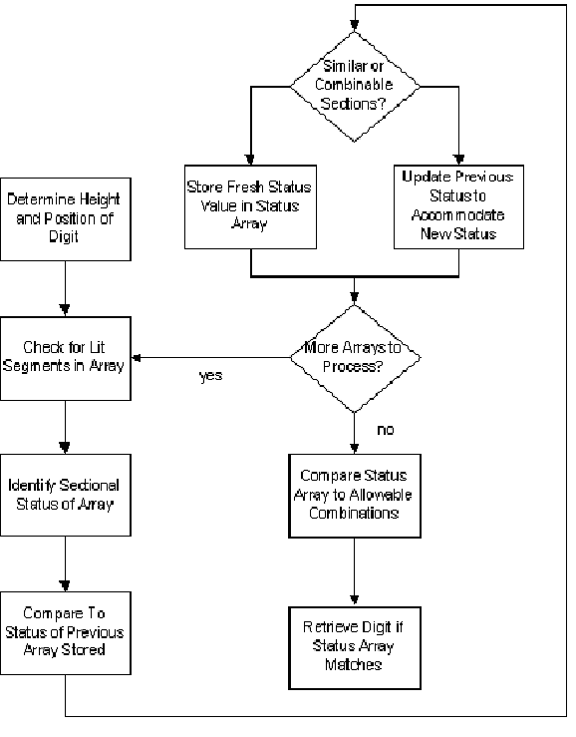
Figure 23: Data processing flow diagram.
Find the height of display: It is essential to locate the beginning and ending point of the 7-segment display in relation to the scanner. So that the bits in the data arrays correspond to the sections of the scanned 7-segment displays can be identify accurately.
Since the height of the numerical digits of the displays is the same, finding the height is much easier. It is simply locating the overall maximum and minimum points in the stored data arrays that pass the light threshold.

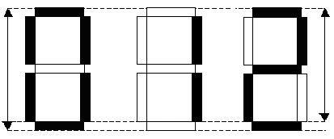
Figure 24: Numerical digit height variations.

The next step is to classify the sections of the segment check if they are turned on or off. The following shows the dimensions of a 25.4mm Kingbright 7-segment display, which was used in this project for testing.
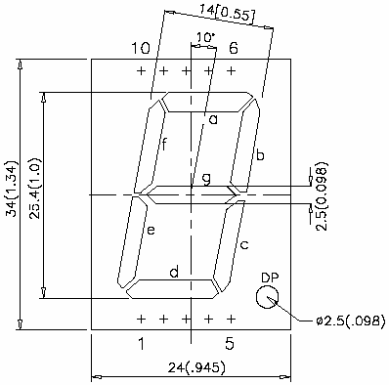
Figure 25: KingBright 25.4mm display.
(KingBright, 2003)

Determine which sections are active: The segment is separated into 5 sections (A to E) and each section is checked. Mid point markers are set to the central bit of each section as they determine whether the section is active or not. The markers are set to the following approximations:

Amid – 0.9
Bmid – 0.7
Cmid – 0.5
Dmid – 0.3
Emid – 0.1
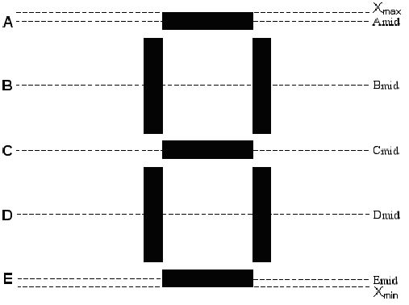
Figure 26: Mid point markers.

Sections B and D are relatively large compare to sections A, C and E. If all the sections are checked with equal priority, the light from sections B and/or D will most likely overflow into sections A, C and E. Hence, the sections B and D are checked first, followed by the sections A, C and E. Only the combination of sections B and D or the combination of sections A, C and E are possible in a single column. If sections B and/or D are active, then sections A, C and E are inactive and vice versa.

A status number table (refer to Table 1) containing the different combinations of sections is created. A status number from the table is then assigned to the status array according to the identification of the status of the sections in a single data array.

Status Number | Active Sections
0 | All off
1 | B & D
2 | B
3 | D
4 | A, C & E
5 | A & C
6 | A & E
7 | C & E
8 | A
9 | C
10 | E

Table 1: Status number.

Sometimes, the user might scan the 7-segment display at different angles instead of the correct 90 degrees angle. For example, a number ‘nine’ scan with the scanner held on an angle will provide the following result in the status array:

0 2 8 5 4 4 4 4 2 1 3 0
(All off, B, A, A&C, A&C&E, A&C&E, A&C&E, A&C&E, B, B&D, D, All off)

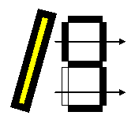
Figure 27: Imperfect scanning.

From the result of the example status array, it can be seen that ‘four’ in the status is repeated for a few times. The repeated statues are discarded, as they are not necessary for the decoding in the later part. The example status array is reduced to:

0 2 8 5 4 4 4 4 2 1 3 0 à 0 2 8 5 4 2 1 3 0

The only possible combinations of sections B and/or D being on are status 2 (B), status 3 (D) and status 1 (B & D). If both statues 2 and 3 occur in the status array, it means that both sections B and D are, thus the both statues are combined into status 1. If any of status 2 or status 3 occurs directly before or after status 1 appears, they will combine into one status 1. The method of status combination is also applied on sections A, C and E.

Previous Status | Current Status | Combined Status
8 (A) | 9 (C) | 5 (A & C)
8 (A) | 10 (E) | 6 (A & E)
8 (A) | 5 (A & C) | 5 (A & C)
8 (A) | 6 (A & E) | 6 (A & E)
8 (A) | 7 (C & E) | 4 (A & C & E)
8 (A) | 4 (A & C & E) | 4 (A & C & E)
9 (C) | 10 (E) | 7 (C & E)
9 (C) | 5 (A & C) | 5 (A & C)
9 (C) | 6 (A & E) | 4 (A & C & E)
9 (C) | 7 (C & E) | 7 (C & E)
9 (C) | 4 (A & C & E) | 4 (A & C & E)
10 (E) | 5 (A & C) | 4 (A & C & E)
10 (E) | 6 (A & E) | 6 (A & E)
10 (E) | 7 (C & E) | 7 (C & E)
10 (E) | 4 (A & C & E) | 4 (A & C & E)
5 (A & C) | 6 (A & E) | 4 (A & C & E)
5 (A & C) | 7 (C & E) | 4 (A & C & E)
5 (A & C) | 4 (A & C & E) | 4 (A & C & E)
6 (A & E) | 7 (C & E) | 4 (A & C & E)
6 (A & E) | 4 (A & C & E) | 4 (A & C & E)
7 (C & E) | 4 (A & C & E) | 4 (A & C & E)
2 (B) | 3 (D) | 1 (B & D)
2 (B) | 1 (B & D) | 1 (B & D)
3 (D) | 1 (B & D) | 1 (B & D)

Table 2: Status combination.
Using the combining status method, the example status array is further reduced to:

0 2 8 5 4 2 1 3 0 à 0 2 5 4 2 1 3 0
0 2 5 4 2 1 3 0 à 0 2 4 2 1 3 0
0 2 4 2 1 3 0 à 0 2 4 1 3 0
0 2 4 1 3 0 à 0 2 4 1 0

Removing the 0 status from both end gives the final status array of
2 (B) 4 (A & C & E) 1 (B & D)

Comparing the final status array with a look-up table of legitimate status array, the identity of the scanned number is obtained.

Digit | Status Array
Zero | 1 6 1
One | 1
Two | 3 4 2
Three | 4 1
Four | 2 9 1
Five | 2 4 3
Six | 1 4 3
Seven | 8 1
Eight | 1 4 1
Nine | 2 4 1

Table 3: Number identification.

If neither of the number identification is matched, there was a scanning error or the digit scanned is invalid.

4.5 Output
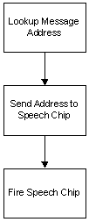

Figure 28: Output flow diagram.

After the program has identified the digit, the last thing to do is to play a pre-recorded speech. The program use a speech chip addressing look-up table (refer to APPENDIX B) to find the desired speech’s address and send it to the ISD speech chip. A pulse is also sent to the chip to start the playback of the desired speech until an EOM occurred.

5.0 RESULTS

5.1 Frequency Selection
The frequency limit of the programmable I/O must be determined in order to select suitable frequency for both SI and CLK. The frequency ratio of the CLK to the SI must at least 514:1 (refer to Figure 13), thus the CLK frequency was found out first. The CLK frequency was set to 62.75 kHz with a period of 16μs. Two separate functions were used to find the CLK edge, one to read A0 and the other to skip (refer to APPENDIX D).

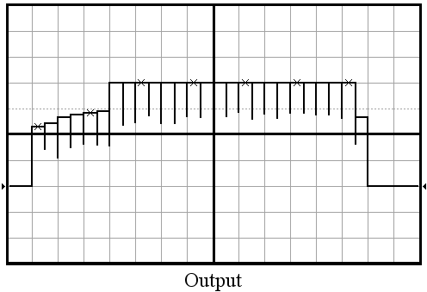

Figure 29: Frequency test 1.

The software code was edited to read and store the values of AO at every negative CLK edge. Figure 31 shows that there are 5 ‘low’ pixels and 17 ‘high’ pixels. The dataArray [] contained 2 ‘low’ pixels and 6 ‘high’ pixels, imply that every third pixel was read. The total time to read and store one pixel onto the M16C was approximately (16μs x 3) = 48μs. The frequency limit of the programmable I/O ports was found to be approximately 20.833 kHz.
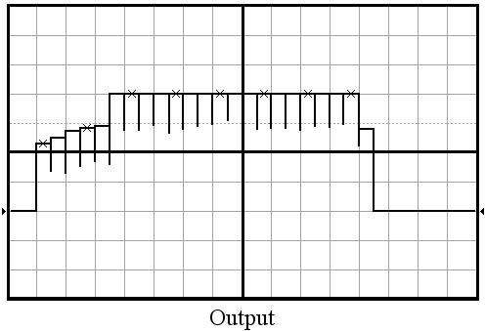

Figure 30: Frequency test 2.

The CLK frequency was configured to 15.686 kHz with a period of 63.75μs so that each pixel is read and stored into M16C. The total time to read and store one pixel onto the M16C was approximately (63.75μs x 2) = 127μs. This value is greater than the minimum required time (64μs) to read off every second CLK edge and within the frequency limit (20.833 kHz) of the I/O ports. SI and CLK were set to 30.16 Hz and 15.686 kHz respectively, giving a ratio of every single SI pulse to 520 CLK pulses.

5.2 Testing
A series of tests were conducted to check the accuracy of prototype shown in Figure 32. Two Kingbright 24mm LED displays were used for the testing of single and double digits scanning. Both displays were fixed together in a Styrofoam to keep them stable and allow double digits scanning. In order to have a smooth scanning and minimum excess light inference, the Styrofoam surface was wrapped in black electrical tape.
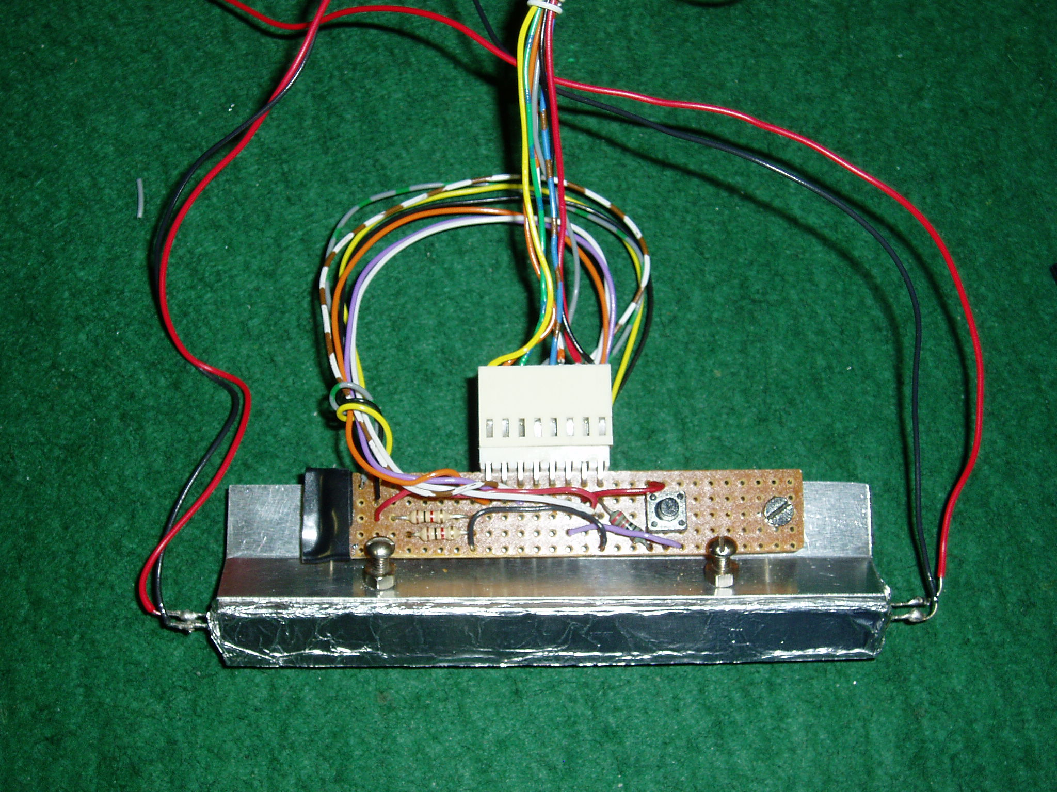
Start Button
Lighting Aid

Figure 31: Scanner (Top View).

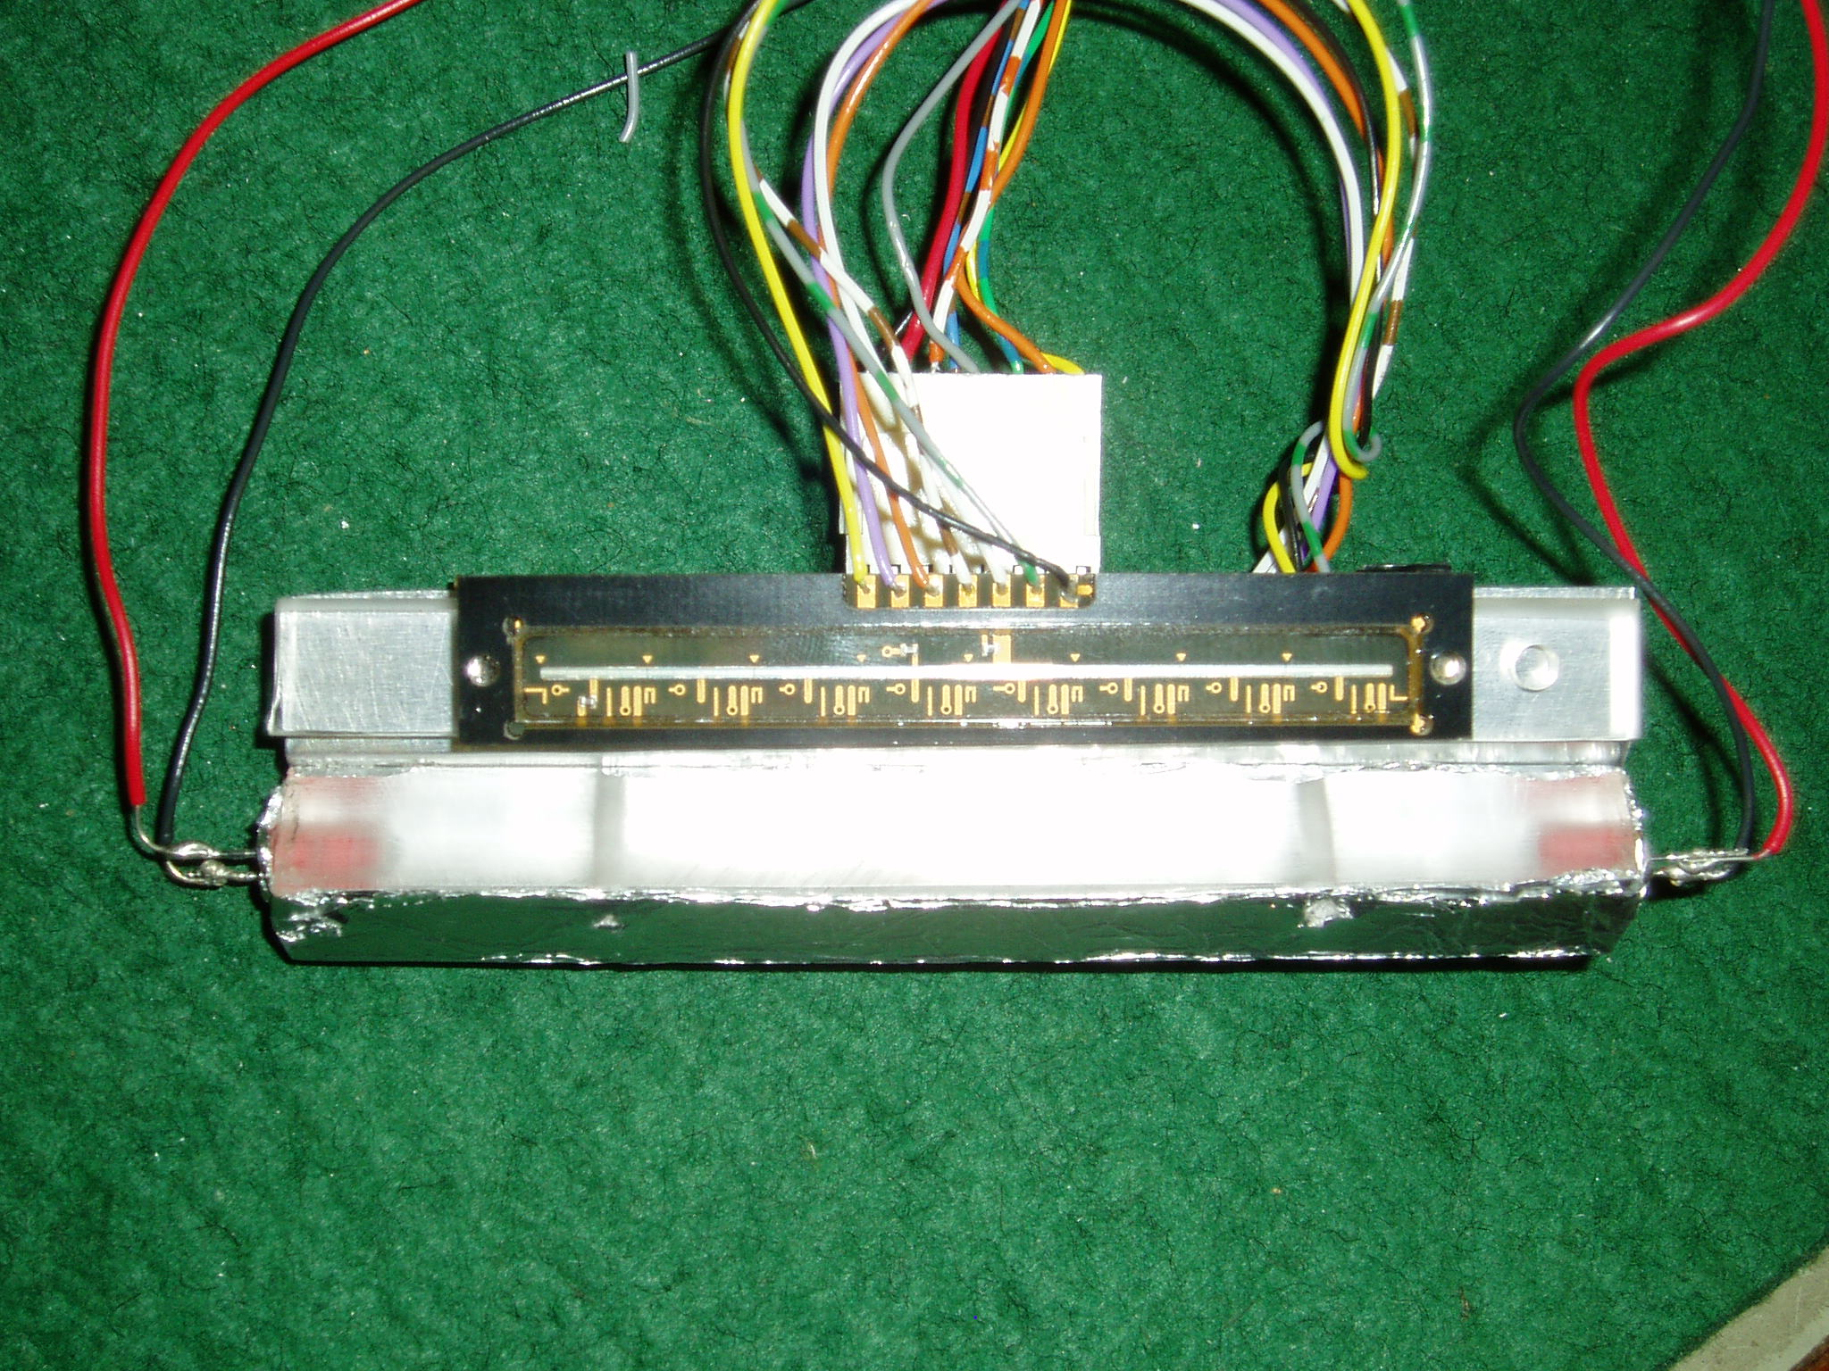
TSL208R Scanner
Lighting Aid
LED
LED

Figure 32: Scanner (Bottom View).
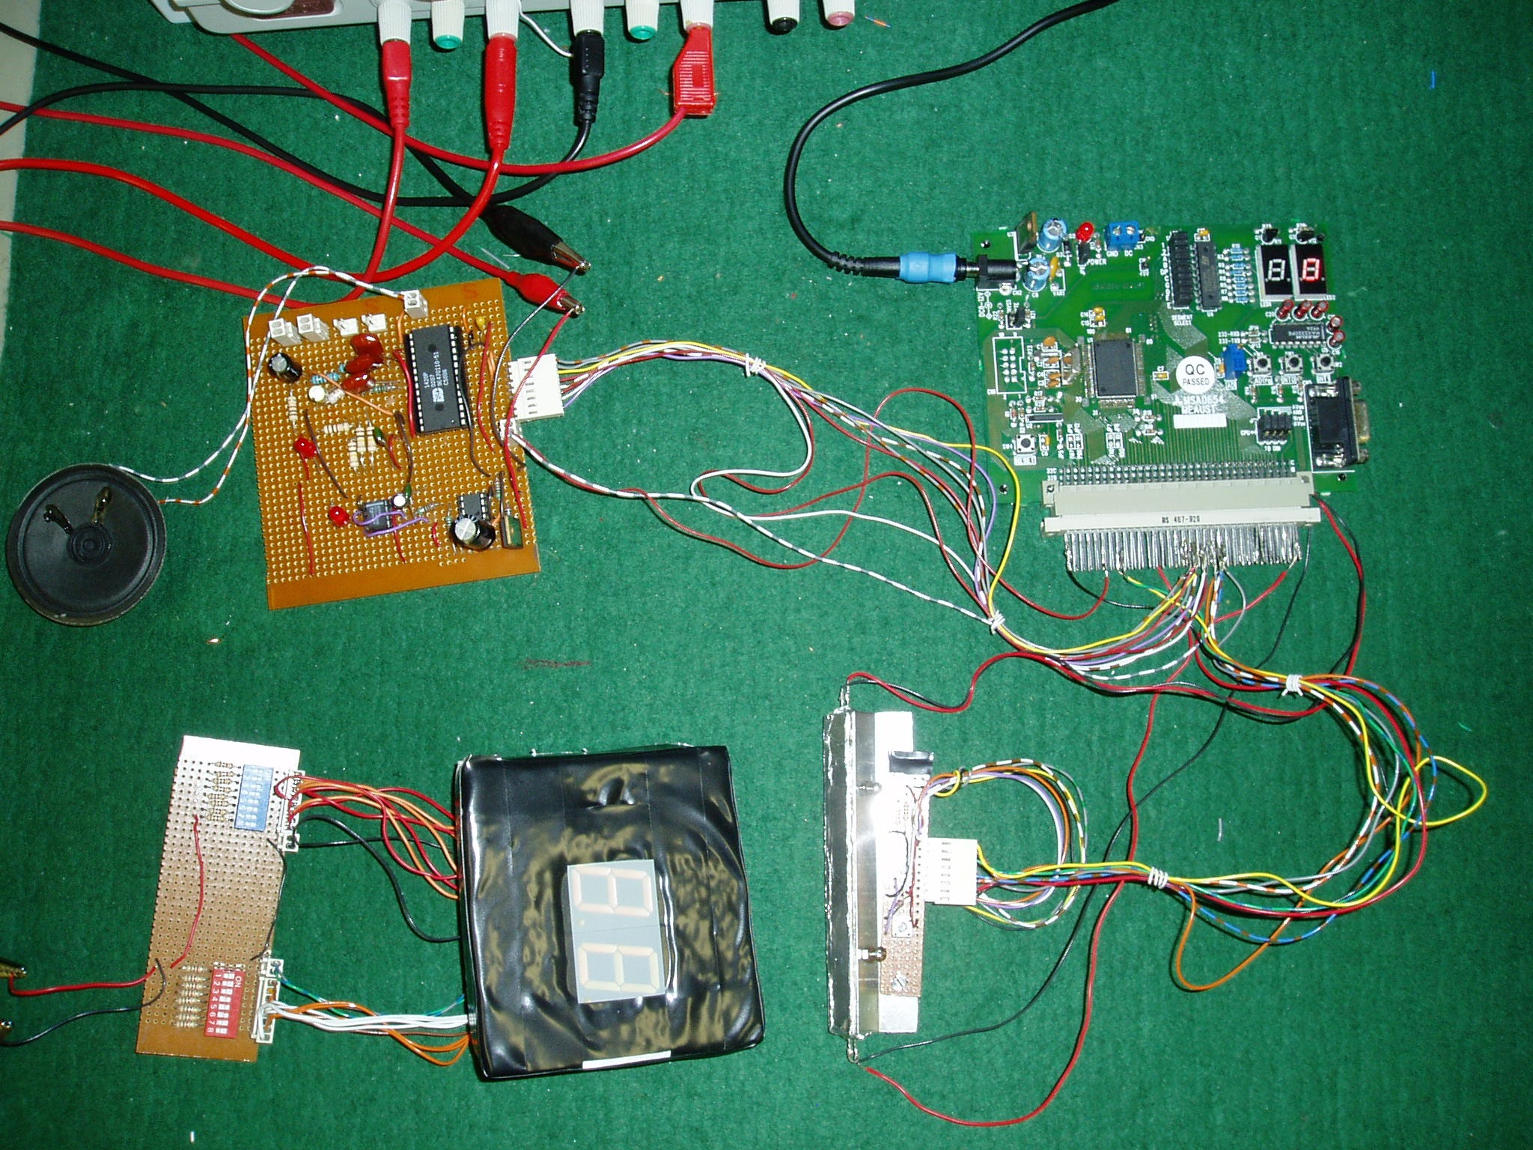
TSL208R Scanner
M16/62 Microcontroller
LED Displays
Power Supply Circuit
ISD1420 Speech Output Circuit

Figure 33: A view of the prototype.

The single LED display digit scanning was conducted first with a series of ten sweeps for each numerical digit. After that, another series of ten sweeps for ten combinations of two different numerical digits were conducted for double LED displays digits scanning.

5.2.1 Single digit testing
 | Test
Digit |  | 1 | 2 | 3 | 4 | 5 | 6 | 7 | 8 | 9 | 10 | Result
Digit | 0 | √ | √ | √ | √ | √ | √ | √ | √ | √ | √ | 100%
Digit | 1 | √ | √ | √ | √ | √ | √ | √ | √ | √ | √ | 100%
Digit | 2 | √ | √ | √ | √ | √ | X | √ | √ | √ | √ | 90%
Digit | 3 | √ | √ | X | √ | √ | √ | √ | √ | √ | √ | 90%
Digit | 4 | √ | √ | √ | √ | √ | √ | √ | √ | √ | √ | 100%
Digit | 5 | √ | √ | √ | √ | √ | √ | X | √ | √ | √ | 90%
Digit | 6 | √ | √ | √ | √ | √ | √ | √ | √ | √ | √ | 100%
Digit | 7 | √ | √ | √ | √ | X | √ | √ | √ | √ | √ | 90%
Digit | 8 | √ | √ | √ | √ | √ | √ | √ | √ | √ | √ | 100%
Digit | 9 | √ | √ | √ | √ | √ | √ | X | √ | √ | √ | 90%
Digit | Total average |  |  |  |  |  |  |  |  |  |  | 95%

Table 4: Single digit testing results.

5.2.2 Double digits testing
 | Test
Digit |  | 1 | 2 | 3 | 4 | 5 | 6 | 7 | 8 | 9 | 10 | Result
Digit | 09 | X | √ | √ | X | √ | √ | X | X | X | √ | 50%
Digit | 12 | √ | X | X | √ | √ | √ | √ | √ | X | X | 60%
Digit | 23 | √ | √ | X | X | √ | X | X | √ | √ | √ | 60%
Digit | 34 | √ | X | X | √ | X | X | X | √ | √ | √ | 60%
Digit | 45 | √ | X | √ | √ | X | √ | √ | X | √ | √ | 70%
Digit | 56 | X | X | √ | √ | √ | √ | X | √ | X | √ | 60%
Digit | 67 | √ | X | X | √ | √ | X | √ | √ | √ | √ | 70%
Digit | 78 | X | X | √ | √ | X | √ | √ | X | √ | X | 50%
Digit | 89 | √ | X | X | √ | √ | √ | X | X | X | X | 40%
Digit | 90 | X | √ | X | X | X | √ | √ | X | √ | √ | 50%
Digit | Total average |  |  |  |  |  |  |  |  |  |  | 57%

Table 5: Double digits testing results.

6.0 CONCLUSION

6.1 Achievements
The current device is able to achieve the following criteria:
- The device works on LED 7-segment displays.
- The device successfully identifies single with an accuracy of 95% (tested on a 24mm 7-segment display).
- The device can identify double 7-segment numerical digits with an accuracy of 57% (tested on a 24mm 7-segment display).
- A clearly audible speech stating the digit scanned is played upon completion of scan
- A ‘please re-scan’ speech is played when an invalid digit is scanned or a wild scanning is encountered.
- A ‘low battery’ warning is played within a few flashing intervals of LED when the battery is getting weaker.
- Additional lighting aid is added to the scanner.
- The device is implemented into two separate PCBs (One for the scanner and the other for the power supply and speech output devices).
- The speed in which the user scans the digit does not affect the output.
- Slightly inaccurate scans will still produce an accurate result.

The device currently carries the following operational limitations:
- The device can scan a digit up to a maximum height of 68mm, and a minimum height so that the incident light entering the scanner does not completely saturate the region.
- The Scanner unit must be held flush against the display when scanning.
- Sharp angled or wild scanning will reduce the chance of a correct output dramatically.
- The device does not scan LCD 7-segment displays.

6.2 Future Recommendations
The possible improvements and further developments left in the system are:
- The ability to identify dots, dash, colons.
- Improve the accuracy of scanning multiple digits.
- Ensure the overall power consumption of the device is low.
- Allow the scanning of increasingly small displays. (12.7mm 7-segment display).
- Allow sharp angled scan sweeps and still produce a correct result.
- Automatically adjust the light threshold to allow for dimly lit LED displays.
- Allow the scanning of LCD 7-segment displays. (using the lighting aid)
- Design and build a unit housing.

7.0 BIBLIOGRAPHY

Kernighan, B.W. & Ritchie D.M. “The C Programming Language”, 2nd Edition, 1988, Prentice Hall

Mitsubishi Electric Australia “Mitsubishi M16C/62 MCU Starter Kit Board (MSA0654-MEAUST) Installation Procedure”, June 2002, Version 2.0
http://www.m16canz.com

Mitsubishi Electric “M16C/62 StarterKit2 User’s Manual”, April 2001, Revision D
http://www.mitsubishichips.com

Renesas Solution Corporation “M3T-NC30WA V.5.10 Release 1 Release Note”, May 2003, First Edition
http://www.renesas.com

Mitsubishi Electric “M16C/60 M16C/20 Series <C language> Programming Manual”, 2001, Revision C4
http://www.mitsubishichips.com

Mitsubishi Electric “M16C/62 Group User’s Manual”, 2001, Revision C4
http://www.mitsubishichips.com

Renesas Technology “M16C/62 Group (M16C/62P) Hardware Manual”, June 2003, Revision 1.11
http://www.renesas.com

KingBright “SC10-21EWA 25.4mm (1.0 Inch) Single Digit Numeric Display Data Sheet”, Dec 2002, Revision V.1
http://www.kingbright.com

KingBright “SC05-21EWA 12.7mm (0.5 Inch) Single Digit Numeric Display Data Sheet”, May 2003, Revision V.2
http://www.kingbright.com

Texas Advanced Optoelectronic Solutions “TSL208R 512 x 1 Linear Sensor Array Data Sheet”, October 2002
http://www.taosinc.com

Winbond Electronics Corporation “ISD1400 Series Single-Chip Voice Record/Playback Device 16- and 20 Second Duration Data Sheet”, March 2004, Revision 1.0
http://www.isd.com

Phillips Semiconductors “NE/SA/SE555/SE555C Timer Data Sheet”, February 2003
http://www.semiconductors.phillips.com

Phillips Semiconductors “LM111/211/311/311B Voltage Comparator Data Sheet”, August 2001
http://www.semiconductors.phillips.com

National Semiconductor “LM78XX Series Voltage Regulators Data Sheet”, February 1995
http://www.national.com

APPENDIX A: M16C Port Allocations

Port | Bit | Type | Pin | CN4 Connection | Function
Port 2 | 0 | Input | 72 | 11C | Initialization Button
Port 2 | 1 | Input | 71 | 11B | SI input
Port 2 | 2 | Input | 70 | 11A | Clock input
Port 2 | 3 | Input | 69 | 12C | Data from scanner (AO)
Port 2 | 4 | Output | 68 | 12B | Fire speech sequence
Port 3 | 0 | Output | 63 | 13A | Speech Chip addressing A0
Port 3 | 1 | Output | 61 | 14C | Speech Chip addressing A1
Port 3 | 2 | Output | 60 | 14B | Speech Chip addressing A2
Port 3 | 3 | Output | 59 | 14A | Speech Chip addressing A3
Port 3 | 4 | Output | 58 | 15C | Speech Chip addressing A4
Port 3 | 5 | Output | 57 | 15B | Speech Chip addressing A5
Port 3 | 6 | Output | 56 | 15A | Speech Chip addressing A6
Port 3 | 7 | Output | 55 | 16C | Speech Chip addressing A7
Port 7 | 2 | Output | 28 | 25C | SI pulse
Port 7 | 4 | Output | 26 | 25A | Clock pulse
Int0 | 1 | Input | 20 | 27A | Low battery signal interrupt

APPENDIX B: Speech Chip Addressing Chart

Data | Address |  |  |  |  |  |  |  | Hex
Data | A7 | A6 | A5 | A4 | A3 | A2 | A1 | A0 | Hex
“One” | 0 | 0 | 0 | 0 | 0 | 0 | 0 | 0 | 0x00
“Two” | 0 | 0 | 0 | 0 | 0 | 1 | 1 | 0 | 0x06
“Three” | 0 | 0 | 0 | 0 | 1 | 1 | 0 | 1 | 0x0C
“Four” | 0 | 0 | 0 | 1 | 0 | 1 | 1 | 1 | 0x12
“Five” | 0 | 0 | 0 | 1 | 1 | 1 | 0 | 1 | 0x17
“Six” | 0 | 0 | 1 | 0 | 0 | 1 | 0 | 0 | 0x1C
“Seven” | 0 | 0 | 1 | 0 | 1 | 1 | 0 | 1 | 0x20
“Eight” | 0 | 0 | 1 | 1 | 0 | 1 | 1 | 0 | 0x25
“Nine” | 0 | 0 | 1 | 1 | 1 | 1 | 0 | 1 | 0x2B
“Zero” | 0 | 1 | 0 | 0 | 0 | 1 | 0 | 0 | 0x2F
“Point” | 0 | 1 | 0 | 0 | 1 | 1 | 0 | 0 | 0x34
“Low Battery” | 0 | 1 | 0 | 1 | 0 | 1 | 0 | 0 | 0x39
“Please Rescan” | 0 | 1 | 0 | 1 | 0 | 1 | 0 | 0 | 0x40

APPENDIX C: Ledspkrdata.h Code Listing
/***************************************************************/
/* Header File for MSA0654-MEAUST board */
/* Filename: ledspkrdata.h */
/* Written by: Alan Suyko 28/7/99 */
/* Updated to include spoken digits by Wei Chou Han */
/* November, 2004. */
/***************************************************************/

/*
A
F |_| B Inner segment - G
E |_| C Decimal point - DP
D

Condition: LED Segment On = Logic 0, LED Segment Off = Logic 1

--------------------------------------------------------------------------------------------------------------------
| Digit | DP | G | F | E | D | C | B | A |P0 data|
--------------------------------------------------------------------------------------------------------------------
| 0 | 1 | 1 | 0 | 0 | 0 | 0 | 0 | 0 | C0 |
--------------------------------------------------------------------------------------------------------------------
| 1 | 1 | 1 | 1 | 1 | 1 | 0 | 0 | 1 | F9 |
--------------------------------------------------------------------------------------------------------------------
| 2 | 1 | 0 | 1 | 0 | 0 | 1 | 0 | 0 | A4 |
--------------------------------------------------------------------------------------------------------------------
| 3 | 1 | 0 | 1 | 1 | 0 | 0 | 0 | 0 | B0 |
--------------------------------------------------------------------------------------------------------------------
| 4 | 1 | 0 | 0 | 1 | 1 | 0 | 0 | 1 | 99 |
--------------------------------------------------------------------------------------------------------------------
| 5 | 1 | 0 | 0 | 1 | 0 | 0 | 1 | 0 | 92 |
--------------------------------------------------------------------------------------------------------------------
| 6 | 1 | 0 | 0 | 0 | 0 | 0 | 1 | 0 | 82 |
--------------------------------------------------------------------------------------------------------------------
| 7 | 1 | 1 | 1 | 1 | 1 | 0 | 0 | 0 | F8 |
--------------------------------------------------------------------------------------------------------------------
| 8 | 1 | 0 | 0 | 0 | 0 | 0 | 0 | 0 | 80 |
--------------------------------------------------------------------------------------------------------------------
| 9 | 1 | 0 | 0 | 1 | 1 | 0 | 0 | 0 | 98 |
--------------------------------------------------------------------------------------------------------------------
*/

unsigned char leddigit[10] = {0xC0,0xF9,0xA4,0xB0,0x99,0x92,0x82,0xF8,0x80,0x98}; // digits 0-9
unsigned char speakdigit[13] = {0x2F, 0x00, 0x06, 0x0C, 0x12, 0x17, 0x1C, 0x20, 0x25, 0x2B, 0x34, 0x39, 0x40 };

APPENDIX D: 7Segment.c Code Listing

/*******************************************************************/
/* Engineering Project Code , 7-Segment Display Reader */
/* Wei Chou, Han (12327487) */
/* Curtin University of Technology, Bentley. */
/* This code works as of 1st November 2004, */
/* Copyright 2004. */
/*******************************************************************/

#include "sfr62.h"
#include "ledspkrdata.h"
#pragma INTERRUPT int0

#define arrayNo 25 // number of available arrays to store data
#define SIpause 1 // number of SI pulses to skip to act as a pause
#define arrayLength 256 // half the size of TSL208R array in bits

#define Amid 0.9 // ratios used to segment digit
#define Bmid 0.7
#define Cmid 0.5
#define Dmid 0.3333
#define Emid 0.1

/*global variables*/

int
i, j, z, // general counters
Xmin, Xmax, value, // top and bottom of 7-seg display being scanned
arrays, // total number of linear arrays scanned currently
dataArray[arrayNo][arrayLength], // arrays of input data (0s and 1s)
digit, // identified 7-seg number
statusArray[10], // collection of unique statuses
status, // current status
getVout, // voltage AO from scanner
tempArray[arrayLength], // used to check for change in data with previous array
Apoint, Bpoint, // sectional markers of 7-seg display
Cpoint, Dpoint,
Epoint, //
// 0: all off
// 1: B + D ||A ------
// 2: B ||------| |
// 3: D || | |
// 4: A + C + E ||B | |
// 5: A + C ||______| |
// 6: A + E ||C ------
// 7: C + E ||------| |
// 8: A || | |
// 9: C ||D | |
// 10: E ||______| |
// 11: decimal ||E ------

endOfNumber, // flag that signifies end of digit scanned
timecount,
button; // last known state of initialisation button (Port 2_0)
/*prototypes*/

void initPort(void); // initialise the M16 I/O ports
void initInterrupt(void); // initialise int0
void initTimers(void); // setup timers on m16 for SI and CLK
void initArray(void); // resets arrays after each run
void initVariables(void); // initialise necessary global variables
void detectButton(void); // checks for button press
void detectSI(void); // checks for existance of SI pulse
void detectClock(void); // checks for positive clock edge
void getPixel(void); // gets output from scanner
void checkArray(void); // ensures zeros or same data is not stored
void maxminDetect(void); // detects maximum and minimum markers, and also calculates // sectional divisions
void actualMax(void); // finds max if scanner edge has extra information
void actualMin(void); // finds min if scanner edge has extra information
void checkSegments(void); // checks to see if segments are lit
void checkACE(void); // checks segments A, C and E
void checkBD(void); // checks segments B and D if ACE are all off
void numberType(void); // decodes sectional information into a recognised digit
void pause(void); // pause between subsequent array gathering sessions
void speakNumber(void); // speaks number or error message
void int0(void); // low battery interrupt

/*************************************************************/
/* The main function waits for the initialisation button */
/* to be depressed. Then it stores the data from the */
/* TSL208R until it runs out of memory or it finds zero */
/* data. It then determines the digit that was scanned */
/* and provides a speech output to the user. */
/**************************************************************/

void main(void)
{
initPort();
initInterrupt();
initTimers();
initArray();

while(1)
{
initVariables();

p1 = 0xFD;
/*DETECT BUTTON PRESS TO BEGIN SCANNING*/
p0 = leddigit[0];

while(button == 0) detectButton();
p0 = leddigit[1];

while(button == 1)
{
i = 0;
detectSI();
while(i < arrayLength)
{
detectClock();
getPixel();
}
checkArray();
detectButton();
if (arrays == arrayNo) button = 0;
if (endOfNumber == 1) button = 0;
}
p1 = 0xFE;
p0 = 0xFF;
if (arrays > 0)
{
maxminDetect();
if ((Xmin != 0) && (Xmax != arrayLength))
{
checkSegments();
numberType();
if (digit == 12) p0 = 0x86;
else speakNumber();
}
}
initArray();
}
}

/*********************************************************/
/* This function initialises the necessary global */
/* variables required for a fresh scan */
/*********************************************************/
void initVariables(void)
{
Xmin = arrayLength;
Xmax = 0;
status = 0;
button = 0;
arrays = 0;
j = 0;
z = 1;
getVout = 0;
endOfNumber = 0;
}

/**************************************************************/
/* This function sets the M16 ports to input and output */
/* modes. */
/**************************************************************/
void initPort(void)
{
pd0 = 0xFF; // output mode
pd1 = 0xFF; // output mode
pd2 = 0x10; // input mode
pd3 = 0xFF; // output mode
pd7 = 0xFF; // output mode
pu00 = 0; // no pull up for P0_0 to P0_3
pu01 = 0; // no pull up for P0_4 to P0_7
pu02 = 0; // no pull up for P1_0 to P1_3
pu03 = 0; // no pull up for P1_4 to P1_7
pu04 = 0; // no pull up for P2_0 to P2_3
pu05 = 0; // no pull up for P2_4 to P2_7
pu06 = 0; // no pull up for P3_0 to P3_3
pu07 = 0; // no pull up for P3_4 to P3_7
pu16 = 0; // no pull up for P7_0 to P7_3
pu17 = 0; // no pull up for P7_4 to P7_7
p1 = 0xFD; // enable LED2 and disable LED1
p0 = 0xFF; // turn off all segments
p2 = 0x10; // initialise bit 4 to one and the rest of port 2 to zero
p3 = 0x00; // initialise port 3 to zero
p7 = 0xFF; // initialise port 7
}

/*********************************************************/
/* This function enables INT0 interrupt. */
/*********************************************************/
void initInterrupt(void)
{
int0ic = 1;
asm("fset i");
timecount = 0;
}

/***************************************************************/
/* This function configures the timers on the M16 to act */
/* as SI (30.16Hz) and CLK (15.686kHz). */
/***************************************************************/
void initTimers(void)
{
// SI CN4-25C
ta1mr = 0xA7; // count source = 10: f32 (2us)
ta1 = 0x0140; // m = 64 = 30.16Hz. n = 1

// CLK CN4-25A
ta2mr = 0x27; // count source = 00: f1 (62.5ns)
ta2 = 0x7F03; // m = 3 = 15686Hz. n = 127

tabsr = 0x06; // Starts timer counting flag for A1 and A2

// cycle time = 1/f1 x (m+1) x 255
// high level width = 1/f1 x (m+1) x n
}

/************************************************************/
/* This function resets the contents of each array, */
/* ready for the next scan. */
/************************************************************/
void initArray(void)
{
for (j = 0; j < arrayNo; j++)
{
for (i = 0; i < arrayLength; i++)
{
dataArray[j][i] = 0;
tempArray[i] = 0;
}
}

for (i = 0; i < 10; i++)
{
statusArray[i] = 0;
}
}

/**********************************************************/
/* This function checks if the initialisation button is */
/* depressed. */
/**********************************************************/
void detectButton(void)
{
if (p2_0 == 0) button = 0;
else button = 1;
}

/*********************************************************/
/* This function waits for a POSITIVE SI edge */
/*********************************************************/
void detectSI(void)
{
while (p2_1 == 1)
{}
while (p2_1 == 0)
{}
}

/*********************************************************/
/* This function waits for a NEGATIVE CLK edge */
/*********************************************************/
void detectClock(void)
{
while (p2_2 == 0)
{}
while (p2_2 == 1)
{}
p0 = leddigit[7];
}

/*********************************************************************/
/* This function reads the ouput from AO at NEGATIVE CLK */
/* edges. */
/*********************************************************************/
void getPixel(void)
{
while (p2_2 == 0)
{}
while (p2_2 == 1)
{}

dataArray[j][i] = p2_3;
i++;
p0 = leddigit[4];
}

/******************************************************************/
/* This function checks the previous scan with the */
/* current scan. If there is a change of at least 3 */
/* pixels it stores the array. It also ensures that no */
/* empty arrays are stored. This function also enables */
/* the endOfNumber flag when data has stored and zero */
/* data is found. */
/******************************************************************/
void checkArray(void)
{
int dataChange = 0, nonZero = 0;

for (i=0; i<arrayLength; i++)
{
if (tempArray[i] != dataArray[j][i]) dataChange++;
if (dataArray[j][i] != 0) nonZero++;
}

if ((dataChange > 2) && (nonZero > 0))
{
for (i=0; i<arrayLength; i++)
{
tempArray[i] = dataArray[j][i];
}

j++;
arrays++;
}

if ((nonZero == 0) && (arrays > 0))
{
endOfNumber = 1;
}
}

/***************************************************************/
/* This function detects the max and min points of the */
/* digit that was scanned. It checks to make sure it */
/* avoids extra data on the edges of the scan. It also */
/* calculates the segments of the digit. */
/***************************************************************/
void maxminDetect(void)
{
int tempValue, checkPoint, flagMax = 0, flagMin = 0;
j = 0;

while(j < arrays)
{
value = dataArray[j][0];
checkPoint = 0;

for (i = 1; i < arrayLength; i++)
{
if (value != dataArray[j][i]) checkPoint++;
value = dataArray[j][i];
}

for (i = 0; (i < arrayLength) && (dataArray[j][i] != 1); i++) tempValue = i;
if (tempValue < Xmin) Xmin = tempValue;

for (i = arrayLength; (i > 0) && (dataArray[j][i] != 1); i--) tempValue = i;
if (tempValue > Xmax) Xmax = tempValue;

if (checkPoint == 2 || checkPoint == 4 || checkPoint == 6)
{
if (Xmax == arrayLength)
{
flagMax = 1;
flagMin = 1;
}

if (flagMax == 1) actualMax();
if (flagMin == 1) actualMin();
}
else if ((checkPoint == 3) || (checkPoint == 5) || (checkPoint == 7))
{
if (Xmax == arrayLength) flagMax = 1;
if (flagMax == 1) actualMax();

if (Xmin == 0) flagMin = 1;
if (flagMin == 1) actualMin();
}
else if (checkPoint == 8)
{
actualMax();
actualMin();
}
else if (checkPoint == 1) // should re-scan data
{
Xmin = 0;
Xmax = arrayLength;
}
j++;
}

Apoint = ((Xmax - Xmin)*Amid + Xmin);
Bpoint = ((Xmax - Xmin)*Bmid + Xmin);
Cpoint = ((Xmax - Xmin)*Cmid + Xmin);
Dpoint = ((Xmax - Xmin)*Dmid + Xmin);
Epoint = ((Xmax - Xmin)*Emid + Xmin);
}

/************************************************************/
/* This function finds the correct maxpoint if there is */
/* extra data on one of the scanners edge. */
/************************************************************/
void actualMax(void)
{
int maxCheck = 0, maxValue = 0;
value = 1;

for (i = arrayLength; (i > 0) && (maxCheck < 2); i--)
{
if (value != dataArray[j][i]) maxCheck++;
value = dataArray[j][i];
maxValue = i;
}

if (maxValue > Xmax) Xmax = maxValue;
}

/***********************************************************/
/* This function finds the correct minpoint if there is */
/* extra data on one of the scanners edge. */
/***********************************************************/
void actualMin(void)
{
int minCheck = 0, minValue = arrayLength;
value = 1;

for (i = 0; (i < arrayLength) && (minCheck < 2); i++)
{
if (value != dataArray[j][i]) minCheck++;
value = dataArray[j][i];
minValue = i;
}

if (minValue < Xmin) Xmin = minValue;
}

/*****************************************************************/
/* This function checks to see which segments are on or */
/* off. */
/*****************************************************************/
void checkSegments(void)
{
j = 0;

while(j < arrays)
{
checkBD();
j++;
}
}

/*****************************************************************/
/* This function is used to check the B and D segments. */
/*****************************************************************/
void checkBD(void)
{

/* SECTION B AND D ARE ON */
if ((dataArray[j][Bpoint] == 1) && (dataArray[j][Dpoint] == 1))
{
if (status != 1)
{
if (status == 2 || status == 3) z--;
statusArray[z] = 1;
z++;
status = 1;
}
}

/* SECTION B IS ON */
else if (dataArray[j][Bpoint] == 1)
{
if (status != 2)
{
if (status == 3)
{
z--;
statusArray[z] = 1; // B, then D. assumed to be BD
}
else statusArray[z] = 2;
z++;
status = 2;
}
}

/* SECTION D IS ON */
else if (dataArray[j][Dpoint] == 1)
{
if (status != 3)
{
if (status == 2)
{
z--;
statusArray[z] = 1; // D then B. assumed to be BD
}
else statusArray[z] = 3;
z++;
status = 3;
}
}
else checkACE();
}

/*********************************************************/
/* This function is used to check the A, C and E */
/* segments. */
/*********************************************************/
void checkACE(void)
{

/* SECTIONS A, C AND E ARE ON */
if ((dataArray[j][Apoint] == 1) && (dataArray[j][Cpoint] == 1) && (dataArray[j][Epoint] == 1))
{
if (status != 4)
{
if (status == 5 || status == 6 || status == 7 || status == 8 || status == 9 ||
status == 10) z--;
statusArray[z] = 4;
z++;
status = 4;
}
}

/* SECTIONS A AND C ARE ON */
else if ((dataArray[j][Apoint] == 1) && (dataArray[j][Cpoint] == 1))
{
if (status != 5)
{
if (status == 8 || status == 9) z--;
statusArray[z] = 5;
z++;
status = 5;
}
}

/* SECTIONS A AND E ARE ON */
else if ((dataArray[j][Apoint] == 1) && (dataArray[j][Epoint] == 1))
{
if (status != 6)
{
if (status == 8 || status == 10) z--;
statusArray[z] = 6;
z++;
status = 6;
}
}

/* SECTIONS C AND E ARE ON */
else if ((dataArray[j][Cpoint] == 1) && (dataArray[j][Epoint] == 1))
{
if (status != 7)
{
if (status == 9 || status == 10) z--;
statusArray[z] = 7;
z++;
status = 7;
}
}

/* SECTION A IS ON */
else if (dataArray[j][Apoint] == 1)
{
if (status != 8)
{
statusArray[z] = 8;
z++;
status = 8;
}
}

/* SECTION C IS ON */
else if (dataArray[j][Cpoint] == 1)
{
if (status != 9)
{
statusArray[z] = 9;
z++;
status = 9;
}
}

/* SECTION E IS ON */
else if (dataArray[j][Epoint] == 1)
{
if (status != 10)
{
statusArray[z] = 10;
z++;
status = 10;
}
}

/* ALL SECTIONS ARE OFF */
else
{
if (status != 0)
{
statusArray[z] = 0;
status = 0;
}
}
}

/***************************************************************/
/* This function determines the digit that was scanned. */
/***************************************************************/
void numberType(void)
{
if (statusArray[1] == 1)
{
if (statusArray[2] == 4)
{
if (statusArray[3] == 3) digit = 6; //number is six
else if (statusArray[3] == 1) digit = 8; //number is eight
}
else if ((statusArray[2] == 6) && (statusArray[3] == 1)) digit = 0; //number is zero
else if (statusArray[2] == 0) digit = 1; //number is one
else if (statusArray[2] == 10) digit = 10; //number is point
}
else if ((statusArray[1] == 3) && (statusArray[2] == 4) &&
(statusArray[3] == 2)) digit = 2; //number is two
else if ((statusArray[1] == 4) && (statusArray[2] == 1)) digit = 3; //number is three
else if (statusArray[1] == 2)
{
if ((statusArray[2] == 9) && (statusArray[3] == 1)) digit = 4; //number is four
else if (statusArray[2] == 4)
{
if (statusArray[3] == 3) digit = 5; //number is five
else if (statusArray[3] == 1) digit = 9; //number is nine
}
}
else if ((statusArray[1] == 8) && (statusArray[2] == 1)) digit = 7; //number is seven

else digit = 12; //number is ERROR
}

/*********************************************************/
/* This function acts as a delay. */
/*********************************************************/
void pause(void)
{
int SIcount = 1;

while(SIcount <= SIpause)
{
detectSI();
SIcount++;
}
}

/****************************************************************/
/* This function addresses to the ISD1420 to provide a */
/* speech output. */
/***************************************************************/
void speakNumber(void)
{
p0 = leddigit[digit];
p3 = speakdigit[digit];
p2_4 = 0;
pause();
p2_4 = 1;
}

/******************************************************************/
/* This function produces a warning speech when low */
/* battery occurs. */
/******************************************************************/
void int0(void)
{
digit = 11;

if (timecount == 2)
{
speakNumber();
timecount++;
}
else if (timecount == 6) timecount = 0;

else timecount++;
}

