8.9.2 Lab: Configure an Ethernet NIC to use DHCP

Introduction

Print and complete this lab.

In this lab, you will configure an Ethernet NIC to use DHCP to obtain an IP address.

Recommended Equipment
- Linksys 300N router
- A Computer running Window XP Professional
- Ethernet patch cable

Step 1
Plug one end of the Ethernet patch cable into “Port 1” on the back of the router.

Plug the other end of the Ethernet patch cable into the network port on the NIC in your computer.

Plug in the power cable of the router if it is not already plugged in.

Turn on your computer and log on to Windows as an administrator.

Click start

Right-click My Network Places, and then choose Properties.

The “Network Connections” window appears.

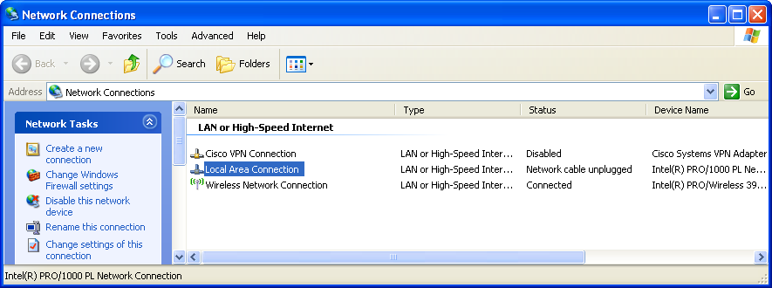

Picture My Network Places and choose Properties

Step 2
Right-click Local Area Connection, and then choose Properties.

The “Local Area Connection Properties” window appears.

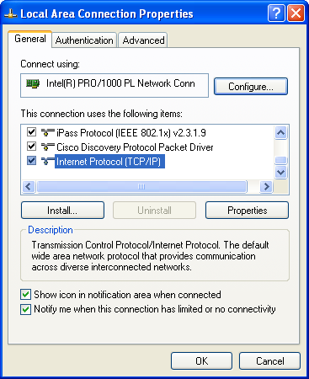
Picture Local Area Connection and then choose Properties

What is the name and model number of the NIC in the “Connect using:” field?

What are the items listed in the “This connection uses the following items:” field?

Step 3
Choose Internet Protocol (TCP/IP).

Click Properties.

The “Internet Protocol (TCP/IP) Properties” window appears.
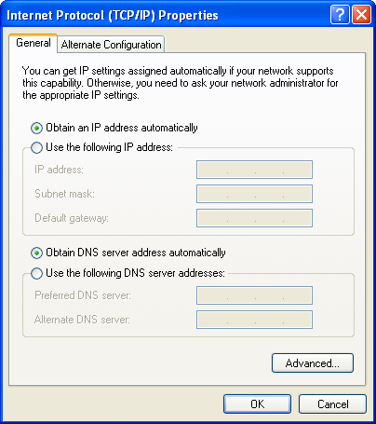
This picture shows Internet Protocol (TCP/IP) Properties alternate configuration

What is the IP address, Subnet mask, and Default gateway listed in the fields of the “Use the following IP address:” area?

Click the Obtain an IP address automatically radio button.

Click OK.

The “Internet Protocol (TCP/IP) Properties” window closes.

This picture shows Local Connection Properties
Click OK.

Restart your computer.

Step 4
Log onto Windows as an administrator.

Check the lights on the back of the NIC. These lights will blink when there is network activity.

Choose Start > Run....

Type cmd and click OK.

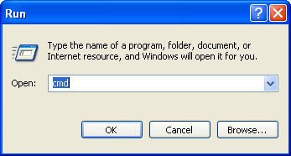
Picture, type the name of a program etc and Windows will open it for you
DType ipconfig/all, and then press the Enter key.
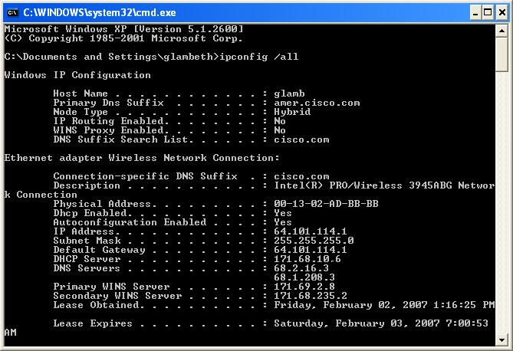
Diagram Microsoft Windows XP 1version 5.111.26001
What is the IP address and subnet mask of the “Ethernet Adapter Local Area Network Connection”?

What is the IP address of the DHCP server?

On what date was the Lease Obtained?

On what date does the Lease Expire?

