5.6.3 Lab: Windows Registry Backup and Recovery

Introduction

Print and complete this lab.

In this lab, you will back up a computer registry. You will also perform a recovery of a computer registry. The registry is also called System State data.

Recommended Equipment
The following equipment is required for this exercise:
- A computer system running Windows XP is required for this exercise.

Step 1
Log on to the computer as yourself.

Click Start > Run.

Type ntbackup and then click OK. The “Backup or Restore Wizard” window appears.

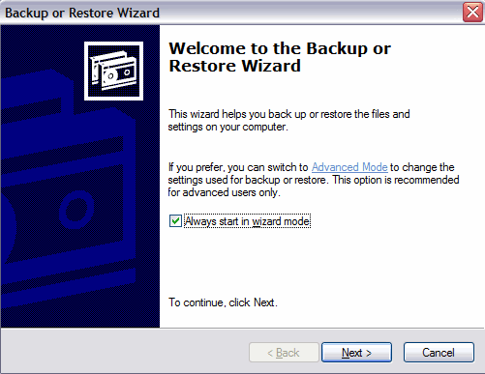

Step 2
Click Advanced Mode.

The Backup Utility window appears.

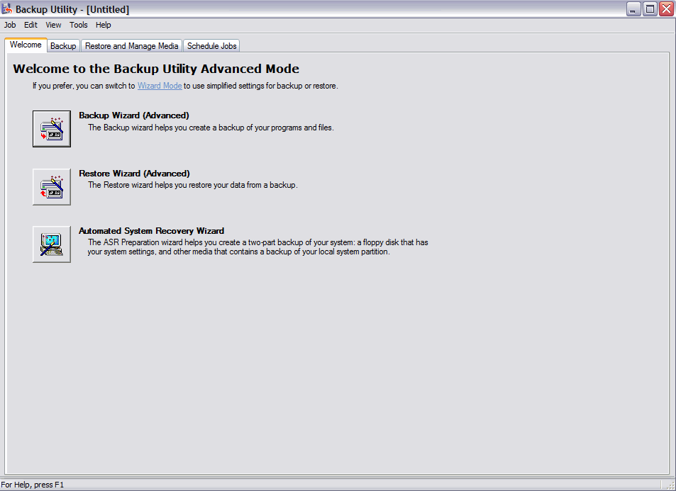
This is a picture of the Backup Utility window

Step 3
Click Backup Wizard.

The “Welcome to the Backup Wizard” window appears.

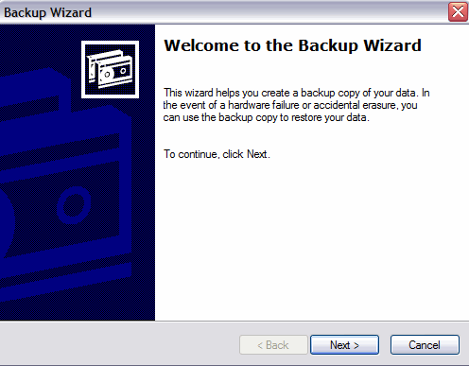

Step 4
Click Next.

Click the Only back up the System State data radio button.

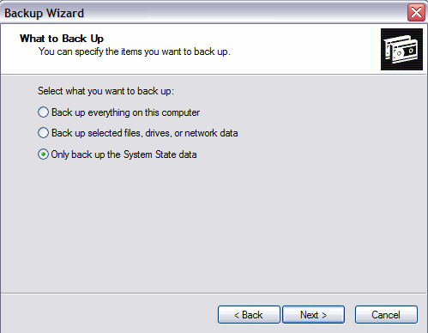

Step 5
Click Next.

The “Backup Type, Destination, and Name” window appears.

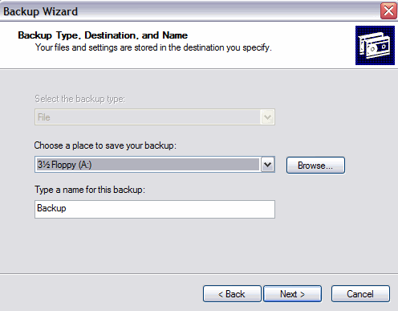

Step 6
Click Browse….

If you are asked to insert a disk into the floppy disk drive, click Cancel.

The “Save As” dialog box appears.

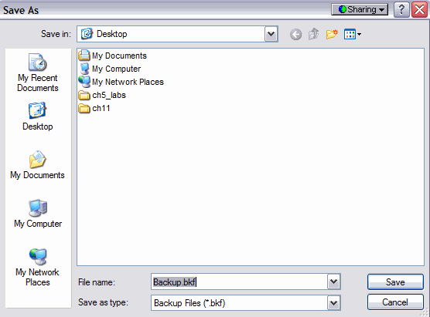
This is a picture of the Save As dialog box

Step 7
Click the My Documents icon on the left side of the “Save As” dialog box.

Click Save.

The “Backup Type, Destination, and Name” window re-appears.

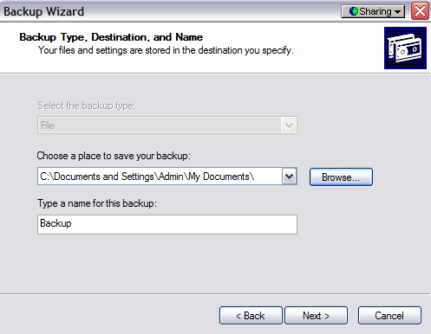

Step 8
Click Next.

The “Completing the Backup Wizard”

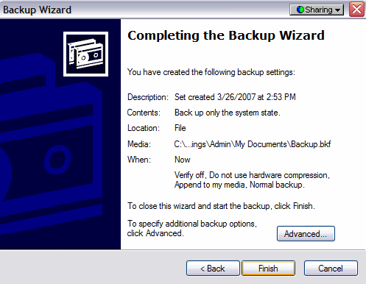

Step 9
Click Advanced….

The “Type Of Backup” window appears.

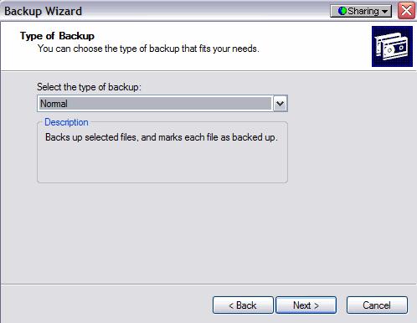

This is a picture of the Type of Backup window

The default backup type is “Normal”. If available, make sure that “Backup Migrated Remote Storage Data” is not checked.

Step 10
Click Next.

The “How To Backup” window appears.

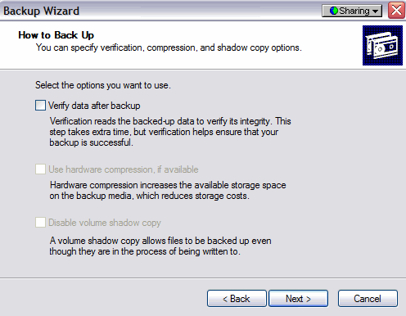

This picture shows you can specify verification, compression, and shadow copy options

Step 11
Click the Verify Data After Backup check box, and then click Next.

The “Backup Options” window appears.

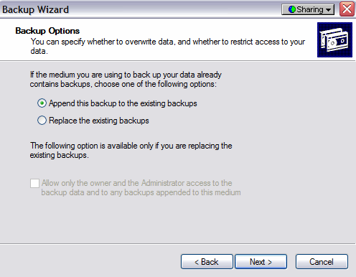

This picture shows you can specify whether to overwrite data and restrict access to your data

Step 12
Click Replace the existing backups, and then click Next.

The “When to Back Up” window appears.

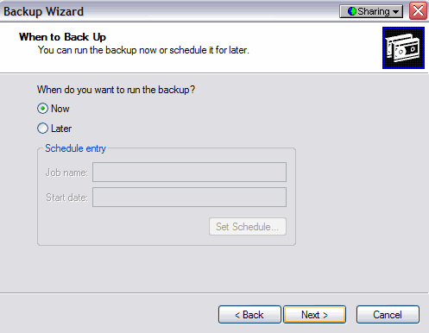

Step 13
At the “When To Back Up” window, click Now and then click Next.

The “Completing the Backup Wizard” window appears.

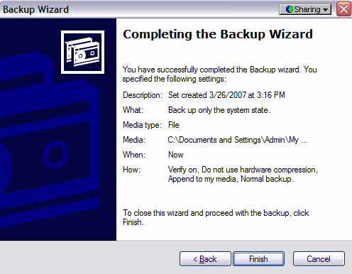

Step 14
Click Finish.

The “Backup Progress” window appears.

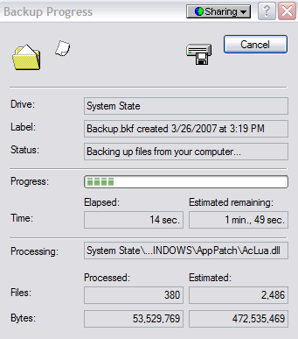

The “Backup Progress” window indicates that the backup is complete.

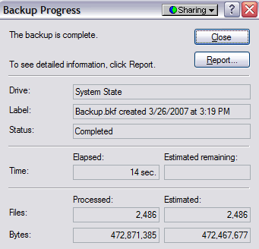

Step 15
Click Report.

The Notepad application window appears containing the report.

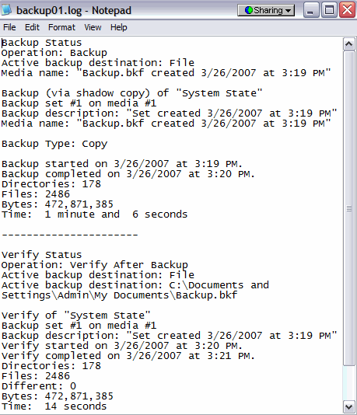

Close Notepad.

In the Backup Progress dialog box, click Close.

Close the Backup Utility.

Step 16
Click Start > Run….

Type regedit in the “open:” field. The Registry Editor window appears.

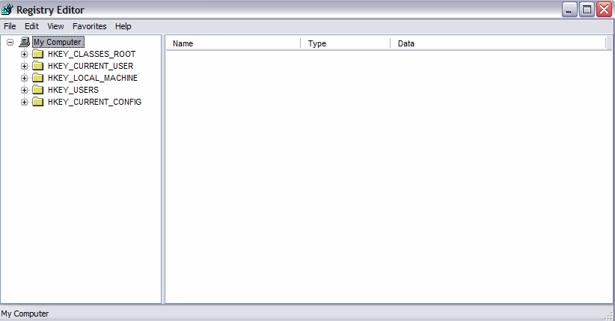

Step 17
Expand the HKEY_CURRENT_USER Registry Key.

Expand the Control Panel Registry Key.

Expand the PowerCfg Registry Key

Right-Click the Screen Saver.Stars Registry Key

Click Delete

Click File > Exit in the Registry Editor window.

Browse to the “My Documents” folder and locate the “backup.bkf” file.

Double-click the backup file to bring up the Backup Utility Wizard.

Click Next.

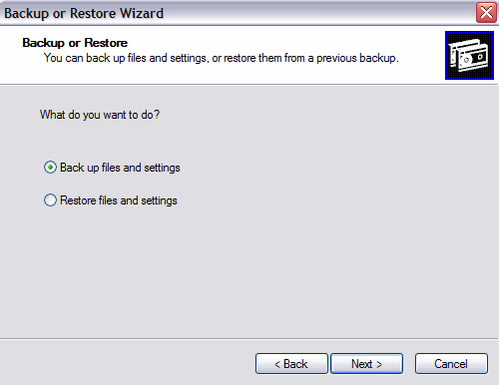

This picture you can backup or Restore

Step 18
Click the Restore files and settings radio button and then click Next.

The “What to Restore” window appears.

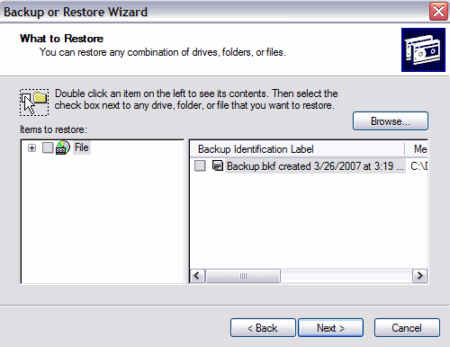
This picture shows you can restore any combination of drives, folders, or files

Step 19
Expand the file.

Expand the backup.bkf file.

Click the System State check box.

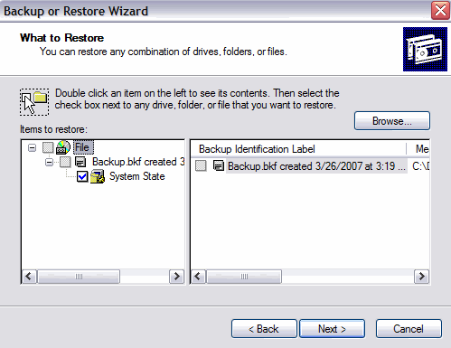

This picture shows you can restore any combination of drives, folders, or files

Step 20
Click Next.

The “Completing the Backup or Restore Wizard” window appears.

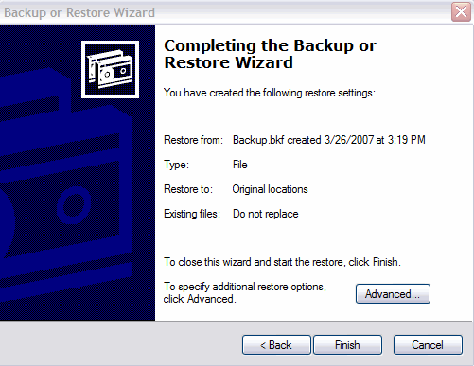

Step 21
Click Advanced.

The “Where to Restore” window appears.

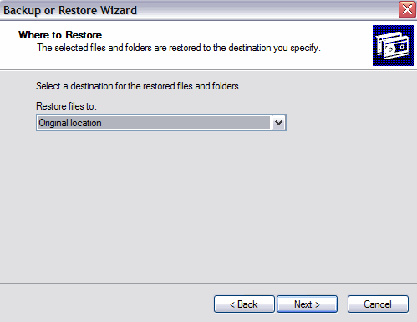

Step 22
The default restoration location is “Original location”.

Click Next.

The “Restoring System State will always overwrite current System State unless restoring to an alternate location.” Warning window appears.

Click OK.

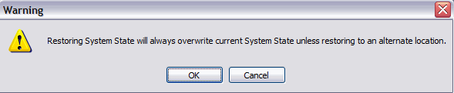

Step 23
Click the Replace existing files if they are older than the backup files radio button.

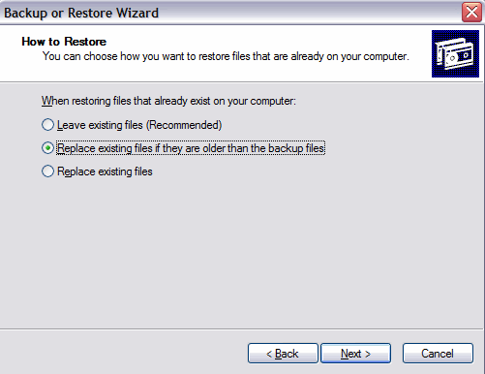

Step 24
Click Next.

The “Advanced Restore Options” window appears

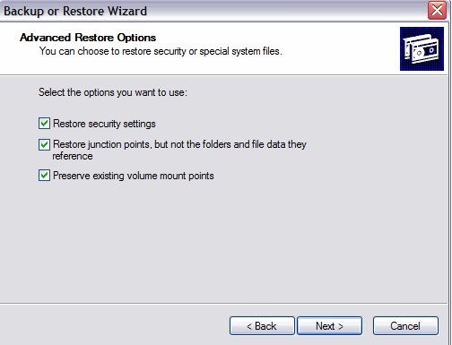

Be sure that all three check boxes are selected, and then click Next.

Click Finish.

The system recovery begins by copying the files back to the computer.

When prompted to restart the computer, click Yes. The computer will restart.

Step 25
Click start > Run….

Type regedit in the “Open:” field.

Click OK.

You should see the “Screen Saver.Stars” Registry key in the Registry Editor application window.

Click File > Exit.

- How does backing up the system state files save time?

