5.5.4 Lab: Install Third-Party Software

Introduction

Print and complete this lab

In this lab, you will install and remove a third party software application by using the Microsoft Windows XP Professional Installation CD. The student will install the CITRIX ICA 32-bit Windows Client application.

Recommended Equipment

The following equipment is required for this exercise:
- A computer system that is using Windows XP
- A Microsoft Windows XP installation CD

Step 1
Log on to the computer with the Administrator account.
Place the Windows XP Professional installation CD into the CD drive. Use Windows Explorer to navigate to the following folder:
D:\VALUEADD\3RDPARTY\MGMT\CITRIX

Locate the ICA32.exe application in the folder. Click the ICA32 icon to start the installation process of the Citrix application. You may need to double-click the icon to start the installation.

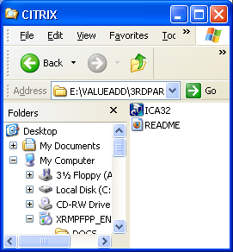

The above picture is your CITRIX page

Step 2
Click Next when the InstallShield Wizard window opens.

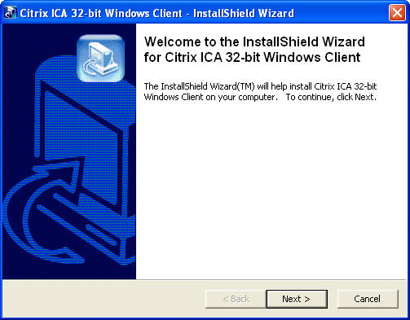

Picture Welcome to the InstallShield WIZARD

window opens displaying the file extraction progress.

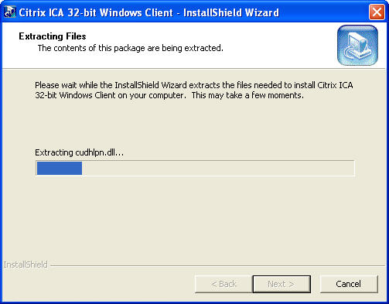

pPicture Extracting files
After the files have been extracted, the ICA Client Setup program begins. Click Next to begin the installation.

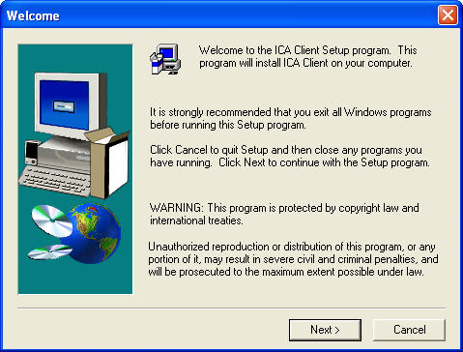

Picture Welcome to the ICA Client Setup program
Click Yes on the License agreement.

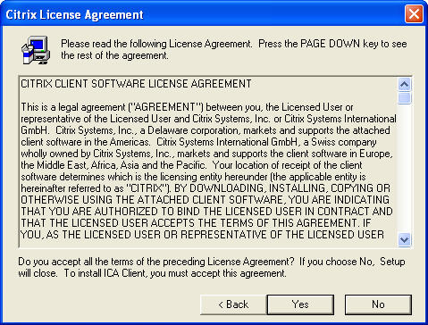
This picture is License agreement
Use the default location. Click Next.

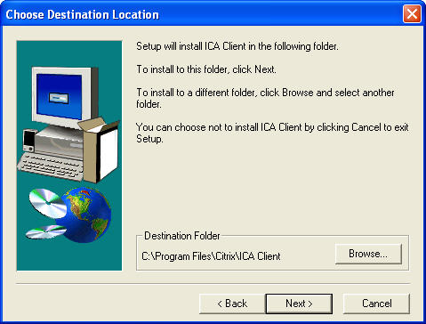

Picture Choose Destination Location
Use the default location. Click Next.

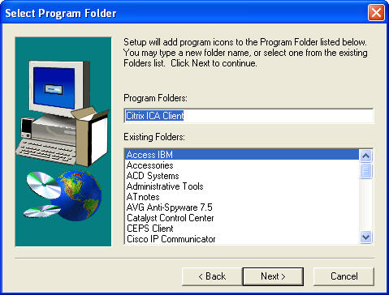
Picture Select Program Folder
Enter “student” as the ClientName. Click Next.

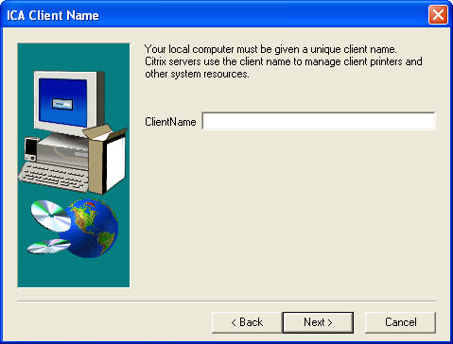

Picture Enter “student” as the ClientName
In the Select Desired Features window, leave the default choice of No. Click Next.

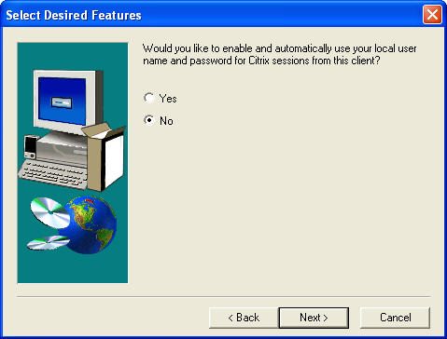
Picture Select Desired Features window
You have successfully installed the Citrix program.

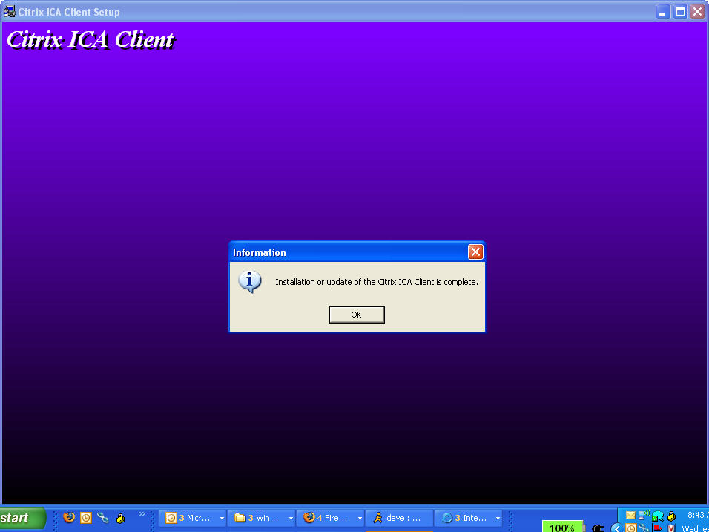

Step 3
To uninstall a program, choose Start > Control Panel > Add or Remove Programs. Click the Citrix ICA Client in the list. Click Change/Remove.

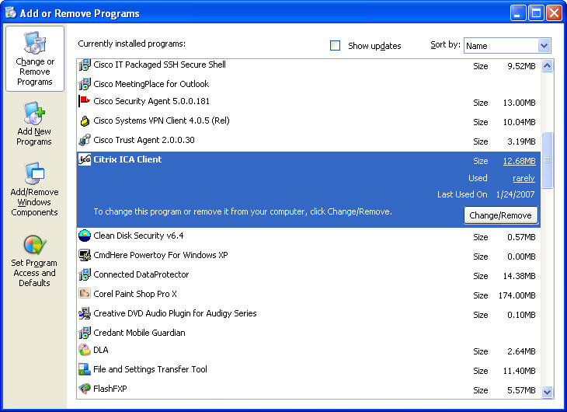

This picture is add or remove programs
Click Yes to confirm the removal.

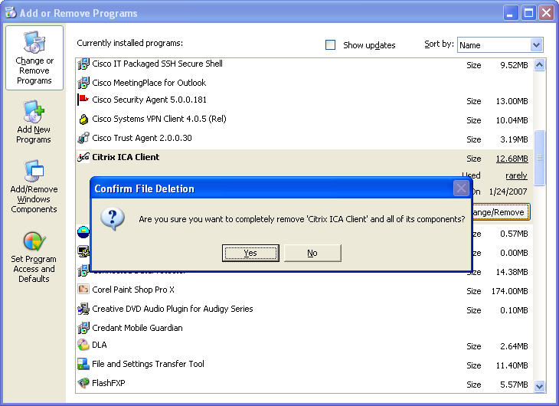
Picture Confirm removal

The following screen will appear displaying the removal progress:

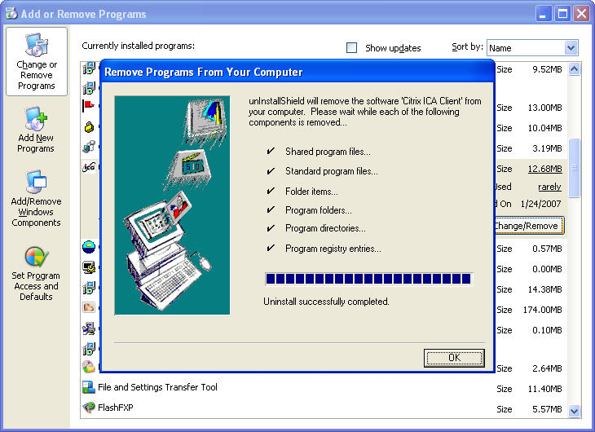
Picture Add or Remove a program
After the application removal process, the Add or Remove Programs window no longer shows the Citrix ICA Client in the list.

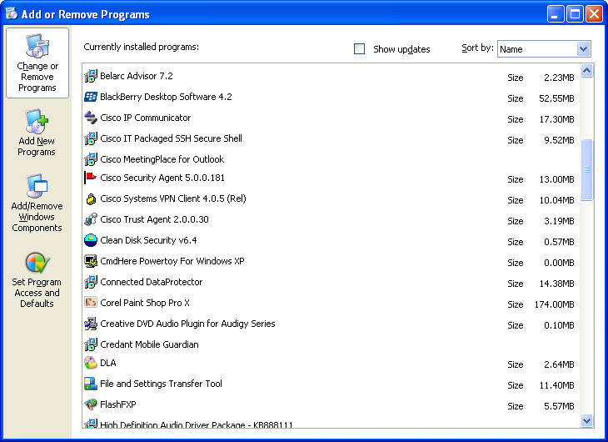
Picture After application removal [rocess the Add or Remove Program window shows

- Why does Microsoft recommend using Add/Remove Programs to remove an installed application?

