5.5.1 Lab: Run Commands

Introduction

Print and complete this lab.

In this lab, you will open the same program by using the Windows Explorer and the “run…” command.

Recommended Equipment
The following equipment is required for this exercise:
- A computer system running Windows XP

Step 1
Boot the computer and log on as yourself.

Right-click the start button and then click Explore.

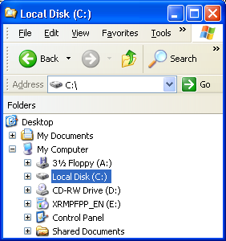

The above picture shows your Local Disk (C:)

Step 2
Right-click the Local Disk(C:) hard disk drive.

Click Properties and then click the Disk Cleanup button.

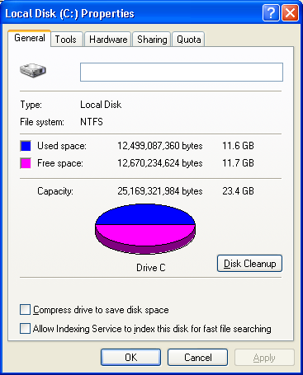
Picture Local Disk (C:) hard disk drive

The Disk Cleanup for (C:) window appears.

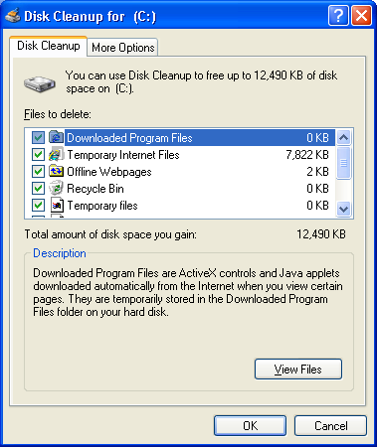

Picture Disk Cleanup for C: window
Windows calculates the amount of space used by unnecessary files.

Click Cancel.

Step 3
Open the Run dialog box by clicking Start > Run….

Type cleanmgr in the “Open:” field.

Click OK.
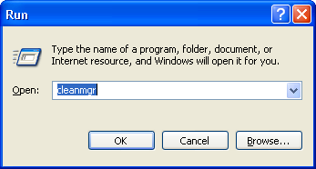

Picture Type name of program etc and Windows willopen for you
The “Disk Cleanup for (C:)” window opens.

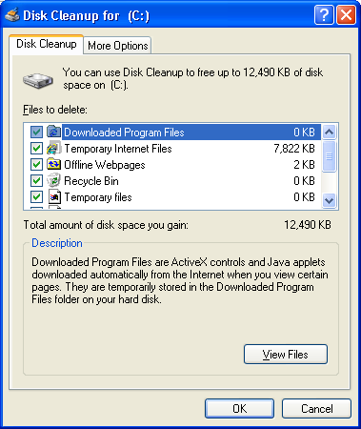
Picture Disk cleanup more options

Step 3
Click the OK button.

- Why should disk cleanup be performed regularly?

