5.4.5 Lab: Create Accounts and Check For Updates

Introduction

Print and complete this lab.

In this lab, you will create user accounts and configure the operating system for automatic updates after the Windows XP Professional installation process.

Recommended Equipment
The following equipment is required for this exercise:
• A computer with a new installation of Windows XP Professional

Step 1
Boot the computer. Navigate to the “Control Panel” window by clicking Start > Control Panel.

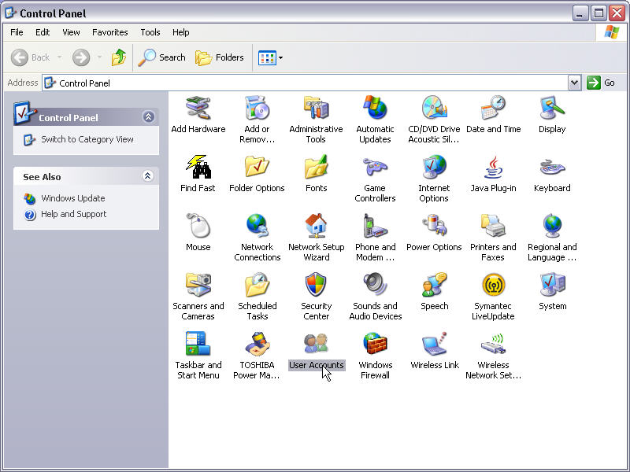

The above picture represents your control Panel

Step 2
Double-click the User Accounts icon.

The “User Accounts” window appears. Click Create a new account.

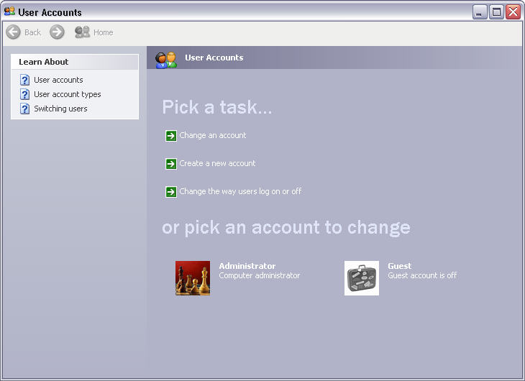
Picture User Accounts page

Step 3
At “Name the new account”, type your name in the field and then click Next.

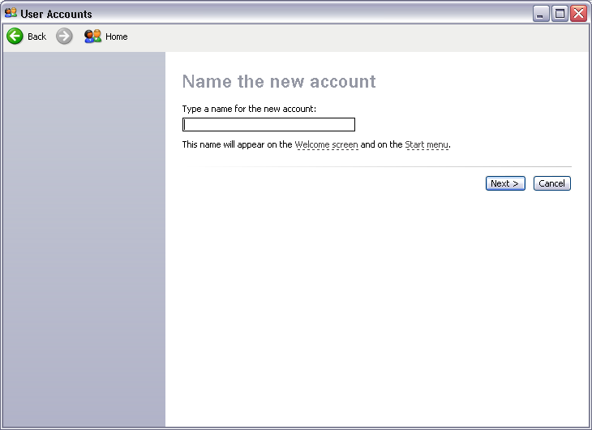

Picture Name the new account

Step 4
At “Pick an account type”, leave the default setting of Computer administrator and click Create Account.

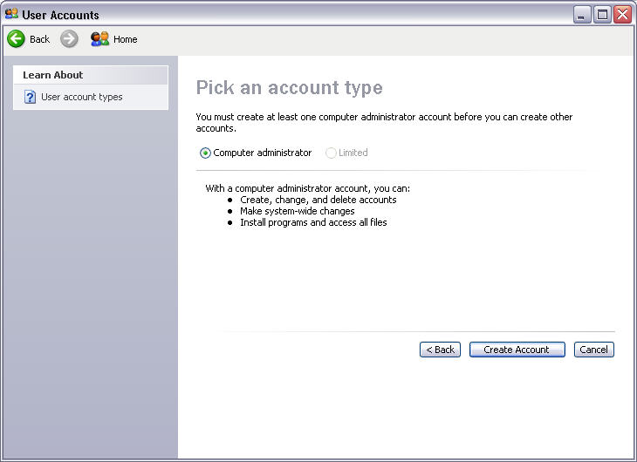

Picture Pick an account typeYou have now finished creating a new account. Log off the computer and log back on as yourself. Leave the password field blank.

Step 5
Return to the “User Accounts” window of the control panel.

Click your account.

Click Create a password.

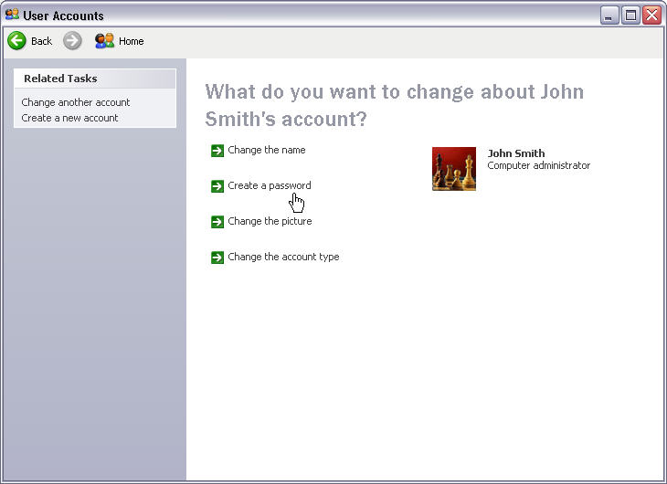

Picture Create a password

Step 6
On the “Create a password for your account” page, type your first initial and your last name in the “Type a new password:” field. Example: jsmith

Type the same password in the “Type the new password again to confirm:” field.

Type fi last name in the “Type a word or phrase to use as a password hint:” field.

Click Create Password.

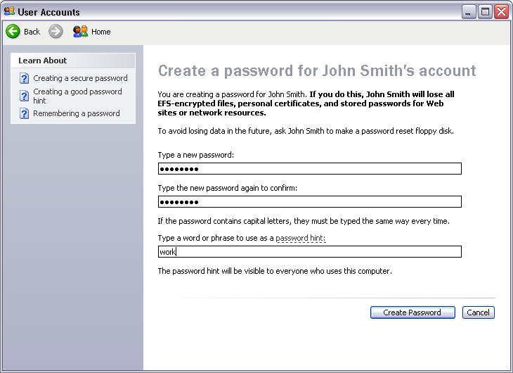

Picture Create a Password

Step 7
Click the red X in the upper-right corner of the “User Accounts” window to close the window.

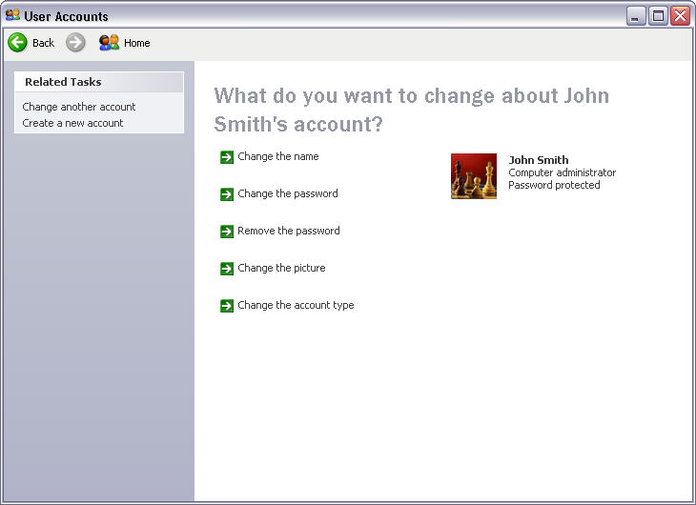

Picture User Accounts window

Step 8
Click Start > Control Panel.

Double-click the Automatic Updates icon.

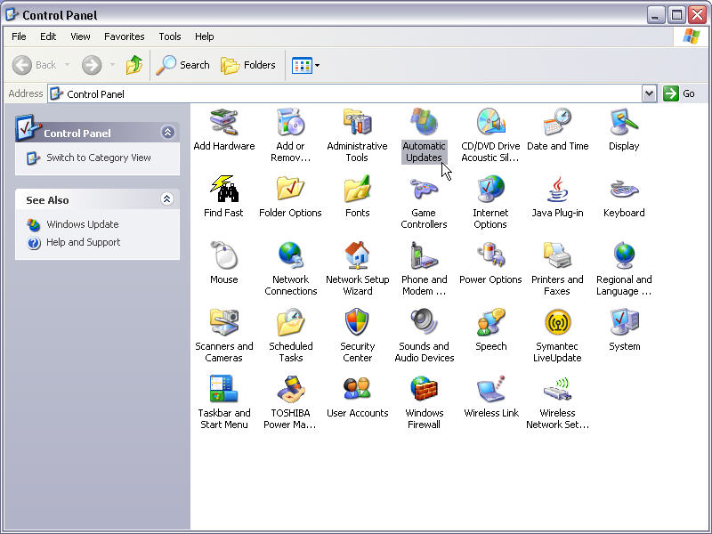
Picture Automatic updates icon

The above picture represents your Icon panel

Step 9
The “Automatic Updates” dialog box appears.

Click the Automatic (recommended) radio button.

Click OK to accept the change and close the dialog box.

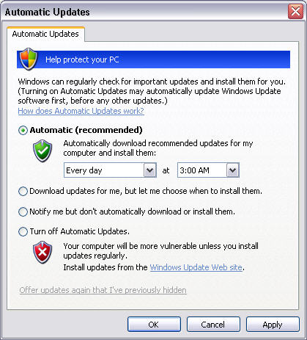
Picture Automatic (recommended) radio button

