16.3.2 Lab: Configure Windows XP Firewall

Introduction

Print and complete this lab.

In this lab you will explore the Windows XP Firewall and configure some advanced settings.

Step 1
Navigate to the Windows XP Firewall:

Start > Control Panel > Security Center

The Firewall indicator shows the status of the firewall. The normal setting is “ON”.

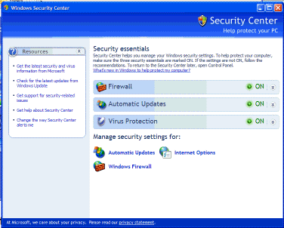

Picture Firewall indicator shows the status of the firewall

Access the controller for the firewall by clicking Windows Firewall at the bottom of the window.

Step 2
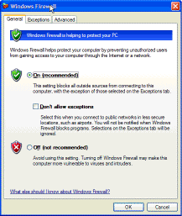
Picture access the controller by clicking Windows Firewall
In the space below, state why turning off the Windows Firewall is not advised.

Step 3
From the Windows Firewall control menu select the Exceptions tab. Programs and services that Windows Firewall is not blocking will be listed with a checkmark.

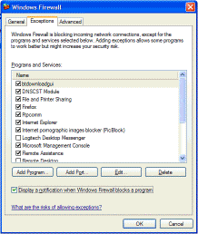
Picture Windows Firewall control menu select the exceptions tab.

You can add applications to this list. This may be necessary if your customer has an application that requires outside communications but for some reason the Windows Firewall cannot perform the configuration automatically. You must be logged on to this computer as an administrator to complete this procedure.

Creating too many exceptions in your Programs and Services file can have negative consequences. Describe a negative consequence to having too many exceptions.

Step 4

From the Windows Firewall control menu select the Advanced tab to view the Network Connection Settings. Network Connection Settings displays the different connections configured for your computer.

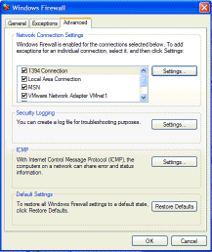

Click the Settings button in the Network Connection Settings area. The Advanced Settings window has two tabs: Services and ICMP. Click the Services tab.

In the space below, list the services that are available.

Step 5
There are many applications that users do not normally see that also need to get through the Windows Firewall to access your computer. These are the network level commands that direct traffic on the network and the Internet.

Under the ICMP heading, click the Settings button. You will see the menu where ICMP exceptions are configured.

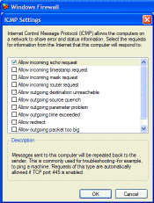
Picture see menu where ICMP exception are configured
In the example here, allowing incoming echo requests is what allows network users to “ping” your computer to determine if it is present on the network and how fast information travels to and from it.

In the space below, list the requests for information that your computer will respond to.

