15.5.3 Lab: Test the Wireless NIC

Print and complete this lab.

In this lab, you will check the status of your wireless connection, investigate the availability of wireless networks, and test connectivity.

Recommended Equipment
- A computer with Windows XP Professional installed
- A wireless NIC installed
- An Ethernet NIC installed
- Linksys WRT300N Wireless Router
- Internet connectivity

Step 1
Disconnect the Ethernet patch cable from your computer.

A red “X” appears over the “Local Area Connection” icon.

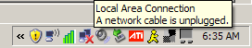

Picture Local Area connection A network cable unplugged
Hover over the “Wireless Network Connection” icon in the tray.

What is the Speed and Signal Strength?

Speed:

Signal Strength:

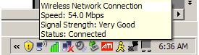

Open a command window.

Ping 127.0.0.1.

How many Replies did you receive?

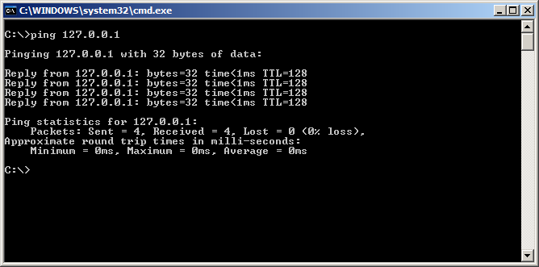

diagram
Use the ipconfig command.

What is the IP address of the default gateway?

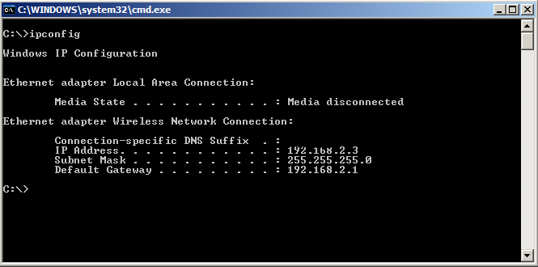

diagram
Ping the default gateway.
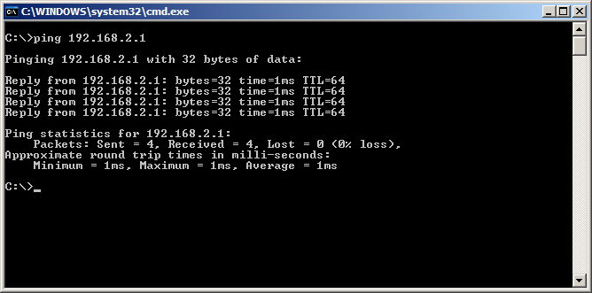
diagram
A successful ping indicates that there is a connection between the computer and the default gateway.

Step 2
Open a web browser.

Type www.cisco.com in the “Address” field, and then press Return.



picture www.cisco.com in Address field
Step 3
Open the Network Connections window.
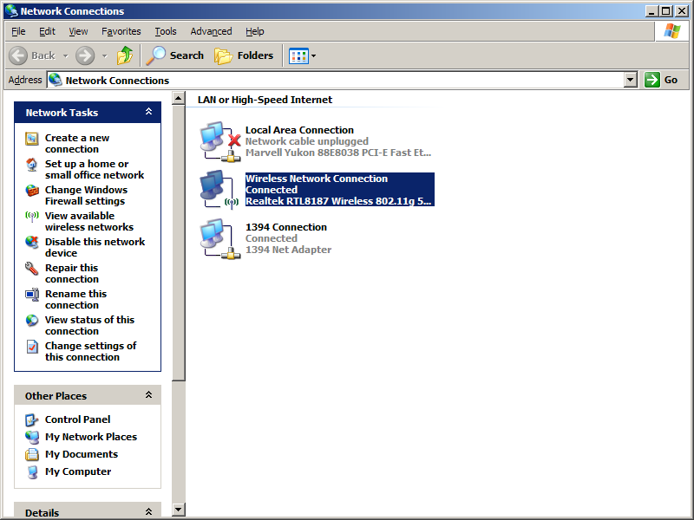
Picture Open the Network Connections window

Right-click the wireless connection and choose Properties.

Click the Wireless Networks tab.

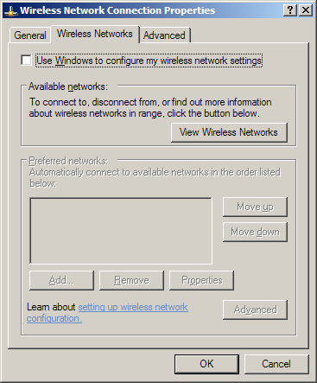
Picture Wireless Network tab
Click the View Wireless Networks button.

What are the names of the wireless networks that are available?

