15.5.2 Lab: Configure Wireless Router

Print and complete this lab.

In this lab, you will configure and test the wireless settings on the Linksys WRT300N.

Recommended Equipment
- A computer with Windows XP Professional
- A Wireless NIC installed
- An Ethernet NIC installed
- Linksys WRT300N Wireless Router
- Ethernet patch cable

Step 1
Connect the computer to one of the Ethernet ports on the wireless router with an Ethernet patch cable.

Plug in the power of the wireless router. Boot the computer and log in as an administrator.

Step 2
Choose start > Run…, and type “cmd”. Press the Return key.

Type ipconfig.

What is the default gateway for the computer?

Step 3
Open Internet Explorer. Type “192.168.1.1” in the “Address” field, and then press Return.

Picture Open Internet Explorer Type “192.168.1.1”
The “Connect to 192.168.1.1” window appears.
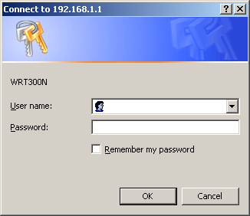
Picture Connect to 192.168.1.1 window

Type “admin” in the “Password:” field.

The Setup screen appears.

Step 4
Click the “Wireless” tab.

Choose “Mixed” in the “Network Mode:” drop-down box.

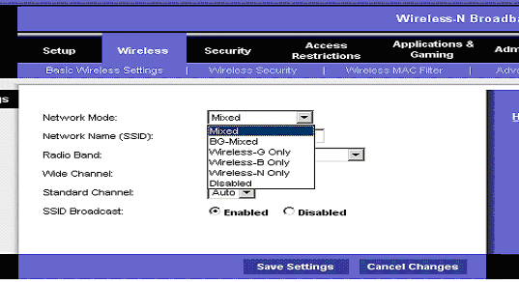

Picture Mixed in the Network Mode drop-down box
What is the default SSID for the wireless router?

Type “cisco#” in the “Network Name (SSID):” field, where # is the number assigned by your instructor.

Click Save Settings.

The “Settings are successful” screen appears.

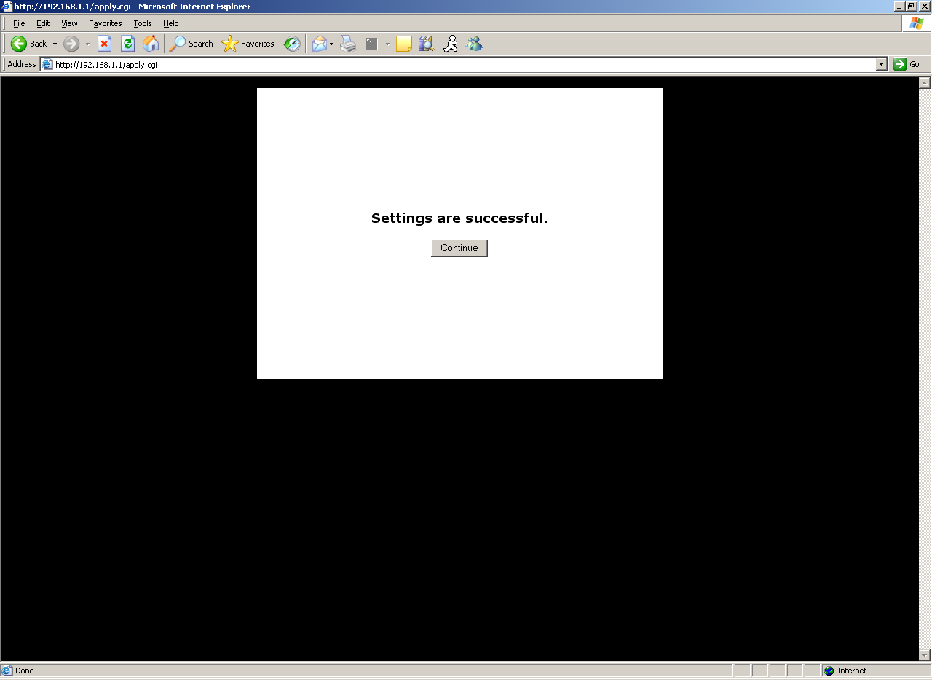

Picture confirming settings are successful
Click Continue, and then close the browser window.

Step 4
Unplug the Ethernet patch cable from the rear of the computer.

Choose start, and then right-click My Network Places. Choose Properties.

Double-click the wireless adapter, and then select View Wireless Networks.

What wireless network(s) are available?

Choose cisco#, and then click the Connect button.

Open Internet Explorer, and then connect to the wireless router.

Log into the wireless router.

Close Internet Explorer.

