15.4.2b Lab: Share a Folder, Share a Printer, and Set Share Permissions

Introduction

Print and complete this lab.

In this lab, you will create and share a folder, share a printer, and set permissions for the shares.

Recommended Equipment
- Two computers running Windows XP Professional that are directly connected to each other or through a switch or hub.
- A printer installed on one of the two computers

Step 1
Choose My Computer > Tools > Folder Options

Click the View tab.

Uncheck the “Use Simple File Sharing (Recommended)” checkbox, and then click OK.

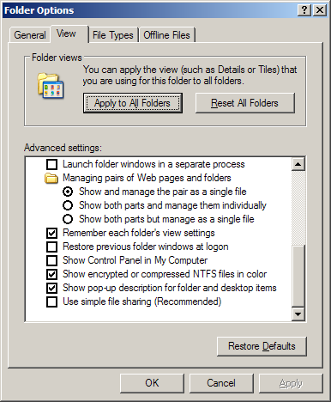

Picture Use Simple File Sharing checkbox

Step 2
Right-click the desktop, and then choose New > Folder.

Type Example, and then press the Return key.

Open WordPad. Type “This is an example document.”.

Save the file in the “Example” folder with the name “Brief.doc”, and then close WordPad.

Step 3
Right-click the Example folder, and then choose Sharing and Security

Click the Share this folder radio button, and then click OK.

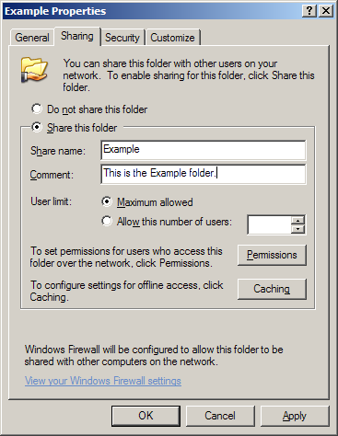
Picture Example folder as above
What is the icon of the “Example” folder?

On the computer with the shared folder, right-click My Computer, and then click the Computer Name tab.

What is the name of the computer?

Step 4
On the other computer, choose start > Run…
Type \\computername\Example, where computername is the name of the computer with the “Example” folder, and then press the Enter key.

Open the “Brief.doc” file.

Delete the text in the “Brief.doc” file, and then choose File > Save.

What happens?

Click OK.

Close WordPad, and then choose NO when prompted to save changes to the file.

Step 5
Return to the computer with the shared folder.

Right-click Example folder > Sharing and Security, and then click Permissions.

What are the default permissions?

Step 6
Open the Control Panel on the computer with the attached printer.

Choose Printers and Other Hardware > Printers and Faxes.

Right-click the icon of the installed printer, and then choose Sharing….

Click the Share this printer radio button, and then click OK.

Picture Share this printer radio button

Step 7
Return to the computer that is not directly connected to a printer.

Open the Control Panel. Choose Printers and Other Hardware > Printers and Faxes.
Choose File > Add Printer on the screen below.

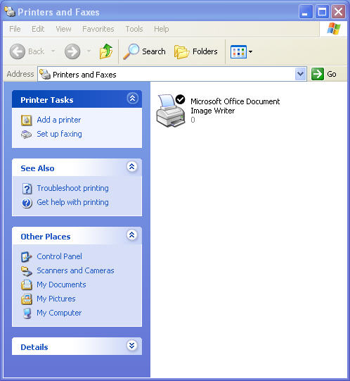
Picture of Printers and Faxes

The “Add Printer Wizard” window appears.

Click Next.

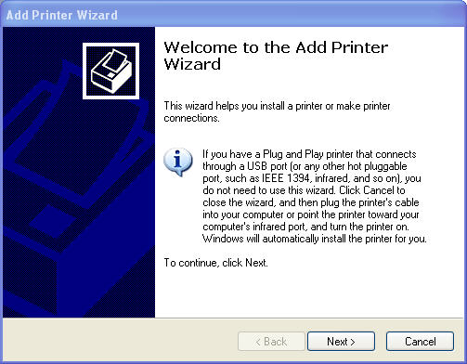
Picture of Welcome to the Add Printer Wizard
The Local or Network Printer of the Add Printer Wizard window appears. Click the A network printer, or a printer attached to another computer radio button, and then click Next.

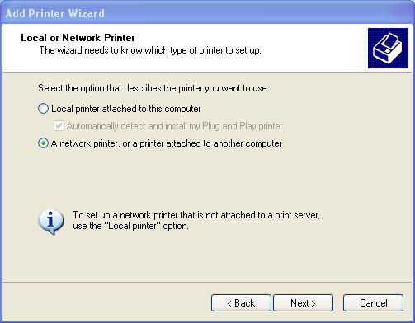
Picture Local or Network Printer

The “Specify a Printer” window appears.

Click the Connect to this printer radio button, and then click Next.

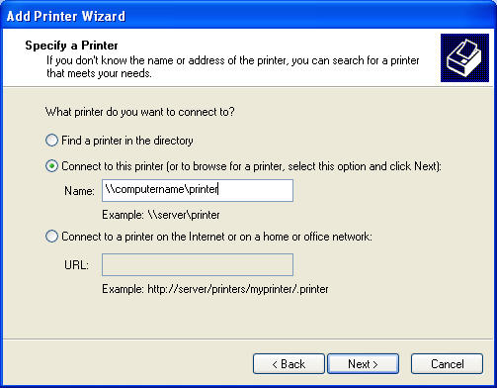

Picture Specify a Printer
The Browse for a Printer window appears.
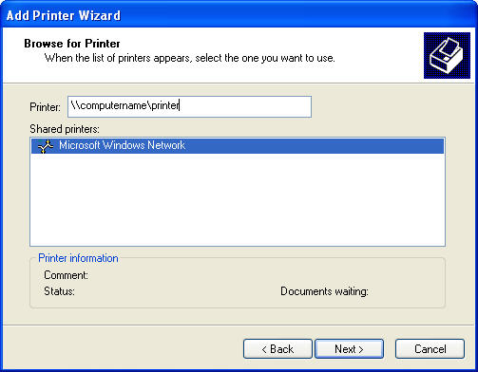
Picture Browse for Printer

Expand “Shared printers”.

Choose the printer from the list, and then click Next.

The “Default Printer” screen of the “Add Printer Wizard” appears.
Click Next.

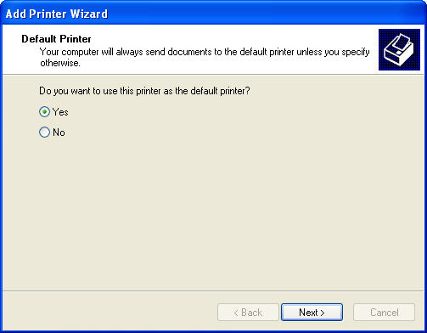
Picture Default Printer

The “Completing the Add Printer Wizard” window appears.

Click Finish.

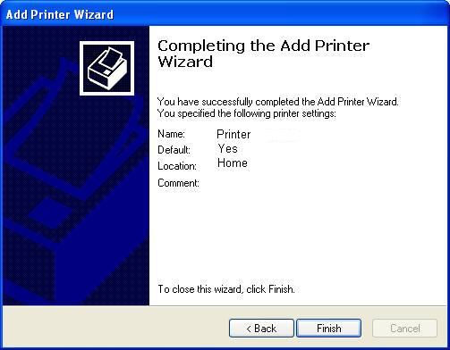
Picture Completing the Add Printer Wizard

Step 8
Choose start > Printers and Faxes.

Right-click the printer you installed, and then choose Properties.

The “Printer Properties” window appears.

Choose the General Tab, and then click Print Test Page.

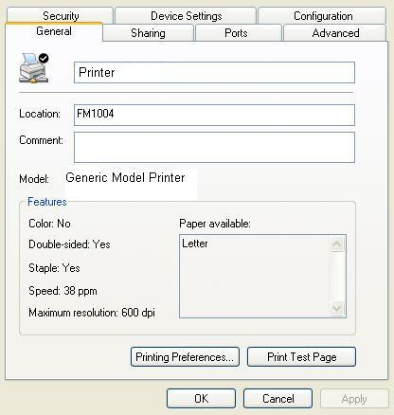

Picture Printers and Faxes
Click OK in the confirmation dialog box, and then click OK to close the printer properties window.

