15.4.2a Lab: Configure Browser Settings

Print and complete this lab.

In this lab, you will configure browser settings in Microsoft Internet Explorer. You will select Internet Explorer as the default browser.

Recommended Equipment
- A computer with Windows XP Professional installed
- An Internet connection
- Mozilla Firefox browser installed (from lab in chapter 12)

Step 1
Choose Start > Run…. Type www.cisco.com, and press Return.

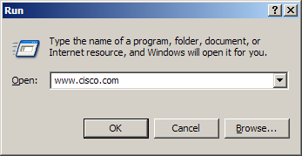
Picture choose Start>run

Which browser was used to open the web page?

If you answered “Internet Explorer”:

Choose start > All Programs > Mozilla Firefox > Mozilla Firefox.

Choose Tools > Options, and click the “Main” tab.

Click the Always check to see if Firefox is the default browser on startup check box, and then click OK.

Restart your computer.

Choose start > All Programs > Mozilla Firefox > Mozilla Firefox.

Click Yes to make Firefox the new default browser.
If you answered “Firefox”:

Choose start > All Programs > Internet Explorer.

Choose Tools > Internet Options, and then click the “Programs” tab.

Click the “Internet Explorer should check to see whether it is the default browser”, and then click OK.

Restart your computer.

Choose start > All Programs > Internet Explorer.

Click Yes to make Internet Explorer the new default browser.

Step 2
Choose Start > Run…. Type www.cisco.com, and press Return.

Picture Type name of program etc
Which browser was used to open the web page this time?

Make Internet Explorer your default browser.

Open Internet Explorer, and then choose Help > About Internet Explorer.

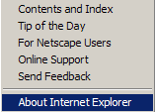
Picture about Internet explorer

Which version of Internet Explorer is installed on your computer?

Step 3
Choose Tools > Internet Options.

The “Internet Options” window appears.

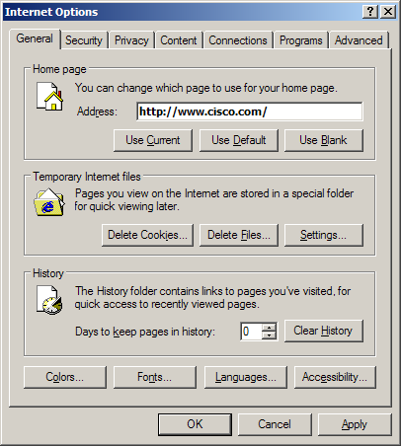
Picture Internet Options

Click the Settings button, and then click the View Files button.

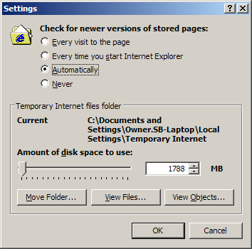
Picture of Settings
How many temporary Internet files were listed?

Close the “Temporary Internet Files” window.

Close the “Settings” window.

Choose Delete Files…
A confirmation window appears.

Click the OK button.

Click the Settings button, and then click the View Files button.

How many temporary Internet files were listed?

Step 3
Click the down arrow at the right end of the “address” field to view previously visited sites.

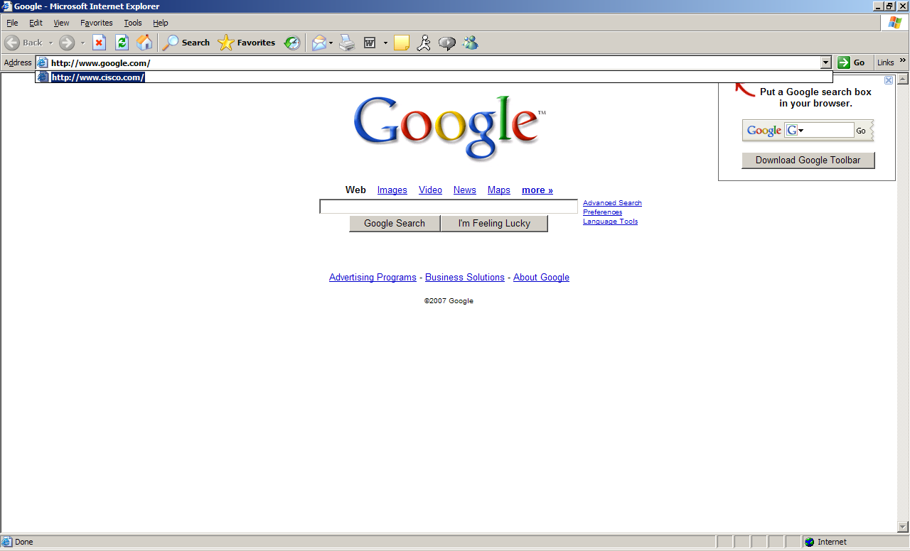
Picture Google pagae

How many sites are listed in the drop-down box?

To clear the browser history, choose Tools > Internet Options, and then click the Clear History button.

A confirmation window appears. Click Yes.

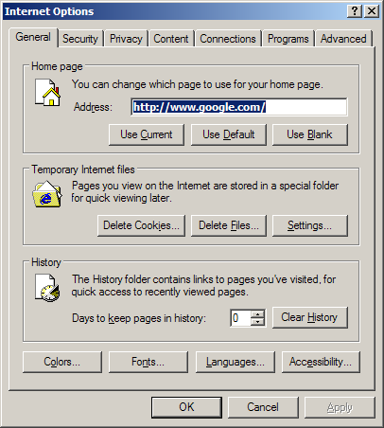
Picture Confirmation window
Click the down arrow at the right end of the “address” field to view previously visited sites.

How many sites are now found in the drop-down box?

Step 4
Use this path to change Security settings:

Choose Tools > Internet Options, and then click the Security tab.

Click the Custom Level button.

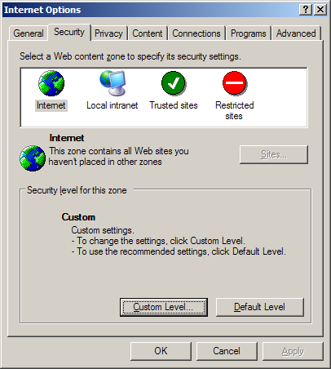
Picture Custom Level Button

The “Security Settings” window appears.

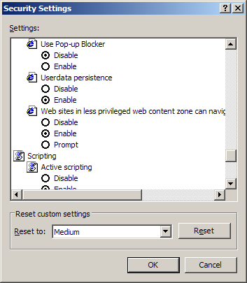

Picture Security Settings
Select the options in the list that you wish to change, and then click OK.

