14.3.2 Lab: Share the All-in-one Printer/Scanner

Introduction

Print and complete this lab.

In this lab, you will share the Epson printer/scanner, configure the printer on a networked computer, and print a test page from the remote computer.

Recommended Equipment
- Two computers directly connected or connected through a hub or switch
- Windows XP Professional installed on both computers
- An Epson® CX7800 installed on one of the computers

Step 1
Click My Computer > Tools > Folder Options > View, and then uncheck Use Simple File Sharing (Recommended)

Click OK.

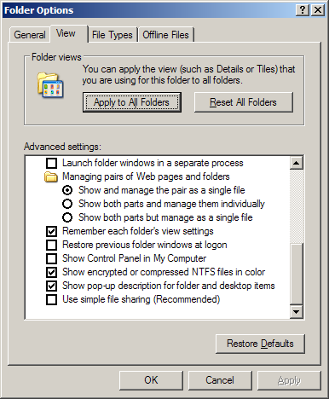
Picture Folder Options

Step 2Picture Folder Options
Choose start > Printers and Faxes.

Right-click Epson CX7800, and then choose Properties.
Click the Sharing tab.

Choose Share this printer. Name the new share Example, and then click Apply.

Click OK.

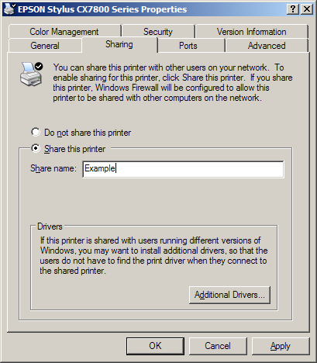

Picture Sharing this printer

Step 3
Log on to the computer without the printer/scanner connected, and then choose start > Printers and Faxes.

Click Add a printer.

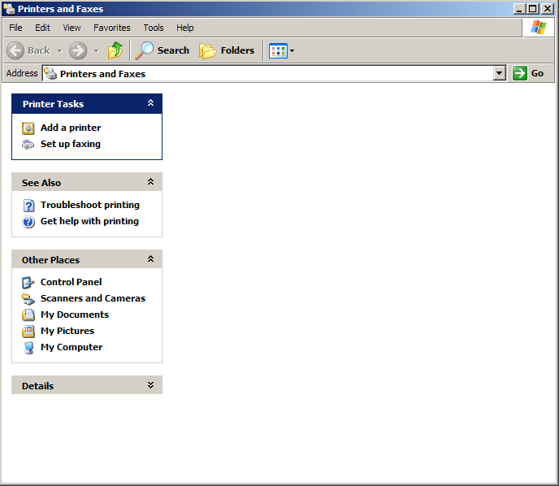
Picture Add a printer
The “Add Printer Wizard” window appears.

Click Next.

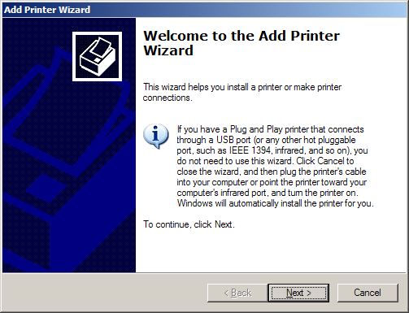

Picture Add Printer Wizard
The “Local or Network Printer” window appears.

Click the A network printer, or a printer attached to another computer radio button, and then click Next.

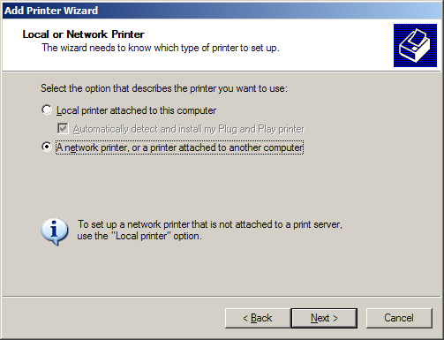
Picture Local or Network Printer
Type \\computername\printer in the Connect to this printer (or to browse for a printer, select this option and click Next): radio button, where computername is the name of the computer with the connected printer/scanner and printer is the name of the printer/scanner.

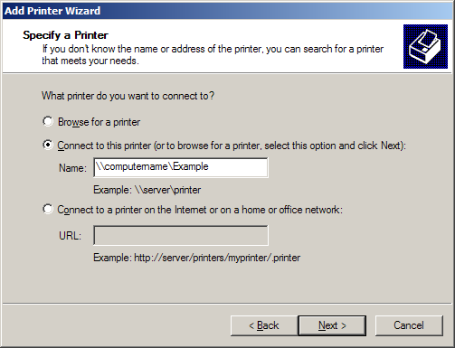

Picture Add Printer Wizard Specify a printer

Step 4
Choose start > Printers and Faxes.

Right-click Epson Stylus, and then choose Properties.

Click the Print Test Page button.

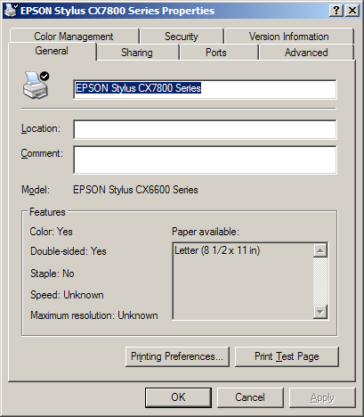
Pictures Printers and Fixes

