14.2.4 Lab: Install an All-in-one Printer/Scanner

Introduction

Print and complete this lab.

In this lab, you will check the Windows XP Hardware Compatibility List (HCL) for the Epson Stylus CX7800, install the all-in-one printer/scanner, upgrade the driver and any associated software, and test the printer and scanner.

Recommended Equipment
- A computer with the Windows XP Professional operating system
- An available USB port on the computer
- An Epson® Stylus CX7800 printer/scanner
- Printer/scanner installation CD
- An Internet connection

Step 1
Open Internet Explorer.

Search the Microsoft Website for “windows xp professional hcl”

Instructor: These instructions follow the current Microsoft Website. This website may change over time.

Choose “Windows XP”.

Choose “Devices”.

Choose the processor type used by the computer.

Select “Printers & Scanners”.

Choose “Start”.

Search the HCL for “Epson Stylus CX7800”.

What Company manufactures this component?

For what operating system(s) was this component designed?

For what operating system(s) has this component been certified?

Step 2
Carefully unpack and assemble the printer/scanner if necessary. Follow the manufacturer’s instructions.
Plug the printer/scanner into a grounded wall outlet and turn on the unit. Do not attach the USB cable to the computer until instructed to do so.

Step 3
Insert the manufacturer’s software CD into the optical drive. If the installation program does not start automatically, select start > My Computer, and then double-click the Epson CD-ROM icon.

The “Install Menu” window appears.

Click Install.

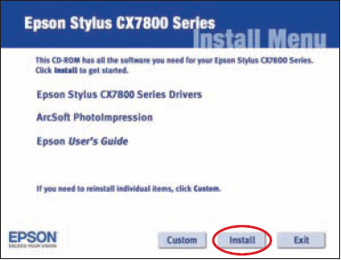
Picture Epson Stylus CX7800 Series Install Menu

Connect the USB cable when instructed.

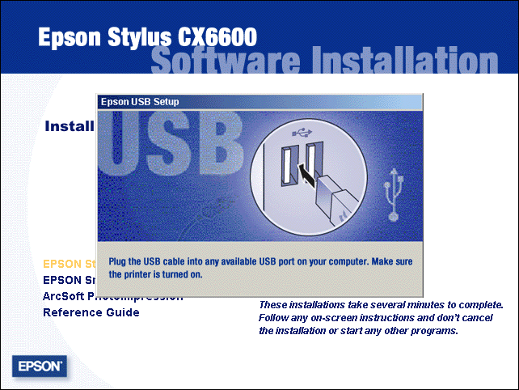

Picture Epson Stylus CS6600 Software Installation
The “License Agreement” window appears.

Click Yes.
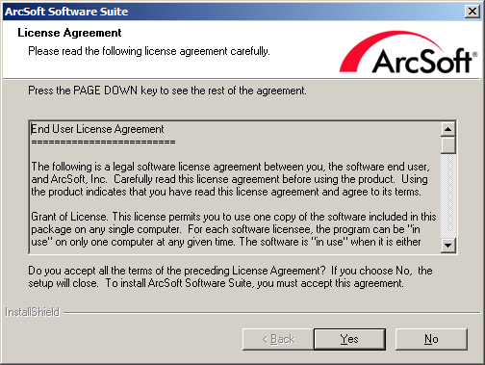
Picture License Agreement

The “Epson Product Registration” window appears.

Click Cancel.

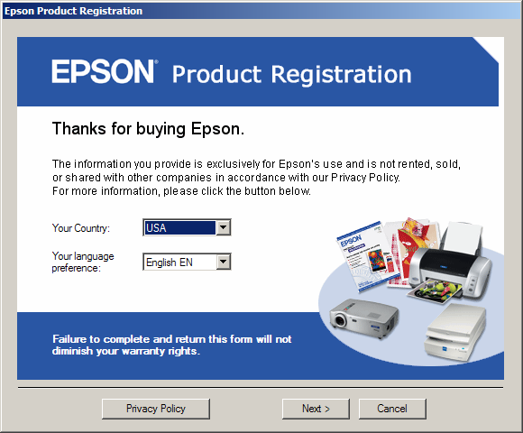

Picture EPSOM registration

Step 4
Go to the Epson Website and download the newest drivers for the Epson Stylus CX 7800.

Click start, and then right-click My Computer. Choose Manage > Device Manager.

The Device Manager appears in the right column.

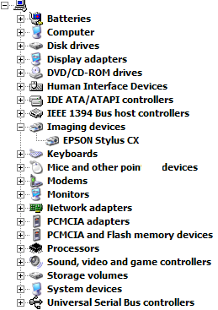

Double-click the Epson Stylus CX, and then select the Driver tab.

Choose Update Driver…

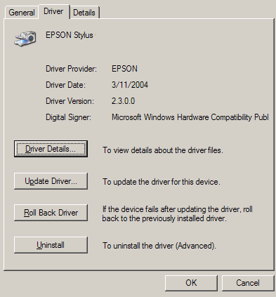

Picture Choose update driver
Follow the instructions to install the driver that was downloaded.
Choose start > Printers and Faxes.

Right-click Epson Stylus, and then click Properties.

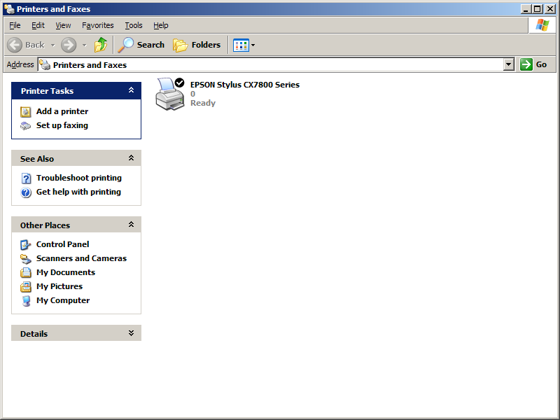
Pictures Printers and Faxes

Click the Print Test Page button.

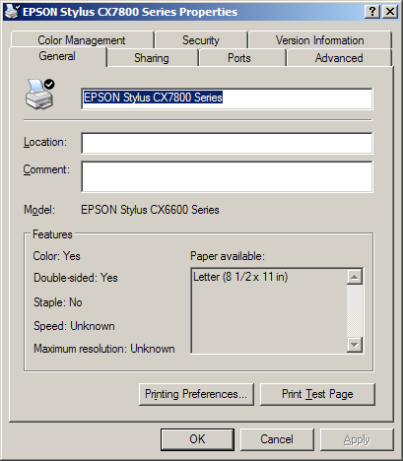

Picture Print Test Page

Step 5
Place a picture or document in the upper left corner of the scanner, face down.

Double-click the Epson Scan icon on the desktop or open the Epson SmartPanel using the start menu.

Scan the image.

Print the scanned image.

