12.4.1 Lab: Schedule Task Using GUI and at Command

Introduction

Print and complete this lab.

In this lab, you will schedule a task using the Windows XP GUI and schedule a task in a cmd window using the at command.

Recommended Equipment
- A computer running Windows XP Professional

Step 1
Log on to Windows as an administrator.

Choose Start > Control Panel.

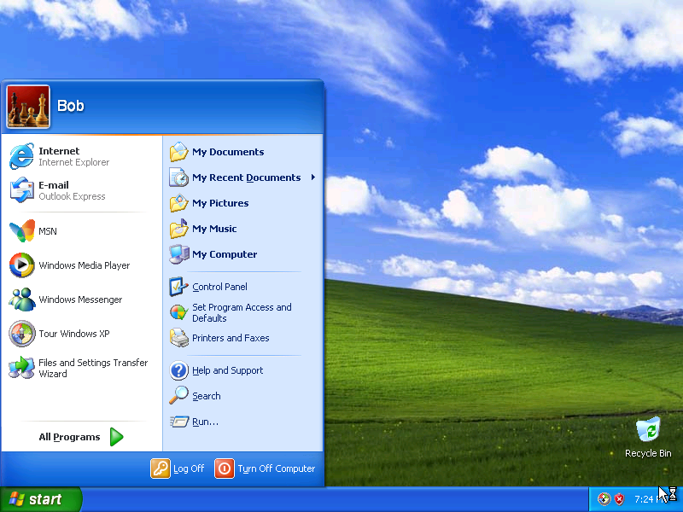

Picture Control Panal

Step 2
The “Control Panel” window appears.

Click Performance and Maintenance.

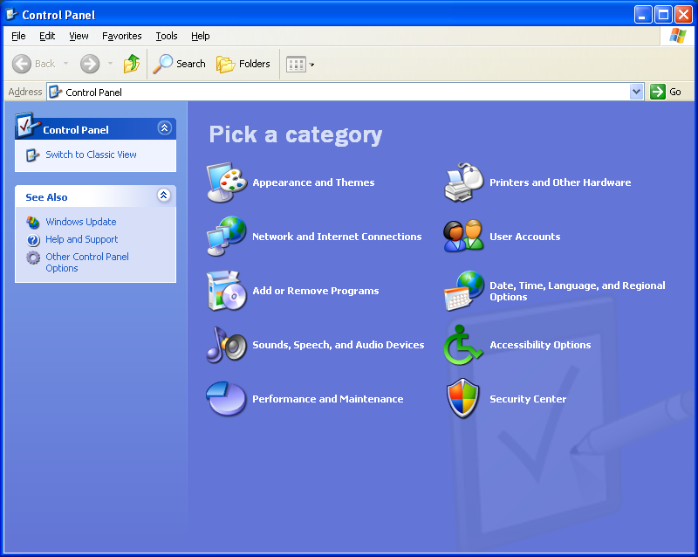

Picture Control Panal window

Step 3
The “Performance and Maintenance” window appears.

Click Scheduled Tasks.

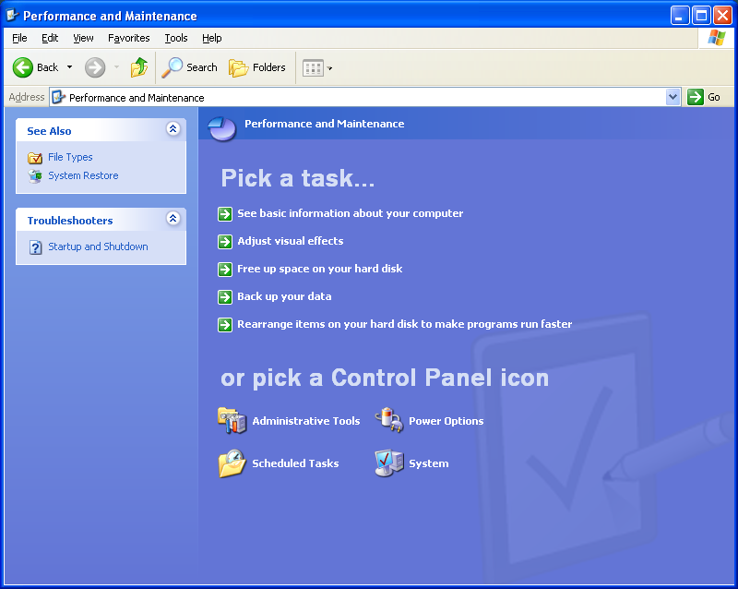
Picture Performance and Maintenance window appears

Step 4
The “Scheduled Tasks” window appears.

Double-click Add Scheduled Task.

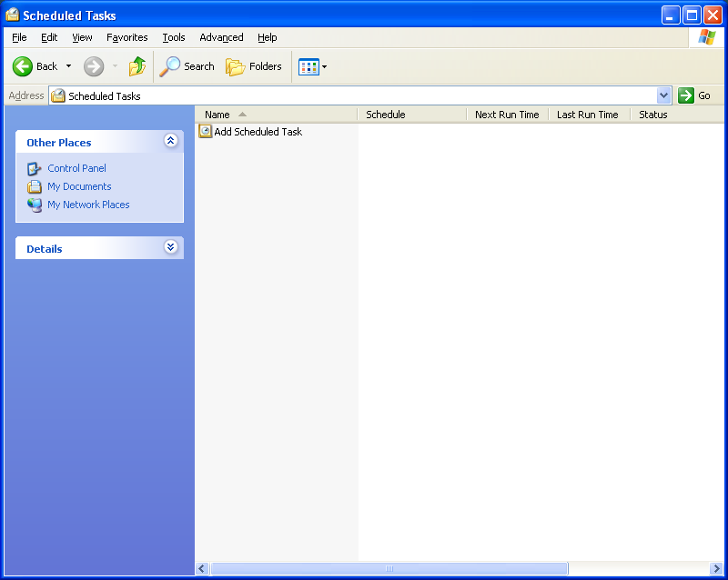

Picture Scheluled Task

Step 5
The “Scheduled Task Wizard” appears.

Click Next.

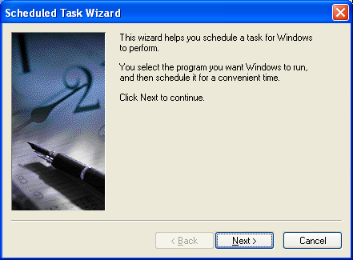
Picture Scheduled Task Wizard Page

Scroll down the Application window, and then select Disk Cleanup.

Click Next.

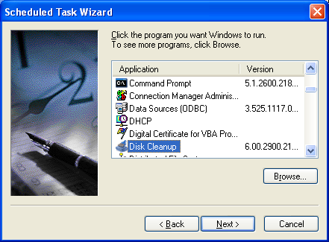
Picture of Scheduled Task Wizard Various Tasks
Type Disk Cleanup in the “Type a name for this task.” field.

Click the Weekly radio button, and then click Next.

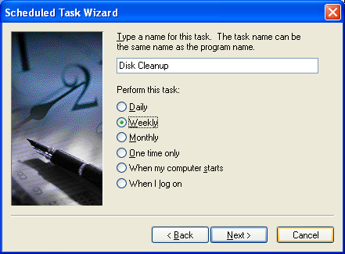

Picture Disk Cleanuup
Use the scroll buttons in the “Start time:” field to select “6:00 PM”.

Use the scroll buttons in the “Every _ weeks” field to select “1”.

Check the “Wednesday” check box, and then click Next.

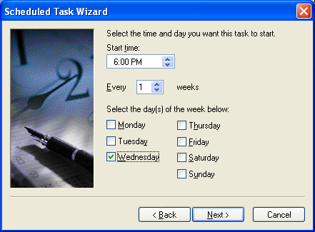
Picture Select the time and day
Enter your username and password in the appropriate fields.

Click Next.

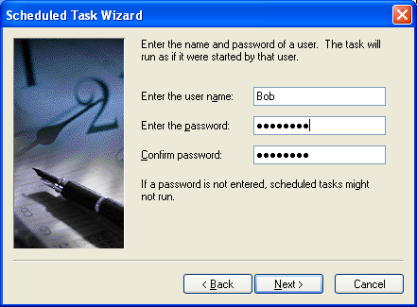
Picture password

The “You have successfully scheduled the following task:” window appears.

Click Finish.

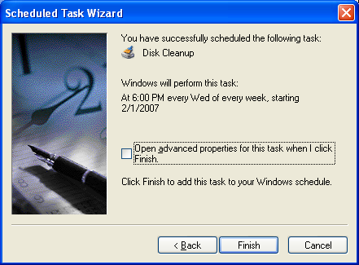

Picture Confirming Disk Cleanup

Step 6
The scheduled task that you created appears in the “Scheduled Tasks” window.

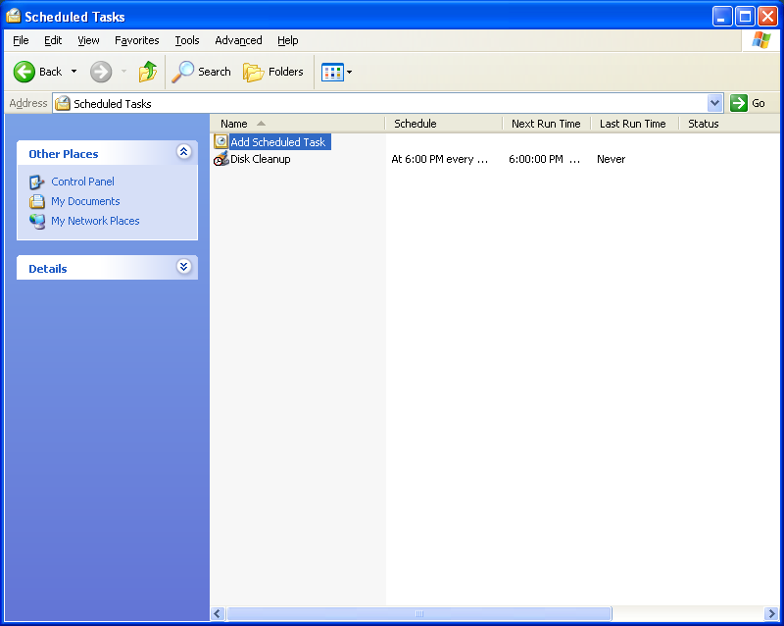

Picture Scheduled task created appears in Scheduled Tasks window

Step 7
Choose Start > Run…

Type cmd, and then click OK.

The “C:\WINDOWS\System32\cmd.exe” window appears.

Picture “C:WINDOWS|System 32\cmd.exe appears
Type at/?, and then press the Enter key.

The options for the at command are displayed.

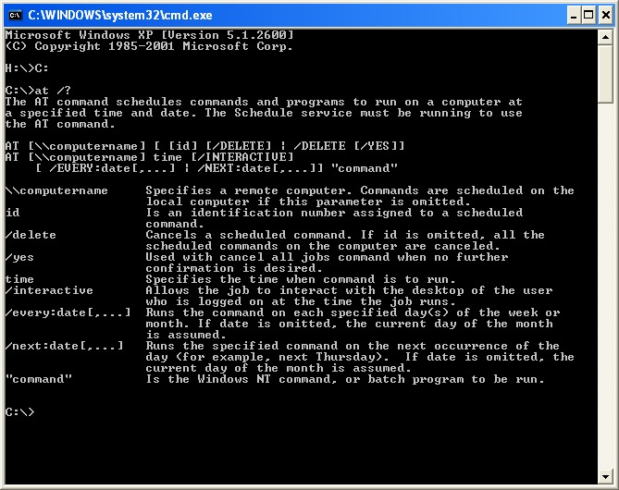
Picture options for the at command displayed
Type at 20:00 /every:W backup.

Note that the time must be military time.

“Added a new job with job ID = 1” is displayed.

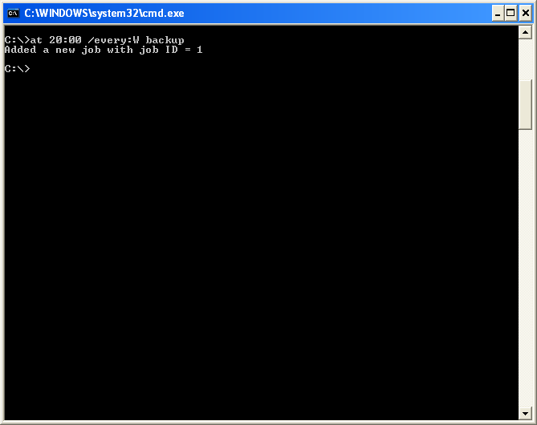
Pictured Added a new job with job ID
Type at \\computername. For example at \\labcomputer

The scheduled job appears.

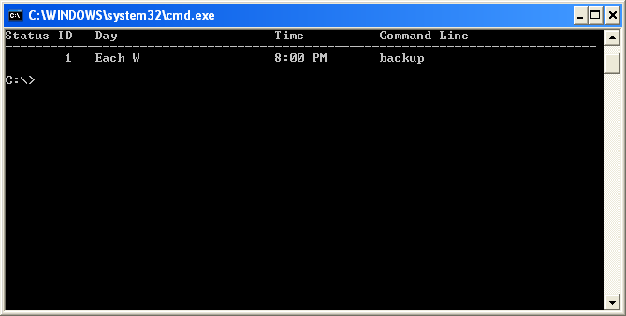
Pictured Type at\ll\computername

Which command would you enter to get the backup to run every Tuesday and Wednesday at 3:00 PM?

Type exit, and then press the Return key.

Step 8
Open the Scheduled Tasks window.

The task created using the at command is listed in the window.

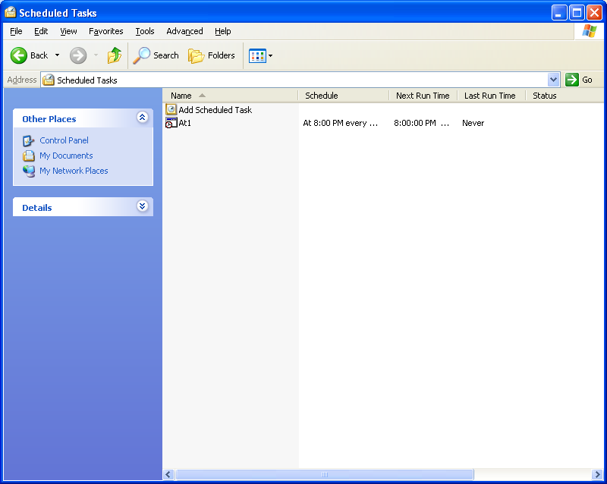

Picture Scheduled Tasks window

Step 9
Right-click your scheduled task.

Choose File > Delete.

The “Confirm File Delete” window appears.

Click Yes.

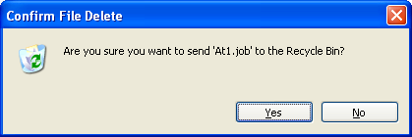

Picture confirm File Delete
The task created using the at command is removed from the scheduled tasks window.

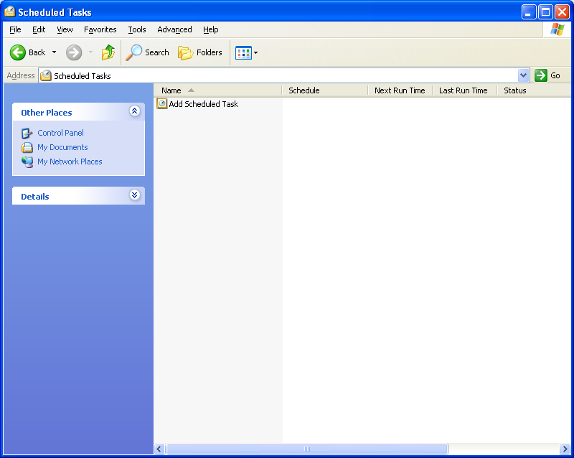

Picture the task created using the at command is removed

