Lab 12.2.5: Install an Alternate Browser (Optional)

Introduction

Print and complete this lab.

In this lab, you will install the Mozilla Firefox Web Browser.

Recommended Equipment
- A computer running Windows XP Professional
- Internet access

Step 1
Choose start > All Programs > Internet Explorer.

In the “Address” field, type www.mozilla.com.

Press Enter.

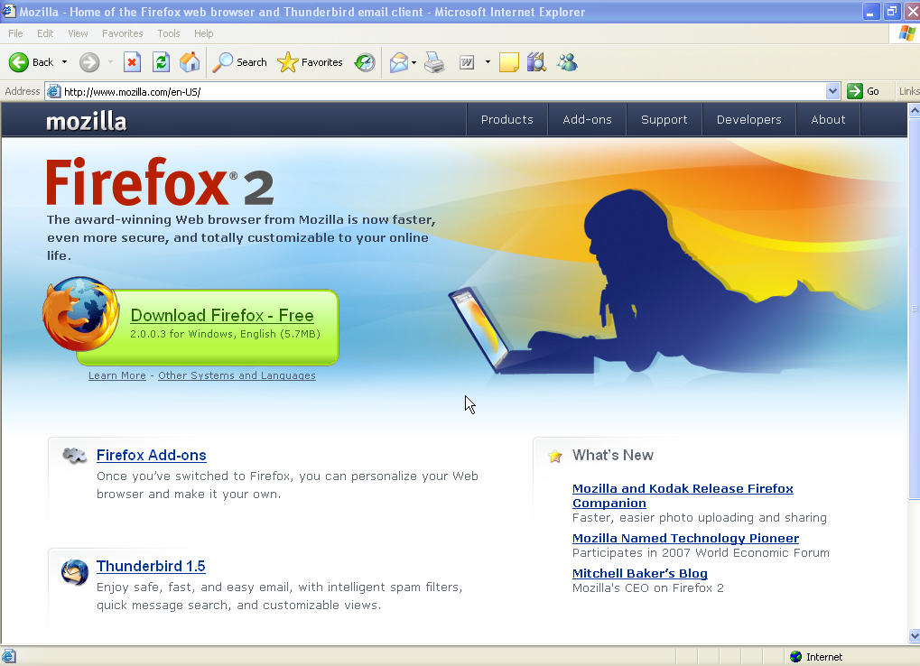

Picture Forefox 2

Step 2
Click the Download Firefox – Free link.

The “File Download – Security Warning” window appears.

Click Run.

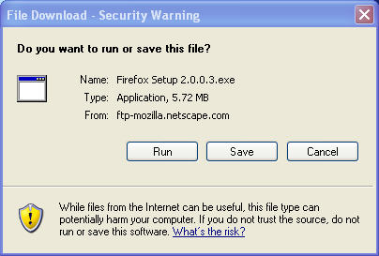

Picture file download Security Warning
The Internet Explorer download window appears.

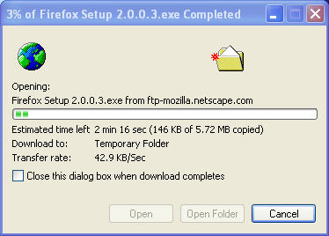

Picture Security warning
The Internet Explorer – Security Warning window may appear.

Click Run.

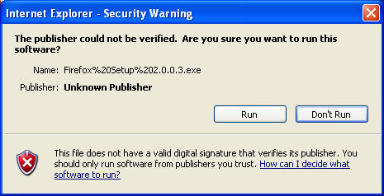

Step 3
The “Mozilla Firefox Setup” window appears.

Click Next.

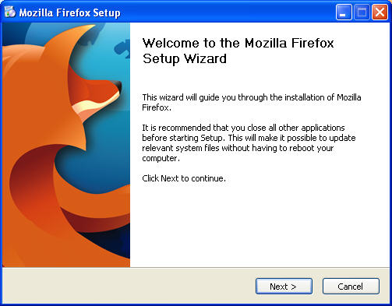

Picture Welcome to the Mozilla Firefox Setup World
The “License Agreement” window appears

Click the I accept the terms in the License Agreement radio button.

Click Next.

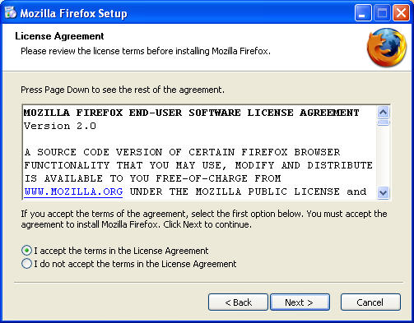
Picture License Agreement
The “Setup Type” window appears. The default is “Standard”.

Click Next.

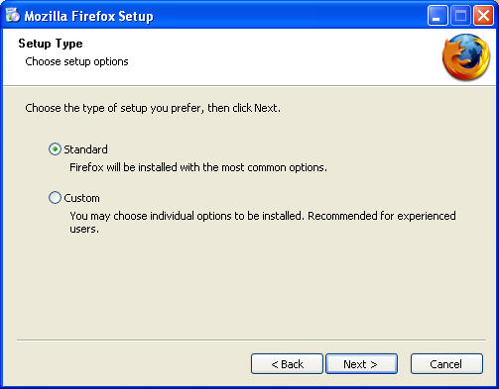

The “Installing” window appears.

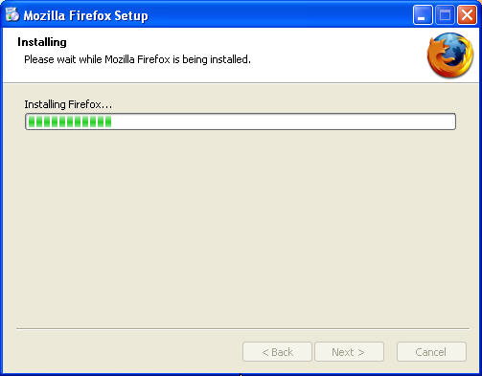
The “Completing the Mozilla Firefox Setup Wizard” window appears. The default is “Launch Mozilla Firefox now”.

Click Finish.

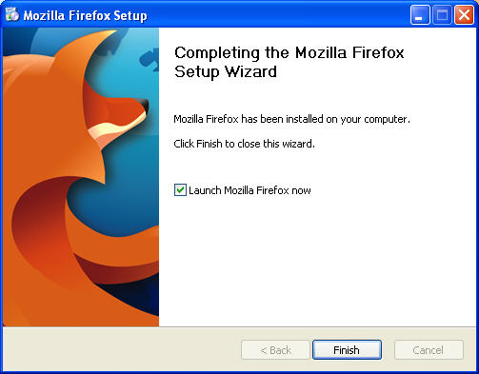

Step 4
The “Import Wizard” window appears. The default is “Microsoft Internet Explorer”.

Click Next.

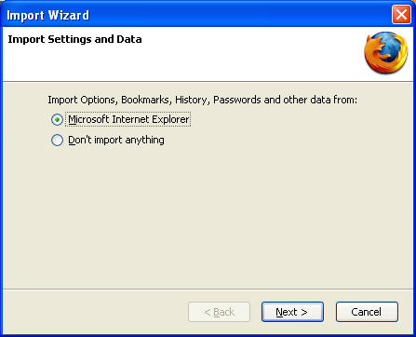
Picture Import Wizard apppears
The “Home Page Selection” window appears. The default is “Firefox Start, a fast search page with search results by Google”.

Click Next.

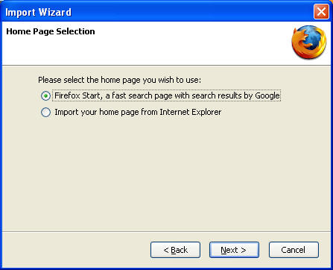
Picture Home Page Selection
The “Import Wizard” window will appear.

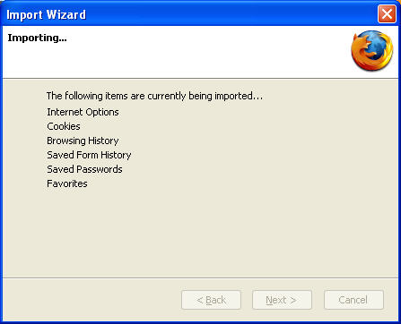

Picture Importing

Step 5
The “Welcome to Firefox - Mozilla Firefox” window appears.

The “Default Browser” window appears. The default is “Always perform this check when starting Firefox.”.

Click No.

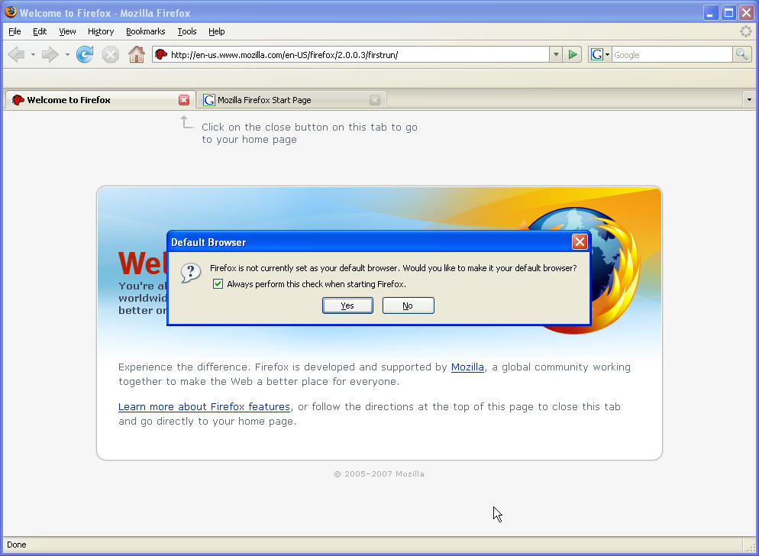
Picture Default Browser window

The “Options” window appears.

Click Browse.

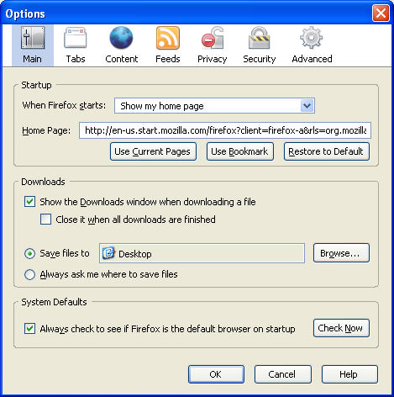
Picture Options window appears
The “Browse For Folder” window appears.

Choose My Documents, and then click OK.

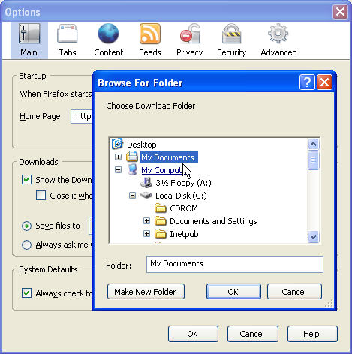
Picture Browse For Folder window
The “Browse For Folder” window closes.

Click OK.

Note the Mozilla Firefox icon on your desktop.

