12.2.3 Lab: Create a Partition in Windows XP Pro

Introduction

Print and complete this lab.

In this lab, you will create a FAT32 formatted partition on a disk. You will convert the partition to NTFS. You will identify the differences between the FAT32 format and the NTFS format.

Recommended Equipment
- Computer running Windows XP Professional
- Unpartitioned space of at least 1 GB on the hard disk drive.

Step 1
Log on to Windows as an administrator.

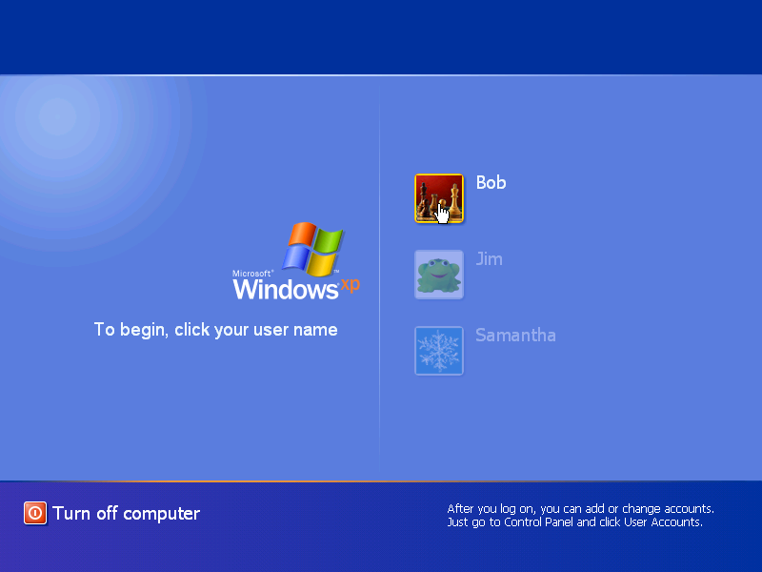

Picture Log on to windows

Step 2
Click start.

Right-click My Computer, and then click Manage.

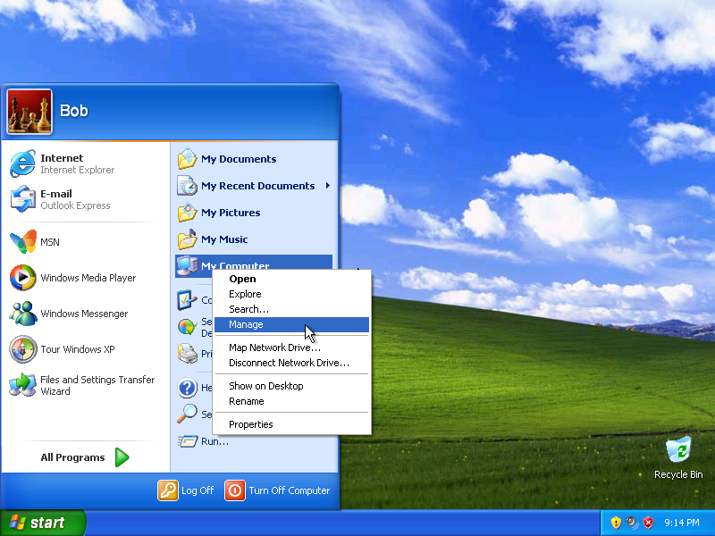

Picture My computer

Step 3
The “Computer Management” window appears.

Click Disk Management on the left side of the screen.

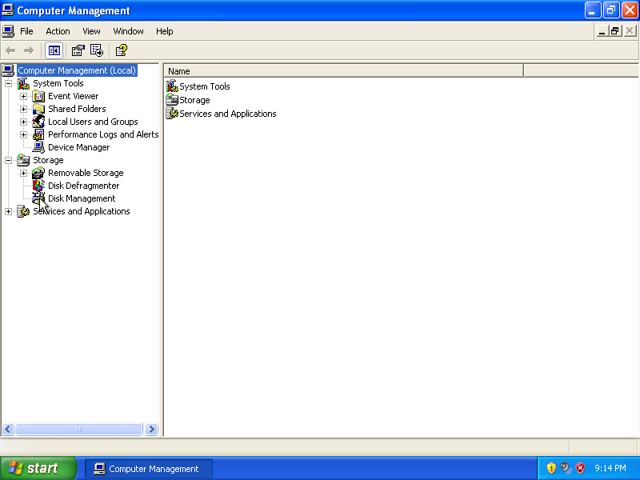

Picture Disk Management on left side of screen

Right-click the green-outlined block of Free Space.

Click New Logical Drive….

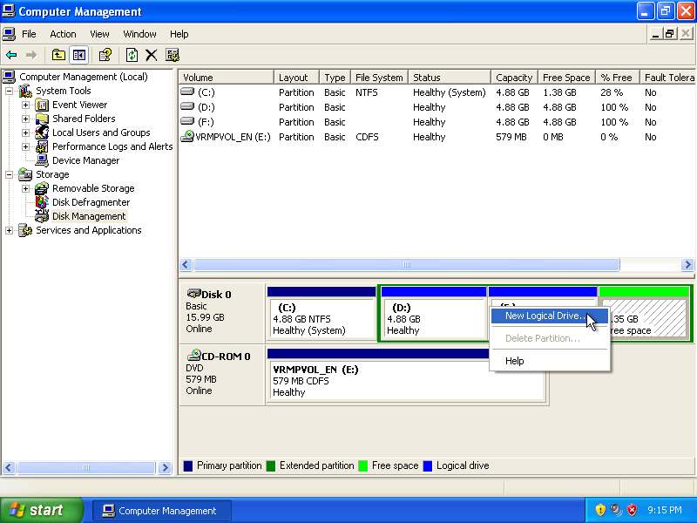

Picture New Logical Drive

Step 4
The “New Partition Wizard” window appears.

Click Next.

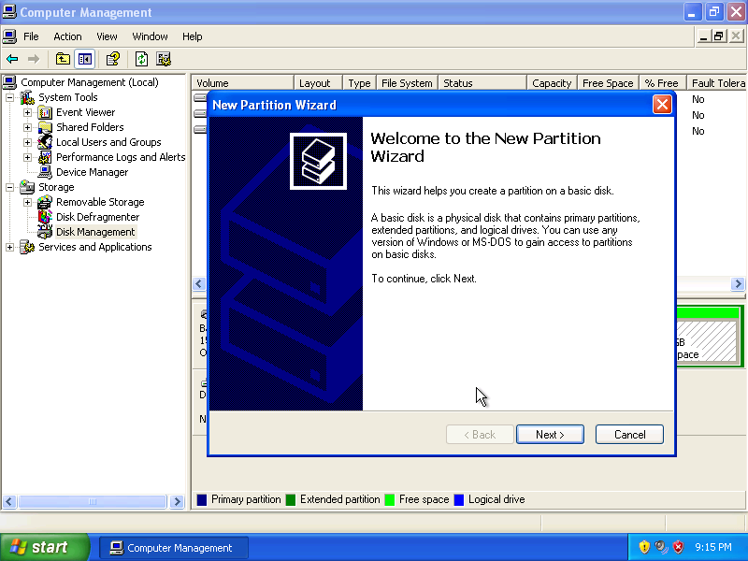

Picture The New Partition Wizard window appears

Click the Logical drive radio button, and then click Next.

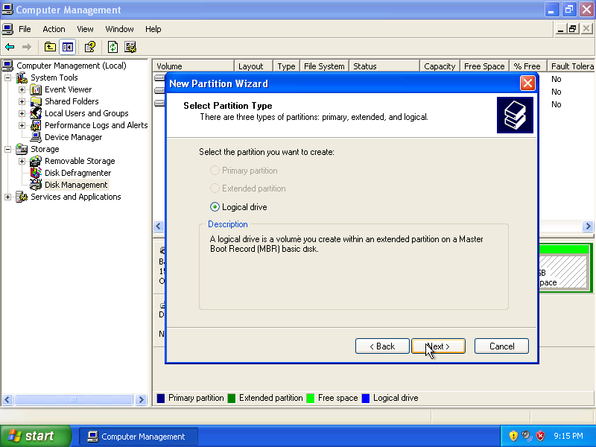
Picture Logical drive radio button
Type 500 in the “Partition size in MB:” field.

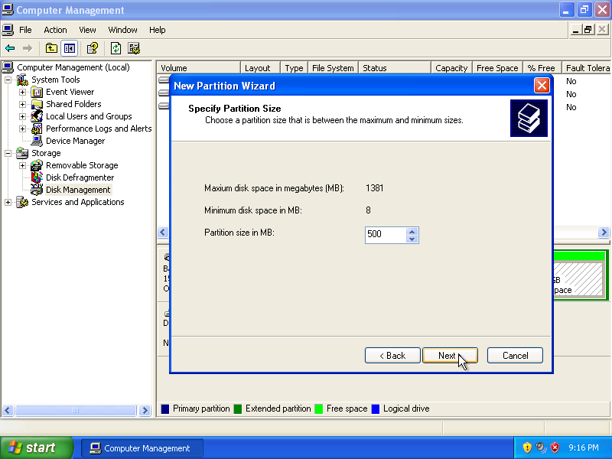

Picture Type 500 in the Partition size in MB:” field

Click the Assign the following drive letter: radio button.

Select G from the drop-down menu.

Click Next.

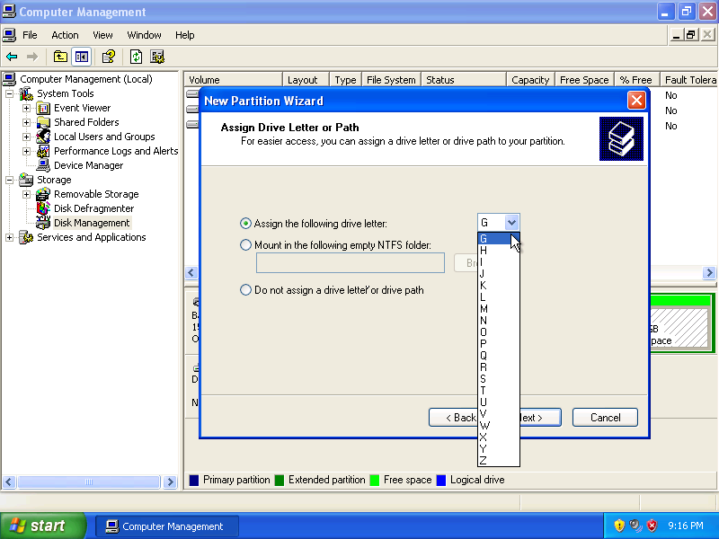
Picture Assign the following drive letter: radio button Select G from the drop-down menu
Click the Format this partition with the following settings: radio button.

Click Next.

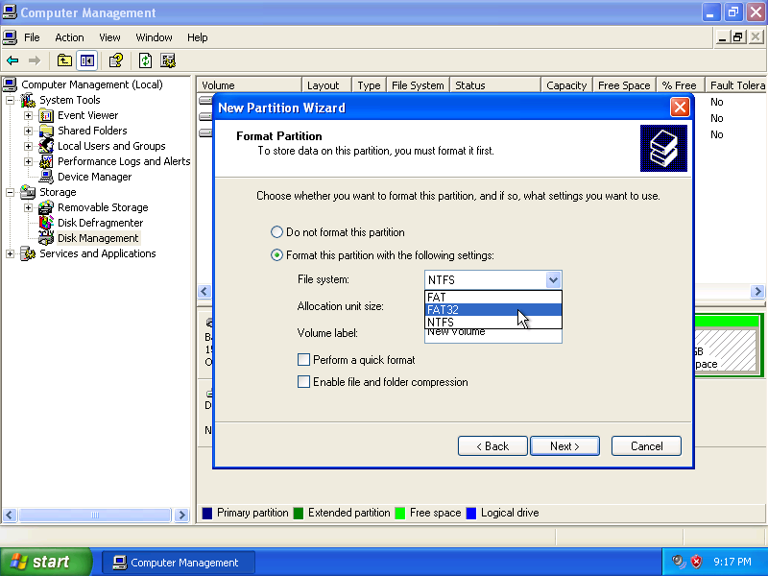
Picture, Format this partition with the following settings:

Click Finish.

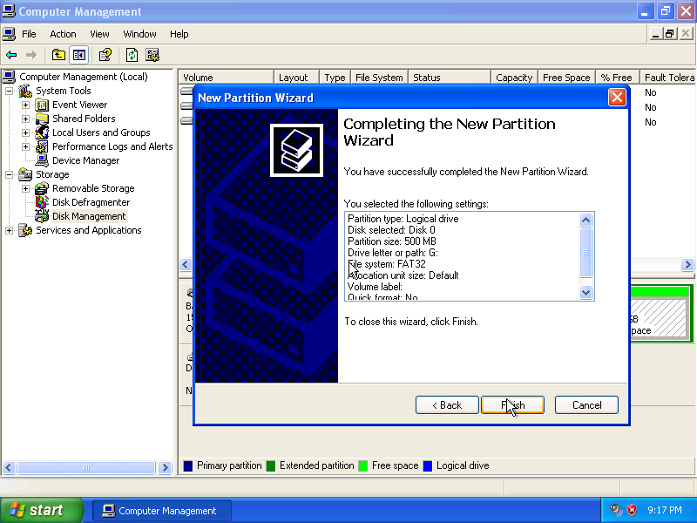

Picture Click finish

Step 5
The “Computer Management” window re-appears while the new volume is formatted.

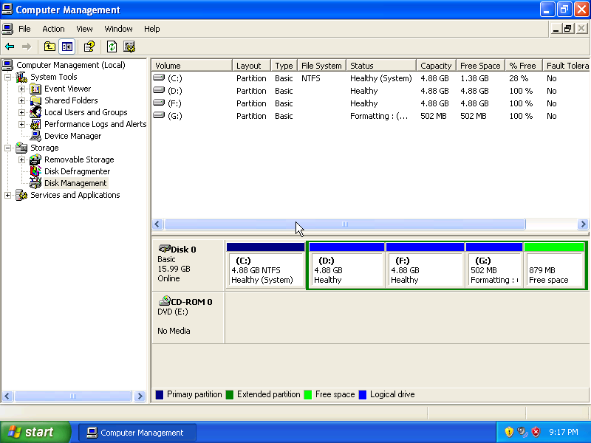

Picture The Computer Management window re-appears while new volume is formatted

The “Computer Management” window shows the new “Healthy” volume.

Step 6
Open My Computer

Click the Local Disk (G:) drive.

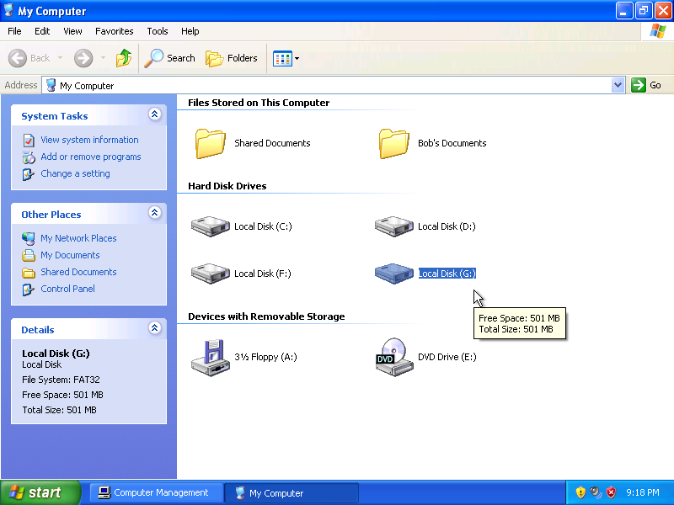

Picture My computer, Local Disk (G) drive

The “Details” area on the left of the “My Computer” window displays information about the G: drive.

What is the File System?

How much Free Space is shown?

Right-click the Local Disk (G:) drive

Choose Properties.

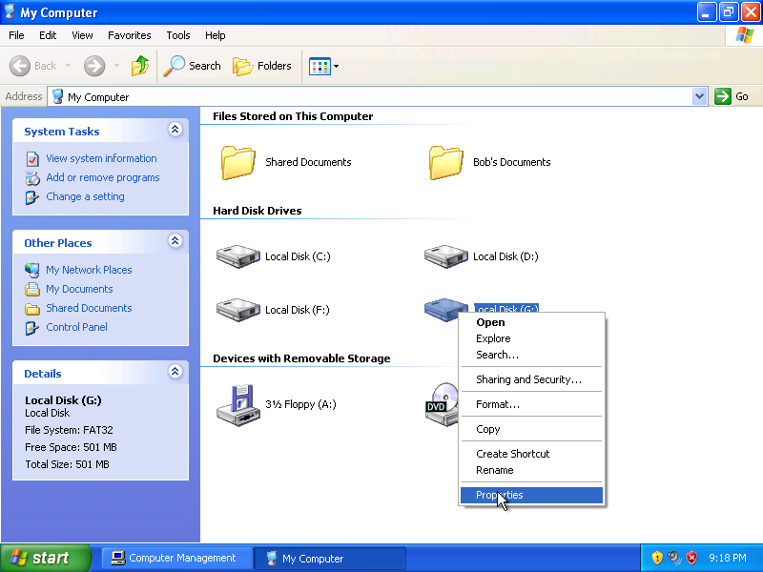

Picture Choose Properties

Step 7
The “Local Disk (G:) Properties” window appears.

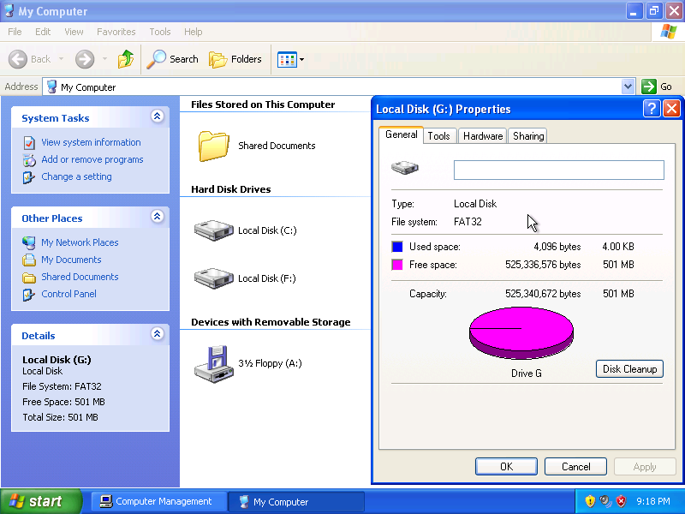
Picture The Local Disk (G☺ Properties window appears

What is the File system of the G: drive?

List the tabs found in the “Local Disk (G:) Properties” window?

Click OK.

Double-click the Local Disk (G:) drive.

Step 8
Right-click anywhere in the white space of the window.

Choose New > Text Document.

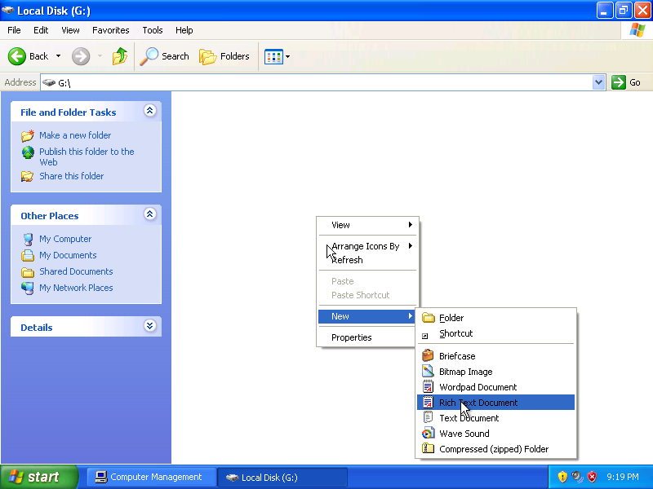
Picture Choose New> Text document
Type Test and press Return.

Step 9
Right-click the Test document in the window and choose Properties.

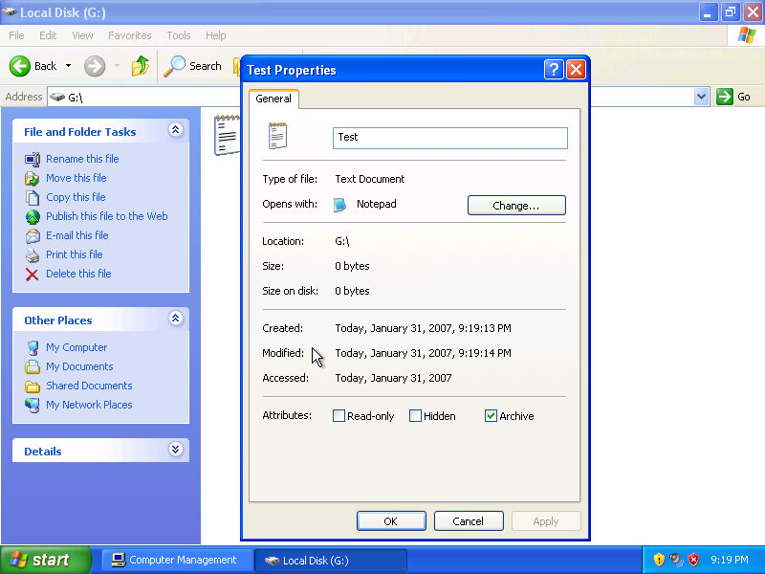

The “Test Properties” window appears.

Notice that there is a tab in the “Test Properties” window called “General”.

Click OK.

Step 10
Choose Start > Run.

In the “Open:” field, type cmd, and then Click OK.

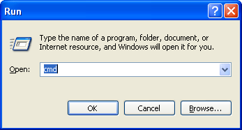

Step 11
The “C:\WINDOWS\system32\cmd.exe” window appears.

Type convert G: /fs:NTFS.

The convert command changes the file system of a volume without losing data.

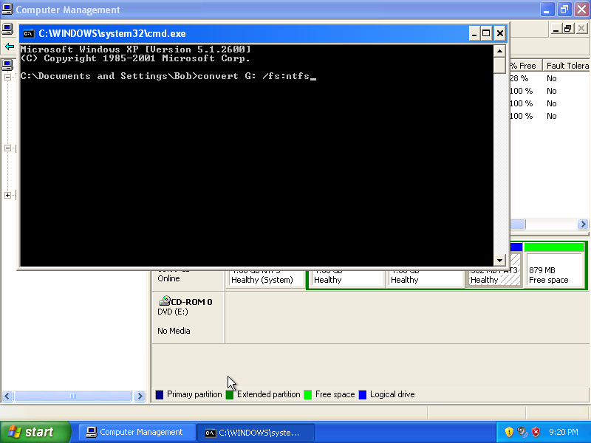

Press the Enter key.

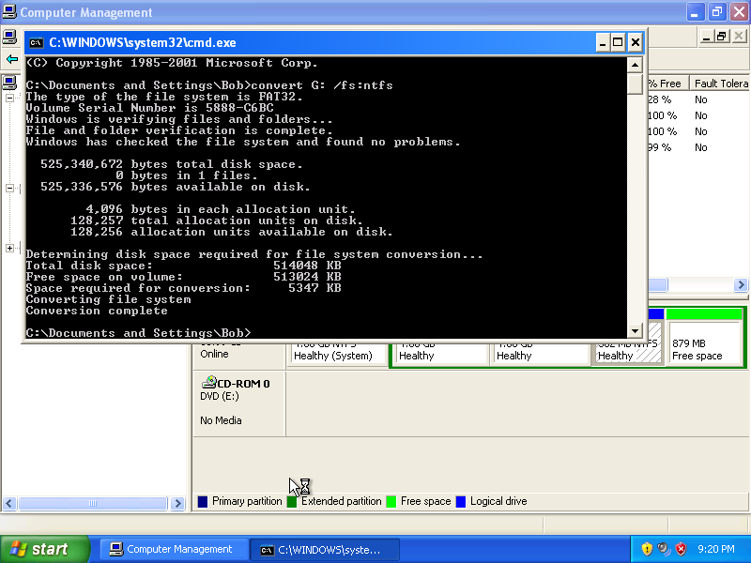

Type exit, and then press Return.

Step 12
The “C:\WINDOWS\System32\cmd.exe” window closes.

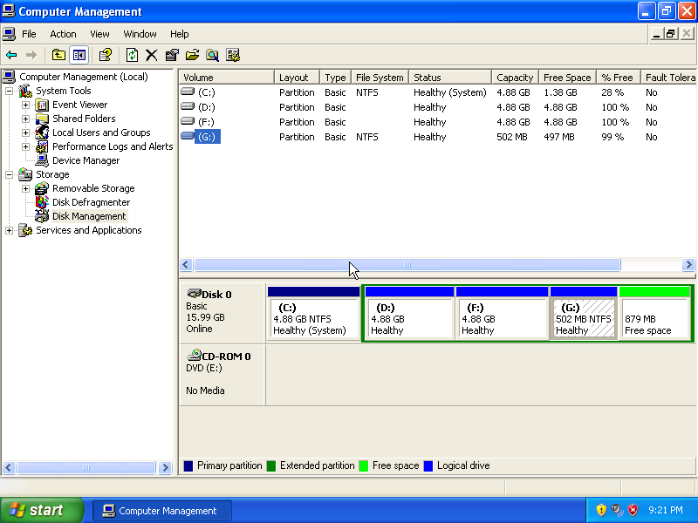

What is the File System of the G: drive?

Step 13
Open My Computer.

Right-click the G: drive, and then click Properties.

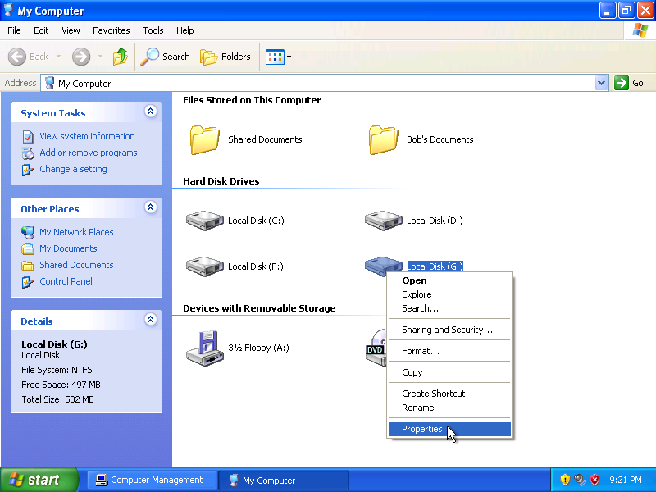

Step 14
The “Local Disk (G:) Properties” window appears.

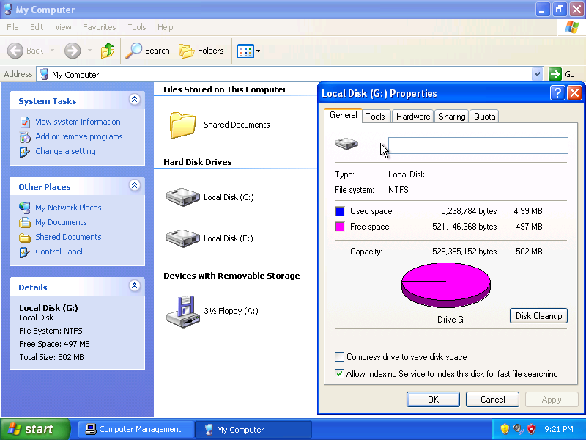

What are the tabs in the “Local Disk (G:) Properties” window?

When the volume was FAT32, there were four tabs. What is the name of the new tab that was added after the volume was converted to NTFS?

Click Cancel, and then double-click the G: drive.

Step 15
Right-click the Test document, and then click Properties.

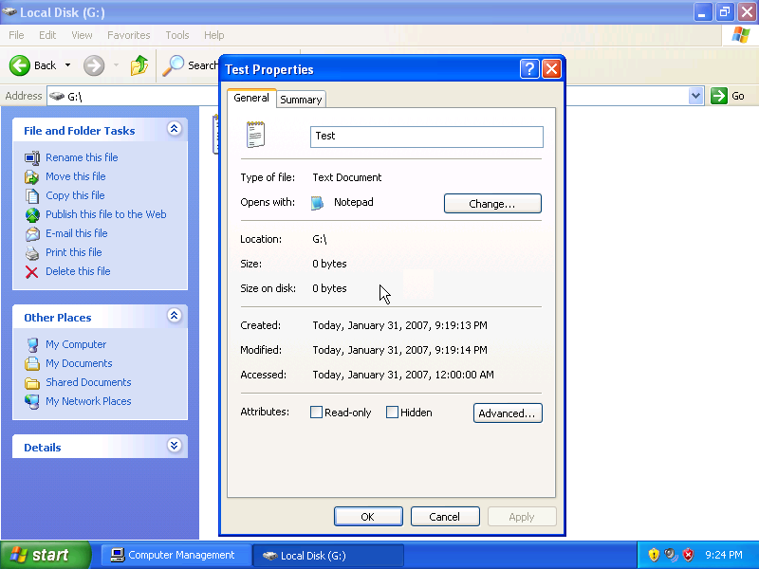
What are the tabs in the “Test Properties” window?

When the volume was FAT32, there was one tab. What is the name of the new tab that was added after the volume was converted to NTFS?

Click OK.

Step 16
Choose Tools > Folder Options…

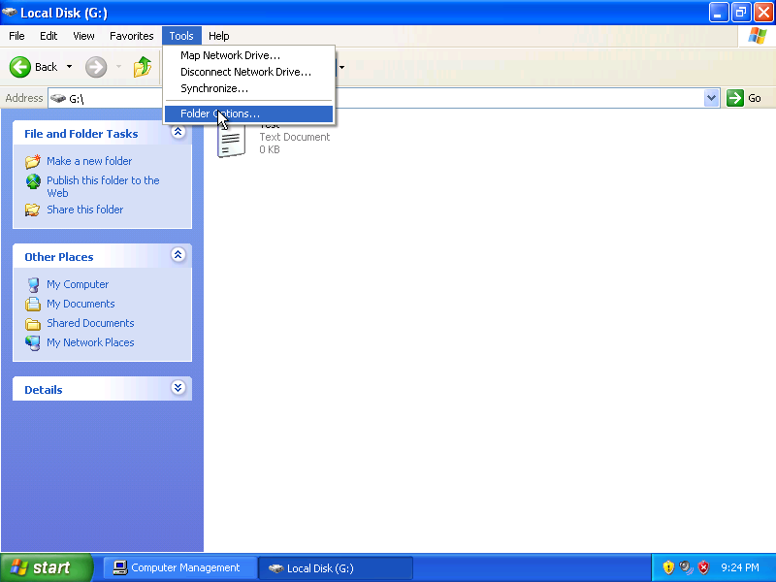

Step 17
The “Folder Options” window appears.

Click the View tab.

Scroll to the bottom of the “Advanced settings:” area, and then uncheck Use simple file sharing (Recommended).

Click OK.

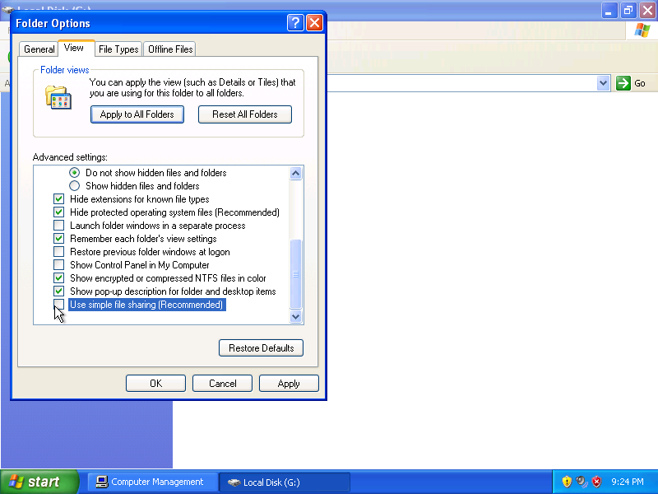

The “Folder Options” window closes.

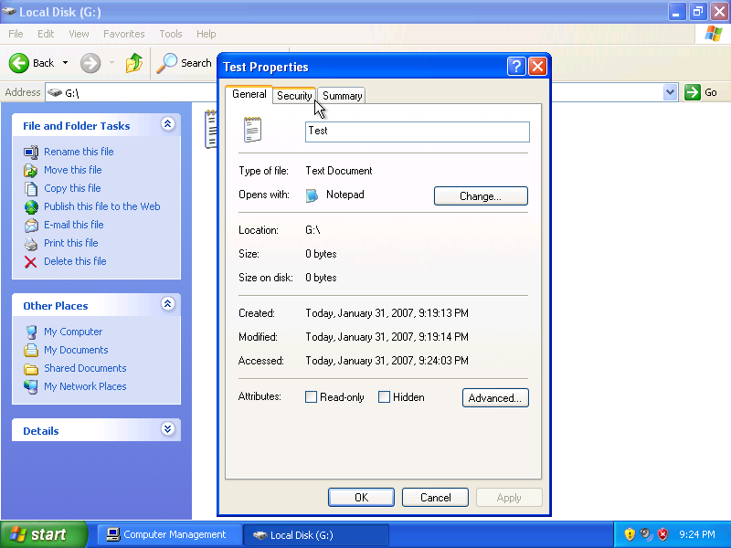

What are the tabs in the “Test Properties” window?

When “simple file sharing” was enabled, there were two tabs. What is the name of the new tab that was added after “simple file sharing” was turned off?

Step 18
Right-click the G: drive, and then choose Properties.

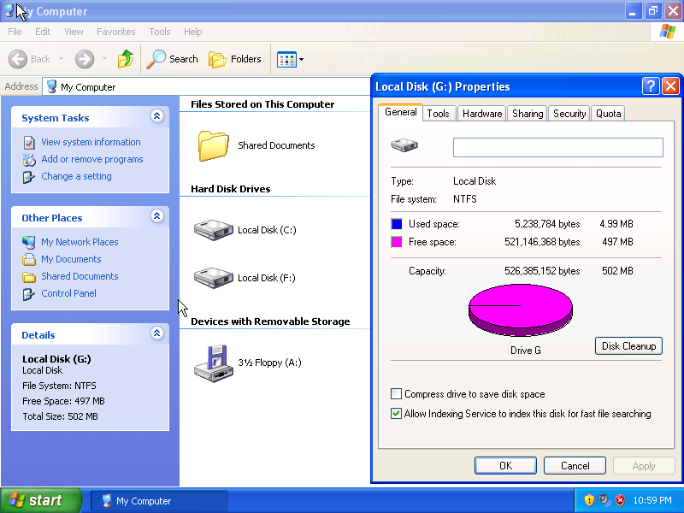

What are the tabs in the “Local Disk (G:) Properties” window?

When “simple file sharing” was enabled, there were five tabs. What is the name of the new tab that was added after “simple file sharing” was turned off?

