12.2.2 Lab: Advanced Installation of Windows XP

Introduction

Print and complete this lab.

In this lab, you will install a Windows XP Professional operating system by using an answer file for automation. You will customize partition settings and create an administrative user and limited users.

Recommended Equipment
The following equipment is required for this exercise:
- A computer with a new installation of Windows XP Professional
- Windows XP Professional installation CD
- A blank, formatted floppy disk

Step 1
Log on to the computer.

Insert the Windows XP Professional CD in the CD-ROM drive.

Click Perform additional tasks.

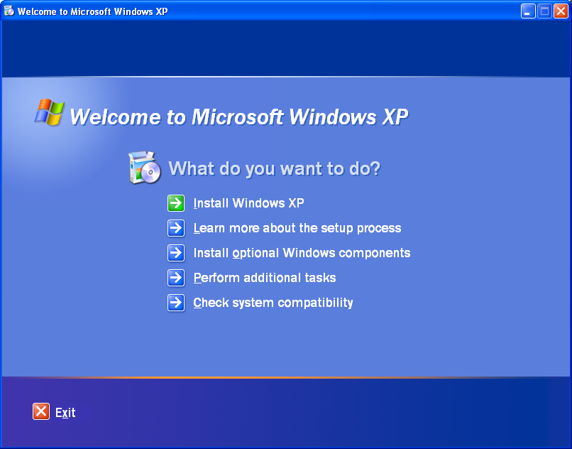

Picture Welcome to Microsoft Windows XP

Step 2
Click Browse this CD.

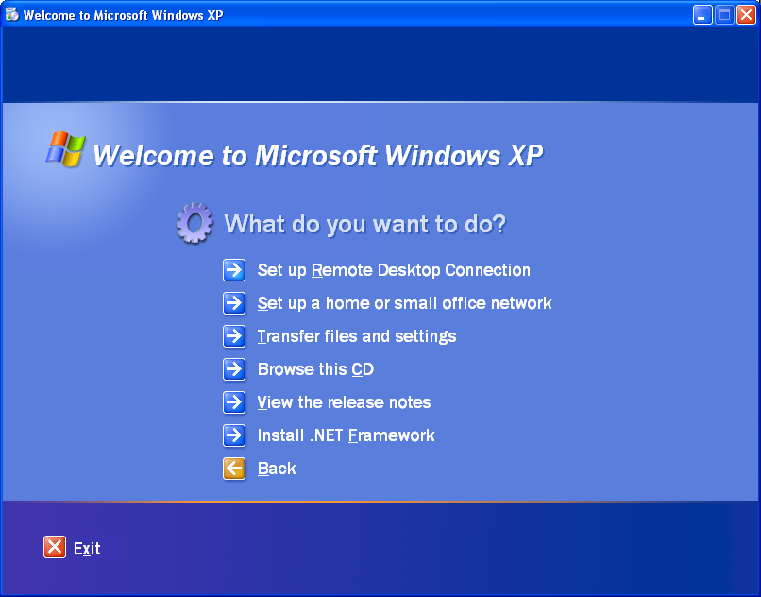

Picture What do you want to do?
Double-click the Support folder.

Double-click the Tools folder.

Double-click Deploy.CAB

Highlight all of the files by clicking Edit > Select All.

Right-click setupmgr.exe and then click Extract.

Click Make New Folder to create a folder on the C: drive.

Name the folder “Deploy”.

Click Extract to extract the files from the CD to C:\Deploy.

Browse to C:\Deploy.

Step 3
Double-click setupmgr.exe.

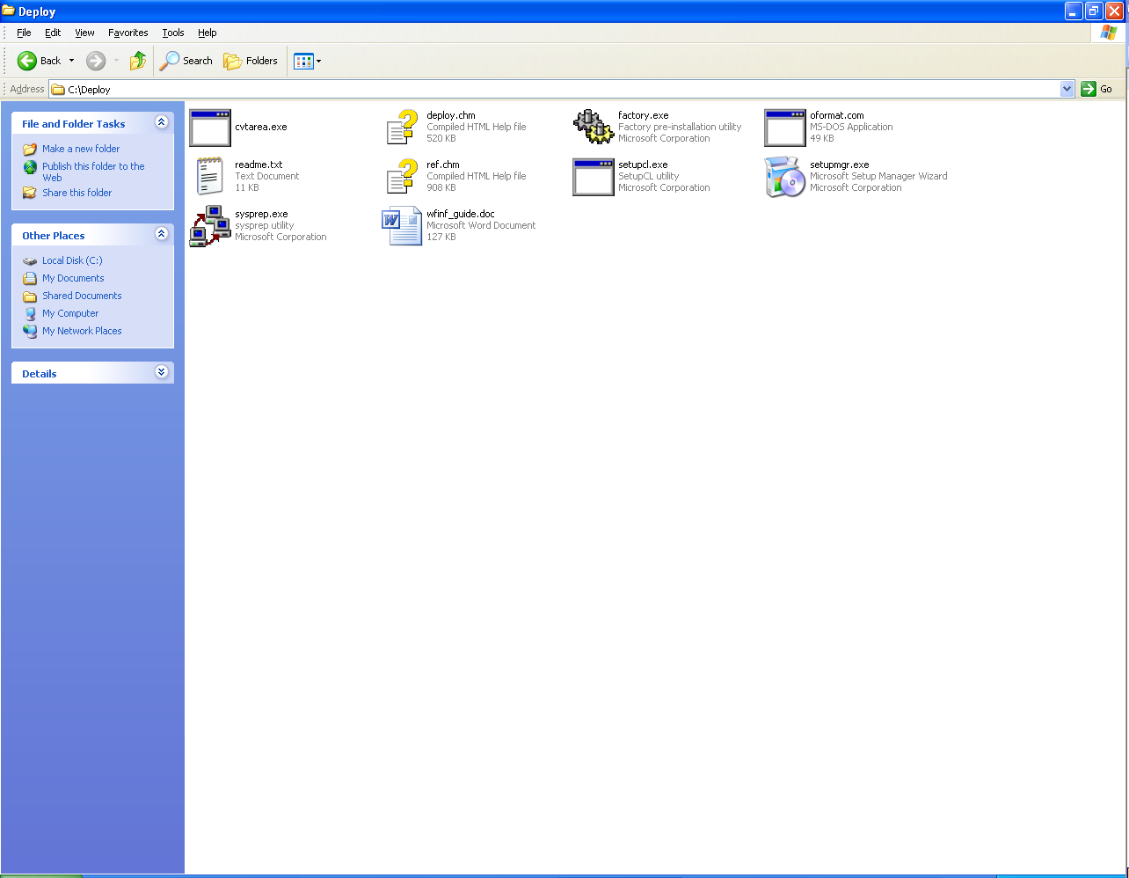

Picture Setupmgr.exe

Step 4
The “Setup Manager” window appears.

Click Next.

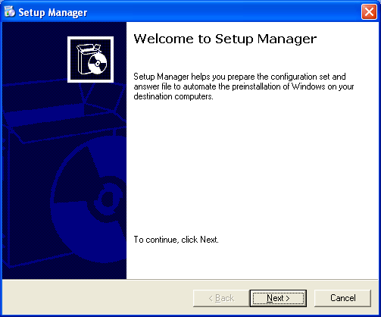

Picture Welcome to Setup Manager

The Create new button should be checked by default.

Click Next.

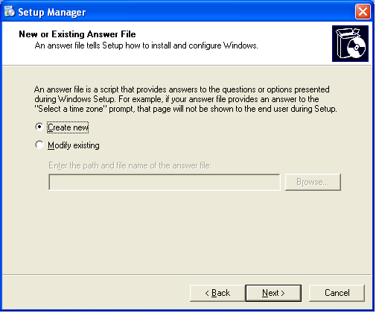
Picture The Create new button should be checked by default

Click the unattended setup radio button.

Note that a CD-based answer file name must be Winnt.sif.

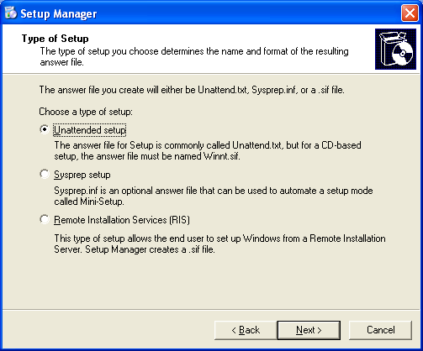
Click the Windows XP Professional radio button, and then click Next.

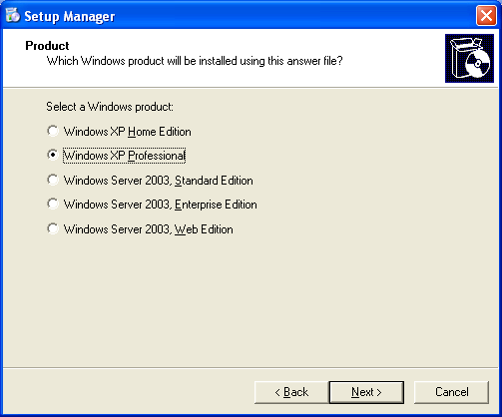

Picture Setup Manager Product, which windows product will be installed using this answer file

Click the Fully automated radio button, and then click Next.

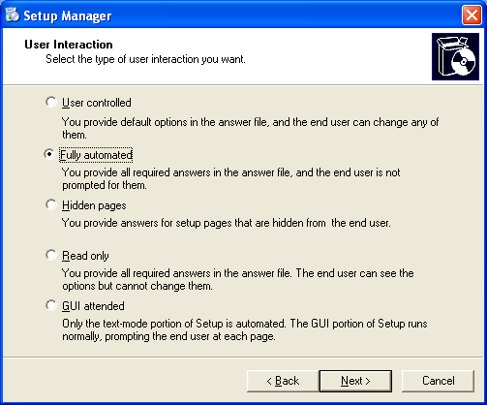
Picture User Interaction
Click the Set up from a CD radio button, and then click Next.

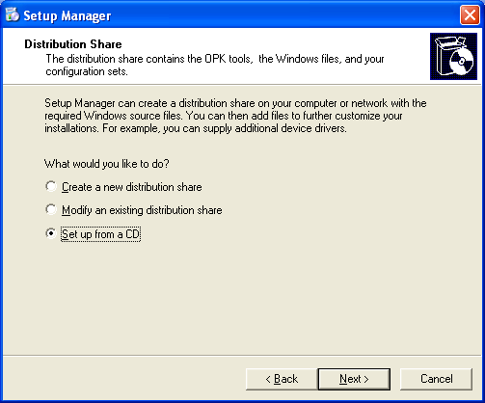
This picture is Setup Manager Distribution Share

Click the I accept the terms of the License Agreement checkbox, and then click Next.

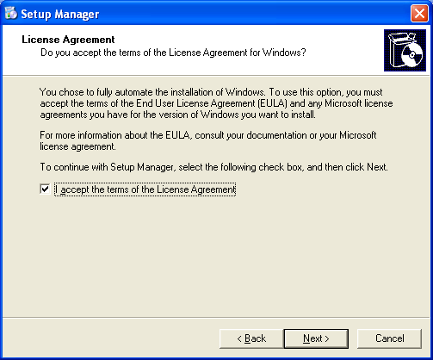
This picture Setup Manager License Agreement
Click Name and Organization in the list on the left.

Type the name and the organization name provided by your instructor.

Click Next.

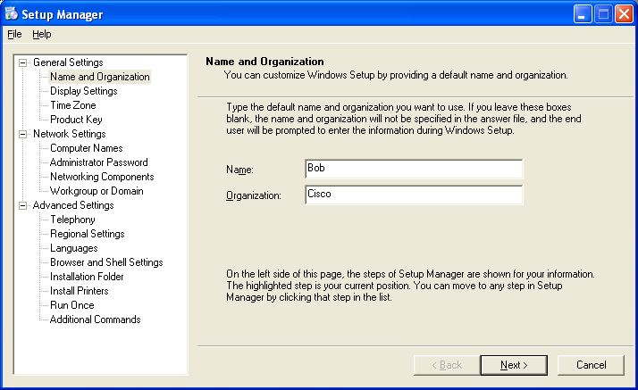

Click Time Zone in the list on the left.

Click the time zone for your location from the “Time zone:” drop-down box, and then click Next.

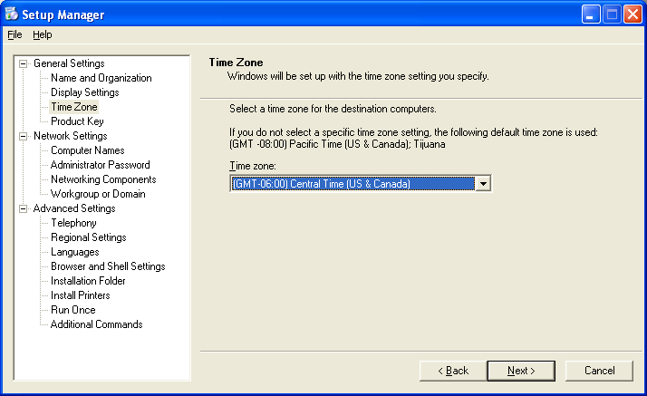

Highlight Product Key in the list on the left.

Type the Windows XP Professional product key supplied by your instructor in the “Product Key:” fields.

Click Next.

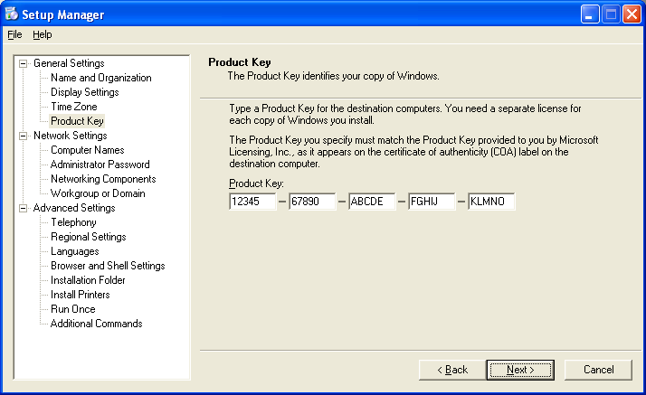

Click Computer Names in the list on the left.

Type the computer name provided by your instructor in the “Computer name:” field, and then click Add.

The computer name will then display in the “Computers to be installed:” field.

Click Next.

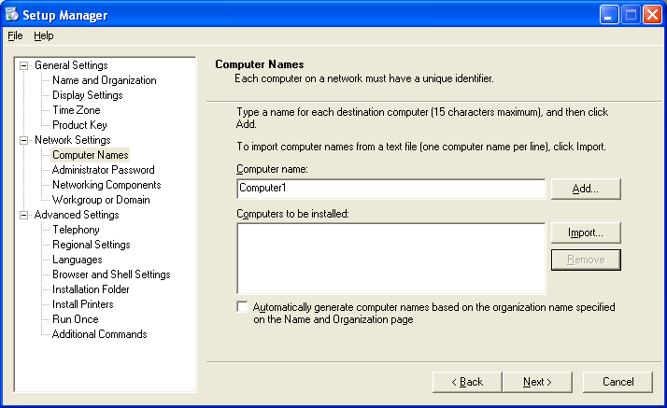
Click Administrative Password in the list on the left.

Type your first initial of your first name and your complete last name in the “Password:” and “Confirm password:” fields. (For example, jsmith)

Click Next.

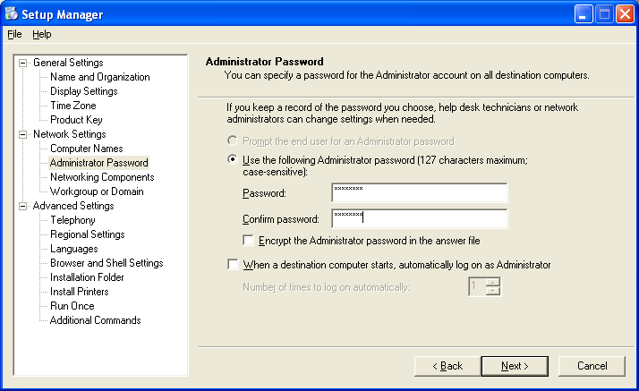

Click Workgroup or Domain in the list on the left.

Click the Workgroup radio button.

Type the Workgroup name LabGroup1 in the “Workgroup:” field, and then click Next.

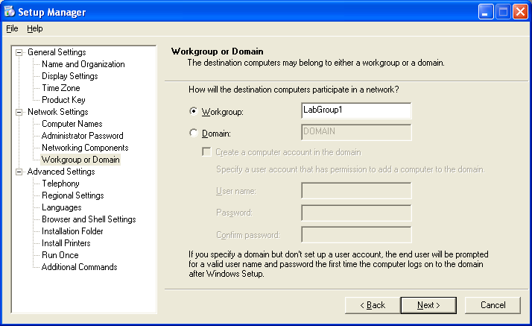

Click Additional Commands in the list on the left, and then click Finish.

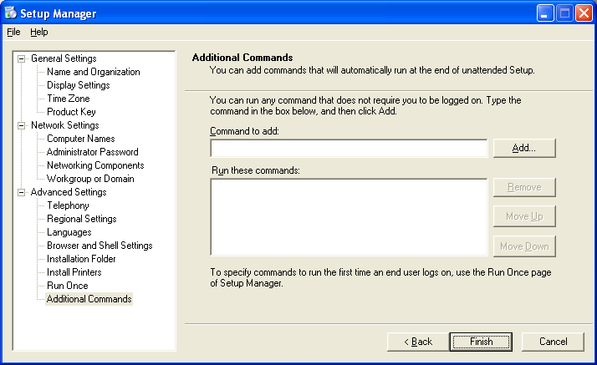

Type “C:\Deploy\unattend.txt” in the “Path and file name:” field if it is not already displayed.

Click OK.

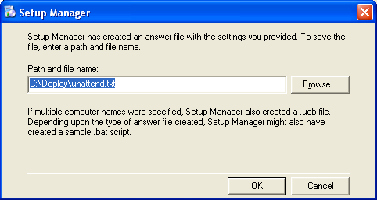
Click File > Exit.

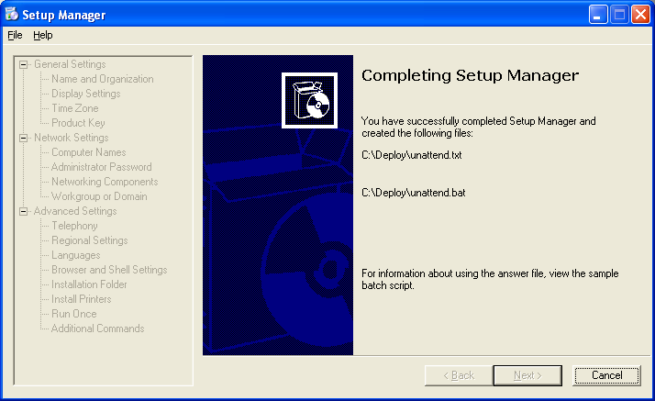
This picture is Completing Setup Manager

Step 5
Browse to “C:\Deploy”.

Right-click unattend.txt, and then click copy.

Browse to “A:\”.

Click File > Paste.

Right-click unattend.txt, and then click rename.

Type Winnt.sif as the new file name, and press Enter.

Remove the floppy disk from the floppy drive.

Click start > Turn Off Computer.

Click Restart

Step 6
When the “Press Any Key to Boot from CD” message appears, press any key on the keyboard. Insert the floppy disk. The system will inspect the hardware configuration.

The Windows XP Setup screen appears while the program loads the necessary files.


Step 7
The Welcome to Setup screen appears. Press Enter.

The “Windows XP Licensing Agreement” screen appears.

Press F8.

Windows XP Professional Setup will search to determine if another operating system already exists on the hard drive.
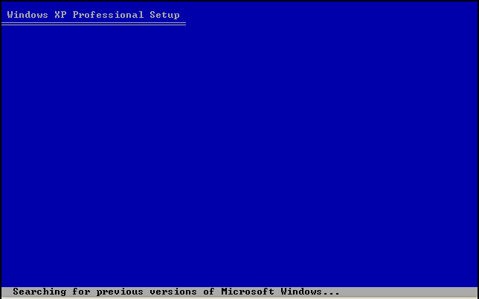

Press ESC.

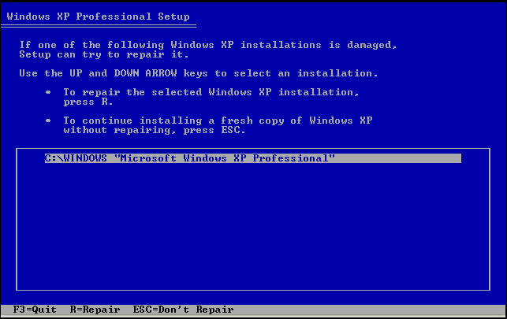
Press the D key.

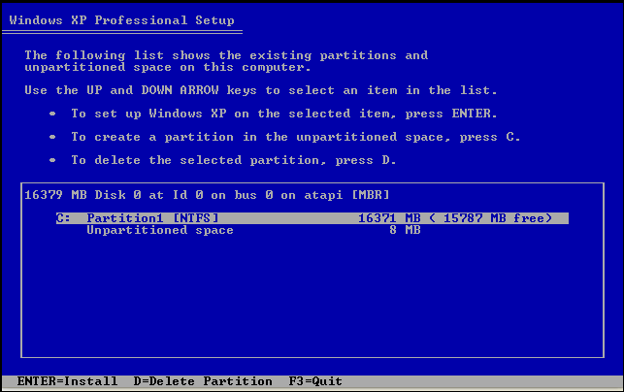

Press Enter.
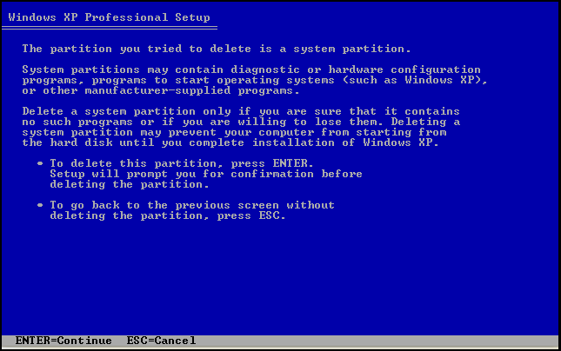
Press the L key.

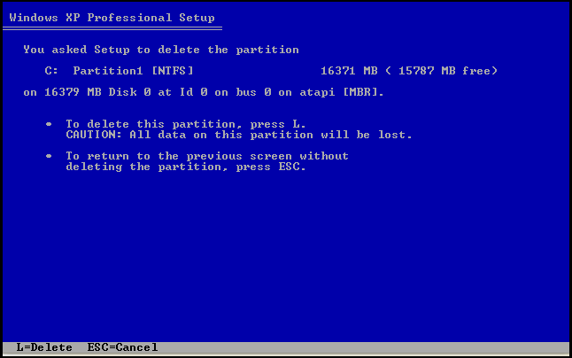

Press the C key.

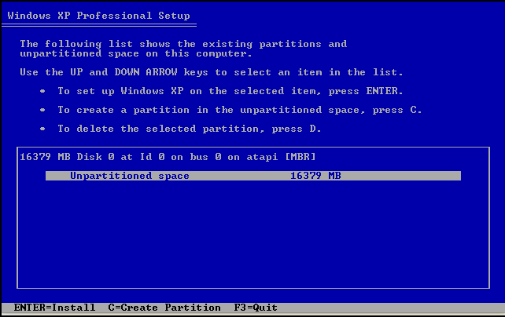
Type 5000 in the “Create partition of size (in MB):” field.

Press the Enter key.
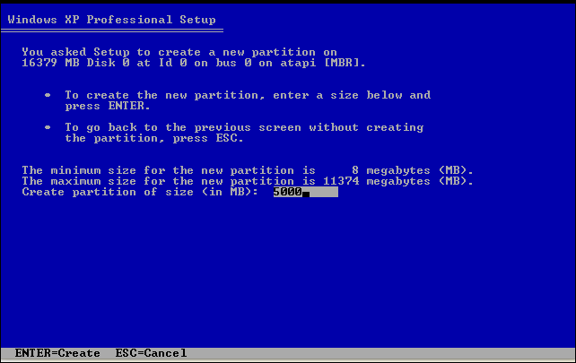

Press the down arrow key to select “Unpartitioned space”.
Press the C key.

Create another partition of 5000 MB.

Repeat this process one more time. You will have three partitions of 5000 MB each.

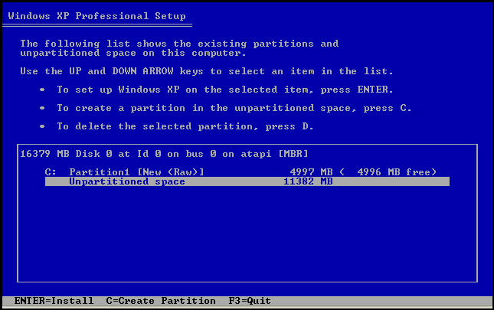
Select C: Partition1 and press the Enter key.

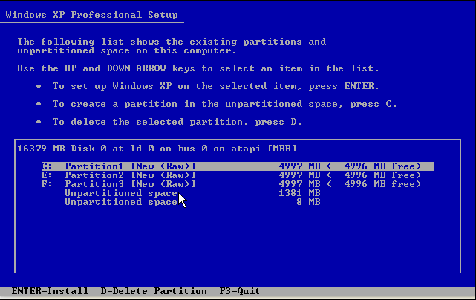

Select “Format the partition using the NTFS file system”.

Do not select ““Format the partition using the NTFS file system <Quick>”.

Press the Enter key.

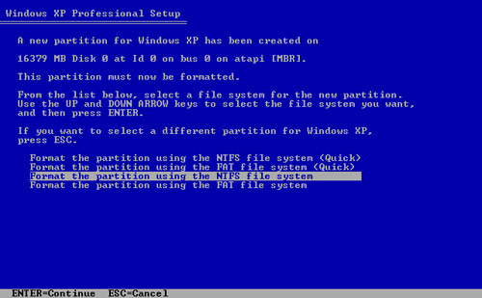
The “Please wait while Setup formats the partition” screen appears.

The system will restart automatically.

After the system restarts, the message “Press Any Key to Boot from CD” appears.

Do not press any keys.

The installation should continue without prompting you for any settings.

The system will restart automatically.

After the system restarts, the message “Press Any Key to Boot from CD” appears.

Do not press any keys.

Step 8
The “Welcome to Microsoft Windows” screen appears.

Click Next.

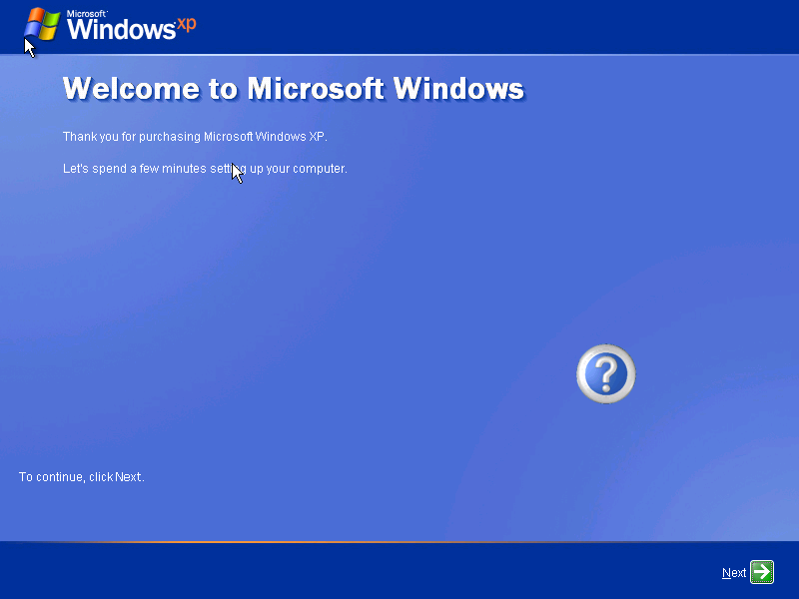

Click the Help protect my PC by turning on Automatic Updates now radio button.

Click Next.

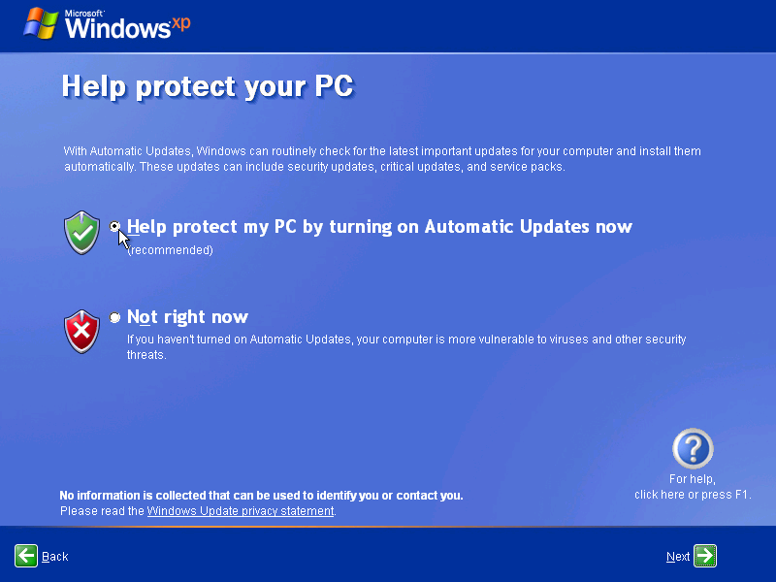

Picture “Help protect your Computer”
Click the Yes, this computer will connect through the local area network or home network radio button.

Click Next.

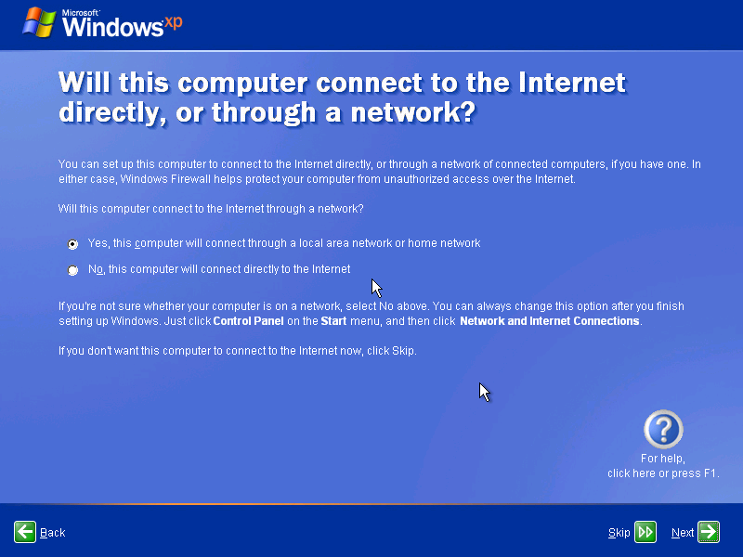
This picture asks the question will this computer connect to the Internet directly, or through a network?

Click the No, not at this time radio button, and then click Next.

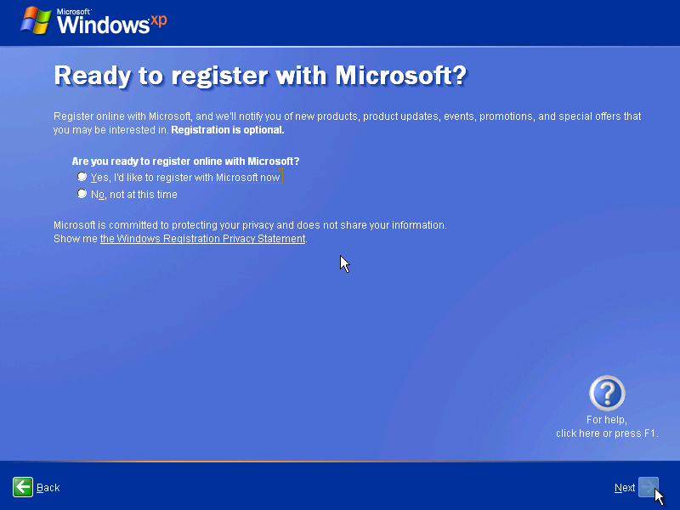
This picture asks Are you ready to register with Microsoft?
Type the name provided by your instructor in the “Your name:” field.

Click Next.

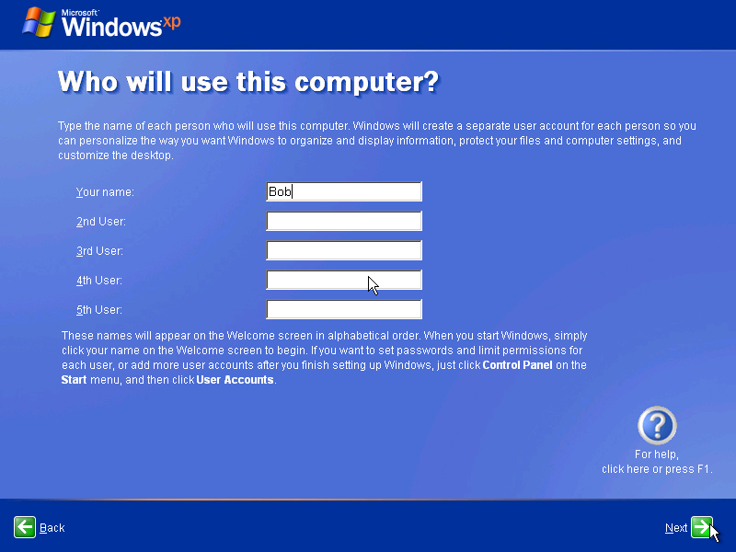

This picture asks “Who will use this Computer?”
The “Thank you!” screen appears.

Click Finish.

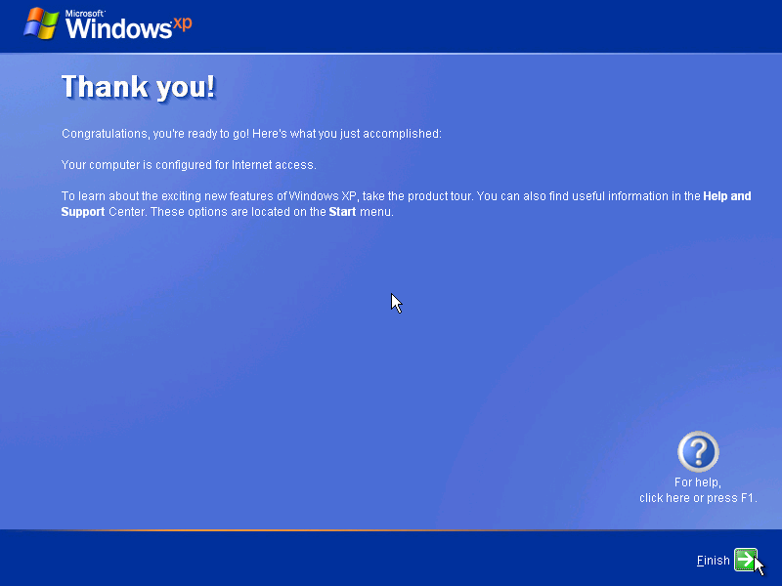
Thank You

Step 9
The “Windows XP Professional” desktop appears.

Click start > Control Panel.

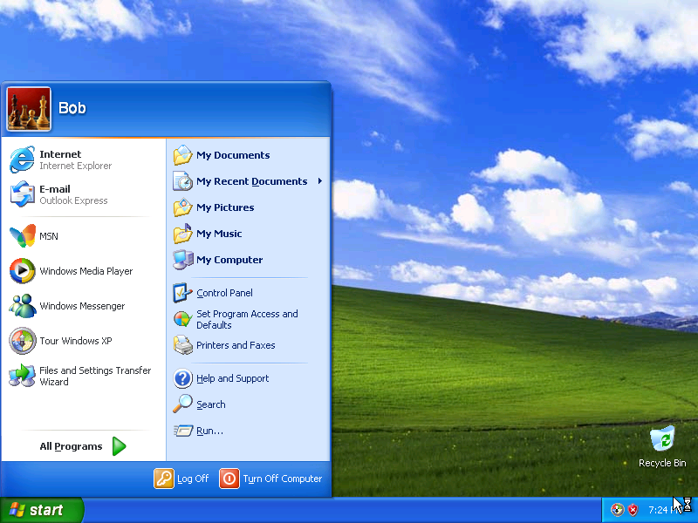

Step 10
Click User Accounts.

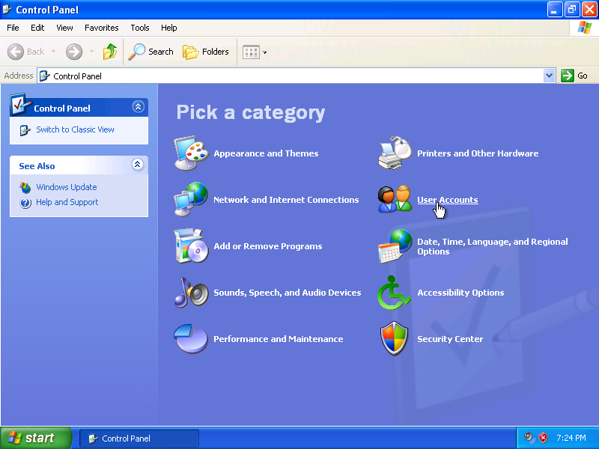
This picture asks you to Pick a Category
Click Create a new account from the “Pick a task…” list.

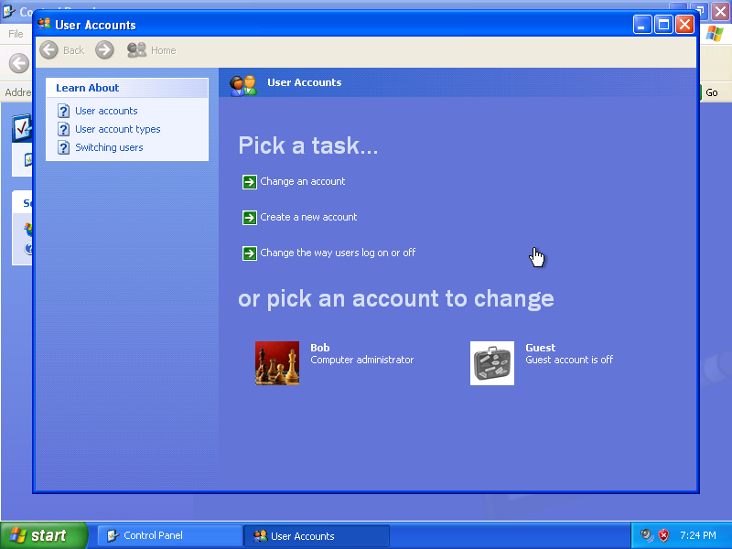
This picture asks you to “Pick a Task”

Type the name provided by your instructor in the “Type a name for the new account:” field.

Click Next.

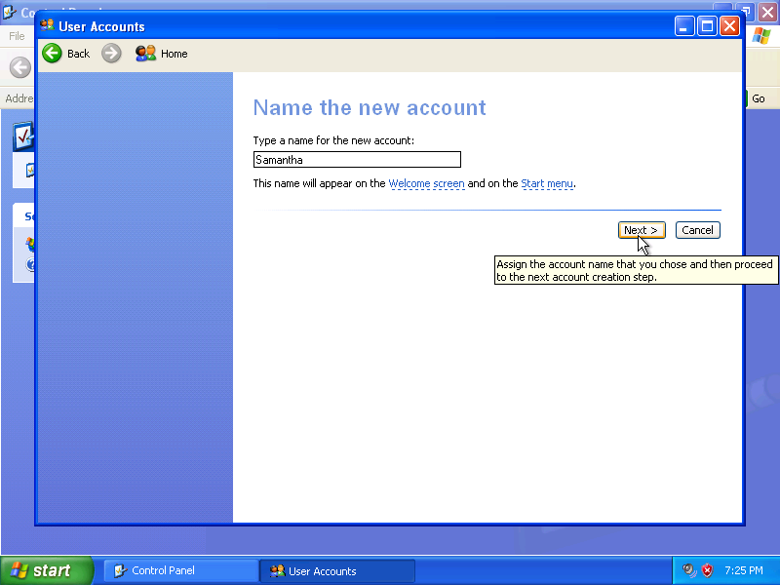

This picture asks you to Name the new account
Click the Limited radio button.

Click Create Account.

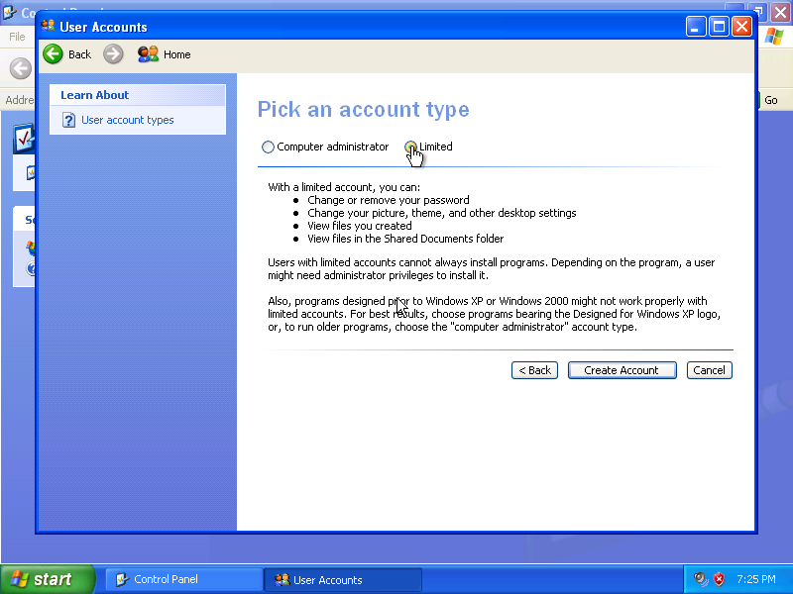
This picture asks you to Pick an account.

The “User Accounts” window appears.

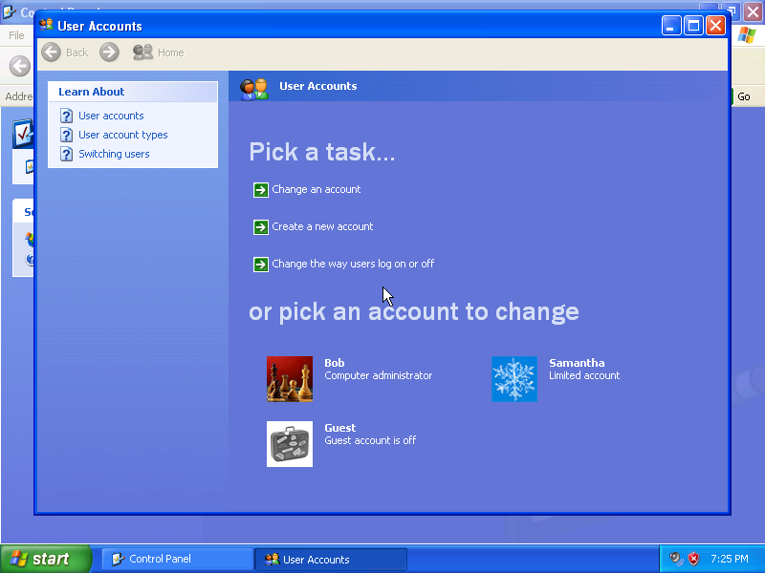

Create a second limited user. Your instructor will provide the name of the user.
What was the name of the file used to automate the installation located on the floppy disk?

How do you think automating the installation will help the IT Department if they have to repeat the procedure on 100 computers?

