11.4.4 Lab: BIOS File Search

Introduction

Print and complete this lab.

In this lab, you will identify the current BIOS version, and then search for BIOS update files.

Recommended Equipment
- Computer running Windows XP Professional
- Internet access

Step 1
Boot your computer.

During POST, BIOS information is displayed on the screen for a short period of time.

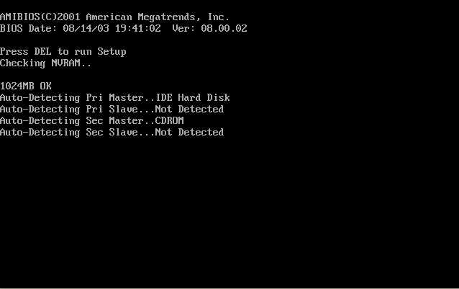

Do not log on to Windows.

What key or combination of keys is used to run Setup on your computer?

Restart your computer and enter Setup.

Step 2
The “BIOS Setup Utility” screen appears.

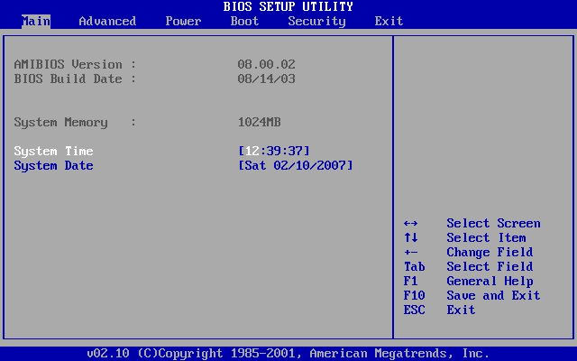

Who is the manufacturer of the BIOS?

Which BIOS version is installed in your computer?

CAUTION: Do not update your BIOS.

What is the current BIOS version available for the motherboard?

What features, if any, have been added to the new BIOS version?

What changes, if any, have been made to the new BIOS version to fix problems?

What are the instructions to update the new BIOS version?

