16.4.3 Lab: Data Backup and Recovery in Windows XP

Introduction

Print and complete this lab.

In this lab, you will back up data. You will also perform a recovery of the data.

Recommended Equipment
The following equipment is required for this exercise:
- A computer system running Windows XP is required for this exercise.

Step 1
Log on to the computer as an administrator.

Navigate to the location where backed up files will be stored. For example, use the external hard drive H:\. Create a folder called Backup Location.

Create a text file on the desktop called Backup File One. Open the file and type the text “The text in this file will not be changed.”

Create another text file on the desktop called Backup File Two. Open the file and type the text “The text in this file will be changed.”

Step 2
Click Start > All Programs > Accessories > System Tools > Backup. The Backup or Restore Wizard window appears.

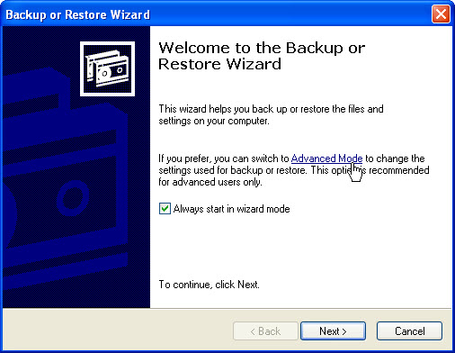

Click Advanced Mode.

Step 3
The Backup Utility window appears.

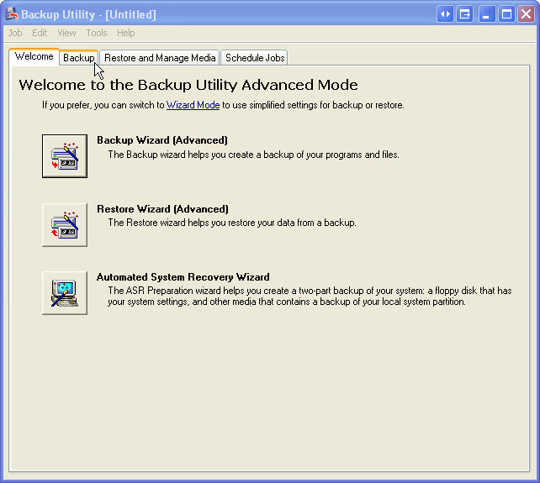

Click the Backup tab.

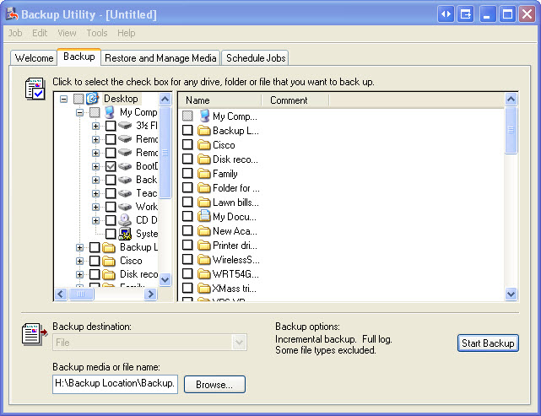

Step 4
From the menu select Tools > Options.

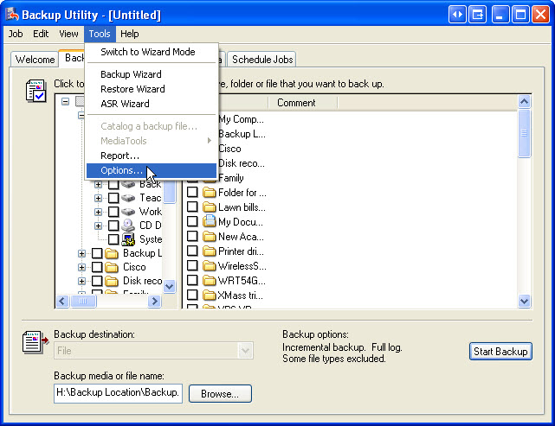

Select the default Backup Type to Normal.

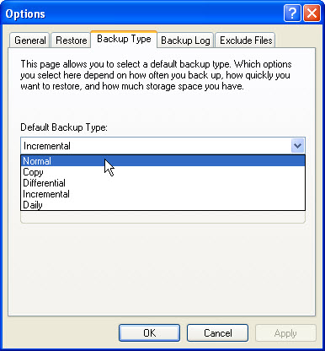

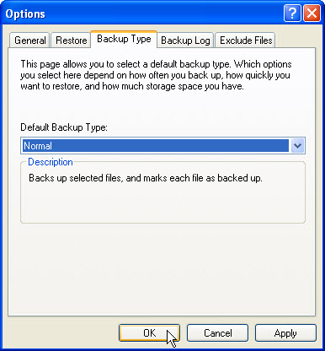

What is the description of a normal backup?

Click Ok.

Step 5
Click the Desktop: icon in the left panel. Then locate in the right panel the files named Backup File One and Backup File Two, and place a check mark next to the files.

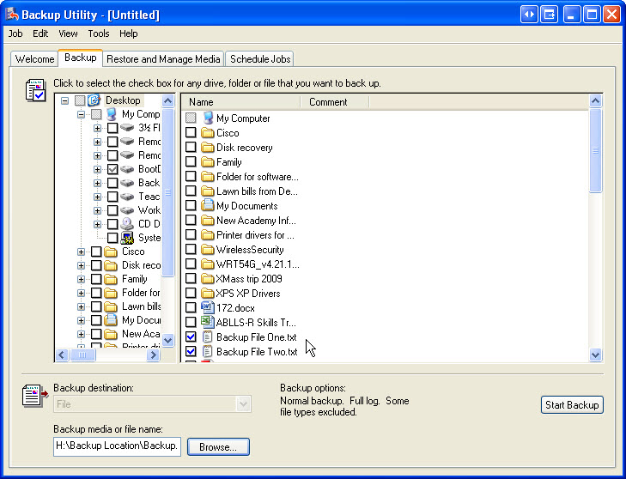

Step 6
Click the Browse button. If asked to insert a disk into drive A, click Cancel.

Locate the Drive H: folder called Backup Location. Select the Backup Location folder and click Open. Click Save.

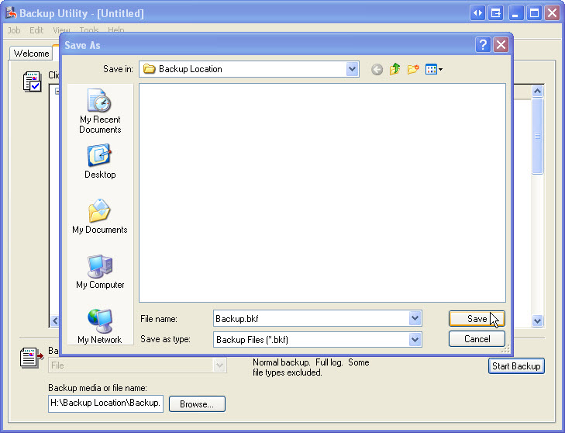

Step 7
Click Start Backup button.

The Backup Job Information window appears. Keep the default settings.

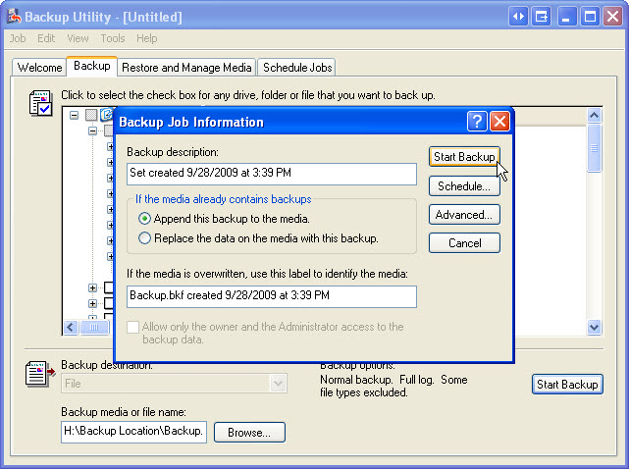

What is the default label for the backup file?

Click Start Backup.

The Backup Progress window appears.

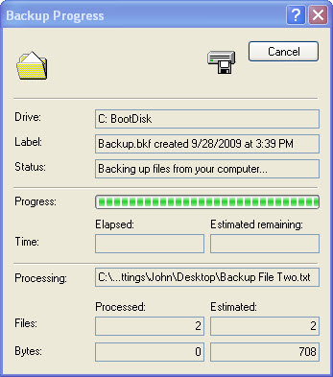

When the backup is finished, click Report.

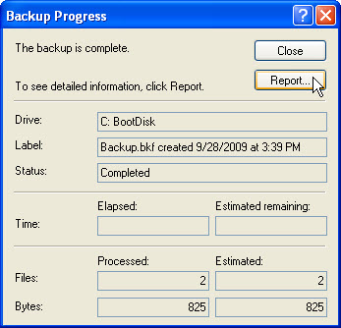

A backup log file opens. Scroll to the bottom of the file.

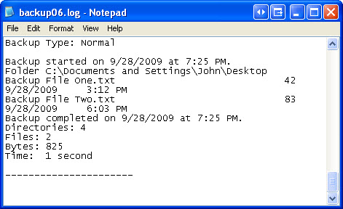

What files were backed up?

Close the notepad document.

Click Close to exit Backup Progress.

Step 8
Navigate to the Desktop. Delete Backup File One and Backup File Two.

Empty the Recycle Bin.

Step 9
Click on the Backup Utility window so it is activated.

Click the Restore and Manage Media tab.

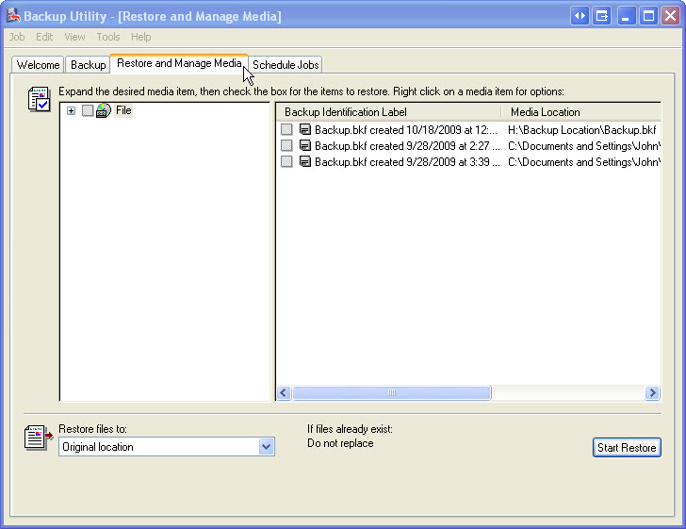

In the left panel expand the most recent backup file. Place a check mark in the checkbox.

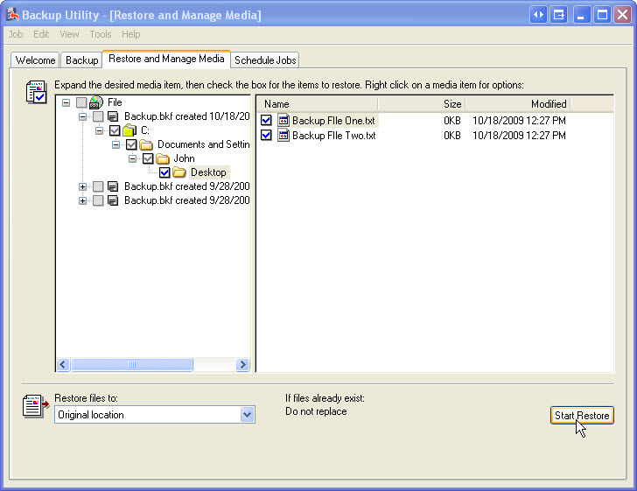

Make sure the Restore file to is set to Original location.

Click Start Restore > OK.

When the restore is finished, click Close.

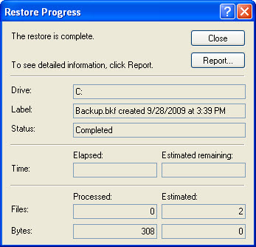

Navigate to the desktop.

Are the two files restored to the desktop?

Step 10
Open file Backup File Two. Add the following text “More text added.” to the file. Save the file.

Step 11
Click the Backup Utility window.

In the main menu select Tools > Options > Backup Type tab.

Change the default Backup Type to Incremental.

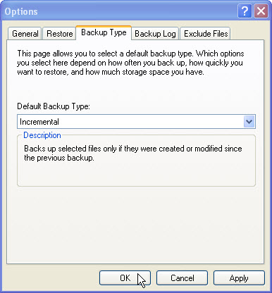

What is the description of an incremental backup?

Click Ok.

Step 12
Click the Backup Tab. Click the Desktop icon in the left panel. Locate in the right panel the file named Backup File One and Backup File Two. Place a check mark next to the files.

Click Start Backup button.

The Backup Job Information window appears. Keep the default settings.

What is the default label for the backup file?

Click Start Backup.

When the backup is finished, click Report.

Scroll to the bottom of the file.

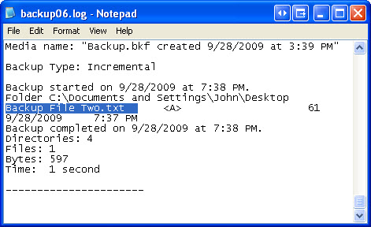

What file(s) were backed up?

Close the notepad document.

Click Close to exit Backup Progress.

Step 13
Click the Schedule Job tab.

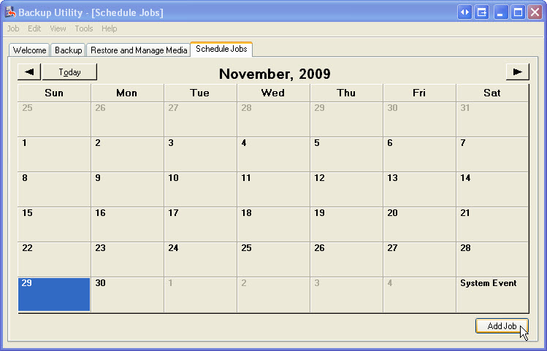

Click Add Job > Next.

Select Back up selected files, drivers, or network data.

Click Next.

Locate and place a check mark next to files Backup File One and Backup File Two.

Click Next.

Click the Browse button, then locate and select the Backup Location folder. Click Open > Save.

Click Next.

Set backup type to Daily.

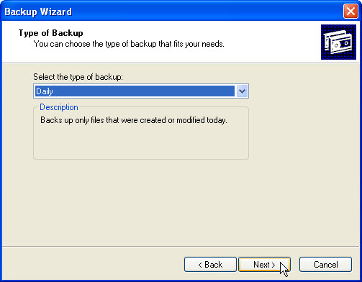

What is the description of a daily backup?

Click Next > Next > Next.

The When to Back Up window appears, select Later.

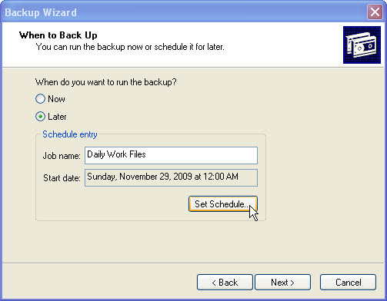

For Job name type Daily Work Files, then click Set Schedule.

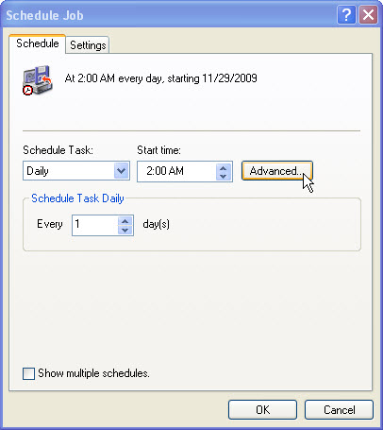

Set Schedule Task to Daily, Start time to 2:00 AM, Schedule Task Daily Every 1 day(s), and then click the Advanced button.

The Advanced Schedule Options window appears, click Cancel.

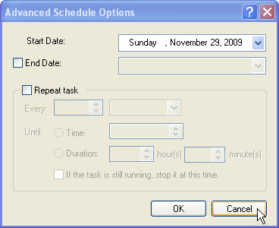

Click the Settings tab.

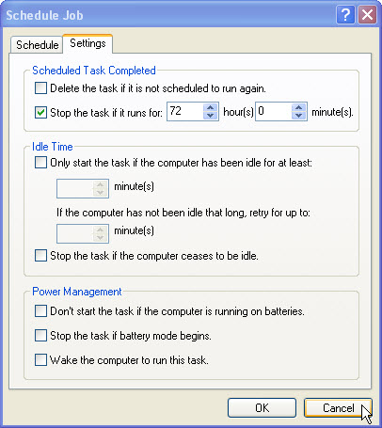

What is the default maximum time allowed to run a backup?

Click OK.

Enter the administrator password and confirm the password.
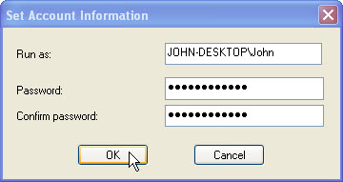

Click OK.

The When to Back Up screen appears with the new settings.

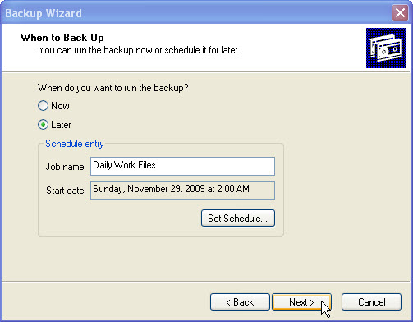

Click Next > OK.

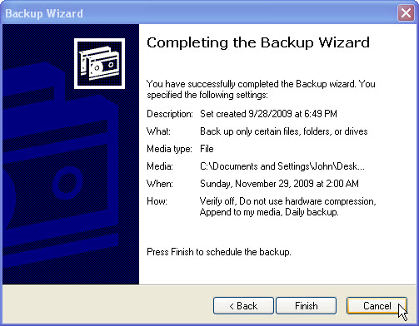

Click Cancel. Do not save the scheduled backup. Close the Backup Utility [Schedule Jobs] window.

Step 14
Delete the following from the Desktop: Backup File One, and Backup File Two.

Delete the Backup Location folder from Drive H:.

Empty the trash.

