16.4.3 Optional Lab: Data Backup and Recovery in Windows Vista

Introduction

Print and complete this lab.

In this lab, you will back up data. You will also perform a recovery of the data.

Recommended Equipment
The following equipment is required for this exercise:
- A computer system running Windows Vista is required for this exercise

Step 1
Log on to the computer as an administrator.

Create a text file on the desktop called Backup File One. Open the file and type the text “The text in this file will not be changed.”

Create another text file on the desktop called Backup File Two. Open the file and type the text “The text in this file will be changed.”

Step 2
Click Start > All Programs > Accessories > System Tools > Backup Status and Configuration. The Backup Status and Configuration window appears.

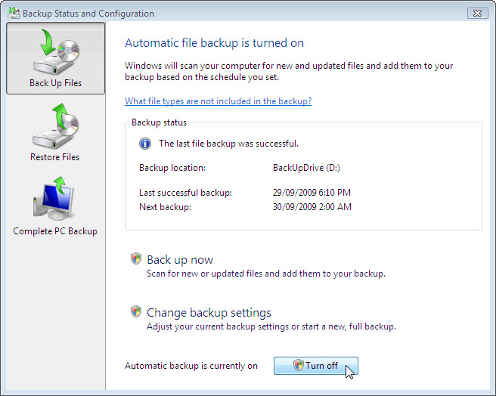

If automatic backup is turned on click Turn Off > Continue.

Step 3
Click Change backup settings > Continue.

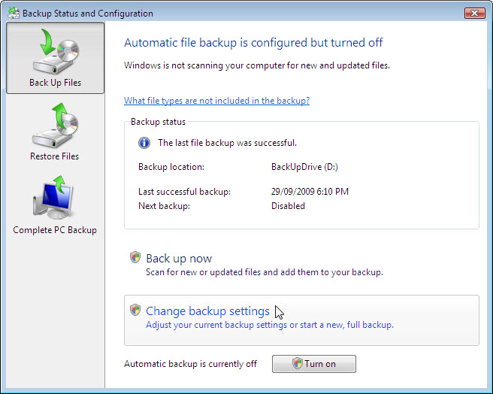

Select the location where the backup will be stored. In this example an external hard drive is used.

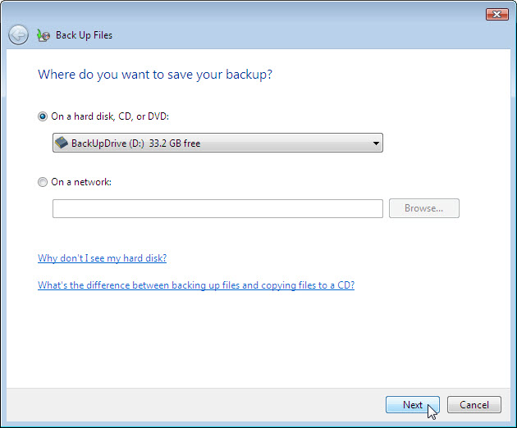

Click Next.

Step 4

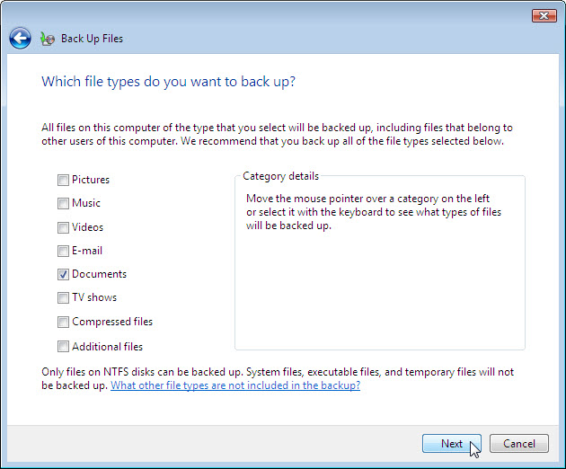

What file type can be backed up?

What file types will not be backed up?

Only files on what type of disk can be backed up?

Make sure only file type Documents is selected.

Click Next.

Step 5
The How often do you want to create a backup? screen appears.

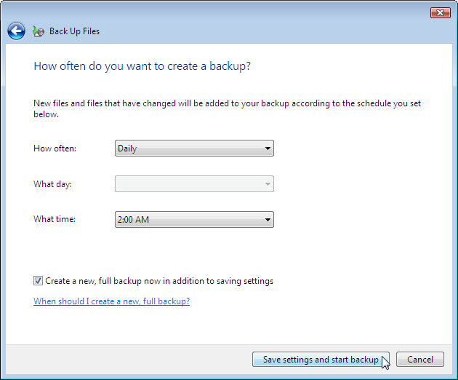

Set the following conditions:
How often – Daily
What day – blank
What time – 2:00 AM

Which files will be backed up?

Place a check mark in the checkbox Create a new, full backup now in addition to saving settings.

Click Save settings and start backup.

The Creating a shadow copy progress screen appears.

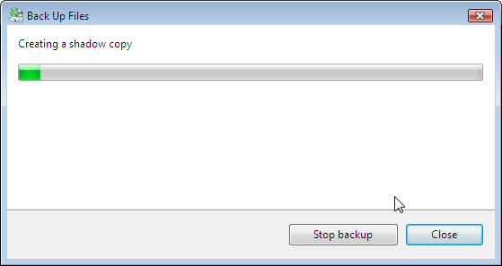

When the backup is finished, click Close.

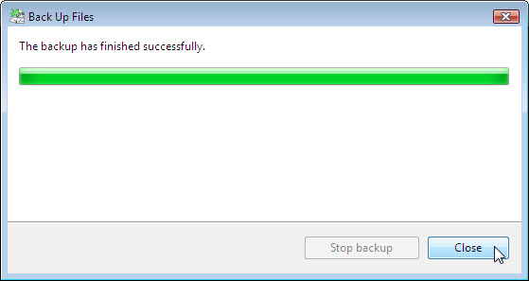

Step 6
The Backup Status and Configuration window appears.

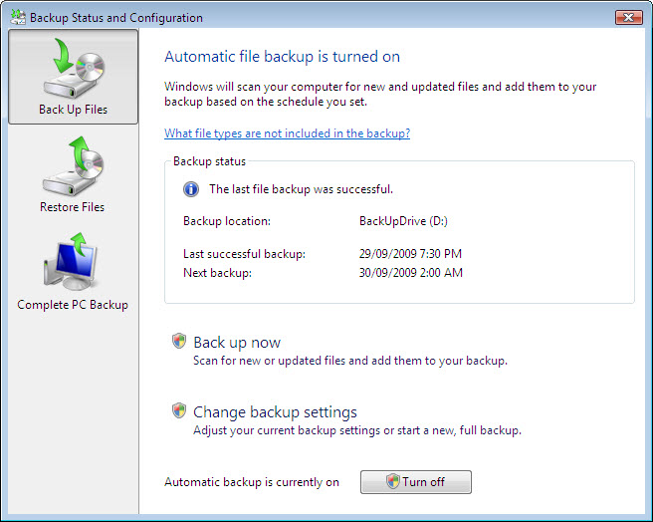

When will the next backup take place?

What is the state of automatic backup?

Step 7
Navigate to the Desktop. Delete Backup File One and Backup File Two.

Empty the Recycle Bin.

Step 8
Click on the Backup Status and Configuration window.

Click Restore Files.

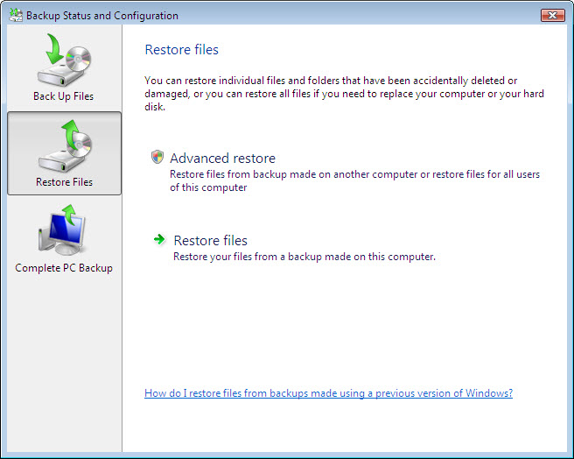

Step 9
Click Restore files.

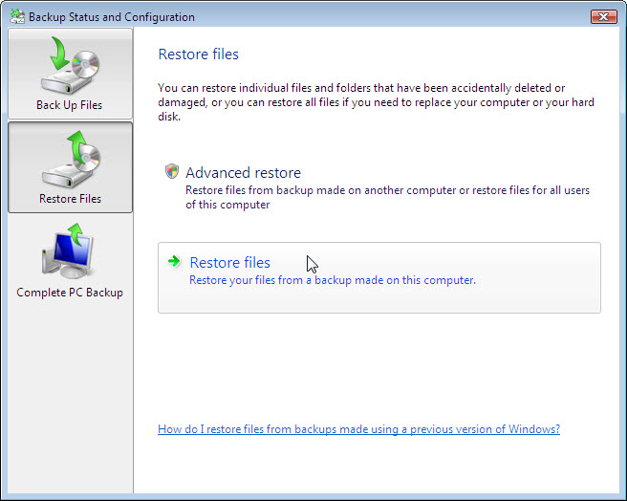

Step 10
The What do you want to restore? screen appears.

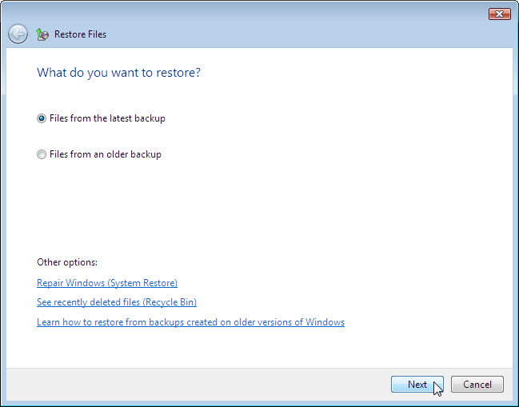

Select Files from the latest backup, and then click Next.

Step 11
The Select the files and folders to restore screen appears.

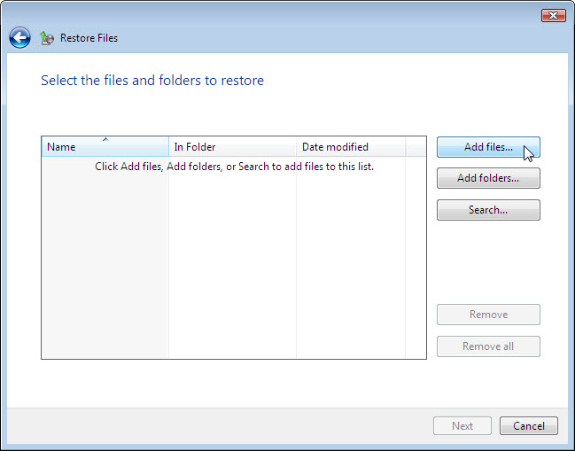

Click Add files.

Navigate to the Desktop and locate files Backup File One and Backup File Two. Select both files by clicking Backup File One and then holding down the Ctrl key while clicking Backup File Two. Click Add.

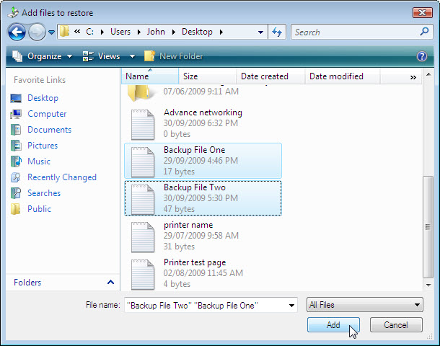

The two files should show up in the Select the files and folders to restore screen.

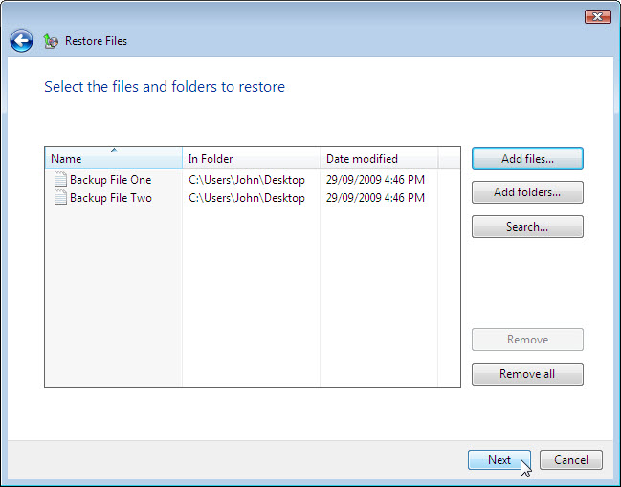

Click Next.

Step 12
The Where do you want to save the restored files? screen appears.

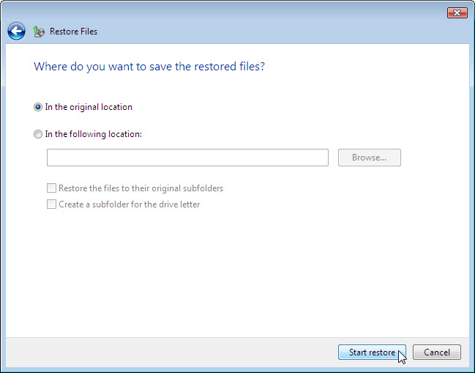

Select In the original location, and then click Start restore.

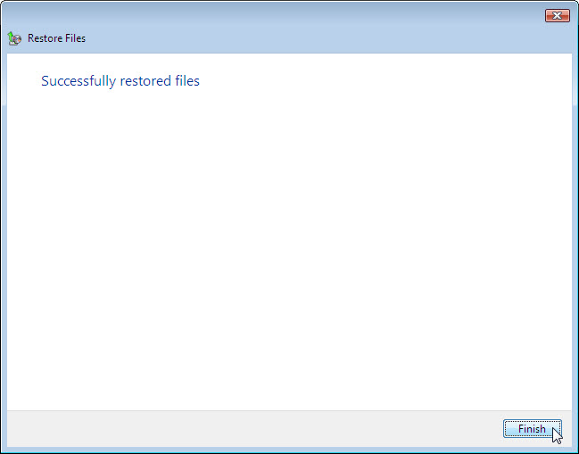

When the Successfully restored files screen appears, click Finish.

Step 13
Navigate to the Desktop.

Are the two files restored to the Desktop?

Step 14
Open file Backup File Two. Add the following text “More text added.” to the file. Save the file.

Step 15
Click on the Backup Status and Configuration window.

Click Back Up Files.

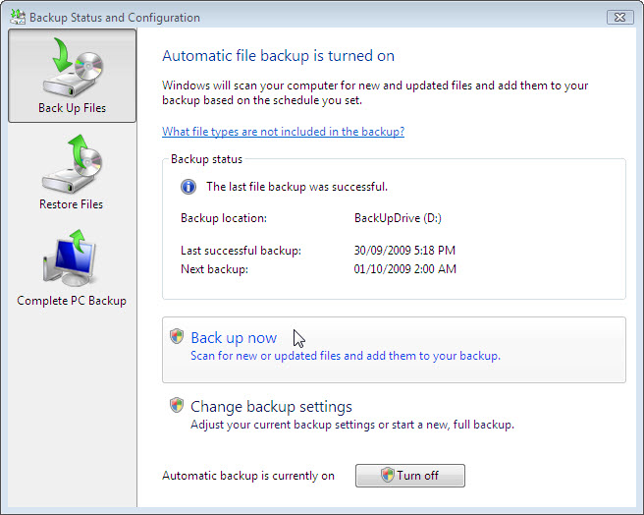

Which files will be backed up?

To where will the files be backed up?

Click Back up now > Continue.

The progress bar appears. When the backup is completed click Close.

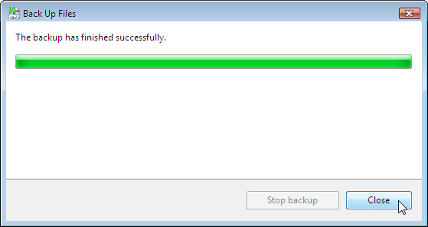

Step 16
Navigate to the Desktop. Delete Backup File Two.

Empty the Recycle Bin.

Step 17
Click on the Backup Status and Configuration window so it is activated.

Click Restore Files icon.

Click Restore files.

Restore both Backup File One and Backup File Two.

Step 18
Navigate to the Desktop. Open file Backup File Two.

What text is in the file?

Step 19
Delete the following from the Desktop: Backup File One, and Backup File Two.

Empty the trash.

