16.4.3 Optional Lab: Data Backup and Recovery in Windows 7

Introduction

Print and complete this lab.

In this lab, you will back up data. You will also perform a recovery of the data.

Recommended Equipment
The following equipment is required for this exercise:
- A computer system running Windows 7 is required for this exercise

Step 1
Log on to the computer as an administrator.

Create a text file on the desktop called Backup File One. Open the file and type the text “The text in this file will not be changed.”

Create another text file on the desktop called Backup File Two. Open the file and type the text “The text in this file will be changed.”

Note: Remove all extra folder and files from the computers Desktop. This will help to reduce the length of time to complete the backup for this lab.

Step 2
Click Start > All Programs > Maintenance > Backup and Restore. The “Back up or restore your files” screen appears.

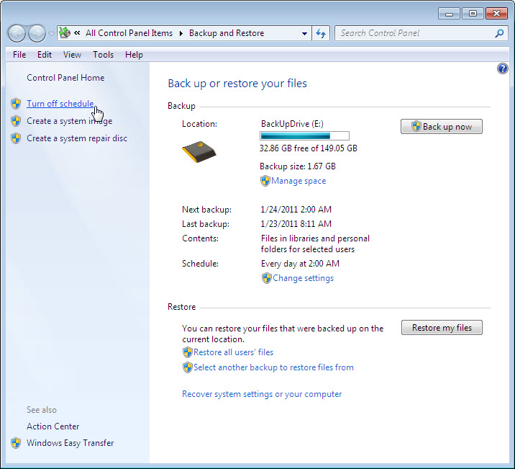

If a backup is scheduled to run, click Turn off schedule.

Step 3
Click Change settings.

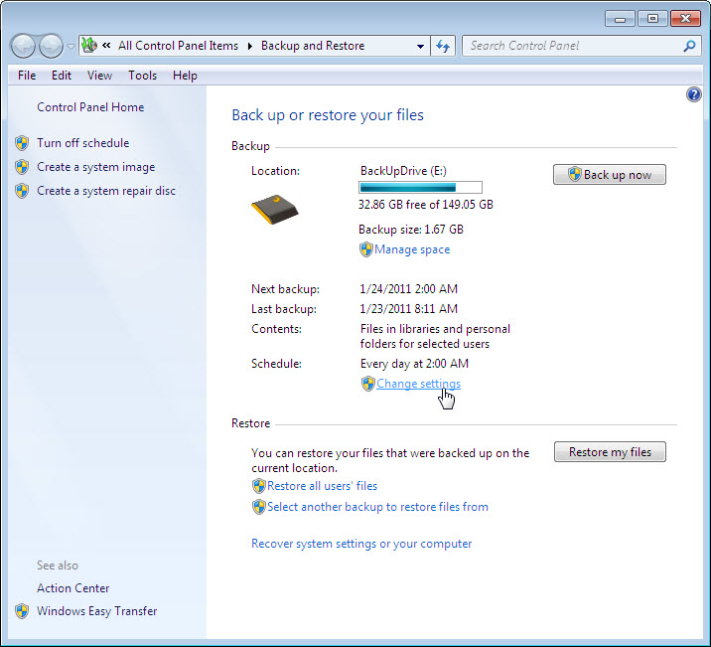

Select the location where the backup will be stored. In this example an external hard drive is used.

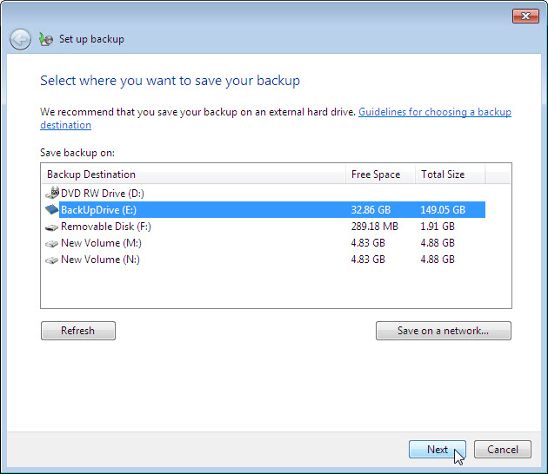

Click Next.

Select Let me choose.

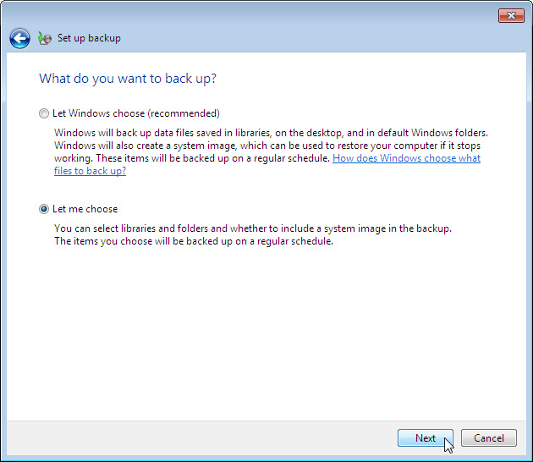

Click Next.

Step 4

Expand the user account, you logged on as, so you can view the different locations.

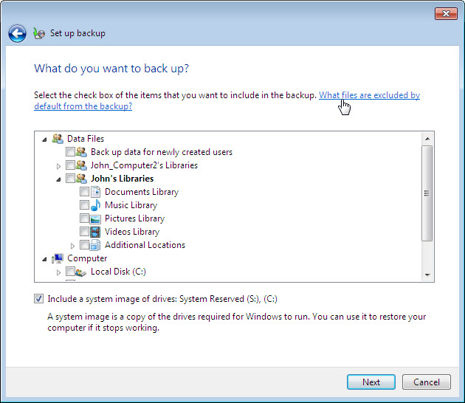

Which libraries can be backed up?

Click What files are excluded by default from the backup.

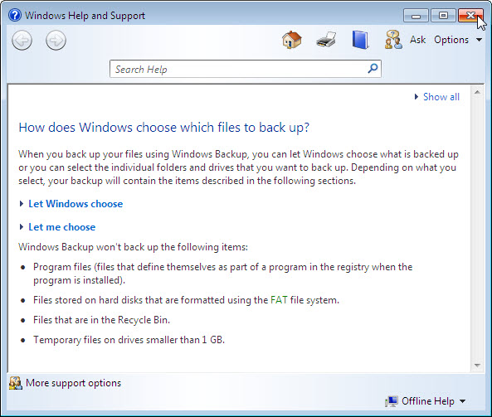

Windows Backup will not backup which items?

Close the “Windows Help and Support” window.

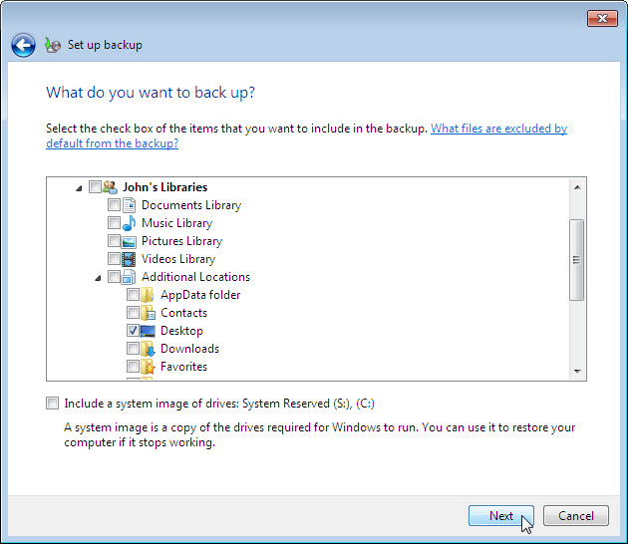

Expand Additional Locations and make sure only Desktop is selected. Make sure no other location is selected.

Remove the check mark from Include a system image of drives:.

Click Next.

Step 5
The “Review your backup settings” screen appears.

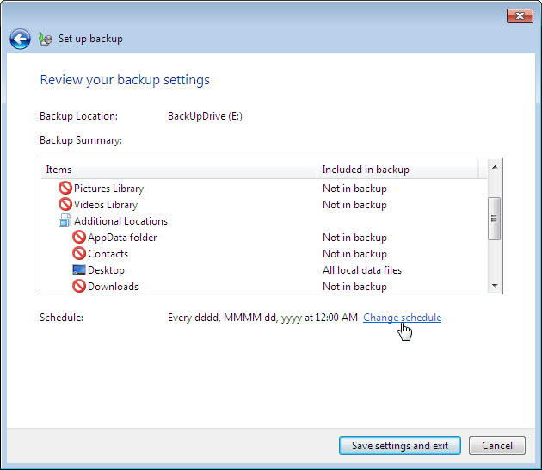

Click Change schedule.

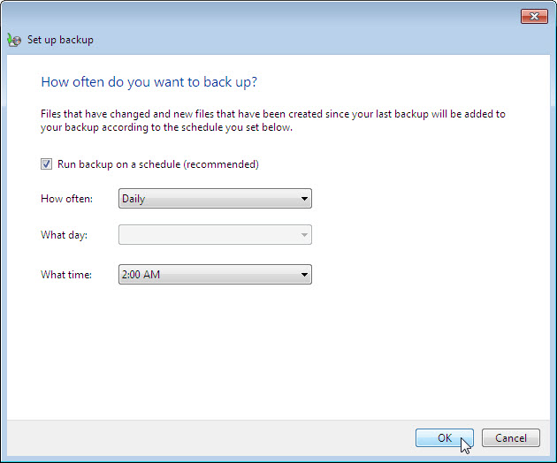

Place a check mark in the checkbox Run backup on a schedule (recommended).

Set the following conditions:
How often – Daily
What day – blank
What time – 2:00 AM

Which files will be backed up?

Click OK.

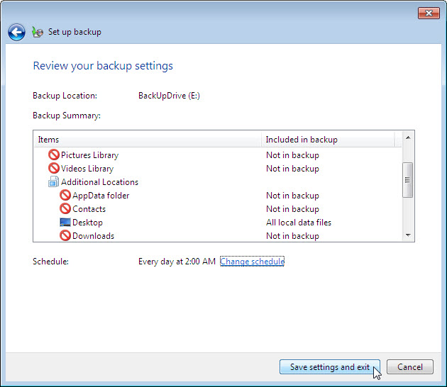

Click Save settings and exit.

Step 6
The Backup and Restore window appears.

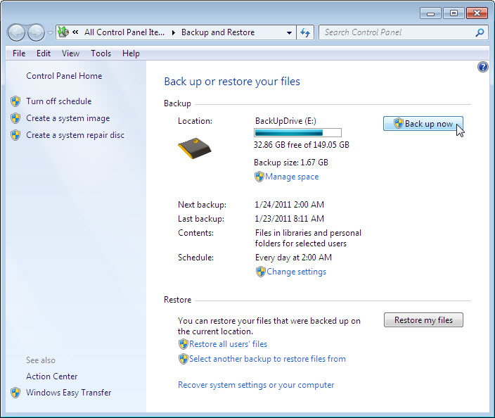

When will the next backup take place?

What is the state of the schedule, on or off?

Click Back up now > View Details.

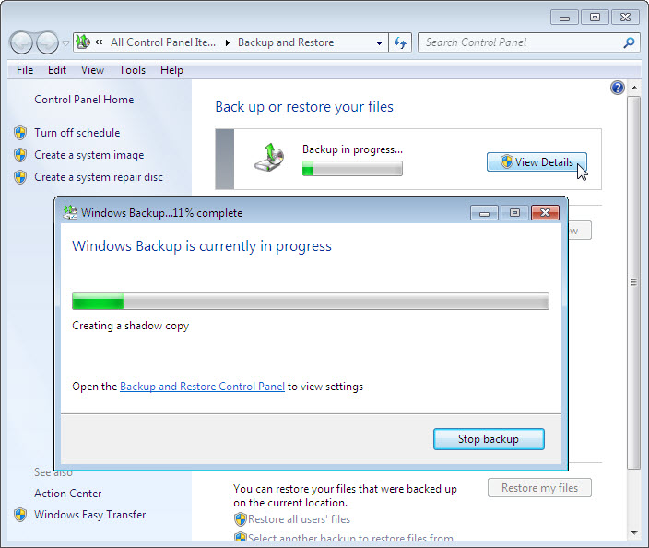

The “Windows Backup is currently in progress” screen appears.

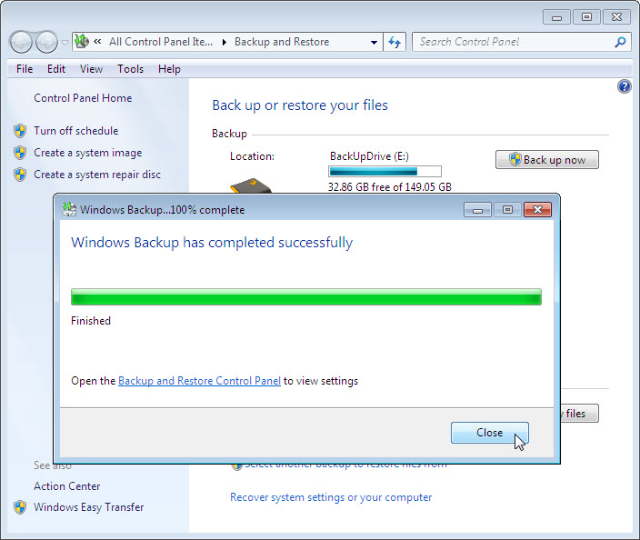

When the backup is finished, click Close.

Step 7
Navigate to the Desktop. Delete Backup File One and Backup File Two.

Empty the Recycle Bin.

Step 8
Click on the Backup and Restore window.

Click Select another backup to restore files from.

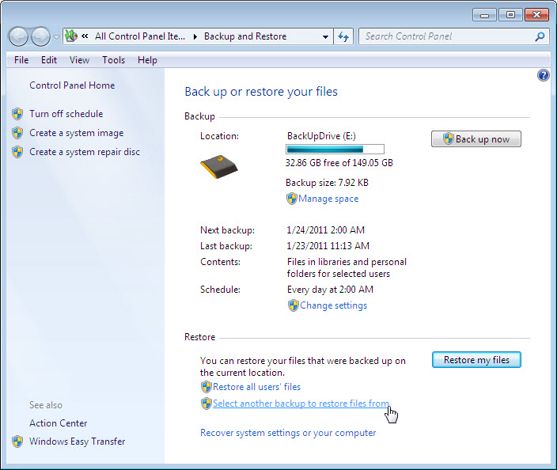

The “Select the backup that you want to restore files from” screen appears.

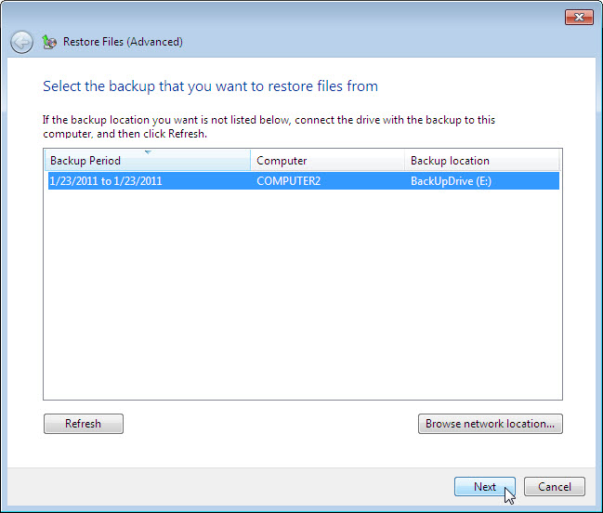

Select the location the files are stored at and then click Next.

Step 9
The “Browse or search your backup for files and folders to restore” screen appears.

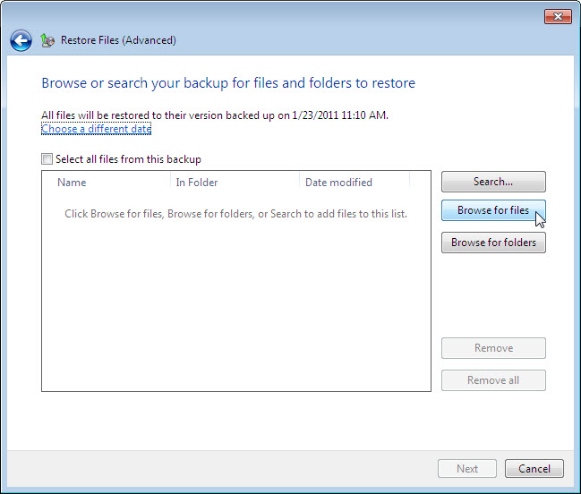

Click Browse for files.

Step 10
The “Browse the backup for files” window appears.

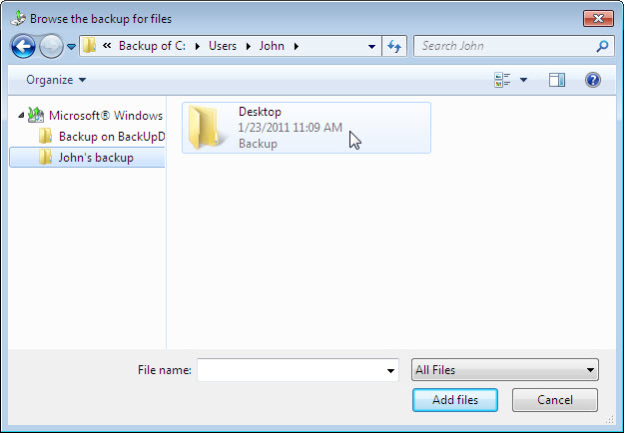

Click the user you are logged on as, backup. Example: John’s backup.

Double-click Desktop and locate files Backup File One and Backup File Two. Select both files by clicking Backup File One and then holding down the Ctrl key while clicking Backup File Two. Click Add files.

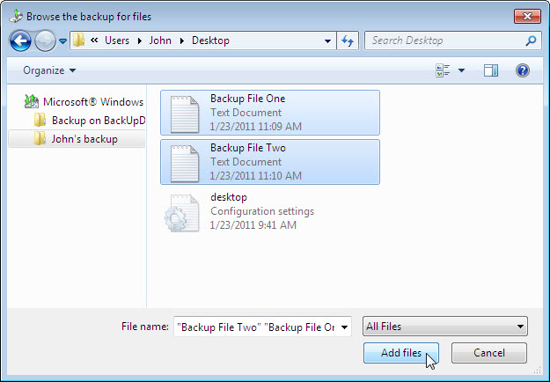

The two files should show up in the “Browse or search your backup for files and folders to restore” screen.

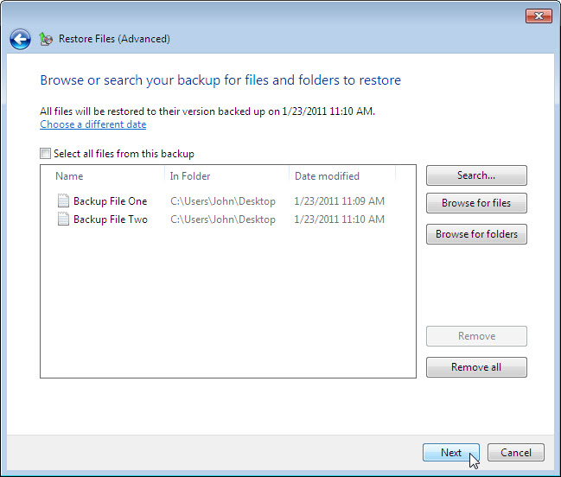

Click Next.

Step 11
The “Where do you want to save the restored files?” screen appears.

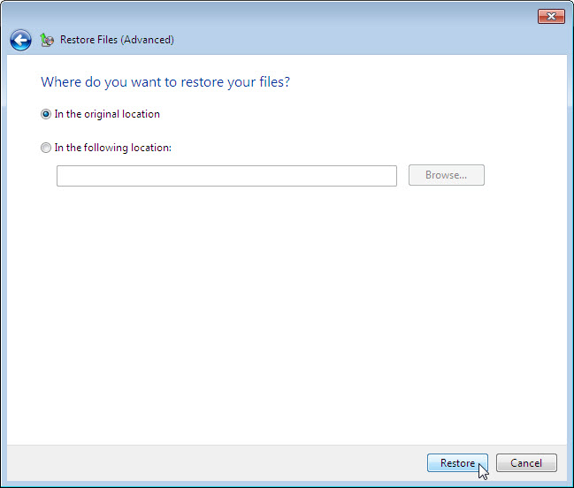

Select In the original location, and then click Restore.

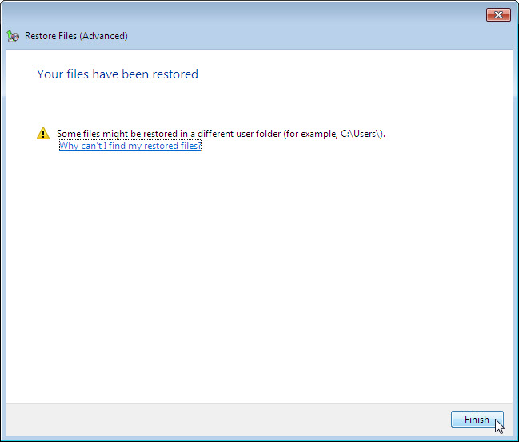

When the Your files have been restored screen appears, click Finish.

Step 12
Navigate to the Desktop.

Are the two files restored to the Desktop?

Step 13
Open file Backup File Two. Add the following text “More text added.” to the file. Save the file.

Step 14
Click on the Backup and Restore window.

Click Back up now.

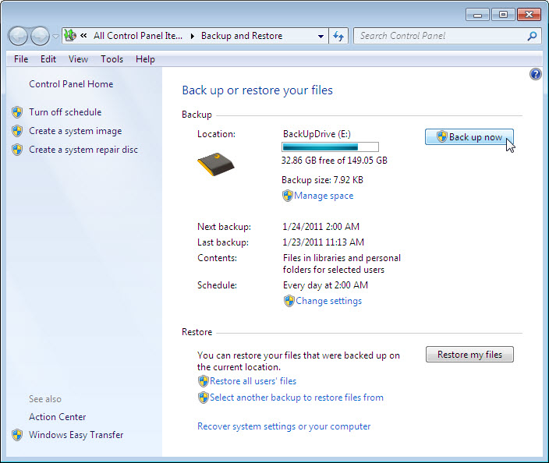

Step 15
Navigate to the Desktop. Delete Backup File Two.

Empty the Recycle Bin.

Step 16
Click on the Backup and Restore window so it is activated.

Click Select another backup to restore files from.

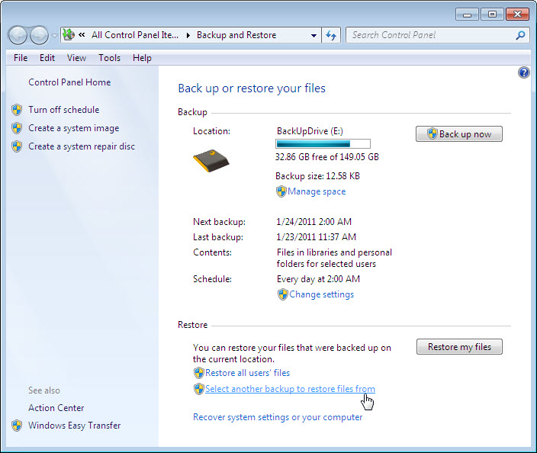

Select the location the files are stored at and then click Next > Browse for files > user’s backup > Desktop.

Restore Backup File Two.

Step 17
Navigate to the Desktop. Open file Backup File Two.

What text is in the file?

Step 18
Delete the following from the Desktop: Backup File One and Backup File Two.

Empty the Recycle Bin.

