16.3.2 Lab: Configure Windows XP Firewall

Print and complete this lab.

In this lab you will explore the Windows XP Firewall and configure some advanced settings.

Recommended Equipment
- Two computers directly connected or connected through a hub or switch
- Windows XP installed on both computers
- Computers are in the same workgroup and share the same subnet mask

Step 1
From computer 1, right-click the desktop, select New > Folder. Name the folder Cisco. Share the folder, use the default name Cisco.

From computer 2 open My Network Place > select View workgroup computers and connect to computer 1.

Can you see the shared folder Cisco?

Note: If you answered no, ask the instructor for help.

Close My Network Place.

Note: Use computer 1 for the rest of the lab unless otherwise stated.

Step 2
Navigate to the Windows XP Firewall:

Click Start > Control Panel > Security Center.

The Firewall indicator shows the status of the firewall. The normal setting is “ON”.

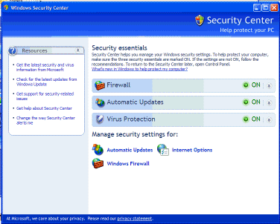

Access Windows firewall by clicking Windows Firewall at the bottom of the window.

Step 3
The Windows Firewall window opens.

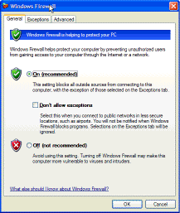

In the space below, state why turning off the Windows Firewall is not advised.

Step 4
From the Windows Firewall window select the Exceptions tab. Programs and services that Windows Firewall is not blocking will be listed with a checkmark.

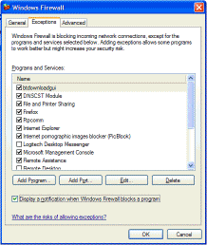

You can add applications to this list. This may be necessary if your customer has an application that requires outside communications but for some reason the Windows Firewall cannot perform the configuration automatically. You must be logged on to this computer as an administrator to complete this procedure.

Click What are the risks of allowing exceptions?

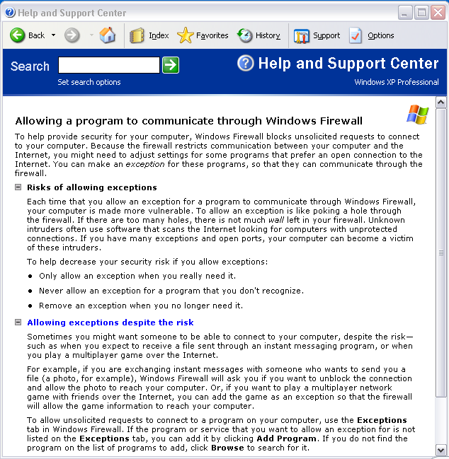

Creating too many exceptions in your Programs and Services file can have negative consequences. Describe a negative consequence to having too many exceptions.

Close the Help and Support Center window.

Step 5
From computer 1:
To turn off an exception, remove the check mark from File and Printer Sharing > OK.

From computer 2:
Open My Network Place > View workgroup computers and connect to computer 1.

Can you connect to computer 1?

From computer 1:
To turn on an exception, add a check mark to File and Printer Sharing > OK.

From computer 2:
Refresh My Network Place and connect to computer 1.

Can you connect to computer 1?

Log off computer 2. Use computer 1 for the rest of the lab.

Step 6
From the Windows Firewall control menu select the Advanced tab to view the Network Connection Settings. Network Connection Settings displays the different connections configured for your computer.

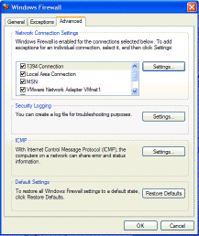

Click the Settings button in the Network Connection Settings area. The Advanced Settings window has two tabs: Services and ICMP. Click the Services tab.

In the space below, list the services that are available.

Step 7
There are many applications that users do not normally see that also need to get through the Windows Firewall to access your computer. These are the network level commands that direct traffic on the network and the Internet.

Under the ICMP heading, click the Settings button. You will see the menu where ICMP exceptions are configured.

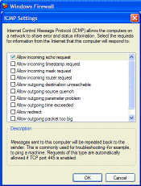

In the example here, allowing incoming echo requests is what allows network users to ping your computer to determine if it is present on the network and how fast information travels to and from it.

In the space below, list the requests for information that your computer will respond to.

Close all windows.

