16.3.2 Optional Lab: Configure Windows Vista Firewall

Print and complete this lab.

In this lab you will explore the Windows Vista Firewall and configure some advanced settings.

Recommended Equipment
- Two computers directly connected or connected through a hub or switch
- Windows Vista installed on both computers
- Computers are in the same workgroup and share the same subnet mask

Step 1
For computer 1, right-click on the desktop select New > Folder. Name the folder Cisco.

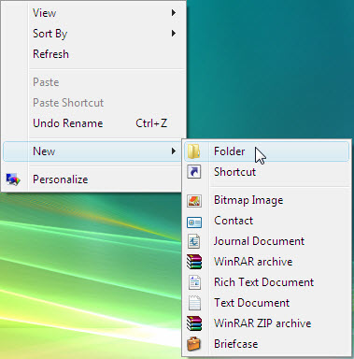

Right-click on the Cisco folder then select Share > Continue.

Share the folder, use the default name Cisco.

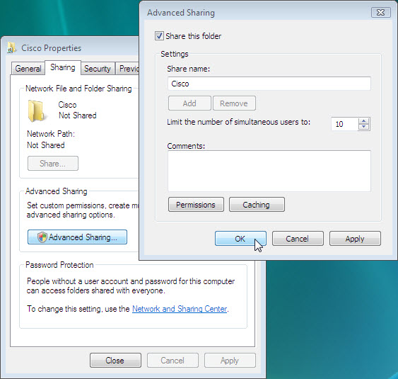

From computer 2 click Start > Network and try to connect to computer 1.

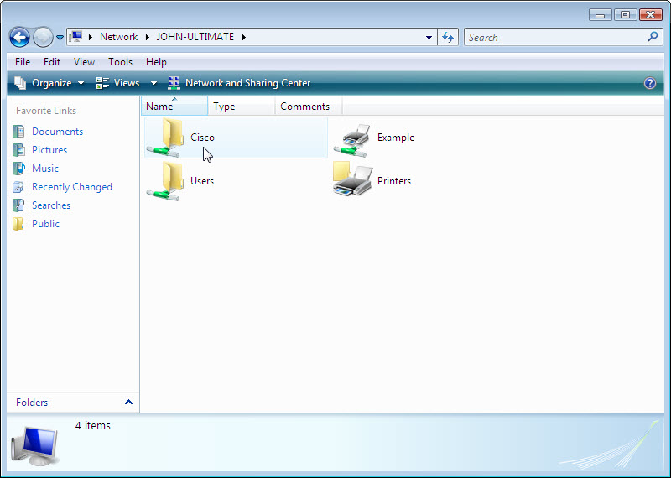

Can you see the shared folder Cisco?

Note: If you answered no, ask the instructor for help.

Close Network.

Note: Use computer 1 for the rest of the lab unless otherwise stated.

Step 2
Navigate to the Windows Vista Firewall:

Click Start > Control Panel > Security Center.

The Firewall indicator shows the status of the firewall. The normal setting is “ON”.

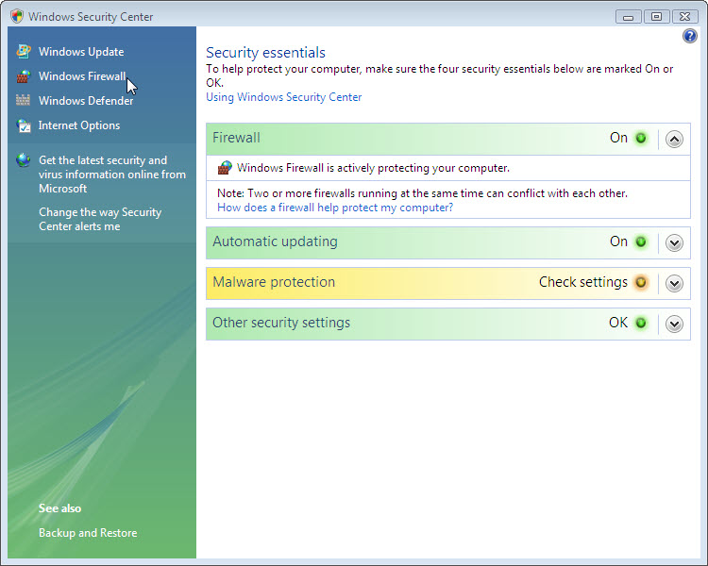

Access Windows firewall by clicking Windows Firewall at the right side of the window.

Step 3
Click Change settings > Continue.

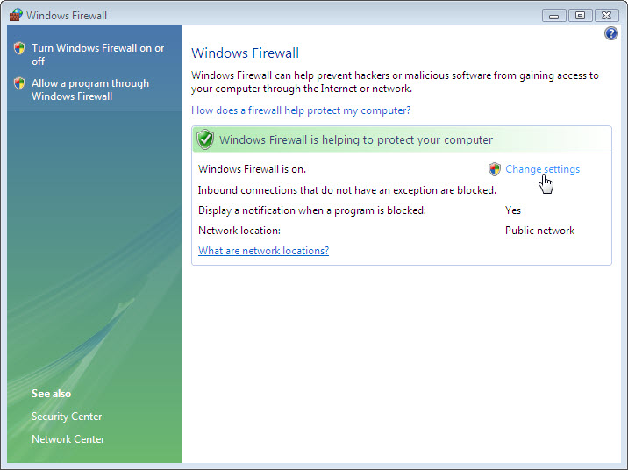

The “Windows Firewall Settings” window opens.

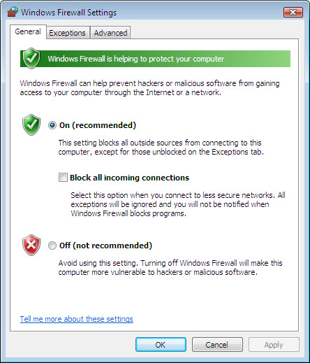

In the space below, state why turning off the Windows Firewall is not advised.

Step 4
From the “Windows Firewall Settings” window select the Exceptions tab. Programs and services that Windows Firewall is not blocking will be listed with a checkmark.

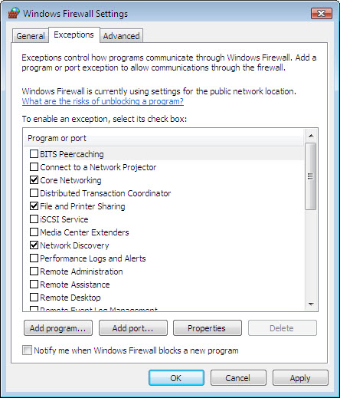

You can add applications to this list. This may be necessary if your customer has an application that requires outside communications but for some reason the Windows Firewall cannot perform the configuration automatically. You must be logged on to this computer as an administrator to complete this procedure.

Click What are the risks of unblocking a program?

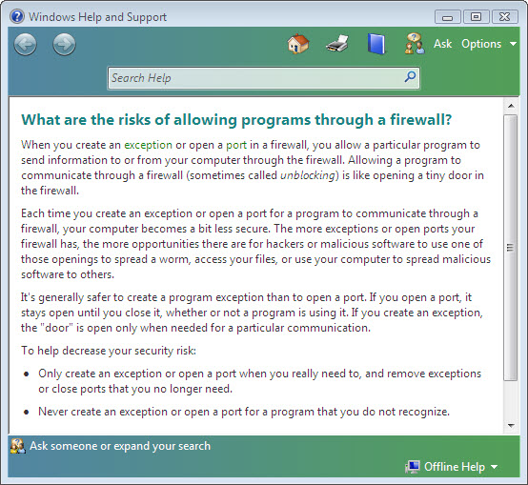

Creating too many exceptions in your Programs and Services file can have negative consequences. Describe a negative consequence to having too many exceptions.

Close “Windows Help and Support” window.

Step 5
From computer 1:
To turn off an exception remove the check mark from File and Printer Sharing > OK.

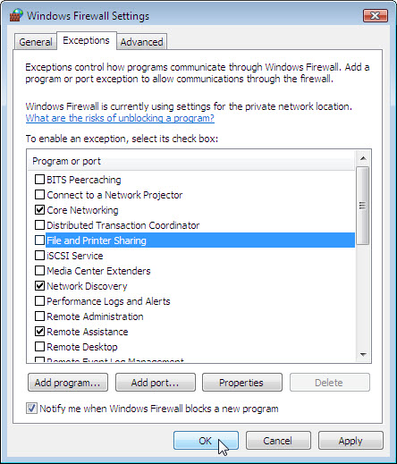

From computer 2:
Open My Network Place > select View workgroup computers and try connecting to computer 1.

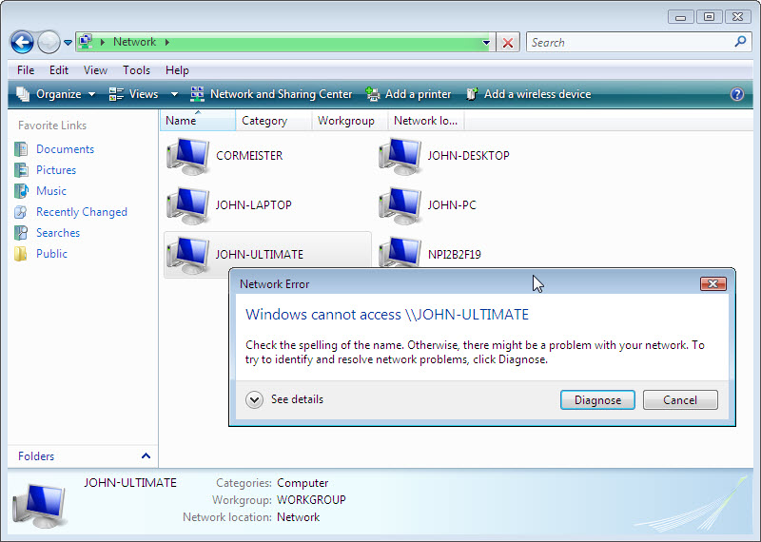

Can you connect to computer 1?

From computer 1:
To turn on an exception add a check mark to File and Printer Sharing > OK.

From computer 2:
Refresh My Network Place and try connecting to computer 1.

Can you connect to computer 1?

Log off computer 2. Use computer 1 for the rest of the lab.

Step 6
From the Windows Firewall Settings window select the Advanced tab to view the Network Connection Settings. Network Connection Settings displays the different connections configured for your computer.

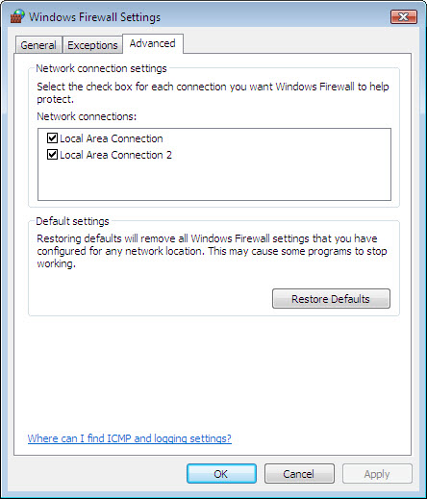

In the space below, list the connections protected by Windows Firewall.

Close all open Windows Firewall windows.

Step 7
There are many applications that users do not normally see that also need to get through the Windows Firewall to access your computer. These can be accessed in Windows Firewall with Advanced Security.

Click Start > Control Panel > Administrative Tools > Windows Firewall with Advanced Security > Continue.

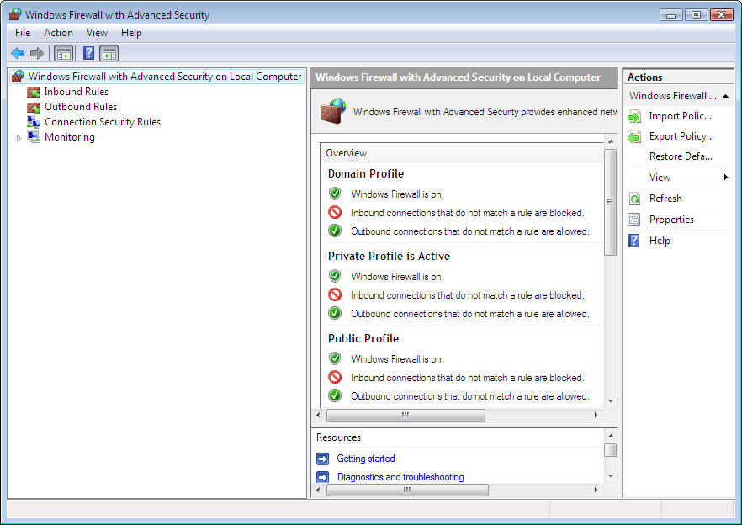

What three firewall profiles are shown?

Which firewall profile is active?

Click Inbound Rules. Expand the window so you can see the full name of the Inbound rules. Locate Files and Printer Sharing (Echo Request – ICMPv4-In). Right-click on the rule and select Properties.

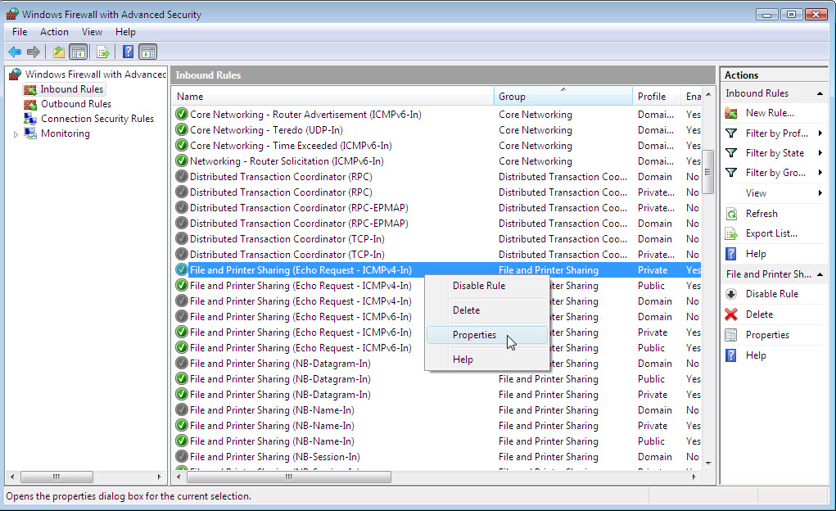

The “Files and Printer Sharing (Echo Request – ICMPv4-In) Propertise” window appears.

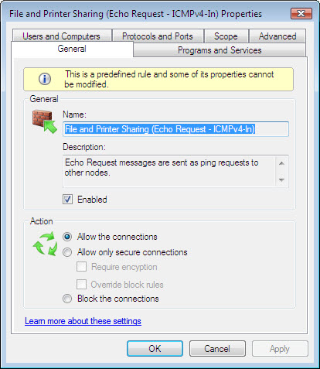

Click Protocols and Ports tab > Customize.

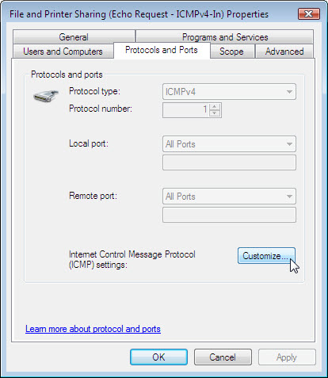

The “Customize ICMP” Settings window appears.

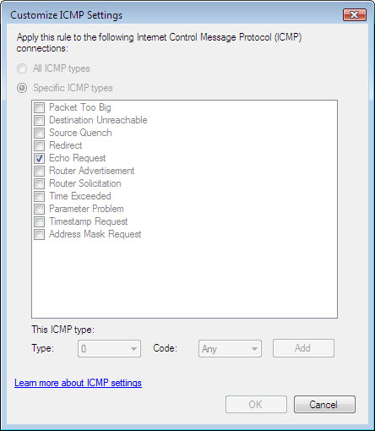

In the example here, allowing incoming echo requests is what allows network users to “ping” your computer to determine if it is present on the network and how fast information travels to and from it.

In the space below, list the requests for information that your computer will not respond to.

Close all open windows.

