16.3.2 Optional Lab: Configure Windows 7 Firewall

Print and complete this lab.

In this lab you will explore the Windows 7 Firewall and configure some advanced settings.

Recommended Equipment
- Two computers directly connected or connected through a hub or switch
- Windows 7 installed on both computers
- Computers are in the same workgroup and share the same subnet mask

Step 1
For computer 1, right-click on the desktop, select New > Folder. Name the folder Cisco.

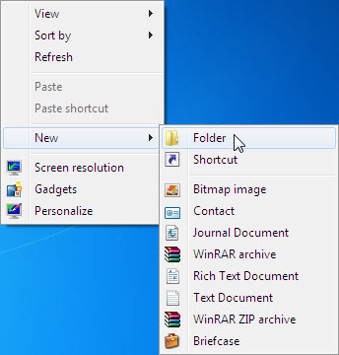

Right-click on the Cisco folder then select Share with > Advanced sharing > Advanced Sharing.

Share the folder, use the default name Cisco.

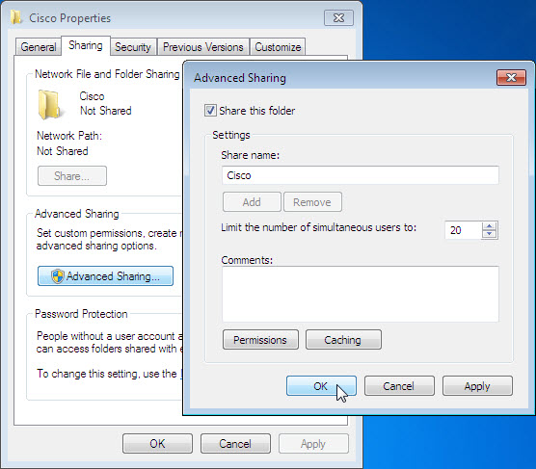

From computer 2 click Start > Network and connect to computer 1.

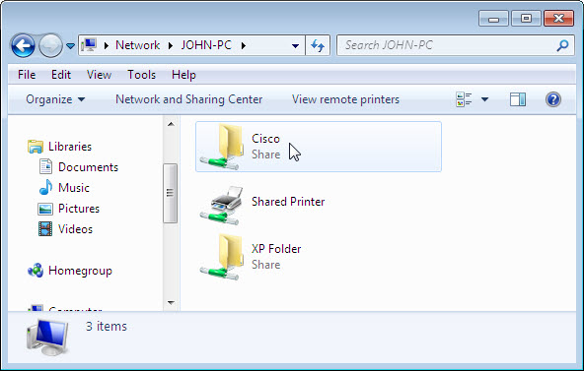

Can you see the shared folder Cisco?

Note: If you answered no, ask the instructor for help.

Close Network.

Note: Use computer 1 for the rest of the lab unless otherwise stated.

Step 2
Navigate to the Windows 7 Firewall:

Click Start > Control Panel > System and Security > Windows Firewall.

The Firewall indicator shows the status of the firewall. The normal setting is “On”.

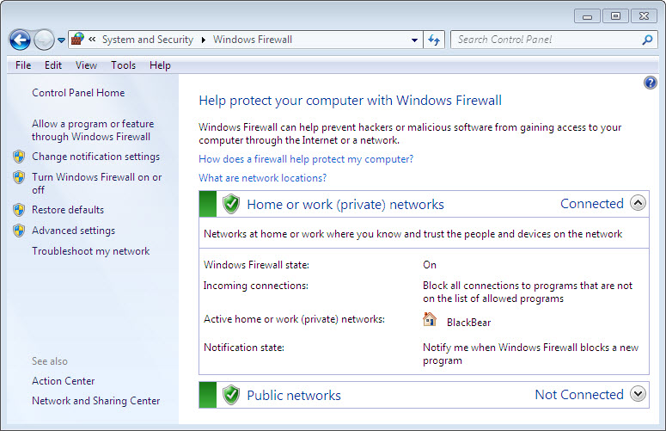

In the space below, state the beniffities of Windows Firewall.

Step 3
Click Allow a program or feature through Windows Firewall.

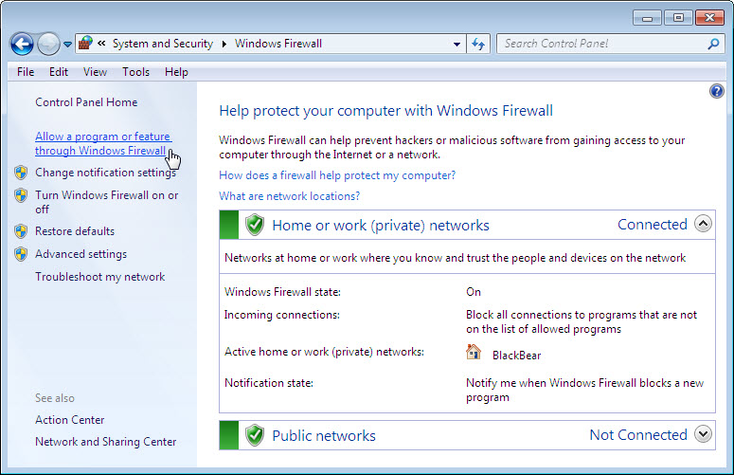

Step 4
Programs and services that Windows Firewall is not blocking will be listed with a check mark.

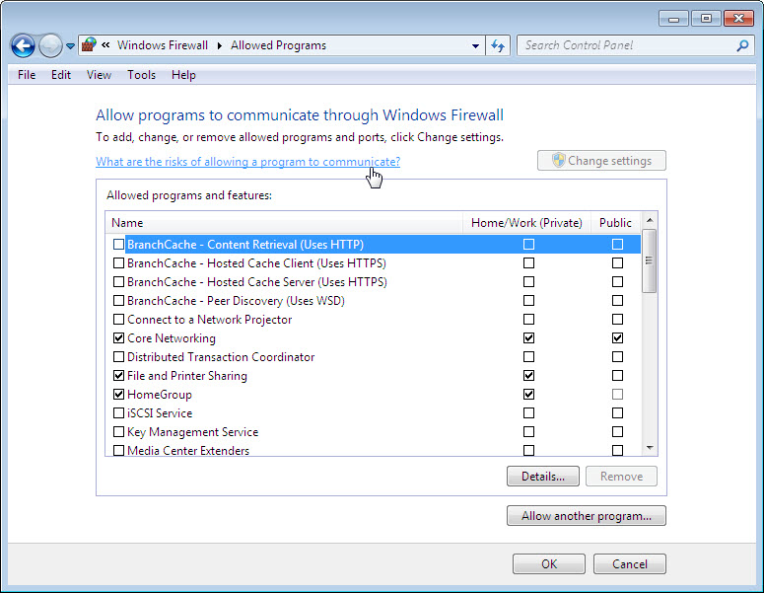

You can add applications to this list. This may be necessary if your customer has an application that requires outside communications but for some reason the Windows Firewall cannot perform the configuration automatically. You must be logged on to this computer as an administrator to complete this procedure.

Click What are the risks of allowing a program to communicate?.

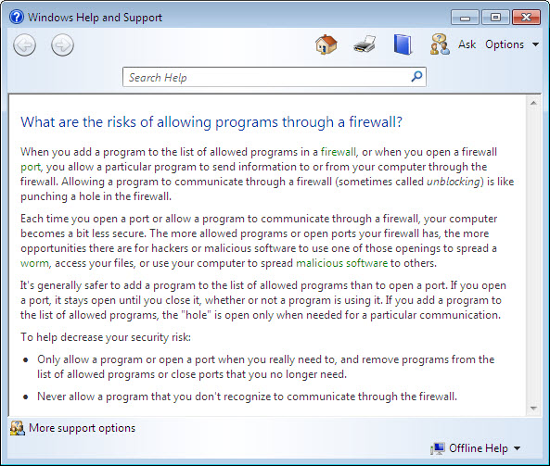

Creating too many exceptions in your Programs and Services file can have negative consequences. Describe a negative consequence to having too many exceptions.

Close Windows Help and Support window.

Step 5
From computer 1:
To turn off an exception, remove the check mark from File and Printer Sharing > OK.

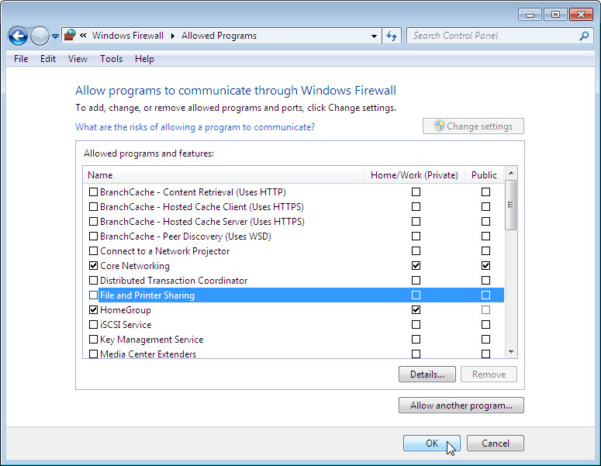

From computer 2:
Open Network connect to computer 1.

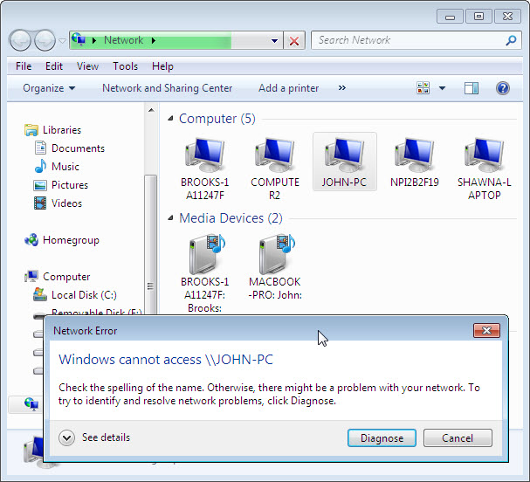

Can you connect to computer 1?

From computer 1:
To turn on an exception add a check mark to File and Printer Sharing > OK.

From computer 2:
Refresh Network and connect to computer 1.

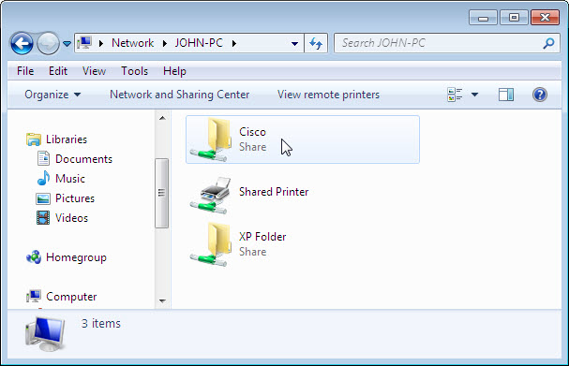

Can you connect to computer 1?

Log off computer 2. Use computer 1 for the rest of the lab.

Step 6
Click Start > Control Panel > System and Security > Administrative Tools > Windows Firewall with Advanced Security > Inbound Rules.

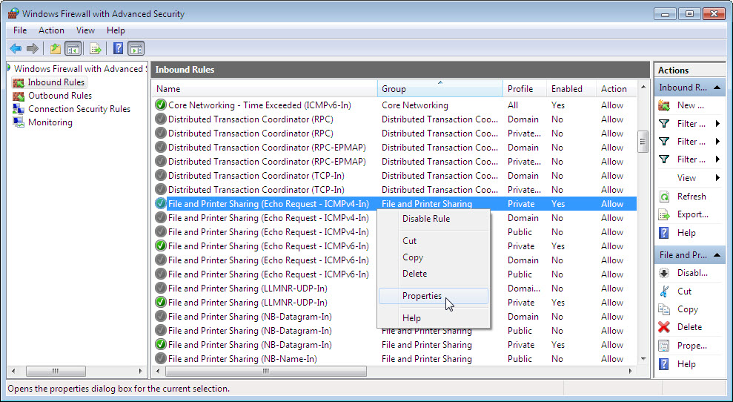

Expand the window so you can see the full name of the Inbound rules. Locate Files and Printer Sharing (Echo Request – ICMPv4-In).

Right-click on the rule and select Properties > Advanced tab > Customize. The Advance tab displays the profile(s) used by the computer and the Customize Interface Types window displays the different connections configured for your computer.

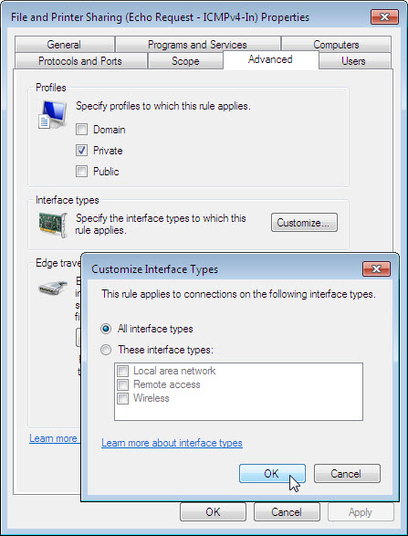

Click OK.

Click Programs and Services tab.

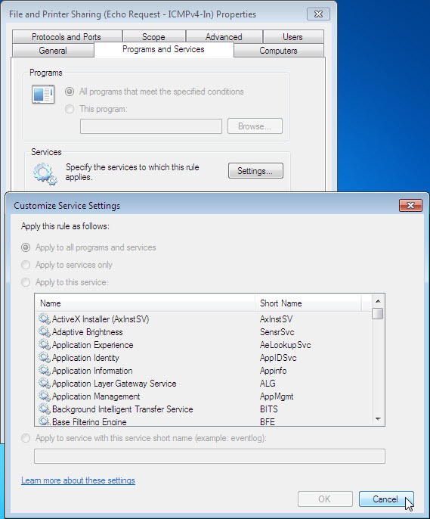

In the space below, list the short name of four services that are available.

Click Cancel.

Step 7
There are many applications that users do not normally see that also need to get through the Windows Firewall to access your computer. These are the network level commands that direct traffic on the network and the Internet.

Click Protocols and Ports tab. For the ICMP settings, click the Customize button. You will see the menu where ICMP exceptions are configured.

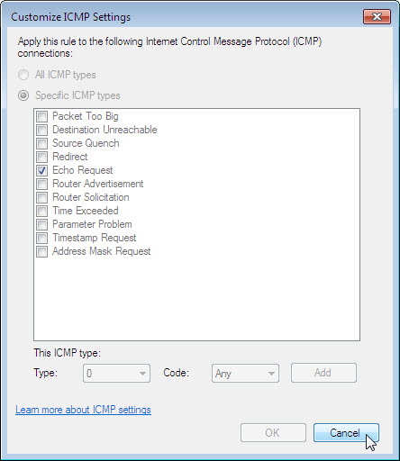

In the example here, allowing incoming echo requests is what allows network users to ping your computer to determine if it is present on the network and how fast information travels to and from it.

In the space below, list the Specific ICMP types.

Close all windows.

