16.3.1 Lab: Configure Wireless Security

Introduction

Print and complete this lab.

In this lab, you will configure and test the wireless settings on the Linksys WRT300N.

Recommended Equipment
- Two computers with Windows XP or Windows Vista
- An Ethernet NIC installed in computer 1
- A Wireless NIC installed in computer 2
- Linksys WRT300N Wireless Router
- Ethernet patch cable

Step 1
Ask the instructor for the following information that is used during the lab.

Default Login Information:
User Name (if any) _____________________________________
Password ____________________________________________

Basic Wireless Settings:
Network Name (SSID) __________________________________

Important: Only use configurations assigned by the instructor.

Note: use computer 1 for all lab instructions unless stated.

Step 2
Connect computer 1 to an Ethernet ports on the wireless router with an Ethernet patch cable.

Plug in the power of the wireless router. Boot the computer and log in as an administrator.

Step 3
Open the command prompt.

Type ipconfig.

What is the IP address for the computer?

What is the default gateway for the computer?

Step 4
Open Internet Explorer and connect to the wireless router.

Type “admin” in the “Password:” field.

The Setup screen appears. Click Wireless tab.

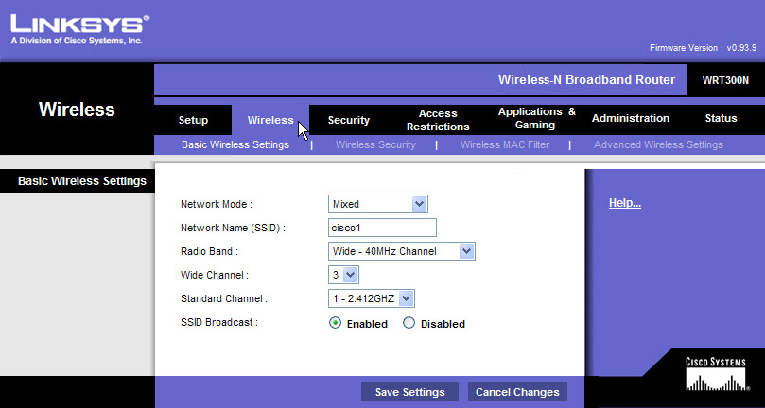

Step 5
Click Wireless Security tab, then for Security Mode select WPA2 Personal.

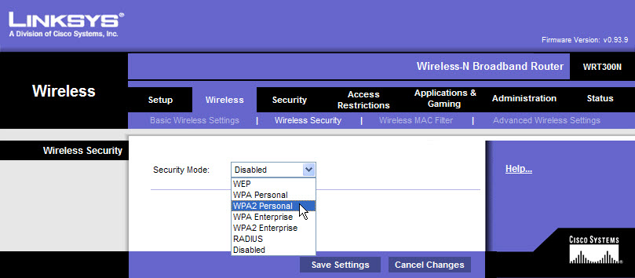

Set the following settings:
Encryption – AES
Pre-shared Key – c!scol&b1361
Key Renewal – 3600

Click Save Settings > Continue.

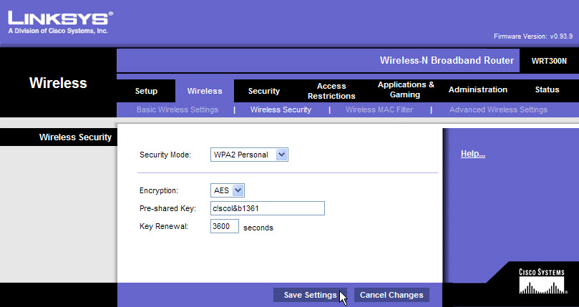

Keep Internet Explorer open to the Linksys router.

Step 6
Log in to computer 2, the wireless computer, as the administrator.

Connect to the wireless network. If asked for a security key or passphase enter: c!scol&b1361

Open the command prompt.

Type ipconfig /all.

What is the physical address of the wireless NIC?

Type ping IPaddress. Where IPaddress is the IP address of computer 1.

Was the ping successful?

Keep the command prompt window open.

Step 7
From computer 1, make sure Internet Explorer is active.

Under the Wireless tab click Wireless MAC Filter.

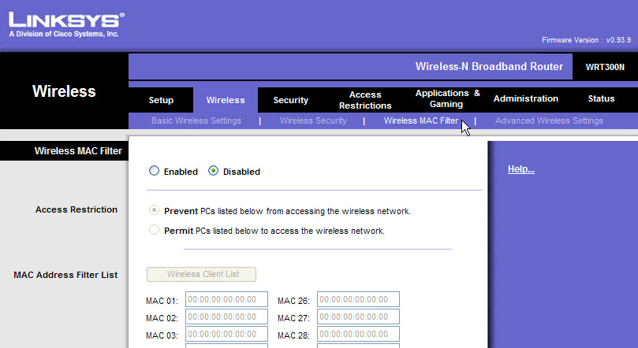

Select Enabled > Prevent > click Wireless Client List button.

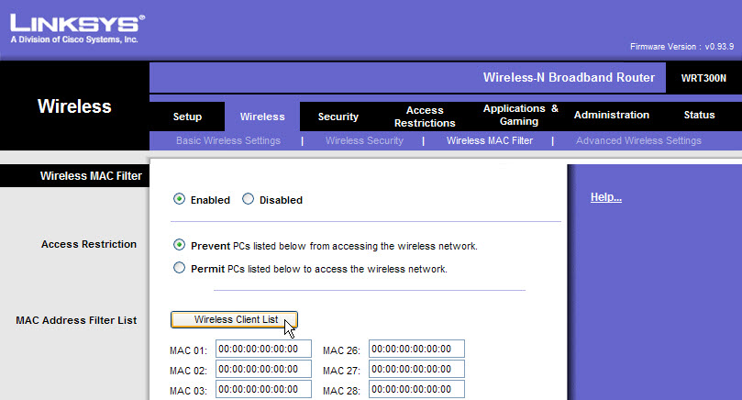

Step 8
Select Save to MAC Address Filter List check box for computer 2.

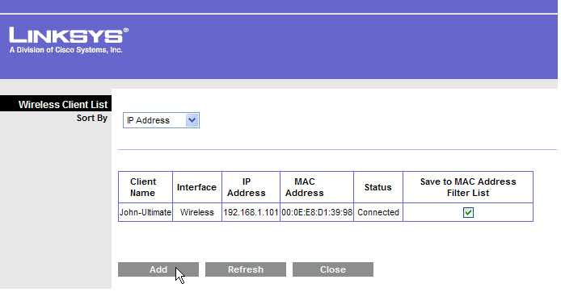
Click Add.

The Wireless MAC Filter window opens.

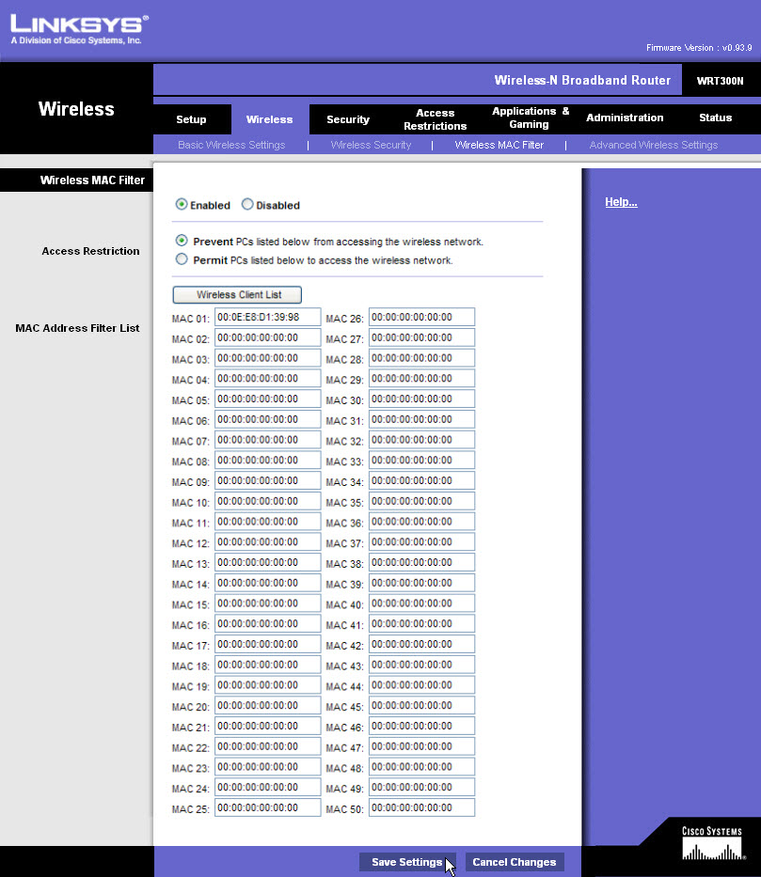

Click Save Settings > Continue.

Step 9
From computer 2:
In the command prompt window type ping IPaddress. Where IPaddress is the IP address of computer 1.

Was the ping successful?

Step 10
From computer 1, click the browser so it is activated.

Click Administration on the main tab bar.

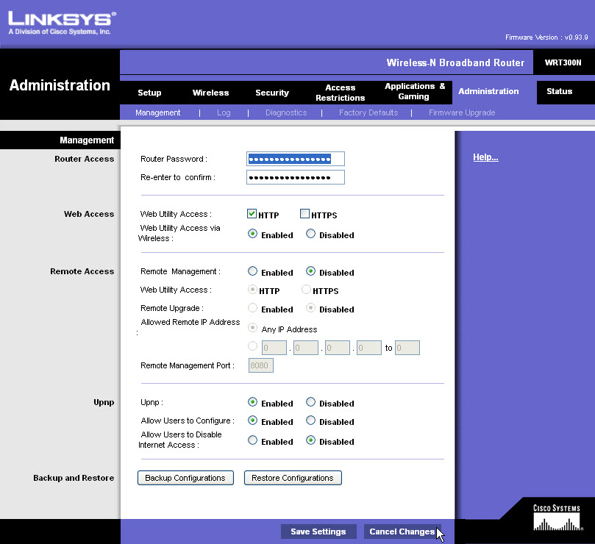

Highlight the Router Password, type lab1631. Type the same password in Re-enter to confirm.

Click Cancel Changes. Do not save the new password.

Step 11
Click Security on the main tab bar.

By default SPI Firewall Protection is Enabled.

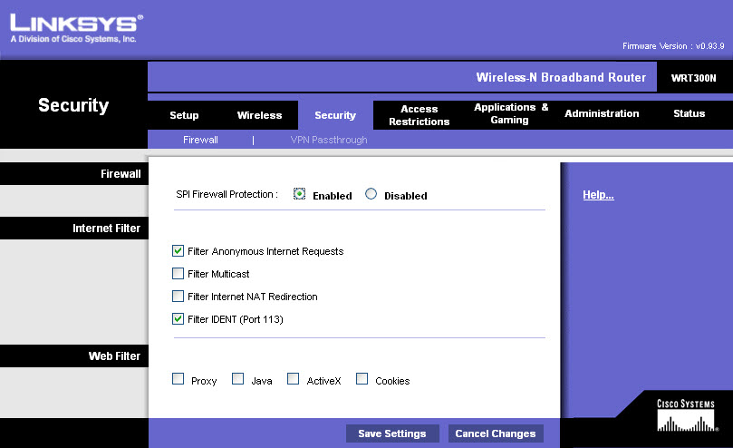

What Internet Filters are activated?

What Web Filters are activated?

Step 12
Click Applications & Gaming on the main tab bar.

Click Single Port Forwarding.

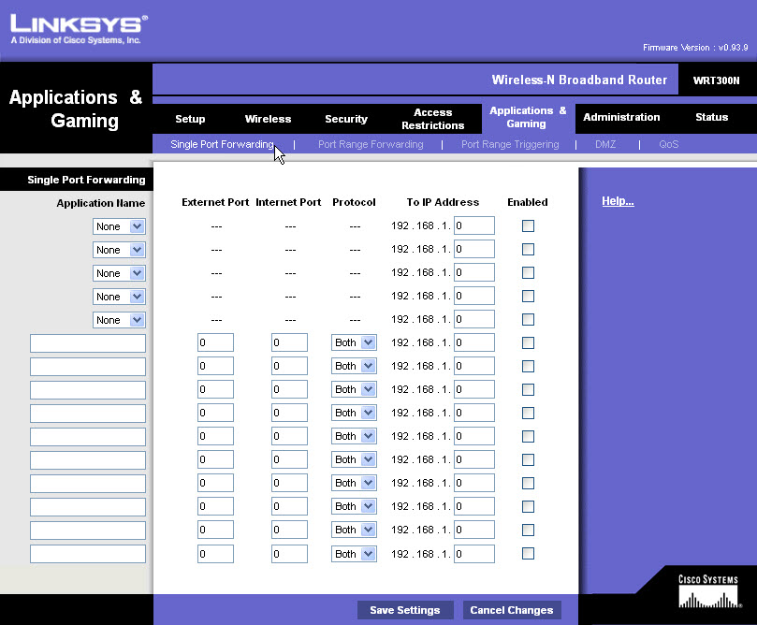

To forward an otherwise blocked port to a specific computer, select Application Name FTP.

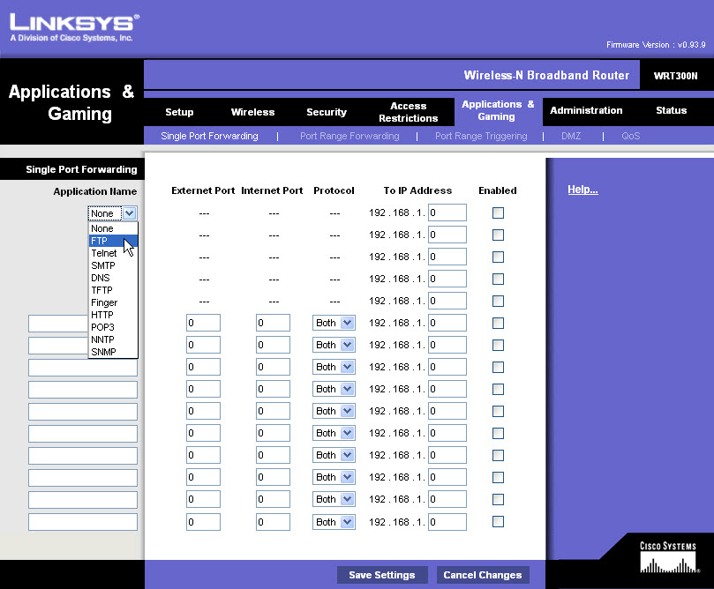

Type the last octet of the IP address for the computer and then click Enabled checkbox.

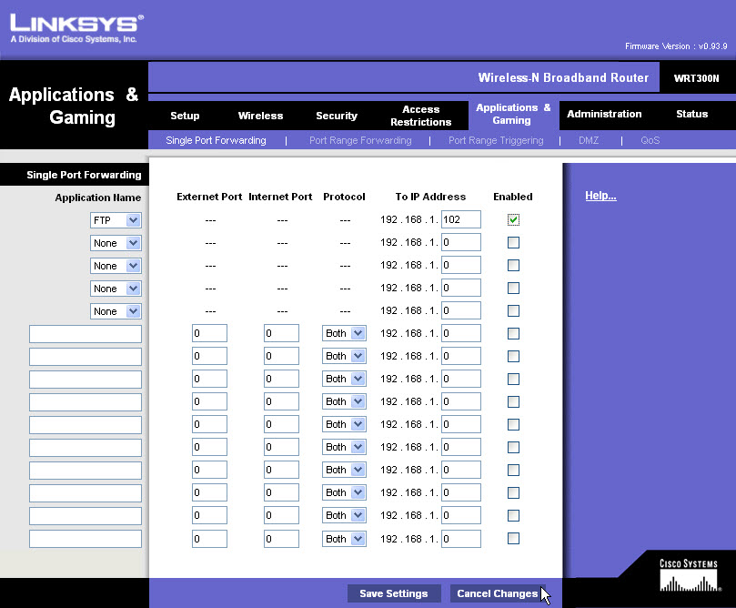

Click Cancel Changes. Do not save the new setting.

Step 13
Click Port Range Triggering.

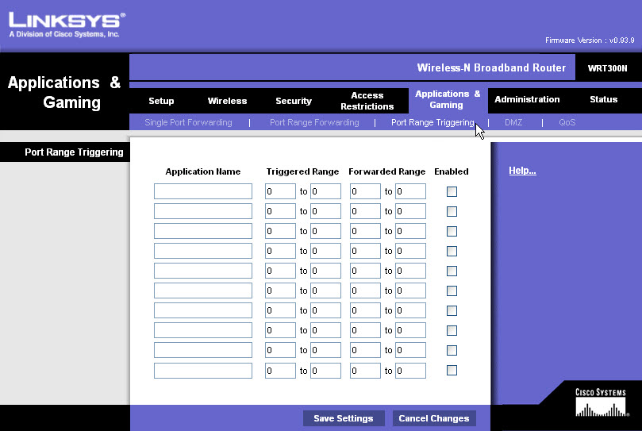

To open an otherwise blocked port, type in the application name IRC. Then type the Triggered Range 6660 to 7000, Forwarded Range 113 to 113 and then click Enabled checkbox.

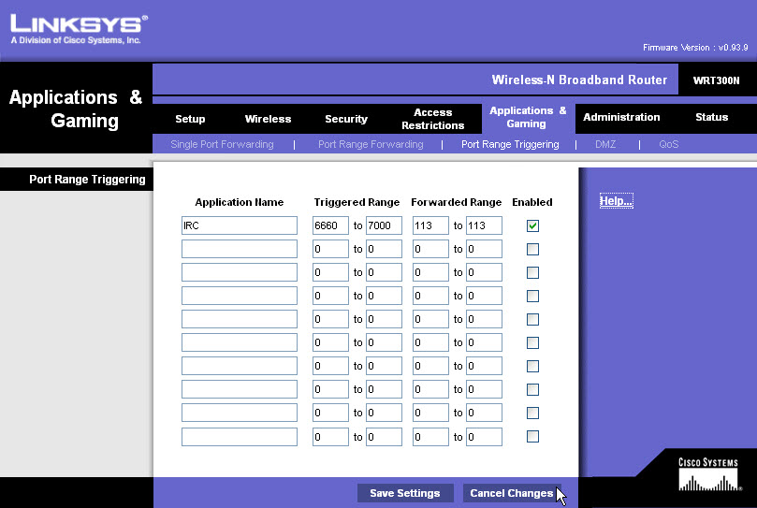

Click Cancel Changes. Do not save the new setting.

Step 14
From computer 1, click Wireless tab.

Click Wireless MAC Filter > Disable.

Click Save Settings > Continue.

