15.5.3 Optional Lab: Test the Wireless NIC in Windows Vista

Introduction

Print and complete this lab.

In this lab, you will check the status of your wireless connection, investigate the availability of wireless networks, and test connectivity.

Recommended Equipment
- A computer with Windows Vista installed
- A wireless NIC installed
- An Ethernet NIC installed
- Linksys WRT300N Wireless Router
- Internet connectivity

Step 1
Disconnect the Ethernet cable from your computer.

A red “X” appears over the “Local Area Connection” icon.

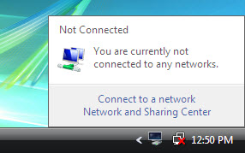

Connect to a wireless network.

Hover over the “Wireless Network Connection” icon in the tray.

What is the name of the wireless connection?

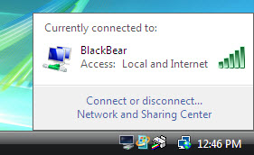

Open a command window.

Ping 127.0.0.1.

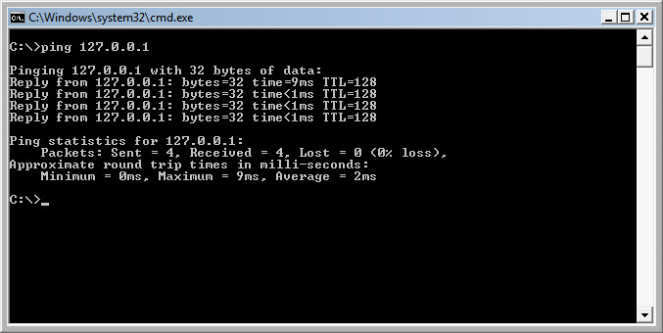

How many Replies did you receive?

Use the ipconfig command.

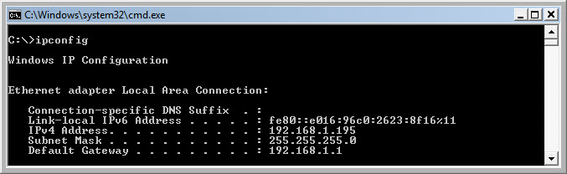

What is the IP address of the default gateway?

Ping the default gateway.

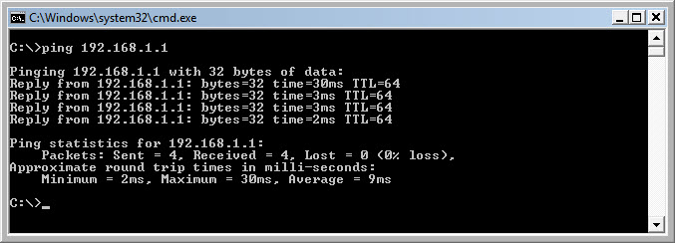

A successful ping indicates that there is a connection between the computer and the default gateway.
Step 2
Open a web browser.

Type www.cisco.com in the “Address” field, and then press Enter.



Step 3
Open the Network Connections window.

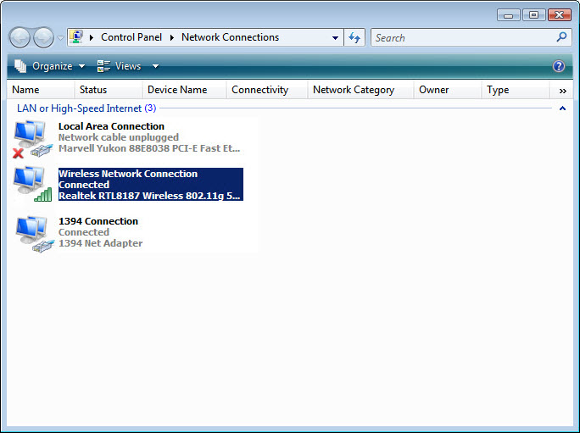

Right-click the wireless connection and choose Connect / Disconnect.

Select All from the Show dropdown menu. Press the Refresh button.

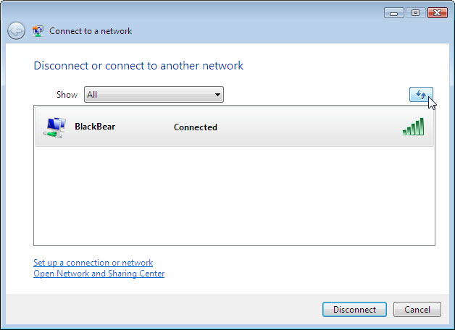

What are the names of the wireless networks that are available?

