15.5.3 Optional Lab: Test the Wireless NIC in Windows 7

Introduction

Print and complete this lab.

In this lab, you will check the status of your wireless connection, investigate the availability of wireless networks, and test connectivity.

Recommended Equipment
- A computer with Windows 7 installed
- A wireless NIC installed
- An Ethernet NIC installed
- Linksys WRT300N Wireless Router
- Internet connectivity

Step 1
Disconnect the Ethernet cable from your computer.

An “orange dot” appears over the “Connections” icon.



Connect to a wireless network.

Hover over the “Connections” icon in the tray.

What is the name of the wireless connection?
Answers may vary.

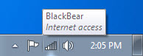

Open a command window.

Ping 127.0.0.1.

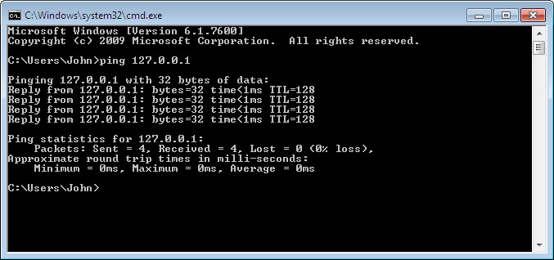

How many Replies did you receive?

Use the ipconfig command.

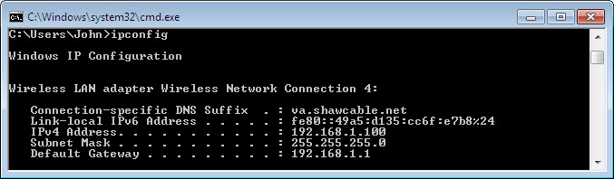

What is the IP address of the default gateway?

Ping the default gateway.

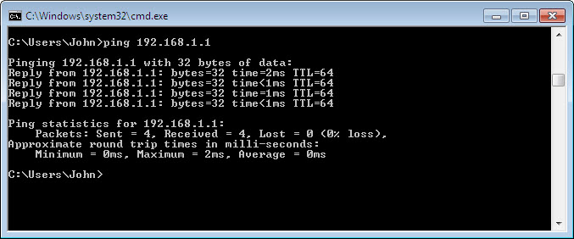

A successful ping indicates that there is a connection between the computer and the default gateway.

Step 2
Open a web browser.

Type www.cisco.com in the “Address” field, and then press Enter.

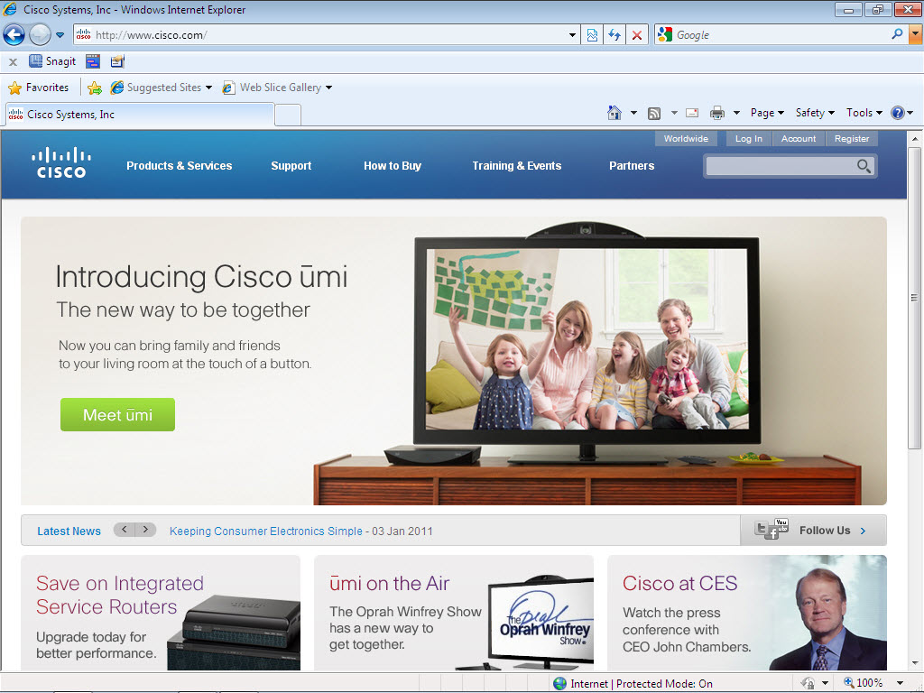

Step 3
Open the Network Connections window.

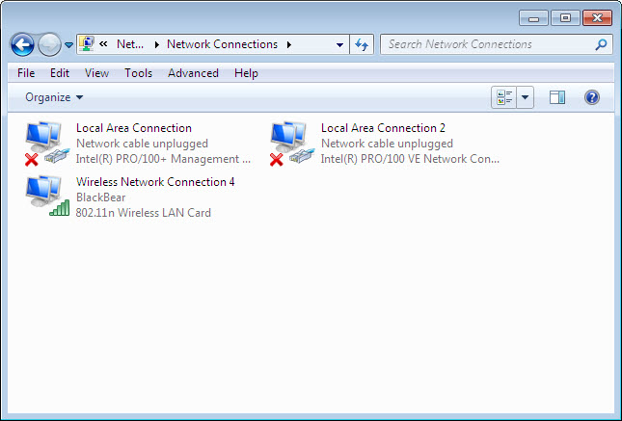

Right-click the wireless connection and choose Connect / Disconnect.

Select All from the Show drop-down menu. Press the Refresh button.

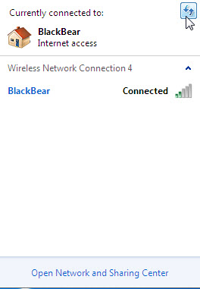

What are the names of the wireless networks that are available?

