15.5.2 Lab: Configure Wireless Router

Introduction

Print and complete this lab.

In this lab, you will configure and test the wireless settings on the Linksys WRT300N.

Recommended Equipment
- A computer with Windows XP Professional or Windows Vista
- A Wireless NIC installed
- An Ethernet NIC installed
- Linksys WRT300N Wireless Router
- Ethernet patch cable

Step 1
Ask the instructor for the following information that is used during the lab.
Router Static IP Information:
IP address

Subnet mask

Gateway

DNS

SSID Values:
New SSID

Wireless Security:
Pre-shared key

Important: Only use configurations assigned by the instructor.

Step 2
Connect the computer to one of the Ethernet ports on the wireless router with an Ethernet patch cable.

Plug in the power of the wireless router. Boot the computer and log in as an administrator.

Step 3
Open the command prompt.

Type ipconfig /renew.

What is the default gateway for the computer?

Step 4
Open Internet Explorer. Type the IP address of your default gateway in the “Address” field, and then press Return.

The “Connect to” window appears.

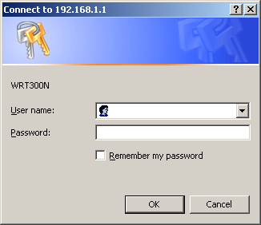

Type “admin” in the “Password:” field.

The Setup screen appears.

Step 5
What is the Internet Connection Type assigned to the router?

To configure the router with a static IP address, click the dropdown menu Internet Connection Type and select Static IP.

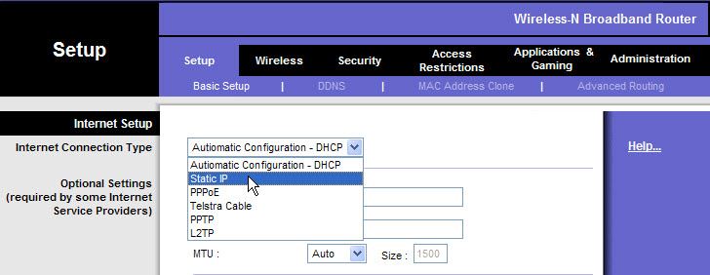

Enter the following static IP information provided by the instructor (step 1): Internet IP Address, Subnet Mask, Default Gateway, and DNS 1.

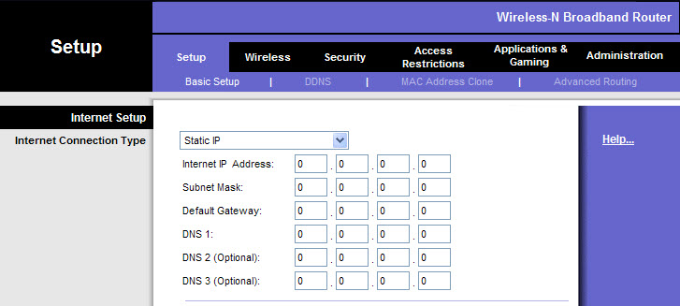

Click Save Settings.

The “Settings are successful” screen appears.

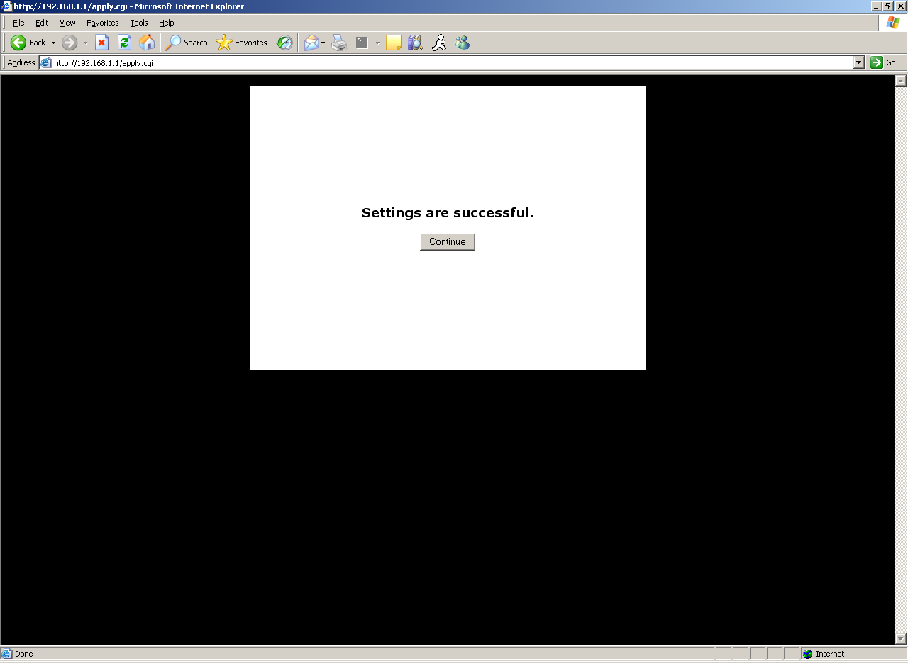

Click Continue. Keep the router configuration page open.

Step 6
Open the command prompt again.

Type ipconfig /all, and record the following information.

Computer IP information:

IP address ________________________________

Subnet mask ______________________________

Gateway __________________________________

DNS _____________________________________

Use this information to configure the wireless NIC with static IP information.

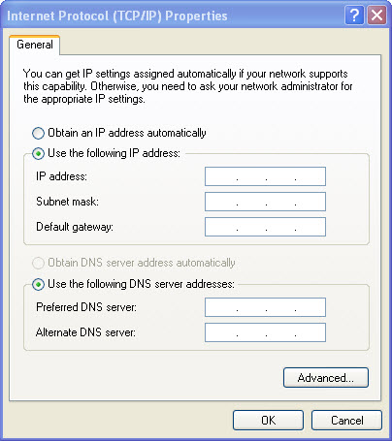

Save these settings.

Step 7
Click the “Wireless” tab.

Click Network Mode dropdown menu.

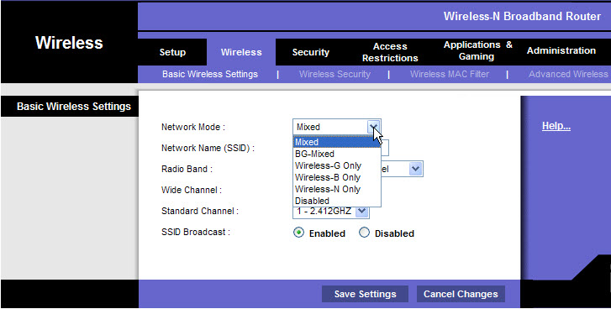

What 802.11 technologies are supported?

Choose “Mixed” in the “Network Mode:” drop-down box.

What is the default SSID for the wireless router?

Type “cisco#” in the “Network Name (SSID):” field, where # is the number assigned by your instructor.

Click Save Settings > Continue.

Close Internet Explorer.

Step 8
Unplug the Ethernet cable from the computer.

View wireless networks associated with the wireless adapter configured for the computer.

What wireless network(s) are available?

Choose cisco#, and then click the Connect button.

Open Internet Explorer. Type the IP address of your default gateway in the “Address” field, and then press Return.

The “Connect to” window appears.

Type “admin” in the “Password:” field.

The Setup screen appears.

Disable SSID broadcast.

Click Save Settings > Continue.

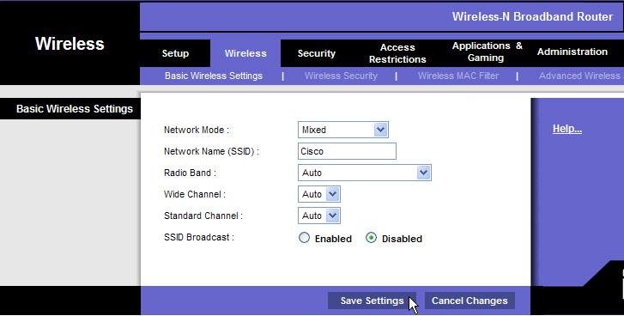

Why would you disable SSID broadcast?

View wireless networks associated with the wireless adapter configured to the computer.

What wireless network(s) are available?

Click on the router configuration page so it is activated.

Enable SSID broadcast.

Click Save Settings > Continue.

