15.5.1 Optional Lab: Install a Wireless NIC in Windows Vista

Introduction

Print and complete this lab.

In this lab, you will install and configure a wireless NIC.

Recommended Equipment
- A computer with Windows Vista installed
- Empty PCI slot on the motherboard
- A wireless access point or router
- A wireless PCI NIC
- An antistatic wrist strap

Step 1
Turn off your computer. If a switch is present on the power supply, set the switch to “0” or “off”. Unplug the computer from the AC outlet. Remove the side panels from the case.

Put on the antistatic wrist strap and attach it to an unpainted metal surface of the computer case.

Choose an appropriate slot on the motherboard to install the new wireless NIC.

You may need to remove the metal cover near the slot on the back of the case.

Make sure the wireless NIC is properly lined up with the slot. Push down gently on the wireless NIC.

Secure the wireless NIC mounting bracket to the case with a screw.

Attach the antenna to the antenna connector on the back of the computer.

Disconnect the antistatic wrist strap. Replace the case panels. Plug the power cable into an AC outlet. If a switch is present on the power supply, set the switch to “1” or “on”.

Step 2
Boot your computer, and then log on as an administrator.

The wireless NIC will be detected by Windows. The “Found New Hardware” window will appear.
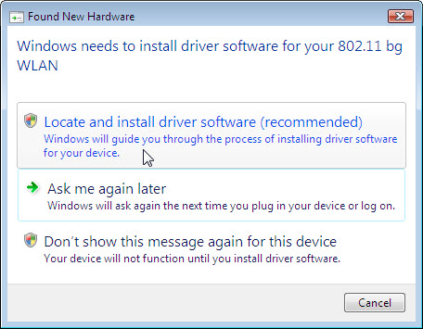

Click Locate and install driver software (recommended). Click Continue.

You will be prompted to insert the manufacturer’s CD.

Insert the CD.

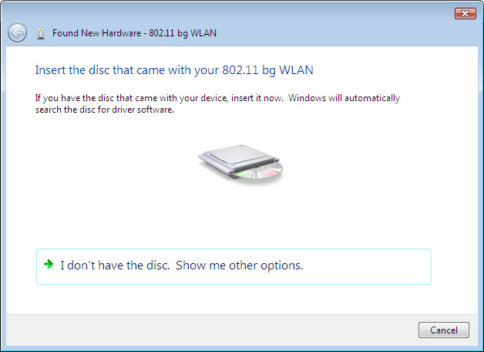

Once the drivers are installed click Close to complete the driver installation process.

Step 3
Click Start > right-click Computer, and choose Manage > Continue.

Choose Device Manager, and then expand “Network Adapters”.

What network adapters are installed in the computer?

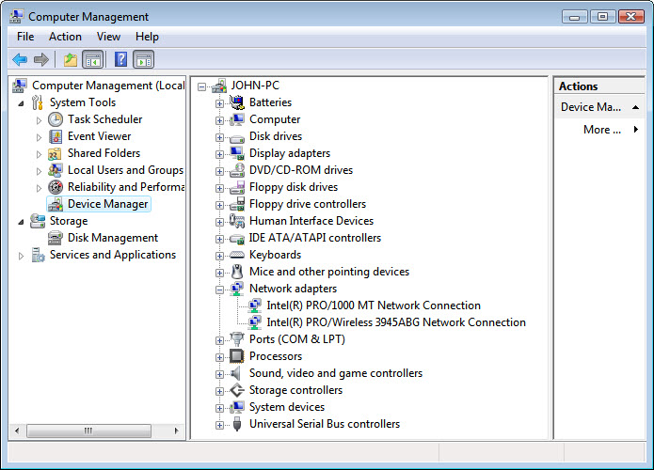

Close the “Computer Management” window.

Step 4
Choose Start.

Right-click Network > Properties > select Manage network connections.

Double-click the wireless NIC, and then click the Properties button > Continue.

Choose Internet Protocol Version 4 (TCP/IPv4), and then click the Properties button.

Click the Obtain an IP address automatically radio button.

Click the Obtain DNS server address automatically radio button.

Click OK.

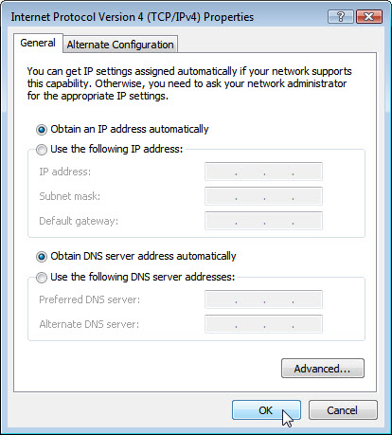

Step 5
Choose Start > Start Search.

Type cmd, and then press the Enter key.

Type ipconfig /all, and then press the Enter key.

What is the IP address of the computer?

What is the subnet mask of the computer?

What is the default gateway of the computer?

What are the DNS servers for the computer?

What is the MAC address of the comptuer?

Is DHCP Enabled?

What is the IP address of the DHCP server?

Step 6
A wireless NIC may also be configured with a static IP address.

Choose Start.

Right-click Network > Properties > select Manage network connections.

Double-click the wireless NIC, and then click the Properties button > Continue.

Choose Internet Protocol Version 4 (TCP/IPv4), and then click the Properties button.

Click the Use the following IP address radio button. Type the IP address, subnet mask and default gateway addresses from step 5.

Click the Use the following DNS server address radio button. Type the DNS address from step 5.

Click OK.

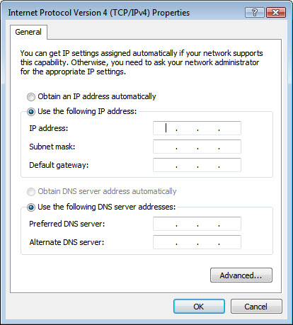

Step 7
Choose Start > Start Search.

Type cmd, and then press the Enter key.

Type ipconfig /all, and then press the Enter key.

Is DHCP Enabled?

Step 8
Return the NIC to original settings.

Choose Start.

Right-click Network > Properties > select Manage network connections.

Double-click the wireless NIC, and then click the Properties button > Continue.

Choose Internet Protocol Version 4 (TCP/IPv4), and then click the Properties button.

Click the Obtain an IP address automatically radio button.

Click the Obtain DNS server address automatically radio button.

Click OK.

