15.5.1 Optional Lab: Install a Wireless NIC in Windows 7

Introduction

Print and complete this lab.

In this lab, you will install and configure a wireless NIC.

Recommended Equipment
- A computer with Windows 7 installed
- Empty PCI or PCIe slot on the motherboard
- A wireless access point or router
- A wireless PCI or PCIe NIC
- An antistatic wrist strap

Step 1
Turn off your computer. If a switch is present on the power supply, set the switch to “0” or “off”. Unplug the computer from the AC outlet. Remove the side panels from the case.

Put on the antistatic wrist strap and attach it to an unpainted metal surface of the computer case.

Choose an appropriate slot on the motherboard to install the new wireless NIC.

You may need to remove the metal cover near the slot on the back of the case.

Make sure the wireless NIC is properly lined up with the slot. Push down gently on the wireless NIC.

Secure the wireless NIC mounting bracket to the case with a screw.

Attach the antenna to the antenna connector on the back of the computer.

Disconnect the antistatic wrist strap. Replace the case panels. Plug the power cable into an AC outlet. If a switch is present on the power supply, set the switch to “1” or “on”.

Step 2
Boot your computer, and then log on as an administrator.

The wireless NIC should be detected by Windows and drivers installed. If Windows does not have the required drivers, the “Add Hardware” screen will appear.

Click Next.
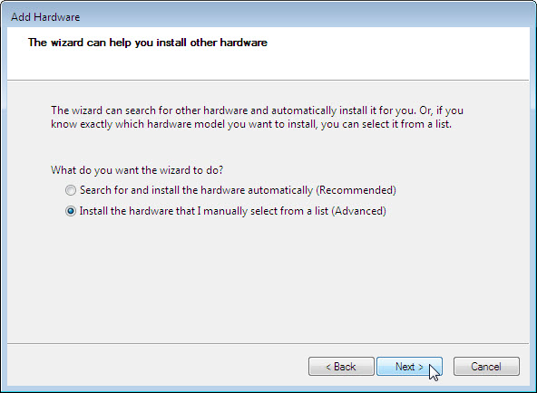

Select the Install the hardware that I manually select from a list (Advanced) radio button. Click Next.

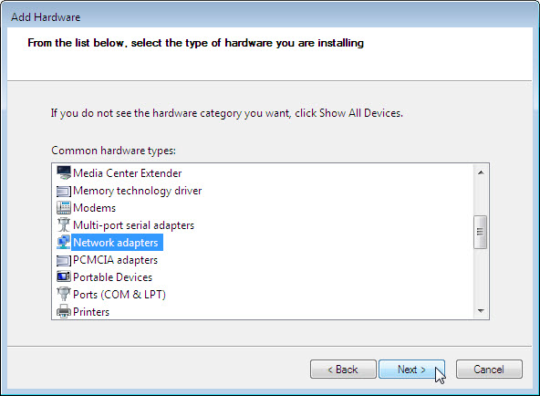

Scroll down the list, select Network adapters, and then click Next.

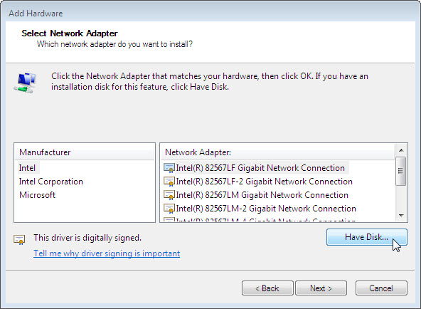

Click Have Disk.

Follow instruction to locate and install the drivers.

Once the drivers are installed click Finish to complete the driver installation process.

Step 3
Click Start > right-click Computer > Manage.

Choose Device Manager, and then expand “Network adapters”.

What network adapters are installed in the computer?

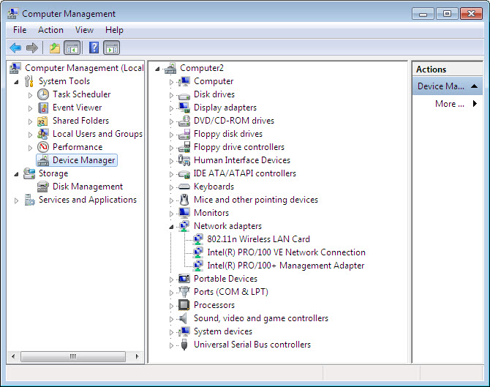

Close the “Computer Management” window.

Step 4
Choose Start.

Right-click Network > Properties > select Change adapter settings.

Right-click the wireless NIC > Properties.

Choose Internet Protocol Version 4 (TCP/IPv4), and then click the Properties button.

Click the Obtain an IP address automatically radio button.

Click the Obtain DNS server address automatically radio button.

Click OK.

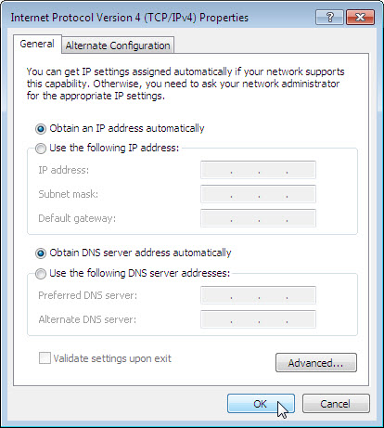

If the wireless NIC needs to be connected to a wireless network, right-click the wireless NIC, select Connect/Disconnect to connect to the wireless network.

Close all open windows.

Step 5
Choose Start > Search programs and files.

Type cmd, and then press the Enter key.

Type ipconfig /all, and then press the Enter key.

For the wireless NIC:
What is the IP address?

What is the subnet mask?

What is the default gateway?

What are the DNS servers?

What is the MAC address?

Is DHCP Enabled?

What is the IP address of the DHCP server?

Step 6
A wireless NIC may also be configured with a static IP address.

Choose Start.

Right-click Network > Properties > select Change adapter settings.

Right-click the wireless NIC > Properties.

Choose Internet Protocol Version 4 (TCP/IPv4), and then click the Properties button.

Click the Use the following IP address radio button. Type the IP address, subnet mask and default gateway addresses from step 5.

Click the Use the following DNS server addresses radio button. Type the DNS address from step 5.

Click OK.

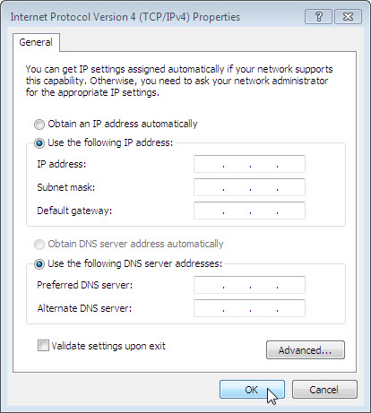

Step 7
Choose Start > Search programs and files.

Type cmd, and then press the Enter key.

Type ipconfig /all, and then press the Enter key.

Is DHCP Enabled for the wireless NIC?

Step 8
Return the NIC to original settings.

Choose Start.

Right-click Network > Properties > select Change adapter settings.

Right-click the wireless NIC > Properties.

Choose Internet Protocol Version 4 (TCP/IPv4), and then click the Properties button.

Click the Obtain an IP address automatically radio button.

Click the Obtain DNS server address automatically radio button.

Click OK.

