15.4.2 Optional Lab: Share a Folder, Share a Printer, and Set Share Permissions in Windows Vista

Introduction

Print and complete this lab.

In this lab, you will create and share a folder, share a printer, and set permissions for the shares.

Recommended Equipment
- Two computers running Windows Vista that are directly connected to each other or through a switch or hub
- A printer installed on one of the two computers

Step 1
Click Start > Control Panel > double-click Folder Options.

Click the View tab.

Uncheck the “Use Sharing Wizard (Recommended)” checkbox, and then click OK.

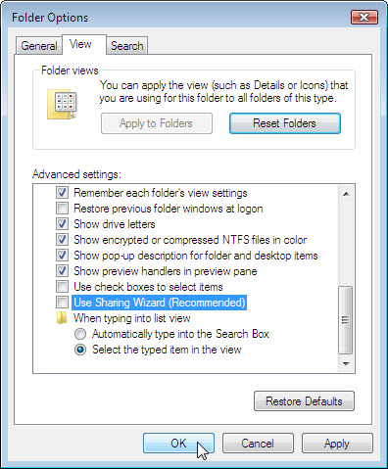

Step 2
Right-click the desktop, and then choose New > Folder.

Type Example, and then press the Return key.

Open WordPad. Type “This is an example document.”.

Save the file in the “Example” folder with the name “Brief.doc”, and then close WordPad.

Step 3
Right-click the Example folder, and then choose Sharing > Advanced Sharing > Continue.

Click the Share this folder radio button, and then click OK.

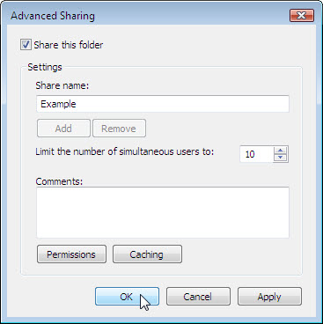

What is the icon of the “Example” folder?

On the computer with the shared folder, click Start > right-click Computer > Properties.

What is the name of the computer?

Step 4
On the other computer, choose Start > Start Search.

Type \\computername\Example, where computername is the name of the computer with the “Example” folder, and then press the Enter key.

Open the “Brief.doc” file.

Delete the text in the “Brief.doc” file, and then choose File > Save.

What happens?

Click OK.

Close WordPad, and then choose Don’t Save when prompted to save changes to the file.

Step 5
Return to the computer with the shared folder.

Right-click Example folder > Sharing, and then click Advanced Sharing > Continue > Permissions.

What are the default permissions?

Step 6
Open the Control Panel on the computer with the attached printer.

Double click Printers.

Right-click the icon of the installed printer, and then choose Run as administrator > Sharing > Continue.

Click the Share this printer radio button, and then click OK.

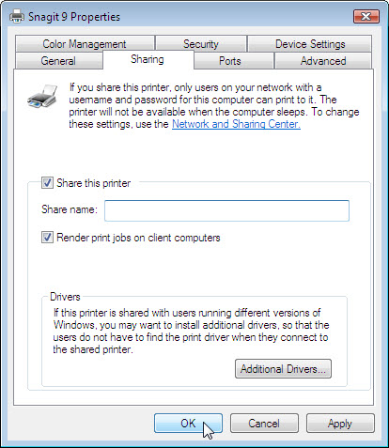

Step 7
Return to the computer that is not directly connected to a printer.

Open the Control Panel. Double click Printers.
Choose Add Printer on the screen below.

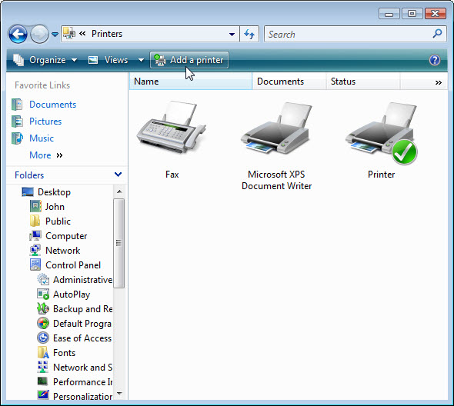

The “Add Printer” window appears.

The “Choose a local or network printer” of the “Add Printer” window appears. Click Add a network, wireless or Bluetooth printer.

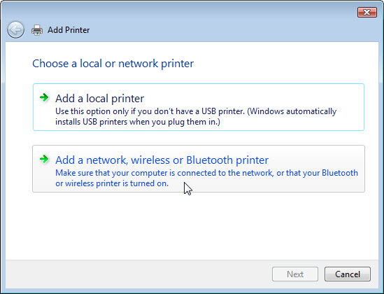

The “Searching for available Printers …” page appears.

Select Printer on computername if it is displayed in the search list.

If the printer was not in the search list, find a printer by name or TCP/IP address.
Select The printer that I want isn’t listed and select the radio button Select a shared printer by name and type \\computername\printer.
Click Next.

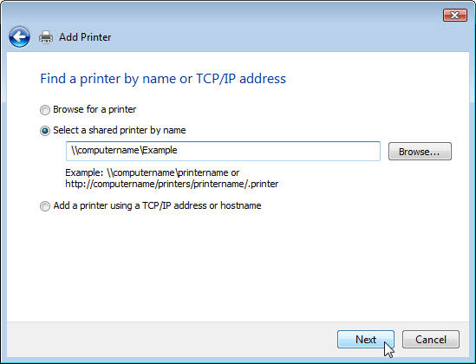

If prompted to install drivers click Install drivers. If User Account Control appears, click Continue.

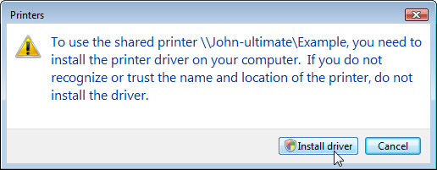

Accept all default setting, click Next then click Finish.

Step 8
Choose Start > Control Panel > Printers.

Right-click the printer you installed, and then choose Properties.

The “Printer Shared Properties” window appears.

Choose the General Tab, and then click Print Test Page.

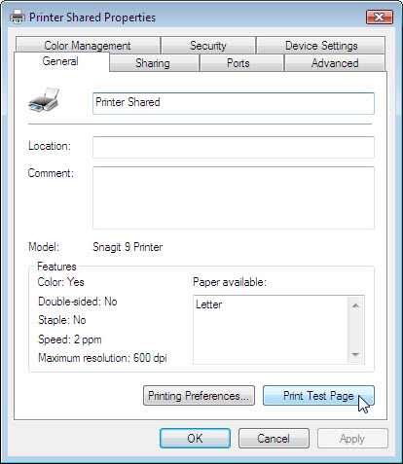

Click OK in the confirmation dialog box, and then click OK to close the printer properties window.

