15.4.2 Optional Lab: Share a Folder, Share a Printer, and Set Share Permissions in Windows 7

Introduction

Print and complete this lab.

In this lab, you will create and share a folder, share a printer, and set permissions for the shares.

Recommended Equipment
- Two computers running Windows 7 that are directly connected to each other or through a switch or hub
- A printer installed on one of the two computers

Step 1
On one computer click Start > Control Panel > Appearance and Personalization > Folder Options.

Click the View tab.

Uncheck the “Use Sharing Wizard (Recommended)” checkbox, and then click OK.

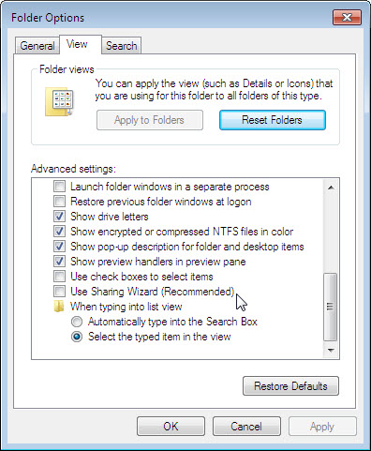

Step 2
Right-click the desktop, and then choose New > Folder.

Type Example to name the folder, and then press the Enter key.

Open Notepad. Type “This is an example document.”.

Save the file in the “Example” folder with the name “Brief”, and then close Notepad.

Step 3
Right-click the Example folder, and then choose Sharing with > Advanced Sharing > Advanced Sharing.

Click the Share this folder checkbox, and then click OK.

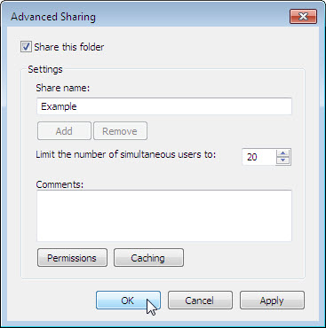

On the computer with the shared folder, click Start > right-click Computer > Properties.

What is the name of the computer?

Step 4
On the other computer, choose Start > Search programs and files.

Type \\computername\Example, where computername is the name of the computer with the “Example” folder, and then press the Enter key.

Open the “Brief” file.

Delete the text in the “Brief” file, and then choose File > Save.

What happens?

Click OK.

Close Notepad, and then choose Don’t Save when prompted to save changes to the file.

Step 5
Return to the computer with the shared folder.

Right-click Example folder > Sharing with > Advanced Sharing > Advanced Sharing > Permissions.

What are the default permissions?

Step 6
Open the Control Panel on the computer with the attached printer.

Click View devices and printers.

Right-click the icon of the installed printer, and then choose Printer properties > Sharing tab.

Click the Share this printer checkbox, and then click OK.

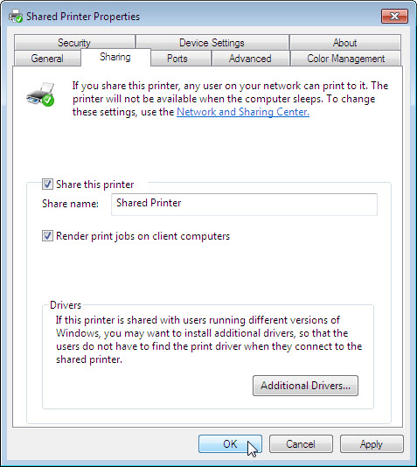

Step 7
Return to the computer that is not directly connected to a printer.

Open the Control Panel > View devices and printers.
Choose Add a Printer.

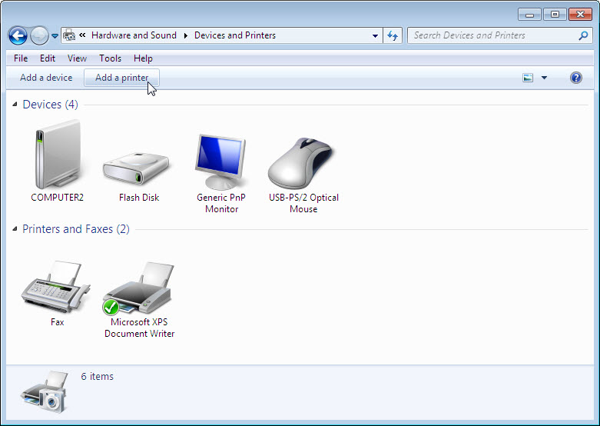

The “Add Printer” window appears.

The “What type of printer do you want to install” of the “Add Printer” window appears. Click Add a network, wireless or Bluetooth printer.

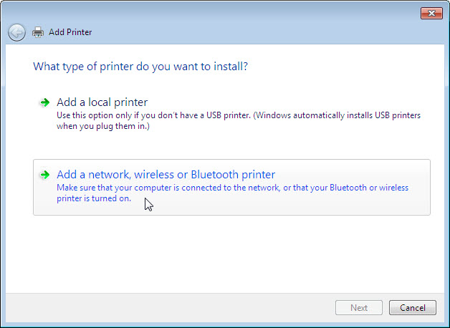

The “Searching for available Printers …” page appears.

Select Printer on computername if it is displayed in the search list.

If the printer was not in the search list, find a printer by name or TCP/IP address.
Select The printer that I want isn’t listed and select the radio button Select a shared printer by name and type \\computername\printer.

Click Next.

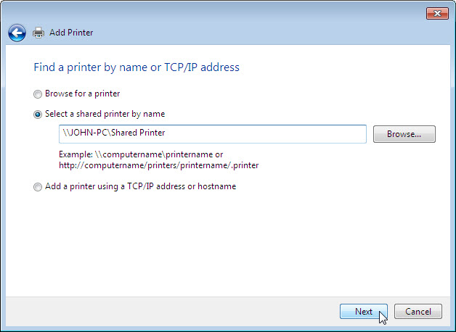

If prompted to install drivers click Install driver. If User Account Control appears, click Continue.

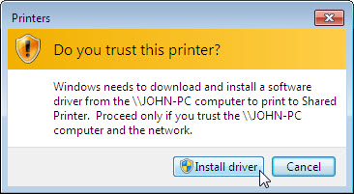

After the drivers install, click Next then click Finish.

Step 8
Choose Start > Control Panel > View devices and printers.

Right-click the printer you installed, and then choose Printer properties.

The “Shared Printer Properties” window appears.

Choose the General tab, and then click Print Test Page.

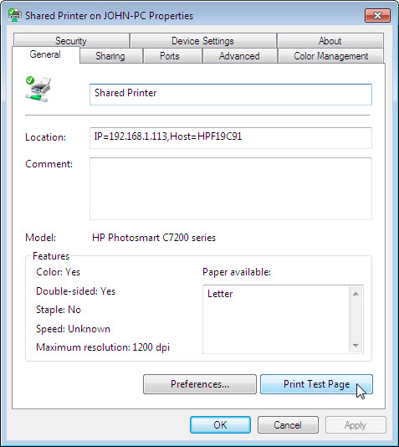

Click Close in the confirmation dialog box, and then click OK to close the printer properties window.

