14.3.2 Lab: Share the All-in-one Printer/Scanner in Windows XP

Introduction

Print and complete this lab.

In this lab, you will share the All-in-one printer/scanner, configure the printer on a networked computer, and print a test page from the remote computer.

Recommended Equipment
- Two computers directly connected or connected through a hub or switch
- Windows XP installed on both computers
- An All-in-one Printer/Scanner installed on one of the computers

Step 1
Click My Computer > Tools > Folder Options > View, and then uncheck Use Simple File Sharing (Recommended).

Click OK.

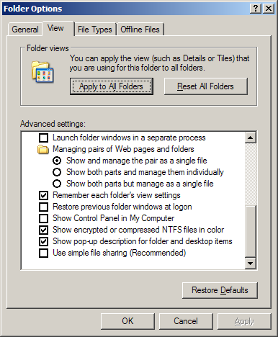

Step 2
Choose Start > Printers and Faxes.

Right-click the All-in-one Printer/Scanner, and then choose Properties.
Click the Sharing tab.

Choose Share this printer. Name the new share Example, and then click Apply.

Click OK.

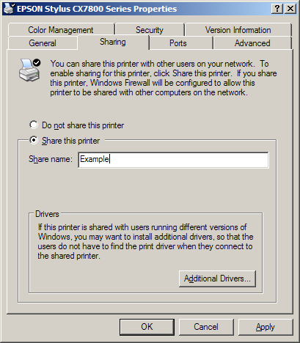

Step 3
Log on to the computer without the printer/scanner connected, and then choose Start > Printers and Faxes.

Click Add a printer.

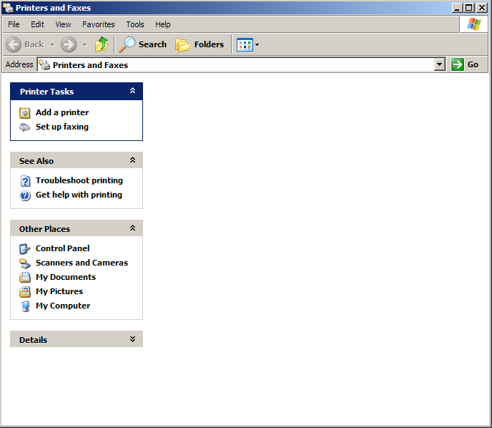
The “Add Printer Wizard” window appears.

Click Next.

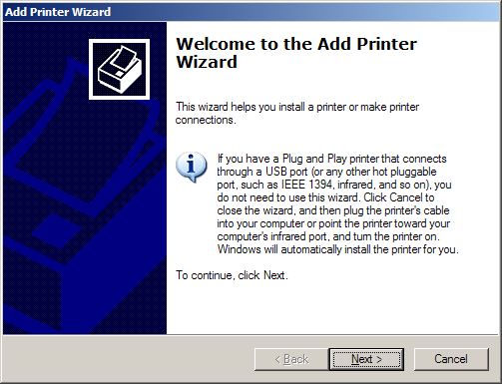

The “Local or Network Printer” window appears.

Click the A network printer, or a printer attached to another computer radio button, and then click Next.

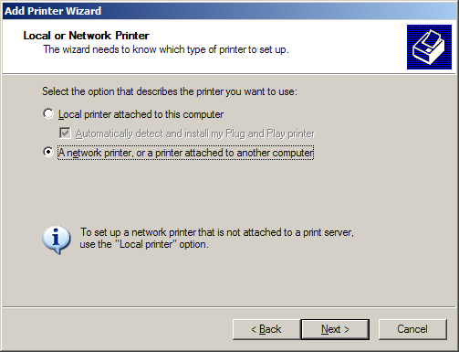
Type \\computername\printer in the Connect to this printer (or to browse for a printer, select this option and click Next): radio button, where computername is the name of the computer with the connected printer/scanner and printer is the name of the printer/scanner.

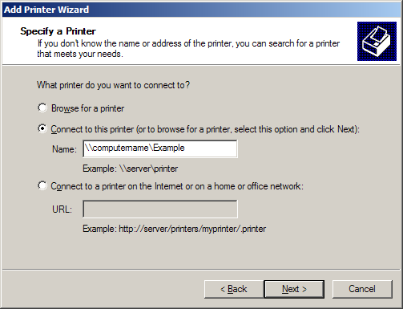

Step 4
Choose Start > Printers and Faxes.

Right-click the All-in-one Printer/Scanner, and then choose Properties.

Click the Print Test Page button.

