14.3.2 Optional Lab: Share the All-in-one Printer/Scanner in Windows Vista

Introduction

Print and complete this lab.

In this lab, you will share the All-in-one printer/scanner, configure the printer on a networked computer, and print a test page from the remote computer.

Recommended Equipment
- Two computers directly connected or connected through a hub or switch
- Windows Vista installed on both computers
- An All-in-one Printer/Scanner installed on one of the computers

Step 1
Click Start > Computer > Tools > Folder Options > View, and then uncheck Use Sharing Wizard (Recommended) if it is checked.

Click OK.

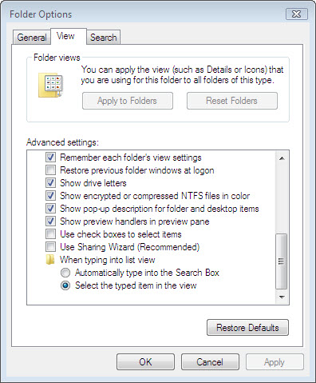

Step 2
Click Start > Network > Network and Sharing Center > Password protected sharing, and then check Turn off password protected sharing.

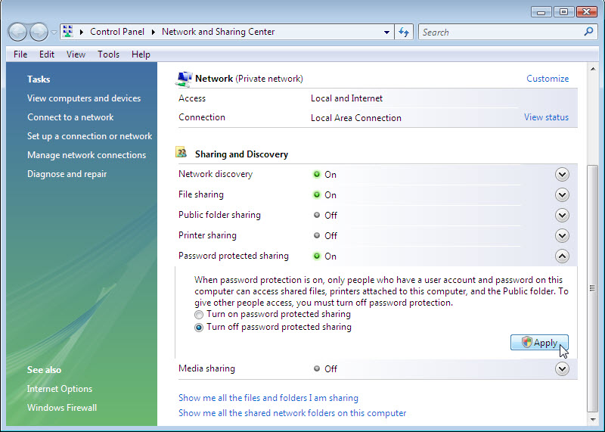

Click Apply. If User Account Control appears, click Continue.

Step 3
Choose Start > Control Panel > double click Printers.
Right-click the All-in-one Printer/Scanner, and then choose Properties.
Click the Sharing tab.

Click Change sharing options. If User Account Control appears, click Continue.

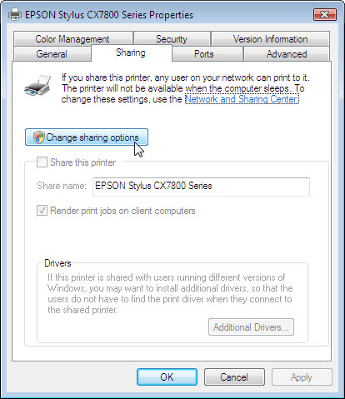

Choose Share this printer. Name the new share Example, and then click OK.

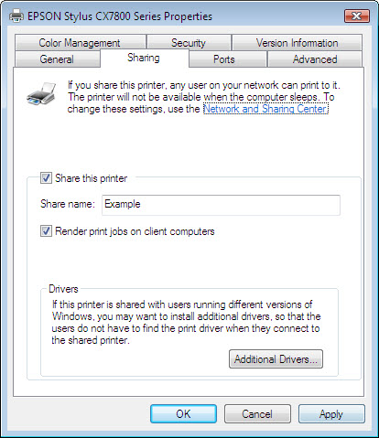

Step 4
Log on to the computer without the printer/scanner connected, and then choose Start > Control Panel > Printers.

Click Add a printer.

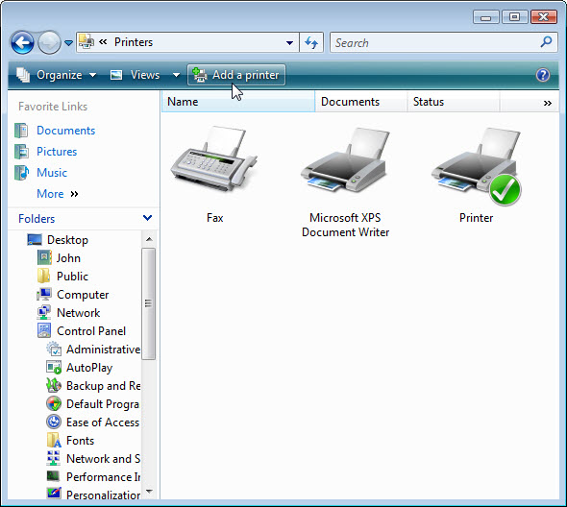
The “Add Printer” window appears.

Click Add a network, wireless or Bluetooth printer.

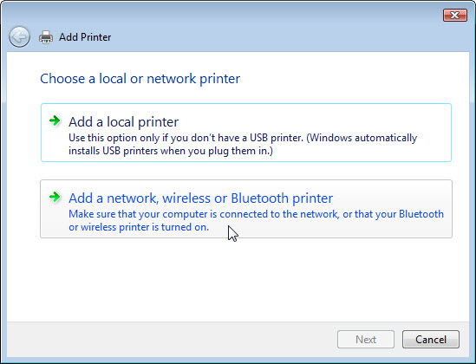

The “Searching for available Printers …” page appears.

If displayed in the search list select Printer on Computername and then click Next.

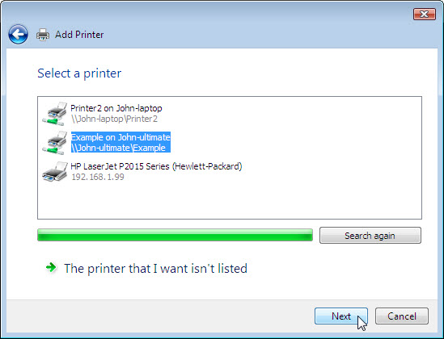

Or to find a printer by name or TCP/IP address, select The printer that I want isn’t listed.

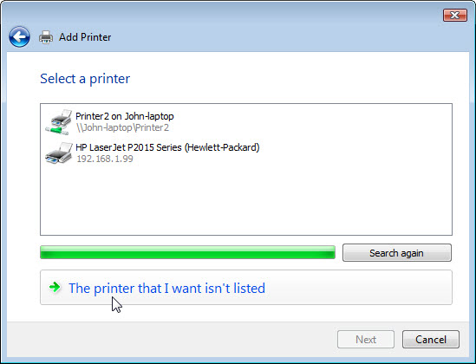

Select the radio button Select a shared printer by name and type \\computername\printer, where computername is the name of the computer with the connected printer/scanner and printer is the name of the printer/scanner.

Click Next.

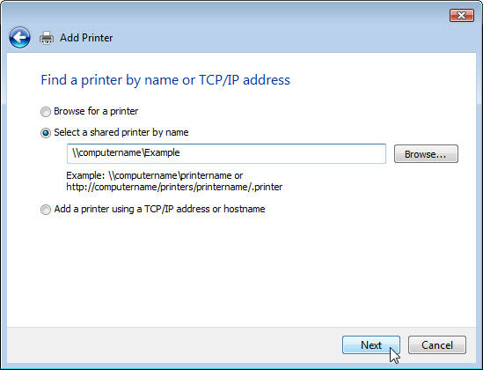
If prompted to install drivers click Install driver. If User Account Control appears, click Continue.

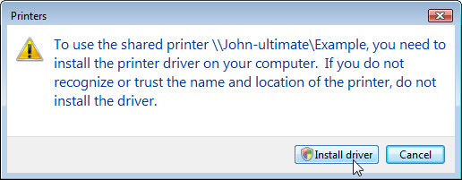

Accept all default settings, click Next and then click Finish.

Step 5
Choose Start > Control Panel > double click Printers.

Right-click the All-in-one Printer/Scanner, and then choose Properties.

Click the Print Test Page button.

